DATA SCIENCE PORTFOLIO CASE STUDY
Financial Deterioration Screening
From point-in-time SEC data to an analyst review queue
SEC EDGAR + FRED | 117 active issuers | Financial cutoff 31 Dec 2025

The business problem
An analyst cannot deeply review every public company every quarter. This project builds a screening layer that ranks companies for follow-up when operating earnings may become insufficient relative to interest expense. False alerts are reviewed manually; missed deterioration is considered more costly.

What I built
- A filing-aware SEC EDGAR and FRED/ALFRED pipeline with source and availability lineage.
- A reproducible 117-company sample: 75 Consumer Discretionary and 42 Utilities issuers.
- Financial-ratio, trend, volatility, and peer-relative features with fold-local missing-data treatment.
- Expanding-window model validation with outcome embargoes and company-clustered uncertainty.
- An interpretable partially pooled logistic primary, pooled benchmark, and constrained boosting challenger.
- Sector-specific thresholds that attain at least 80% recall while minimizing review workload.

Point-in-time pipeline and leakage controls
The most important engineering requirement was to reproduce what an analyst could actually have known at each historical decision date. Fiscal period-end dates were not treated as publication dates. SEC filing availability, amendments, macro vintages, and feature availability were retained explicitly.
Leakage risk | Control
Using later filings | Filter every fact by its public availability date
Using immature outcomes | Require the complete consecutive future window before labeling
Global imputation | Fit imputation and missing indicators inside each training fold
Feature-selection leakage | Select variables only within outer-fold training history
Random train/test mixing | Use expanding calendar windows and label embargoes
Threshold overstatement | Label all metrics as development OOF until a new future test matures

Modeling and feature decisions
The primary logistic model was chosen for interpretability, not because it had the highest score. Gradient boosting reached 0.412 development PR-AUC versus 0.379 for the partially pooled logistic model. The challenger is stronger statistically, while the primary is easier to explain to an analyst.
Stable selected variables included current interest coverage, its year-over-year change, volatility and sector percentile, free-cash-flow-margin sector percentile, operating margin, and revenue growth. Refinancing gap was selected in one early fold but was unstable and absent from the latest-fold recommendation; filing delay remained a data-quality field rather than direct distress evidence.
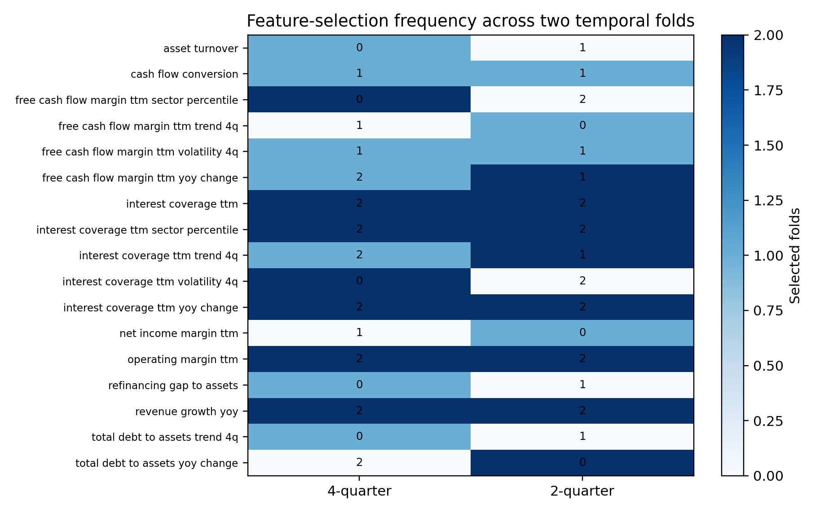
Fold-local selection emphasizes understandable operating, cash-flow, and debt-service measures.

Main operating result
At the paired calibrated four-quarter policy, overall recall was 80.5%, precision was 23.2%, and 67.3% of company-quarters entered review. High recall is achievable, but the workload is substantial.
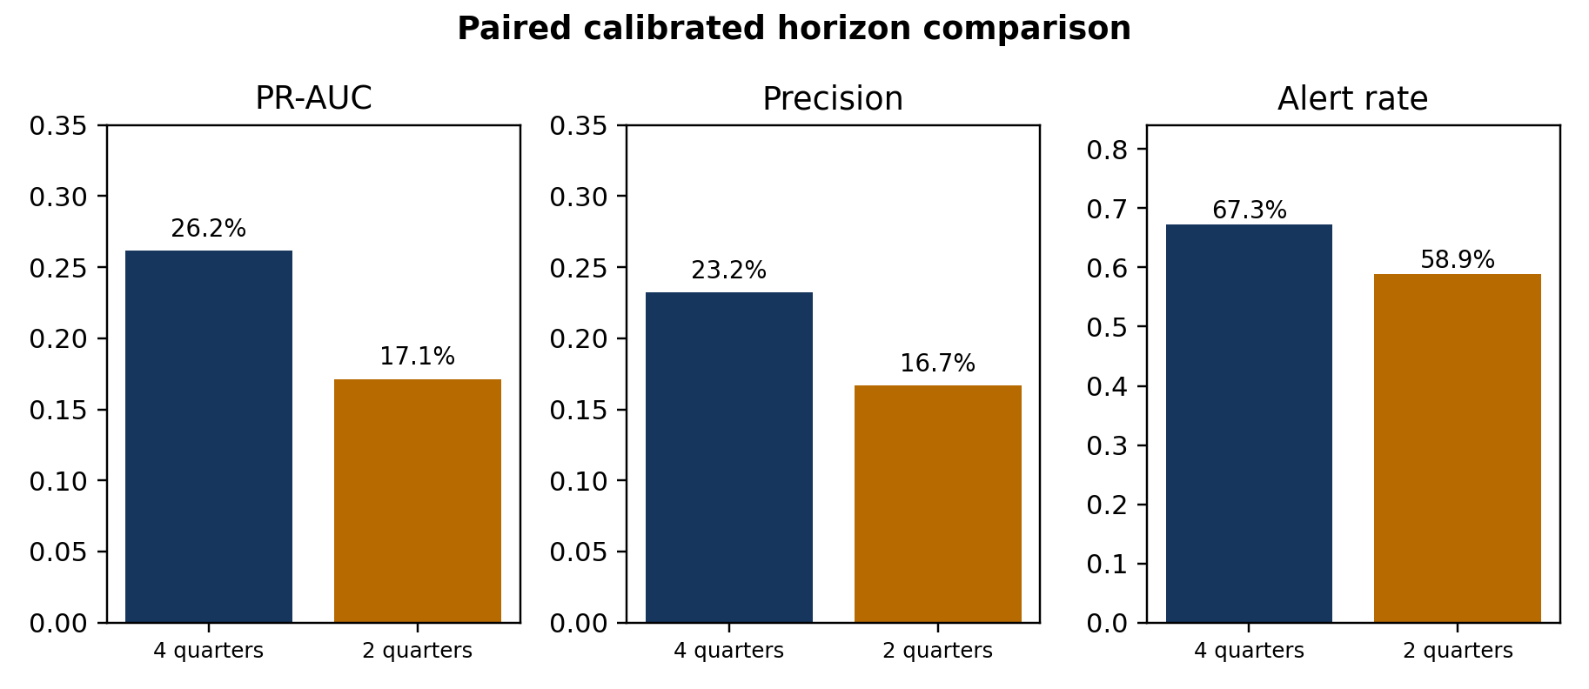
The two-quarter sensitivity reduces workload but weakens ranking and precision.
The two-quarter sensitivity retained 81.2% recall and reduced alerts to 58.9%. Its PR-AUC fell from 0.262 to 0.171, however, and precision fell from 23.2% to 16.7%.

Three real model decisions

True Positive: DBI
The model assigned 69.3% against a 10.5% threshold. Current interest coverage was 6.01x and future minimum coverage was 0.93x.
Useful early-review alert: the subsequent coverage outcome met the deterioration rule.
Not an error; the available financial signals ranked this event above its sector threshold.

False Positive: UAA
The model assigned 92.1% against a 10.5% threshold. Current interest coverage was -7.49x and future minimum coverage was -3.67x.
Potentially useful as a precautionary review, but it consumed capacity without a qualifying four-quarter event.
Weak contemporaneous signals resembled deterioration, but future coverage did not satisfy both the level and decline rules.

Missed Deterioration: NRG
The model assigned 12.1% against a 12.3% threshold. Current interest coverage was 6.89x and future minimum coverage was -1.48x.
Not useful operationally because the deterioration was missed at the selected threshold.
The observed predictors produced a score just below the sector cutoff; the later coverage decline was not strong enough in the available signals to trigger review.

Limitations and what I would do next
- Keep the post-2025 future period unopened until four-quarter outcomes mature.
- Measure real analyst capacity before operationalizing a 60%–70% alert rate.
- Recalibrate probabilities when new labels mature; investigate drift rather than retraining automatically.
- Consider adding Industrials only after validating sector mappings and KPI comparability.
- Preserve the four-quarter outcome as primary and use two quarters only as a secondary near-term screen.

Skills demonstrated
Financial statement analysis, SEC/FRED data engineering, point-in-time joins, temporal cross-validation, missing-data methods, imbalanced classification, feature selection, calibration, interpretability, clustered uncertainty, model governance, automated testing, and communication of statistical results in a financial decision context.

Resume-ready summary
- Developed a point-in-time financial-deterioration screening pipeline using SEC filings and macro data for 117 active Consumer Discretionary and Utility issuers.
- Implemented expanding-window validation, fold-local feature selection, calibrated classification, and sector thresholds exceeding 80% recall in both sectors.
- Compared an interpretable partially pooled logistic model with pooled logistic and constrained boosting; the challenger achieved 0.412 development PR-AUC.
- Empirically tested two- versus four-quarter warning horizons using paired folds and issuer-clustered bootstrap uncertainty, documenting a workload-versus-precision tradeoff.
All results are explicitly labeled as development evidence. The project does not claim bankruptcy prediction, causal effects, or final prospective performance.

