FINANCIAL RISK & DATA SCIENCE RESEARCH
Corporate Financial Deterioration Early-Warning Platform
Phase 2: model improvement, interpretability, and horizon sensitivity
SEC EDGAR + FRED | 117 active issuers | Financial cutoff 31 Dec 2025

Executive summary
This study develops a point-in-time analyst-screening system for detecting weakening corporate debt-service capacity. The system is not a bankruptcy model and does not replace credit analysis. It prioritizes recall so that potentially deteriorating firms reach manual review.
Main conclusion. The two-quarter sensitivity model met the 80% recall requirement in both sectors and reduced the paired alert rate by 8.3 percentage points. However, PR-AUC declined by 0.090 and precision declined by 6.6 percentage points. The shorter horizon therefore reduces queue size, but the remaining alerts are less concentrated with true events. It is useful as a secondary near-term screen, not a superior replacement for the four-quarter primary outcome.
Paired calibrated result | 4-quarter primary | 2-quarter sensitivity
Eligible validation rows | 397 | 397
Event prevalence | 19.4% | 12.1%
PR-AUC | 0.262 | 0.171
Recall | 80.5% | 81.2%
Precision | 23.2% | 16.7%
Alert rate | 67.3% | 58.9%
Brier score | 0.159 | 0.106
Median warning lead | 2.0 quarters | 1.0 quarters

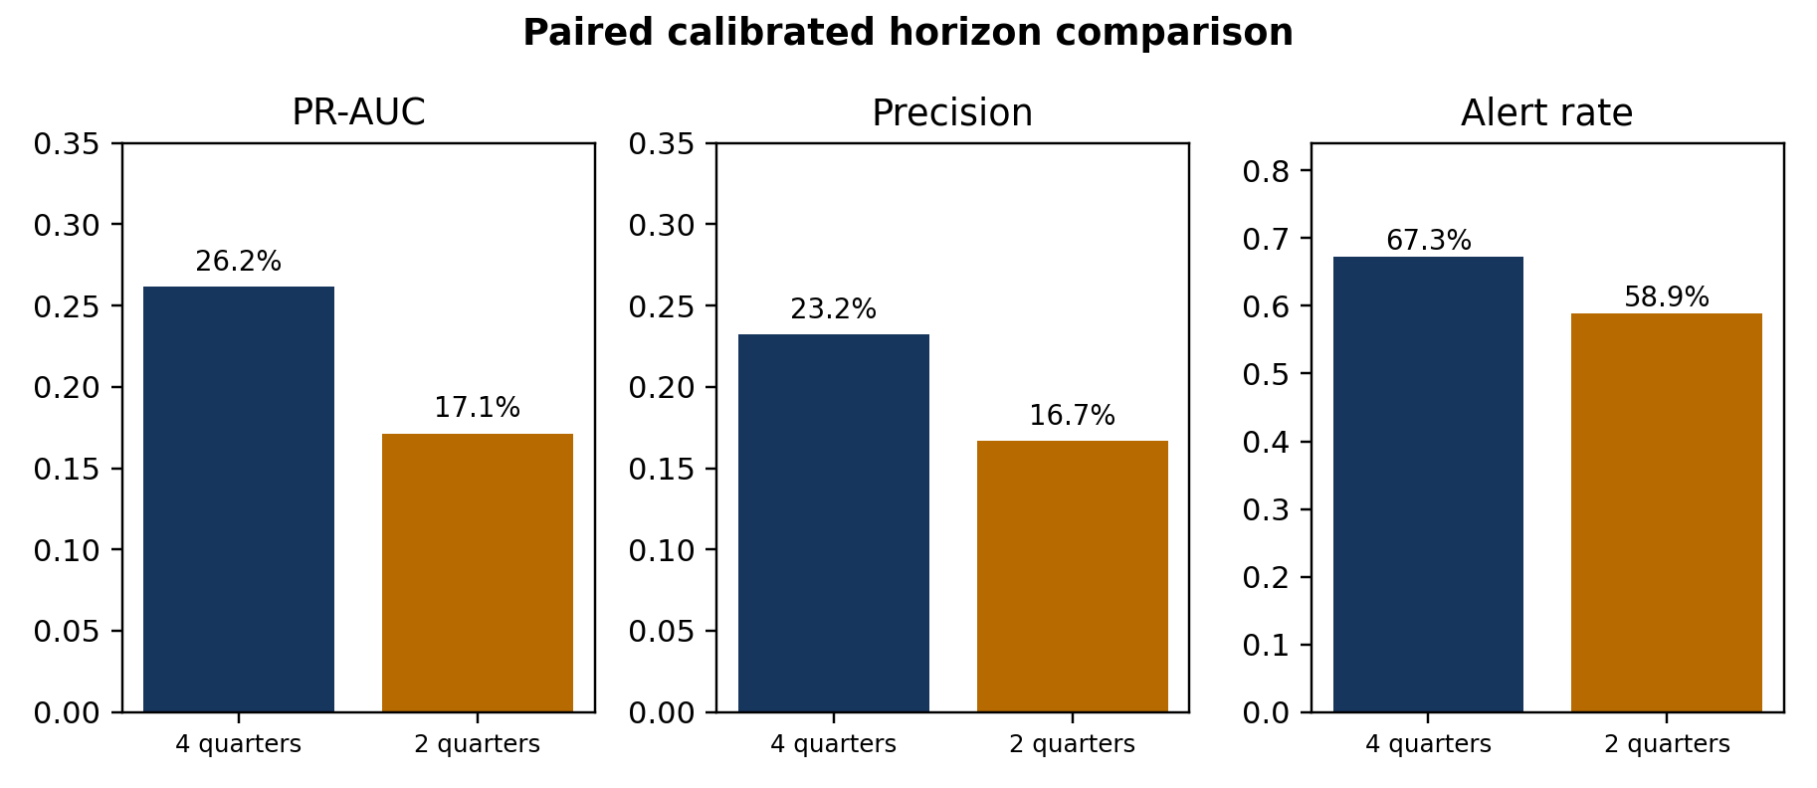
Figure 1. The shorter horizon lowers workload but also weakens ranking and alert precision.

1. Business and financial question
Credit and equity analysts often screen many issuers before performing detailed filing review, covenant analysis, valuation work, or management assessment. The project asks whether public financial statements and macroeconomic information can rank active companies by the risk of a material decline in interest coverage.
- Primary financial outcome: within four future fiscal quarters, interest coverage falls below 1.5x and declines at least 40% from the current level.
- Secondary sensitivity outcome: apply the same economic rule over two future fiscal quarters.
- Decision objective: attain at least 80% recall separately in Consumer Discretionary and Utilities, then minimize the number of alerts.
Interest coverage connects operating earnings to contractual interest expense. A decline below 1.5x indicates a narrow earnings cushion, but the rule is a research definition—not a covenant, default forecast, or investment recommendation.

2. Data, population, and sampling
The analysis uses SEC EDGAR company facts and filing metadata for financial statements, plus FRED/ALFRED macroeconomic series. Every field carries an availability date so that a decision row contains only information public at that time.
Design element | Phase 2 treatment
Population | Currently listed US operating companies; delisted companies excluded by scope
Selection date | 2 August 2026
Financial cutoff | 31 December 2025
Sample | 75 Consumer Discretionary and 42 Utilities issuers
Randomization | Seeded stratified random sampling without replacement; seed 42
Eligibility | Reliable interest coverage and assets; occasional optional-field gaps permitted
Synthetic data | None

Grocery-dominant discount retailers are excluded because their sales mix is staples-oriented. Sector assignment uses SEC SIC mappings and reviewed business descriptions; store format alone does not determine sector membership.

3. Point-in-time analytical pipeline
- Retrieve and checksum public source responses without committing credentials or raw data.
- Normalize XBRL concepts, construct financial ratios, and preserve filing and availability lineage.
- Join only macro vintages available at each decision date.
- Build future labels only where all required future quarters are consecutive and observed.

4. Modeling design and leakage controls
The primary classifier is a regularized partially pooled logistic model. It shares a common relationship across sectors while allowing a small number of Utility deviations. A pooled logistic model is the benchmark and constrained gradient boosting is the nonlinear challenger.

Expanding-window validation
Each validation period occurs after its training history. Labels are admitted to training only when the full outcome window was already observable before the validation origin. This embargo prevents future outcomes from leaking backward into model fitting.

Fold-local feature selection
Within each outer training fold, candidate variables pass missingness and variance checks, correlation pruning, and repeated temporal permutation-importance testing. The outer validation period is never used to choose features. Missing indicators and imputation are also fitted only within training folds.
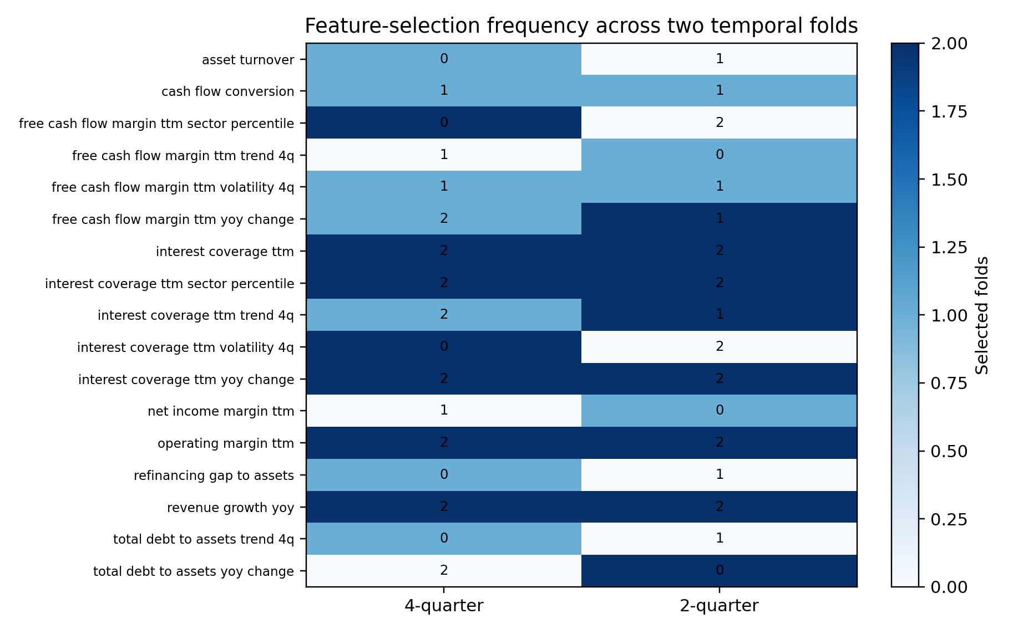
Figure 2. Counts show how often each candidate survived fold-local selection; zero means it was evaluated but not retained.
Refinancing gap/assets was selected in one of two folds, but was not stable and was not retained by the latest-fold recommendation. Filing delay is excluded from the classifier and appears only as a data-quality and case-review field.

5. Four-quarter primary model results
Model | PR-AUC | Precision* | Recall* | Brier
Partially pooled logistic | 0.379 | 0.415 | 0.391 | 0.157
Constrained boosting | 0.412 | 0.415 | 0.391 | 0.153

*Precision and recall in this model-comparison table use the common 20% alert-rate reference point. The separate operational threshold policy targets 80% sector recall.
The boosting challenger ranked events better, but the partially pooled logistic model remains the registered primary because its structure and financial relationships are easier to defend. This is an explicit interpretability-performance tradeoff rather than an attempt to hide the stronger challenger.

6. Two-quarter sensitivity experiment
The comparison was frozen before examining results: four quarters remained primary; two quarters used the identical 1.5x and 40% rules; both horizons used the same issuers, same paired validation company-quarters, same fold calendar, and independent fold-local feature selection. Calibration used only earlier out-of-fold predictions.
Horizon | Sector | Rows | Prev. | PR-AUC | Recall | Precision | Alerts
4Q | Consumer | 251 | 21.9% | 0.279 | 80.0% | 27.7% | 63.3%
4Q | Utilities | 146 | 15.1% | 0.262 | 81.8% | 16.7% | 74.0%
2Q | Consumer | 251 | 13.9% | 0.207 | 80.0% | 21.1% | 53.0%
2Q | Utilities | 146 | 8.9% | 0.120 | 84.6% | 10.9% | 69.2%

Both horizons exceeded 80% recall in each sector. Utilities required much larger review queues and produced lower precision at both horizons, reflecting a smaller event set and weaker ranking. Equal recall is not forced; each sector simply has to clear the minimum standard.

Statistical uncertainty
Two-quarter minus four-quarter | Estimate | Company-clustered 95% interval
PR-AUC | -0.090 | [-0.195, -0.013]
Precision | -0.066 | [-0.111, -0.027]
Alert rate | -0.083 | [-0.123, -0.043]
Brier score | -0.053 | [-0.072, -0.033]
Median lead (quarters) | -1.000 | [-1.500, -1.000]

The alert-rate reduction, precision decline, and PR-AUC decline all have company-clustered intervals that exclude zero. Companies—not individual quarters—were resampled because observations from the same issuer are correlated.

Calibration and lead time
The four-quarter paired model used pooled intercept recalibration and achieved a Brier score of 0.159 with expected calibration error 0.069. The two-quarter model retained none calibration; its Brier score was 0.106 and calibration error 0.040.
The lower two-quarter Brier score partly reflects lower event prevalence, so it should not be read as proof of better ranking. Median warning lead fell from 2.0 to 1.0 quarters in the correctly alerted paired events. That is structurally expected: a shorter outcome window cannot capture later-onset deterioration.

7. Company-level financial case analysis

True Positive: Designer Brands Inc. (DBI)
At 2024-06-04, the four-quarter model scored 69.3% against its 10.5% sector threshold. Interest coverage was 6.01x, free-cash-flow margin 6.4%, operating margin 5.5%, and debt/assets 18.3%.
Associated model-facing conditions included leverage is rising. These are predictive associations, not causal findings.
Useful early-review alert: the subsequent coverage outcome met the deterioration rule.
Not an error; the available financial signals ranked this event above its sector threshold.

False Positive: Under Armour, Inc. (UAA)
At 2024-05-29, the four-quarter model scored 92.1% against its 10.5% sector threshold. Interest coverage was -7.49x, free-cash-flow margin -27.8%, operating margin -3.8%, and debt/assets 14.0%.
Associated model-facing conditions included weak free cash flow versus sector peers; weak debt-service capacity versus sector peers. These are predictive associations, not causal findings.
Potentially useful as a precautionary review, but it consumed capacity without a qualifying four-quarter event.
Weak contemporaneous signals resembled deterioration, but future coverage did not satisfy both the level and decline rules.

Missed Deterioration: NRG ENERGY, INC. (NRG)
At 2024-02-28, the four-quarter model scored 12.1% against its 12.3% sector threshold. Interest coverage was 6.89x, free-cash-flow margin 0.8%, operating margin 12.5%, and debt/assets 27.4%.
No monitored ratio was extreme enough to generate a standard reason code. This absence is itself informative: the later decline was not apparent in the model's strongest contemporaneous indicators.
Not useful operationally because the deterioration was missed at the selected threshold.
The observed predictors produced a score just below the sector cutoff; the later coverage decline was not strong enough in the available signals to trigger review.

8. Financial interpretation
- The model is strongest as a prioritization system, not an autonomous credit decision.
- Weak peer-relative cash generation and debt-service capacity are understandable review triggers.
- A false alert can still identify a financially weak company even when the exact future label is not met.
- A missed event can arise when current financial ratios appear healthy but deteriorate later; no historical classifier can observe an unreported future shock.

9. Limitations and model governance
- The active-company-only sample creates survivorship bias and cannot represent delisted or failed firms.
- The 2023-and-later Phase 1 period has already been examined, so Phase 2 results are development evidence rather than a final untouched test.
- Only two sectors are included, and Utilities have fewer issuers and deterioration events.
- Overlapping quarterly outcomes are correlated; company-clustered uncertainty reduces but does not eliminate this concern.
- Thresholds were estimated from development predictions and may require recalibration when future outcomes mature.
- The label measures a specific interest-coverage deterioration pattern, not default, downgrade, fraud, or investment loss.

Readiness conclusion
The implementation objectives are complete, but Phase 2 is not ready for a definitive future-performance claim. A new test beginning after the frozen 2025 financial cutoff should remain unopened until four-quarter outcomes mature. Until then, all reported values should be described as temporal out-of-fold development evidence.

10. Reproducibility and data lineage
The repository provides a locked Python environment, versioned YAML configuration, deterministic seeds, ordered CLI stages, automated tests, source manifests, model/data cards, and generated evidence tables. Private SEC identification and the FRED key belong only in the ignored .env file. The committed .env.example contains placeholders.
Artifact | Purpose
configs/phase2.yml | Frozen sampling, label, validation, model, and threshold policy
docs/phase2_methodology.md | Technical definitions in plain language
docs/phase2_reproducibility.md | Environment, commands, source attribution, and expected outputs
reports/generated/phase2_horizon_*.csv | Auditable empirical sensitivity results
reports/generated/phase2_company_case_studies.csv | Selected TP, FP, and missed-event evidence
tests/ | Unit, leakage, selection, sampling, and policy checks

11. Conclusion
The project demonstrates a complete financial data-science workflow: point-in-time data engineering, economically interpretable labels and features, imbalance-aware evaluation, temporal cross-validation, fold-local preprocessing and feature selection, calibration, threshold optimization, uncertainty analysis, and case-level interpretation.
The empirical horizon test does not support replacing the four-quarter primary outcome. Two quarters reduces workload and produces probabilities with a lower Brier score, but it identifies a narrower and more immediate event, ranks those events less effectively, lowers precision, and cuts warning lead time. The defensible deployment concept is therefore a two-layer analyst screen: four quarters for medium-term deterioration and two quarters as an optional near-term sensitivity flag.

