**Code Test**

**EndPoint:** <http://localhost:59864/Api/GetAllEmployeeDetails/> - all employees

<http://localhost:59864/Api/GetEmployeeDetails/1> - particular employee

We need to login to access the data therefore the default user is already created in the database credential is given below

**Username:**  Anish

**Password:**  password

Access the endpoint without login.

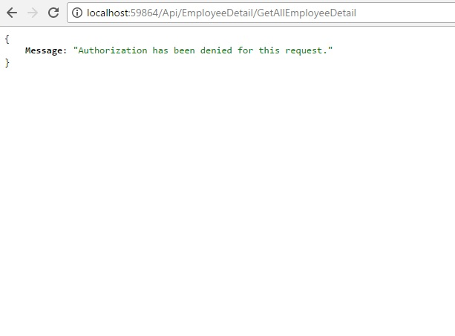

Login Url: <http://localhost:59864/Home/Index> (Default Page)

|  |  |
| --- | --- |
|  | After successful login, access token will be provided. |

**Testing Using Postman – Chrome Extension**

Access token is added to the header and sent GET request for the endpoint:

<http://localhost:59864/Api/EmployeeDetail/GetAllEmployeeDetail>

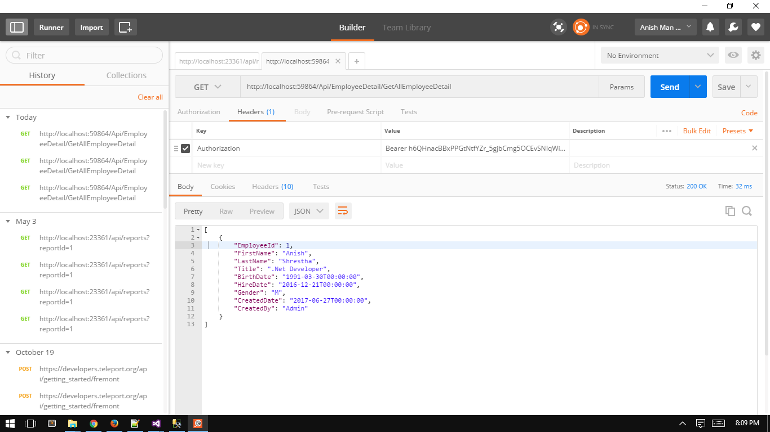

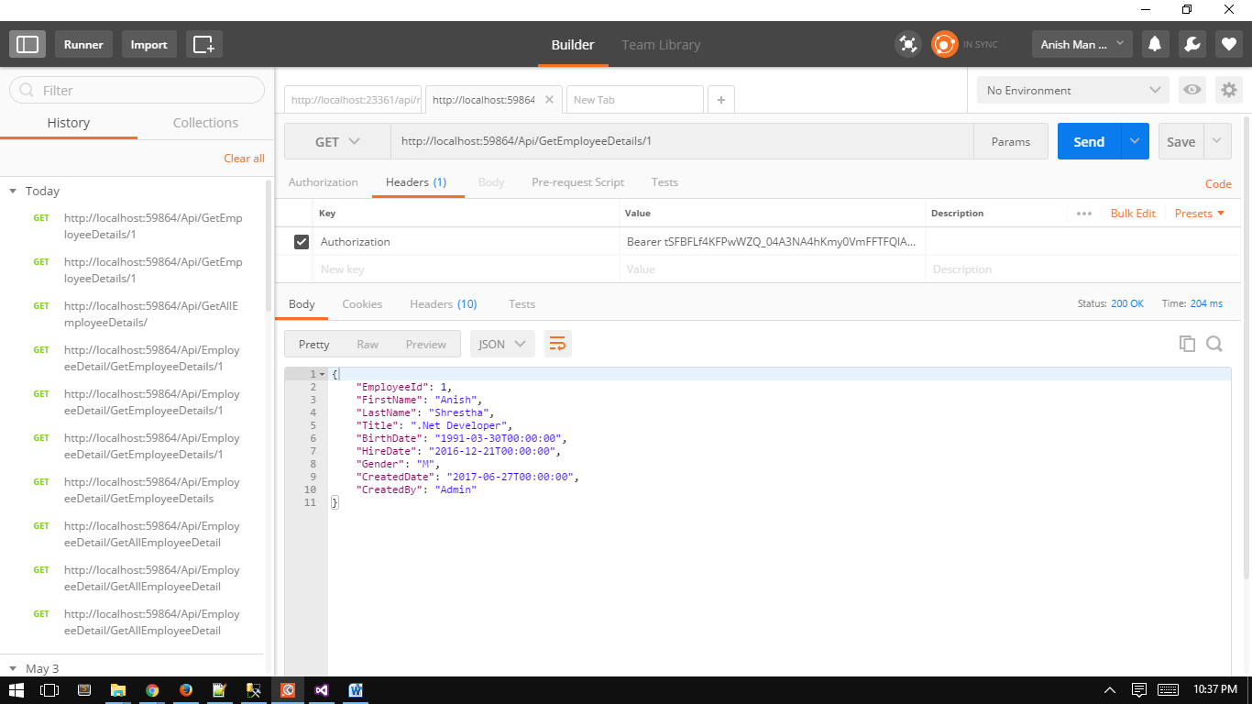

The access token is also stored in the browser using session

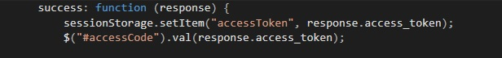

**Consuming API**

Now, using the session stored displaying the employee information:

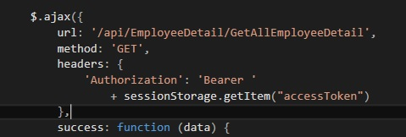

<http://localhost:59864/Home/EmployeeDetail>

*(this page is only accessible after login)*

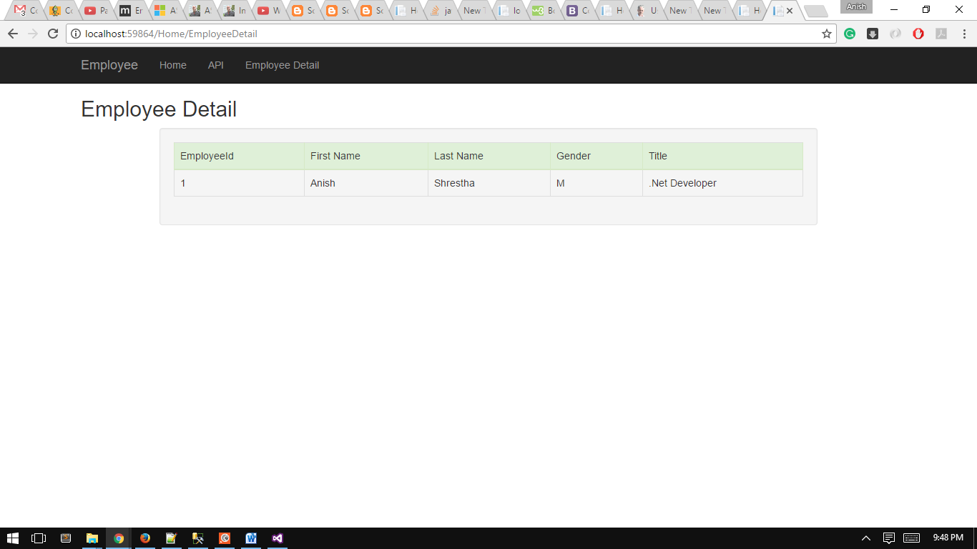

**Note:**

For creating the authorization tables for newly created database -

**Package Manager Console > Update-Database**

(This will also create the default user from the seed data –

This is in Employee.WebAPI->Migration->Configuration.cs)