GIT HUB:-

jenkins

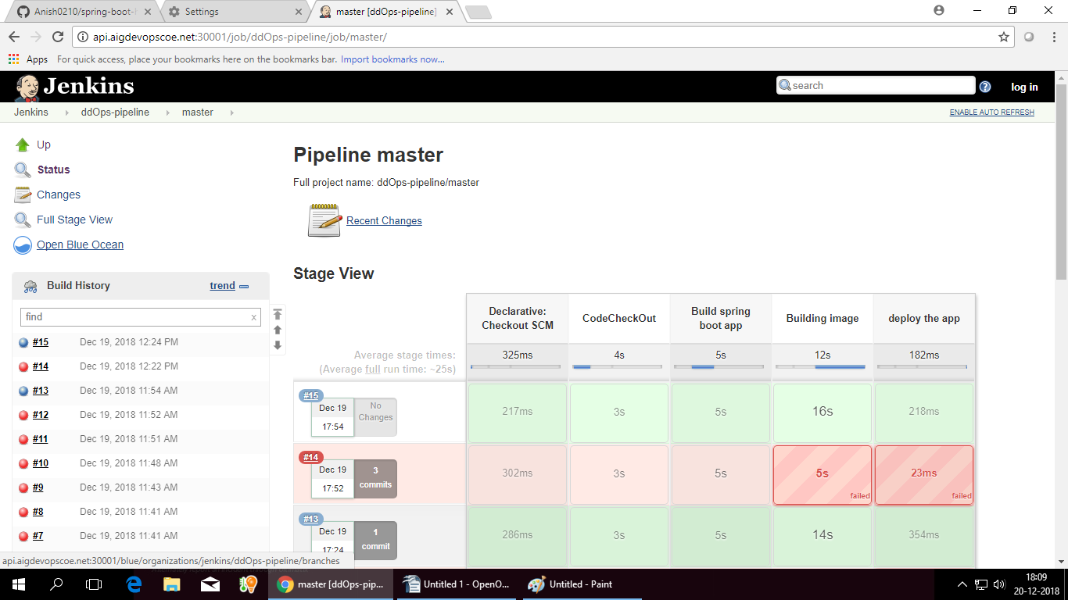

Docker

Graphana

graph

