Supabase for Dynamo AI (https://app.dynamoai.in/)
Full schema
There are three tables users, chats, messages
Each table is commonly connected with id
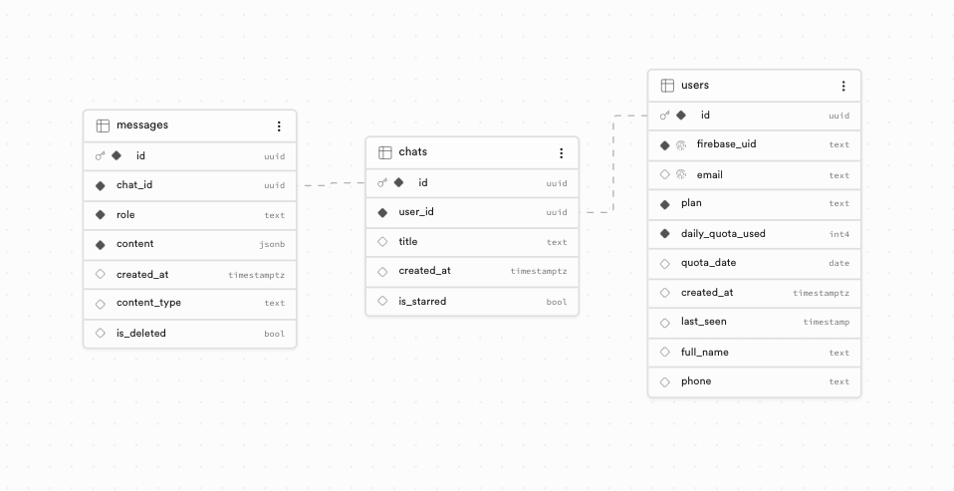
About Tables
Users - Store all the information related to the user’s topology, important information like firebase_id, plan (free/plus), daily_quaota_used and other user data
Chats - Store information related to the user’s chat title, created and other details
Messages - Store information of the user’s message along with the chat_id, content (stores both user and system content), role and other informations.
SQL definition of users table
create table public.users (
id uuid not null default gen_random_uuid (),
firebase_uid text not null,
email text null,
plan text not null default 'free'::text,
daily_quota_used integer not null default 0,
quota_date date null,
created_at timestamp with time zone null default now(),
last_seen timestamp without time zone null,
full_name text null,
phone text null,
constraint users_pkey primary key (id),
constraint users_email_key unique (email),
constraint users_firebase_uid_key unique (firebase_uid)
) TABLESPACE pg_default;
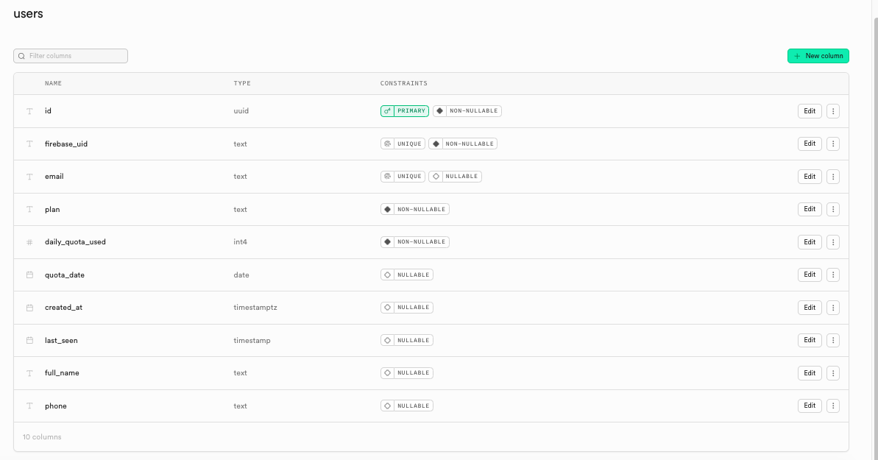
SQL definition of chats table
create table public.chats (
id uuid not null default gen_random_uuid (),
user_id uuid not null,
title text null,
created_at timestamp with time zone null default now(),
is_starred boolean null default false,
constraint chats_pkey primary key (id),
constraint chats_user_id_fkey foreign KEY (user_id) references users (id) on delete CASCADE
) TABLESPACE pg_default;
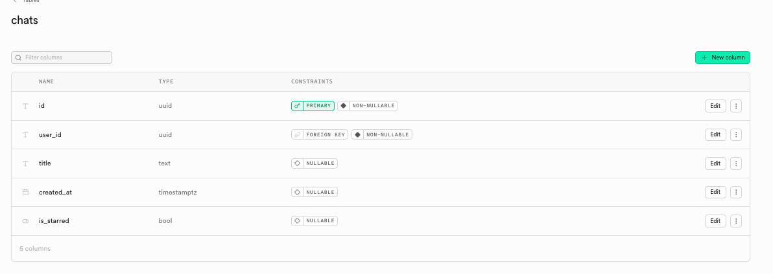
SQL definition of messages table
create table public.messages (
id uuid not null default gen_random_uuid (),
chat_id uuid not null,
role text not null,
content jsonb not null,
created_at timestamp with time zone null default now(),
content_type text null default 'text'::text,
is_deleted boolean null default false,
constraint messages_pkey primary key (id),
constraint messages_chat_id_fkey foreign KEY (chat_id) references chats (id) on delete CASCADE,
constraint messages_role_check check (
(
role = any (
array['user'::text, 'assistant'::text, 'system'::text]
)
)
)
) TABLESPACE pg_default;

create index IF not exists idx_messages_chat_id_created_at on public.messages using btree (chat_id, created_at) TABLESPACE pg_default;
