Dynamo AI Features Documentation

1. Main Chat Window Features
Dynamo AI provides multiple intelligent modes and tools inside the main chat interface:
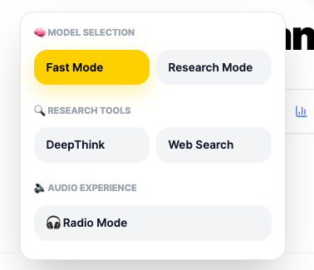
- Fast Mode: Uses Gemini 2 for quick responses. Optimized for speed.
- Research Mode: Uses Gemini 2 but structured for deeper, more accurate responses.
- DeepThink: Provides detailed, structured, and in-depth explanations.
- Web Search: Uses Tavily API to fetch real-time internet data.
- Radio Mode: Converts responses into a two-person dialogue format (currently missing in frontend logic).
- File Upload: Allows users to upload documents (PDF, CSV, Images etc.) for analysis.
- Voice Input: Users can speak instead of typing for easier interaction.
Future Plan:
- Fast Mode → Upgrade to Gemini 3.1
- Research Mode → Upgrade to Kimi 2.5

Main Chat UI
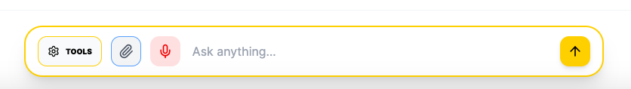

2. Additional Observations
Potential missing or incomplete features:
- Radio Mode frontend logic not implemented fully.
- Export / Quick Actions may not be properly connected.
- Quota system UI feedback may not be visible to users.
Left Sidebar

1. Left Sidebar Overview
The left sidebar in Dynamo AI provides navigation, quick tools, chat history, and user profile access. It is a core interaction layer that enhances usability and workflow efficiency.

2. Search & New Chat
- Search Bar: Allows users to search previous chats from history.
- + New Chat: Starts a fresh conversation session.
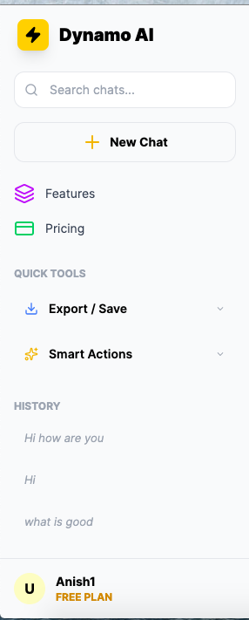

3. Features & Pricing Navigation
Users can navigate to:
- Features Page: https://dynamoai.in/features.html
- Pricing Page: https://dynamoai.in/pricing.html
Note: Pricing page needs redesign for Free vs Plus plan clarity.

4. Quick Tools (Core Feature)
Export / Save:
- Allows users to download chats in PDF, Word, or PowerPoint.
- Current Issue: Not working due to missing frontend integration.
Smart Actions:
- One-click transformations:
• Summarise
• Explain Simply
• Create Executive Deck
- Current Issue: Not working due to missing frontend logic.
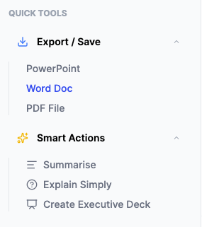

5. Chat History
- Logged out: Shows 'No recent chats'.
- Logged in: Displays past conversations.
- Users can star or delete chats.
- Improvement Needed: UI upgrade for star/delete interactions.

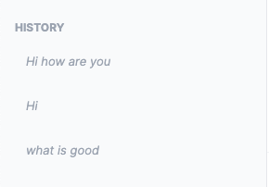

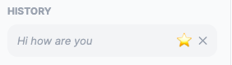
6. User Profile Section
- Displays user name and plan (Free/Plus).
- Avatar shows first two letters of user name.
- Clicking opens profile menu with:
• Upgrade Plan (https://dynamoai.in/pricing.html)
• How to use Dynamo AI (https://dynamoai.in/guide.html)
• Support (support@dynamoai.in)
• Logout (Currently not working in frontend)
The bug error in the user profile in both should be consistent and needs UI improvement
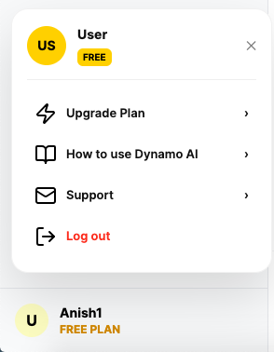

7. Related Frontend Files
- sidebar.js → Controls sidebar UI and interactions
- profile.js → Handles profile popup
- auth.js → Authentication logic
- utils.js → Shared helper functions
- chat.js → Core chat logic integration
8. Top Header Navigation
The top header provides quick access to core navigation and user account controls.
- Features: Redirects to https://dynamoai.in/features.html
- Pricing: Redirects to https://dynamoai.in/pricing.html
- Dark/Light Mode Toggle: Allows users to switch between themes for better usability.
- Login / Sign Up: Allows new users to create accounts or existing users to log in.
- Logout: Available when user is logged in.

