College Procurement & Approval Workflow System
Database & Workflow Design Documentation
Compiled from design discussion notes

Part 1: Revised Database & Workflow Requirements
These changes make the system much more realistic. The biggest tweak is that Budget Head, Budget Item, item category, quantity-level approval, partial approval, carry-forward, and hierarchy all need to be first-class concepts—not just notes inside a request.
Here is the revised structure for the proper documentation.

1. Budget Head vs Budget Item
These should be two separate entities.

Budget Head
Represents the broader financial classification under which expenditure is recorded.
Example:
- Laboratory
- Infrastructure
- IT Equipment
- Office Expenses
- Academic Activities
- Maintenance
- Student Activities

Budget Item
Represents the specific item being requested.
Example:
- Budget Head: Laboratory → Budget Item: Chemistry Glassware
- Budget Head: IT Equipment → Budget Item: Wireless Microphone
So the relationship is:
Budget Head
│
└── Budget Items
│
├── Item A
├── Item B
└── Item C

2. Budget Item Type
Every Budget Item should have a classification.

Three categories:
- Consumable
- Capital
- Revenue
So:
Budget Head
↓
Budget Item
↓
Item Type
┌───────────┬──────────┬──────────┐
│ Consumable│ Capital │ Revenue │
└───────────┴──────────┴──────────┘
The user should select the Budget Item, and its category can either be automatically populated or selected based on the configured master data.
Recommended: automatic population.
For example:
- Budget Item = Printer Cartridge
- Type = Consumable
The requester shouldn't have to decide financial classification manually if the college has already configured it.

3. Request Can Contain Multiple Items
This is an important change. A request should not represent only one item. One request can contain multiple budget items.
Example: Request #REQ-1024
Item | Quantity | Estimated Amount
Microphone | 2 | ₹20,000
Speaker | 2 | ₹30,000
HDMI Cable | 5 | ₹5,000
Tripod | 4 | ₹12,000

Total Tentative Amount = ₹67,000
Therefore:
REQUEST
│
├── Item 1
├── Item 2
├── Item 3
└── Item 4
This is why request_items needs to be a separate table.

4. Item-Level Approval
This is the important new requirement mentioned.
Suppose the requester asks for: 4 items
The approving authority may approve: Only 2 items
Therefore, approval cannot exist only at the request level. It must support:
- Request-level status
- Item-level status
For example:
Item | Requested Qty | Approved Qty | Status
Microphone | 2 | 2 | Approved
Speaker | 2 | 0 | Rejected
HDMI Cable | 5 | 5 | Approved
Tripod | 4 | 0 | Rejected

Request status: Partially Approved
This is different from completely rejecting the request.

5. Quantity-Level Partial Approval
We should go one level further.
Suppose: Requested quantity = 10
Purchase Committee may approve: Quantity = 6
Therefore:
Requested Quantity: 10
Approved Quantity: 6
Rejected Quantity: 4
So the database should preserve:
requested_quantity
approved_quantity
rejected_quantity
Do not overwrite the original requested quantity.

6. Amount-Level Partial Approval
The same applies to money.
Example: Requested: ₹80,000
Committee approves: ₹60,000
Database stores:
Requested Amount = ₹80,000
Approved Amount = ₹60,000
Rejected/Unapproved Amount = ₹20,000
This gives complete financial traceability.

7. Partial Approval at Purchase Committee
For requests below ₹50,000, Purchase Committee can:

Approve
All requested items/quantities are approved.

Reject
Request is rejected.

Partially Approve
Some items or quantities are approved.
Example: Requested: 4 items — Approved: 2 items
The system calculates:
Approved Amount = ₹35,000
instead of the original: Requested Amount = ₹45,000
The Purchase Committee cannot increase the requested amount.
If the required approved amount exceeds the applicable authority limit, the request must be routed to the appropriate higher approval workflow.

8. Partial Approval at Principal
The Principal should also have:
- Approve
- Reject
- Partial Approve
- Escalate
for the ₹50,000 to <₹5 lakh workflow.
Example: Requested = ₹3,20,000
Principal approves: ₹2,40,000
or: 3 out of 5 requested items.
The system records: Principal Decision: Partially Approved
with:
- Approved items
- Rejected items
- Approved quantities
- Approved amount
- Reason/comment
- Digital signature
- Timestamp

9. CDC Approval
If Principal escalates:
Principal
↓
CDC
CDC has:
- Approve
- Reject
- Partial Approve
- Escalate
If CDC partially approves:
Requested = ₹4,00,000 — CDC approves = ₹3,00,000
or: Requested = 5 items — CDC approves = 3 items
The same generic partial-approval engine should be used.

10. Chairman + Vice President — Final Authority
Above CDC:
Principal
↓
CDC
↓
Chairman + Vice President

Approve
All applicable requested items/amount.

Reject
Reject the request.

Partial Approve
Approve selected items/quantities/amount.

No Escalation
This is the final stage.
Chairman + VP
│
├── Approve
├── Reject
└── Partial Approve
There is no further escalation.

11. Important: Multiple Approvers
For CDC and final authority, don't design the database assuming there will always be exactly two people. Instead:
Workflow Stage
↓
Required Approvers
↓
User 1
User 2
User 3...
For example, in the escalation hierarchy, the CDC stage sits directly above the Principal — with its Grant Member and Non-Grant Member stacked vertically as a chain of required approvers, not side by side — and Final Authority sits above CDC in the same vertical form:
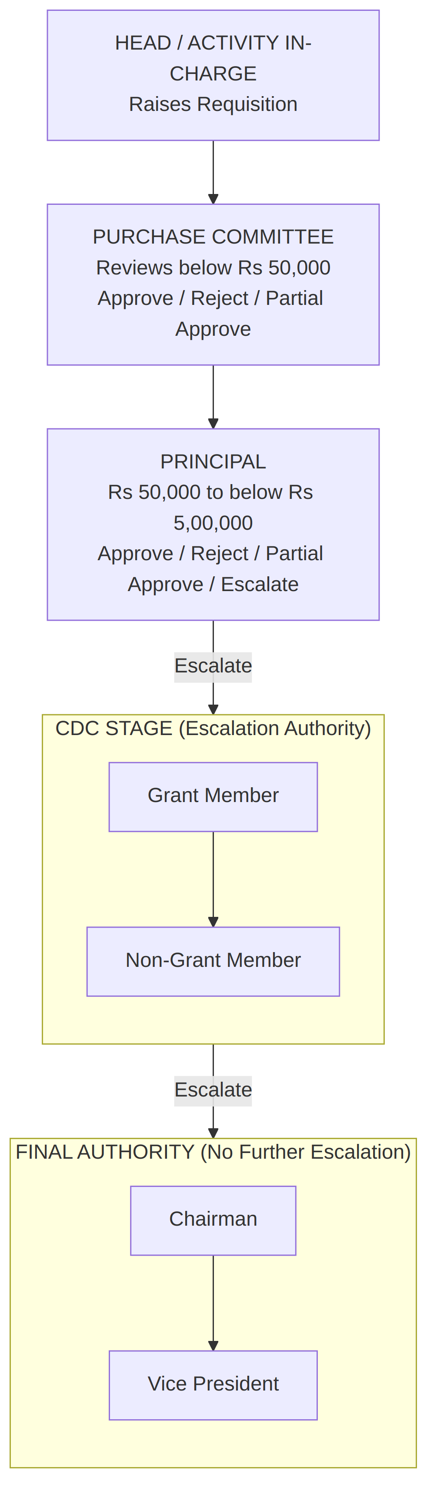
Figure: Approval hierarchy — CDC members and Final Authority members shown vertically, above Principal
The number of people at each stage can therefore be configured.

12. Academic Year Carry-Forward
This is another important addition.
A request raised in one academic year may need to continue into the next academic year.
Example:
Request Raised
Academic Year: 2025–26
Financial Year: 2026–27
Suppose the request isn't completed before the academic year ends. It should not be deleted or recreated. Instead:

Carry Forward
2025–26
↓
Carry Forward
↓
2026–27
The system keeps the same request history.

13. Carry-Forward Rule
When carrying forward:

Preserve:
- Original Request ID
- Original requester
- Original request date
- Original budget head
- Original budget item
- Original quantities
- Original approvals
- Original rejection reasons
- Original comments
- Digital signatures
- Audit trail
But create a new academic-year allocation/context.
Example:
REQ-1024

Original Academic Year:
2025–26

Carry Forward To:
2026–27
The system should show: “Carried Forward From AY 2025–26” — rather than pretending it was a new request.

14. Financial Year Must Still Be Independent
Don't accidentally merge Academic Year and Financial Year.
For every request:
Academic Year
+
Financial Year
are separate fields. Example:
Academic Year: 2025–26
Financial Year: 2026–27
A carry-forward to the next academic year should therefore allow the system to update the relevant academic-year allocation without destroying the original financial records.

15. Revised Request Structure
Your request now becomes:
REQUEST
│
├── Request Number
├── Raised By
├── Department
├── Course
├── Academic Year
├── Financial Year
├── Budget Head
├── Tentative Total Cost
│
└── REQUEST ITEMS
│
├── Budget Item
├── Item Type
│ ├── Consumable
│ ├── Capital
│ └── Revenue
├── Requested Quantity
├── Estimated Unit Cost
├── Estimated Total
├── Approved Quantity
├── Approved Amount
├── Item Status
└── Approval Remarks

16. Revised ER Diagram
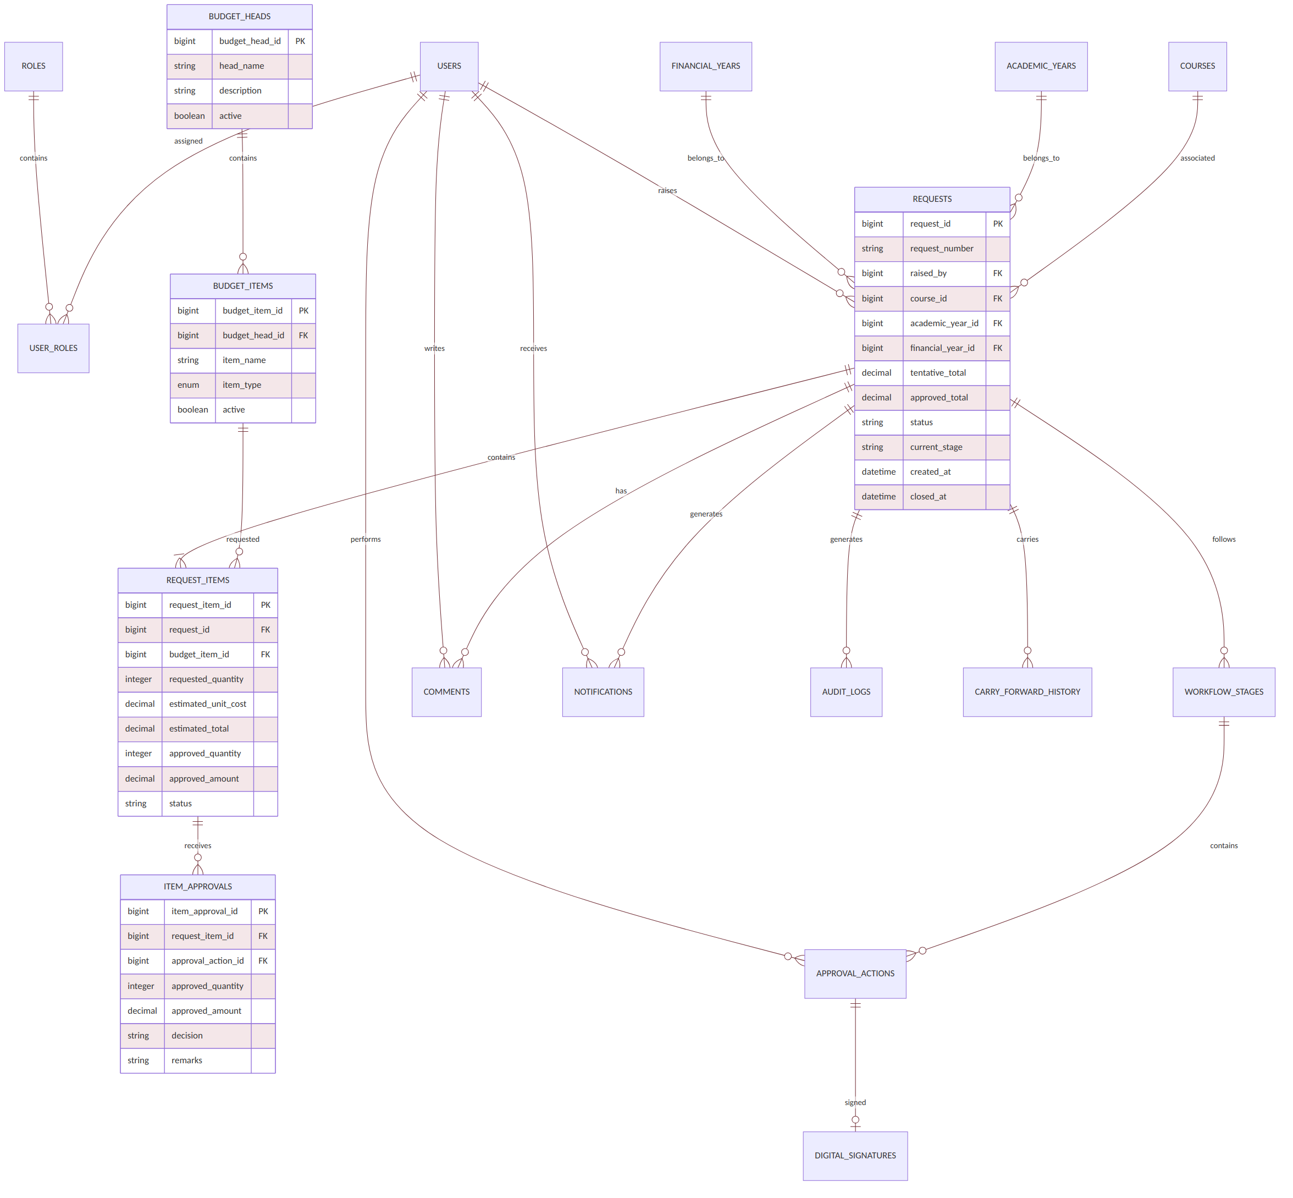
Figure: Revised entity-relationship diagram

17. Revised Workflow
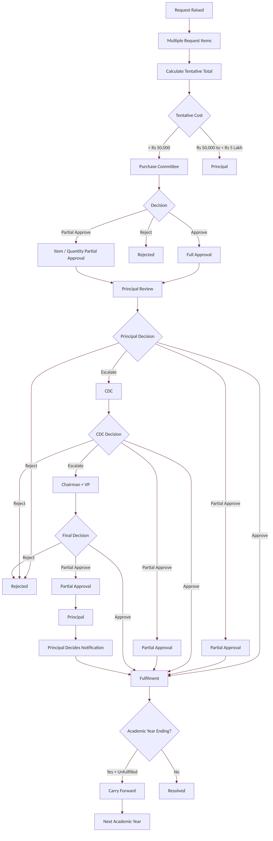
Figure: Revised approval workflow

18. Revised Status Model
Don't use only Approved / Rejected. A richer status system is needed:
DRAFT
↓
SUBMITTED
↓
UNDER_PURCHASE_COMMITTEE_REVIEW
↓
UNDER_PRINCIPAL_REVIEW
↓
UNDER_CDC_REVIEW
↓
UNDER_FINAL_AUTHORITY_REVIEW
↓
APPROVED
PARTIALLY_APPROVED
REJECTED
ESCALATED
FULFILMENT_PENDING
FULFILLED
CLOSED
CARRIED_FORWARD
The current status tells you where the request is now. The audit trail tells you everything that happened before.

19. One More Important Database Rule
For partial approval, never modify the original request.

Bad:
Requested: 4
Approved: 2
and deleting the other 2.

Good:
Requested Quantity: 4
Approved Quantity: 2
Unapproved Quantity: 2
Similarly:
Requested Amount: ₹80,000
Approved Amount: ₹50,000
Unapproved Amount: ₹30,000
This gives you proper financial auditability.

20. Final Conceptual Architecture
Your system now essentially has six layers:
┌─────────────────────────────────────────┐
│ 1. MASTER DATA │
│ Users | Roles | Courses | Budget Heads │
│ Budget Items | Academic/Financial Year │
└─────────────────────────────────────────┘
↓
┌─────────────────────────────────────────┐
│ 2. REQUEST │
│ Request + Multiple Items + Quantities │
│ Tentative Cost │
└─────────────────────────────────────────┘
↓
┌─────────────────────────────────────────┐
│ 3. WORKFLOW │
│ Purchase Committee → Principal → CDC │
│ → Chairman + VP │
└─────────────────────────────────────────┘
↓
┌─────────────────────────────────────────┐
│ 4. DECISION │
│ Approve | Reject | Partial | Escalate │
└─────────────────────────────────────────┘
↓
┌─────────────────────────────────────────┐
│ 5. ACCOUNTABILITY │
│ Digital Signature | Comments | Emails │
│ Notifications | Audit Trail │
└─────────────────────────────────────────┘
↓
┌─────────────────────────────────────────┐
│ 6. LIFECYCLE │
│ Fulfil → Close → Carry Forward │
│ → Next Academic Year │
└─────────────────────────────────────────┘
This is the version to use as the foundation for formal documentation. The particularly important upgrades are Budget Head → Budget Item → Type, multiple items per request, item/quantity-level partial approval, partial approval at every applicable authority, configurable hierarchy/roles, and academic-year carry-forward without destroying the original audit history.

Part 2: Database Structure & Diagram Set
For this particular system, a purely NoSQL database is not recommended. The workflow has strong relationships, approvals, roles, financial-year tracking, audit trails, signatures, and hierarchical permissions. That calls for a relational database.
JSON fields can still be used for flexible metadata, but the core should be structured.

1. Database Decision

Recommended: Structured Relational Database
Use: PostgreSQL / MySQL
Personally recommended: PostgreSQL.
Why? The system has highly connected entities:
- Users ↔ Roles
- Users ↔ Requests
- Requests ↔ Courses
- Requests ↔ Academic Year
- Requests ↔ Financial Year
- Requests ↔ Approval Stages
- Approval Stages ↔ Approvers
- Approvals ↔ Digital Signatures
- Requests ↔ Comments
- Requests ↔ Notifications
- Requests ↔ Audit Logs
- Requests ↔ Sanctioned Amount
- Approval stages ↔ Escalation hierarchy
This is exactly where relational databases shine.

2. Core Database Entities
The database can be divided into these major modules:

User & Role Management
- users
- roles
- user_roles

Academic & Financial Structure
- courses
- academic_years
- financial_years

Request Management
- requests
- request_items

Approval Workflow
- workflow_stages
- approval_actions
- approval_levels
- escalation_rules

Communication
- comments
- notifications

Security & Accountability
- digital_signatures
- audit_logs

Optional
- departments
- cdc_members
- budget_heads

3. High-level ER Diagram
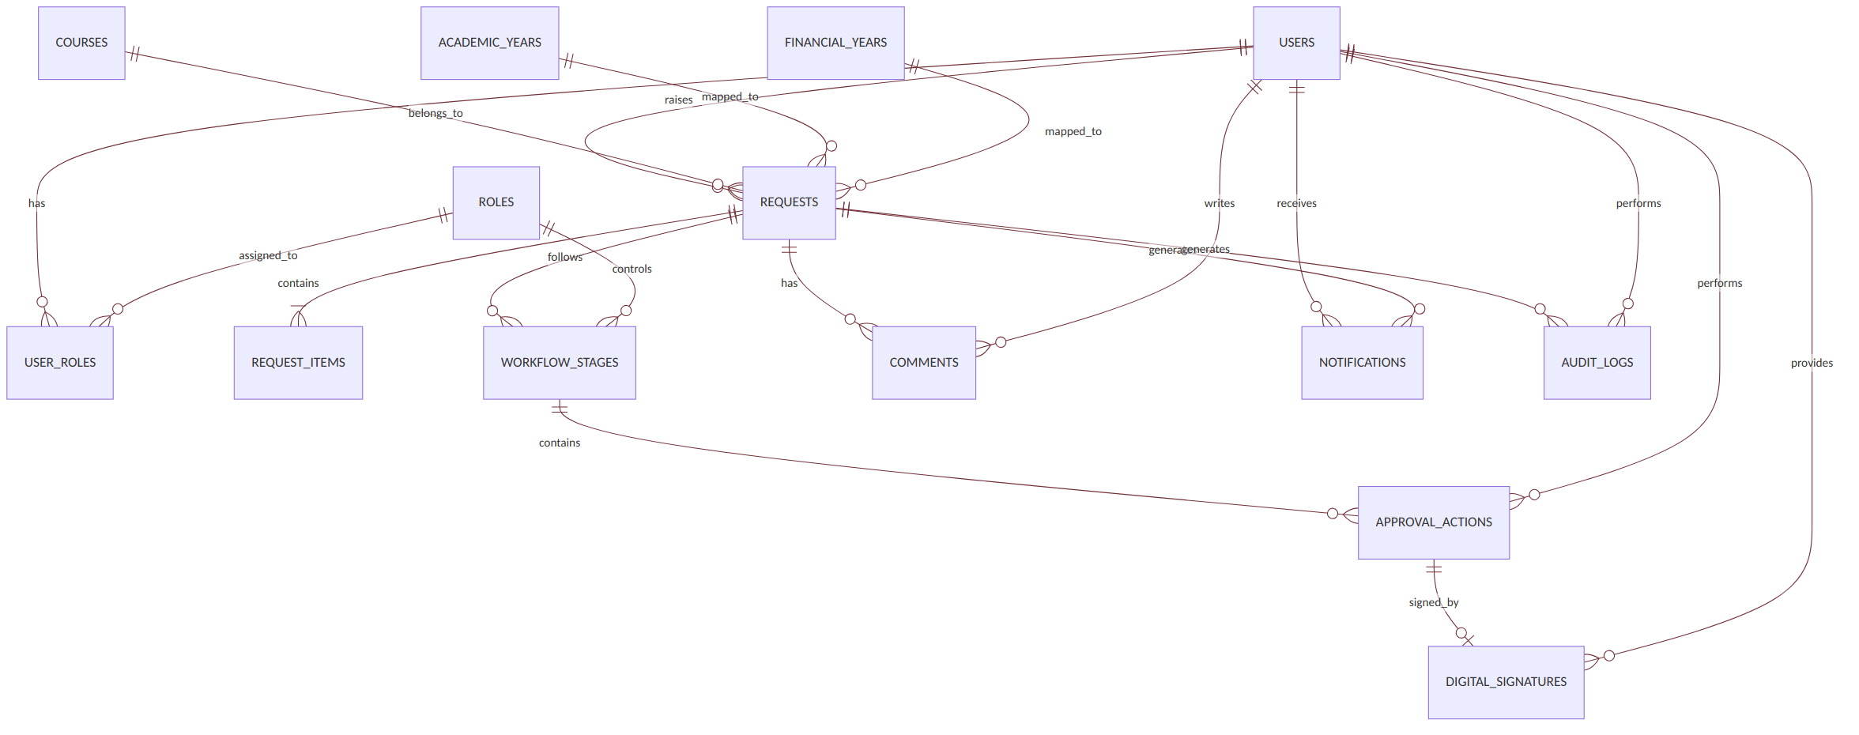
Figure: High-level entity-relationship diagram
This is the main ERD to put into the documentation.

4. User & Role Structure
The important thing here is that roles should NOT be hard-coded into the application. Instead:
USERS
|
|
USER_ROLES
|
|
ROLES

Example roles
Role | Purpose
HEAD | Raises requisition
ACTIVITY_INCHARGE | Raises requisition
PURCHASE_COMMITTEE | Reviews < ₹50,000
PRINCIPAL | Approval / escalation authority
CDC_MEMBER | CDC review
CDC_GRANT_MEMBER | Grant-side CDC authority
CDC_NON_GRANT_MEMBER | Non-grant CDC authority
CHAIRMAN | Final authority
VICE_PRESIDENT | Final authority
ADMIN | System administration

The advantage is that if the college adds another CDC member, the process is to add a user and assign a role. The application does not need to be rewritten.

5. Request Database Structure
The main table is:

requests
requests
--------------------------------
request_id
request_number
raised_by
budgetary_item
quantity
course_id
academic_year_id
financial_year_id
tentative_cost
sanctioned_amount
current_status
current_stage
created_at
updated_at
closed_at

Important distinction
Both of the following are needed:
tentative_cost
and
sanctioned_amount
Because: Requested = ₹40,000, Purchase Committee = ₹35,000.
The system must preserve both. Never overwrite ₹40,000 with ₹35,000.

6. Request Item Structure
Budgetary Item should actually be made its own entity.
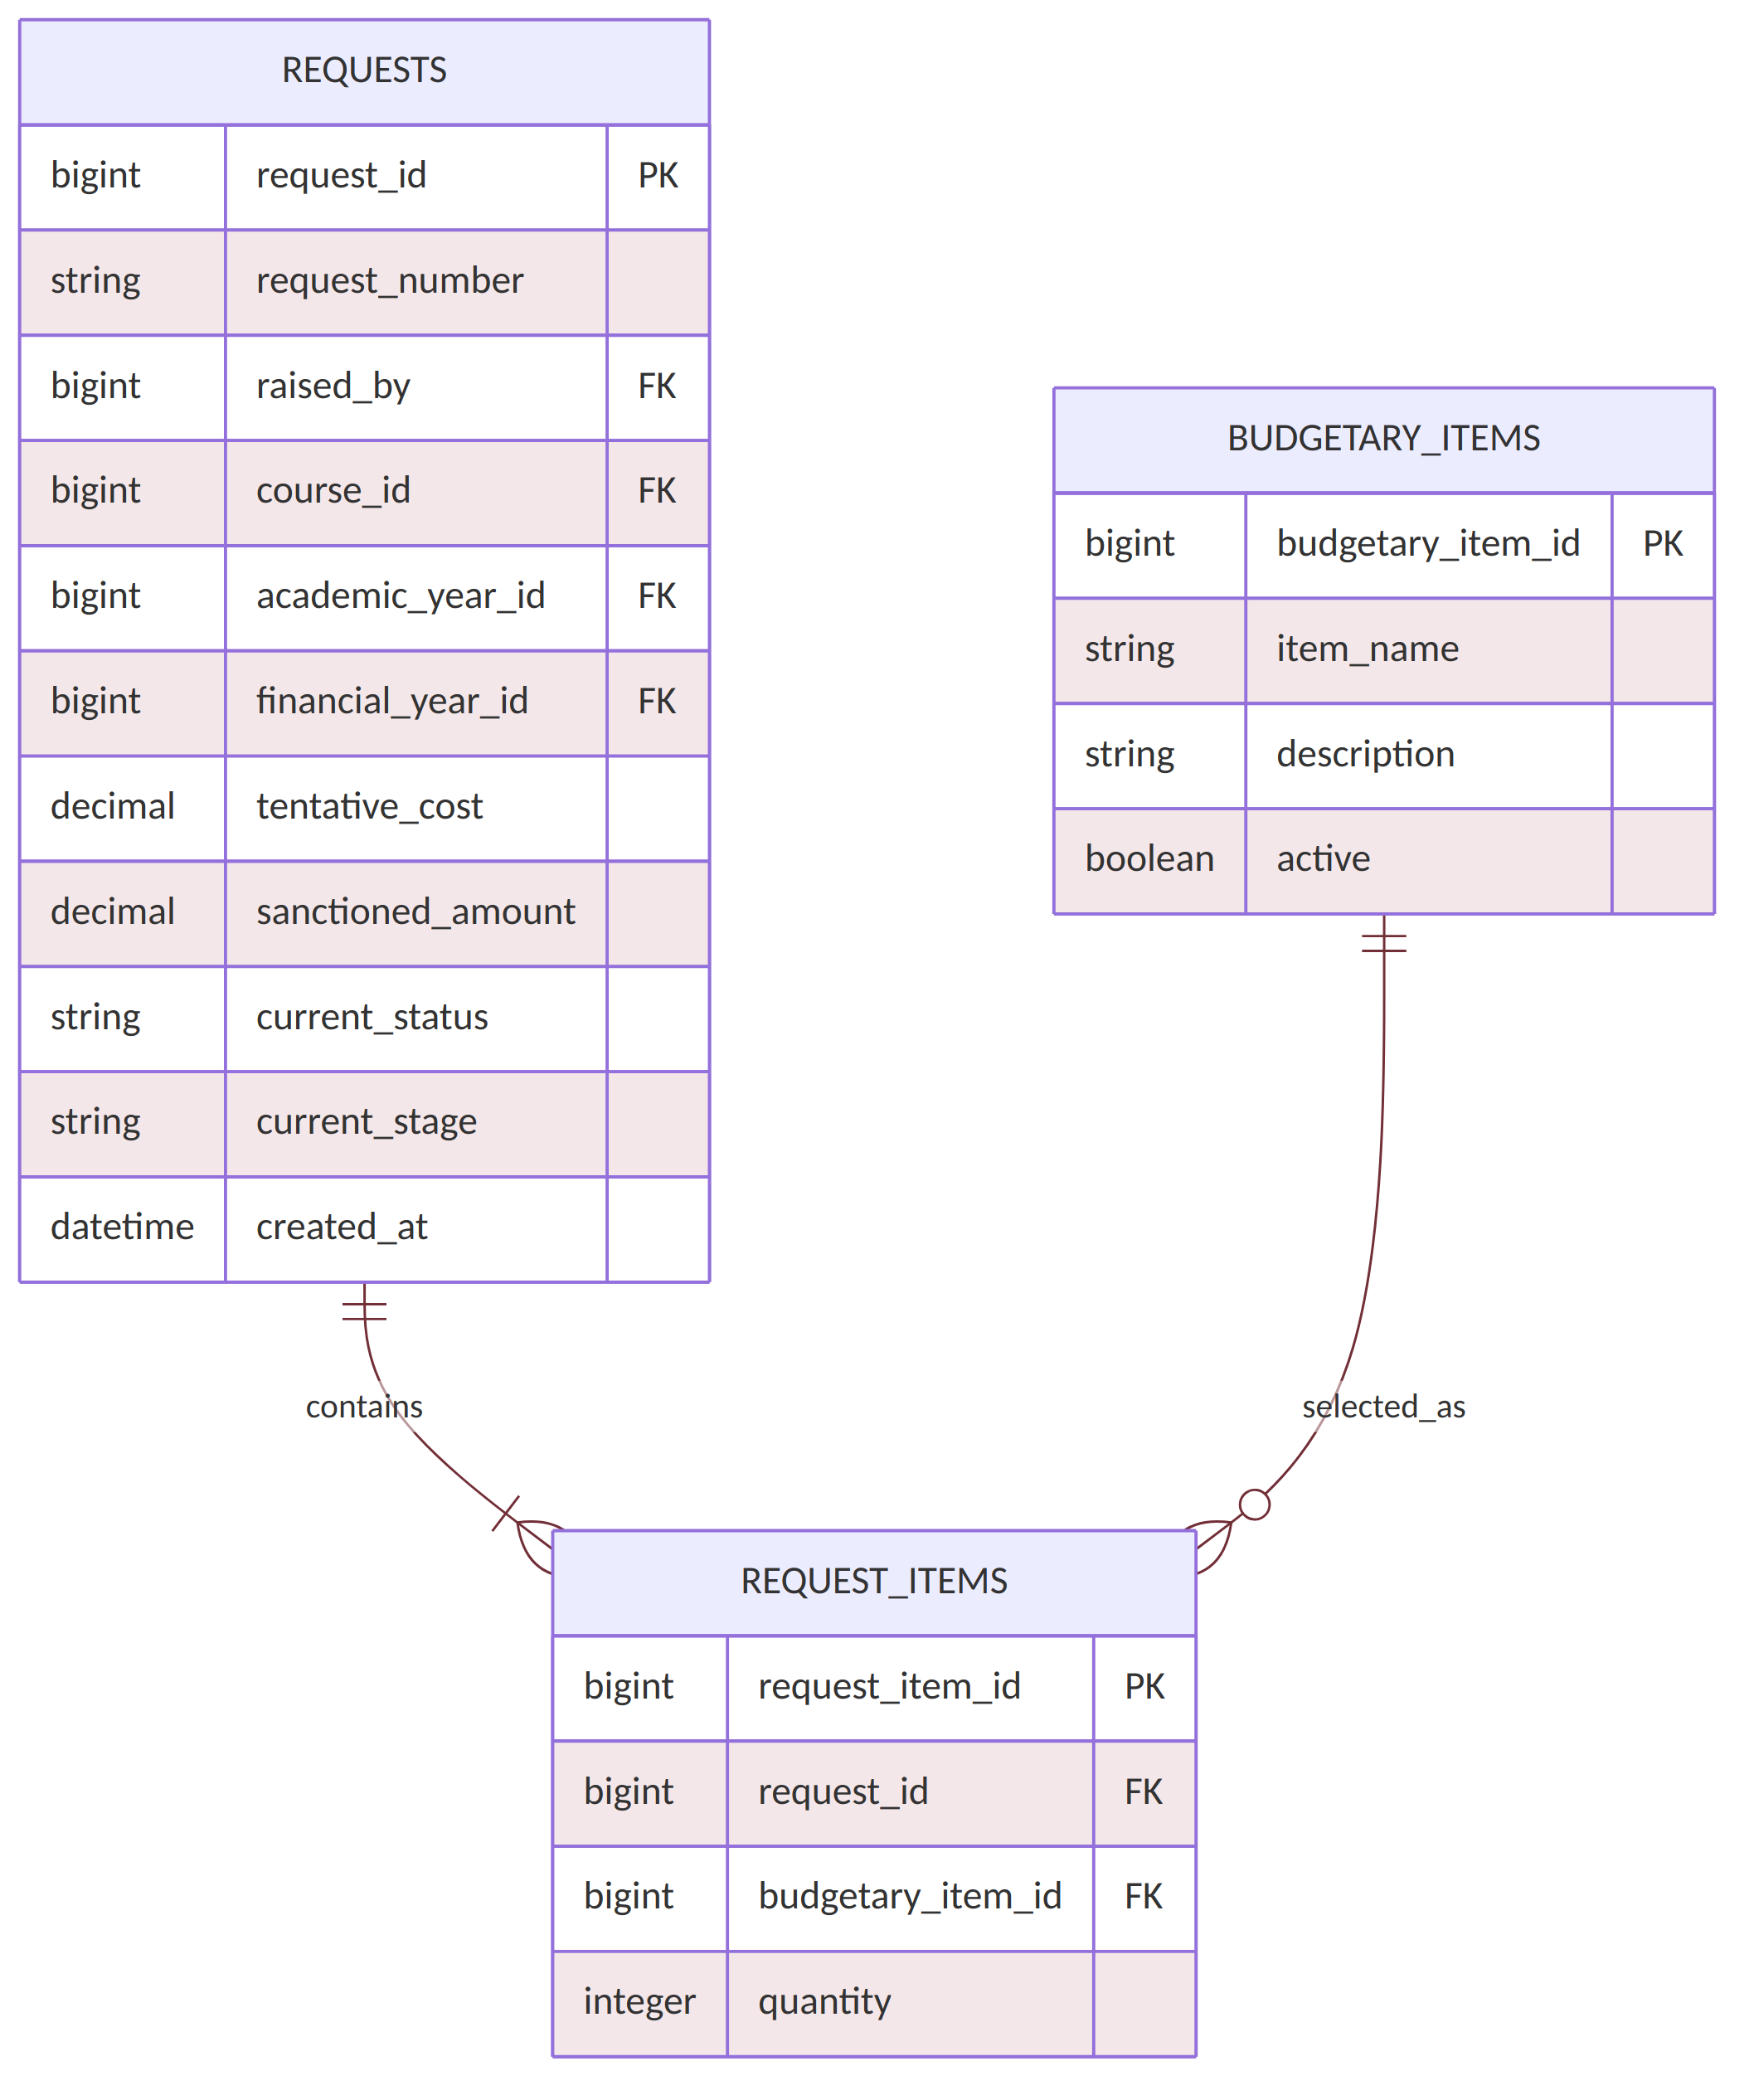
Figure: Request item entity-relationship diagram
This gives flexibility if one request eventually contains multiple budgetary items.

7. Academic Year vs Financial Year
This deserves its own design because it was specifically discussed.
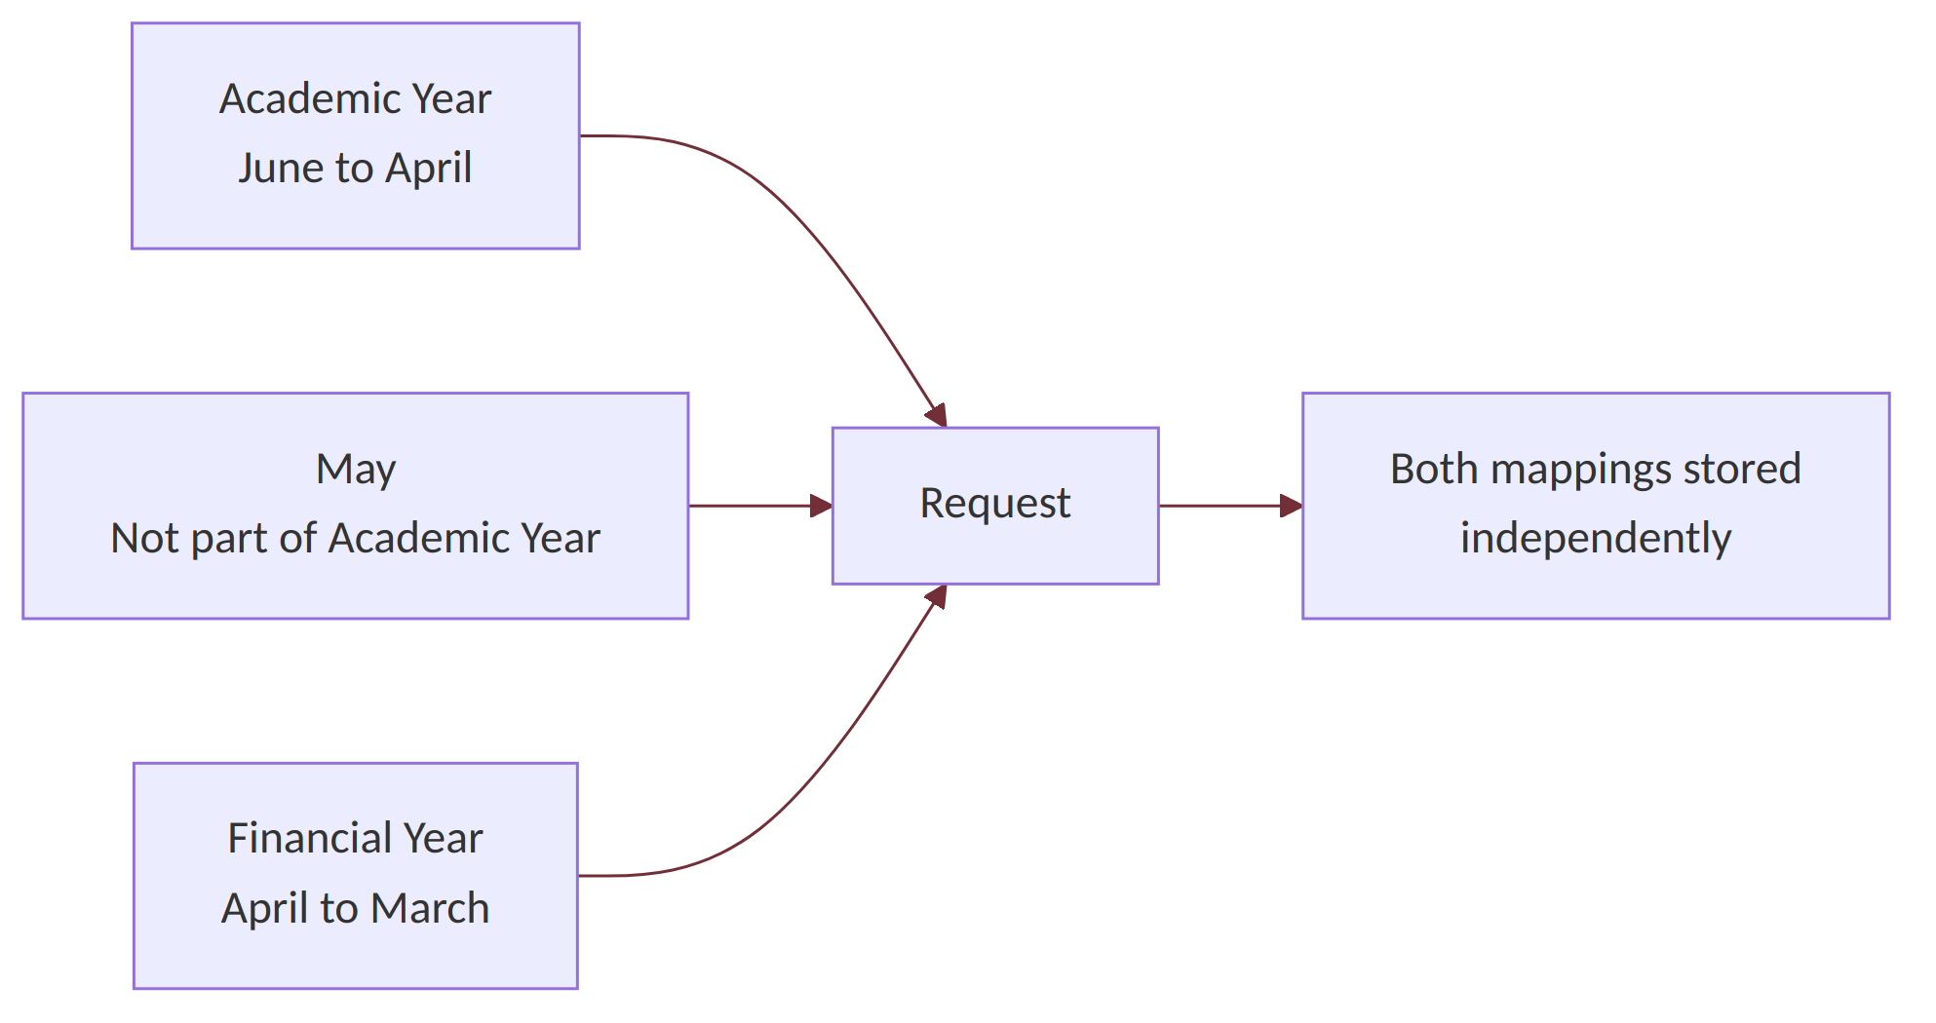
Figure: Academic Year vs Financial Year mapping
For example:
Request Date: May 2026

Academic Year: 2025-26
Financial Year: 2026-27
The system should not derive one from the other. Both should be stored independently.

8. Approval Workflow Diagram
This is the most important diagram in the project.
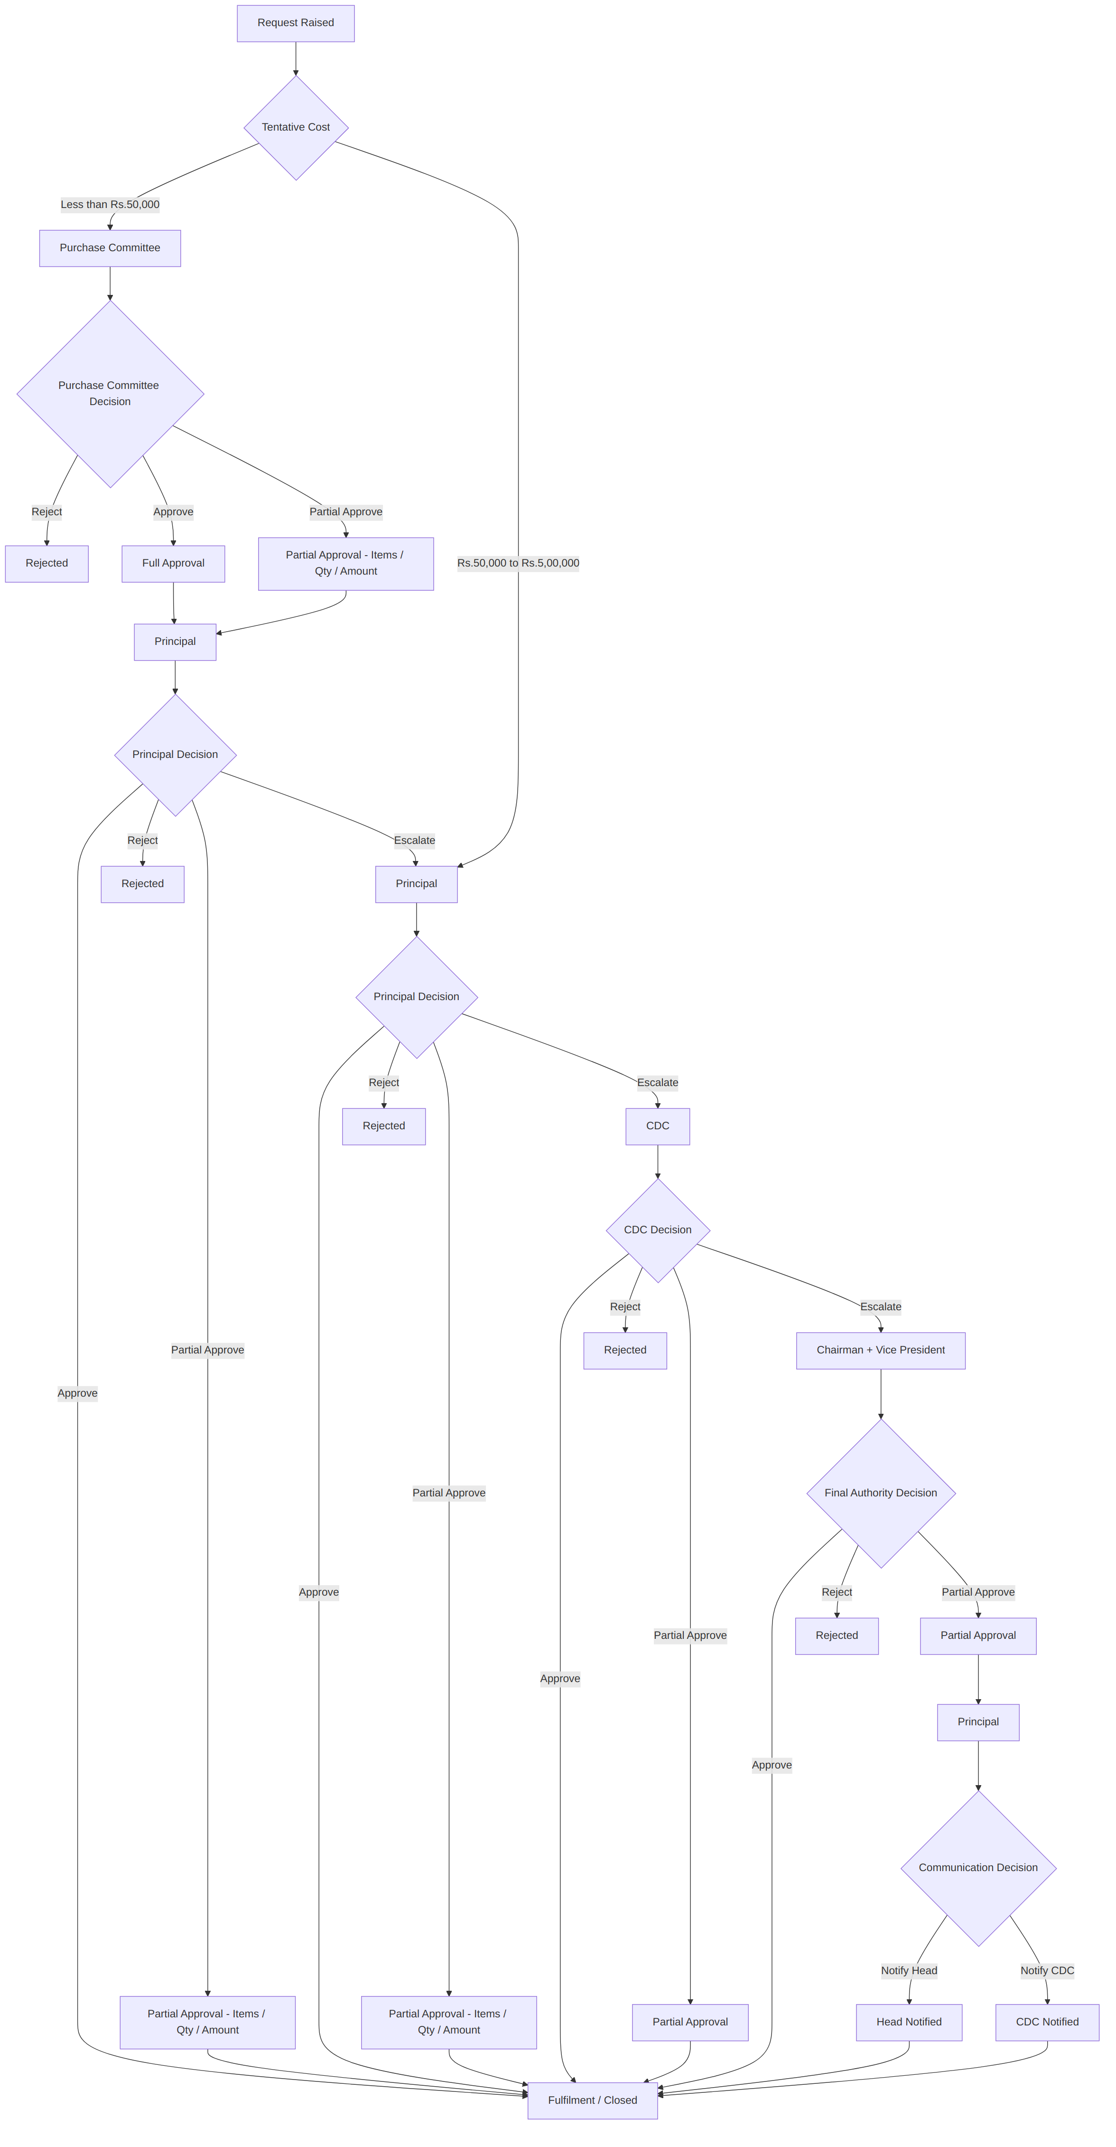
Figure: Approval workflow diagram

9. Approval State Diagram
This shows how a single request changes status.
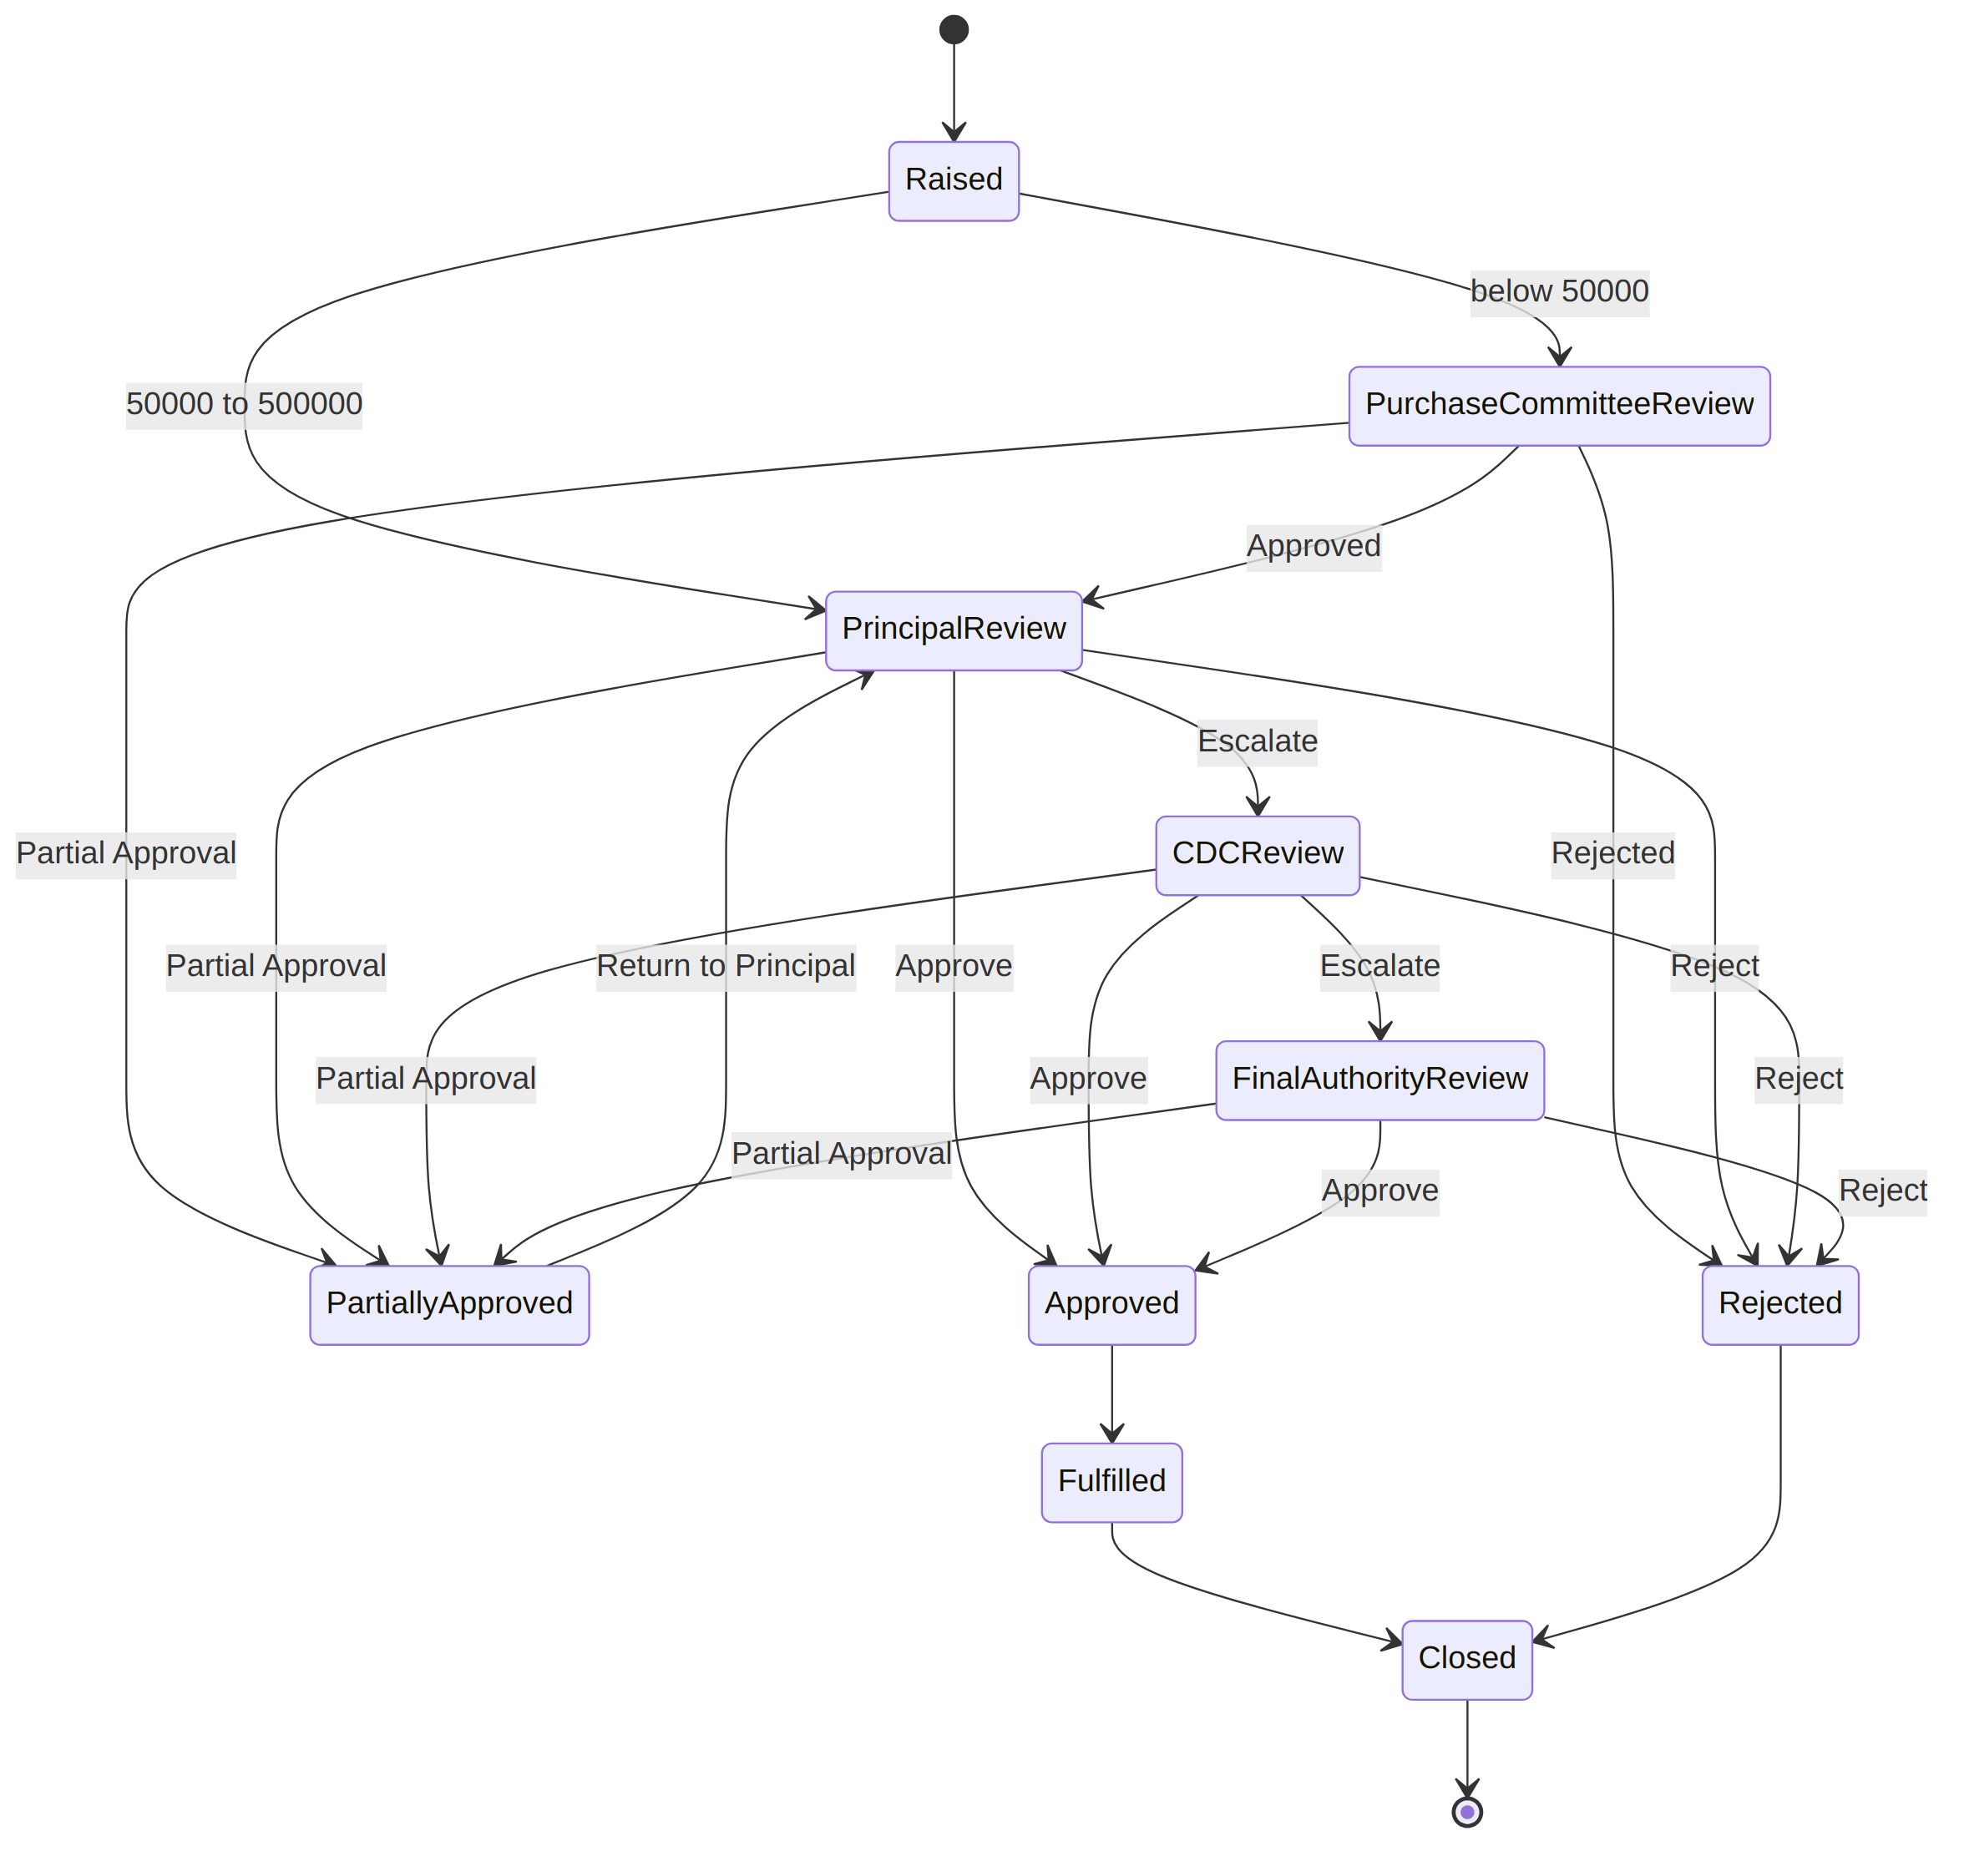
Figure: Approval state diagram

10. Approval Action Table
Instead of putting everything directly inside requests, create:

approval_actions
approval_actions
------------------------------------
action_id
request_id
stage_id
performed_by
action
previous_status
new_status
comments
amount_requested
amount_approved
rejection_reason
created_at
signature_id
Possible actions:
APPROVE
REJECT
ESCALATE
PARTIAL_APPROVE
FORWARD
RETURN
This is extremely useful because the entire life of a request can be reconstructed.

11. Complete Audit Trail
Suppose: Head raises request on August 10.
Database:
10 Aug
HEAD
RAISED
Then:
10 Aug
PRINCIPAL
RECEIVED
Then:
12 Aug
PRINCIPAL
ESCALATED
CDC
Then:
13 Aug
CDC GRANT MEMBER
COMMENTED
Then:
14 Aug
CDC
ESCALATED
CHAIRMAN + VP
Then:
15 Aug
CHAIRMAN
PARTIAL_APPROVAL
₹2,50,000
Then:
16 Aug
PRINCIPAL
NOTIFIED HEAD
Every single one becomes a record.

12. Audit Log Diagram
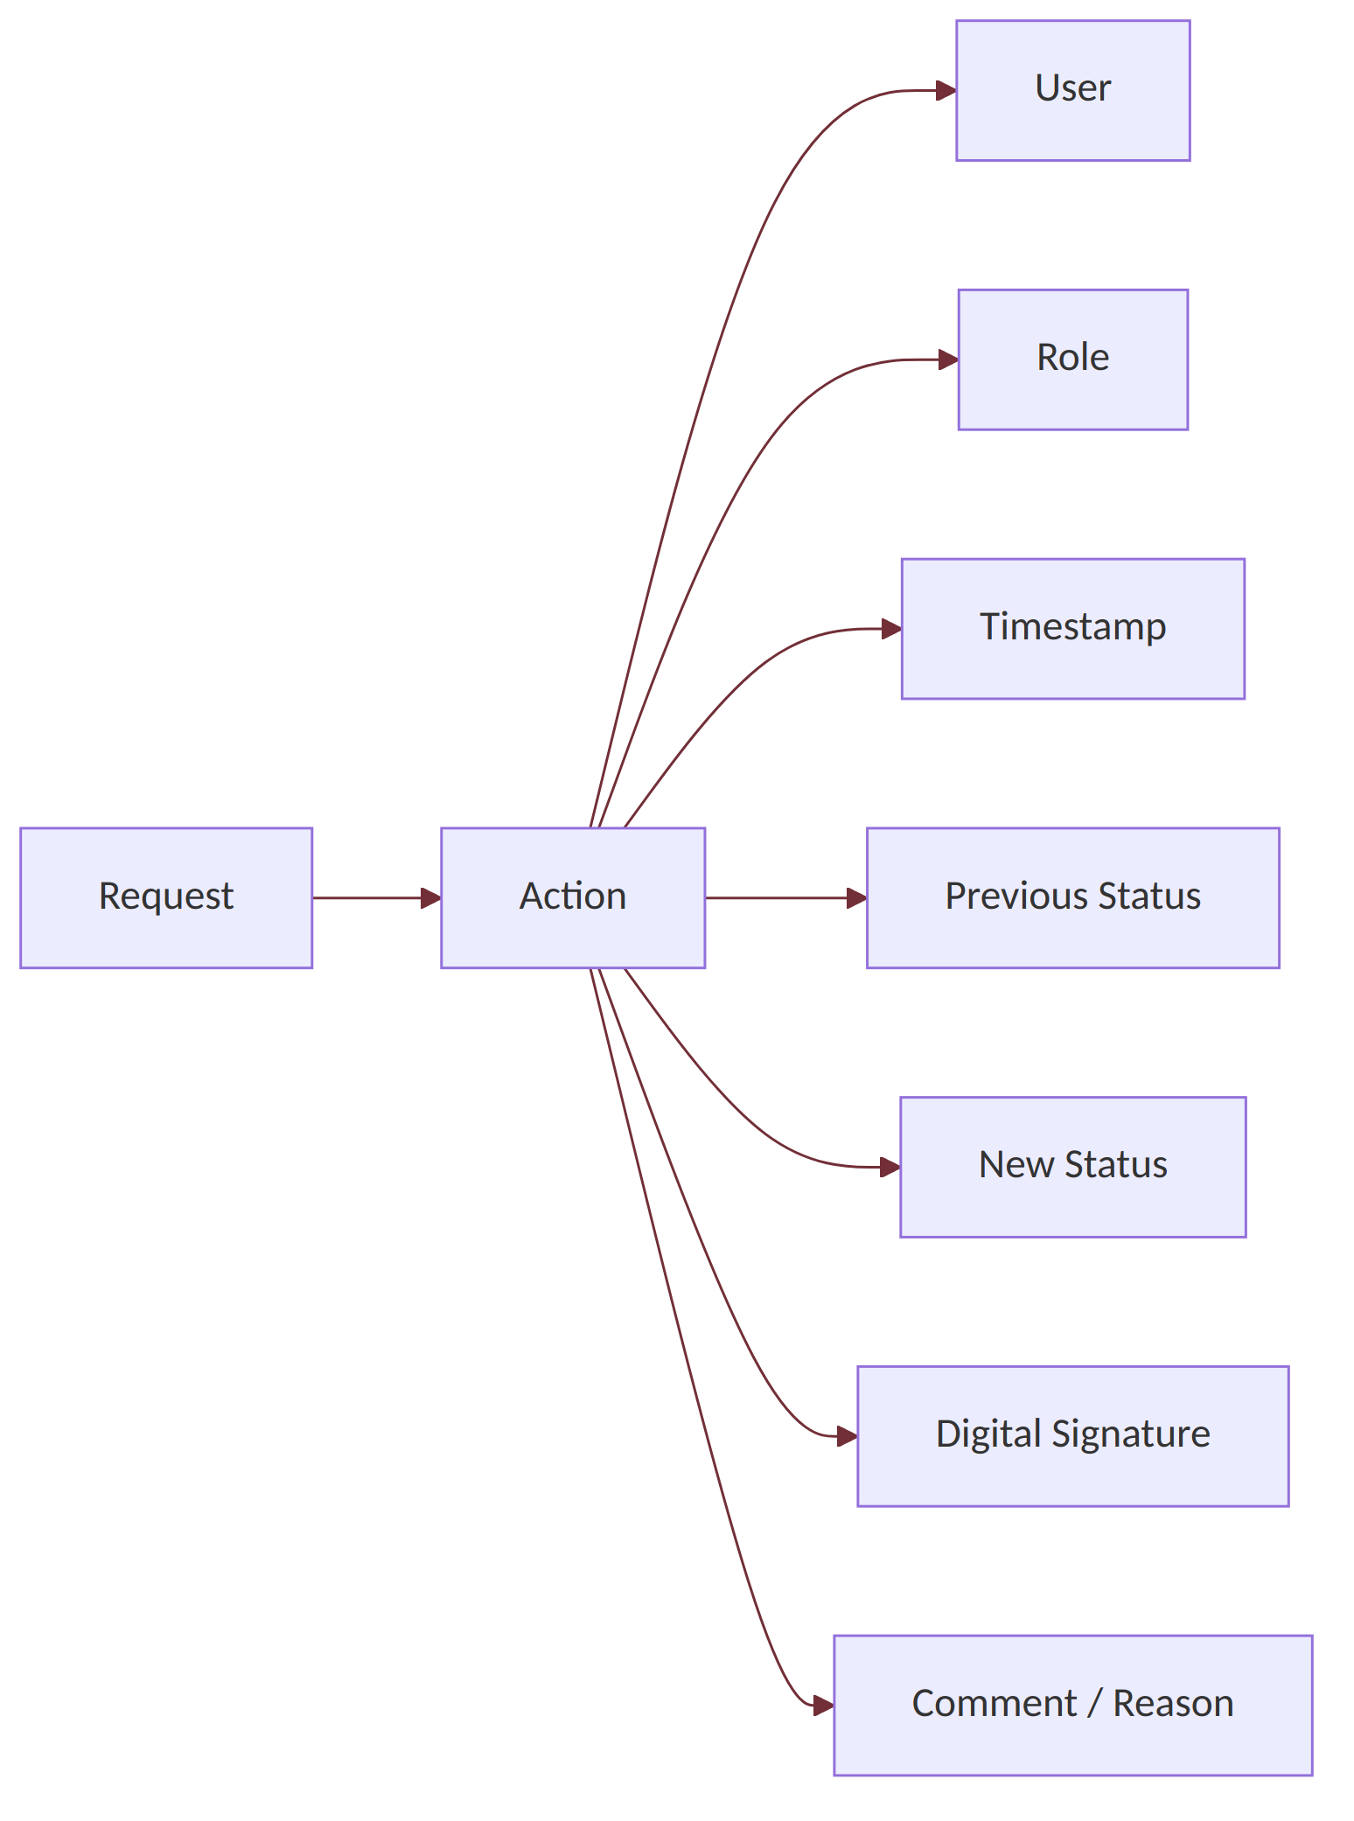
Figure: Audit log diagram
This means the system can answer:
- Who approved this?
- When?
- What amount was sanctioned?
- Who escalated it?
- What was the reason for rejection?
That's the whole point of the audit trail.

13. Role-Based Access Diagram
Another important diagram for the documentation.
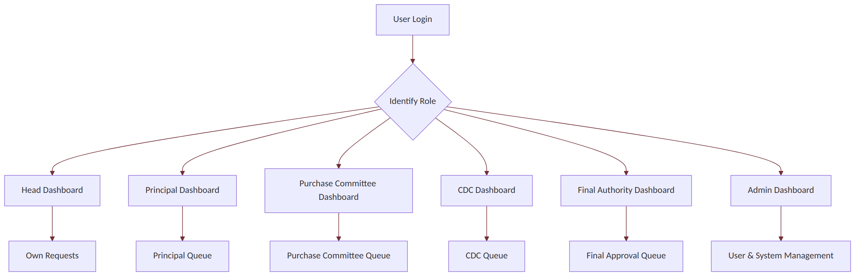
Figure: Role-based access diagram

14. Hierarchical Comment Visibility
This is one of the unique requirements and should definitely appear in the system design.
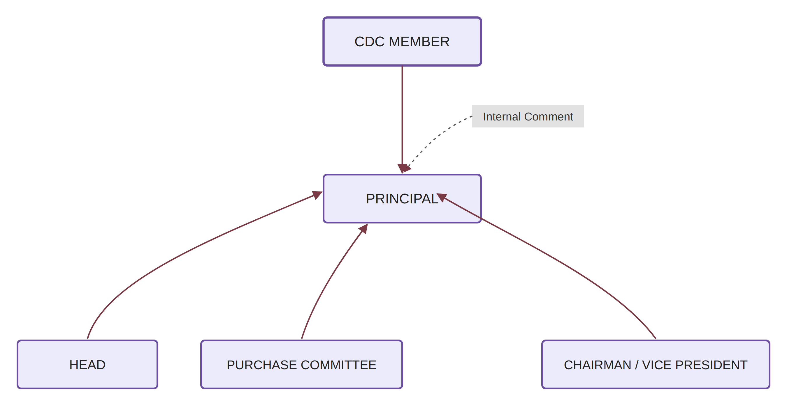
Figure: Hierarchical comment visibility diagram

Rule
If CDC member comments: “Grant budget is unavailable. Consider Non-Grant budget.”
That comment is visible to: CDC Member → Principal
Not automatically: CDC Member → Purchase Committee → Head
This requires comment-level visibility permissions.

15. Notification Architecture
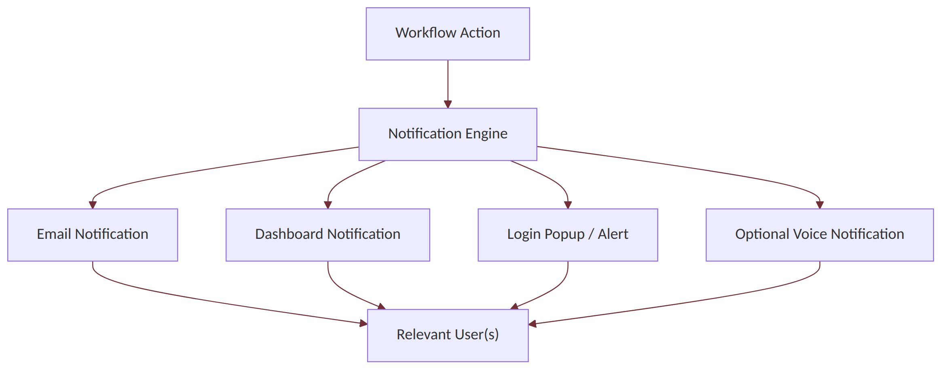
Figure: Notification architecture diagram
The notification engine should determine recipients from roles and workflow stage, not hard-coded email addresses.

16. Pending Request Intelligence
This is the innovative feature discussed.
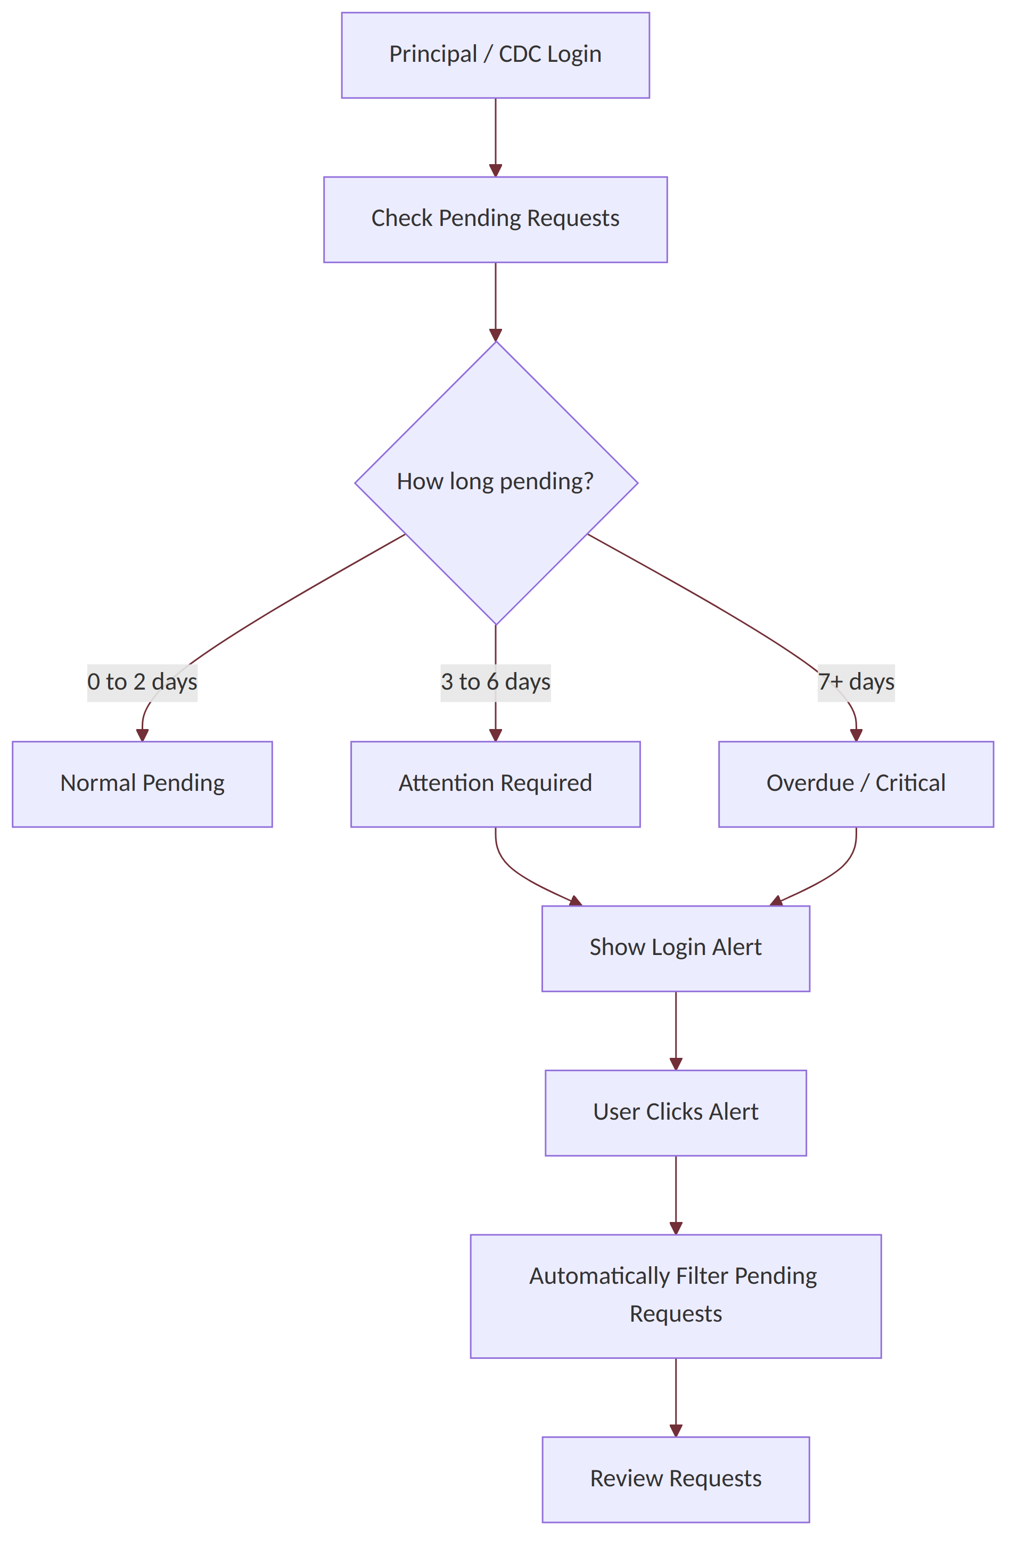
Figure: Pending request intelligence diagram
Example:
🔔 Attention Required
3 requests have been pending for more than 3 days.
Review Requests →
Clicking it should automatically open: Pending > 3 Days — rather than dumping the user onto the entire request list.

17. Dashboard Architecture

Principal Dashboard
┌───────────────────────────────────────────────┐
│ Principal Dashboard │
├───────────────────────────────────────────────┤
│ Financial Year: [2026–27 ▼] │
│ │
│ Total Requests Pending Approved │
│ 42 7 24 │
│ │
│ Rejected Escalated Partial │
│ 5 4 2 │
├───────────────────────────────────────────────┤
│ 🔔 ATTENTION │
│ 3 requests pending > 3 days │
│ [Review Now] │
├───────────────────────────────────────────────┤
│ Recent Requests │
│ │
│ REQ-1024 Pending at CDC 2 days │
│ REQ-1025 Approved 1 day │
│ REQ-1026 Rejected 4 days │
└───────────────────────────────────────────────┘
And clicking any request opens its timeline.

18. Request Timeline
This should be one of the nicest UI features.
REQ-1024
Microphone Purchase
Requested: ₹42,000
Sanctioned: ₹37,500

● 10 Aug
Request Raised
By: Activity In-charge
✓ Digital Signature

↓

● 11 Aug
Purchase Committee Approved
Sanctioned: ₹37,500
✓ Digital Signature

↓

● 11 Aug
Sent to Principal

↓

● 12 Aug
Principal Approved
✓ Digital Signature

↓

● 12 Aug
Fulfilment Initiated

↓

● 15 Aug
Request Closed
For rejected requests:
● Rejected
Reason:
"Insufficient budget allocation."

Rejected by: Principal
Date: 14 Aug
✓ Digital Signature

19. Database Architecture
Overall:
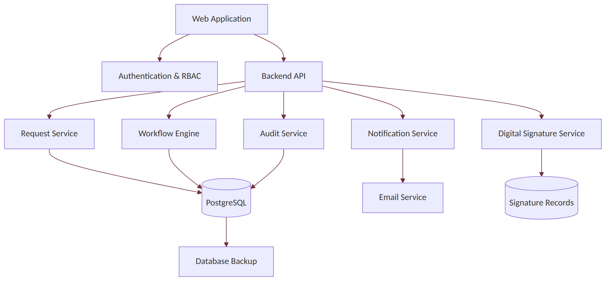
Figure: Database architecture diagram

20. Structured vs Unstructured Data
The question of whether data should be structured or unstructured is addressed as follows.

Structured data
Use PostgreSQL for:
- Users
- Roles
- Requests
- Courses
- Academic years
- Financial years
- Amounts
- Approval stages
- Decisions
- Status
- Dates
- Comments metadata
- Notifications
- Audit logs
- Digital signature records

Semi-structured data
PostgreSQL JSONB can be used for things like:
{
"additional_requirements": {
"brand_preference": "Any",
"urgency": "Medium",
"specifications": [
"Wireless",
"Rechargeable"
]
}
}
This is useful because different departments may have different extra requirements.

Unstructured data
Actual files should not be dumped into database rows.
Examples:
- Quotations
- PDFs
- Bills
- Supporting documents
- Scanned approvals
- Purchase orders
Store them in: Object/File Storage
and keep only:
file_id
request_id
file_name
file_type
storage_path
uploaded_by
uploaded_at
in PostgreSQL.

21. Final Recommended Architecture
┌─────────────────────┐
│ Web Application │
└──────────┬──────────┘
│
┌──────────▼──────────┐
│ Authentication + RBAC│
└──────────┬──────────┘
│
┌──────────▼──────────┐
│ Backend API │
└──────────┬──────────┘
│
┌────────────────────┼────────────────────┐
│ │ │
▼ ▼ ▼
Request Service Workflow Engine Notification
│ │ │
└────────────────────┼────────────────────┘
│
┌───────▼────────┐
│ PostgreSQL │
└───────┬────────┘
│
┌─────────────────┼─────────────────┐
▼ ▼ ▼
Audit Logs Digital Signatures File Storage

The key design principle
Build this as a workflow-driven procurement/request management system, not just a CRUD form.
The heart of the database should be:
Request → Workflow Stage → Action → Role → Decision → Signature → Notification → Audit Trail
Once that is designed correctly, the same engine can handle: Principal → CDC → Chairman/VP — without creating an entirely separate workflow.
And that's the clever part of the project: the approval hierarchy becomes configurable through roles and workflow rules rather than being hard-coded. That makes the system much more impressive as a CS project—and much more realistic for an actual college deployment.

