CS 5158/6058 Data Security and Privacy, Fall 2019
Project 1: One-Time Pad Instructor: Dr. Boyang Wang
Name: Anish Ghantasala M#13518394

Step 1: Directory structure : src,data,build. where the source files(.java) are stored in src folder. The files when compiled(.class) are given in the build folder. The text files,screenshot are stored in data folder.
OS: Windows 10
Language used: Java 1.8.0.221

Step 2:
- Encryption: The following function compiles the Encrypt class and stores the class file generated in build folder:
javac Encrypt.java -d ../build
To execute the encrypt function, change the directory to the build directory and give the following command:
java Encrypt
Enter the message filename and it’s extension: ../data/Plaintext.txt (any filename)
Enter the key-file filename and it’s extension: ../data/key.txt
The cipher text is displayed and stored in the filename cipher.txt in the data folder.
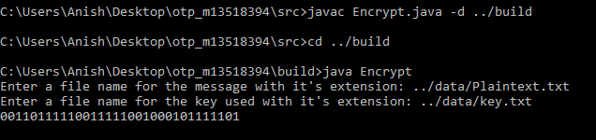

- Decryption:The following function compiles the Decrypt class and stores the class file generated in build folder:
javac Decrypt.java -d ../build
To execute the decrypt function, change the directory to the build directory and give the following command:
java Decrypt
Enter the cipher-text filename and it’s extension: cipher.txt
Enter the key-file filename and it’s extension: key.txt
The text is displayed and stored in the filename GenText.txt in the data folder.
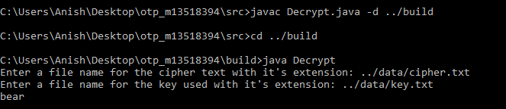

Step 3:Random Key generation
To generate a random key generation function, the input is given in the command line to generate lambda bit random key.
The following command is used to compile the .java file present in the src folder which generates a .class file in build folder.
javac Lambda.java -d ../build
To execute the lambda function, change the directory to the build directory and give the following command:
java Lambda <any-lambda-value>
java Lambda 15
The new key of lambda bits is generated and displayed. The key generated is stored in the filename newkey.txt in the data folder.
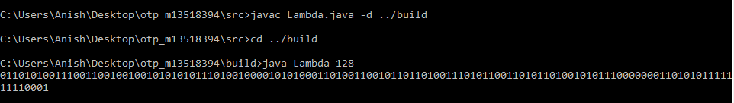

For the given, lambda=3, 5000 random keys are generated. The keys generated are counted and the frequency of all 8 different keys generated are displayed on the console.
The following command is used to compile the .java file present in the src folder which generates a .class file in build folder.
javac rkandfreq.java -d ../build
To execute the random-keys generation and frequency counting function, change the directory to the build directory and give the following command:
java rkandfreq
5000 minimum keys are generated and the frequency of each key is displayed.

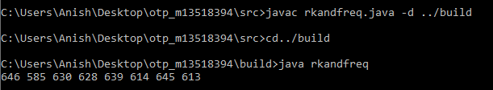
Step 4:Average running time
To generate average running time of the encrypt function for the given lambda value 128, a new message of 16 characters is taken to equalize with the number of bits.
The following command is used to compile the .java file present in the src folder which generates a .class file in build folder:
javac Encrypt_128.java -d ../build
To execute the average time generation function, change the directory to the build directory and give the following command:
java Encrypt_128
Enter the message filename and it’s extenstion: ../data/Message_128.txt (any filename with 16 characters)
Enter the keyfile filename and it’s extension: ..data/newkey.txt (any file name with 128 bit key)
The cipher text is displayed and stored in the filename cipher_128.txt in the data folder.
