**Project 4 Report**

**Configuration:**

|  |  |
| --- | --- |
| Operating System | Windows 10 OS |
| Language Used | Java 1.8 |
| Run target function | java POW data/input.txt |
| Run solution function | java POW data/input.txt data/target.txt data/solution.txt |
| Verify function | java POW verify data/input.txt data/target.txt data/solution.txt |

**Step 1:**

We write a java code to generate a 256bit binary number with level of difficulty number of zeros at the beginning. The level of difficulty should be between 20 and 26. The output is written to target.txt in data directory. The bytes written in difficulty level can be shown as below:

d=20:

d=21

d=22



d=23

d=24



d=25

d=26

**Step 2:**

Now by taking the input from input.txt in data directory and concatenate it with a random string

**Step 3:**

The above obtained result is now converted into decimal and is compared with 256bit binary number (converted into binary). If it is lesser than 256bit binary number then our program will return the random string to solution.txt file in data directory. If it is greater then the program finds other random until it becomes lesser value.

**Step 4:**

We should run the program for every level of difficulty value and note down time of execution for each value. Finally, we need to calculate the average of obtained execution times. The average running time for various difficulty level can be shown as below:

d=20

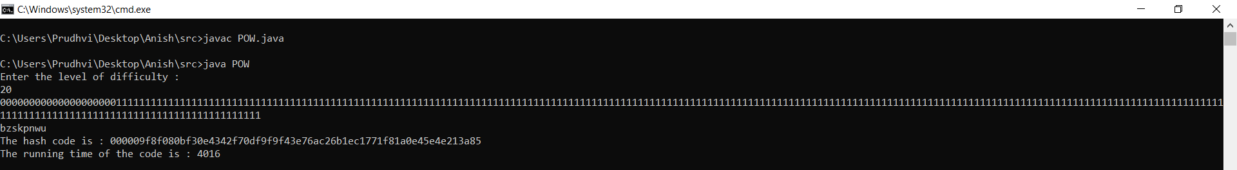

d=21

d=22

d=23

d=24

d=25

d=26

**Step 5:**

The above written java program is verified against verify.java program if verify.java returns 1 then our program is working correctly or else it is not working properly.

