

**TRIBHUVAN UNIVERSITY**

**INSTITUTE OF ENGINEERING**

**THAPATHALI CAMPUS**

**Proposal**

**On**

**Ludo Game Simulation**

**Submitted By:**

Anish Timsina [THA077BEI007]

Ashim Panthi [THA077BEI009]

Bishal Khadka [THA077BEI015]

Khagendra Raj Joshi [THA077BEI022]

**Submitted To:**

Department of Electronics and Computer Engineering

Thapathali Campus

Kathmandu, Nepal

February, 2022

# ABSTRACT

It is a mini project assigned by electronics and computer department to the first year /second semester students for sole purpose of developing problem solving, analyzing skills and teamwork of the students. Thus a team of four members was formed to accomplish the task.

Ludo Game Simulation is a computer program that imitates the manual method of playing ludo boardgame. The motivation behind this project work is the need to strengthen understanding of processes and more specifically their reflective understanding of video games. This system is achieved by writing a computer program using Object Oriented Programming Language(i.e.C++) that allows players to roll a dice randomly, take decisions and move the tokens on the outcome of the dice on a well-designed graphical interface.

# ACKNOWLEDGEMENT

We would like to express our sincere gratitude towards the Institute of Engineering, Tribhuvan University for the inclusion of the project in the course of Object Orieted Programming in Bachelors in Electronics, Communication, and Information Engineering. We are also thankful to our subject teacher Er. Saroj Shakya sir and the Department of Electronics and Computer Engineering, Thapathali Campus for providing us support which is needed for this project. We are greatful to our family members for their financial as well as physical support to achieve our goal to complete this dream project.

Anish Timsina [THA077BEI007]

Ashim Panthi [THA077BEI009]

Bishal Khadka [THA077BEI015]

Khagendra Raj Joshi [THA077BEI022]

# Table of Contents

ABSTRACT i

ACKNOWLEDGEMENT ii

Table of Contents iii

List of Figures v

List of Abbreviations vi

1. INTRODUCTION 1

1.1 Background Introduction 1

1.2 Motivation 1

1.3 Problem Definition 1

1.4 Objectives 2

2. LITERATURE REVIEW 3

2.1 Work of Existing/Researched Related Topic 3

2.1.1 LUDO King 3

2.1.2 LUDO Master 4

2.1.3 Ludo Pro - Hamro Games 4

2.2 How Is It Done? 4

2.3 Importance/Applications of This Project 4

2.3.1 Importance: 4

2.3.2 Applications: 5

2.3.3 Drawbacks Of Existing System 5

3. PROPOSED SYSTEM ARCHITECTURE 6

3.1 System Architecture 6

3.1.1 First Window or Welcome Interface 6

3.1.2 Second Window or Main Menu Interface 6

3.1.3 Third Window 7

3.1.4 Fourth Window 7

3.1.5 Fifth Window or Gameplay Interface 7

3.1.6 Sixth Window 7

3.2 Tools and Environment 8

4. METHODOLOGY 9

4.1 Welcome Window: 9

4.2 Menu 9

4.3 Selecting play with human or computer 9

4.4 Selecting number of players 9

4.5 Selecting a colour 9

4.6 Gameplay 10

4.7 Ending Window 10

5. SCOPE AND APPLICATIONS 16

6. TIME ESTIMATION 17

7. FEASIBILITY ANALYSIS 18

7.1 Practical uses 18

7.2 Cost 18

7.3 Complexity of the software 18

8. EPILOGUE 19

8.1 Expected Output 19

References 21

# List of Figures

Figure 1 block diagram of project 6

Figure 2 proposed system artitecture 8

Figure 3 flowchart for gameplay 11

Figure 4 flowchart for menu 12

Figure 5 flowchart for setting 13

Figure 6 flowchart for board 14

Figure 7 flowchart for roll dice 15

Figure 8 Time Grant chart 17

Figure 9 Rectangular theme 19

Figure 10 Circular theme 20

# List of Abbreviations

IOE = Institute Of Engineering

IOT = Internet Of Things

GUI = Graphical User Interface

SFML = Simple and Fast Multimedia Library

OOP = Object Oriented Programming

IOS= IPhone Operating System

# INTRODUCTION

Ludo is a strategy board game for two to four players, in which the players race their four tokens from start to finish according to the rolls of a single die. Like other cross and circle games, Ludo is derived from the Indian game Pachisi. This game is played by younger children not only in our country Nepal but all over the world.

## Background Introduction

Ludo is a board game for two to four players, in which the players race their four tokens from start to finish according to die rolls. The game and its variants are popular in many countries and under various names. Specific areas of the Ludo board are typically coloured bright yellow, green, red, and blue. Each player is assigned a colour and has four tokens of matching colour. The board is normally square with a cross-shaped game track, with each arm of the cross consisting of three columns of squares—usually six squares per column.

## Motivation

On this 21st century people are connecting with each other digitally. Thus, Ludo can be the best form of entertainment in our free times. It is hard to carry paper or wooden board wherever we go. So, we always as a player wanted to play it anywhere by making it portable. Thus making ludo as an application, we can play it wherever we want and wherever we go. Moreover, we do not need to find friends as we can play it when we are alone with computers. Ludo is one of most common and popular game of childhood. Its coding is not much difficult, however it will require considerable knowledge on graphics. This makes the project challenging yet approachable. Thus we decided to take up this as our project topic.

## Problem Definition

A ludo game is for 2 to 4 players. It takes input on console from players one by one and updates the graphics of Ludo Board. Each player is assigned a colour and has four tokens of matching colour. The goal of the game is to move all four of the player's pieces clockwise once around the board, up the home column, and into the home triangle. To begin, a player must roll a six to move a piece out of the base and onto the start position. That piece is then in play.

## Objectives

The main objectives of our project are listed below:

* To develop an application named Ludo Game Simulation using c++.
* To learn the use of graphics in object oriented programming.
* To develop a multiplayer ludo game with simple codes as far as possible.

# LITERATURE REVIEW

LUDO game is not a new concept. It already exists in many parts of the world. Many ludo games have been developed and are freely available on various platforms. Ludo games have been developed for the purpose of entertainment and are one of the best medium for interaction between friends and can help in strengthening bonds between friends.

## Work of Existing/Researched Related Topic

The work of our researched topic is to create an entertainment and recreation-based game that can be played by two or more than two people as per their requirements. Each player is assigned a specific color and are given four pieces. In this board game two to four players race their tokens from start to finish according to the dice rolls. During game play the token moves clockwise from the starting square around the perimeter of the board, and up the player's home column to the finishing square. Players are not allowed to move a token out of the starting area unless they roll a six on the dice. In this game, players must carefully play their token or they run the risk of sending it back to the starting point to start all over again. When a player one’s token lands on square that is already occupied by Player two’s token of different color, Player two’s token is returned to its starting point. Player who brings all their tokens to the finish wins the game. There are many ludo game apps like Ludo king, Ludo club, Ludo classic, Ludo world etc .Some are described below:

### LUDO King

Ludo king is a free-to-play mobile game application developed by Indian studio Gametion Technologies Pvt Ltd. Gametion is owned by Vikash Jaiswal. It is developed on the unity game engine and is available on android, iOS, kindle, and Windows Phone platforms. The objective of the game is to move 4 tokens from the starting point around the board to the center of the board, also known as home. The first person to do this wins the game.

### LUDO Master

Ludo master is a new ludo game for free played between friends and family. Ludo master is the most popular and exciting game. It is the best game to share the great interests and childhood memories with your friends. The gameplay is simple at first and will become immensely challenging once you play with higher level players.

### Ludo Pro - Hamro Games

It is Nepali variant of Ludo game available for mobile and is also known as Ludo Pro, developed by Hamro Patro.  It is a classical and popular board game, which can be played by all age group of people. Normally, it is played by rolling the dice and moving the token assigned to each player. This game has been developed by Hamro Patro team for Android phone users for a great gaming experience.

## How Is It Done?

This project can be accomplished by developing software that could perform all the above-mentioned tasks. To develop this software, we are using the fast and versatile computer programming language i.e., ‘C++ Programming language.’ And ‘SFML Library’ for graphics.

This software makes maximum use of the data input and output from the files. It takes data from the console user on information about how many players are playing the game and assigns them with color and they race their four pieces from start to end point. The early player to so will win the game.

## Importance/Applications of This Project

### Importance:

The major importance of this project is to create a game where people can enjoy their free time happily. The game is virtual so that the presence of people is not required. The money required while buying the Ludo set can be saved. We must not be worried about the protection of the tokens and sets.

### Applications:

This software can be used by any people that are seeking entertainment and want to enjoy with the friends during this panic state of lockdown and use their time in engaging with each other's. People must not take the board and invite friend, instead they can sit at their own places and play the game anytime they require. Moreover, as gaming is being a big craze in the youth. Games like this which provide entertainment have higher scope. This game does not contain any age bar as this game can be played by any year child or youth. It can be the best choice as stress relieving game in the busy life pattern of the people.

### Drawbacks Of Existing System

The major drawbacks of existing system are that the board that are required for playing game can get lost and carrying the board can be tenacious. The tokens used for game are required and could get lost. In generic the game could not be portable for people. They can be listed in points as follow:

* Board is required, carrying it can be tenacious.
* The tokens required can get lost.
* Need more than one people to play.
* Cannot be played wherever we want (as we do not carry board and tokens where ever we go).

# PROPOSED SYSTEM ARCHITECTURE

Architecture and working of this game of Ludo will consist of six different windows or user interface that will be designed to run in sequence during a single complete execution of this game.

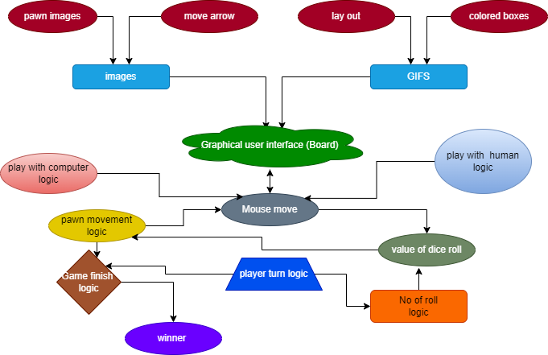

Figure 1 block diagram of project

## System Architecture

### First Window or Welcome Interface

Users are first welcomed into the Game with the display of welcome window. This will display the name of the project and creators. Clicking any key from keyboard will automatically terminate this window and take user to second window.

### Second Window or Main Menu Interface

This window will have two options for users, either play with computer or play with friends. Choosing any one option from this window will take user to nest interface.

### Third Window

Here user will be asked to choose the number of players to play the game. Available number of players being 2 or 3 or 4.

### Fourth Window

This window will ask user to choose colour of tokens if playing with computer or playing users are less than four. It will be displayed only if above conditions are fulfilled else it will be avoided.

### Fifth Window or Gameplay Interface

Here user will enjoy the game of ludo. But there will be an option for pausing which will provide user with five different options viz,

* Menu: It will take user to main menu which is a second window.
* Continue: If player is already playing it will continue game in same state as it was left.
* New Game: This option reset all progress of game and will start again freshly with previously selected settings.
* Setting: It will provide an user with the option to change between two available themes for ludo board.

Also, players name with colour of their tokens will be displayed as an information about the fixature of game.

### Sixth Window

And finally, after the completion, name of the winner no. of time the game was played and options for, if user want to play again, go back to main menu or to exit from the game will be displayed.

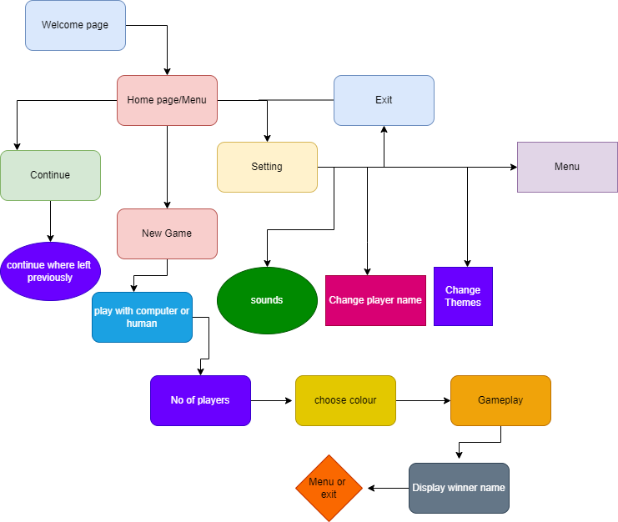

Figure 2 proposed system architecture

## Tools and Environment

To develop this software, we used Visual Studio Code and Code blocks as text editor and was compiled using GNU gcc compiler. This software is compiled and run through this integrated environment.

1. Visual Studio Code :: Text Editor
2. GNU GCC compiler :: Compiler
3. Code Blocks :: IDE
4. SFML Library

# METHODOLOGY

We are going to implement the function of object oriented programming(C++) to build a ludo game. This game is going to create the environment of fun. In our program ,first we are going to display the introduction part, after the introduction session the user gets new interface where rules, regulation and controls will be displayed. Then we will go straight to our main part of the game. This game is going to run in the following manner:

## Welcome Window:

This is the first window that user will see after opening the game. This contains all the rules related to the game and also the controls of the game. This will be created using SFML library.

## Menu

In this window, user can continue the previous game if left. Also he can start a new game or exit from the game. The user can also go to setting where he/she can turn on/off sound ,change player name, and change the theme of board.

## Selecting play with human or computer

In this window, The user can choose whether he want to play with friends or with computer.

## Selecting number of players

In this window the users can choose upto 2 to 4 players to play the game. After choosing the number of player, it goes to selecting the colour only if players are less than four in play with human cases and computer. In case of playing with computer user can also choose colour for him.

## Selecting a colour

In this window the users can choose the colour if he is playing against computer and also if the players is less than 4 he can choose required number of colours. After choosing a colour the game starts.

## Gameplay

This is the main part of the program where user play the actual ludo game. The objective of the game is to move 4 tokens from the starting point around the board to the center of the board, also known as home. The first person finish all the tokens wins the game. Each player rolls the dice and the one who brings six begins the game. Players alternate turns in a clockwise direction. To enter a token into play from its yard to its starting square, a player must roll a 6. If the player has no tokens yet in play and rolls other than a 6, the turn passes to the next player. Once a player has one or more tokens in play, he selects a token and moves it forwards along the track for the number of squares indicated by the die. Players must always move a token according to the die value rolled. Passes are not allowed; if no move is possible, the turn moves to the next player. When a 6 is rolled, the player may choose to advance a token already in play, or may enter another staged token to its starting square. Rolling a 6 earns the player an additional or "bonus" roll in that turn. If the bonus roll results in a 6 again, the player earns an additional bonus roll. Players may not end their move on a square they already occupy. If the advance of a token ends on a square occupied by an opponent's token, the opponent token is returned to its owner's yard. The returned token can be reentered into play only when the owner rolls a 6.

The Board for Gameplay is prepared using STML library defined by the class of window. A window can be created and opened directly upon construction. All the works must be tracked like any key pressed, mouse moved or any other external sources connected. Since the only role of a STML is to be loaded and mapped to graphical entities, almost all its functions are about loading and updating it.

* 1. Ending Window

This window is displayed after the game is completed and shows rank achieved by all of the players with the option whether to go to Menu or exit.

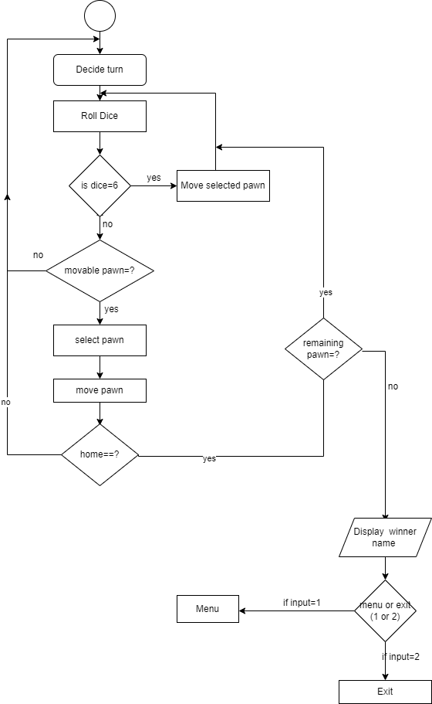

Figure 3 flowchart for gameplay

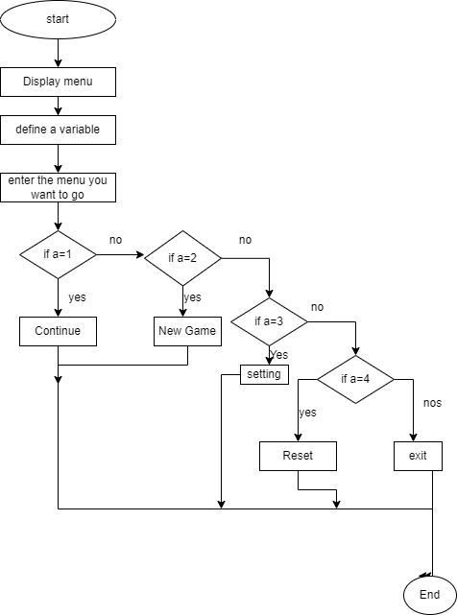

Figure 4 flowchart for menu

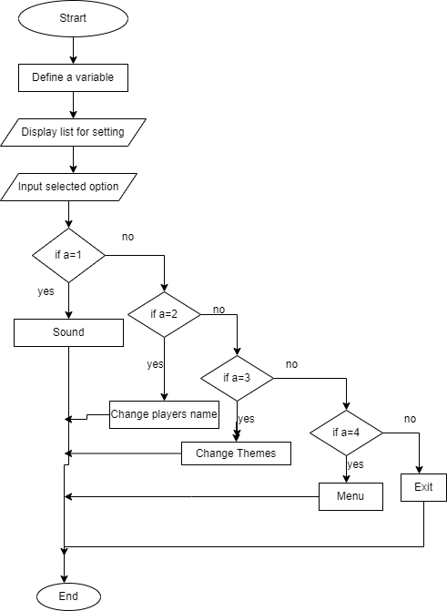

Figure 5 flowchart for setting

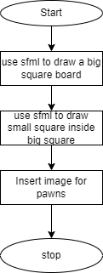

Figure 6 flowchart for board

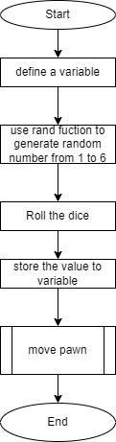

Figure 7 flowchart for roll dice

# SCOPE AND APPLICATIONS

The main purpose of this application is in mobile game industry by publishing it into different app store platforms and online gaming websites so that everyone can have the reach to it. Also by modifying and combining with other board games like carom, card games etc. it can also be a proper professional gaming app and can give proper competition to other apps in play store, ios app stores like app platforms. By monetization, those apps we can also get some financial benefits.

Some of the applications of this application can be:

1. It can be used as mobile game.
2. It can be played when we are alone. No need to wait for other people to play it.
3. It can be played with online friends by applying certain changes.

# TIME ESTIMATION

Figure 8 Time Grant chart

# FEASIBILITY ANALYSIS

## Practical uses

Practically this application can be used especially in gaming industry where this types of board games are getting more hyped and users these days as most of people cannot play outdoor sports in their break or free time so you can see every age group people playing these kind of board games in Bus, café etc. as they are easy to play and understand. So it can be more fruitful if we combine this with several others boards to single app and publish those apps.

Apart from that it can be personal and can be shared among friend circle, specific community where people can play enjoy and appreciate the app by playing against each other or alone when bored.

## Cost

As mention above combing this game with other board games into single app we can have maximum benefits. Also we can publish this app solo as ludo game has become extremely popular these days so it will not be surprise if it does well in various app stores. We cannot say anything about the cost of this app as it is not tailored software and various other similar ludo game is out in the market for free. So it depends upon the monetization of the app and how well it performs on those open platforms like play store apple store etc.

## Complexity of the software

This software is very user friendly and quite easy to play as everyone in this life time must have played this game once. So there will not be any problems while using this software as it completely similar to that of board ludo game just in digital form.

# EPILOGUE

## Expected Output

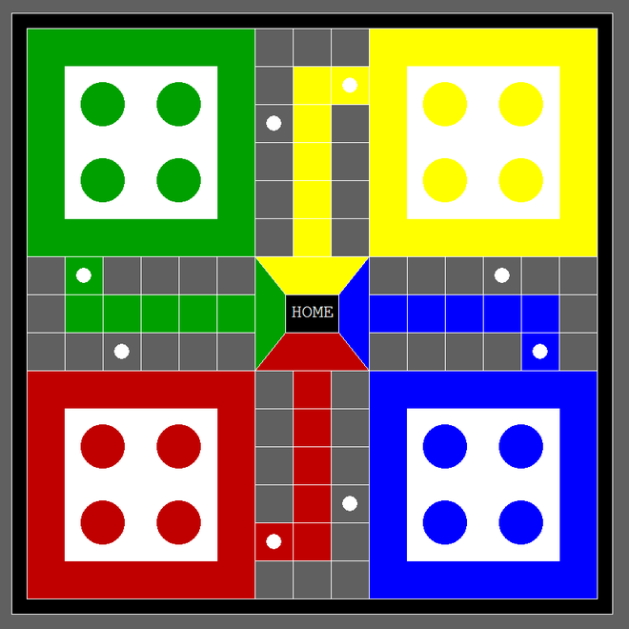

Figure 9 Rectangular theme

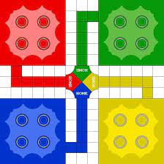

Figure 10 Circular theme

# References

|  |  |
| --- | --- |
| [1] | R. Pupius, SFML Game Development By Example, Birmingham: packt publishing limited, 2015. |
| [2] | E. Balagurusamy, Object Oriented Programming With C++, Delhi: Tata McGraw Hill Education Private Limited, 2010. |
| [3] | "wikipedia," [Online]. Available: en.wikipedia.org/wiki/Ludo (board_game). |
| [4] | [Online]. Available: en.wikipedia.org/wiki/Ludo (board_game). |