

**TRIBHUVAN UNIVERSITY**

**INSTITUTE OF ENGINEERING**

**THAPATHALI CAMPUS**

**A Project Report**

**On**

**Ludo Game Simulation**

**Submitted By:**

Anish Timsina [THA077BEI007]

Ashim Panthi [THA077BEI009]

Bishal Khadka [THA077BEI015]

Khagendra Raj Joshi [THA077BEI022]

**Submitted To:**

Department of Electronics and Computer Engineering

Thapathali Campus

Kathmandu, Nepal

April,2022

# DECLARATION

We hereby declare that the project work report entitled “Ludo game simulation” submitted for the partial fulfillment of the requirements for the course of CT 451 Object Oriented Programming is our original work and the Project Work Report has not formed the basis for the award of any degree, diploma, or other similar titles.

Signature:

Anish Timsina [THA077BEI007]

Signature:

Ashim Panthi [THA077BEI009]

Signature:

Bishal Khadka [THA077BEI015]

Signature:

Khagendra Raj Joshi [THA077BEI022]

# 

# ACKNOWLEDGEMENT

We would like to express our sincere gratitude towards the Institute of Engineering, Tribhuvan University for the inclusion of the project in the course of Object Oriented programming in Bachelors in Electronics, Communication and Information Engineering. We are also thankful to our subject teacher Er. Saroj Shakya sir and the Department of Electronics and Computer Engineering, Thapathali Campus for providing us support which is needed for this project.

At last but not least we will like to thank our parents (The living god) who toil hard and their prayer invisibly saves us from any problem.

Anish Timsina [THA077BEI007]

Ashim Panthi [THA077BEI009]

Bishal Khadka [THA077BEI015]

Khagendra Raj Joshi [THA077BEI022]

# ABSTRACT

It is a mini project assigned by electronics and computer department to the first year /second semester students for sole purpose of developing problem solving, analyzing skills and teamwork of the students. Thus a team of four members was formed to accomplish the task.

Ludo Game Simulation is a computer program that imitates the manual method of playing ludo boardgame. The motivation behind this project work is the need to strengthen understanding of processes and more specifically their reflective understanding of video games. This system is achieved by writing a computer program using Object Oriented Programming Language(i.e.C++) that allows players to roll a dice randomly, take decisions and move the tokens on the outcome of the dice on a well-designed graphical interface.

# Table of Contents

DECLARATION ii

ACKNOWLEDGEMENT iii

ABSTRACT iv

Table of Contents v

List Of Figures viii

List of Abbreviations ix

1. INTRODUCTION 10

1.1 Background Introduction 10

1.2 Motivation 10

1.3 Problem Definition 10

1.4 Objectives 11

1.5 Applications 11

1.6 Feasibility Analysis 11

1.6.1 Economic Feasibility 11

1.6.2 Technical Feasibility 11

1.6.3 Operational Feasibility 12

1.6.4 Practical Uses 12

1.7 System Requirement 12

1.7.1 Software Requirement 12

1.7.2 Hardware Requirement 12

2. LITERATURE REVIEW 14

2.1 First Window or Welcome Interface 14

2.2 Second Window or Main Menu Interface 14

2.3 Third Window or Gameplay Window 14

3. DESIGN AND METHODOLOGY 16

3.1 Welcome Window: 16

3.2 Menu 16

3.3 Selecting number of players and colour 16

3.4 Gameplay 16

4. IMPLEMENTATION AND RESULT 18

4.1 Introduction: 18

Some screenshots of results 18

5. CONCLUSION & FURTHER WORK 23

5.1 Conclusion 23

5.2 Further Works 23

References 24

APPENDICES 25

# List Of Figures

Figure 1.Block diagram 14

Figure 2.Ludo board drawn on paint 17

Figure 3. Starting page 18

Figure 4.Starting page with cursor pointing 18

Figure 5. Main menu 19

Figure 6.Cursor position in menu 19

Figure 7. Cursor position on Exit 20

Figure 8. Gameplay page 20

Figure 9.Gameplay with tokens drag and drop 21

# List of Abbreviations

IOE = Institute Of Engineering

IOT = Internet Of Things

GUI = Graphical User Interface

SFML = Simple and Fast Multimedia Library

OOP = Object Oriented Programming

IOS= IPhone Operating System

# INTRODUCTION

Ludo is a strategy board game for two to four players, in which the players race their four tokens from start to finish according to the rolls of a single die. Like other cross and circle games, Ludo is derived from the Indian game Pachisi. This game is played by younger children not only in our country Nepal but all over the world.

# Background Introduction

Ludo is a board game for two to four players, in which the players race their four tokens from start to finish according to die rolls. The game and its variants are popular in many countries and under various names. Specific areas of the Ludo board are typically coloured bright yellow, green, red, and blue. Each player is assigned a colour and has four tokens of matching colour. The board is normally square with a cross-shaped game track, with each arm of the cross consisting of three columns of squares—usually six squares per column.

# Motivation

On this 21st century people are connecting with each other digitally. Thus, Ludo can be the best form of entertainment in our free times. It is hard to carry paper or wooden board wherever we go. So, we always as a player wanted to play it anywhere by making it portable. Thus making ludo as an application, we can play it wherever we want and wherever we go. Moreover, we do not need to find friends as we can play it when we are alone with computers. Ludo is one of most common and popular game of childhood. Its coding is not much difficult, however it will require considerable knowledge on graphics. This makes the project challenging yet approachable. Thus we decided to take up this as our project topic.

# Problem Definition

A ludo game is for 2 to 4 players. It takes input on console from players one by one and updates the graphics of Ludo Board. Each player is assigned a colour and has four tokens of matching colour. The goal of the game is to move all four of the player's pieces clockwise once around the board, up the home column, and into the home triangle. To begin, a player must roll a six to move a piece out of the base and onto the start position. That piece is then in play.

# Objectives

The main objectives of our project are listed below:

* To develop an application named Ludo Game Simulation using c++.
* To learn the use of graphics in object oriented programming.
* To develop a multiplayer ludo game with simple codes as far as possible.

# Applications

This software can be used by any people that are seeking entertainment and want to enjoy with the friends during this panic state of lockdown and use their time in engaging with each other's. People must not take the board and invite friend, instead they can sit at their own places and play the game anytime they require. Moreover, as gaming is being a big craze in the youth. Games like this which provide entertainment have higher scope. This game does not contain any age bar as this game can be played by any year child or youth. It can be the best choice as stress relieving game in the busy life pattern of the people.

# Feasibility Analysis

# 1.6.1 Economic Feasibility

Economic feasibility analysis is the most commonly used method for determining the efficiency of a new project. It is also known as cost analysis. It helps in identifying profit against investment expected from a project. This program is highly economical and feasible. Since it is written in the C++ programming language, compiled by the C++ compiler using the IDEs like code block and VS code, it has not much of the economical investment but a lot of time has been invested on idea generation, research, and coding. So economically it is highly satisfying. Use of this software can give good feel of playing real world ludo game to anyone who have played ludo game before.

# 1.6.2 Technical Feasibility

The technical feasibility study is the complete study of the project in terms of input, processes, output, fields, programs, and procedures. It is a very effective tool for long-term planning and troubleshooting. The technical feasibility study should most essentially support the financial information of an organization. It is a technically well-managed program whose source code can be easily modified for better improvement and for debugging any error.

# 1.6.3 Operational Feasibility

Operational feasibility refers to the measure of solving problems with the help of a new proposed system. It helps in taking advantage of the opportunities and fulfills the requirements as identified during the development of the project. It takes care that the management and the users support the project. It is very easy to use. Simply, a person who understands the English language can use this program. The software is very user-friendly in design as it very similar to the real life ludo game.

# 1.6.4 Practical Uses

Practically this application can be used especially in gaming industry where this types of board games are getting more hyped and users these days as most of people cannot play outdoor sports in their break or free time so you can see every age group people playing these kind of board games in Bus, café etc. as they are easy to play and understand. So it can be more fruitful if we combine this with several others boards to single app and publish those apps.

Apart from that it can be personal and can be shared among friend circle, specific community where people can play enjoy and appreciate the app by playing against each other or alone when bored.

# System Requirement

# 1.7.1 Software Requirement

This program does not require a lot of software. This program can run just in any operating system as the C++ language is machine-independent. After the compilation process is performed, a .exe file is generated which runs in any OS without the need of any compiler.

# 1.7.2 Hardware Requirement

This program is an economically feasible program so it doesn’t require a lot of hardware. Any computer either be laptop or desktop that has an operating system installed in it with the hardware requirements of the OS can run this program. It can run on the lowest-performing PC available in the market. Thus this software is a boon for all those people having low system requirements due to their poor economical condition. Also, PCs having higher specifications can support the program with ease.

# LITERATURE REVIEW

# First Window or Welcome Interface

Users are first welcomed into the Game with the display of welcome window. This will display the name of the project and creators. Clicking any key from keyboard will automatically terminate this window and take user to second window.

# Second Window or Main Menu Interface

This window will have two options for users, either start new game or exit game. If the user click in the new game option the it will take user to the third window and if user press to the exit option then game will be terminated.

# Third Window or Gameplay Window

Here user will enjoy the game of ludo. .

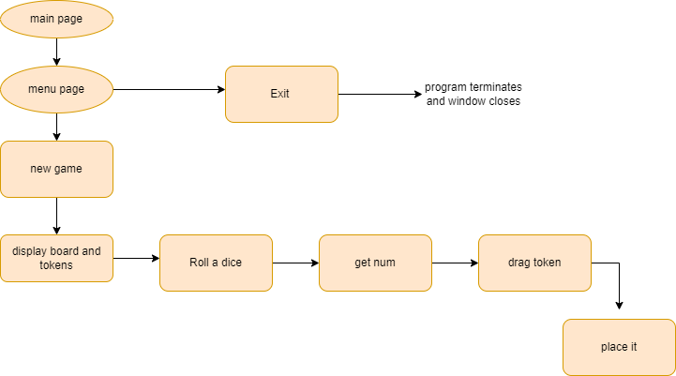

Figure 1.Block diagram

# DESIGN AND METHODOLOGY

# Welcome Window:

This is the first window that user will see after opening the game. This contains all the developers name and the click option which will take user to the menu window . This will be created using SFML library.

# Menu

In this window can start a new game or exit from the game.

# Selecting number of players and colour

The users can choose upto 4 players to play the game and there must be minimum 2 players to play the game. After choosing the number of player the themselves have to choose their color from the given color in the board. This is very much similar to the real world ludo as only dice and gotti for four player is provided and user have to select themselves according to their wish.

# Gameplay

This is the main part of the program where user play the actual ludo game. The objective of the game is to move 4 tokens from the starting point around the board to the center of the board, also known as home. The first person finish all the tokens wins the game. Each player rolls the dice and the one who brings six begins the game. Players alternate turns in a clockwise direction. To enter a token into play from its yard to its starting square, a player must roll a 6. If the player has no tokens yet in play and rolls other than a 6, the turn passes to the next player. Once a player has one or more tokens in play, he selects a token and moves it forwards along the track for the number of squares indicated by the die. Players must always move a token according to the die value rolled. Passes are not allowed; if no move is possible, the turn moves to the next player. When a 6 is rolled, the player may choose to advance a token already in play, or may enter another staged token to its starting square. Rolling a 6 earns the player an additional or "bonus" roll in that turn. If the bonus roll results in a 6 again, the player earns an additional bonus roll. Players may not end their move on a square they already occupy. If the advance of a token ends on a square occupied by an opponent's token, the opponent token is returned to its owner's yard. The returned token can be reentered into play only when the owner rolls a 6.

The Board for Gameplay is used from the picture extracted from website. Here all the work such as moving gotti cutting the gotti and deciding the winner must be done by player themselves only board, gotti and dice roll is provided to the players. This very much similar to real life ludo.

# IMPLEMENTATION AND RESULT

## **Introduction:**

Project implementation is the phase where theoretical design, visions, and plans turn into a working system. Its success depends on many internal and external factors. It is the most critical part of the project as it is the step of achieving the new system that will work and be effective.

Careful planning, investigation of the existing system, designing of methods to change the system, and analysis of the advantages of change come under the stages of the implementation cycle.

## **Some screenshots of results**

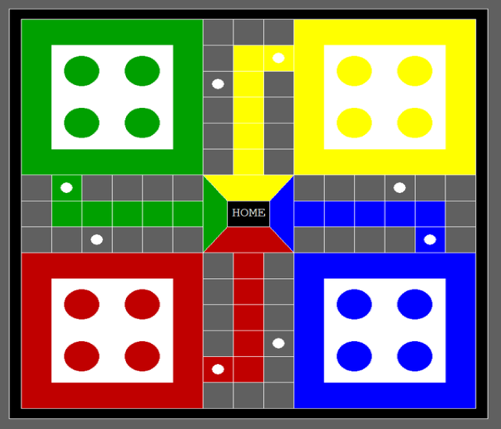

Figure 2.Ludo board drawn on paint

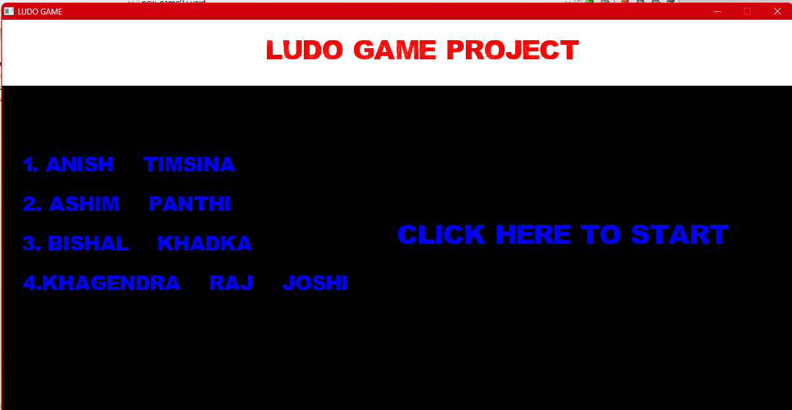

Figure 3. Starting page

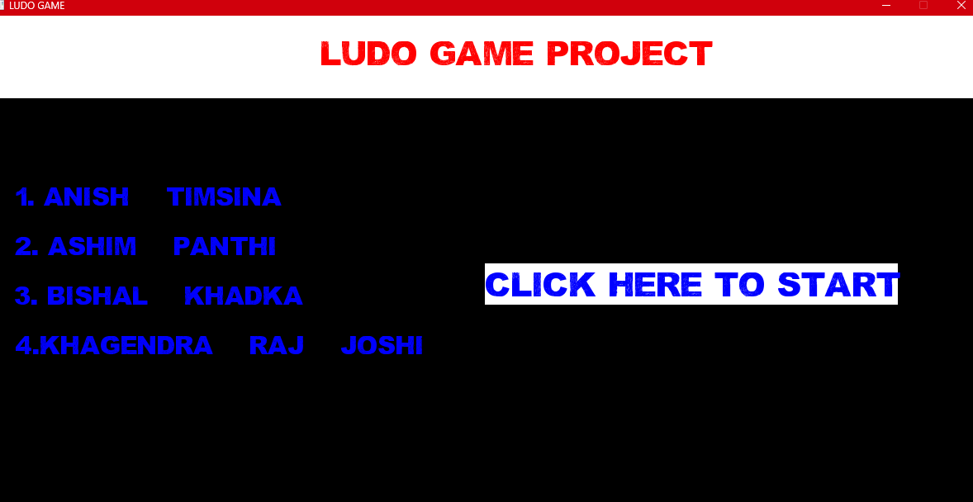

Figure 4.Starting page with cursor pointing

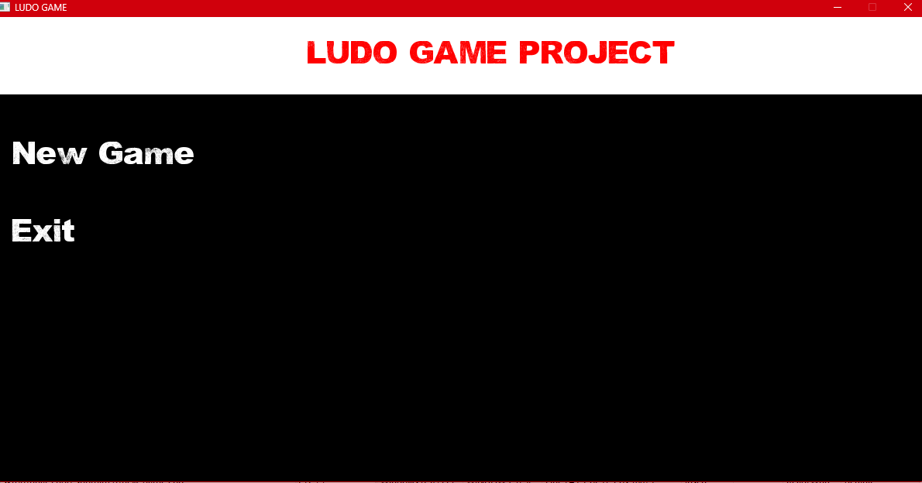

Figure 5. Main menu

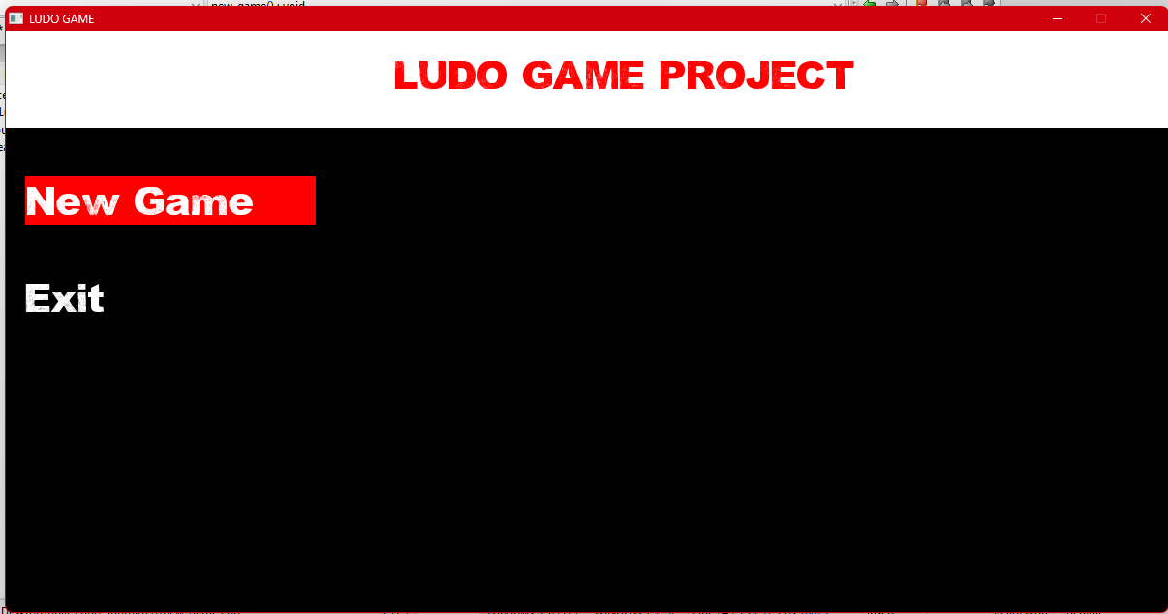

Figure 6.Cursor position in menu

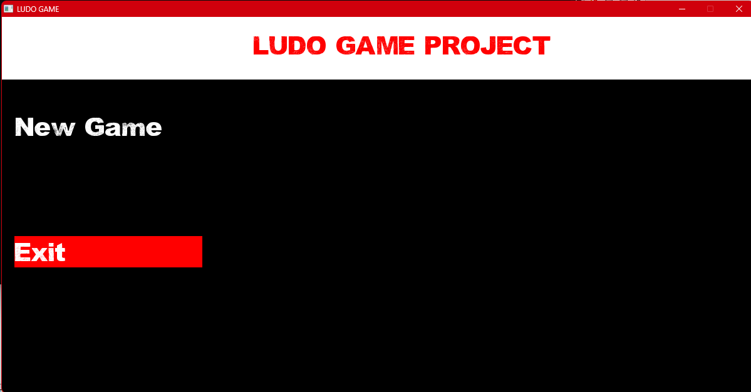

Figure 7. Cursor position on Exit

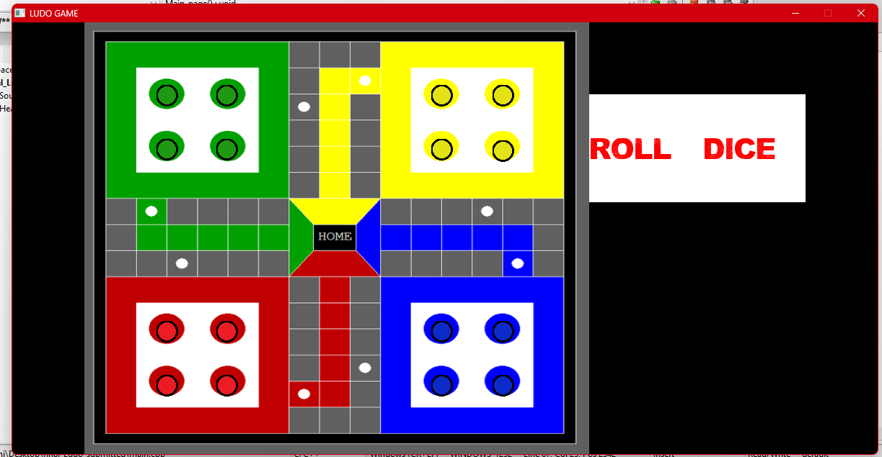

Figure 8. Gameplay page

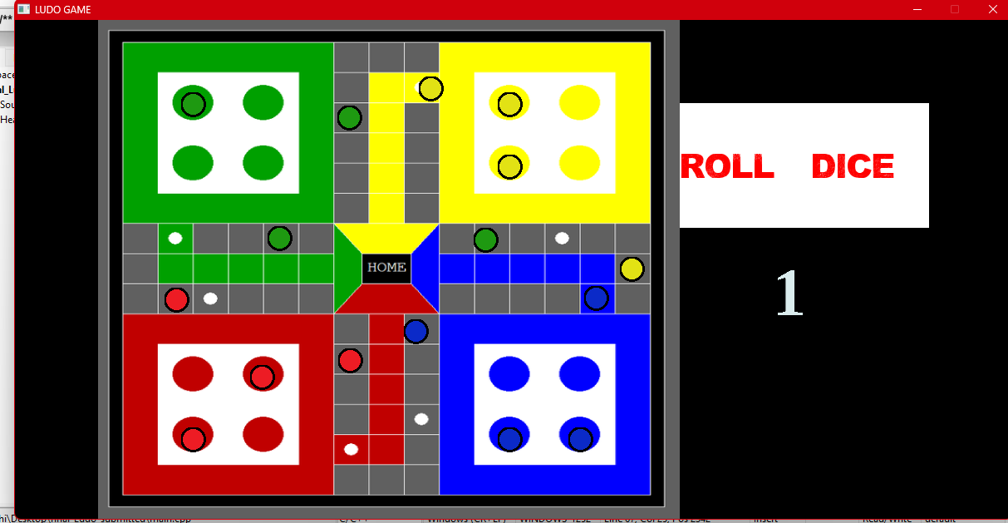

Figure 9.Gameplay with tokens drag and drop

# CONCLUSION & FURTHER WORK

# Conclusion

Since Practically this application can be used especially in gaming industry where this types of board games are getting more hyped and users these days as most of people cannot play outdoor sports in their break or free time so you can see every age group people playing these kind of board games in Bus, café etc. as they are easy to play and understand. So it can be more fruitful if we combine this with several others boards to single app and publish those apps.

Apart from that it can be personal and can be shared among friend circle, specific community where people can play enjoy and appreciate the app by playing against each other or alone when bored.

# Further Works

This project has lot of further work do be done. Due to lack of time we could only provide board and gotti with dice to the players. All the moves in the game is done by player themselves so we should minimize player work by provided all automated feature such as the application should itself move the gotti pressed by player according to the dice roll number and also player turn should be recognized by the software itself. The feature for provding various board. Selection of number player colour and appearance of gooti according to number of player according to the selected number of player must to added and also the winner should be recognized by application itself.

# References

|  |  |
| --- | --- |
| [1] | R. Pupius, SFML Game Development By Example, Birmingham: packt publishing limited, 2015. |
| [2] | E. Balagurusamy, Object Oriented Programming With C++, Delhi: Tata McGraw Hill Education Private Limited, 2010. |
| [3] | "wikipedia," [Online]. Available: en.wikipedia.org/wiki/Ludo (board_game). |
| [4] | [Online]. Available: en.wikipedia.org/wiki/Ludo (board_game). |

# APPENDICES