Upon investigating the https[:]//cracked[.]sh/Thread-Email-Pass-%E2%98%81-8-9-MILLION-URL-LOGIN-PASS-%E2%98%81?pid=46458043#pid46458043 we found that the threat actor mazika1 has posted a url https[:]//gofile[.]io/d/t8EC97.
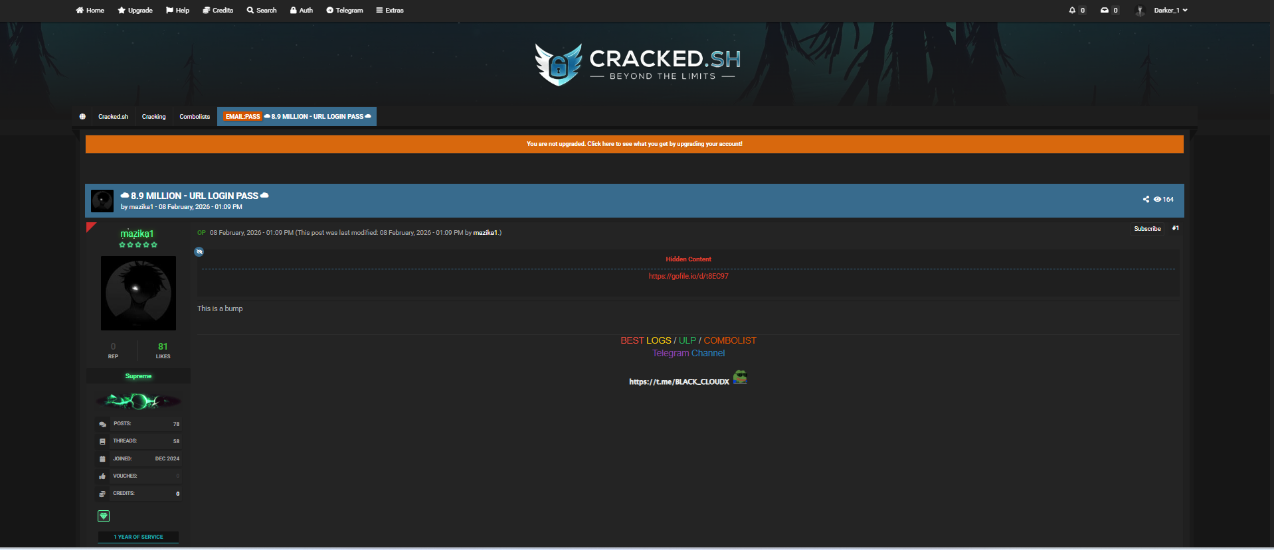
Upon checking the url https[:]//gofile[.]io/d/t8EC97 it is currently showing the content does not exist.
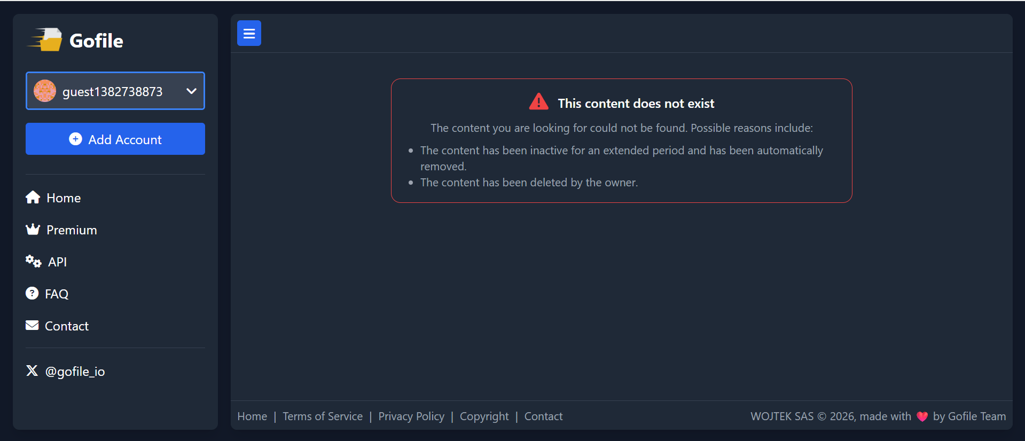
Upon investigating the telegram link https[:]//t[.]me/Nullcyber_Cloud/319 we identified credentials related to bms-app-access and the e11268 account. No additional information associated with bms-app-access or the url https[:]//nsac[.]isdb[.]org/guest/IsDB-GUEST_login[.]php was found.
