**Q1. Design IQ BOT to upload documents for processing.**

**Part 1: Train IQ Bot**

**Step 1: Create a New Learning Instance**

* Click on "Create New Learning Instance".
* Fill in details:
  + Name: InvoiceIQBot2
  + Document type: User-defined
  + Language: English
  + Industry: General
* Click Next.

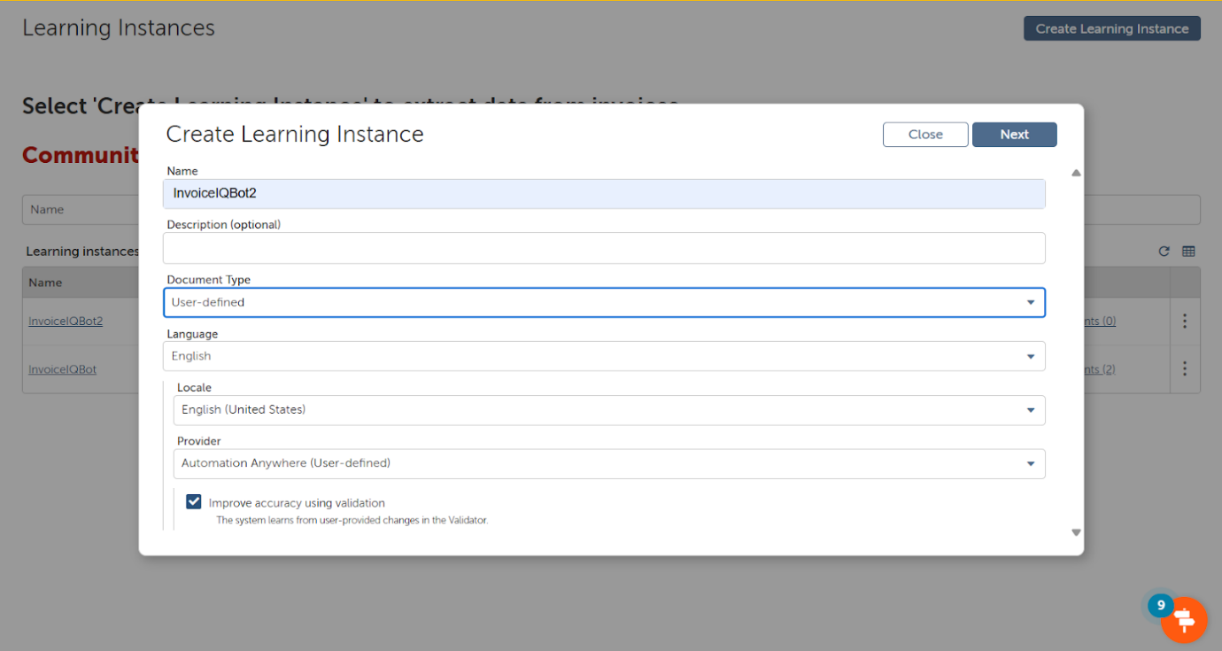

**Step 2: Upload Training Documents**

* Upload invoice1.pdf and invoice2.pdf as Training documents.
* IQ Bot automatically extracts fields and shows them for mapping.

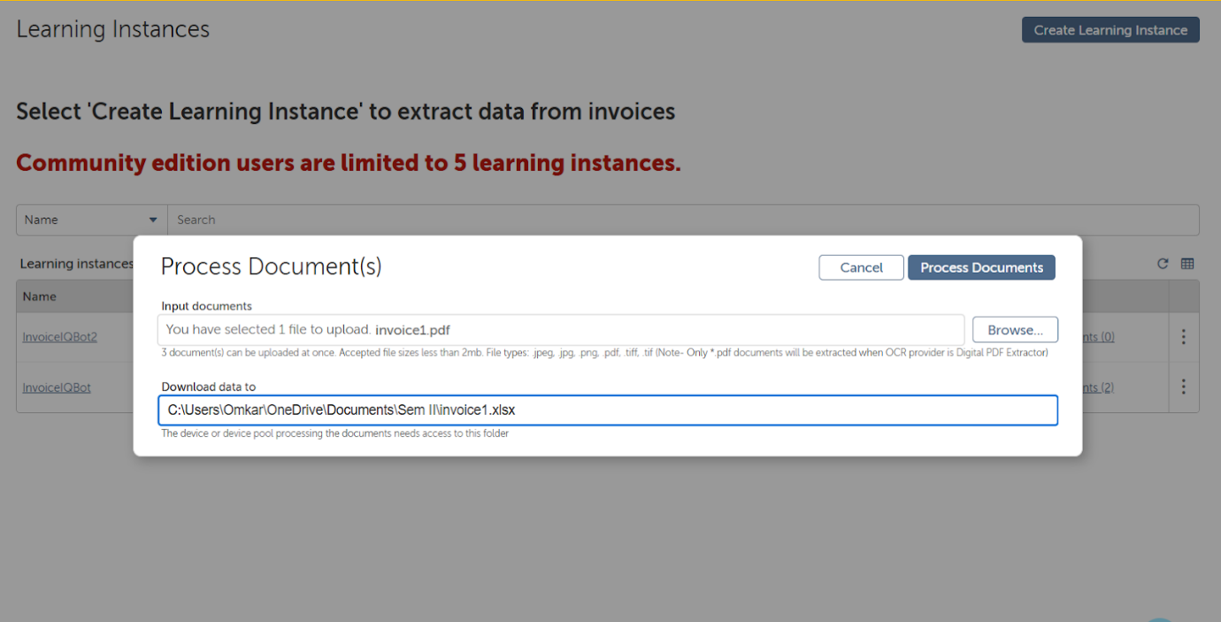

**Step 3: Define Fields to Extract**

* Map key fields such as:
  + Invoice Number
  + Due Date
  + Vendor Name
* Use drag-and-drop or type the field names on the preview screen.

**Step 4: Train the Bot**

* Save the mapping.
* Click Train Bot.
* Wait for the training process to complete.

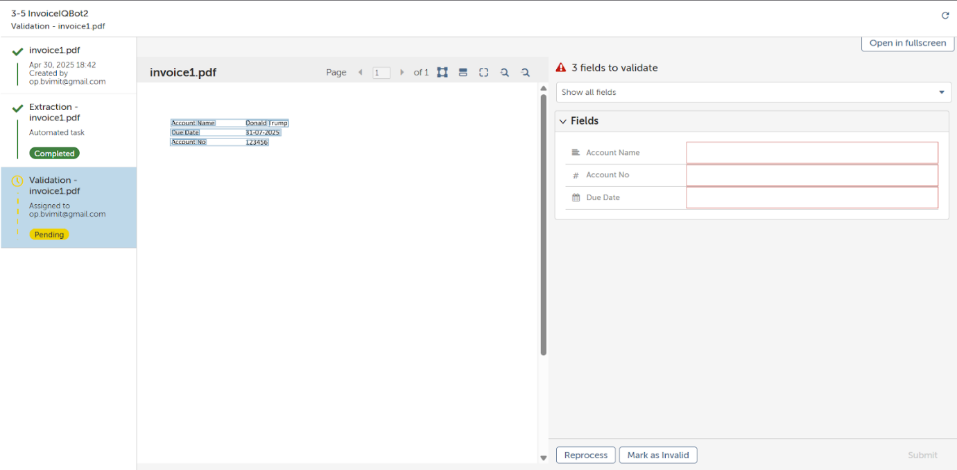

**Step 5: Publish Learning Instance**

* After training, click Publish.
* This instance is now ready to extract data from new invoices.

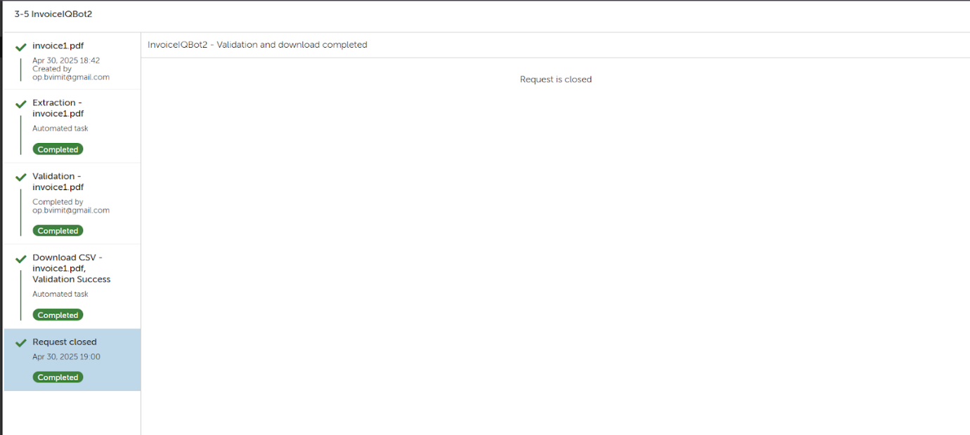

**Part 2: Use IQ Bot in Task Bot**

**Step 1: Open Bot Creator (Automation Anywhere Bot Agent)**

* Launch Bot Creator and create a new Task Bot (InvoiceTaskBot).

**Step 2: Use IQ Bot Package**

* Use the IQ Bot Package (available under packages).
* Add "Upload Document to IQ Bot" action.

**Configure Upload Document to IQ Bot:**

* Learning Instance Name: InvoiceIQBot2
* File Path: Provide path to invoice3.pdf
* Output folder: Specify a folder where extracted CSV will be saved (e.g., C:\ExtractedIQBotData)
* Save Response: Save Response as a Record (e.g., Record1)

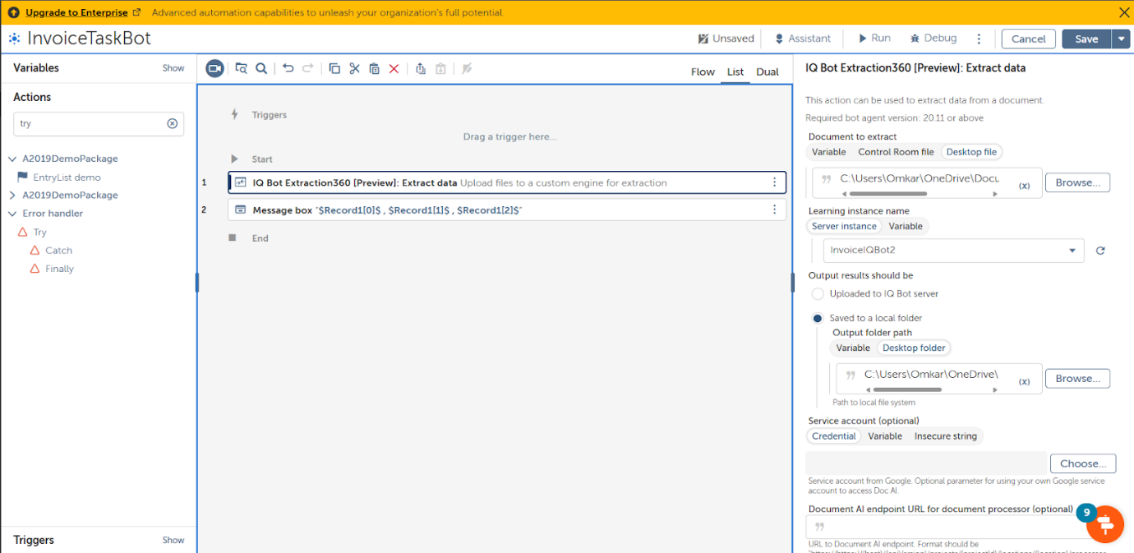

**Step 3: Display Using Message Box**

* Use Message Box action to display extracted values like:

