**Automation anywhere Advanced Commands**

**1. Launching a website (Facebook)**

Step1: Create a bot

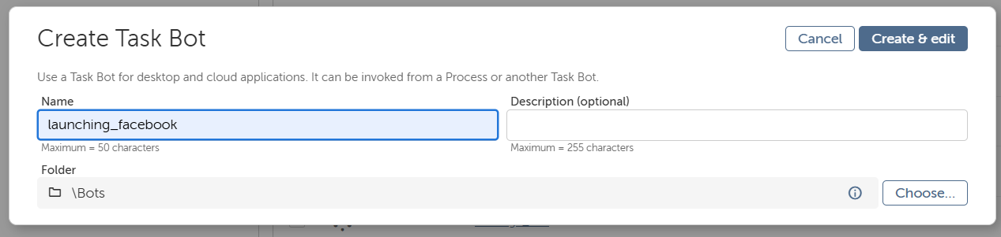

Step2: Add browser open action and select the link

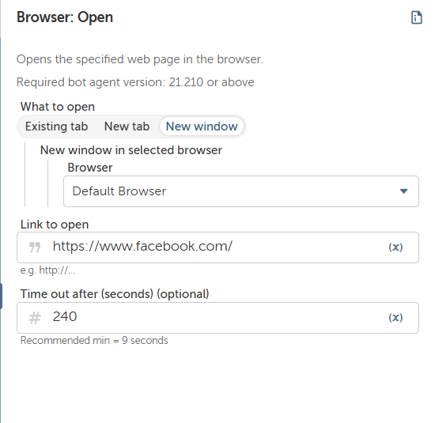

Srep3: Add messagebox to display the message

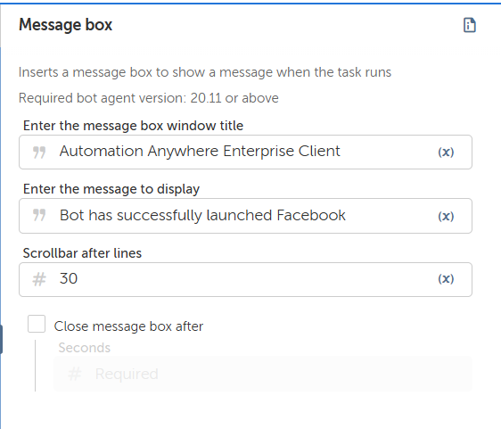

Final Flow:

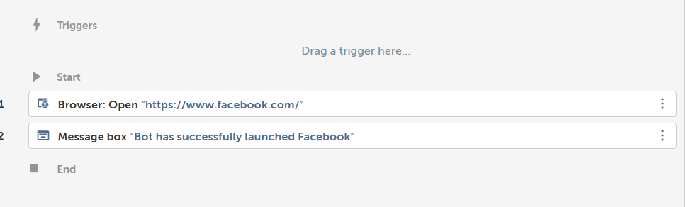

**Output:**

Before running the bot:

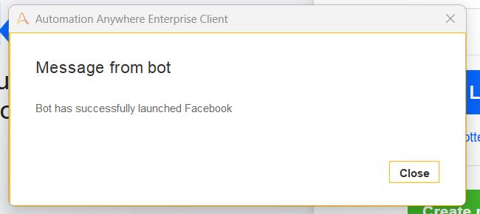

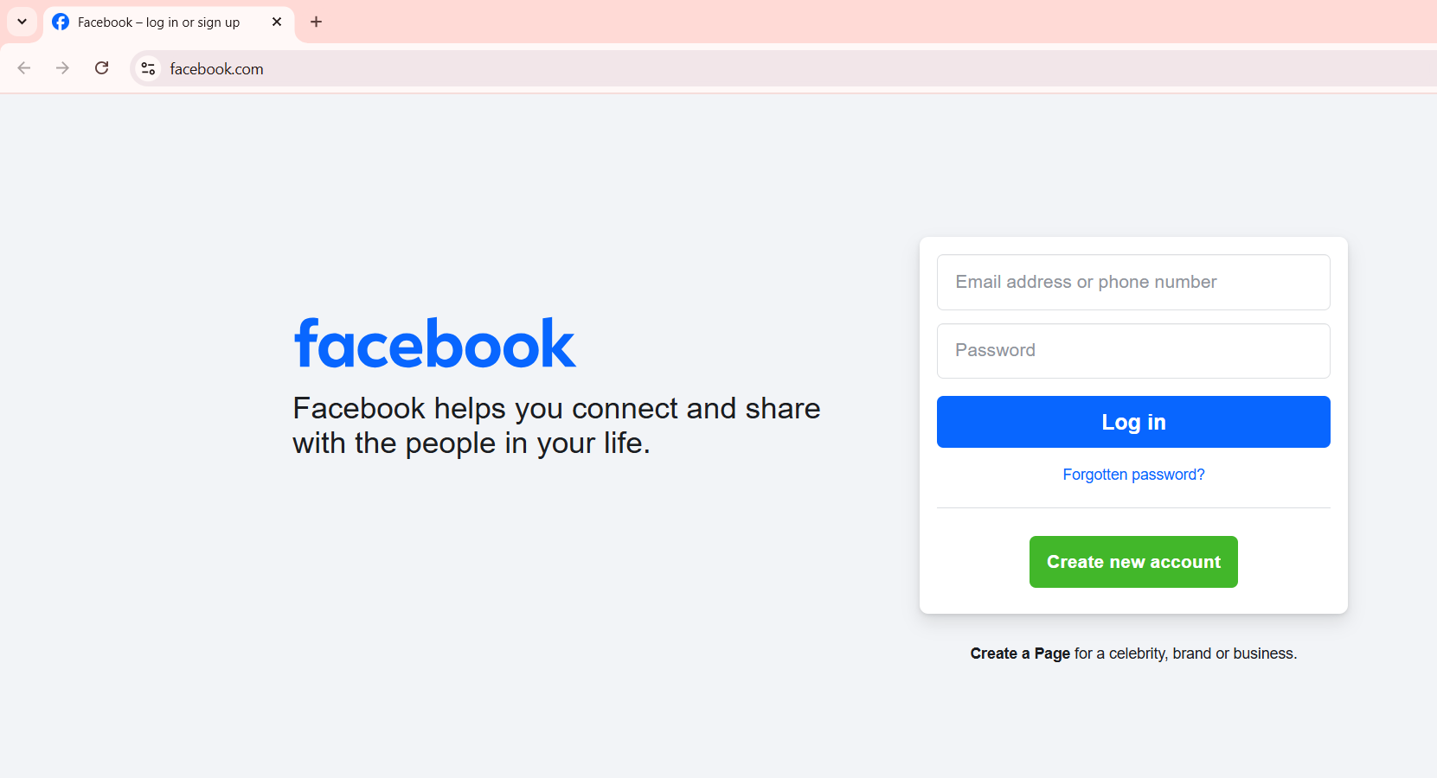

**2. Bot to work with MSPaint**

Step1: Create a bot

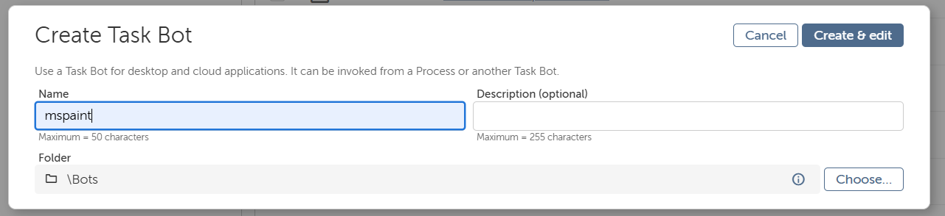

Step2: Flow of the Bot to Capture, open and close the MS paint

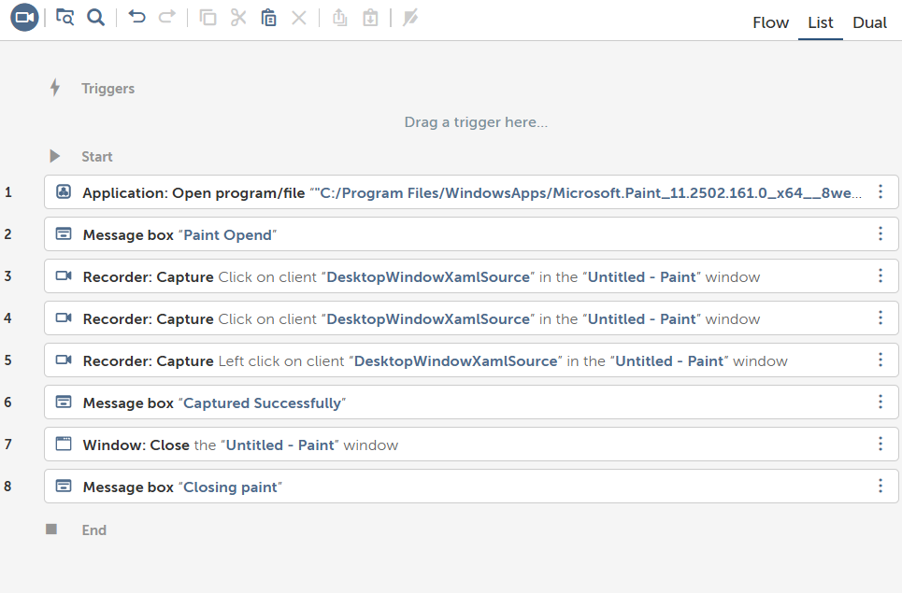

**Output:**

Taskbar before running the bot

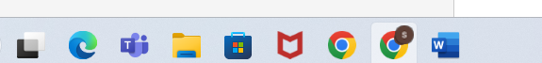

Taskbar after running the bot

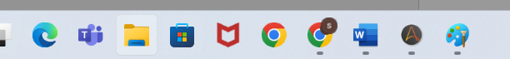

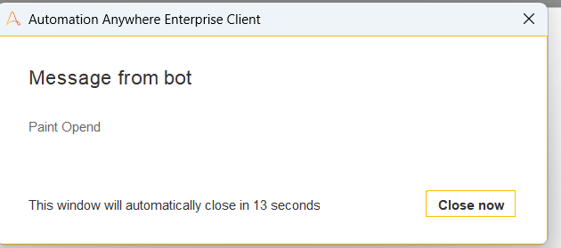

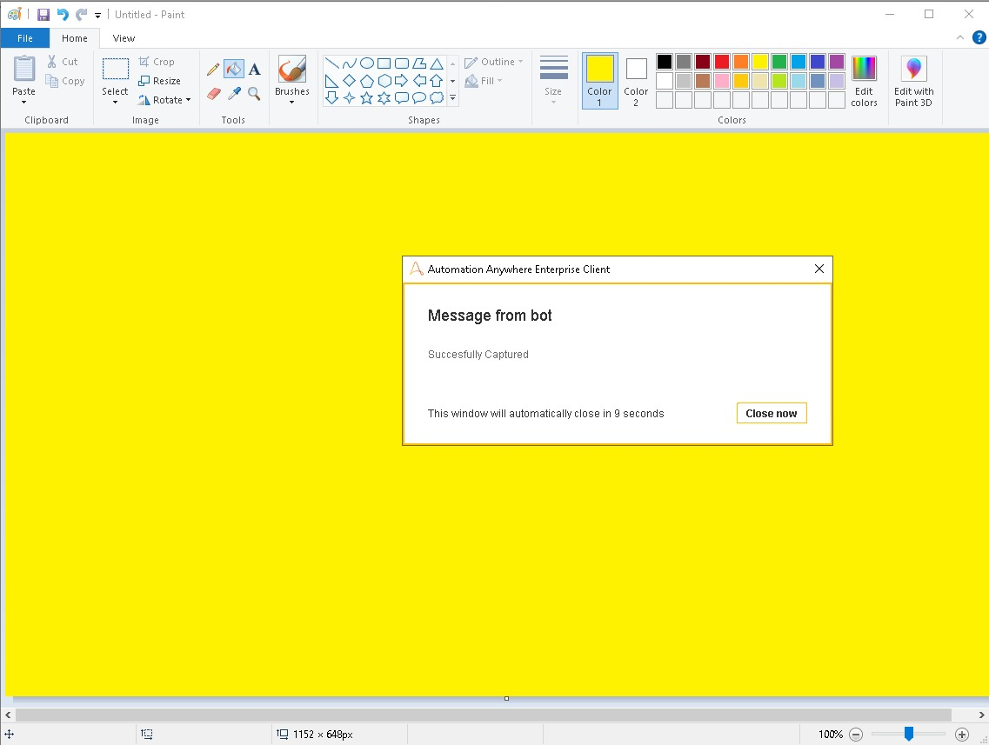

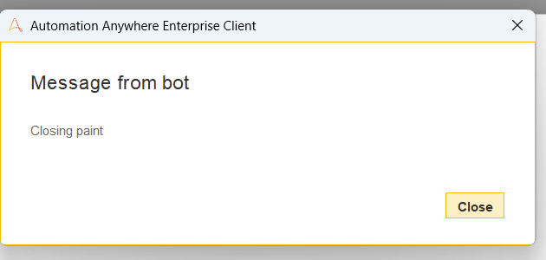

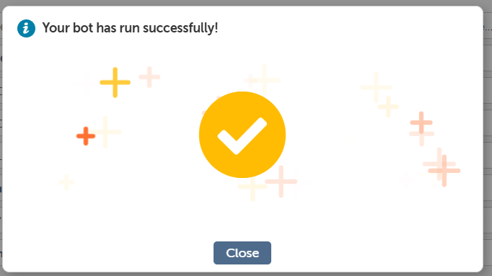

**3. Automate the action of getting title of active window.**

Step1: Create the Bot

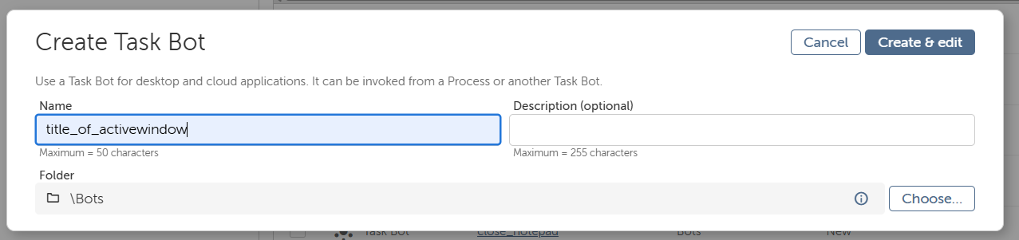

Step2: Select the action of get title of active window

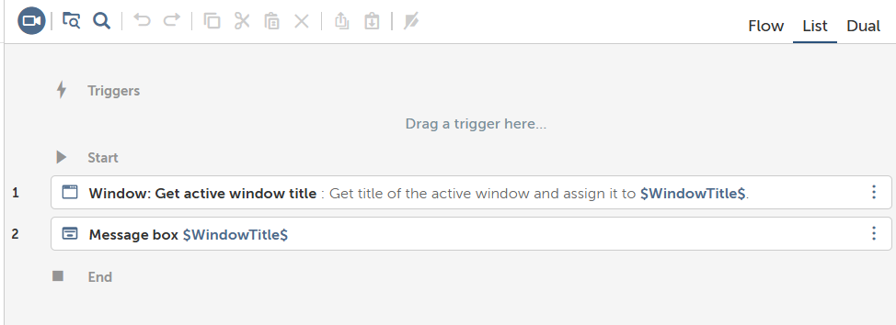

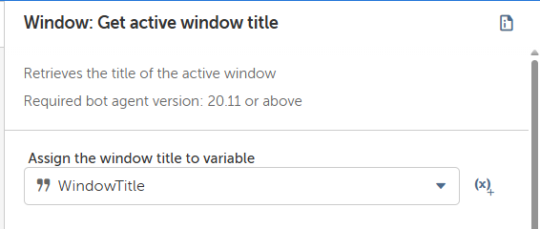

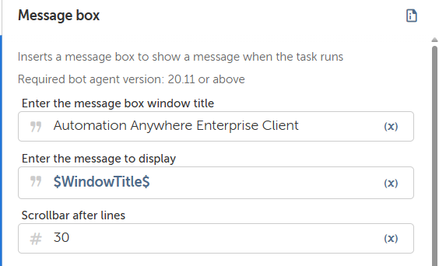

**Output:**

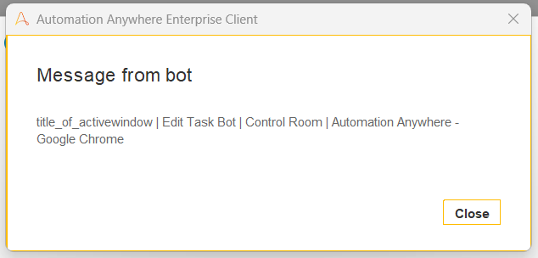



**4. Automate action of closing notepad window**

Step1: Select If condition

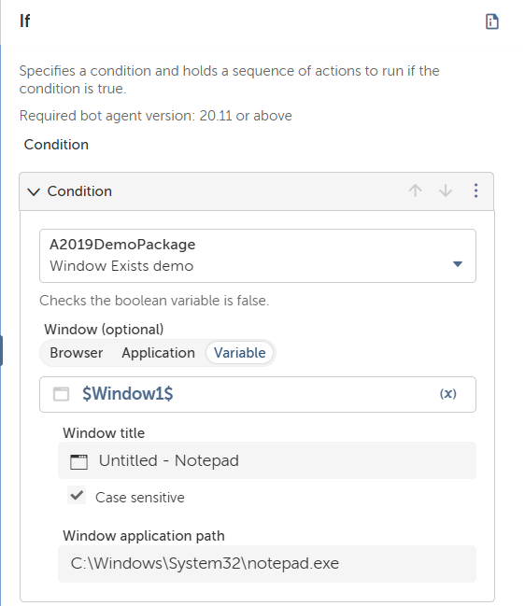

Step2: Add message box

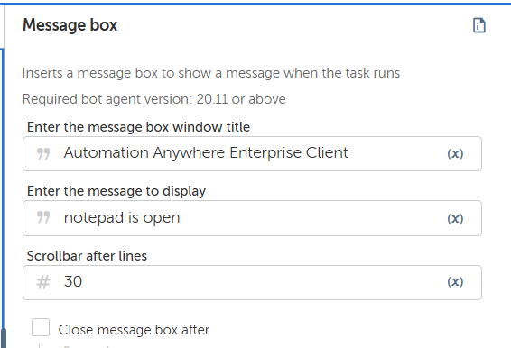

Step3: Select action of closing window

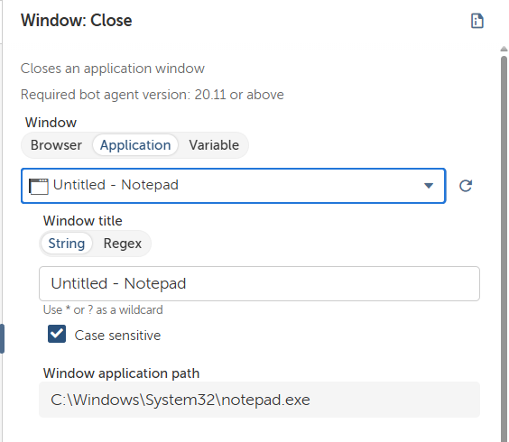

Step4: Add message box to display final message

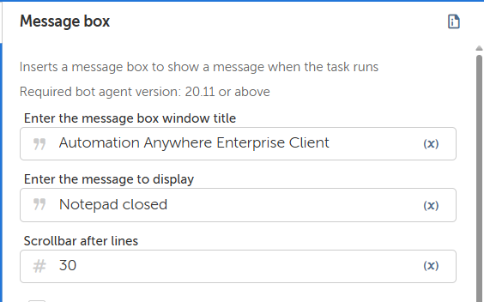

Final Flow:

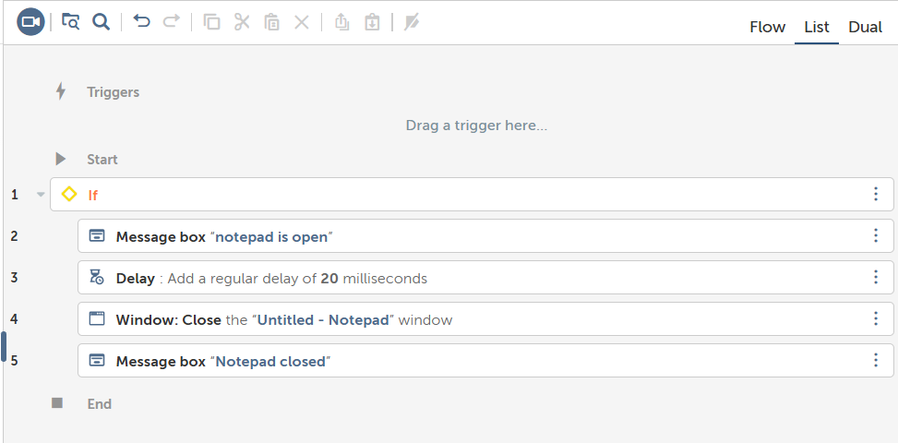

**Output:**

Before running bot



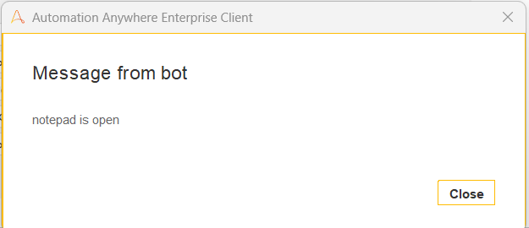

After running Bot



