**Q1. Introduction to Automation Anywhere A2019.**

Robotic Process Automation is entity which mimics human actions with sequence of steps automatically i.e. without human intervention.

**Why to use RPA:**

1. Customer Satisfaction – reduce manual errors and faster services
2. Analytics – improve data quality and increase scope of data collection
3. Compliance – reduce human contact with sensitive data and reduce fraud.

**Benefits of RPA:**

1. Reduce Burden on IT: Does not disturb underlying legacy systems.
2. Reliability: Bots can work 24*7 effectively.
3. Cost Cutting Technology: Reduces the size of the manual workforce and hence reduce costs.
4. No Coding Required: Programming skills are not necessary.
5. Accurate: Less prone to errors and functions with accuracy and uniformity.
6. Productivity Rate: Execution time much faster than manual process approach.
7. Compliance: Follows rules to provide audit free trail.
8. Consistency: Repetitive tasks are performed in the same manner each time.

What can we automate using Robotic Process Automation?

* Excel HTML
* JAVA
* ERP
* Email
* PDF
* Web App
* Desktop App
* Image
* Client Server Architecture
* Bot Creator is the developer client
* Bot Runner is the runner client
* 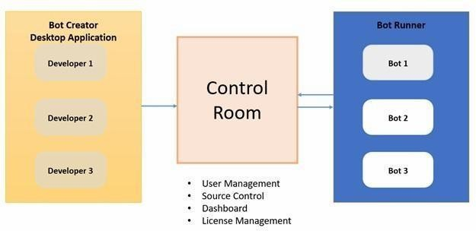Control Room is the server

**Create your First Bot:**

Steps to follow

1. Open Community Edition Account: https://www.automationanywhere.com/products/enterprise/community-edition
2. Login to Control Room
3. Install BotAgent and connect device

Bot: Display Hello Message

Step 1: Add message box action and enter the message: “Omkar Pendkalkar”

Bot name: HelloMessagebot

Recorder:

* Can works on web and desktop application.
* Recorder is object oriented as it captures object controls such as buttons, textboxes etc.
* Captures keystrokes and mouse click.

**Example:**

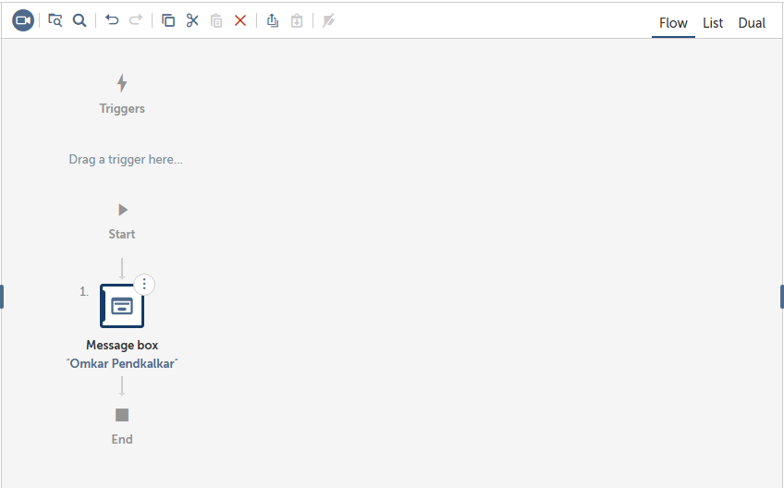

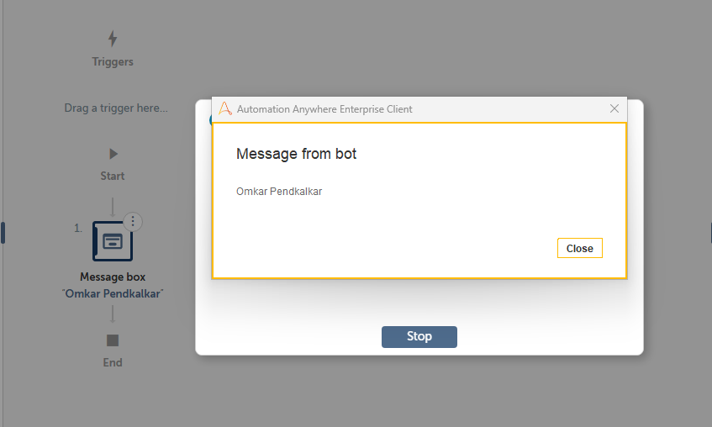

**Q2. Actions in Automation Anywhere A2019.**

It is the containers where you can store any type of data e.g. string, numbers etc.

**Types of Variables:**

* User (Local) Variables
* System Variables
* Credential Variables

**User Variable:**

* Used for a specific task or set of tasks.
* A user variable can hold one value or multiple values.

**System Variables:**

In the System variables, there are pre-defined variables that are provided by Automation Anywhere. System variables are available to be used in all automation tasks. System Variable types include the following components as follows.

* Date and Time System Variables – System-related date and time variables.
* System Variables – Loop: Useful in conjunction with Loop commands.
* Excel System Variables – Useful for Excel automation.
* Email System Variables – Useful for Email automation.
* Trigger Variables – Useful in conjunction with triggers.
* PDF System Variables – Useful to be used with PDF command.
* System Variables – Specific to System Settings/Parameters Variables specific to a particular client machine.

Credential variables store sensitive information that’s used when running automation tasks. Credential variables can be used only by the Bot Creator and only in Command fields that need a credential input.

**Actions:**

* These are essential building blocks of a Bot. They are the commands that tell a Bot what to do.
* Actions are grouped into packages.
* For example, the File package contains File related actions, such as Create, Open, Delete, Print Multiple files and Rename that you can insert into the Bot editor to automate a process working with files.
* Excel advanced package contains Excel-related actions, such as Open, Go to cell, and Delete cells, that you can insert in to the Bot editor to automate a spreadsheet process.

**String Operation:**

Methods to Manipulate and Extract Strings

* Assign – Assigns a value or a variable value to another string variable
* Extract Text – Use the before, before and/or after, or the after settings to extract a sub-string from a body of text.
* Before: You provide the text that precedes the text you’re interested in extracting, and the action will return everything that comes after.
* Before and After: You provide the text that precedes the text you’re interested in as well as the text which comes after the text you’re interested in. The action will return all the text that comes between the two.
* Before or After: You provide the text that may precede the text you’re interested in as well as the text which may come after the text you’re interested in. The action will attempt to return the preceding/subsequent text.
* After: You provide the text that comes after the text you’re interested in extracting, and the action will return everything that comes before.
* Compare – Compares two strings and returns True if the strings are identical.
* Uppercase – Converts the source string to upper case.
* Length - Gets the length of a string.
* Split – Splits the source string into multiple strings using a delimiter.
* To Boolean - Splits the source string into multiple strings using a delimiter.
* Substring – Extract part of a larger body of text based on a start position and optional length.

The optional length lets you specify how many characters you intend to extract; the alternative is that text from the starting position through the end of the provided source string would be extracted.

* Find –
* Returns the position of matching text within a larger body of text.
* Can be hard-coded text, or could be a regular expression.
* Replace - Splits the source string into multiple strings using a delimiter.
* Lowercase – Splits the source string into multiple strings using a delimiter.
* Reverse – Splits the source string into multiple strings using a delimiter.
* Trim – Splits the source string into multiple strings using a delimiter.
* To Number – Splits the source string into multiple strings using a delimiter.

**If statement:**

Conditional Statement which executes a task if the condition is either true or false

**Conditions for if Statement:**

Number/String/Boolean Windows exists

Web Control Exists Task/Script Exists File/Folder Exists Data Table

Date Time

Bot: To open calculator if it isn’t open

* Step 1: Check if the Calculator is open. In If action select the condition Window exists.

Select the calculator application from the Windows option Display Message “Application is already running”

* Step 2: If not open the calculator. Add Else action and have application: open action to open the calculator application.
* Step 3: Close the program. Close the application.

**Example:**

