A Major Project Proposal on

**“Rentalhere*”***

Submitted in partial fulfillment of the requirements for the degree of

Bachelor of Engineering in Software Engineering at Pokhara University.

### *By*

**Adit Bhandari**

**Alin Sapkota**

**Anish Adhikari**



### Department of Research and Development

**GANDAKI COLLEGE OF ENGINEERING AND SCIENCE**

Phirke-8 pokhar, Kaski, Nepal

**(June, 2023)**

A Major Project Proposal on

**“Rentalhere*”***

Submitted in partial fulfillment of the requirements for the degree of

Bachelor of Engineering in Software Engineering at Pokhara University.

### *By*

**Adit Bhandari**

**Alin Sapkota**

**Anish Adhikari**

**Project Supervisor**

Er Santosh Panta



### Department of Research and Development

**GANDAKI COLLEGE OF ENGINEERING AND SCIENCE**

Phirke-8 pokhar, Kaski, Nepal

**(June, 2023)**

# APPROVAL CERTIFICATE

This project proposal enlist a website **RENTHERE** prepared and submitted by Adit Bhandari, Alin Sapkota and Anish Adhikari under the supervision of Er. Santosh Panta in partial fulfillment of the requirements for the Practical of Minor project in Diploma in Computer Engineering has been examined and approved for development.

Date of evaluation: June, 2023

………………………………………….

Er Santosh Panta

(Project Supervisor)

Research and Development

Pokhara Engineering College

Pokhara-8 Phirke

# ABSTRACT

he main aim of the project is to develop a website for the Nepalese users where they can rent any product they want for certain time use or can let others rent their own product where the user can be a costumer or the seller. This web will act as the mediator between the rent product user and product rent giver. As we know the there are no such web present for the Nepalese user where they can rent multiple type of product through the same web. Webs like yoodizel and my rent on the global market but they provide the facility only to certain countries on which Nepal is excluded. Hence the citizen of the country need the web the actively run in our country through which they can rent large variety of product in the country through same web.

# TABLE OF CONTENT

APPROVAL CERTIFICATE i

ABSTRACT ii

TABLE OF CONTENT iii

TABLE OF FIGURE iv

LIST OF ABBREVIATIONS v

Chapter 1 INTRODUCTION 1

1.1 BACKGROUND 1

1.2 PROBLEM STATEMENT 2

1.3 OBJECTIVE 3

Chapter 2 LITERATURE REVIEW 4

Chapter 3 TOOLS AND METHODOLOGY 7

3.1 PRIMARY 7

3.2 SECONDARY 7

3.3 ANALYSIS AND DESIGN 11

Chapter 4 TIMELINE CHART 13

References 14

# TABLE OF FIGURE

Figure 1 Use Case Diagram ........................................................................8

Figure 2 ER Diagram ................................................................................11

Figure 3 Gantt Chart (Time Diagram)………...........................................11

# LIST OF ABBREVIATIONS

PHP: Hypertext Preprocessor

UML: Unified Modeling Language

CSS: Cascading Style Sheets

HTML: Hypertext Markup Language

JS: JavaScript

ER: Entity Relation

# Chapter 1 INTRODUCTION

## 1.1 BACKGROUND

As we in the normal basis cannot buy every product. Which are mostly use for the short basis it may be out of the budget 0f or may exceed the monthly expenses of the normal citizen or for us common people. And renting for the product which are not goanna be used on the daily basis is the best way to reduce the monthly expenses. And there is no application for the Nepali citizen to rent multiple type products through the medium of the same web. Although we can rent the products like cars, bikes, cycles in different web but there is no specific places or its goanna be difficult for the costumer to find such places easily. Generally, costumers have to go and search for the places where we can have products for the rent which is difficult to find in new places or the city.

Usually we can rent product like cars and bikes easily in the car bike rent house where as there no such places for the rent of products like projector, or speakers which can be hard to find which indirectly leads the costumer to buy the new products even if it is said to be for the short time use of the product to which we can conclude as an unnecessary expense for a common man or the citizen.

In this paper we represent the result of our investigation about the need about the web to be conclude

## 1.2 PROBLEM STATEMENT

As buying of product for short time use is the cause of the unnecessary expenses. As we can rent product in present time but there is no platform to act as an intermediate between costumer and rent user through which they can be in touch with each other any time possible without being physically present in front of each other.

Before this application, following are the problems to user

1. Less variety of product is same place.
2. No proper mean to contact between renter and customer.
3. People didn’t get to explore and manage their expenses as there were less variety of products which and be rented
4. Common peoples can also set their un used product for the rent through which they can earn extra pair of money.

## 1.3 OBJECTIVE

The main objective of this project is to develop a web where we can rent a product or set a product for the rent and act as a mediator between the rent provider and product rent user.

#### 1.3.1 GENERAL OBJECTIVES

* To act as a mediator between the rent provider and rent user.
* To make people familiar with online renting system.

#### 1.3.2 SPECIFIC OBJECTIVES 

* To make a proper use of unused item.
* To provide platform where any product can be rented or can be given for the rent.
* To give sent service any time possible and as long as possible.

# Chapter 2 LITERATURE REVIEW

In the era of technology and technical devices, it is said to be must to digitalize any work as possible hence. There are lot of platform where we can rent the product for primary use such as Rental Nepal, basobas, yoodize, fatliama, myrent…etc. Through which we can rent products.

After doing some research and some back ground check, we find similar projects made on the same field in the past to which we have look into it. In most of the cases the sites provide less variety of product or specific product and some were built for the international markets only. There were no sites in which provide large variety of products as well available for the Nepali market and for the use of the Nepali peoples.

**Rental Nepal** [1]**:** This is one of the rental website currently running in Nepal. It mainly used for the rent of the Land and rooms deal only. It provides less variety of products for rental services. And it is mainly use in cities like ktm, bhaktapur etc….

 **Logo:**

**Basobas** [2]**:** The second website on the list that is currently in been used in Nepal. Along with website this company also provide the app for the users in the paly store. This web sites also deals with different agencies for the better service of its users. And it is only used in main cities of Nepal.

**Logo:**

**Yoodize** [3]**:** The 3rd web on the list which provide the facility of any product in the rent feature. With the presence of app in the play store. Currently running in the United States of America. And is used by the costumers in large range. It only used in USA and was founded by Jason Fairbourne on 2018.

**Logo:**

**Fatliama** [4]**:** The 4th web on the list which is running on multiple countries and provide the feature of renting anything in the web. It also provides its app in the play store and gives large variety of products. From small products to big products. It was founded by Chaz Englander in 2015. And is only used in countries such as US, USA, Canada.



**Logo:**

My Rent [5]: A rent web with the moto of do more and save money which provides the feature of large variety of product for the rental use and is used in Singapore. It also gives the feature of app in play store to its users. The company was established on 2020.

 **Logo:**

# Chapter 3 TOOLS AND METHODOLOGY

## 3.1 PRIMARY

The primary working of the project can be outlined as:

* Tasks division to team member on the basis of their interest.
* Weekly meeting to assess and propose restructuring of plans when required.
* Project documentation by team member(s) at the end of each task.
* Regular discussion with the project to update our mentor about the progress of our project.

## 3.2 SECONDARY

Since we are building a web so the Visual Studio Code would be the major development tool for us. Using Git hub is another tool for sharing information and code among the team.

In this project the relevant research data will be collected by investigating previous research work and existing websites. Collected data will be further analyzed to resolve the existing problems in website.

**Tools Used**:

* Visual Studio Code
* Github
* Online Web Server
* Dia
* Figma

**Programming Languages:**

* Html
* CSS
* JavaScript
* PHP

**Iterative model** [6]**:**

It is one of the model used to develop a software to ensure success of the project. In this model of software development, you can start with some of the software specifications and develop the first version of the software. And after the first model new models are created with additional features in it.

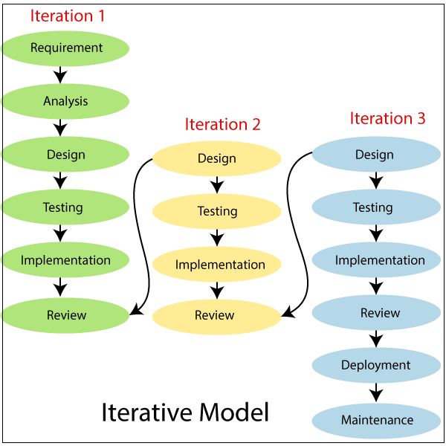 The final output of the project renewed at the end of the Software Development Life Cycle (SDLC) process.

The various phases of Iterative model are as follows [7]:

**1. Requirement gathering & analysis:** In this phase, requirements are gathered from customers and check by an analyst whether requirements will fulfil or not. Analyst checks that need will achieve within budget or not. After all of this, the software team skips to the next phase.

**2. Design:** In the design phase, team design the software by the different diagrams like Data Flow diagram, activity diagram, class diagram, state transition diagram, etc.

**3. Implementation:** In the implementation, requirements are written in the coding language and transformed into computer programmers which are called Software.

**4. Testing:** After completing the coding phase, software testing starts using different test methods. There are many test methods, but the most common are white box, black box, and grey box test methods.

**5. Deployment:** After completing all the phases, software is deployed to its work environment.

**6. Review:** In this phase, after the product deployment, review phase is performed to check the behavior and validity of the developed product. And if there are any error found then the process starts again from the requirement gathering.

**7. Maintenance:** In the maintenance phase, after deployment of the software in the working environment there may be some bugs, some errors or new updates are required. Maintenance involves debugging and new addition options.

## 3.3 ANALYSIS AND DESIGN

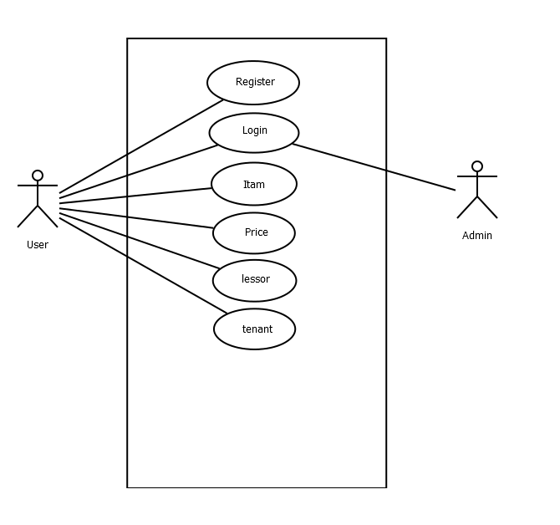

**Figure 1 Use Case Diagram**

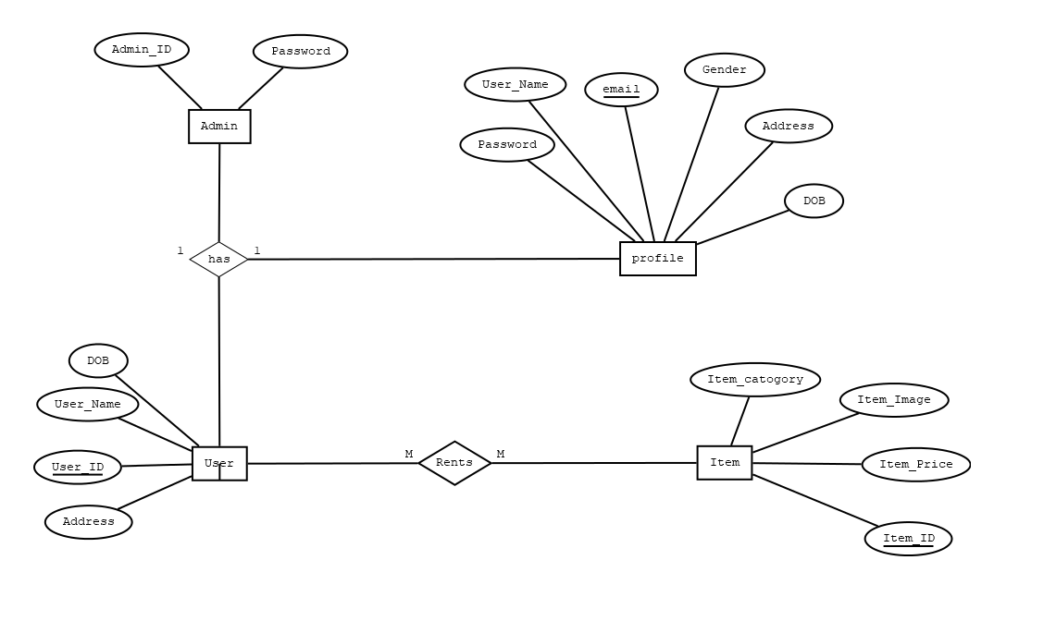

**Figure 2 ER Diagram**

# Chapter 4 TIMELINE CHART

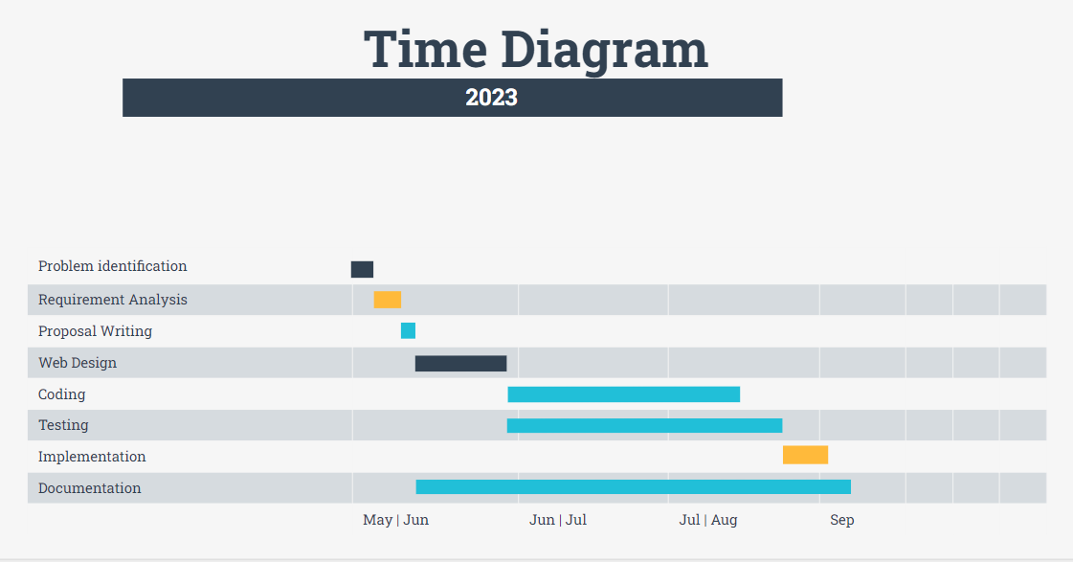

**Table 1 Gantt Chart**

# References

|  |  |
| --- | --- |
| [1] | "Rental Nepal," Real Estate and Research center, [Online]. Available: https://www.rentalnepal.com. |
| [2] | "Basobas," Basobaas Nepal Pvt. Ltd., [Online]. Available: https://basobaas.com/properties/for-rent. |
| [3] | "Yoodize," [Online]. Available: https://www.yoodlize.com. |
| [4] | "Fatliama," Fat Llama, Inc., [Online]. Available: https://fatllama.com. |
| [5] | "My Rent," myRent Ltd, [Online]. Available: https://www.myrent.co.nz. |
| [6] | "Laptrinhx," [Online]. Available: https://laptrinhx.com/iterative-model-in-software-engineering-1408694444. |
| [7] | "Javatpoint," SSS IT Pvt Ltd, [Online]. Available: https://www.javatpoint.com/software-engineering-iterative-model. |