ASSIGNMENT 07
Colour Blind Mode for the HMT Watches Website
Assignment No. | 07
Name | Anish Bandal
PRN | 1032240033
Group | 02
Assignment Title | Added Colorblind option to optimize website for colorblind people
Objective
To optimize the HMT Watches website for colour-blind users by adding a Colour Blind Mode option in the header and ensuring that important information (stock status, ratings, verification, actions) is conveyed through text, icons and contrast rather than colour alone.

Website Screenshots
Figure 1: Home page – Colour Blind Mode selector in the header
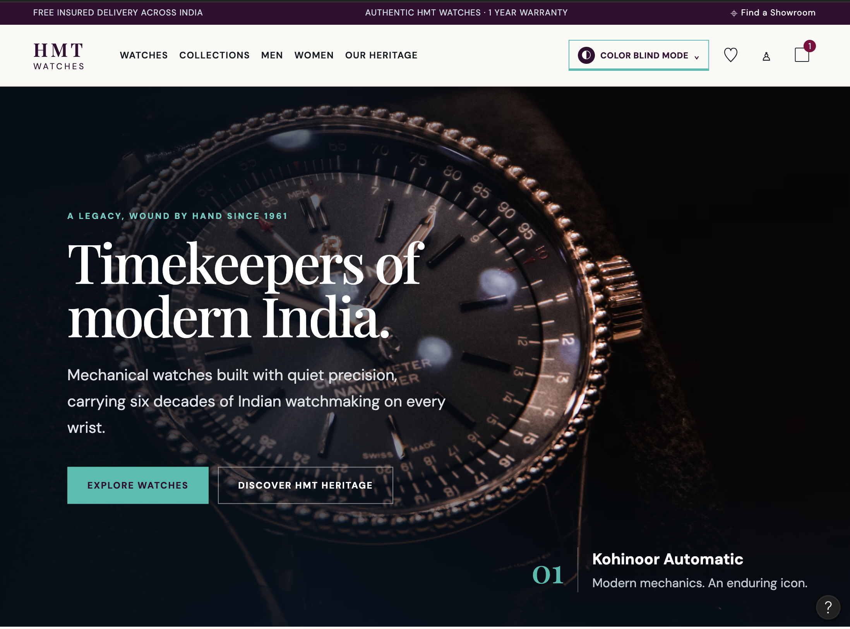
The “Color Blind Mode” control sits in the top navigation bar, always visible and keyboard-focusable, with a clear teal outline.
Figure 2: Product listing – stock badges with icons and text
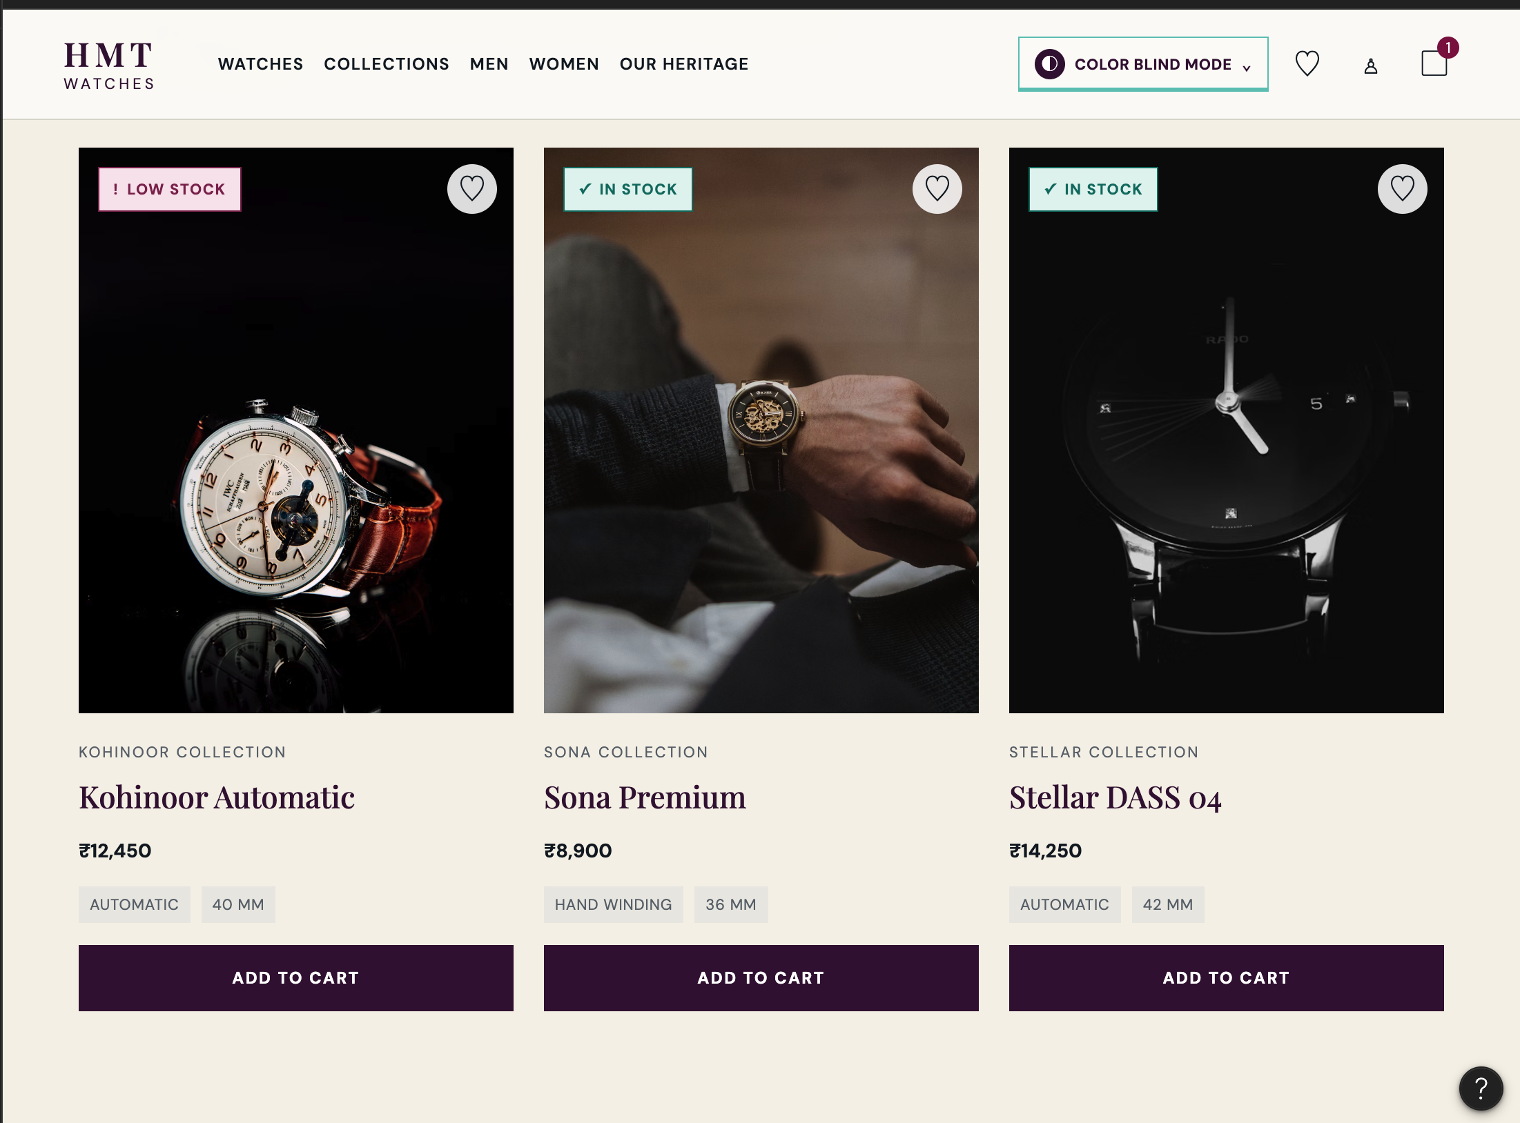
Stock status (“Low Stock”, “In Stock”) is shown with an icon plus a text label, so it does not depend on colour alone.

Figure 3: Mechanical collection banner
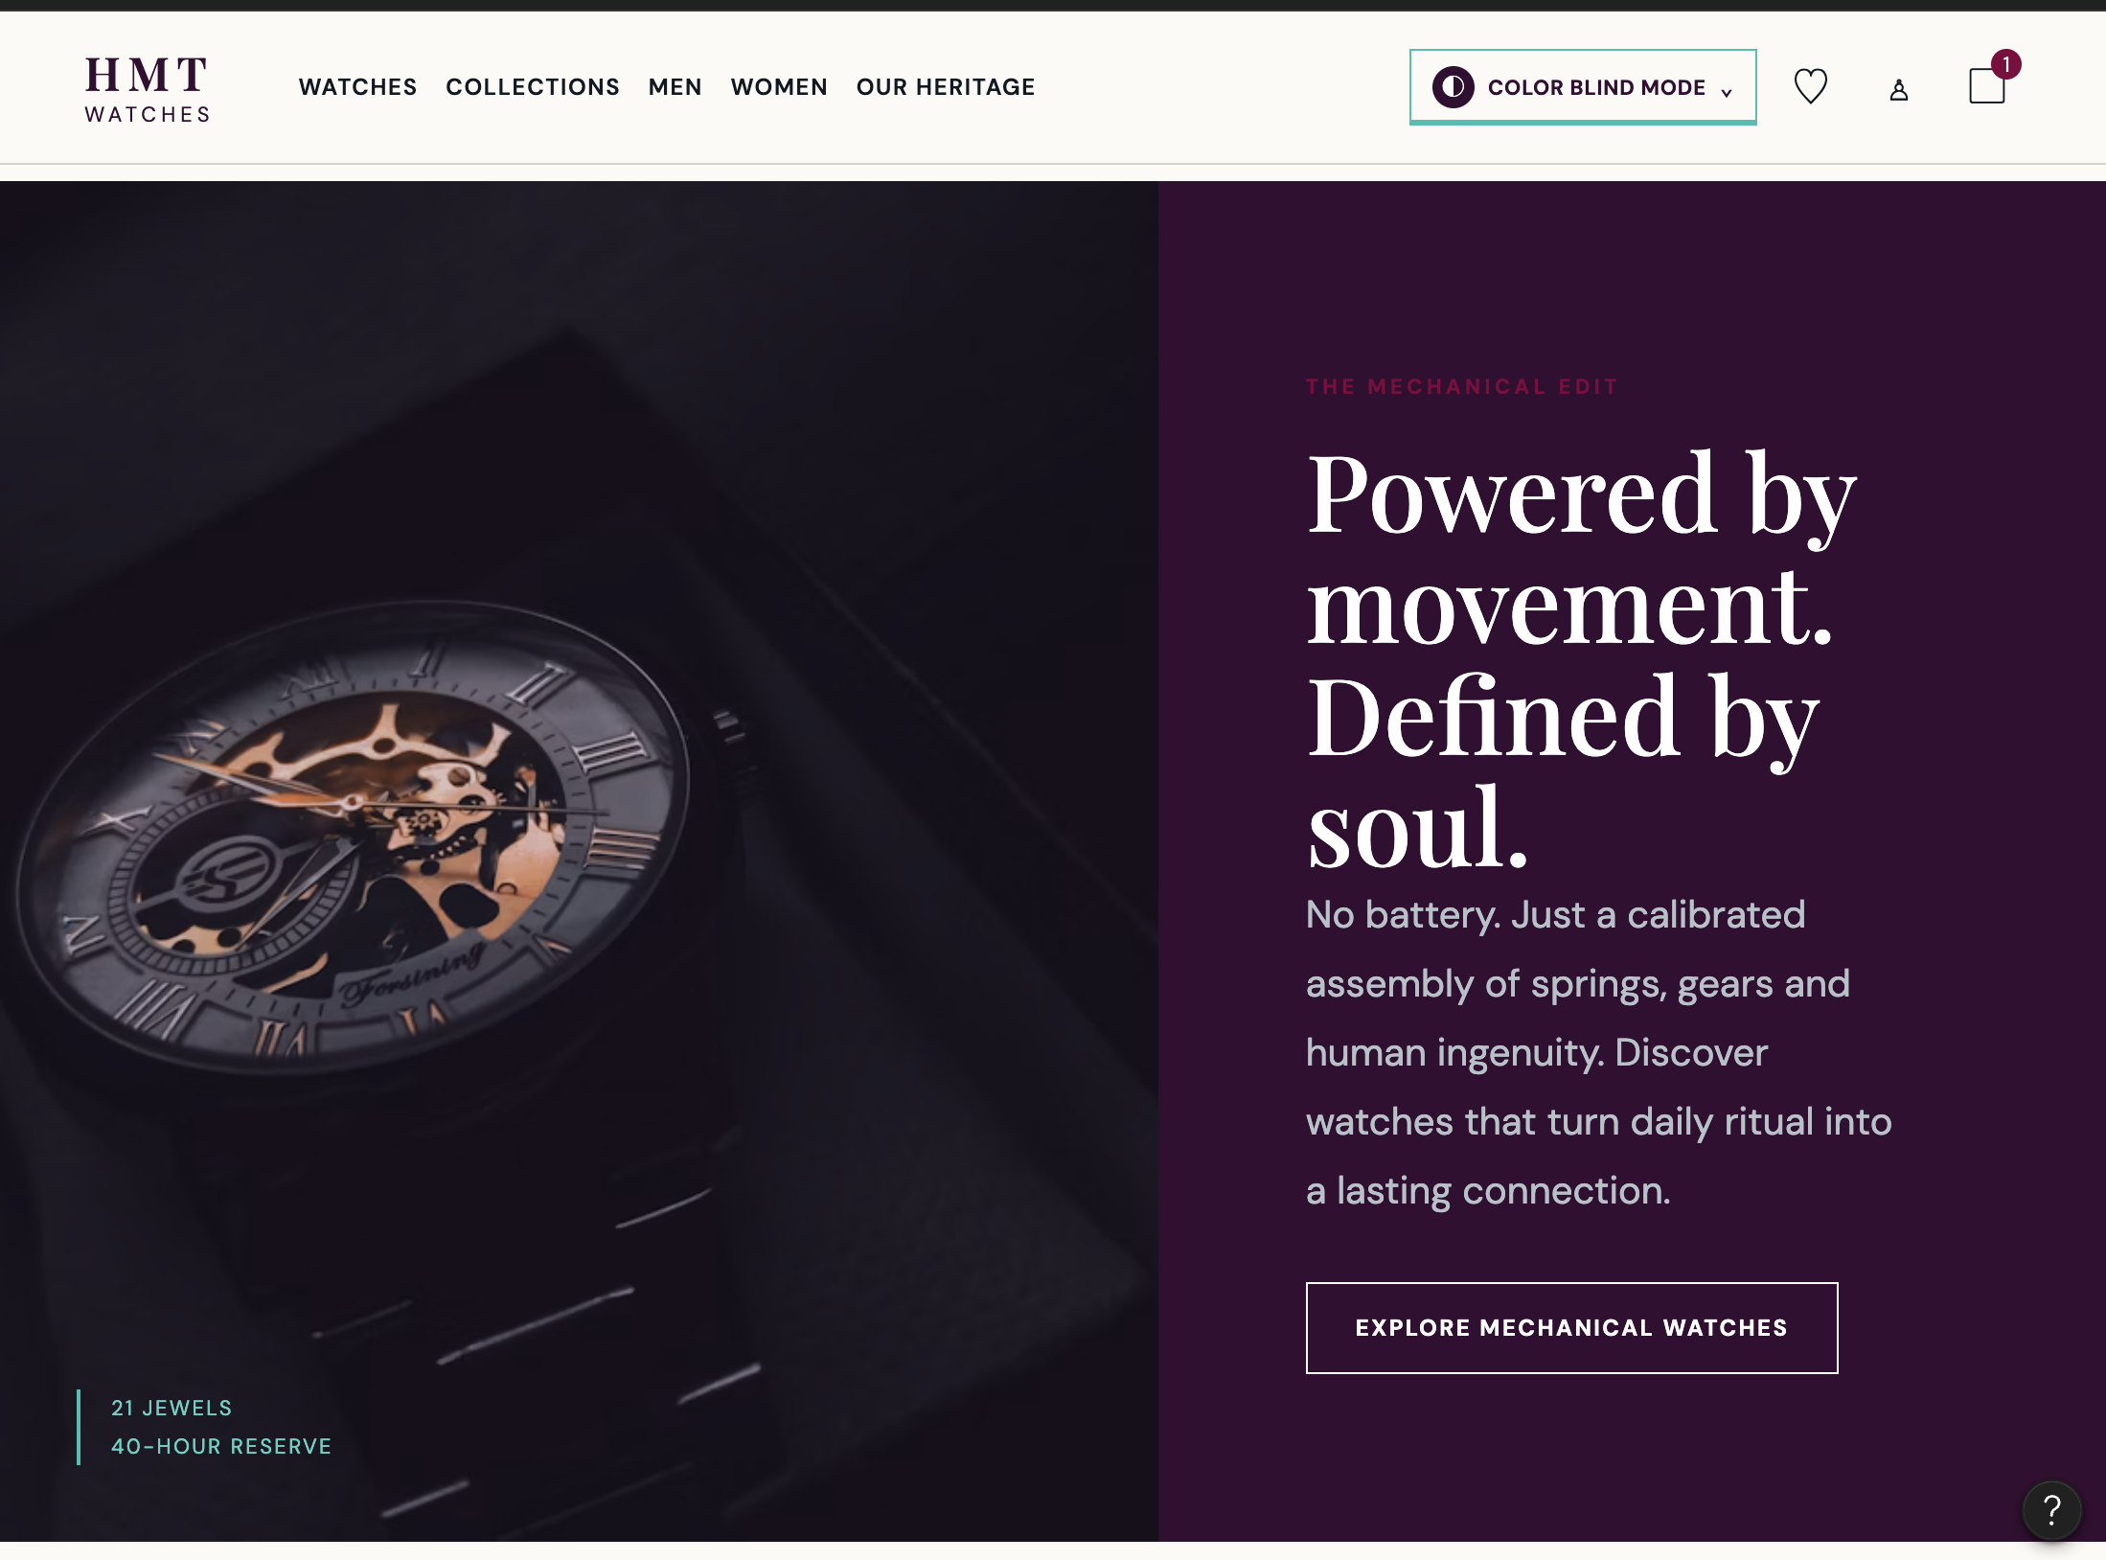
High-contrast white text on a dark background, with large readable headings and a clearly outlined call-to-action button.
Figure 4: New Arrivals – Out of stock / Coming soon / In stock
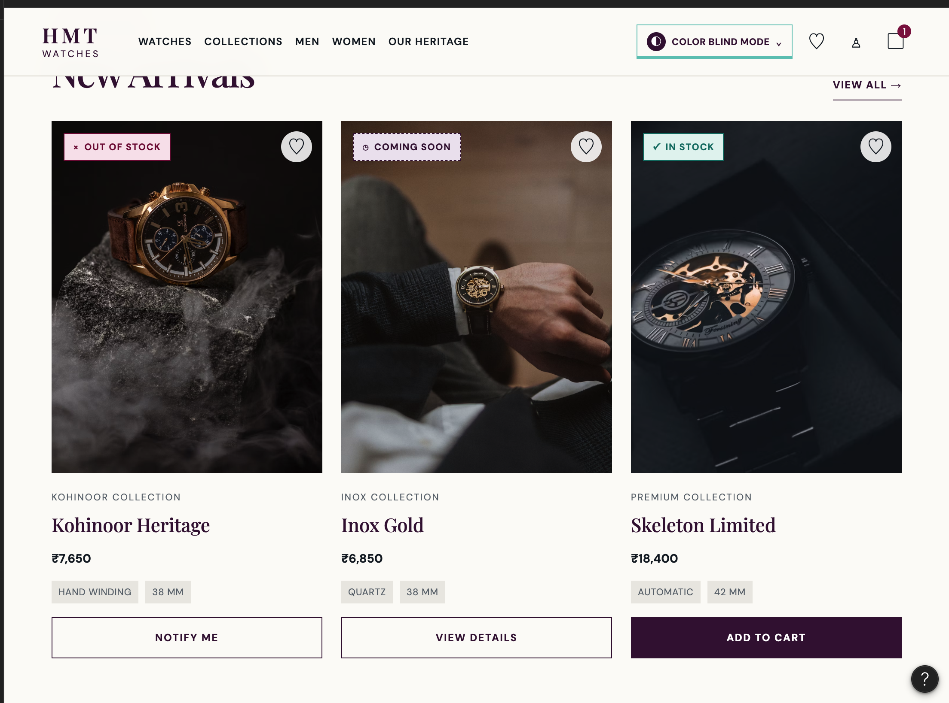
Each state uses a distinct symbol (×, clock, ✓), border style (solid vs. dashed) and label, making them distinguishable for colour-blind users.

Figure 5: Heritage section
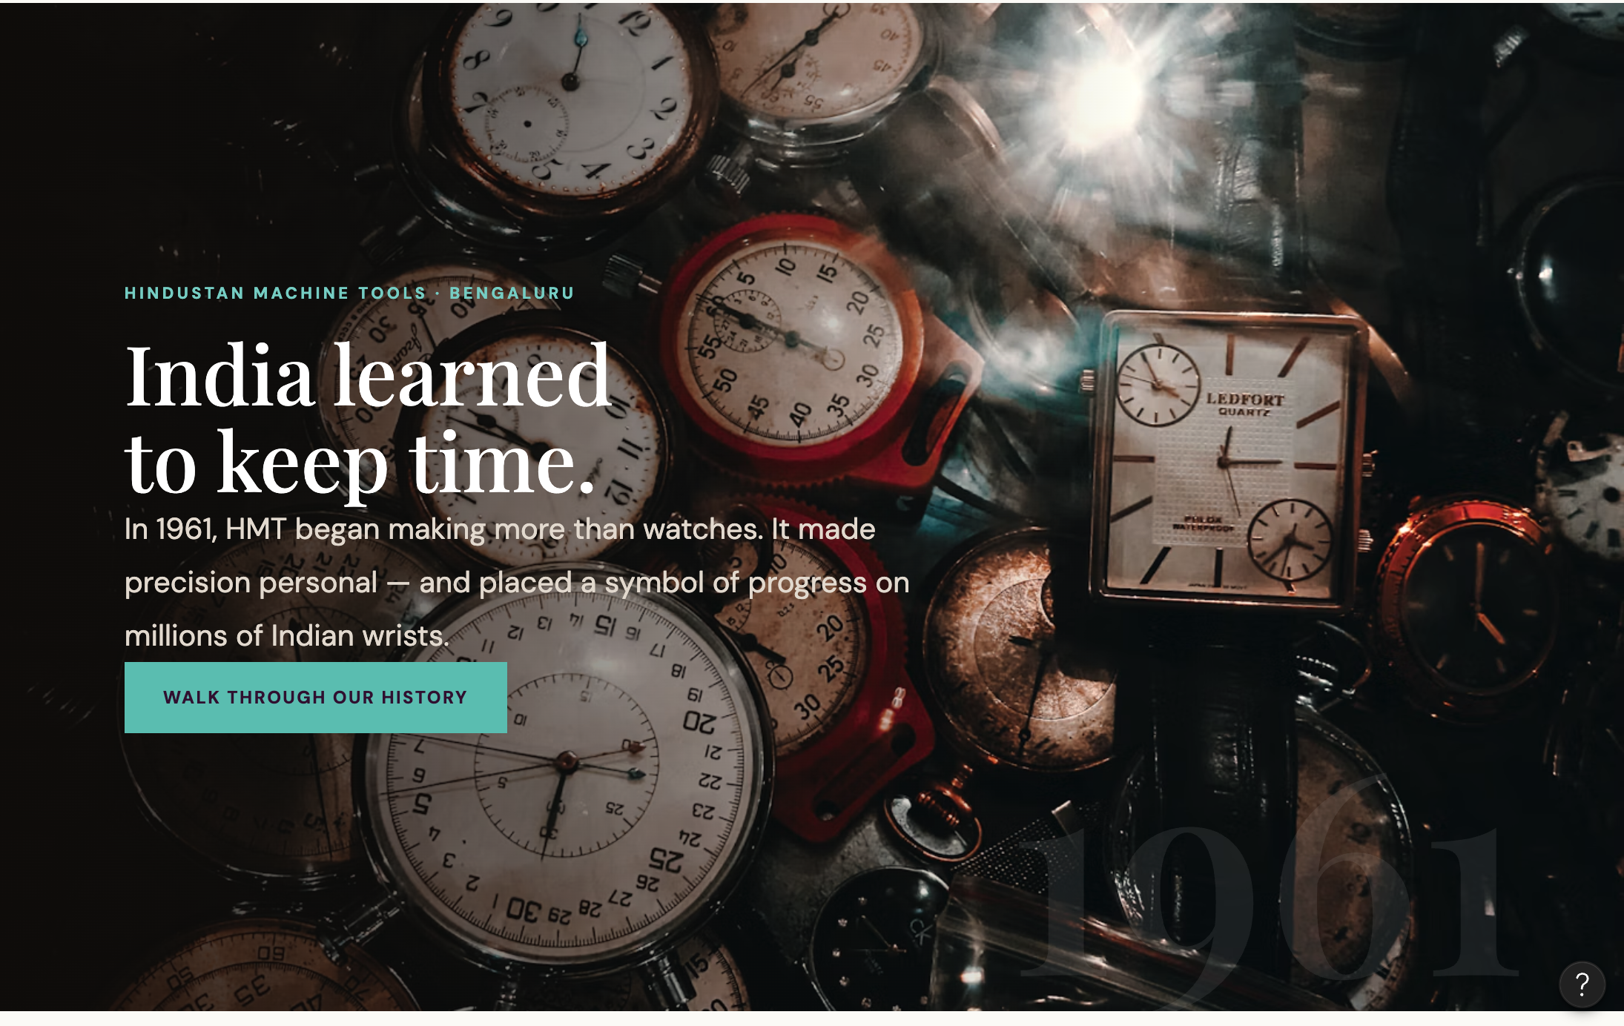
Light text on a dark image overlay and a high-contrast teal button keep content legible.
Figure 6: Showroom finder and footer
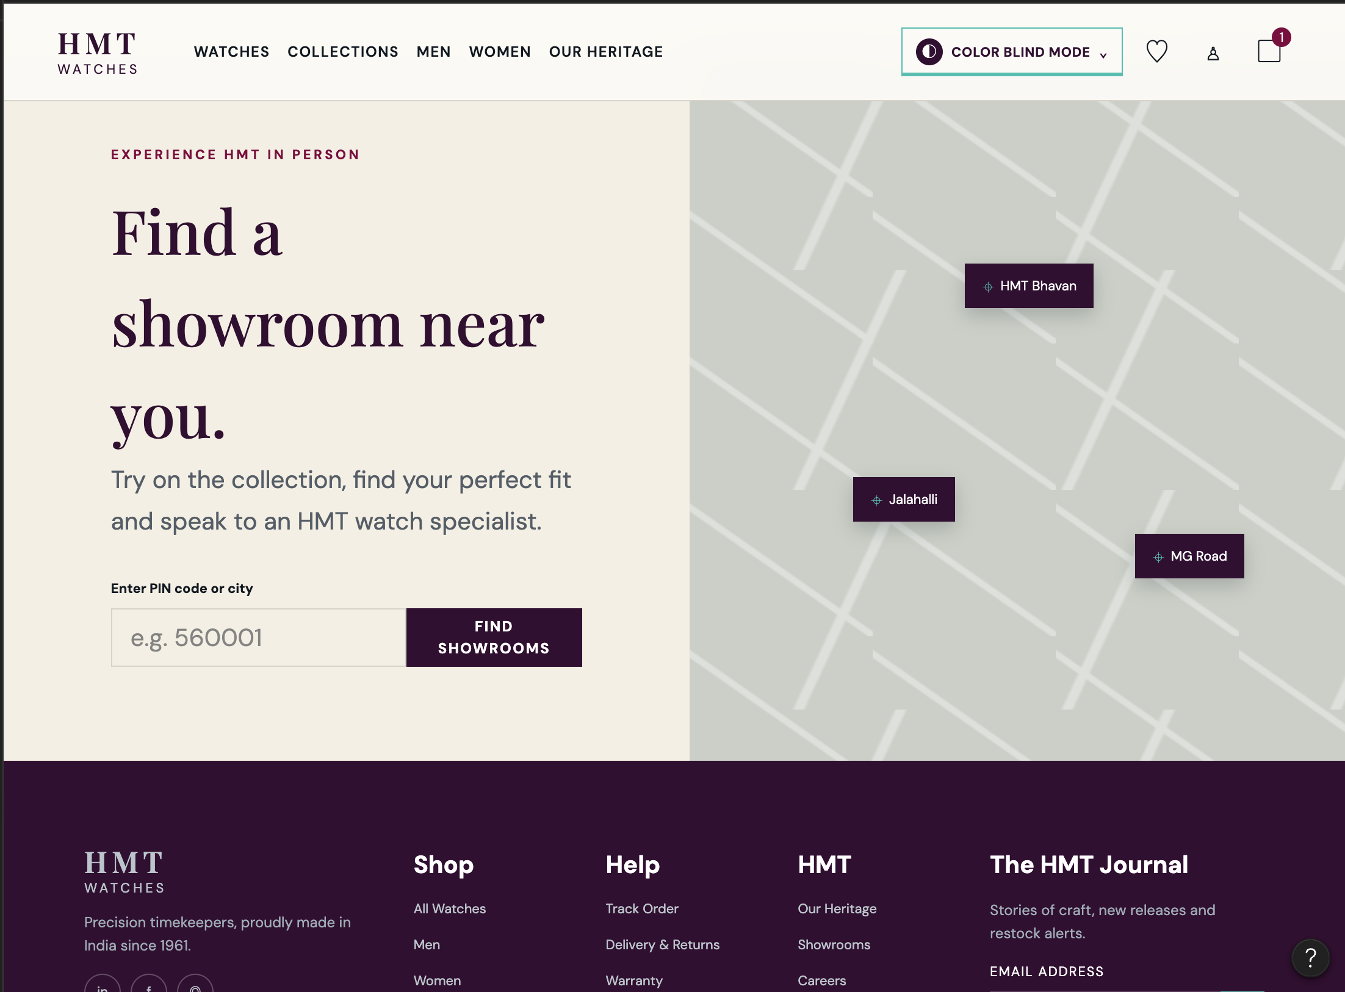
Form label, input and button are clearly separated with strong contrast; map pins carry text labels rather than colour coding.

Figure 7: Customer reviews
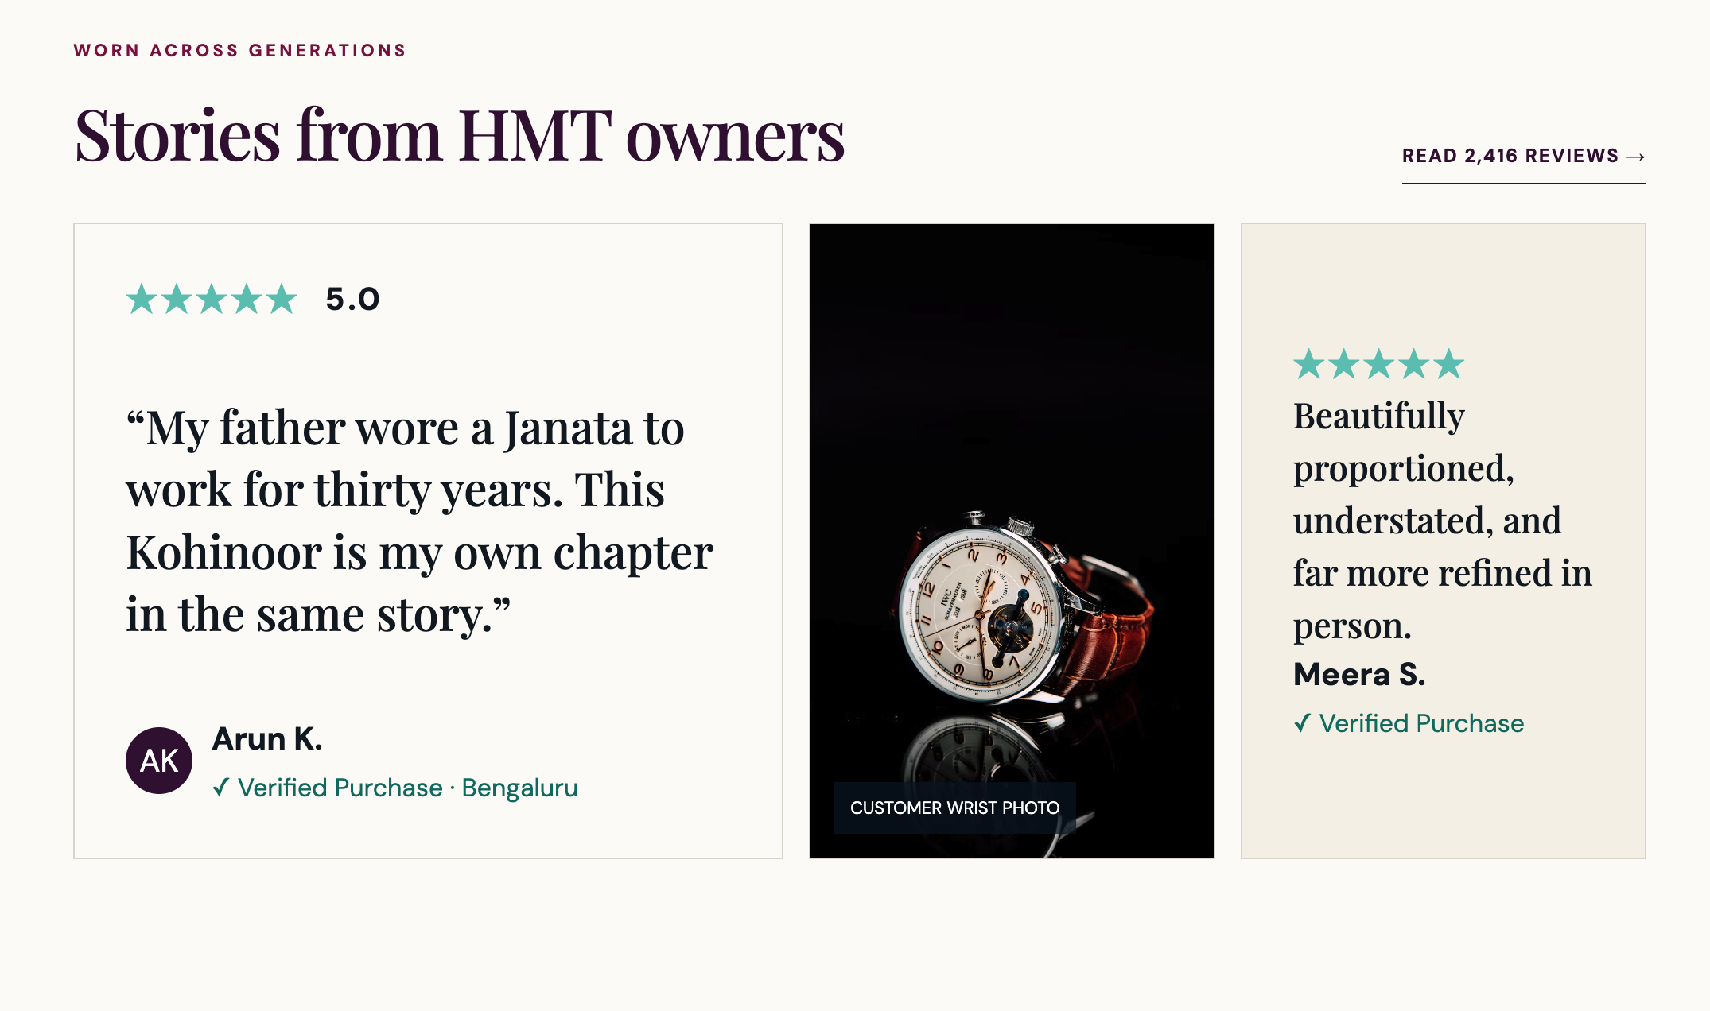
Star ratings are accompanied by a numeric score, and “Verified Purchase” uses a ✓ icon along with text.

