Phase 4

(Artificial intelligence)

**Sentiment Analysis for Marketing**

In this phase we build Employing NLP techniques Generating insights.

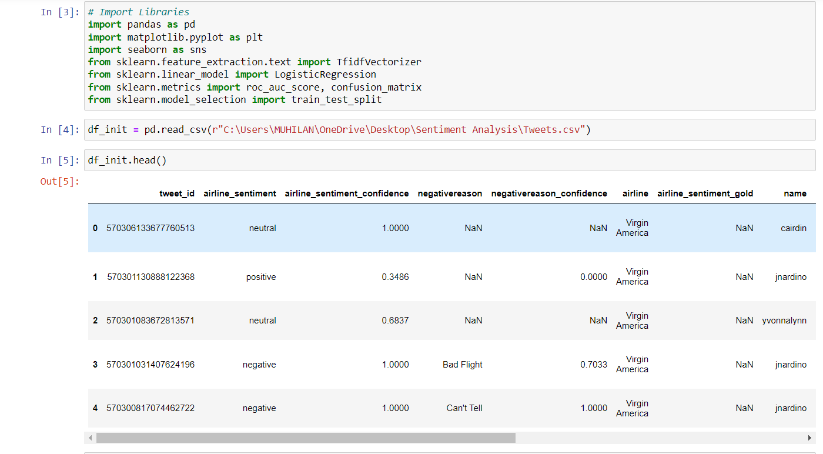

Importing require packages and Reading the dataset.

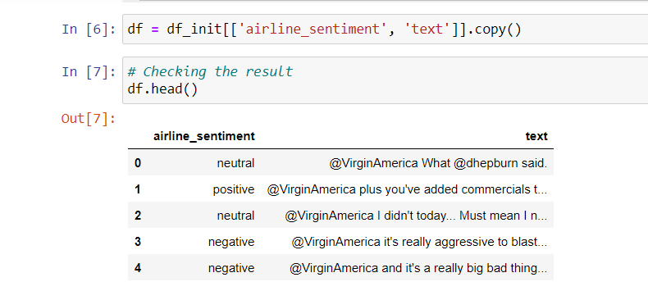

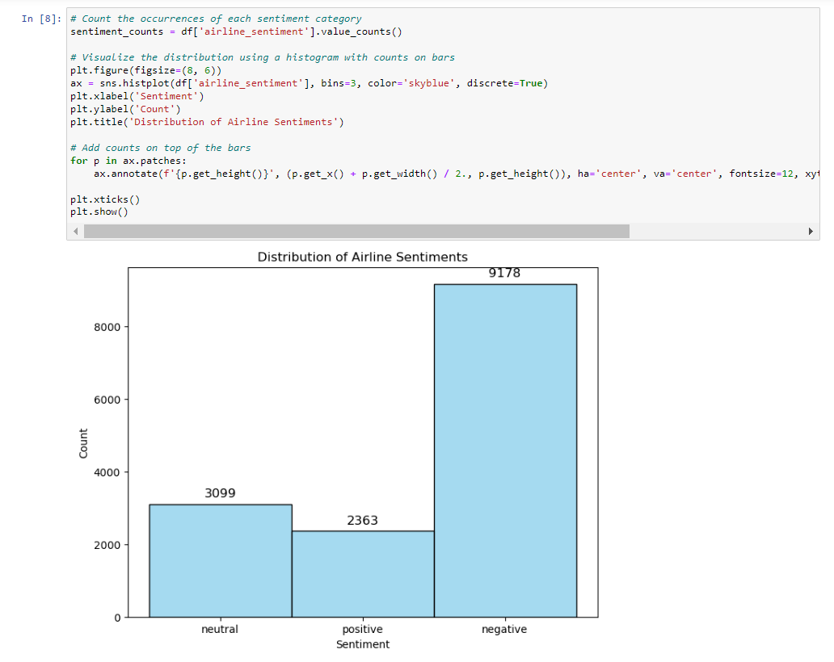

Make count the occurrences of each sentiment category and visualize the distribution using histogram.

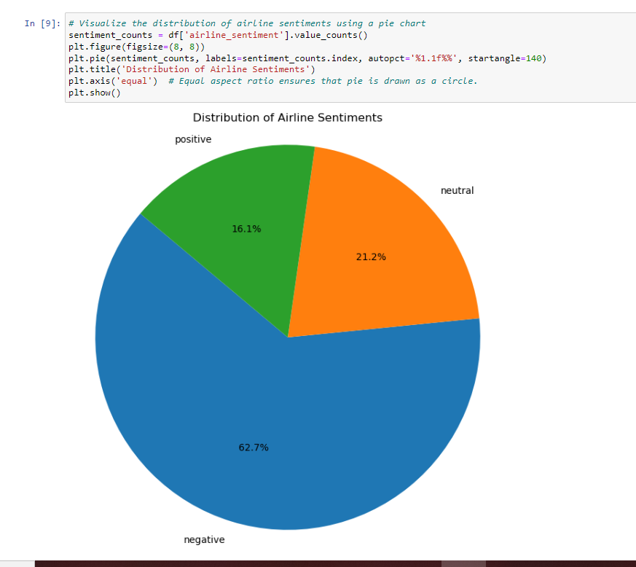

Visualize the distribution of Airline Sentiment using Pie chart

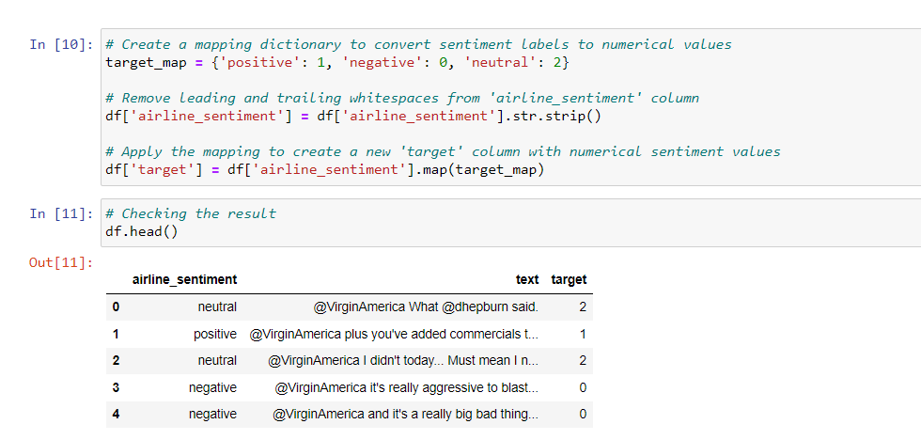

Create mapping dictionary,Remove leading and trailing whitespaces from ‘airline_sentiment’

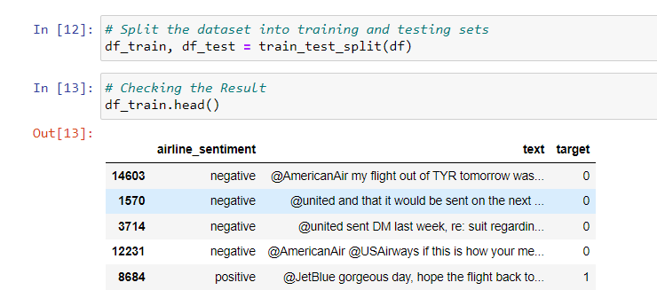

Split the dataset into training and testing sets and check the result.

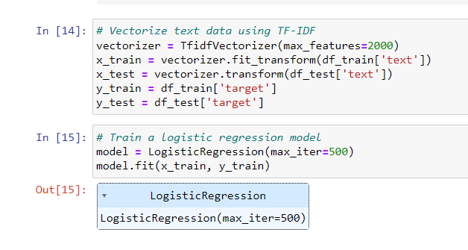

Train a dataset using Logistics regression model.

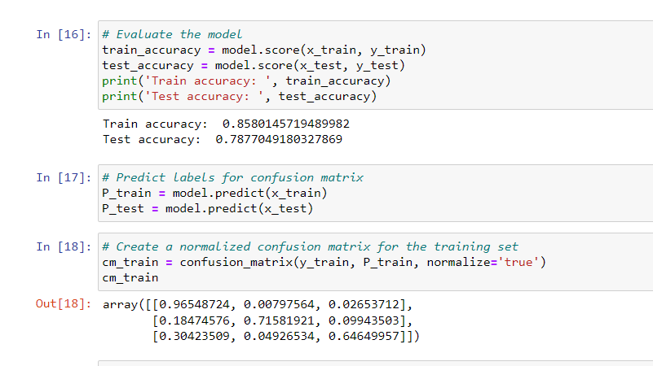

Create a normalized confusion matrix for the training set in three dimentional array.

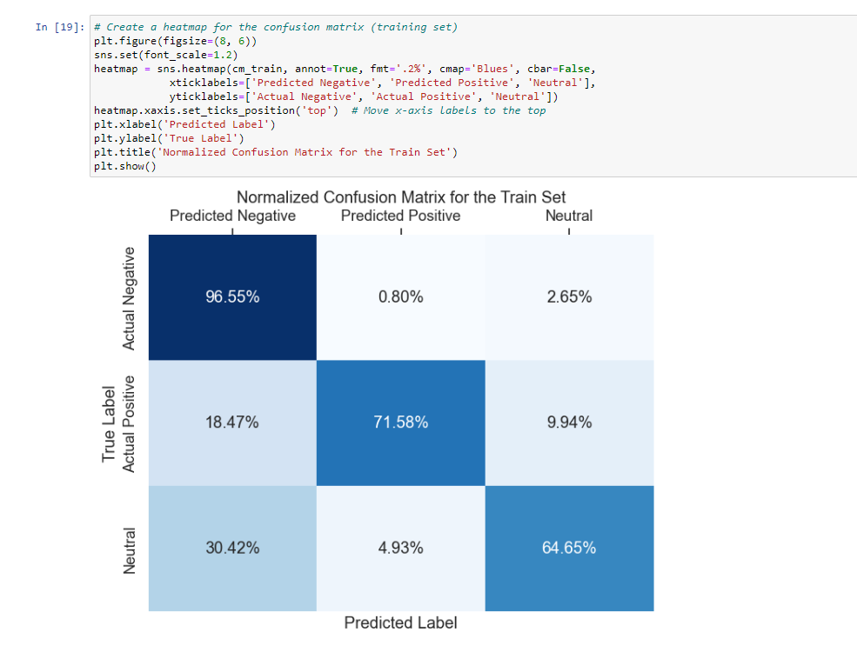

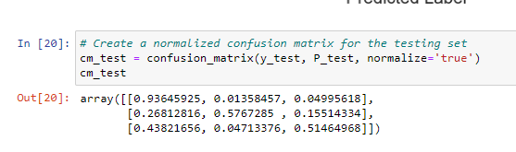

Heatmap for a confusion matrix&Normalized confusion matrix for the testing set

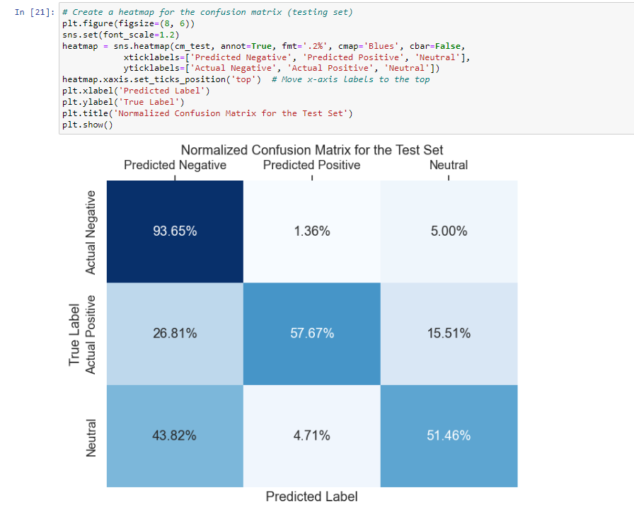

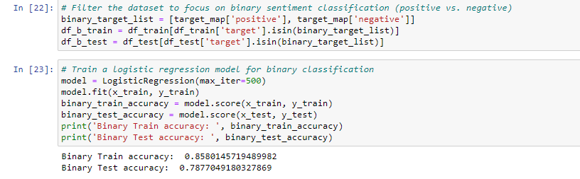

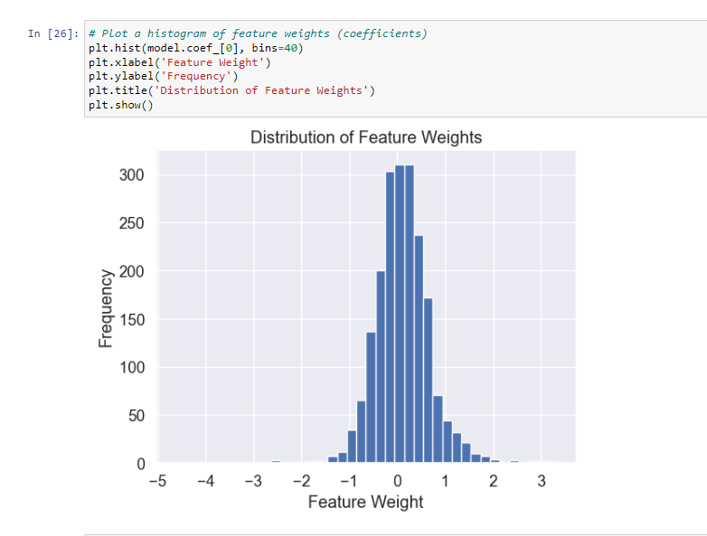

Histogram of feature weights

