**Sentiment Analysis for Marketing**

**(Problem definition and Design thinking)**

**What is Twitter Sentiment Analysis?**

Twitter sentiment analysis analyzes the sentiment or emotion of tweets. It uses natural language processing and machine learning algorithms to classify tweets automatically as positive, negative, or neutral based on their content. It can be done for individual tweets or a larger dataset related to a particular topic or event.

**Why is Twitter Sentiment Analysis Important?**

**Understanding Customer Feedback:** By analyzing the sentiment of customer feedback, companies can identify areas where they need to improve their products or services.

Reputation Management: Sentiment analysis can help companies monitor their brand reputation online and quickly respond to negative comments or reviews.

Political Analysis: Sentiment analysis can help political campaigns understand public opinion and tailor their messaging accordingly.

**Crisis Management:** In the event of a crisis, sentiment analysis can help organizations monitor social media and news outlets for negative sentiment and respond appropriately.

Marketing Research: Sentiment analysis can help marketers understand consumer behavior and preferences, and develop targeted advertising campaigns.

**How to Do Twitter Sentiment Analysis?**

In this article, we aim to analyze Twitter sentiment analysis using machine learning algorithms, the sentiment of tweets provided from the Sentiment140 dataset by developing a machine learning pipeline involving the use of three classifiers (Logistic Regression, Bernoulli Naive Bayes, and SVM)along with using Term Frequency- Inverse Document Frequency (TF-IDF). The performance of these classifiers is then evaluated using accuracy and F1 Scores. For data preprocessing, we will be using

Natural Language Processing’s (NLP) NLTK library.

**Twitter Sentiment Analysis: Problem Statement**

In this project, we try to implement an NLP Twitter sentiment analysis model that helps to overcome the challenges of sentiment classification of tweets. We will be classifying the tweets into positive or negative sentiments. The necessary details regarding the dataset involving the Twitter sentiment analysis project are:

The dataset provided is the Sentiment140 Dataset which consists of 1,600,000 tweets that have been extracted using the Twitter API. The various columns present in this Twitter data are:

target: the polarity of the tweet (positive or negative)ids: Unique id of the tweet

date: the date of the tweetflag: It refers to the query. If no such query exists, then it is NO QUERY.

user: It refers to the name of the user that tweetedtext: It refers to the text of the tweet

**Conclusion:**

In conclusion, the initial phase of problem definition and design thinking for sentiment analysis in marketing is crucial for setting a strong foundation for your project. By clearly defining the problem, establishing objectives, and applying design thinking principles, you ensure that your efforts are focused on delivering valuable insights to enhance marketing strategies.

**Sentiment Analysis for marketing**

**Innovation**

**1. Ensemble Methods:**

* **Voting Ensembles:** Combine the predictions of multiple sentiment analysis models (e.g., Naive Bayes, LSTM, BERT) using techniques like majority voting or weighted voting.
* **Stacking:** Train a meta-model on top of base sentiment analysis models to learn how to best combine their predictions.

**2. Feature Engineering:**

* Extract domain-specific features from text data, such as keywords, hashtags, or mentions relevant to your industry.
* Use sentiment lexicons and dictionaries tailored to your marketing domain.



**3. Deep Learning Architectures:**

- Explore the use of deep neural networks, such as CNNs or Transformers, for sentiment analysis, as they can capture complex patterns in text data.

**4. Transfer Learning:**

- Fine-tune pre-trained language models like BERT or GPT-3 on marketing-specific data to leverage their contextual understanding.

**5. Data Augmentation:**

- Augment your training data with techniques like back-translation, synonym replacement, or paraphrasing to increase the diversity of your dataset.

**6. Hybrid Models:**

- Combine rule-based sentiment analysis with machine learning models to benefit from both structured rules and data-driven insights.

**7. Real-time Analysis:**

- Implement real-time sentiment analysis to respond quickly to emerging trends or issues in marketing campaigns.

**8. Cross-lingual Sentiment Analysis:**

- Extend your sentiment analysis to multiple languages to capture global customer sentiment.

**9. Aspect-based Sentiment Analysis:**

- Analyze sentiment at a more granular level by identifying sentiments related to specific aspects or features of your products or services.



1. **Evaluation Metrics:** 
   * Use appropriate evaluation metrics like F1-score, precision, recall, or ROC-AUC to assess the performance of your ensemble model accurately.

1. **Continuous Learning:** 
   * Implement mechanisms for continuous model updates to adapt to changing customer sentiment and marketing trends.

1. **Interpretability:** 
   * Enhance model interpretability by using techniques like attention maps or SHAP values to understand why certain predictions are made.

1. **Feedback Loop:** 
   * Establish a feedback loop by incorporating customer feedback into your sentiment analysis system to improve its accuracy over time.



# Sentiment Analysis for Marketing

In this phase we build Employing NLP techniques Generating insights.

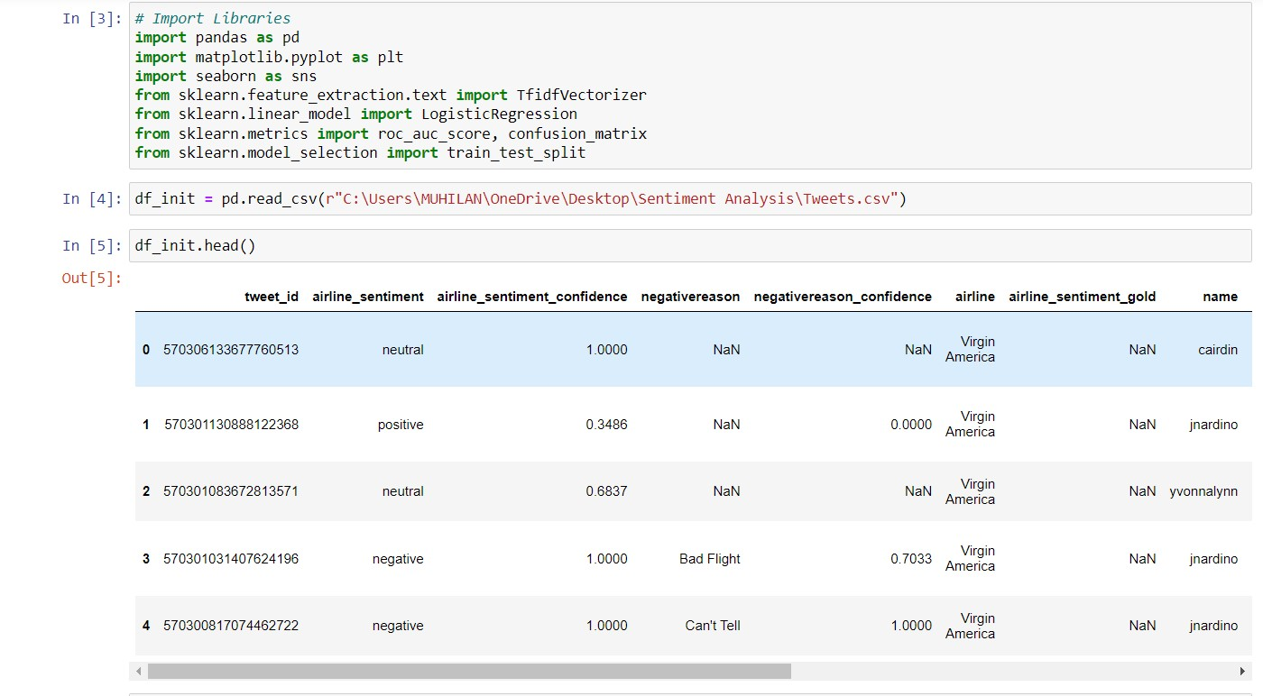

Importing require packages and Reading the dataset.

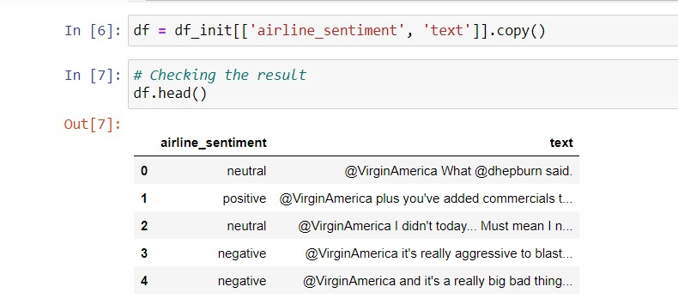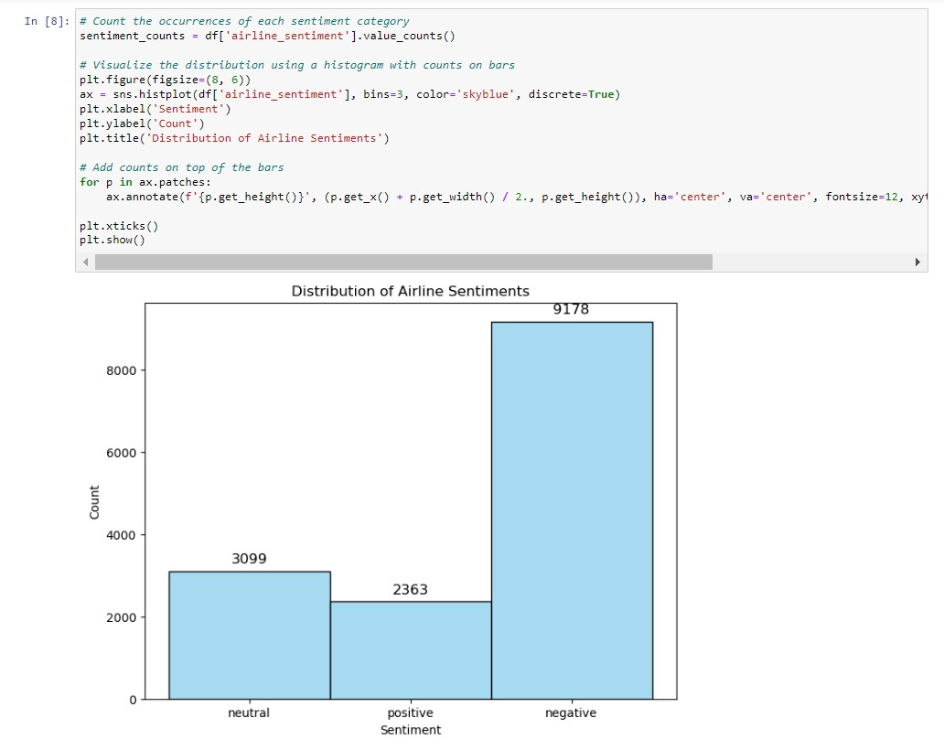

Make count the occurrences of each sentiment category and visualize the distribution using histogram.

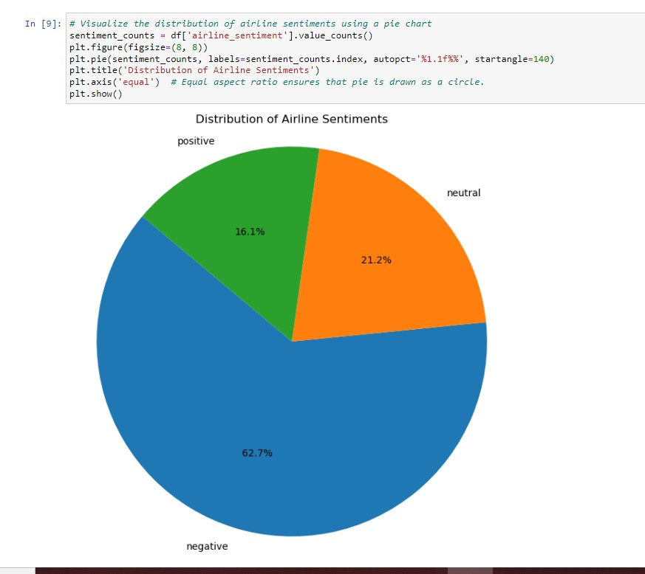

Visualize the distribution of Airline Sentiment using Pie chart

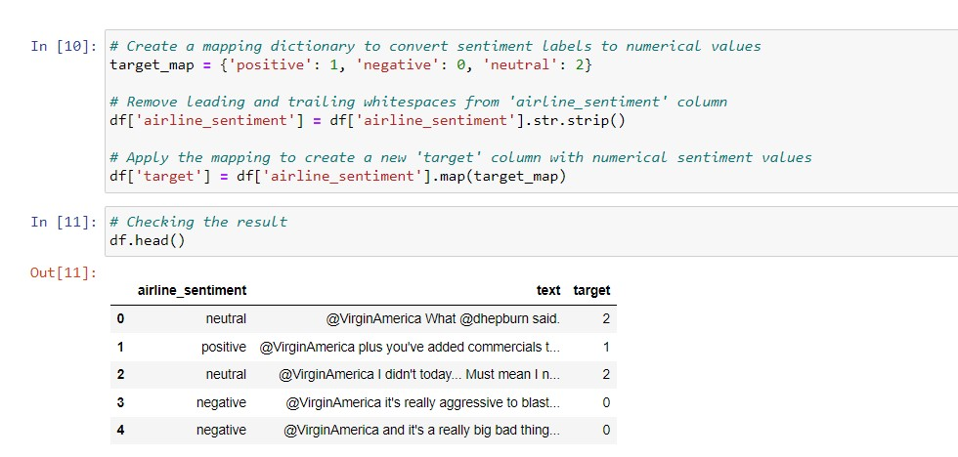

Create mapping dictionary,Remove leading and trailing whitespaces

from ‘airline_sentiment’

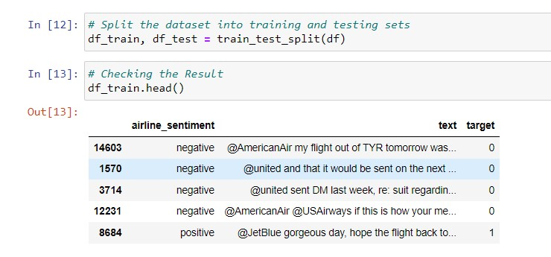

Split the dataset into training and testing sets and check the result.

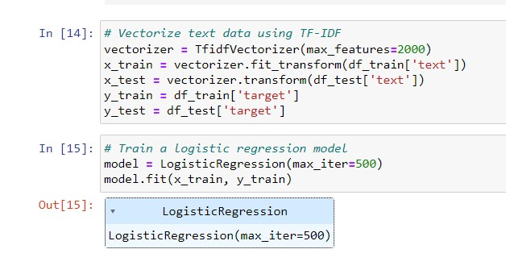

Train a dataset using Logistics regression model.

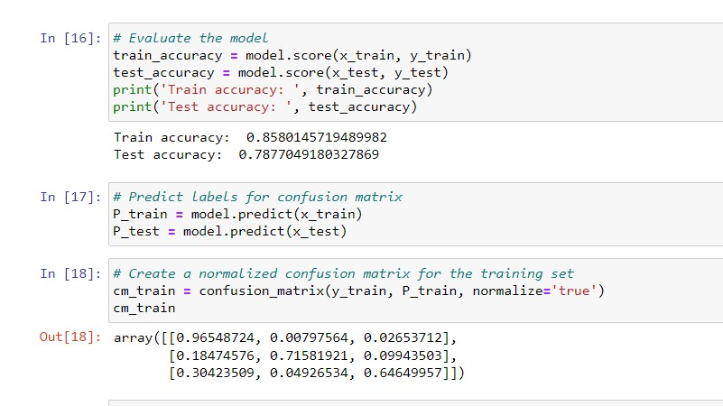

Create a normalized confusion matrix for the training set in three dimentional array.

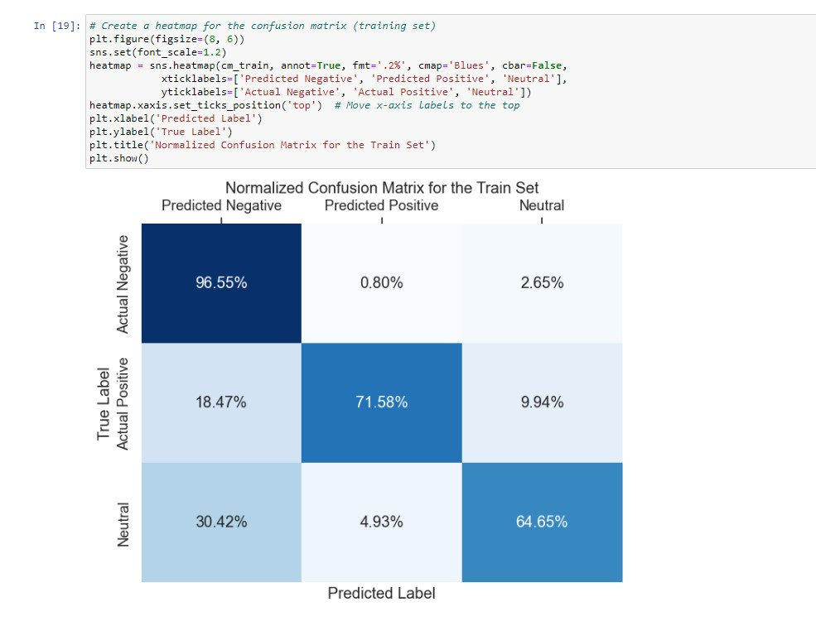

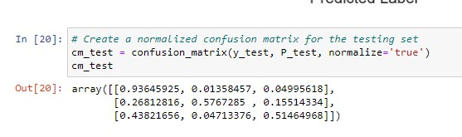

Heatmap for a confusion matrix&Normalized confusion matrix for the testing set

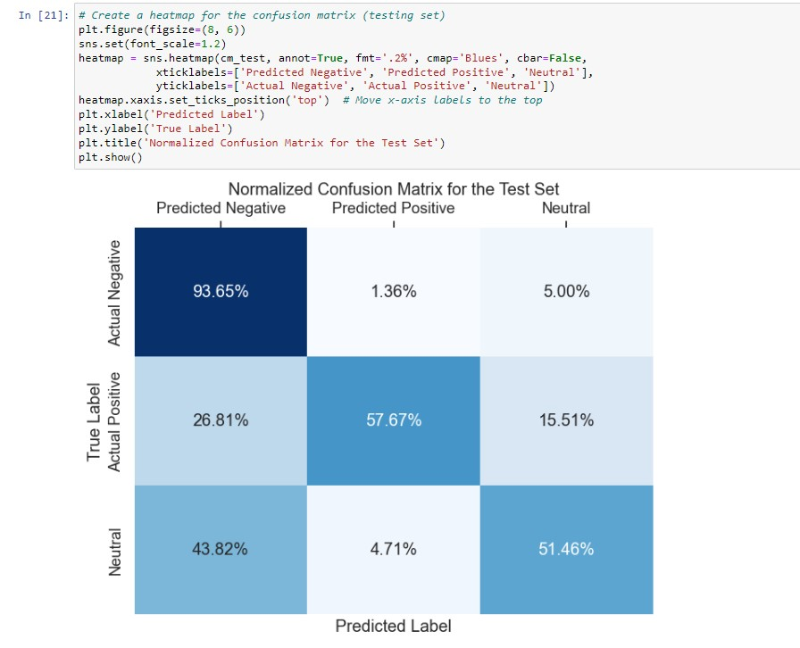

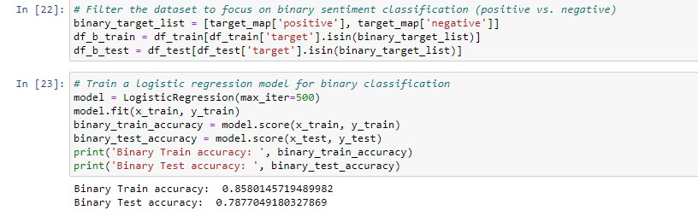

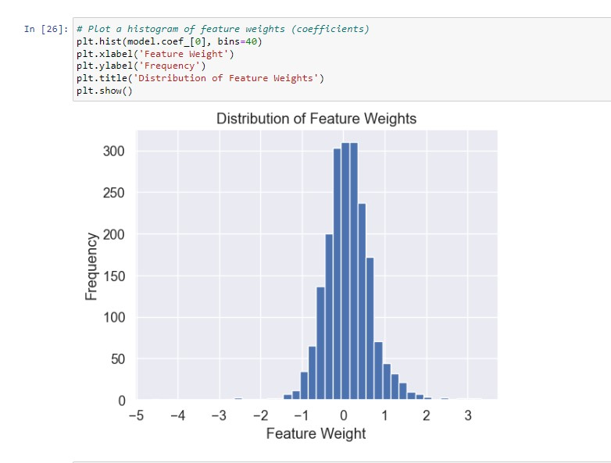

Histogram of feature weights

