ERP PORTAL

Software Requirements Specification (SRS)
Education / School Enterprise Resource Planning Portal

Technology baseline: React + TypeScript | Java 21 + Spring Boot 3 | MySQL 8 | Spring Security + RBAC | JPA/Hibernate

Purpose: define the implementation baseline, functional scope, architecture, authorization model, workflows, data, security, testing and delivery approach for an ERP portal similar to the supplied reference videos.

Purpose, Scope & Assumptions

Purpose
This SRS converts the reference product behavior into implementable, testable requirements for an education ERP. It is the baseline for development tickets, API implementation, database design, QA, senior review and release decisions.

In Scope

Domain | Baseline
Identity/access | Login, logout, password lifecycle, users, roles, permissions, audit
Student lifecycle | Enquiry, admission, student/guardian profile, documents, transfer/exit
Academics | Session, class, section, subject, syllabus, homework, timetable
Attendance | Student/staff marking, correction and summaries
Finance | Fee structures, dues, collection, receipts, discounts, expenses
Operations | Inventory, library, hostel, support/tickets
Administration | Reports, settings, imports/exports, audit

Out of Scope for Release 1
    - Native mobile applications; full statutory general ledger; complex third-party integrations; SaaS multi-tenancy unless separately approved.
    - Statutory payroll/tax compliance unless explicitly added to the approved backlog.

Assumptions
    - Initial architecture is a modular monolith with MySQL as system of record.
    - One institution/branch is assumed initially; branch-aware fields may be retained for future expansion.
    - Backend authorization is authoritative; frontend hiding controls is not a security boundary.
    - Critical writes are server-validated and transactional.

Document Control, Contents & Glossary

Table of Contents — names only
- Purpose, Scope & Assumptions
- Document Control, Contents & Glossary
- Reference Analysis & Product Baseline
- Users, Roles & RBAC
- Architecture & Technology
- Functional Requirements
- Business Workflows & Acceptance Criteria
- Data Model & Data Dictionary
- API & Integration Contract
- Security, Privacy & Compliance
- Quantified Non-Functional Requirements
- Testing, Traceability & Definition of Done
- Deployment, Backup & Operations

Glossary

Term | Meaning
RBAC | Role-Based Access Control
PII | Personally Identifiable Information
RTO/RPO | Recovery Time Objective / Recovery Point Objective
DTO | Data Transfer Object
Scope | Records a role is allowed to access
Acceptance criteria | Observable conditions required for acceptance

Reference Analysis & Product Baseline

Interpretation
The supplied recordings are treated as UI/workflow references rather than a complete requirements source. Navigation, dashboards, tables, filters, forms and role-oriented actions are translated into the baseline below. Behavior not evidenced by the references is explicitly treated as an implementation assumption.

Baseline Traceability

Reference area | Baseline capability | IDs
Authentication/shell | Login and authenticated application shell | REQ-AUTH-001..004
Dashboard | Role-aware KPIs and recent activity | REQ-ADM-003
Students/admission | Profile, guardian, admission, documents | REQ-STU-001..008
Academics | Session/class/section/subject/syllabus/timetable/homework | REQ-ACA-001..005
Attendance | Student/staff marking, correction, summaries | REQ-ATT-001..005
Finance | Fees, payments, receipts, discounts, expenses | REQ-FIN-001..009
Operations | Inventory, library, hostel, support | REQ-OPS-001..005
Administration | Users, roles, reports, settings, audit | REQ-ADM-001..008

Engineering Decisions
    - Modular monolith first; microservices are not required for the initial scope.
    - REST/JSON APIs; React never accesses MySQL directly.
    - Flyway/Liquibase controls schema changes.
    - OpenAPI and Postman are linked to requirement IDs.
    - Sensitive actions produce auditable events.

Users, Roles & RBAC

Authorization Model
User → Role(s) → Permission(s) → Data Scope → Backend API → Allow/Deny. Authorization is evaluated server-side before a protected operation executes.

Standard Roles

Role | Scope / responsibility
SUPER_ADMIN | Institution-wide security, users, roles, permissions, all modules
ADMIN | Institution/branch operational administration
MANAGEMENT | Dashboards, reports and approval/oversight
TEACHER | Assigned classes/subjects, attendance, homework
ACCOUNTANT | Fees, payments, receipts and finance reports
HR / STAFF_ADMIN | Staff records and attendance
LIBRARIAN | Catalog, issue/return and fines
RECEPTION / ADMISSION | Enquiry, admission, student records
INVENTORY_MANAGER | Items, suppliers and stock
SUPPORT_AGENT | Assigned support tickets
PARENT / GUARDIAN | Linked child information
STUDENT | Own permitted academic/attendance information

Permission Convention
MODULE:ACTION, e.g. STUDENT:READ, STUDENT:UPDATE, ATTENDANCE:MARK, FEE:COLLECT, FEE_DISCOUNT:APPROVE, REPORT:EXPORT.

Core rules
    - Deny by default when permission is absent.
    - 401 = unauthenticated/invalid authentication; 403 = authenticated but unauthorized.
    - Data scope applies to list, detail, update, delete and export operations.
    - Role/permission changes are audited and follow the approved token/session invalidation strategy.

RBAC Matrix & Authorization Requirements

Module | Super Admin | Admin | Mgmt | Teacher | Accountant | Parent/Student
Users/Roles | Full | Manage | View | — | — | —
Students | Full | Full | View | Assigned | View | Own/Linked
Academics | Full | Manage | View | Assigned | View | Own/Linked
Attendance | Full | Manage | View | Mark/Assigned | View | Own/Linked
Fees/Payments | Full | Manage | Approve/View | View | Manage | Own/Linked
Discounts | Full | Approve | Approve | — | Approve* | —
Expenses | Full | Manage | Approve | — | Manage | —
Inventory | Full | Manage | View | — | View | —
Library | Full | Manage | View | View | View | Own
Reports | Full | Export | Export/View | Limited | Export | Limited
Settings | Full | Manage | View | — | Limited | —
Audit | Full | View | View | — | — | —

Traceable authorization requirements

ID | Requirement | Verification
REQ-AUTHZ-001 | Protected API operations enforce authentication and permission. | API negative/positive tests
REQ-AUTHZ-002 | Record access is restricted by configured data scope. | In-scope vs out-of-scope IDs
REQ-AUTHZ-003 | Role/permission administration is restricted and audited. | API + audit test
REQ-AUTHZ-004 | Unauthorized requests do not mutate data. | Negative API + DB check
REQ-AUTHZ-005 | Exports enforce the same permission and scope rules as reads. | Export test

Architecture & Technology

Overall Architecture
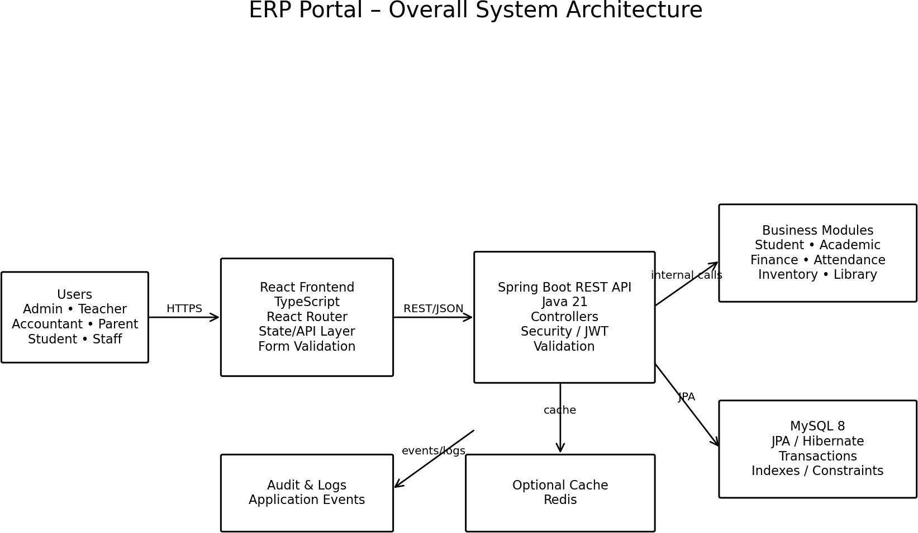

React/TypeScript provides presentation and client state. Spring Boot owns business rules, validation, authorization and transactions. MySQL is the system of record.

Backend Architecture
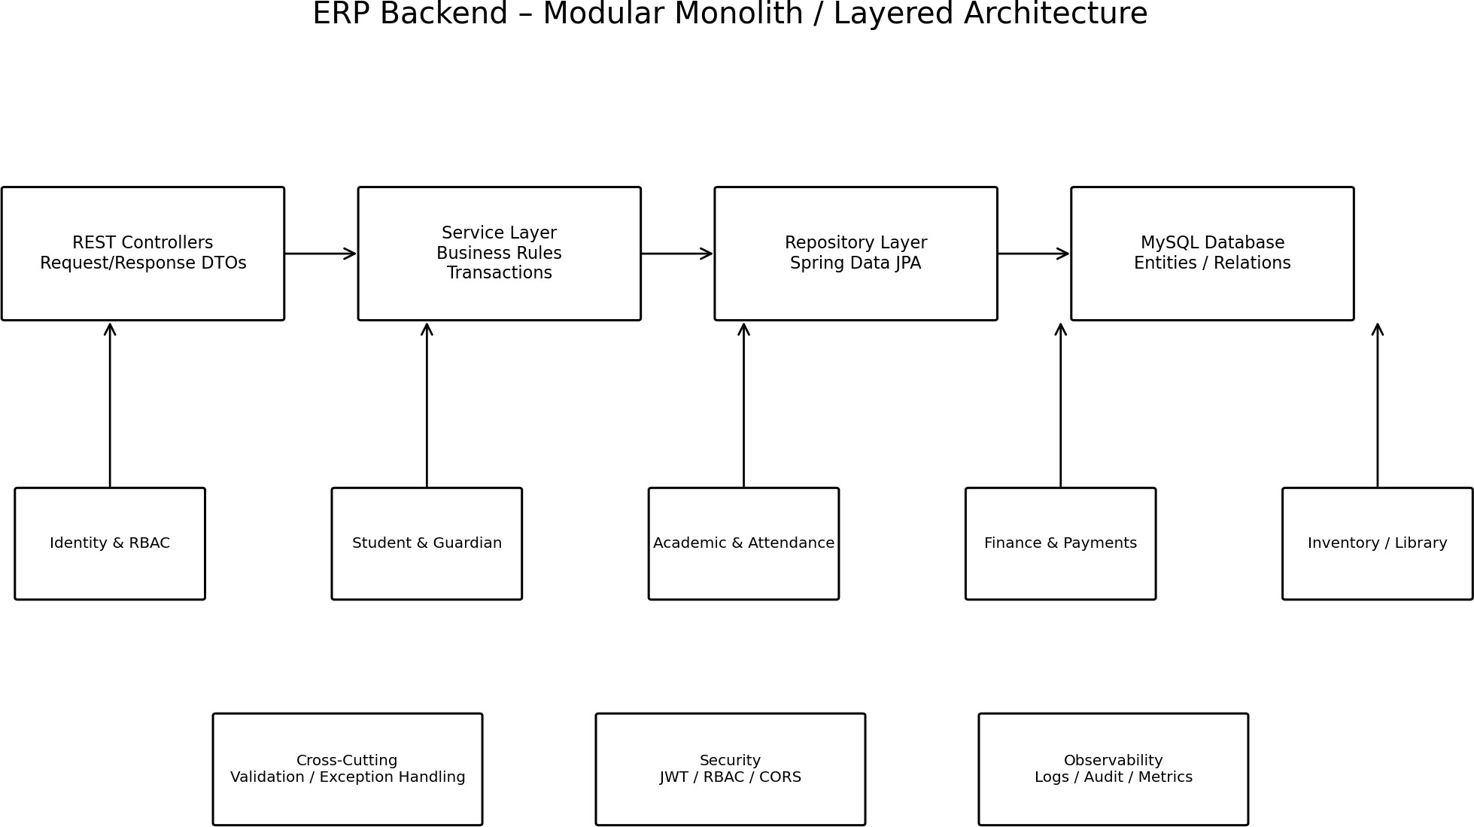

Controller → Service → Repository → Database. Security, validation, exceptions, audit, logging and transactions are cross-cutting controls.

Technology Baseline & Architecture Rules

Layer | Baseline | Rule
Frontend | React + TypeScript + Vite | Route guards; reusable components; client validation
Data fetching | TanStack Query or equivalent | Defined cache/invalidation behavior
Forms | React Hook Form + schema validation | Server validation remains authoritative
Backend | Java 21 + Spring Boot 3.x | Modular monolith
Security | Spring Security | Authentication + endpoint/method authorization
Persistence | Spring Data JPA + Hibernate | DTO/entity separation; service transactions
DB migration | Flyway/Liquibase | Reproducible schema
Database | MySQL 8 | FKs, unique constraints, evidence-based indexes
Testing | JUnit 5, Mockito, Spring Boot Test, Testcontainers | Unit/integration/API evidence
API docs | OpenAPI/Swagger | Versioned contract
Deployment | Docker/reverse proxy/TLS | Environment-specific secrets

Architecture requirements

ID | Requirement
REQ-ARCH-001 | Frontend communicates through versioned REST APIs; no direct DB access.
REQ-ARCH-002 | Business rules reside in services/domain logic, not only UI/controllers.
REQ-ARCH-003 | Schema changes are migration-controlled and reproducible.
REQ-ARCH-004 | Critical writes are transactional and deterministic.
REQ-ARCH-005 | Common API errors follow the approved error contract.

Functional Requirements — Identity & Student

ID | Requirement | Acceptance / evidence
REQ-AUTH-001 | Valid user can authenticate and receive authenticated context. | 200 + token/session + user context
REQ-AUTH-002 | Invalid credentials are rejected without account enumeration. | 401 + generic message
REQ-AUTH-003 | Protected APIs reject missing/expired authentication. | 401
REQ-AUTH-004 | Logout follows configured invalidation strategy. | Protected call rejected after logout as designed
REQ-USER-001 | Authorized admins create/update/deactivate/view users. | USER:MANAGE tests
REQ-STU-001 | Authorized user creates student with mandatory fields. | Missing field → 400
REQ-STU-002 | Admission/student identifier is unique. | Duplicate → conflict/validation
REQ-STU-003 | Student may have linked guardians under configured rules. | Relationship persists/retrieves
REQ-STU-004 | Student lists support search/filter/sort/pagination. | Deterministic page metadata
REQ-STU-005 | Student detail is scope-controlled. | Out-of-scope denied/non-disclosed
REQ-STU-006 | Admission status follows valid transitions. | Invalid transition rejected
REQ-STU-007 | Student documents validate file type/size and metadata. | Invalid upload rejected
REQ-STU-008 | Transfer/exit preserves history. | Status changes; history remains

Functional Requirements — Academic & Attendance

ID | Requirement | Acceptance / evidence
REQ-ACA-001 | Create academic sessions, classes and sections. | Valid create persists
REQ-ACA-002 | Assign subjects to classes/sections and teachers. | Assignment visible in teacher scope
REQ-ACA-003 | Timetable prevents configured conflicts. | Conflict rejected
REQ-ACA-004 | Teachers create homework for assigned scope. | Assigned users can view
REQ-ACA-005 | Record syllabus/progress by session/subject. | Progress persists with actor/time
REQ-ATT-001 | Assigned teacher/staff can mark attendance. | Only assigned students accepted
REQ-ATT-002 | Duplicate attendance is prevented/idempotently handled. | Second submission follows contract
REQ-ATT-003 | Attendance correction is restricted and audited. | Old/new value recorded
REQ-ATT-004 | Attendance supports date/class/section filters. | Filtered scope correct
REQ-ATT-005 | Parent/student sees only permitted history. | Own/linked scope enforced

Edge cases
    - Duplicate marking; locked dates; teacher outside assigned section; timezone/date-boundary behavior; correction after report generation.
    - Academic-session changes must not rewrite historical attendance.

6. Functional Requirements — Finance & Operations

ID | Requirement | Acceptance / evidence
REQ-FIN-001 | Define fee structures by session/class/category. | Versioned/dated structure
REQ-FIN-002 | Generate student dues from applicable structure. | Expected line items/totals
REQ-FIN-003 | Authorized cashier posts payment and receipt atomically. | Payment + receipt committed
REQ-FIN-004 | Invalid overpayment/amount rules are rejected unless approved path exists. | 400/409 as applicable
REQ-FIN-005 | Refund/reversal is permission-controlled and audited. | Unauthorized = 403
REQ-FIN-006 | Discount/concession follows approval workflow. | Requester cannot self-approve if SoD
REQ-FIN-007 | Record expenses with approval state. | Approved expense reports
REQ-FIN-008 | Finance exports honor role/date/data scope. | Restricted rows excluded
REQ-FIN-009 | Finance totals reconcile to transactions. | Report matches source
REQ-OPS-001 | Record inventory items and stock movements. | Balance changes correctly
REQ-OPS-002 | Negative stock is rejected unless explicitly configured. | Invalid issue rejected
REQ-OPS-003 | Library supports catalog/issue/return/fines. | Availability/history update
REQ-OPS-004 | Hostel allocation prevents double allocation. | Conflict rejected
REQ-OPS-005 | Support tickets have status, priority, assignee and history. | Lifecycle queryable

Functional Requirements — Administration & Reporting

ID | Requirement | Acceptance / evidence
REQ-ADM-001 | Authorized admins manage roles and permissions. | RBAC changes affect access
REQ-ADM-002 | Role/permission changes create audit events. | Actor/target/action/time
REQ-ADM-003 | Dashboards expose role-appropriate KPIs. | No unauthorized KPI/data
REQ-ADM-004 | Reports support required filters/date boundaries. | Deterministic results
REQ-ADM-005 | Exports are permission-controlled and scope-aware. | Export test
REQ-ADM-006 | Bulk imports validate rows and report failures without corruption. | Row-level errors
REQ-ADM-007 | Material business settings are audited/versioned where required. | Change attributable
REQ-ADM-008 | Audit logs support actor/entity/action/date filters. | Filtered result correct

Cross-cutting validation
    - Mandatory fields return structured field errors; IDs/timestamps are server-generated.
    - Sort fields are allow-listed; clients cannot send SQL fragments.
    - Historical records use controlled status/soft-delete where retention or referential integrity requires it.

Definition of Done
A requirement is complete only when implementation, authorization, validation, critical tests, API evidence, reproducible migration, documented errors and acceptance criteria are all demonstrated against its ID.

Business Workflows & Acceptance Criteria — Admission

Student Admission Workflow
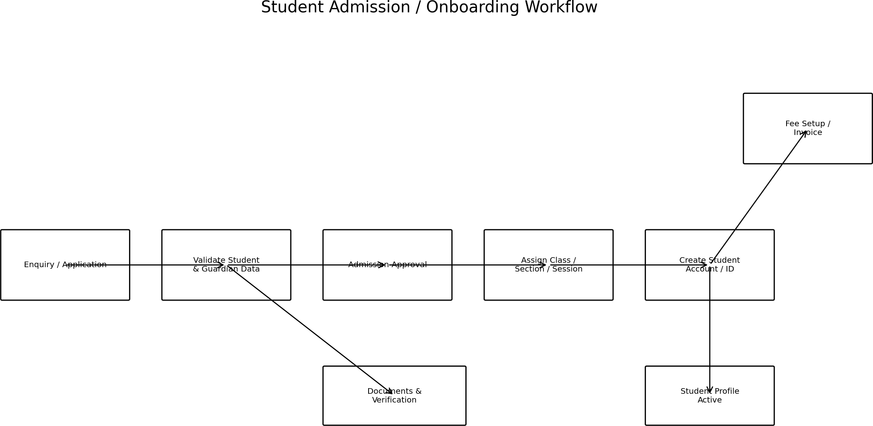

AC ID | Given | When | Then
AC-STU-001 | Authorized admission user + new applicant | Submit applicant | Student/admission created with unique ID
AC-STU-002 | Existing identifier | Submit admission | Duplicate rejected; no second student
AC-STU-003 | User outside student scope | Request detail | Denied/non-disclosed
AC-STU-004 | Required document missing | Submit admission | Submission blocked with field error

Workflow invariants
    - Admission state transitions are explicit.
    - Student history is retained through transfer/exit.
    - Authorization applies at every API step, not only the UI.

Finance & Attendance Acceptance Criteria

AC ID | Given | When | Then
AC-FIN-001 | Valid outstanding fee + cashier | Post payment | Payment and receipt commit atomically
AC-FIN-002 | Cashier lacks refund permission | Request refund | 403; no financial mutation
AC-FIN-003 | Discount requires approval | Submit discount | Pending state; no self-approval where prohibited
AC-FIN-004 | Same payment reference submitted twice | Both requests execute | Uniqueness/idempotency prevents duplicate
AC-ATT-001 | Teacher assigned to section | Mark attendance | Only assigned students are accepted
AC-ATT-002 | Attendance already exists | Submit duplicate | Duplicate prevented/idempotently handled
AC-ATT-003 | No correction permission | Request correction | 403; original unchanged

Academic / Attendance Flow
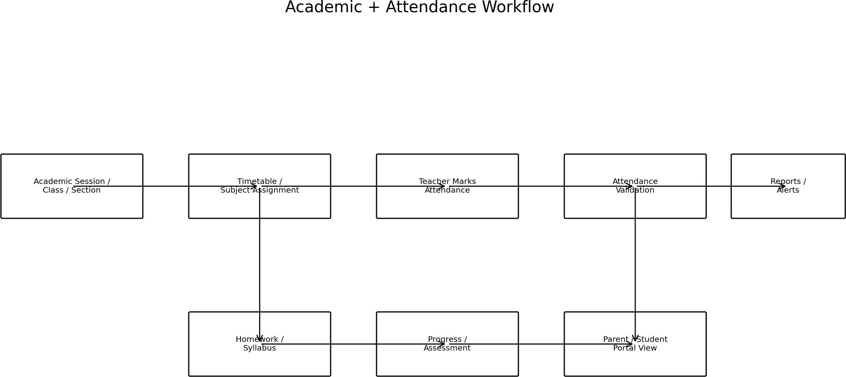

Finance Flow & Invariants
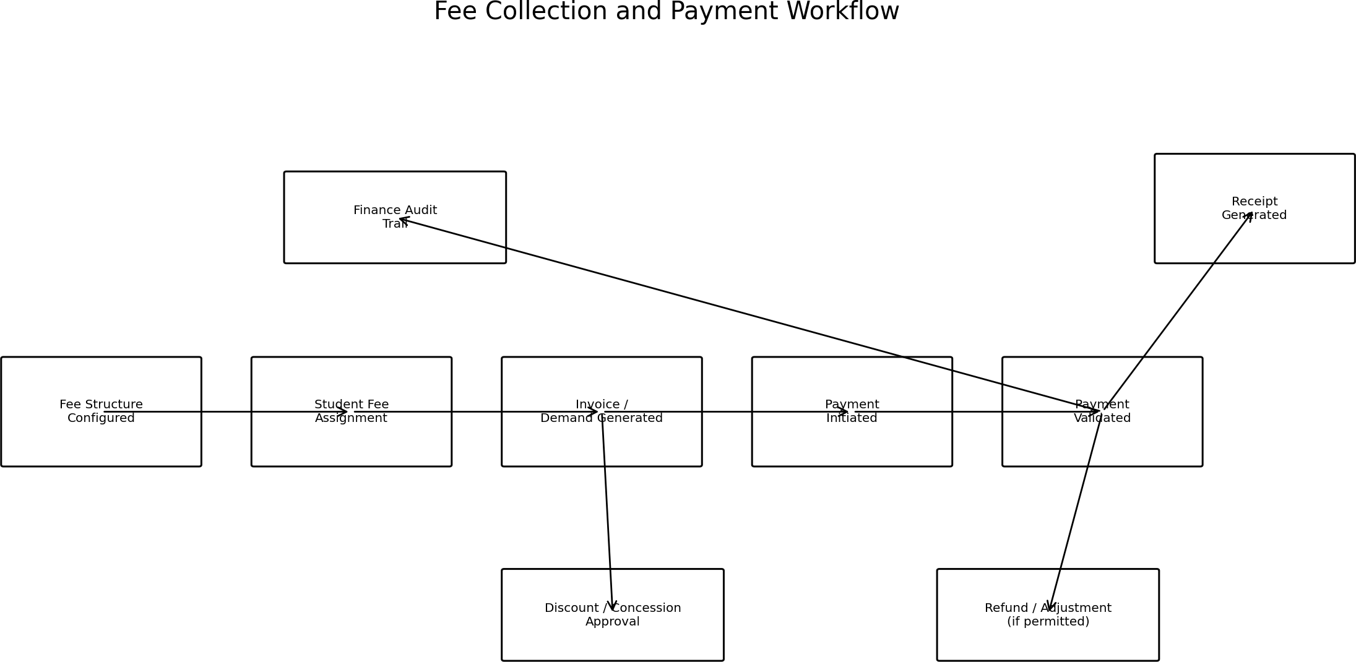

Financial invariants
    - Receipt/payment references are unique.
    - Financial writes occur in a transaction.
    - Refund/reversal never silently deletes original financial evidence.
    - Discounts and expenses record requester, approver, timestamp and outcome.
    - Reports derive from transactional records and use the same date/scope rules as APIs.

Inventory/Library/Hostel invariants
    - Stock movement is the source of inventory balance.
    - Library issue/return updates availability and borrower history.
    - Hostel allocation prevents two active occupants from owning the same bed.

Data Model & Data Dictionary

Conceptual ER Model
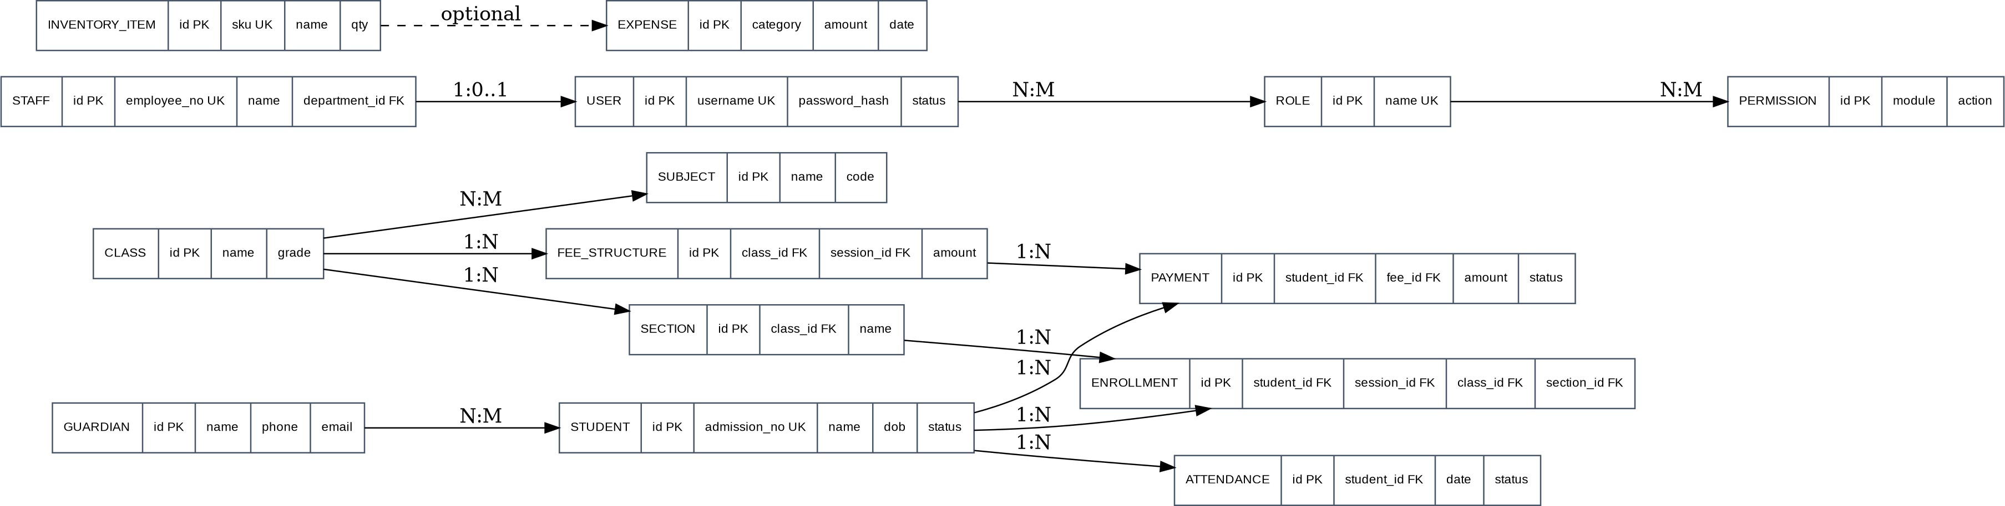
The diagram is conceptual. Physical naming may evolve during implementation provided keys, constraints, behavior and API contracts remain equivalent.

Core entities

Entity | Purpose | Relationships
users | Identity/authentication | roles, audit_logs
roles/permissions | RBAC configuration | users, role_permissions
students | Student master | guardians, admissions, attendance, fees
guardians | Parent/guardian | students
staff | Staff master | attendance, assignments
academic_sessions | Academic period | classes/sections
classes/sections/subjects | Academic structure | students/teachers/timetable
attendance | Presence records | student/staff + session
fee_structures/demands | Charges and dues | student/session
payments/receipts | Financial transactions | student/demand
expenses | Operational expenses | approval
inventory/stock_movements | Stock | items/suppliers
library_items/issues | Circulation | student/staff
audit_logs | Audit evidence | actor + target

Data Dictionary — Identity & Student

Field | Type | Null | Constraint / meaning
users.id | BIGINT | No | PK, generated
users.username | VARCHAR(100) | No | Unique
users.password_hash | VARCHAR(255) | No | Adaptive hash; never plaintext
users.status | ENUM | No | ACTIVE/LOCKED/DISABLED
roles.code | VARCHAR(50) | No | Unique machine-readable code
permissions.code | VARCHAR(100) | No | Unique MODULE:ACTION
students.id | BIGINT | No | PK
students.admission_no | VARCHAR(50) | No | Unique within institution
students.first_name | VARCHAR(100) | No | Required
students.last_name | VARCHAR(100) | Yes | Optional
students.date_of_birth | DATE | Yes | PII/minor data
students.status | VARCHAR(30) | No | APPLIED/ACTIVE/TRANSFERRED/EXITED
guardians.id | BIGINT | No | PK
guardians.name | VARCHAR(150) | No | Required
guardians.phone | VARCHAR(30) | Yes | PII/contact
guardians.email | VARCHAR(254) | Yes | Validated format
student_guardians.student_id | BIGINT | No | FK
student_guardians.guardian_id | BIGINT | No | FK
student_guardians.relation | VARCHAR(30) | No | Configured relationship

Data constraints
    - Foreign keys protect referential integrity; unique constraints prevent duplicate business identifiers.
    - PII fields are minimized and access-controlled.
    - Server timestamps are authoritative for audit events; timezone policy must be documented.

Data Dictionary — Academic, Attendance & Finance

Field | Type | Null | Constraint / meaning
academic_sessions.code | VARCHAR(30) | No | Unique, e.g. 2026-27
classes.id | BIGINT | No | PK
sections.id | BIGINT | No | FK class; unique class+name
subjects.id | BIGINT | No | PK
attendance.id | BIGINT | No | PK
attendance.student_id | BIGINT | No | FK student
attendance.attendance_date | DATE | No | Required
attendance.status | ENUM | No | PRESENT/ABSENT/LATE/etc.
fee_structures.amount | DECIMAL(12,2) | No | >= 0
fee_demands.amount_due | DECIMAL(12,2) | No | >= 0
payments.id | BIGINT | No | PK
payments.student_id | BIGINT | No | FK student
payments.amount | DECIMAL(12,2) | No | > 0 unless adjustment type
payments.reference_no | VARCHAR(80) | No | Unique
payments.status | ENUM | No | POSTED/REFUNDED/REVERSED
expenses.id | BIGINT | No | PK
expenses.amount | DECIMAL(12,2) | No | >= 0
expenses.approval_status | ENUM | No | DRAFT/PENDING/APPROVED/REJECTED
audit_logs.id | BIGINT | No | PK
audit_logs.actor_user_id | BIGINT | No | FK user
audit_logs.action | VARCHAR(100) | No | Business/security action
audit_logs.created_at | TIMESTAMP | No | Server generated

Indexing policy
Indexes must be based on actual query patterns: unique business identifiers, foreign keys, frequent filter columns and approved report paths. Existence of each index must be verified from migration/schema inspection; Postman cannot prove an index exists.

API & Integration Contract

Method | Endpoint | Permission | Purpose
POST | /api/v1/auth/login | Public | Authenticate
POST | /api/v1/auth/logout | AUTH | Logout
GET | /api/v1/me | AUTH | Current user/context
GET | /api/v1/students | STUDENT:READ | Search/filter/page
POST | /api/v1/students | STUDENT:CREATE | Create student
GET | /api/v1/students/{id} | STUDENT:READ | Student detail
PUT | /api/v1/students/{id} | STUDENT:UPDATE | Update student
POST | /api/v1/attendance | ATTENDANCE:MARK | Mark attendance
GET | /api/v1/attendance | ATTENDANCE:READ | Attendance query
GET | /api/v1/fees/demands | FEE:READ | Query dues
POST | /api/v1/payments | FEE:COLLECT | Post payment
POST | /api/v1/payments/{id}/refund | FEE:REFUND | Refund/reverse
GET | /api/v1/reports/{code} | REPORT:READ | Run report
GET | /api/v1/reports/{code}/export | REPORT:EXPORT | Export report
GET | /api/v1/audit | AUDIT:READ | Search audit

Request/response baseline
POST /api/v1/payments: studentId, demandId, amount, method, referenceNo. Success: 201 + paymentId + receiptNo + status + timestamp. Validation 400; auth 401; authorization 403; missing resource 404; duplicate reference 409.

Error contract
{"timestamp":"ISO-8601","status":400,"code":"VALIDATION_ERROR","message":"Request validation failed","path":"/api/v1/students","fieldErrors":[{"field":"admissionNo","message":"must be unique"}],"traceId":"..."}

Security, Privacy & Compliance

Security requirements

ID | Requirement | Evidence
REQ-SEC-001 | Passwords are adaptively hashed; never plaintext/logged. | DB + code review
REQ-SEC-002 | Protected APIs enforce auth + authorization server-side. | API negative tests
REQ-SEC-003 | Production traffic uses TLS. | Deployment review
REQ-SEC-004 | Input validation and safe error handling prevent leakage. | Security/API tests
REQ-SEC-005 | Sensitive actions create audit events. | Audit evidence
REQ-SEC-006 | Secrets are environment-managed, not source-controlled. | Config review
REQ-SEC-007 | Exports/bulk operations obey scope and permission. | API/export tests

Education privacy baseline
The portal processes minors' and guardians' personal information. The institution must identify and comply with the privacy/data-protection law applicable to its deployment. For India, the organization should assess the Digital Personal Data Protection Act, 2023 and applicable rules/notifications. FERPA is relevant to U.S. educational institutions and is not assumed to apply to an India-only deployment. This SRS does not provide legal advice.
Control | Baseline
Purpose limitation | Collect only fields required for defined education/operations purposes.
Access | Least privilege; parent/student limited to own/linked records.
Consent/notices | Institution defines lawful basis, notices and parental-consent process where legally required.
Retention | Define periods by student, finance, audit and document category; respect legal holds.
Data requests | Define operational access/correction/deletion process where applicable.
Breach response | Maintain incident escalation and legally required notification process.
Vendor sharing | Approved data-sharing terms and minimum necessary fields.

Quantified Non-Functional Requirements

ID | Target | Acceptance method
NFR-PERF-001 | p95 API ≤ 500 ms; p99 ≤ 1.5 s under baseline load. | Load test
NFR-PERF-002 | List endpoints ≤ 800 ms p95 with indexed filters/pagination. | API/load test
NFR-PERF-003 | Exports ≤100,000 rows within 60 s or use async job flow. | Performance test
NFR-CAP-001 | 5,000 concurrent authenticated sessions; 500 concurrent active API users. | Load test
NFR-CAP-002 | 100,000 students; 1,000 staff; 5 years attendance/finance baseline dataset. | Representative dataset
NFR-AVAIL-001 | Monthly availability ≥99.5%, excluding approved maintenance. | Monitoring/SLA evidence
NFR-REC-001 | RPO ≤24 h for standard DB backups. | Backup verification
NFR-REC-002 | RTO ≤4 h for restore. | Restore drill
NFR-SEC-001 | Critical/high vulnerabilities resolved or explicitly risk-accepted before production. | Security scan
NFR-UX-001 | Primary workflows usable at 1280×720 and responsive to 360 px width. | UI test
NFR-OBS-001 | Logs include timestamp, level, service, trace ID; secrets/PII excluded. | Log review
NFR-DATA-001 | Critical finance/audit records preserve transactional integrity and audit evidence. | DB/integration test

Capacity note
These are initial engineering targets, not a commercial SLA. Load-test results must be recorded against the actual deployment profile and dataset before production approval. Materially different expected volumes require revised targets and re-approval.

Testing, Traceability & Definition of Done

Test layers

Layer | Purpose | Evidence
Unit | Business rules, validators, mappings | JUnit/Mockito
Integration | JPA, transactions, security, DB | Spring Boot Test/Testcontainers
API/Postman | Auth, RBAC, CRUD, validation, workflow | Collection + results
E2E | Critical UI/API journeys | Automated/manual evidence
Performance | NFR performance/capacity | Load report
Security | Authz, secrets, dependencies, inputs | Scan/test report

Traceability matrix

Requirement group | Primary evidence | Artifact
REQ-AUTH/AUTHZ | Postman + security integration | Auth/RBAC collection
REQ-STU/ACA/ATT | API + integration + selected E2E | Domain test report
REQ-FIN | Transaction + API + reconciliation | Finance report
REQ-OPS | API + integration | Operations report
REQ-ADM | API + audit/export | Admin report
NFR-PERF/CAP | Load test | Performance report
NFR-REC | Backup/restore drill | Recovery evidence
REQ-SEC | Security tests/scans | Security report

Postman limits
Postman can prove: HTTP behavior, auth, authorization, CRUD, validation, pagination, filters and observable workflows. It cannot alone prove: exact Java class structure, existence of a DB index, internal transaction boundaries, code quality or query plans; use code/schema/migration/DB evidence for those.

Definition of Done
Requirement implemented + authorization enforced + critical tests pass + API evidence recorded + migration reproducible + acceptance criteria demonstrated + requirement ID linked to ticket/test.

Deployment, Backup & Operations

Deployment architecture
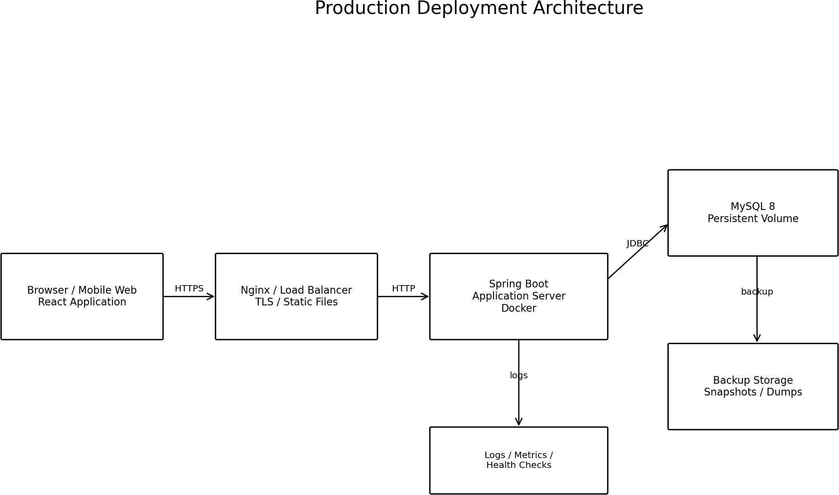

Environments

Environment | Purpose | Controls
Local | Developer implementation | Non-production data
Test/QA | Integration and acceptance | Seed data + automated tests
Staging | Release candidate | Production-like configuration
Production | Live data | TLS, backups, monitoring, restricted access

Backup / restore
    - Automated MySQL backups must meet RPO ≤24 h and be periodically restored.
    - Backups are encrypted and access-controlled; credentials are never stored in source.
    - Recovery drills record restore time, data-loss window, validation checks and owner.

Operations
    - Monitor availability, error rate, latency, DB health, disk and backup status.
    - Use correlation IDs; logs must avoid passwords, tokens and unnecessary PII.

