

HeatCast Heatwave Forecasting
and Comparative Evaluation
Honours Project Report
Submitted in partial fulfilment of the requirements for the degree of
Bachelor of Technology
Computer and Communication Engineering
with Honours in Data Science and Emerging Analytics
Submitted by
Anish Animesh Sahu 16014123011
Aryan Sanganti 16014123014
Ayush More 16014123017
Shashank Dubey 16014123044
Under the guidance of
Dr. Kiran Vishvas Ajetrao
K. J. Somaiya School of Engineering
Somaiya Vidyavihar University
Vidyavihar Mumbai 400077
Academic year 2026 to 2027
November 2026

Certificate
This is to certify that the project report entitled HeatCast Heatwave Forecasting and Comparative Evaluation records the work carried out by Anish Animesh Sahu, Aryan Sanganti, Ayush More and Shashank Dubey in partial fulfilment of the requirements for the degree of Bachelor of Technology in Computer and Communication Engineering with Honours in Data Science and Emerging Analytics at Somaiya Vidyavihar University during the academic year 2026 to 2027.
The project was carried out under the guidance of Dr. Kiran Vishvas Ajetrao. The report presents the problem addressed, system design, implemented forecasting methods, experimental results and conclusions for academic examination.
Project Guide Head of the Department
Dr. Kiran Vishvas Ajetrao
Principal or Dean
Date ____________________
Place ___________________

Declaration
We declare that HeatCast Heatwave Forecasting and Comparative Evaluation presents our project work on heatwave event prediction and forecast verification. We have acknowledged the publications, weather datasets, software and external services used in the project.
The report distinguishes measured results from interpretation and proposed work. Comparisons between methods are limited to their stated data, spatial domain, target, forecast lead and evaluation period. Prospective forecast logging and station-verification software are described according to their implemented capabilities; results requiring future observations or independent station records are not presented as completed evidence.
We submit this report in partial fulfilment of the requirements for the degree of Bachelor of Technology in Computer and Communication Engineering with Honours in Data Science and Emerging Analytics at Somaiya Vidyavihar University.
Anish Animesh Sahu 16014123011
Signature ____________________
Aryan Sanganti 16014123014
Signature ____________________
Ayush More 16014123017
Signature ____________________
Shashank Dubey 16014123044
Signature ____________________
Date ____________________
Place ___________________

Certificate of Approval of Examiners
The project report entitled HeatCast Heatwave Forecasting and Comparative Evaluation, submitted by Anish Animesh Sahu, Aryan Sanganti, Ayush More and Shashank Dubey for the degree of Bachelor of Technology in Computer and Communication Engineering with Honours in Data Science and Emerging Analytics, is submitted for examination by the undersigned.
Internal Examiner
Name ______________________________
Signature __________________________
External Examiner
Name ______________________________
Signature __________________________
Project Guide
Dr. Kiran Vishvas Ajetrao
Signature __________________________
Date ____________________
Place ___________________

Acknowledgements
We thank Dr. Kiran Vishvas Ajetrao for guidance throughout the project and for emphasizing a clear research problem, careful literature review and fair comparison of forecasting methods. We acknowledge the academic support of the Department and K. J. Somaiya School of Engineering at Somaiya Vidyavihar University.
We acknowledge the Copernicus Climate Change Service and ECMWF for ERA5 reanalysis, NOAA for GFS forecasts, and Open-Meteo for the documented interfaces used to retrieve weather data. We also acknowledge the researchers whose work on recurrent networks, meteorological prediction and forecast evaluation informed the project.
The project depends on open scientific software for data processing, model development, verification and visualization. We remain responsible for the experimental choices, interpretation of results and conclusions presented in this report.

Abstract
HeatCast investigates how a forecasting system can identify sustained hot conditions and anticipate the first day of a heatwave while making its warning timing and errors visible. We built a reproducible workflow that prepares meteorological data, defines local heat events, trains and compares forecasting methods, reconstructs warnings from dated numerical forecasts and evaluates outcomes by location, lead time and event type. The study combines a France-centred spatial evaluation, a seven-location European benchmark using ERA5 daily histories from 1981 to 2025, and a 2026 replay of explicitly initialized GFS runs.
A hot day exceeds a local calendar-day 90th-percentile threshold. The long-history experiments use a fixed 1981 to 2010 reference. Ongoing events are the third or later consecutive hot days; onset is the first day of a run lasting at least three days. We evaluate these tasks separately at one-, three- and seven-day leads. Models include LSTM, ConvLSTM, logistic regression, gradient boosting, persistence and climatology. Chronological development, validation-only cutoff selection, regional support counts and paired temporal blocks control the interpretation of results.
In the spatial evaluation, gradient boosting achieves F1 0.8505 against persistence 0.7822, while the ConvLSTM reaches 0.5671. In matched seven-location one-day tests, boosting achieves F1 0.8199 for ongoing events and 0.2961 for onset; corresponding LSTM results are 0.7701 and 0.2181. Ongoing boosting performance declines to 0.2196 at seven days. In the GFS replay, joint-error adjustment reaches one-day onset F1 0.3896 but reduces seven-day ongoing F1 from raw GFS 0.6259 to 0.5581. A development-selected refinement produces one-day onset F1 0.4478, reducing false alerts from 39 to 29 while retaining 15 hits. Its probability Brier score worsens, and uncertainty does not establish a reliable gain over raw GFS.
The project delivers trained models, auditable predictions, research diagnostics, an interactive observatory, prospective capture software and a station-validation adapter. Its findings show that recognizing an ongoing event is substantially easier than warning of onset, that simple baselines remain competitive, and that correction must be evaluated separately at each lead. The evidence supports research and transparent forecast inspection; independent station validation, wider geographic coverage and a future summer of prospective verification remain necessary.
Keywords: heatwave forecasting; ERA5; GFS; LSTM; ConvLSTM; gradient boosting; onset prediction; probabilistic verification.

Contents
Chapter 1 Introduction 1
1.1 Background and motivation 1
1.2 Problem statement 1
1.3 Aim and objectives 1
1.4 Research questions 2
1.5 Scope and experimental boundaries 2
1.6 Project deliverables and practical value 3
Chapter 2 Literature Review and Research Background 4
2.1 Review focus 4
2.2 Temporal modelling and localized temperature 4
2.3 Spatial recurrence and meteorological context 5
2.4 Extreme event verification and data availability 6
2.5 Research gaps and project response 6
Chapter 3 System Design and Methodology 8
3.1 System architecture 8
3.2 Event definition and local reference 9
3.3 Spatial data preparation 9
3.4 Multi location weather histories 10
3.5 Predictor construction 10
3.6 Forecasting models and controls 10
3.7 Model selection and fair comparisons 11
3.8 Archived numerical forecast timing 11
3.9 Joint error adjustment and forecast refinement 12
3.10 Metrics and uncertainty 13
Chapter 4 Implementation Results and Discussion 14
4.1 Implementation and reproducibility 14
4.2 Spatial grid and point model results 15
4.3 Spatial failures and case study 16
4.4 Matched multi location one day comparisons 17
4.5 Lead time and probability quality 18
4.6 Regional annual and transfer results 20
4.7 Issued forecast replay results 22
4.8 Development selected forecast refinement 23
4.9 Event level detection and reliability audit 24
4.10 Prospective capture and independent verification 25
4.11 Findings and practical interpretation 26
Chapter 5 Conclusions and Scope for Further Work 27
5.1 Conclusions against the research questions 27
5.2 Contributions of the completed project 27
5.3 Limitations 28
5.4 Further experiments and completion criteria 28
5.5 Overall conclusion 29
References 30
Appendix A Project Source Register and Reproduction 32
A.1 Reproduction commands 32
Appendix B Evidence and Implementation Status 33

List of Figures
Figure 3.1 HeatCast data prediction and verification workflow 8
Figure 3.2 Hot day onset and ongoing event labels 9
Figure 4.1 Training and validation histories for the recurrent grid and point models 15
Figure 4.2 Precision recall performance in the spatial evaluation 16
Figure 4.3 Spatial F1 difference from persistence and event support 17
Figure 4.4 Observed and predicted event extent on 10 August 2026 17
Figure 4.5 Event performance at one three and seven day leads 19
Figure 4.6 Probability reliability in the one day location models 19
Figure 4.7 Regional skill across event types and forecast leads 20
Figure 4.8 Annual pooled and equal site performance 21
Figure 4.9 Supervised location holdout under known local climatology 21
Figure 4.10 GFS warning skill at matched target dates and locations 22
Figure 4.11 One day onset refinement and its false alert tradeoff 23
Figure 4.12 Actual receipt capture and later verification 25

List of Tables
Table 1.1 Research questions and evidence 2
Table 2.1 Temperature and spatial forecasting studies 4
Table 2.2 Recurrent and severe weather nowcasting studies 5
Table 2.3 Research gaps addressed by the project 6
Table 3.1 Evaluation settings and data conditions 8
Table 3.2 Timing for a target starting on 1 August 2026 12
Table 3.3 Measures used to evaluate forecasts 13
Table 4.1 Main implementation components 14
Table 4.2 Spatial and Paris evaluation results 15
Table 4.3 Spatial quadrant performance 16
Table 4.4 Matched one day methods at seven locations 17
Table 4.5 Gradient boosting performance across leads 18
Table 4.6 One day ongoing performance by location 20
Table 4.7 GFS replay event results 22
Table 4.8 Development selected refinement test results 23
Table 4.9 Event support detection and probability skill 24
Table 5.1 Further work and evidence required for completion 28
Table A.1 Project records supporting the report 32
Table B.1 Completed work and remaining scientific evidence 33

Nomenclature
Nomenclature and notation
Term | Meaning
ERA5 | ECMWF fifth generation atmospheric reanalysis
GFS | NOAA Global Forecast System
NWP | Numerical weather prediction
LSTM | Long short term memory network
ConvLSTM | Convolutional long short term memory network
GB | Histogram gradient boosting classifier
Tmax | Daily maximum near surface air temperature
q90 | Local calendar day 90th percentile
Onset | First day of at least three hot days after a non hot day
Ongoing | Third or later consecutive hot day
Lead | Time between issue and target day
F1 | 2TP divided by 2TP plus FP plus FN
Macro site F1 | Arithmetic mean of separately calculated site F1 values
AP | Average precision
Brier | Mean squared error of an event probability
BSS | Brier skill score relative to a stated baseline
UTC | Coordinated Universal Time
TP FP FN TN | Hits false alerts misses and correct negatives
IoU | Intersection over union of event cells

Chapter 1 Introduction

1.1 Background and motivation
Sustained high temperature is an event defined by duration and local context. A single hot afternoon and a sequence of several unusually hot days create different forecasting questions. A temperature error near a local threshold can alter the detected start, continuation or duration of an event. For a warning system, the useful question is therefore whether the event can be anticipated before its target day, with an acceptable balance between missed events and false alerts.
We developed HeatCast to study that problem using historical meteorology, numerical weather forecasts and explicit event verification. The system connects data preparation with model inference and evaluation, rather than treating a classifier score as the entire forecasting product. Each prediction has a target, a forecast lead, a location, a probability or deterministic decision, and a stated source of verification. This makes it possible to inspect both a successful forecast and the conditions under which it fails.
Recurrent neural networks provide a way to represent weather sequences, and ConvLSTM can retain spatial structure in gridded fields [1–3, 14]. Their suitability does not guarantee superiority over a simple persistence forecast. Temperature persistence can be strong when heat already exists, while new-event onset demands information about an approaching change. We therefore evaluate neural, linear and tree-based methods alongside meteorological controls, with separate conclusions for ongoing and onset tasks.

1.2 Problem statement
The problem addressed is to estimate whether sustained, locally unusual heat will occur at a specified location and future date, and to determine how dependable that estimate is across event type, lead time and geography. The project must distinguish a model that recognizes heat already in progress from a model that warns of the first day of a new event. It must also distinguish historical reanalysis available in a research file from information that could have been available at the warning decision.
A useful solution requires more than a high pooled accuracy. It needs an explicit local event definition, chronological model selection, matched comparisons, probability diagnostics, counts of misses and false alerts, and a record of the forecast run used. Without these controls, strong performance can reflect class imbalance, persistence, future information or an easier target rather than effective early warning.

1.3 Aim and objectives
The aim is to build and evaluate a reproducible heatwave forecasting system whose predictions and limitations can be traced to the data and experimental design. The work addresses the following objectives.
• Prepare meteorological histories and archived forecasts with verified dates, units, coordinates, complete daily records and reproducible source identifiers.
• Define local hot-day thresholds and separate ongoing events from first-day onset, while keeping future verification out of predictor inputs.
• Compare LSTM, ConvLSTM, logistic regression and gradient boosting with matched persistence and climatology controls within each evaluation.
• Measure how skill changes at one-, three- and seven-day lead and reveal regional, annual and low-support failures.
• Evaluate explicitly initialized numerical forecasts under a documented issue-time policy and test whether empirical correction helps.
• Provide saved models, auditable forecast exports, reliability and episode diagnostics, prospective capture and an independent station-verification pathway.

1.4 Research questions
Table 1.1 Research questions and evidence
Question | Evidence used
RQ1 Which methods predict ongoing heat most effectively | Matched spatial and seven-location model comparisons
RQ2 How difficult is first-day onset warning | Separate onset labels, precision, recall and event counts
RQ3 How does performance change with lead and location | One-, three- and seven-day metrics; site and annual diagnostics
RQ4 Can dated numerical forecasts support advance warnings | Single-run GFS replay with explicit issue and verification timing
RQ5 Does forecast refinement improve event skill or probability quality | Purged development selection and retained candidate results
RQ6 What evidence is needed for practical use | Prospective receipt logs, station verification and stated completion criteria

1.5 Scope and experimental boundaries
HeatCast is one project with several complementary evaluation settings. The spatial experiment uses a France-centred ERA5 grid for May to August 2020 to 2026. The multi-location experiment uses daily ERA5 records from 1981 to 2025 at Paris, London, Madrid, Rome, Athens, Berlin and Warsaw. The numerical-forecast experiment reconstructs 2026 warnings from explicitly initialized GFS runs. A forecast-refinement experiment examines a fixed family of empirical and logistic alternatives. Each setting answers a related question under different information and verification conditions.
The settings are not one interchangeable test set. The Paris point LSTM and regional ConvLSTM do not isolate architecture because they do not receive the same spatial information. Likewise, reanalysis-history scores cannot be compared directly with GFS warning scores as if both measured operational availability. The report states the data and timing conditions before presenting each result.
The seven locations represent ERA5 grid cells associated with cities. They do not provide continuous European coverage, country-wide verification or station observations. Event probabilities concern the project’s three-day temperature definition, not a medical risk category, a nationally issued warning level or a claim about heat-related health outcomes.

1.6 Project deliverables and practical value
The deliverables include data-preparation modules, historical thresholds, fitted estimators and neural checkpoints, held-out prediction arrays, warning reconstruction commands, CSV exports, regional audits and an observatory for inspecting results. Additional evaluation modules summarize reliability and whole-event detection. Prospective capture records actual receipt times, while the station adapter specifies the data and quality checks needed for independent verification.
These components help a researcher identify whether a model succeeds because it detects real onset or because an event is already underway. They also help expose a correction that reduces temperature or probability error while increasing false alerts. The practical value is an inspectable forecasting workflow and evidence about where further modelling effort is justified; the project has not measured reductions in health impacts, economic losses or public-warning response.

Chapter 2 Literature Review and Research Background

2.1 Review focus
The literature review considers twelve IEEE journal studies on temperature forecasting, recurrent meteorological models and severe-weather nowcasting [1–12]. Supporting sources describe ERA5, ConvLSTM, climate references, structured validation and probabilistic evaluation [13–22]. The review asks which design principles transfer to daily sustained-heat prediction and which reported results depend on different variables, spatial supports or verification targets.
A study may be useful even when its headline metric is not comparable. Temperature regression concerns continuous errors, whereas HeatCast evaluates whether several threshold exceedances form an event. Radar nowcasting studies address spatial motion at short time intervals; they can motivate recurrent architectures without providing a European heatwave benchmark. We therefore use the literature to justify controls and modelling choices, rather than ranking unrelated numerical scores.
Table 2.1 Temperature and spatial forecasting studies
Reference | Methodological relevance | Boundary for HeatCast
[1] Yu et al 2021 | Localized temperature forecasting with LSTM and urban IoT observations | Urban hourly regression differs from grid-cell daily events
[2] Suleman and Shridevi 2022 | Feature-attention LSTM for weather prediction | Attention over variables is not a matched European spatial experiment
[3] Tekin et al 2024 | ConvLSTM with attention and context matching for weather fields | Upper-air temperature regression differs from near-surface hot spells
[4] Harilal et al 2021 | Auxiliary-informed ConvLSTM for climate downscaling | Downscaling precipitation does not establish heatwave warning skill
[5] Rodrigues et al 2026 | Kriging and recurrent models for severe rainfall nowcasting | Different hazard and lead; useful event-based comparison design
[12] Pavithran et al 2025 | LSTM-based models at several weather aggregation scales | Mean-temperature targets and local-day aggregation differ

2.2 Temporal modelling and localized temperature
Yu et al. [1] examine localized temperature forecasting with LSTM and dense urban observations. The relevant lesson is that historical context and a simple persistence control both matter. The observation network and regression target remain different from HeatCast’s representative reanalysis locations. This supports testing local histories while leaving station-level verification as a separate requirement.
Suleman and Shridevi [2] investigate feature attention within an LSTM weather model. Their work motivates considering multiple meteorological variables and the relative usefulness of those variables. HeatCast tests temperature-only, no-soil and full-feature predictors rather than assuming that every additional input is beneficial. An observed difference between feature sets is a predictive association under the chosen design; it does not identify a physical causal mechanism.
Pavithran et al. [12] study weather prediction at multiple temporal scales. This makes aggregation and forecast horizon relevant design decisions. HeatCast uses UTC daily maxima because the event rule is based on hot days. Results for local-day mean temperature cannot be substituted for those maxima, and a low mean-temperature regression error cannot be converted into heatwave F1.

2.3 Spatial recurrence and meteorological context
Shi et al. [14] introduce the convolutional recurrent structure that motivates ConvLSTM for spatiotemporal sequences. In this architecture, convolutional operations retain a spatial field in the recurrent state. HeatCast uses that idea to predict next-day ongoing heat across a regional grid. It also tests a point-sequence LSTM, but the point and grid results are kept in separate comparison groups because their available spatial information differs.
Tekin et al. [3] investigate ConvLSTM with attention and context matching for numerical weather fields. A central lesson for this project is that an architecture comparison needs common data and spatial support. A more elaborate recurrent model should not be credited for information that its comparator never received. HeatCast therefore makes no architecture-only LSTM-versus-ConvLSTM superiority claim from its point-versus-grid results.
Harilal et al. [4] examine auxiliary inputs in convolutional recurrent downscaling. HeatCast studies a related input question through soil moisture ablation, while recognizing that precipitation downscaling and heatwave prediction are different tasks. Removing soil moisture changes measured predictive performance in a particular run; it does not establish that land-surface processes are physically unimportant.
Table 2.2 Recurrent and severe weather nowcasting studies
Reference | Core idea | Design implication
[6] Luo et al 2021 | PFST-LSTM and pseudoflow for precipitation nowcasting | Spatial memory and alignment are candidate ideas, not implemented HeatCast claims
[7] Xiong et al 2021 | Contextual attention in ConvLSTM | Local and broader context need controlled evaluation
[8] Ma et al 2022 | PrecipLSTM and meteorological sequence modelling | Temporal change can matter beyond the latest field
[9] Ehsani et al 2022 | Representation learning for product latency | Predictor availability must be checked at issue time
[10] Niu et al 2024 | Satellite and radar fusion in FsrGAN | Additional streams require availability and ablation controls
[11] Fan et al 2025 | Multitask severe convective nowcasting | Different targets require separate verification

2.4 Extreme event verification and data availability
Rodrigues et al. [5] compare persistence and recurrent models for severe rainfall with explicit extreme-event assessment. The work illustrates why continuous prediction error and categorical event detection can favour different methods. HeatCast applies that distinction by reporting event F1, precision and recall alongside probability and temperature errors. It also separates exact onset events from repeated ongoing days within one heatwave.
Ehsani et al. [9] make latency relevant to the use of meteorological products. For HeatCast, a daily ERA5 value present in a historical file may not have been published at the warning time. The observation-history benchmark therefore measures retrospective predictive association under an availability assumption. The GFS replay uses a different input pathway: every event day is obtained from one forecast run initialized before the warning decision.
Structured validation is also necessary because adjacent weather records and nearby locations are dependent. Roberts et al. [19] motivate evaluation that respects temporal and spatial structure. HeatCast uses chronological splits, whole-location fields in time-block resampling, and supervised location holdout. These controls reduce particular biases; they do not create independent seasons or eliminate all uncertainty.
Probabilistic evaluation concerns both discrimination and reliability [20]. A model can rank events well but produce poorly calibrated probabilities. F1 also depends on the classification cutoff, whereas Brier score evaluates the probability itself. HeatCast retains both views and reports the baseline used in every skill comparison.

2.5 Research gaps and project response
Table 2.3 Research gaps addressed by the project
Gap | Implemented response | Remaining evidence
Onset confused with continuation | Separate onset and ongoing targets at three leads | More reliable early onset and longer-lead forecasts
Unmatched architecture comparisons | Matched comparisons within each information setting | Common-input LSTM and ConvLSTM experiment
Pooled scores hide geography | Macro-site selection, regional support and site holdout | More locations and northern-region verification
Retrospective data treated as live inputs | Frozen-run warning replay and actual-receipt capture | A complete prospective summer
Probability scores lack a reference | Reliability bins and Brier skill against stated baselines | Independent calibration confirmation
Repeated hot days inflate event counts | Ongoing episodes and exact onset counts reported separately | Event-level checks across more seasons
Reanalysis treated as station truth | Station CSV adapter with quality and reference checks | Independent station observations

These gaps define the contribution as a reproducible forecasting and verification study. HeatCast does not introduce a new recurrent cell or claim that its method is globally optimal. Its research question is whether the implemented methods provide useful event information under clearly stated data and timing conditions, and what the observed failures imply for the next experiment.

Chapter 3 System Design and Methodology

3.1 System architecture
HeatCast separates acquisition, event construction, model development, inference and verification. Acquisition preserves the source response, requested coordinates, units and hashes. Event construction derives local thresholds and target labels. Development selects model settings and cutoffs without using test labels. Inference produces a forecast from information available under the selected experiment. Verification joins that saved forecast with an outcome collected afterward.
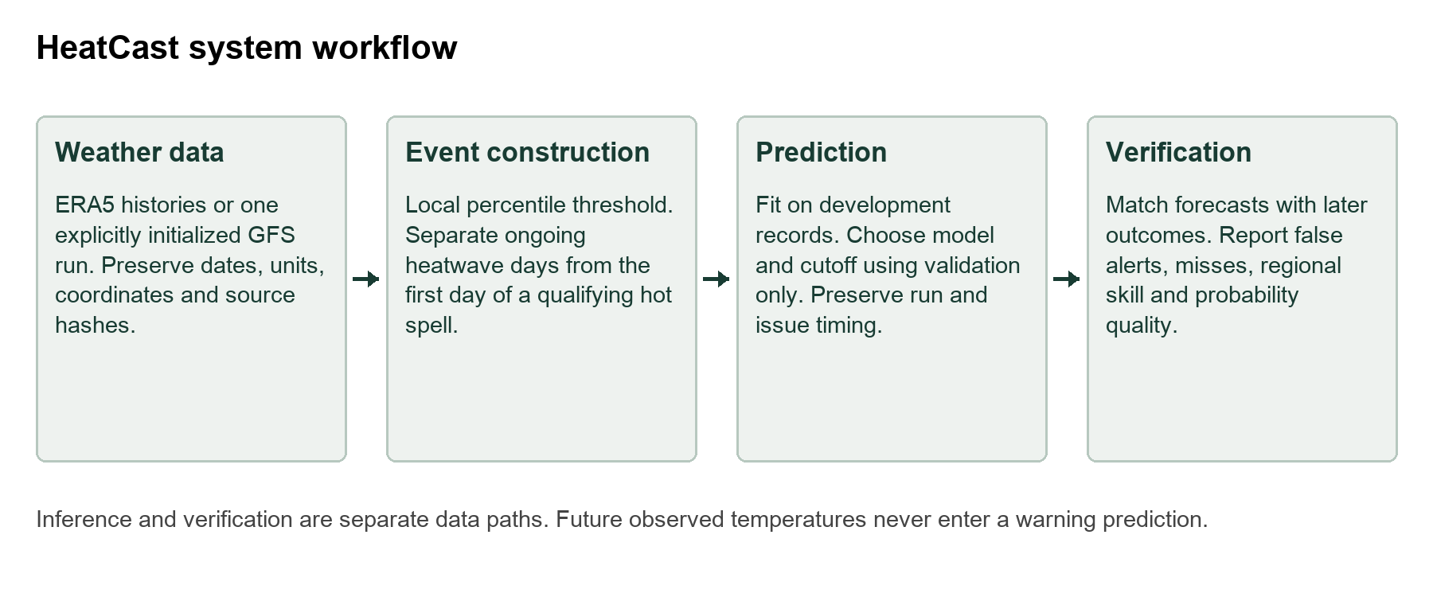
Figure 3.1 HeatCast data prediction and verification workflow
Source: Project system design.
The separation is especially important for onset. Its label requires two subsequent hot days for confirmation, but those observed days must never be used as predictor inputs. The numerical-forecast branch may predict all of those days from an earlier initialized run. A verification array is not supplied to its inference function. The research tests check these boundaries explicitly.
Table 3.1 Evaluation settings and data conditions
Setting | Data and development | Test and purpose
Spatial grid | ERA5 hourly fields; 2020–2022 training and 2023–2024 validation | Available 2025–2026 days; next-day ongoing events over 1507 cells
Seven locations | ERA5 daily 1981–2025; training to 2016 and validation 2017–2020 | 2021–2025; ongoing and onset at 1 3 and 7 days
Issued forecasts | Explicit 2026 GFS runs; development targets 1 May–22 June | 8 July–30 September; actual warning leads 24 72 and 168 hours under replay policy
Forecast refinement | Same GFS development cases; five purged blocks | Same inspected 2026 test; exploratory comparison only

3.2 Event definition and local reference
Let Tmax(s,d) denote maximum temperature at location s on UTC day d, and q90(s,d) its local calendar-day 90th-percentile reference. The hot-day indicator is H(s,d) = 1 when Tmax(s,d) exceeds q90(s,d), and zero otherwise. The long-history and GFS experiments use the fixed 1981–2010 reference with a five-calendar-day window centred on the target calendar day. February 29 shares the February 28 threshold.
The ongoing label O(s,d) is one when H(s,d−2), H(s,d−1) and H(s,d) are all one. The onset label N(s,d) is one when day d−1 is non-hot and days d, d+1 and d+2 are hot. Thus an onset is dated at the first hot day, while an ongoing label starts on the third day. These are the project’s three-day definitions; they are not the six-day ETCCDI warm-spell duration index [16].
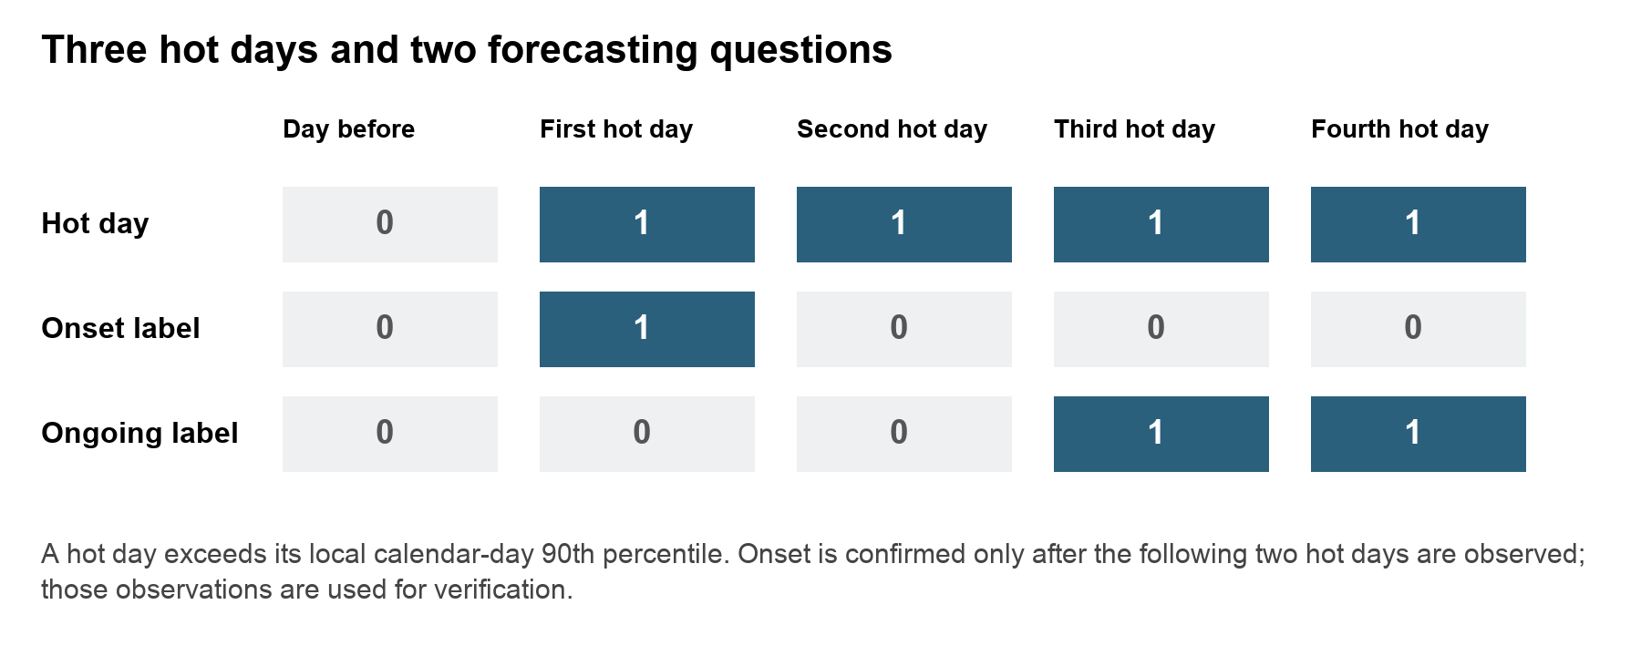
Figure 3.2 Hot day onset and ongoing event labels
Source: Project event definitions.
The 30-year reference predates validation and test records, keeping the event definition fixed across those periods [15]. It is intentionally not a study of adaptation to a moving contemporary normal. The spatial-grid experiment has a shorter training-only 2020–2022 reference and a wider calendar window. Its threshold is an experimental regional reference, so its scores are not directly comparable with the long-history experiment.

3.3 Spatial data preparation
The spatial dataset contains hourly ERA5 maximum-temperature inputs, mean sea-level pressure and surface soil moisture over 42 to 51 degrees north and 5 degrees west to 8 degrees east at 0.25-degree spacing. The resulting grid contains 37 by 53 cells. Complete UTC days are aggregated to maximum temperature in degrees Celsius and mean pressure and soil moisture. Partial days are excluded; the last complete available day is 10 August 2026.
The model uses seven consecutive daily inputs for a next-day ongoing target. Windows that cross missing days or seasonal gaps are excluded. The retained evaluation mask contains 1507 finite cells with training mean soil moisture above 0.001 cubic metres per cubic metre. This removes near-zero ocean encodings but is a documented proxy, not an official land-fraction mask. Scaling parameters use training records only.
Training uses 2020–2022, validation uses 2023–2024 and testing uses available 2025–2026 records. Local hot-day thresholds are estimated from training temperatures within a plus-or-minus 15-calendar-day window. The same dates, labels and retained cells are used for matched grid comparisons. A Paris point series forms its own comparison group.

3.4 Multi location weather histories
The seven-location dataset contains complete daily ERA5 records for Paris, London, Madrid, Rome, Athens, Berlin and Warsaw from 1 January 1981 to 31 December 2025. Open-Meteo requests explicitly select ERA5, UTC days and disabled elevation downscaling. The stored manifest records requested and returned coordinates, units, response hashes and prepared-data identity [13, 17, 21]. These are representative land grid cells associated with the named locations.
Six daily variables are maximum temperature, minimum temperature, mean sea-level pressure, top-layer soil moisture, mean relative humidity and precipitation. Quality checks require aligned dates, finite values, plausible physical ranges and minimum temperature no greater than maximum temperature. The experiment evaluates May–September targets while retaining the preceding observations and following verification days needed to construct valid sequences.
Training ends in 2016, validation spans 2017–2020 and the test spans 2021–2025. Target verification that could cross a chronological boundary is embargoed. Each test contains 765 target dates and 5355 location-days. The one-day test has 497 positive ongoing location-days and 155 exact onset events. Their different prevalence is retained in the interpretation of all metrics.

3.5 Predictor construction
Observation-history predictors end at target day minus lead. Tabular features include temperature anomalies and minimum temperature at lags 0, 1, 2, 3, 6 and 13 relative to that issue day. Full-feature variants also include pressure, soil moisture and humidity at those lags. Three-, seven- and fourteen-day anomaly means and precipitation sums describe recent persistence and moisture conditions. Anomaly change, the known target-day climate threshold, seasonal sine and cosine terms, latitude and longitude complete the feature set.
Temperature-only, no-soil and full-weather variants make input contribution testable. Known calendar thresholds and coordinates do not require future observed weather. The neural multi-location model receives fourteen daily steps with the six meteorological variables and a temperature anomaly, giving seven input features. Its standardization is fitted using training-era observations. Tests alter later records to verify that a target’s features remain unchanged.

3.6 Forecasting models and controls
The LSTM uses a single recurrent layer with 32 hidden units and a linear event-logit head. The point experiment has three channels and seven daily steps. The multi-location LSTM has seven features and fourteen daily steps. Although the recurrent class is shared, these configurations are different experiments and do not provide one common-data score.
The ConvLSTM retains the regional field in hidden and cell states. A three-by-three convolution maps the input and hidden channels into input, forget, output and candidate gates; the hidden width is 12. A one-by-one convolution produces cell logits. The no-soil ablation removes the soil channel while retaining the remaining spatial design. The experiment tests the predictive effect of that channel under one training setup.
Gradient boosting tests 7, 15 or 31 leaves and 180 iterations in the grid, using at most 250000 sampled training cell-days. Multi-location candidates test 7 or 15 leaves and 160 iterations across three feature sets. Both use learning rate 0.07 and L2 regularization 10. These are limited searches, not global optimization.
The multi-location logistic comparator standardizes tabular features and uses regularization C = 1. Neural training uses AdamW, weighted binary cross entropy, validation-loss checkpointing, gradient clipping and early stopping. Spatial neural runs allow at most 35 epochs with patience six; multi-location neural runs allow at most 20 epochs with patience four. Class weighting addresses imbalance in the loss, but does not guarantee calibrated output probabilities.
Persistence and climatology provide meaningful controls. In the spatial study, the categorical persistence control carries the preceding ongoing-event label forward. In the multi-location study, temperature persistence holds the latest observed daily maximum constant for unobserved future days and applies the event rule. Historical climatology estimates training-only seasonal event frequency. These are explicitly different persistence constructions, so baseline interpretation remains tied to each setting.

3.7 Model selection and fair comparisons
Spatial checkpoints and cutoffs use validation data, with the final grid method chosen by validation F1. Multi-location feature and leaf settings are chosen by validation macro-site F1, giving each location equal weight. Candidate classification cutoffs maximize pooled validation F1. Matched one-day logistic and LSTM comparisons use the same sites, targets and chronological periods; their reported champion is selected using validation performance.
A separate local-cutoff policy requires at least 20 positive validation cases at a location; otherwise the pooled cutoff applies. Both policies remain visible because local tuning can overfit sparse support or transfer poorly. Test outcomes do not determine the policy choice.
Model rankings are meaningful only within common conditions. The grid ConvLSTM and point LSTM have different spatial inputs. The reanalysis-history model and GFS replay have different availability assumptions and test years. A fair architecture-only experiment would give both neural methods the same variables, dates, spatial information, label, lead, preprocessing and training budget.

3.8 Archived numerical forecast timing
The issued-forecast study requests explicit GFS Global runs rather than a stitched latest-weather series [18]. Warning decisions occur at 00 UTC on issue day I. The selected run is initialized at 00 UTC on I−1 day, with an assumed publication allowance of twelve hours and a further twelve-hour buffer before the decision. Individual historical receipt timestamps are unavailable, so this is a documented replay assumption.
Targets occur at I+1, I+3 or I+7 days, corresponding to warning leads of 24, 72 and 168 hours. Because the run is already 24 hours old at issuance, initialization-to-target horizons are 48, 96 and 192 hours. Every required event day comes from that same run, including preceding days required by the event rule. No later run or retrospective ERA5 value fills a predictor.
Table 3.2 Timing for a target starting on 1 August 2026
Lead | Warning issue UTC | GFS initialization UTC | Initialization horizon
1 day | 31 July 00 | 30 July 00 | 48 hours
3 days | 29 July 00 | 28 July 00 | 96 hours
7 days | 25 July 00 | 24 July 00 | 192 hours

Development targets are 1 May–22 June 2026. Onset verification extends through 24 June. Under the conservative assumption that a complete ERA5 day becomes usable at D+6 00 UTC, the correction and cutoffs are frozen at 30 June. Common test targets are 8 July–30 September, ensuring that even seven-day warnings occur after that boundary. Of 53 nominal development dates, 50 remain after a missing archived run excludes three matched targets; all 85 test dates are retained.

3.9 Joint error adjustment and forecast refinement
Raw GFS applies the event rule directly to its deterministic temperature trajectory. The joint-error adjustment uses development vectors of ERA5-minus-GFS temperature errors over all event days. Adding a complete vector to the forecast preserves dependence across those days. The probability is the fraction of adjusted trajectories satisfying the event rule. These empirical scenarios are not independent physical weather-model ensemble members.
For development cutoff selection, the error bank excludes dates within seven calendar days of each held-out target. Test predictions use the full frozen development bank only. A pooled cutoff is selected from development outcomes. This design avoids using a test error vector to correct its own forecast, but assumes that early-summer errors remain useful later in the season.
The refinement experiment compares nine fixed alternatives: raw GFS; empirical error vectors scaled by 0.25, 0.5, 0.75 or 1; and pooled logistic margin models with C values 0.1 or 1, with and without balanced class weights. Margin inputs are forecast temperature minus the known local threshold over event days, together with their minimum, maximum, mean, standard deviation and consecutive changes.
Five contiguous development blocks supply held-out predictions. Each training set excludes every date within seven calendar days of the validation block, and whole location fields stay together. Scaling, residual banks and logistic fitting use only the remaining development records. Candidate and cutoff selection maximize macro-site F1 on combined out-of-fold development predictions; ties use development Brier and declared candidate order. Selection metadata is saved before test verification is accessed.
The refinement family was designed after the benchmark test outcomes had been inspected. Development-only fitting prevents direct label leakage, but cannot make that reused test untouched. Its results are therefore exploratory and require confirmation in another season. Every candidate remains reported, and a method is not promoted merely because it has a favourable test point estimate.

3.10 Metrics and uncertainty
Table 3.3 Measures used to evaluate forecasts
Measure | Interpretation | Main caution
Precision | Fraction of positive warnings that verify | Low precision means many false alerts
Recall | Fraction of true events detected | High recall can require many warnings
F1 | Harmonic balance of precision and recall | Depends on target prevalence and cutoff
Macro site F1 | Mean of location-specific F1 | Retain sparse and zero-event support
Average precision | Precision recall ranking summary | Use the event prevalence as context
ROC AUC | Ranking discrimination | Can remain high with poor alert precision
Brier score | Mean of probability minus outcome squared | Rare-event scores need a baseline
Brier skill | One minus model Brier over baseline Brier | Baseline must be stated and matched
Temperature MAE RMSE | Magnitude of forecast temperature error | Does not determine multi-day event accuracy
Episode detection | Whether any labelled ongoing day is detected | Does not establish advance onset warning

Paired temporal resampling retains whole spatial or location fields, preserving dependence among locations on a day. The additional audit uses full-length moving blocks of 3, 7 and 14 days within each contiguous season, keeping each season’s sample size and never crossing winter gaps. The same resampled records are used for a candidate and its baseline. Intervals condition on the fitted models and observed years; they do not capture all uncertainty from retraining or an unseen climate regime.
Reliability uses ten supported probability bins, retaining empty bins. Brier skill references historical climatology in the main audit and frozen development frequencies in refinement. These descriptive diagnostics do not establish calibration.

Chapter 4 Implementation Results and Discussion

4.1 Implementation and reproducibility
The implementation is organized as a Python package with separate modules for data preparation, model fitting, inference and evaluation. Saved arrays preserve the exact target-site records used in comparisons. Model bundles contain the fitted estimator or empirical residual bank, historical reference and cutoff. Forecast exports record issue time, target, lead, task, location, probability, decision and verification status.
Table 4.1 Main implementation components
Component | Implemented role
Data preparation | GRIB aggregation and daily-site acquisition; source hashes and units
Model development | LSTM ConvLSTM logistic and boosting training with chronological selection
Issued forecasts | Exact-run trajectory construction, correction and warning-time audit
Refinement study | Purged development folds, nine candidates and saved inference bundles
Validation audit | Reliability bins, Brier skill, episode detection and block sensitivity
Prospective capture | Actual receipt timestamps and separate delayed verification
Station validation | Quality checks, station-local reference and matched external diagnostics
Observatory | Location/date/lead/task inspection, temperature context and CSV exports

The recorded core model environment uses Python 3.13 with NumPy 2.5.2, pandas 2.3.3, scikit-learn 1.9.0, PyTorch 2.11.0, joblib 1.5.3 and requests 2.32.5. Version records support reconstruction, while source and data hashes identify the actual input artifacts. Neural results use the stated seed and checkpoint policy; repeating a deterministic tree seed alone would not measure sensitivity to the training sample.
The completed checks include 43 protocol and implementation tests. Artifact checks verify the saved research and issued-forecast models, labels, cutoffs and timing. All 3570 development-selected refinement probabilities reproduce from forecast-only arrays. Tests also remove or corrupt verification arrays and confirm that inference is unchanged. These checks establish implementation consistency, not forecasting accuracy on unobserved future data.

4.2 Spatial grid and point model results
Table 4.2 Spatial and Paris evaluation results
Model and scope | Val F1 | Test F1 | AP | Brier
Persistence grid | 0.5838 | 0.7822 | 0.6438 | 0.0633
Climatology grid | 0.0359 | 0.2541 | 0.1432 | 0.1385
ConvLSTM grid | 0.3643 | 0.5671 | 0.6045 | 0.0858
ConvLSTM no soil | 0.3687 | 0.5705 | 0.6438 | 0.0798
Gradient boosting grid | 0.7389 | 0.8505 | 0.8812 | 0.0390
Persistence Paris | 0.0000 | 0.8485 | 0.7436 | 0.0474
LSTM Paris | 0.5000 | 0.5505 | 0.5564 | 0.0994

Gradient boosting is the validation-selected grid method and reaches test F1 0.8505, compared with grid persistence 0.7822. Its conditional F1 interval is approximately 0.7733–0.9022, and the paired difference from persistence is 0.0152–0.1514 under the recorded seven-day block analysis. This supports an advantage for this fitted model and test interval within the spatial setting.
ConvLSTM reaches F1 0.5671, and the no-soil variant reaches 0.5705. Both remain below the matched grid persistence control. The small no-soil difference of about 0.0034 does not establish that soil moisture lacks physical relevance. The run has a short historical reference, a limited neural training search and one reported seed. The result is a predictive ablation under those conditions.
The Paris LSTM reaches F1 0.5505 while Paris persistence reaches 0.8485. Its point inputs and target series differ from the regional field supplied to ConvLSTM. Comparing 0.5505 with 0.5671 would therefore confound architecture with data support. The evidence supports separate within-scope comparisons, rather than a neural architecture ranking.
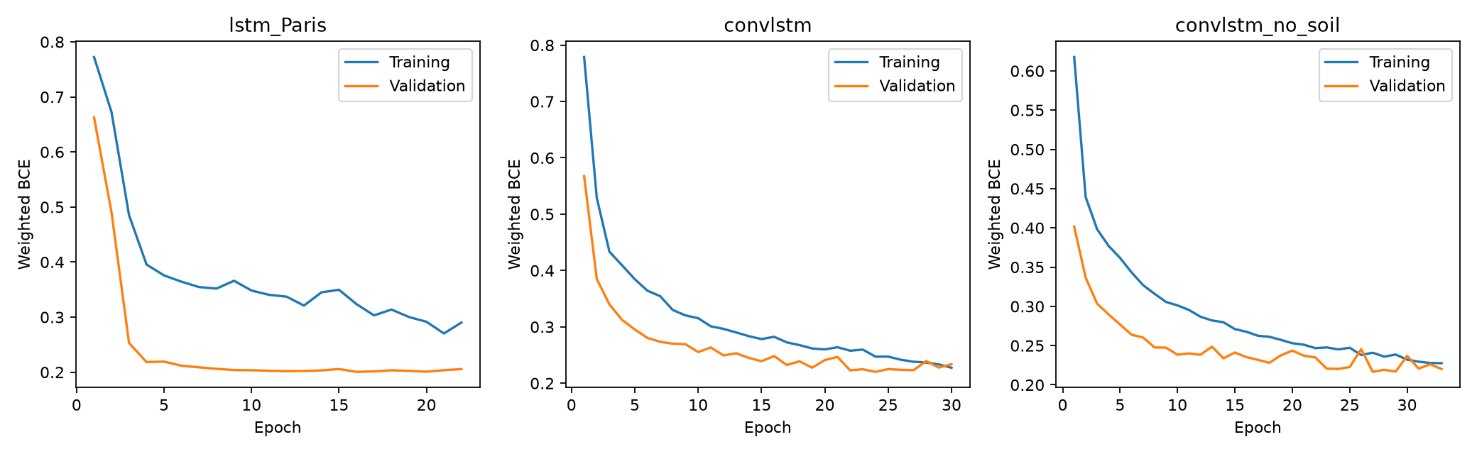
Figure 4.1 Training and validation histories for the recurrent grid and point models
Source: Saved spatial training histories.
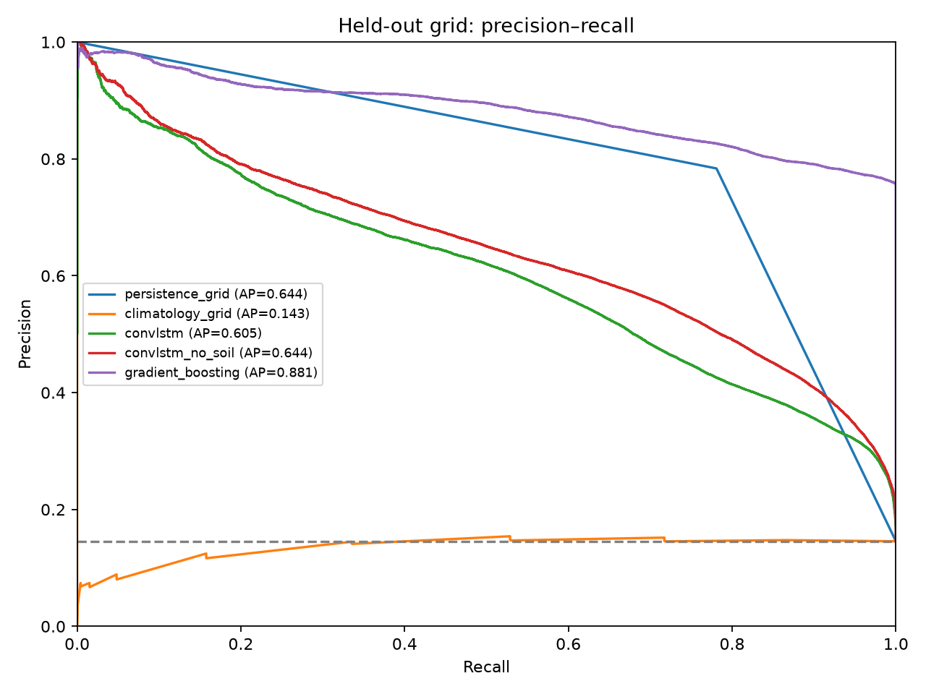
Figure 4.2 Precision recall performance in the spatial evaluation
Source: Saved spatial test predictions. Paris and grid curves retain separate scopes.

4.3 Spatial failures and case study
The regional audit retains event support and local performance instead of treating every cell as equally well evidenced. Four fixed geographic quadrants summarize spatial variation; these are descriptive bins rather than official climate regions. The south-west has F1 0.8050 and recall 0.9082, while the south-east has F1 0.8711 and recall 0.9325. Strong aggregate performance therefore coexists with weaker cells and different event frequencies.
Table 4.3 Spatial quadrant performance
Quadrant | Cells | F1 | Recall | Persistence F1
South west | 298 | .8050 | .9082 | .7166
South east | 381 | .8711 | .9325 | .7987
North west | 315 | .8386 | .9107 | .7783
North east | 513 | .8603 | .9541 | .8007

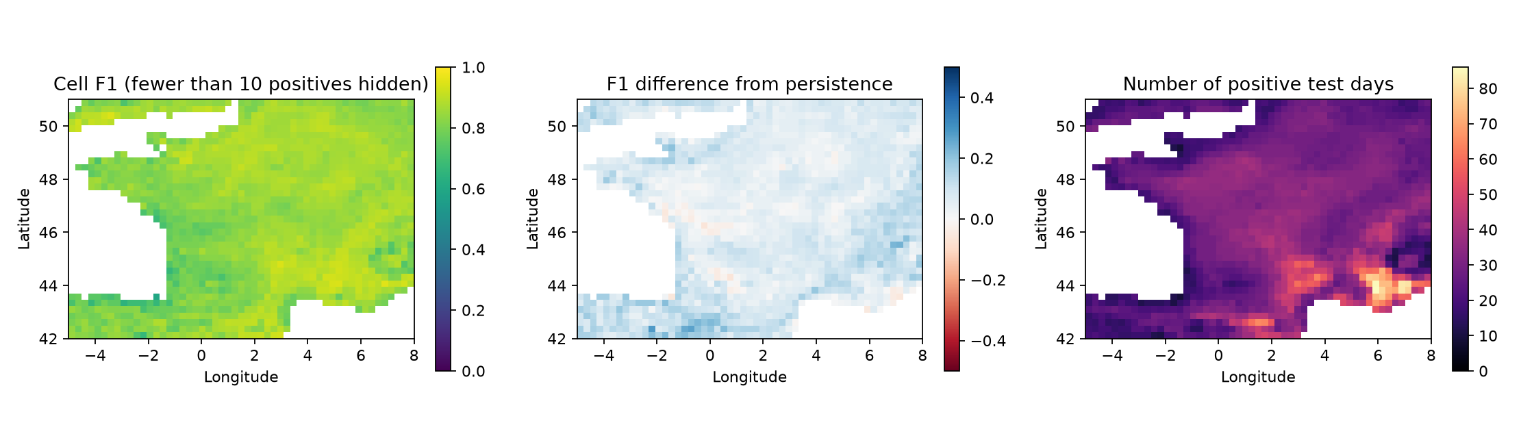
Figure 4.3 Spatial F1 difference from persistence and event support
Source: Cell-level regional audit. Cells with fewer than ten positives are hidden only in the F1 display.
Of 1507 evaluated cells, 1505 have at least ten positive test days. Among supported cells, the lowest reported F1 is 0.6000 at 43.5 degrees north and 1.75 degrees west, with twelve positive days. The map identifies where more representative local validation is needed; it does not justify tuning a replacement model on those same test errors.
The August case study selects the available day with greatest observed labelled extent, 10 August 2026. There are 163 observed event cells and 307 predicted cells, with intersection 157. These imply 150 false-positive cells, six missed cells and IoU 157 divided by 313, approximately 0.502. The model detects much of the observed footprint but overestimates its extent. The event was selected descriptively, so the case does not establish an unprecedented heatwave or a causal climate explanation.
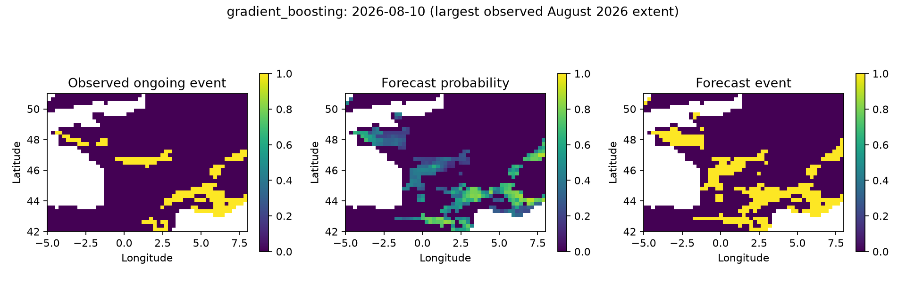
Figure 4.4 Observed and predicted event extent on 10 August 2026
Source: Saved descriptive August case study; date selected by observed event extent.

4.4 Matched multi location one day comparisons
Table 4.4 Matched one day methods at seven locations
Task and method | Val macro F1 | Test F1 | Macro F1 | AP | Brier
Ongoing boosting | .7992 | .8199 | .7988 | .8754 | .0248
Ongoing LSTM | .7344 | .7701 | .7431 | .7876 | .0375
Ongoing logistic | .6919 | .7250 | .6877 | .7275 | .0398
Onset boosting | .2926 | .2961 | .2921 | .2123 | .0256
Onset LSTM | .2243 | .2181 | .1955 | .1385 | .0375
Onset logistic | .1233 | .1137 | .1144 | .0560 | .0283

Gradient boosting leads the matched one-day methods by validation selection and reaches ongoing-event F1 0.8199. It detects 444 of 497 positive location-days, with 142 false alerts and 53 misses. Its precision is 0.7577 and recall 0.8934. The LSTM has higher recall 0.9235 but lower precision 0.6604, producing F1 0.7701. The comparison illustrates a practical alert tradeoff rather than neural superiority.
Onset is harder. Boosting detects 61 of 155 exact starts, with 196 false alerts and 94 misses. F1 is 0.2961 and precision is 0.2374. LSTM onset F1 is 0.2181, while logistic F1 is 0.1137. A high ROC AUC of 0.9123 for the boosting onset model does not remove the low alert precision at the selected cutoff.
Temperature persistence achieves ongoing F1 approximately 0.8043. The boosting advantage is only about 0.0157, and its paired block interval includes zero. We therefore cannot conclude that the apparent advantage is dependable across this sampled period. For one-day onset, boosting does exceed the much weaker persistence control under the recorded paired interval, but its absolute event performance remains limited.

4.5 Lead time and probability quality
Table 4.5 Gradient boosting performance across leads
Task and lead | F1 | Macro F1 | AP | ROC AUC | Brier
Ongoing 1 day | .8199 | .7988 | .8754 | .9895 | .0248
Ongoing 3 days | .4623 | .4168 | .4236 | .8888 | .0684
Ongoing 7 days | .2196 | .1678 | .1768 | .6489 | .0846
Onset 1 day | .2961 | .2921 | .2123 | .9123 | .0256
Onset 3 days | .0597 | .0546 | .0421 | .6083 | .0282
Onset 7 days | .0658 | .0613 | .0362 | .5692 | .0283

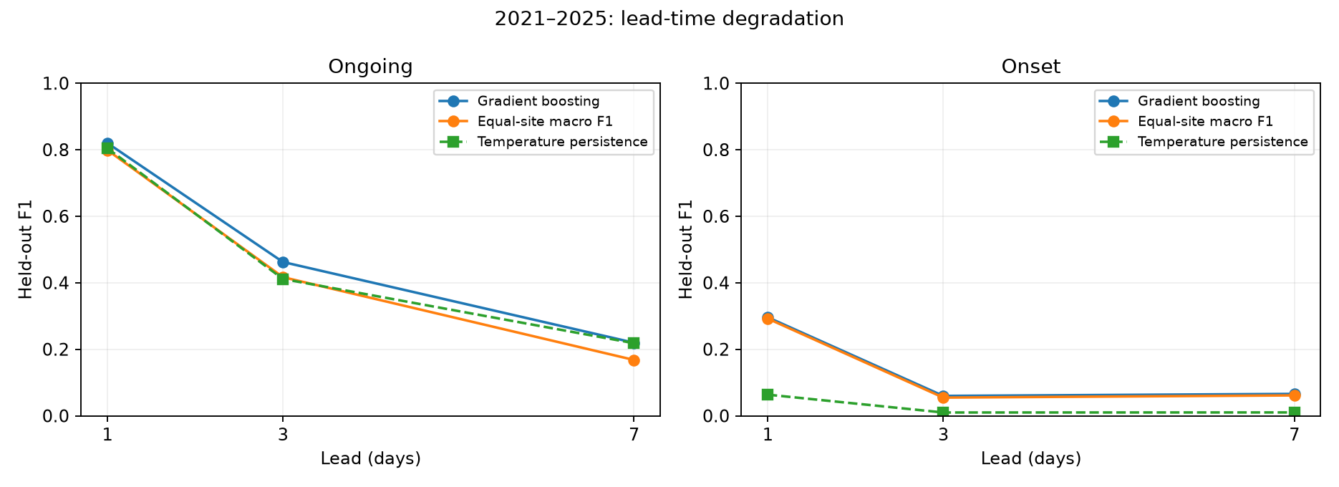
Figure 4.5 Event performance at one three and seven day leads
Source: Saved 2021–2025 multi-location test predictions and matched baselines.
Ongoing F1 falls from 0.8199 at one day to 0.4623 at three days and 0.2196 at seven days. At seven days, persistence and climatology are close to the boosting result. The observation-history model has limited information about future circulation changes, so a short-lead success cannot be presented as reliable week-ahead forecasting.
Onset F1 is low at both longer leads. Seven-day onset detects 48 events but produces 1256 false alerts, compared with 61 hits and 196 false alerts at one day. The larger hit count relative to three-day onset does not mean that seven-day warnings are better: the chosen cutoff changes the warning volume, and precision is only about 0.0368.
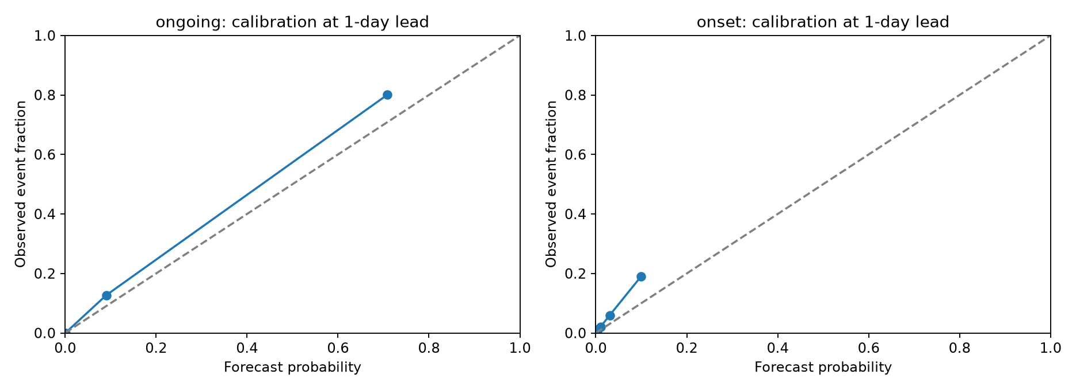
Figure 4.6 Probability reliability in the one day location models
Source: Saved probability calibration diagnostics; event rarity and bin support affect interpretation.
The audit compares Brier scores with the saved historical-climatology probabilities. Brier skill is about 0.718 for one-day ongoing boosting, 0.219 at three days and 0.035 at seven days. Onset Brier skill is about 0.097, 0.005 and 0.002, respectively. Long-lead onset probabilities therefore add little squared-error skill over that probability reference, even where ranking metrics appear above chance.

4.6 Regional annual and transfer results
Table 4.6 One day ongoing performance by location
Location | Positive days | F1 | Recall | Persistence F1
Paris | 55 | .8065 | .9091 | .7692
London | 64 | .7591 | .8125 | .7799
Madrid | 68 | .8054 | .8824 | .8095
Rome | 173 | .8852 | .9364 | .8819
Athens | 34 | .8421 | .9412 | .8000
Berlin | 36 | .6905 | .8056 | .6538
Warsaw | 67 | .8027 | .8806 | .7719

Rome has 173 positive ongoing days, compared with 34 in Athens and 36 in Berlin. A pooled score can therefore be influenced strongly by a high-support location. Berlin has the lowest one-day ongoing F1 at 0.6905. London’s boosting score is below its local persistence F1. Macro-site evaluation exposes these differences by assigning each location equal weight.
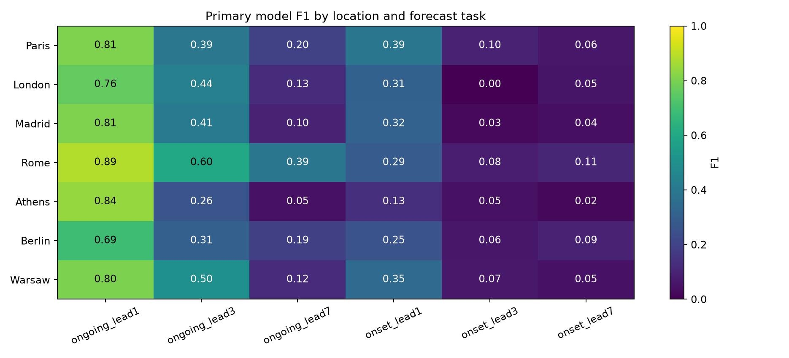
Figure 4.7 Regional skill across event types and forecast leads
Source: Saved multi-location regional metrics; each cell describes a representative location.
Local cutoffs do not consistently improve transfer. One-day ongoing macro F1 is 0.7988 with the pooled cutoff and 0.7903 with local cutoffs. One-day onset falls from 0.2921 to 0.2876. Small improvements at some longer leads do not justify selecting a policy with test scores. Sparse validation events and seasonal differences remain plausible sources of instability.
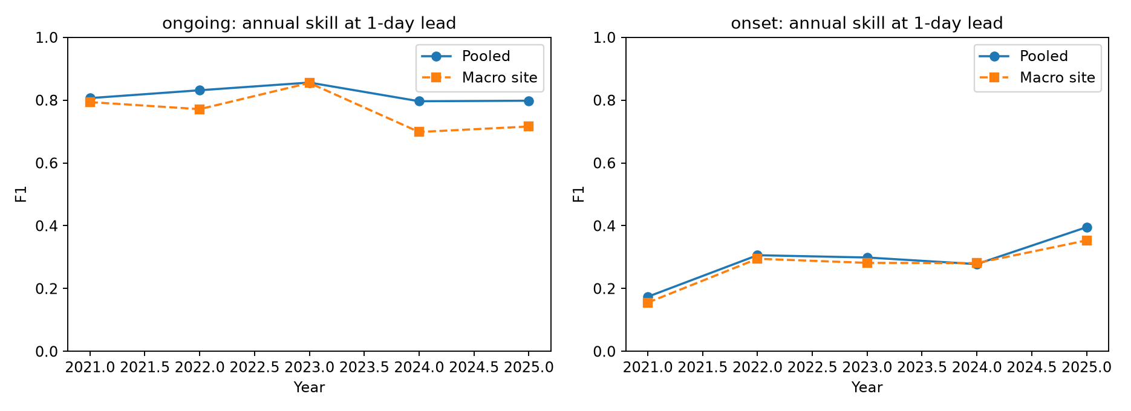
Figure 4.8 Annual pooled and equal site performance
Source: Saved annual metrics from 2021–2025.
An earlier temporal backtest uses training through 2012, validation 2013–2016 and testing 2017–2020. One-day ongoing F1 is 0.7735 and onset F1 is 0.2619. These results support reporting multiple periods, while their overlapping development histories mean that they are not independent replications. Training-sample sensitivity uses whole-day resamples with seeds 7, 21 and 42, preserving locations together.
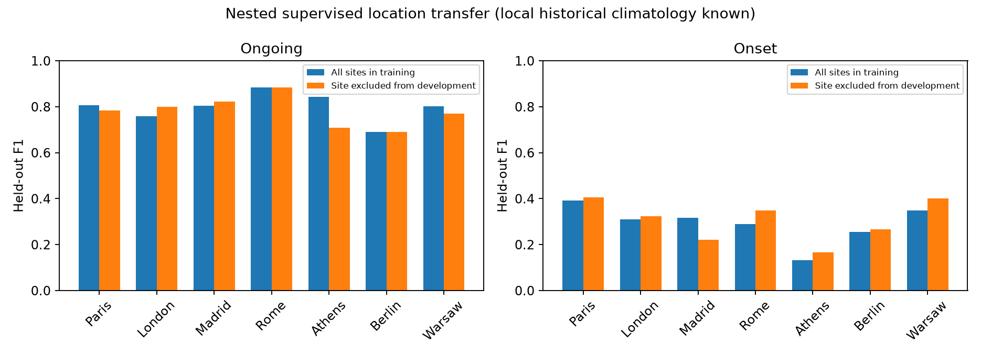
Figure 4.9 Supervised location holdout under known local climatology
Source: Saved nested location-holdout results; the omitted location retains its historical climate reference.
Each location-holdout run excludes that site from supervised training, feature and complexity selection, and cutoff tuning. Local 1981–2010 climatology is still available. Athens ongoing F1 changes from 0.8421 with all-site development to 0.7097 when omitted; Paris changes from 0.8065 to 0.7833. Other sites show smaller changes or occasional gains. This measures transfer to an omitted supervised location with known climate history, not transfer to a region without historical data.

4.7 Issued forecast replay results
Table 4.7 GFS replay event results
Task and lead | Raw F1 | Adjusted F1 | Adj precision | Adj recall | False alerts
Ongoing 1 day | 0.7715 | 0.7744 | 0.6398 | 0.9810 | 58
Ongoing 3 day | 0.7068 | 0.7132 | 0.5808 | 0.9238 | 70
Ongoing 7 day | 0.6259 | 0.5581 | 0.4017 | 0.9143 | 143
Onset 1 day | 0.3774 | 0.3896 | 0.2778 | 0.6522 | 39
Onset 3 day | 0.3077 | 0.3409 | 0.2308 | 0.6522 | 50
Onset 7 day | 0.1154 | 0.0833 | 0.0548 | 0.1739 | 69

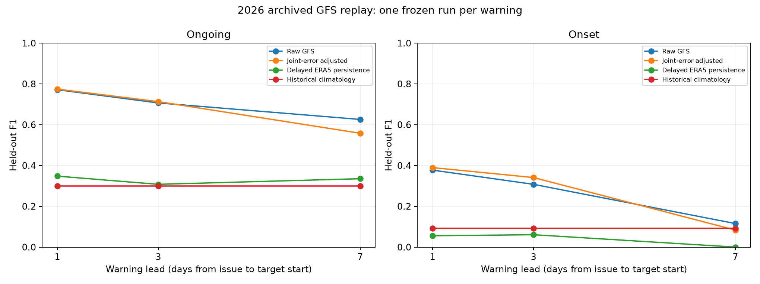
Figure 4.10 GFS warning skill at matched target dates and locations
Source: Saved issued-forecast comparisons for 85 target dates and seven locations.
The replay has 595 test location-days per task and lead, with 105 positive ongoing days and 23 onset events. Raw one-day GFS ongoing F1 is 0.7715; adjustment produces 0.7744. At three days the values are 0.7068 and 0.7132. These are small point gains, and their paired intervals include zero. They do not establish a dependable improvement.
At seven days, adjustment reduces ongoing F1 from 0.6259 to 0.5581. It raises hits from 87 to 96 but increases false alerts from 86 to 143. The recorded paired F1-difference interval, approximately −0.1131 to −0.0297, lies below zero. In this experiment the correction harms categorical performance despite improving some probability and detection measures.
For one-day onset, adjustment increases hits from 10 to 15 of 23 events, but false alerts rise from 20 to 39. F1 rises from 0.3774 to 0.3896, while precision falls. At three days onset F1 rises from 0.3077 to 0.3409 with an even larger warning volume. Seven-day onset remains poor and worsens after adjustment. These results show why correction cannot be judged by recall alone.
Raw target-day temperature MAE rises from about 1.59 degrees Celsius at one-day warning lead to 1.96 at three days and 3.01 at seven days. An event depends on the complete trajectory near a local threshold, so these temperature errors and multi-day dependence jointly influence warning outcomes. ERA5 remains a grid-based verification reference, not a station measurement.

4.8 Development selected forecast refinement
Table 4.8 Development selected refinement test results
Task lead days | Selected method | Selected F1 | Joint error F1 | Raw F1
Ongoing 1 | Error scale 0.25 | 0.7564 | 0.7744 | 0.7715
Onset 1 | Error scale 0.75 | 0.4478 | 0.3896 | 0.3774
Ongoing 3 | Logistic C 0.1 balanced | 0.6978 | 0.7132 | 0.7068
Onset 3 | Error scale 1 | 0.2143 | 0.3409 | 0.3077
Ongoing 7 | Logistic C 1 balanced | 0.5706 | 0.5581 | 0.6259
Onset 7 | Error scale 0.25 | 0.0488 | 0.0833 | 0.1154

The development-selected one-day onset method uses error scale 0.75 and reaches F1 0.4478. It retains 15 hits and eight misses while reducing false alerts from 39 to 29 relative to the benchmark adjustment. Precision increases from 0.2778 to 0.3409 at the same recall 0.6522. This is a favourable point result for alert efficiency on the reused test season.
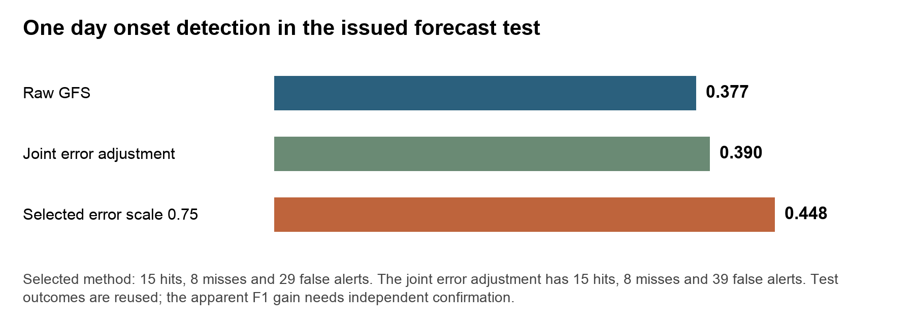
Figure 4.11 One day onset refinement and its false alert tradeoff
Source: Computed from saved GFS benchmark and refinement metrics on identical cases.
The gain has limits. Brier score increases from 0.03254 for the benchmark adjustment to 0.03433 for the selected refinement, so probability error worsens. The paired seven-day-block interval for F1 difference from raw GFS is approximately −0.0313 to 0.1963. Three- and fourteen-day block analyses also include zero. The result therefore motivates prospective testing rather than a claim of established improvement.
Most other selected candidates fail to outperform raw GFS. Seven-day ongoing F1 is 0.5706, above the benchmark adjustment’s 0.5581 but below raw GFS 0.6259. Three-day onset falls to 0.2143, and seven-day onset to 0.0488. The development period contains only 50 dates and differs seasonally from the test period. More complicated fitting and a changed selection policy do not remove that transfer problem.
All 54 candidate-task-lead evaluations remain available, including deterioration. The scale-one refinement is not numerically the same as the benchmark adjustment because its blocked development predictions and macro-site cutoff selection differ. Benchmark bundles remain available, and no universal replacement is justified by these outcomes.

4.9 Event level detection and reliability audit
Table 4.9 Event support detection and probability skill
Setting task lead days | Event support | Detected | Brier skill
ERA5 history ongoing 1 | 159 | 149 | 0.7176
ERA5 history ongoing 3 | 159 | 114 | 0.2192
ERA5 history ongoing 7 | 159 | 68 | 0.0352
ERA5 history onset 1 | 155 | 61 | 0.0974
ERA5 history onset 3 | 155 | 19 | 0.0054
ERA5 history onset 7 | 155 | 48 | 0.0022
GFS adjustment ongoing 1 | 25 | 23 | 0.7119
GFS adjustment ongoing 3 | 25 | 23 | 0.5861
GFS adjustment ongoing 7 | 25 | 23 | 0.4049
GFS adjustment onset 1 | 23 | 15 | 0.1409
GFS adjustment onset 3 | 23 | 15 | 0.1599
GFS adjustment onset 7 | 23 | 4 | -0.0800

An ongoing episode groups consecutive positive ongoing days at one location, without crossing gaps between seasons. A single long event therefore contributes one episode rather than many apparent independent successes. The one-day observation-history model detects at least one ongoing day in 149 of 159 labelled episodes. Exact onset detection remains 61 of 155 events. Episode detection is not an advance warning measure because the episode starts only on the third hot day, and season-boundary episodes may be truncated.
For the adjusted GFS replay, one-day ongoing detection covers 23 of 25 labelled episodes, while exact onset detection is 15 of 23. At seven days, the adjustment still detects 23 ongoing episodes but produces many false alerts. A favourable episode-detection fraction alone therefore cannot establish a useful warning policy.
Seven-day issued-onset Brier skill against saved historical climatology is approximately −0.080. That probability forecast is worse than its stated reference on squared probability error. The audit preserves site-level reliability bins so that low support and overconfident warnings can be examined. It also shows that the one-day ongoing boosting difference from persistence continues to include zero with 3-, 7- and 14-day block lengths.

4.10 Prospective capture and independent verification
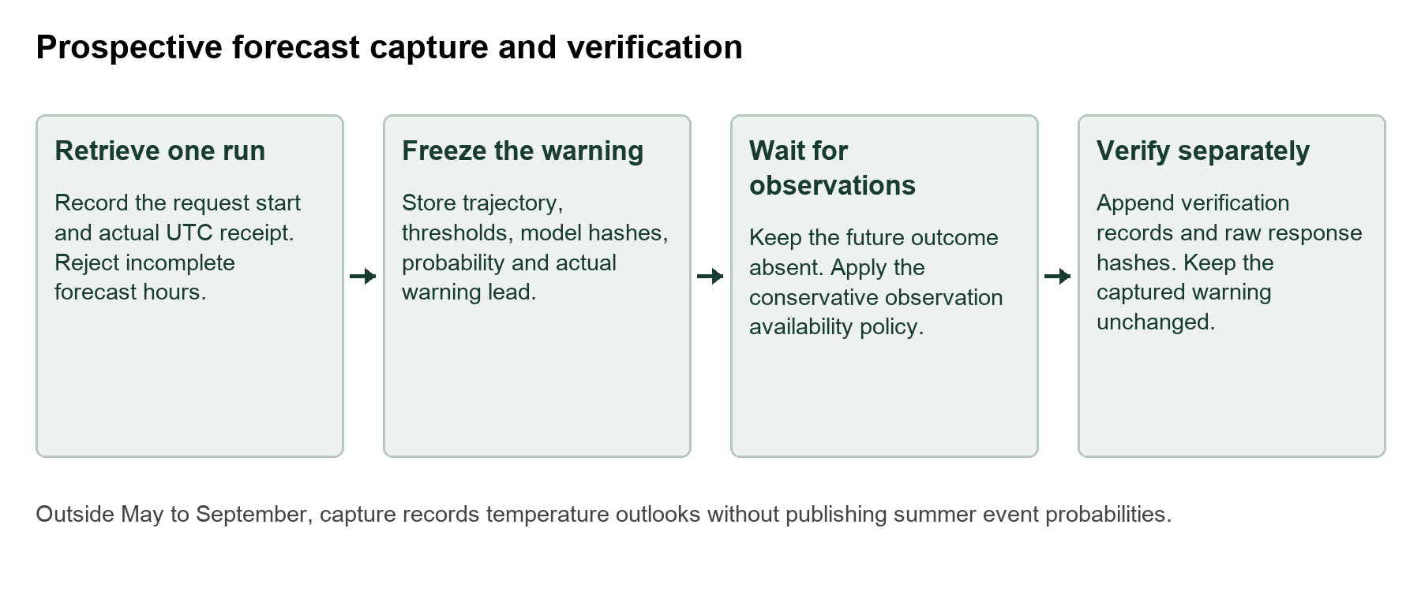
Figure 4.12 Actual receipt capture and later verification
Source: Implemented prospective capture and verification design.
The prospective module requests a single explicitly initialized GFS run and records the actual UTC request and receipt times. It preserves the raw response and hash, daily temperature trajectory, forecast targets and actual warning lead. Summer records also preserve the threshold trajectory, model-file hashes, probability and decision cutoff. The command does not accept a historical receipt timestamp, and repeated capture creates a separate record rather than overwriting an existing warning.
Targets start at least 24, 72 or 168 hours after actual receipt. Because receipt can occur during a UTC day, this differs from the replay’s assumed 00 UTC decision. The real horizon is recorded explicitly. Verification waits until the last required observation day plus six days, then writes a separate ERA5 response and result. It uses the threshold saved with the forecast, so a later model or reference change cannot silently alter the event definition.
A successful live capture saved 42 task-lead-location records. The receipt timestamp was 2 November 2026 at 18:35:42 UTC, equivalent to 3 November at approximately 00:05 IST. Because targets lie outside the evaluated May–September period, these records contain temperature outlooks without heatwave probabilities. This validates the capture pathway, not prospective summer warning skill. No automatic recurring capture schedule is installed, and local timestamps are not independent timestamp certification.
The independent-station adapter accepts provenance-backed daily observations with site, station identity, UTC date, maximum temperature and a quality flag. It requires a stable station identity and rejects duplicate dates, invalid values and incompatible daily definitions. A station-local 1981–2010 reference requires at least 90 percent quality-accepted daily coverage in every reference year and at least 100 samples per five-calendar-day percentile window. Missing or rejected event days are excluded with reasons.
Station outputs include matched cases, exclusion counts, temperature MAE, RMSE and bias, raw GFS event performance using station-local thresholds, and an explicitly labelled comparison of the grid-model probability against station events. That last comparison is an external target-transfer diagnostic, since the probability was developed for an ERA5 grid event. No independent station result is claimed: the adapter has been tested, but real compatible station data are still needed.

4.11 Findings and practical interpretation
The central finding is that event continuation, event onset and probability quality answer different questions. Boosting performs well for one-day ongoing heat in the multi-location benchmark, but detecting a first-day event remains difficult. Numerical forecasts supply future temperature trajectories, yet empirical correction can increase false alerts and fail across seasons or leads. The refinement experiment improves one onset point score without improving all probability metrics or all leads.
The system helps by making these differences inspectable. A researcher can reconstruct the exact run, observe when the warning would have been issued, compare the trajectory with local thresholds and count the missed and false warnings. Regional and episode audits help direct data collection. The observatory supports explanation and CSV access, while the research evidence comes from saved predictions and verification rather than interface appearance.

Chapter 5 Conclusions and Scope for Further Work

5.1 Conclusions against the research questions
RQ1 concerned ongoing heat prediction. Gradient boosting leads the matched spatial evaluation and reaches F1 0.8505, above grid persistence 0.7822. In the seven-location benchmark it reaches 0.8199, while the LSTM reaches 0.7701. The latter setting’s apparent boosting advantage over temperature persistence is not established by its paired uncertainty analysis. Strong performance therefore remains conditional on the target, period and baseline.
RQ2 concerned onset. One-day multi-location onset F1 is 0.2961, much lower than ongoing F1 0.8199. The issued-forecast adjustment detects 15 of 23 onset events at one-day lead but produces 39 false alerts. A selected empirical refinement reduces those false alerts to 29 while retaining the hits; its F1 of 0.4478 is promising, but reused-test status, worse Brier score and intervals crossing zero prevent a stronger generalization claim.
RQ3 concerned lead and geography. One-day performance does not transfer to a week ahead, and pooled metrics conceal regional differences. Berlin has weaker one-day ongoing F1 than Rome; London remains below its own persistence control. Local cutoffs and supervised location holdout have mixed outcomes. These findings justify reporting site support, annual variation and uncertainty alongside a headline score.
RQ4 concerned advance warnings from dated numerical forecasts. The GFS replay demonstrates a reproducible warning experiment using one initialized run and an explicit availability policy. It does not establish historical delivery uptime. Actual-receipt capture provides a path to prospective evidence, but the recorded off-season capture is not a verified summer warning result.
RQ5 concerned refinement. A fixed candidate family and purged development selection do not guarantee better test performance. Most selected alternatives remain below raw GFS. The negative outcomes are useful evidence about limited development support and seasonal transfer, and they discourage replacing a baseline on the basis of a favourable isolated result.
RQ6 concerned practical use. HeatCast supplies the software needed to capture forecasts before outcomes and to evaluate compatible independent stations. Operational usefulness still requires a prospective season, stable receipt and missing-run policies, station evidence and a clearly defined decision cost. No health or public-safety outcome was measured in this project.

5.2 Contributions of the completed project
The project brings local event construction, observation-history learning, numerical-forecast replay and verification into one auditable workflow. It includes separate onset and ongoing targets; chronological selection; matched neural, linear, tree and meteorological comparisons; a soil-moisture ablation; spatial and temporal diagnostics; probability references; episode counts; and reproducible inference bundles.
The contribution is also empirical. The results show when a simple baseline remains strong, where a recurrent model underperforms, and how a correction can improve recall while harming alert precision. The work documents these failures with the same detail as favourable scores. This provides a defensible basis for subsequent experiments rather than an unsupported claim of a universally best model.

5.3 Limitations
The spatial experiment uses a short training-derived threshold reference, a soil-moisture proxy mask and incomplete annual coverage in its final available summer. The multi-location experiment covers seven representative cells rather than the continent. Northern Europe is not adequately validated, and the project does not establish station accuracy, transfer to another continent or prediction of human heat exposure.
Neural experiments use a limited model search and one reported training seed. Conditional block intervals account for dependence in the available test records but do not include all model-training, observation or between-year uncertainty. Overlapping development histories also limit the independence of temporal checks. A common-input comparison of LSTM and ConvLSTM remains necessary to isolate architecture.
The GFS replay contains one season with early-summer development and later-summer testing. Historical receipt times are assumed, forecasts are deliberately 24 hours old at issue, and verification uses ERA5 rather than independent observations. Forecast grids may differ from verification grids. Empirical residual scenarios assume transferable errors and are not a physical ensemble or calibration guarantee.
The forecast-refinement test was already inspected when the candidate family was designed. Development-only selection does not remove that retrospective design dependence. Prospective logging has been exercised outside summer, but a complete prospective season has not been collected. The station-verification adapter requires independent observations before its output can become new evidence.

5.4 Further experiments and completion criteria
Table 5.1 Further work and evidence required for completion
Priority | Experiment or task | Completion evidence
High | Collect a prospective summer | Actual receipt logs, frozen warnings, separate outcomes and missing-run coverage
High | Verify independent stations | Compatible UTC daily observations, station history, local reference and support counts
High | Strengthen onset prediction | Frozen candidate protocol and confirmation on another untouched season
High | Compare neural architectures fairly | Same inputs targets spatial support budgets and at least five recorded seeds
Medium | Broaden geography | Complete northern and climate-zone data with held-out-region evaluation
Medium | Assess forecast ensembles | Archived member trajectories and calibrated event probability verification
Medium | Test reference sensitivity | Predeclared percentile duration and climate-reference alternatives

A controlled neural comparison should supply LSTM and ConvLSTM with the same seven-day regional information and target records. A flattened field gives LSTM the same information set, while ConvLSTM retains the grid structure. Identical local patches with centre-cell outputs are another defensible design if compute is constrained. Parameter counts, tuning trials, training time, seeds and paired outputs must be reported. A point-only LSTM against a spatial ConvLSTM answers a different, information-plus-architecture question.
The onset work should focus on forecast-based predictors that describe the approach and persistence of heat, together with more representative development seasons. Any calibration or alert-cost policy should be fitted on development data and confirmed independently. A reduction in false alerts must be evaluated alongside misses and lead, rather than assuming that a higher F1 defines the best public-warning decision.
Independent stations require careful temporal alignment, quality control and station history. Elevation, urban exposure, relocations and changing instruments can affect comparisons. The supplied adapter deliberately enforces one stated UTC daily definition and stable identities. Additional designs for local-day or morning-to-morning maxima must be documented separately, rather than silently mixing them into the current event reference.
Broader geographic coverage and additional years would test whether the observed results depend on the selected locations and season. Ensemble forecasts could support physical uncertainty estimates if member identity and initialization are preserved. Neither adding locations nor adding model complexity should bypass matched-case verification, support counts or an untouched confirmation set.

5.5 Overall conclusion
We built HeatCast to answer whether sustained heat can be predicted with traceable inputs, useful warning leads and transparent errors. The implemented system demonstrates strong short-lead ongoing-event performance in some settings, weaker exact-onset detection, marked lead-time degradation and mixed effects from forecast correction. It also provides the tools needed to investigate those outcomes and collect stronger evidence. The project’s value is a reproducible and inspectable account of what was predicted, when it could have been known, what actually occurred and what remains to be tested.

References
References 1 to 12 are IEEE journal articles used in the literature review. Supporting research and documentation follow. Reported HeatCast scores are supported by the project records listed in Appendix A.
[1] M. Yu, F. Xu, W. Hu, J. Sun, and G. Cervone, “Using Long Short-Term Memory (LSTM) and Internet of Things (IoT) for Localized Surface Temperature Forecasting in an Urban Environment,” IEEE Access, vol. 9, pp. 137406–137418, 2021.
https://doi.org/10.1109/ACCESS.2021.3116809
[2] M. A. R. Suleman and S. Shridevi, “Short-Term Weather Forecasting Using Spatial Feature Attention Based LSTM Model,” IEEE Access, vol. 10, pp. 82456–82468, 2022.
https://doi.org/10.1109/ACCESS.2022.3196381
[3] S. F. Tekin, A. Fazla, and S. S. Kozat, “Numerical Weather Forecasting Using Convolutional-LSTM With Attention and Context Matcher Mechanisms,” IEEE Transactions on Geoscience and Remote Sensing, vol. 62, art. 4105313, pp. 1–13, 2024.
https://doi.org/10.1109/TGRS.2024.3409084
[4] N. Harilal, M. Singh, and U. Bhatia, “Augmented Convolutional LSTMs for Generation of High-Resolution Climate Change Projections,” IEEE Access, vol. 9, pp. 25208–25218, 2021.
https://doi.org/10.1109/ACCESS.2021.3057500
[5] D. S. Rodrigues, A. N. Caseri, and S. Pesco, “A Hybrid Spatiotemporal Approach for Severe Rainfall Nowcasting Using Kriging and Recurrent Neural Networks,” IEEE Geoscience and Remote Sensing Letters, vol. 23, art. 7507205, 2026.
https://doi.org/10.1109/LGRS.2026.3727525
[6] C. Luo, X. Li, and Y. Ye, “PFST-LSTM: A SpatioTemporal LSTM Model With Pseudoflow Prediction for Precipitation Nowcasting,” IEEE Journal of Selected Topics in Applied Earth Observations and Remote Sensing, vol. 14, pp. 843–857, 2021. Online publication 26 November 2020.
https://doi.org/10.1109/JSTARS.2020.3040648
[7] T. Xiong, J. He, H. Wang, X. Tang, Z. Shi, and Q. Zeng, “Contextual Sa-Attention Convolutional LSTM for Precipitation Nowcasting: A Spatiotemporal Sequence Forecasting View,” IEEE Journal of Selected Topics in Applied Earth Observations and Remote Sensing, vol. 14, pp. 12479–12491, 2021.
https://doi.org/10.1109/JSTARS.2021.3128522
[8] Z. Ma, H. Zhang, and J. Liu, “PrecipLSTM: A Meteorological Spatiotemporal LSTM for Precipitation Nowcasting,” IEEE Transactions on Geoscience and Remote Sensing, vol. 60, pp. 1–8, 2022.
https://doi.org/10.1109/TGRS.2022.3198222
[9] M. R. Ehsani, A. Zarei, H. V. Gupta, K. Barnard, E. Lyons, and A. Behrangi, “NowCasting-Nets: Representation Learning to Mitigate Latency Gap of Satellite Precipitation Products Using Convolutional and Recurrent Neural Networks,” IEEE Transactions on Geoscience and Remote Sensing, vol. 60, pp. 1–21, 2022.
https://doi.org/10.1109/TGRS.2022.3158888
[10] D. Niu, Y. Li, H. Wang, Z. Zang, M. Jiang, X. Chen, and Q. Huang, “FsrGAN: A Satellite and Radar-Based Fusion Prediction Network for Precipitation Nowcasting,” IEEE Journal of Selected Topics in Applied Earth Observations and Remote Sensing, vol. 17, pp. 7002–7013, 2024.
https://doi.org/10.1109/JSTARS.2024.3376987
[11] L. Fan, C. Zhou, and F. Neri, “MT-GAN: A Multitask GAN for Severe Convective Weather Nowcasting,” IEEE Geoscience and Remote Sensing Letters, vol. 22, art. 1000605, pp. 1–5, 2025. Online publication 25 December 2024.
https://doi.org/10.1109/LGRS.2024.3522463
[12] M. S. Pavithran, B. Sreeram, A. V. Pillai, and R. Jothi, “Multi-Scale Weather Forecasting Using Deep Learning Architectures With Chennai Climate Data,” IEEE Access, vol. 13, pp. 207303–207319, 2025.
https://doi.org/10.1109/ACCESS.2025.3640667
[13] H. Hersbach et al., “The ERA5 global reanalysis,” Quarterly Journal of the Royal Meteorological Society, vol. 146, pp. 1999–2049, 2020.
https://doi.org/10.1002/qj.3803
[14] X. Shi, Z. Chen, H. Wang, D.-Y. Yeung, W.-K. Wong, and W.-C. Woo, “Convolutional LSTM Network: A Machine Learning Approach for Precipitation Nowcasting,” Advances in Neural Information Processing Systems, vol. 28, 2015. Conference paper.
https://arxiv.org/abs/1506.04214
[15] World Meteorological Organization, “WMO Climatological Normals.”
https://wmo.int/wmo-climatological-normals
[16] Environment and Climate Change Canada, “Definitions of the core climate extreme indices.”
https://climate-scenarios.canada.ca/?page=climdex-indices
[17] Open-Meteo, “Historical Weather API.” Fixed-model and aggregation documentation.
https://open-meteo.com/en/docs/historical-weather-api
[18] Open-Meteo, “Single Runs API.” Initialization, archive coverage and hindcast documentation.
https://open-meteo.com/en/docs/single-runs-api
[19] D. R. Roberts et al., “Cross-validation strategies for data with temporal, spatial, hierarchical, or phylogenetic structure,” Ecography, vol. 40, pp. 913–929, 2017.
https://doi.org/10.1111/ecog.02881
[20] T. Dimitriadis, T. Gneiting, A. I. Jordan, and P. Vogel, “Evaluating probabilistic classifiers: The triptych,” International Journal of Forecasting, vol. 40, pp. 1101–1122, 2024.
https://doi.org/10.1016/j.ijforecast.2023.09.007
[21] Copernicus Climate Change Service, “ERA5 hourly data on single levels from 1940 to present.” Dataset documentation.
https://cds.climate.copernicus.eu/datasets/reanalysis-era5-single-levels
[22] Copernicus Climate Change Service, “Climate reanalysis.” ERA5 and publication-delay background. The precise replay delay is a project assumption.
https://climate.copernicus.eu/climate-reanalysis

Appendix A Project Source Register and Reproduction
The following project records identify the measured results and implemented procedures. Each evaluation retains its own data definition and comparison conditions. Source hashes and protocol snapshots accompany the saved artifacts.
Table A.1 Project records supporting the report
Record | Evidence supplied
results/metrics.json and REPORT.md | Spatial and Paris model scores, split support and recorded uncertainty
results/research/metrics.json | Multi-location selection, baselines, matched comparisons and robustness
results/research regional and annual CSV files | Location support, annual variation, feature policies and supervised holdout
results/issued_forecasts/metrics.json | GFS timing, event counts, temperature error and paired uncertainty
results/improvement_study/metrics.json | All candidates, development choice, reliability and exploratory inference
results/validation_audit/metrics.json | Episode support, reliability and multiple block-length diagnostics
Data manifests and protocol snapshots | Requested and returned coordinates, units, hashes and evaluation rules
heatcast/prospective.py | Actual-receipt capture and separate verification
heatcast/station_validation.py | Independent-station data contract and matched verification checks
tests and artifact checks | Leakage, timing, label, model reproduction and input isolation checks

A.1 Reproduction commands
python3 -m unittest discover -s tests -v
python3 tests/check_research_artifacts.py
python3 tests/check_issued_artifacts.py
python3 -m heatcast.improvement_study --check
python3 -m heatcast.validation_audit
python3 -m heatcast.prospective capture
python3 -m heatcast.prospective verify data/prospective/CAPTURE_ID
python3 -m heatcast.station_validation --observations station_daily.csv --provenance station_provenance.json

Appendix B Evidence and Implementation Status
Table B.1 Completed work and remaining scientific evidence
Area | Completed | Remaining
Historical modelling | Fitted spatial and multi-location models with matched controls | Independent architecture comparison and broader repeated fits
Issued forecast study | One-season replay using initialized runs and explicit timing | Historical receipt certification and further seasons
Refinement | Nine candidates per task and lead with purged development selection | Untouched confirmation of any favourable result
Probability audit | Brier references and supported reliability bins | Independent calibration confirmation
Event audit | Ongoing episodes and exact onset counts | More seasons and boundary-complete episodes
Prospective workflow | Actual-receipt software and one successful off-season capture | A complete summer with verification
Independent stations | Quality-controlled CSV adapter and reference checks | Compatible independent observations
Geographic coverage | Seven representative European locations and grid diagnostics | Northern and wider regional validation

The status separates software capability from scientific evidence. A passing test shows that a procedure behaves as specified on its test cases; it does not create observations or prove forecast usefulness. The report therefore retains negative results, sparse support and incomplete evidence as part of the findings.

