

HeatCast Heatwave Forecasting
and Comparative Evaluation
Honours Project Report
Submitted in partial fulfilment of the requirements for the degree of
Bachelor of Technology
Computer and Communication Engineering
with Honours in Data Science and Emerging Analytics
Submitted by
Anish Animesh Sahu 16014123011
Aryan Sanganti 16014123014
Ayush More 16014123017
Shashank Dubey 16014123044
Under the guidance of
Dr. Kiran Vishvas Ajetrao
K. J. Somaiya School of Engineering
Somaiya Vidyavihar University
Vidyavihar Mumbai 400077
Academic year 2026 to 2027
November 2026

Certificate
This is to certify that the project report entitled HeatCast Heatwave Forecasting and Comparative Evaluation records the work carried out by Anish Animesh Sahu, Aryan Sanganti, Ayush More and Shashank Dubey in partial fulfilment of the requirements for the degree of Bachelor of Technology in Computer and Communication Engineering with Honours in Data Science and Emerging Analytics at Somaiya Vidyavihar University during the academic year 2026 to 2027.
The project was carried out under the guidance of Dr. Kiran Vishvas Ajetrao. The report presents the problem addressed, system design, implemented forecasting methods, experimental results and conclusions for academic examination.
Project Guide Head of the Department
Dr. Kiran Vishvas Ajetrao
Principal or Dean
Date ____________________
Place ___________________

Declaration
We declare that HeatCast Heatwave Forecasting and Comparative Evaluation is our own project work, carried out under the guidance of Dr. Kiran Vishvas Ajetrao. Except for material explicitly cited or acknowledged, the design, implementation, analysis and report are our work. We acknowledge the publications, weather datasets, software and external services used in the project and accept responsibility for the reported findings.
The report distinguishes measured results from interpretation and proposed work. Comparisons between methods are limited to their stated data, spatial domain, target, forecast lead and evaluation period. Prospective forecast logging and station-verification software are described according to their implemented capabilities; results requiring future observations or independent station records are not presented as completed evidence.
We submit this report in partial fulfilment of the requirements for the degree of Bachelor of Technology in Computer and Communication Engineering with Honours in Data Science and Emerging Analytics at Somaiya Vidyavihar University.
Anish Animesh Sahu 16014123011
Signature ____________________
Aryan Sanganti 16014123014
Signature ____________________
Ayush More 16014123017
Signature ____________________
Shashank Dubey 16014123044
Signature ____________________
Date ____________________
Place ___________________

Certificate of Approval of Examiners
The project report entitled HeatCast Heatwave Forecasting and Comparative Evaluation, submitted by Anish Animesh Sahu, Aryan Sanganti, Ayush More and Shashank Dubey for the degree of Bachelor of Technology in Computer and Communication Engineering with Honours in Data Science and Emerging Analytics, is submitted for examination by the undersigned.
Internal Examiner
Name ______________________________
Signature __________________________
External Examiner
Name ______________________________
Signature __________________________
Project Guide
Dr. Kiran Vishvas Ajetrao
Signature __________________________
Date ____________________
Place ___________________

Acknowledgements
We thank Dr. Kiran Vishvas Ajetrao for guidance throughout the project and for emphasizing a clear research problem, careful literature review and fair comparison of forecasting methods. We acknowledge the academic support of the Department and K. J. Somaiya School of Engineering at Somaiya Vidyavihar University.
We acknowledge the Copernicus Climate Change Service and ECMWF for ERA5 reanalysis, NOAA for GFS forecasts, and Open-Meteo for the documented interfaces used to retrieve weather data. We also acknowledge the researchers whose work on recurrent networks, meteorological prediction and forecast evaluation informed the project.
The project depends on open scientific software for data processing, model development, verification and visualization. We remain responsible for the experimental choices, interpretation of results and conclusions presented in this report.

Abstract
HeatCast investigates how a forecasting system can identify sustained hot conditions and anticipate the first day of a heatwave while making its warning timing and errors visible. We built a reproducible workflow that prepares meteorological data, defines local heat events, trains and compares forecasting methods, reconstructs warnings from dated numerical forecasts and evaluates outcomes by location, lead time and event type. The study combines a France-centred spatial evaluation, a seven-location European benchmark using ERA5 daily histories from 1981 to 2025, and a 2026 replay of explicitly initialized GFS runs.
A hot day exceeds a local calendar-day 90th-percentile threshold. The long-history experiments use a fixed 1981 to 2010 reference. Ongoing events are the third or later consecutive hot days; onset is the first day of a run lasting at least three days. We evaluate these tasks separately at one-, three- and seven-day leads. Models include LSTM, ConvLSTM, logistic regression, gradient boosting, persistence and climatology. Chronological development, validation-only cutoff selection, regional support counts and paired temporal blocks control the interpretation of results.
In the spatial evaluation, gradient boosting achieves F1 0.8505 against persistence 0.7822, while the ConvLSTM reaches 0.5671. In matched seven-location one-day tests, boosting achieves F1 0.8199 for ongoing events and 0.2961 for onset; corresponding LSTM results are 0.7701 and 0.2181. Ongoing boosting performance declines to 0.2196 at seven days. In the GFS replay, joint-error adjustment reaches one-day onset F1 0.3896 but reduces seven-day ongoing F1 from raw GFS 0.6259 to 0.5581. A development-selected refinement produces one-day onset F1 0.4478, reducing false alerts from 39 to 29 while retaining 15 hits. Its probability Brier score worsens, and uncertainty does not establish a reliable gain over raw GFS.
The project delivers trained models, auditable predictions, research diagnostics, an interactive observatory, prospective capture software and a station-validation adapter. Its findings show that recognizing an ongoing event is substantially easier than warning of onset, that simple baselines remain competitive, and that correction must be evaluated separately at each lead. The evidence supports research and transparent forecast inspection; independent station validation, wider geographic coverage and a future summer of prospective verification remain necessary.
Keywords: heatwave forecasting; ERA5; GFS; LSTM; ConvLSTM; gradient boosting; onset prediction; probabilistic verification.

Contents
Chapter 1 Introduction 1
1.1 Background and motivation 1
1.2 Problem statement 1
1.3 Aim and objectives 1
1.4 Research questions 2
1.5 Scope and experimental boundaries 3
1.6 Project deliverables and practical value 3
Chapter 2 Literature Review and Research Background 4
2.1 Review focus 4
2.2 Temporal modelling and localized temperature 4
2.3 Spatial recurrence and meteorological context 5
2.4 Extreme event verification and data availability 6
2.5 Research gaps and project response 6
2.6 Heatwave definitions and warning practice 7
2.7 Heatwave prediction and useful comparators 8
2.8 Numerical forecast post processing and contribution 8
Chapter 3 System Design and Methodology 10
3.1 System architecture 10
3.2 Event definition and local reference 12
3.3 Spatial data preparation 12
3.4 Multi location weather histories 13
3.5 Predictor construction 13
3.6 Forecasting models and controls 13
3.7 Model selection and fair comparisons 15
3.8 Archived numerical forecast timing 16
3.9 Joint error adjustment and forecast refinement 16
3.10 Metrics and uncertainty 17
3.11 Sample support and inferential precision 18
Chapter 4 Implementation Results and Discussion 19
4.1 Implementation and reproducibility 19
4.2 Spatial grid and point model results 20
4.3 Spatial failures and case study 21
4.4 Matched multi location one day comparisons 22
4.5 Lead time and probability quality 23
4.6 Regional annual and transfer results 25
4.7 Issued forecast replay results 27
4.8 Development selected forecast refinement 28
4.9 Event level detection and reliability audit 29
4.10 Prospective capture and independent verification 30
4.11 Error diagnosis and traced forecast cases 31
4.12 Neural training variability 33
4.13 Observatory implementation evidence 34
4.14 Summary of measured outcomes 35
4.15 Findings and practical interpretation 35
Chapter 5 Conclusions and Scope for Further Work 36
5.1 Conclusions against the research questions 36
5.2 Contributions of the completed project 36
5.3 Limitations 37
5.4 Further experiments and completion criteria 37
5.5 Overall conclusion 38
References 39
Appendix A Project Source Register and Reproduction 43
A.1 Reproduction commands 43
Appendix B Evidence and Implementation Status 44

List of Figures
Figure 3.1 HeatCast data prediction and verification workflow 10
Figure 3.2 Module level architecture and data interfaces 10
Figure 3.3 Hot day onset and ongoing event labels 12
Figure 4.1 Training and validation histories for the recurrent grid and point models 20
Figure 4.2 Precision recall performance in the spatial evaluation 21
Figure 4.3 Spatial F1 difference from persistence and event support 22
Figure 4.4 Observed and predicted event extent on 10 August 2026 22
Figure 4.5 Event performance at one three and seven day leads 24
Figure 4.6 Probability reliability in the one day location models 24
Figure 4.7 Regional skill across event types and forecast leads 25
Figure 4.8 Annual pooled and equal site performance 26
Figure 4.9 Supervised location holdout under known local climatology 26
Figure 4.10 GFS warning skill at matched target dates and locations 27
Figure 4.11 One day onset refinement and its false alert tradeoff 28
Figure 4.12 Actual receipt capture and later verification 30
Figure 4.13 Temperature trajectories for traced warning failures 31
Figure 4.14 Published HeatCast observatory interface 34

List of Tables
Table 1.1 Research questions and evidence 2
Table 2.1 Temperature and spatial forecasting studies 4
Table 2.2 Recurrent and severe weather nowcasting studies 5
Table 2.3 Research gaps addressed by the project 6
Table 3.1 Research system requirements 11
Table 3.2 Module input and output contracts 11
Table 3.3 Evaluation settings and data conditions 11
Table 3.4 Neural model dimensions and trainable parameters 15
Table 3.5 Timing for a target starting on 1 August 2026 16
Table 3.6 Measures used to evaluate forecasts 17
Table 3.7 Training validation and test support 18
Table 4.1 Main implementation components 19
Table 4.2 Spatial and Paris evaluation results 20
Table 4.3 Spatial quadrant performance 21
Table 4.4 Matched one day methods at seven locations 22
Table 4.5 Gradient boosting performance across leads 23
Table 4.6 One day ongoing performance by location 25
Table 4.7 GFS replay event results 27
Table 4.8 Development selected refinement test results 28
Table 4.9 Event support detection and probability skill 29
Table 4.10 Changes caused by joint error adjustment 32
Table 4.11 Three seed neural F1 sensitivity 33
Table 4.12 Results and interpretation at a glance 35
Table 5.1 Further work and evidence required for completion 37
Table A.1 Project records supporting the report 43
Table B.1 Completed work and remaining scientific evidence 44

Nomenclature
Nomenclature and notation
Term | Meaning
ERA5 | ECMWF fifth generation atmospheric reanalysis
GFS | NOAA Global Forecast System
NWP | Numerical weather prediction
LSTM | Long short term memory network
ConvLSTM | Convolutional long short term memory network
GB | Histogram gradient boosting classifier
Tmax | Daily maximum near surface air temperature
q90 | Local calendar day 90th percentile
Onset | First day of at least three hot days after a non hot day
Ongoing | Third or later consecutive hot day
Lead | Time between issue and target day
F1 | 2TP divided by 2TP plus FP plus FN
Macro site F1 | Arithmetic mean of separately calculated site F1 values
AP | Average precision
Brier | Mean squared error of an event probability
BSS | Brier skill score relative to a stated baseline
UTC | Coordinated Universal Time
TP FP FN TN | Hits false alerts misses and correct negatives
IoU | Intersection over union of event cells

Chapter 1 Introduction

1.1 Background and motivation
Sustained high temperature is an event defined by duration and local context. A single hot afternoon and a sequence of several unusually hot days create different forecasting questions. A temperature error near a local threshold can alter the detected start, continuation or duration of an event. For a warning system, the useful question is therefore whether the event can be anticipated before its target day, with an acceptable balance between missed events and false alerts.
We developed HeatCast to study that problem using historical meteorology, numerical weather forecasts and explicit event verification. The system connects data preparation with model inference and evaluation, rather than treating a classifier score as the entire forecasting product. Each prediction has a target, a forecast lead, a location, a probability or deterministic decision, and a stated source of verification. This makes it possible to inspect both a successful forecast and the conditions under which it fails.
Recurrent neural networks provide a way to represent weather sequences, and ConvLSTM can retain spatial structure in gridded fields [1–3, 14]. Their suitability does not guarantee superiority over a simple persistence forecast. Temperature persistence can be strong when heat already exists, while new-event onset demands information about an approaching change. We therefore evaluate neural, linear and tree-based methods alongside meteorological controls, with separate conclusions for ongoing and onset tasks.

1.2 Problem statement
The problem addressed is to estimate whether sustained, locally unusual heat will occur at a specified location and future date, and to determine how dependable that estimate is across event type, lead time and geography. The project must distinguish a model that recognizes heat already in progress from a model that warns of the first day of a new event. It must also distinguish historical reanalysis available in a research file from information that could have been available at the warning decision.
A useful solution requires more than a high pooled accuracy. It needs an explicit local event definition, chronological model selection, matched comparisons, probability diagnostics, counts of misses and false alerts, and a record of the forecast run used. Without these controls, strong performance can reflect class imbalance, persistence, future information or an easier target rather than effective early warning.

1.3 Aim and objectives
The aim is to build and evaluate a reproducible heatwave forecasting system whose predictions and limitations can be traced to the data and experimental design. The work addresses the following objectives.
• Prepare meteorological histories and archived forecasts with verified dates, units, coordinates, complete daily records and reproducible source identifiers.
• Define local hot-day thresholds and separate ongoing events from first-day onset, while keeping future verification out of predictor inputs.
• Compare LSTM, ConvLSTM, logistic regression and gradient boosting with matched persistence and climatology controls within each evaluation.
• Measure how skill changes at one-, three- and seven-day lead and reveal regional, annual and low-support failures.
• Evaluate explicitly initialized numerical forecasts under a documented issue-time policy and test whether empirical correction helps.
• Provide saved models, auditable forecast exports, reliability and episode diagnostics, prospective capture and an independent station-verification pathway.
For an independent confirmation study, we define a measurable primary success criterion: one-day onset macro-site F1 above raw GFS on identical cases, with the lower bound of a paired 95 percent temporal-block difference interval above zero. The candidate must also avoid a decrease in precision or recall relative to raw GFS and have positive Brier skill against a frozen development-frequency reference. These criteria are specified here for the next confirmation, after inspection of the present study; they were not predeclared for these results. No numerical F1 target is inferred retrospectively from a favourable score. The current refinement has not met this combined standard.

1.4 Research questions
Table 1.1 Research questions and evidence
Question | Evidence used
RQ1 Which methods predict ongoing heat most effectively | Matched spatial and seven-location model comparisons
RQ2 How difficult is first-day onset warning | Separate onset labels, precision, recall and event counts
RQ3 How does performance change with lead and location | One-, three- and seven-day metrics; site and annual diagnostics
RQ4 Can dated numerical forecasts support advance warnings | Single-run GFS replay with explicit issue and verification timing
RQ5 Does forecast refinement improve event skill or probability quality | Purged development selection and retained candidate results
RQ6 What evidence is needed for practical use | Prospective receipt logs, station verification and stated completion criteria

1.5 Scope and experimental boundaries
HeatCast is one project with several complementary evaluation settings. The spatial experiment uses a France-centred ERA5 grid for May to August 2020 to 2026. The multi-location experiment uses daily ERA5 records from 1981 to 2025 at Paris, London, Madrid, Rome, Athens, Berlin and Warsaw. The numerical-forecast experiment reconstructs 2026 warnings from explicitly initialized GFS runs. A forecast-refinement experiment examines a fixed family of empirical and logistic alternatives. Each setting answers a related question under different information and verification conditions.
The settings are not one interchangeable test set. The Paris point LSTM and regional ConvLSTM do not isolate architecture because they do not receive the same spatial information. Likewise, reanalysis-history scores cannot be compared directly with GFS warning scores as if both measured operational availability. The report states the data and timing conditions before presenting each result.
The seven locations represent ERA5 grid cells associated with cities. They do not provide continuous European coverage, country-wide verification or station observations. Event probabilities concern the project’s three-day temperature definition, not a medical risk category, a nationally issued warning level or a claim about heat-related health outcomes.

1.6 Project deliverables and practical value
The deliverables include data-preparation modules, historical thresholds, fitted estimators and neural checkpoints, held-out prediction arrays, warning reconstruction commands, CSV exports, regional audits and an observatory for inspecting results. Additional evaluation modules summarize reliability and whole-event detection. Prospective capture records actual receipt times, while the station adapter specifies the data and quality checks needed for independent verification.
These components help a researcher identify whether a model succeeds because it detects real onset or because an event is already underway. They also help expose a correction that reduces temperature or probability error while increasing false alerts. The practical value is an inspectable forecasting workflow and evidence about where further modelling effort is justified; the project has not measured reductions in health impacts, economic losses or public-warning response.
The intended immediate stakeholder is a weather researcher or analyst supporting municipal heat preparedness. A warning may trigger staff preparation, outreach or closer monitoring, while a missed onset can delay those actions. In a simple cost–loss model, an action costing C that avoids a loss L is justified when a calibrated event probability exceeds C divided by L. Ratios of 0.10, 0.25 and 0.50 would imply different warning cutoffs even for the same model. These are illustrative decision scenarios, not measured local costs or recommended public-warning thresholds. Stakeholder elicitation and impact evaluation are needed before an operational policy can be chosen [25].

Chapter 2 Literature Review and Research Background

2.1 Review focus
The literature review connects heatwave definitions, warning practice and heat prediction with the models and verification methods used in HeatCast. Twelve IEEE journal studies provide supporting background on temperature forecasting and recurrent meteorology [1–12]. Heat-specific studies and operational guidance address the actual event problem [23–33], while post-processing and modern weather models position the forecast-adjustment design [34–38]. Sources on data and evaluation complete this foundation [13–22]. The review asks which design principles transfer to daily sustained-heat prediction and which reported results depend on different variables, spatial supports or verification targets.
A study may be useful even when its headline metric is not comparable. Temperature regression concerns continuous errors, whereas HeatCast evaluates whether several threshold exceedances form an event. Radar nowcasting studies address spatial motion at short time intervals; they can motivate recurrent architectures without providing a European heatwave benchmark. We therefore use the literature to justify controls and modelling choices, rather than ranking unrelated numerical scores.
Table 2.1 Temperature and spatial forecasting studies
Reference | Methodological relevance | Boundary for HeatCast
[1] Yu et al 2021 | Localized temperature forecasting with LSTM and urban IoT observations | Urban hourly regression differs from grid-cell daily events
[2] Suleman and Shridevi 2022 | Feature-attention LSTM for weather prediction | Attention over variables is not a matched European spatial experiment
[3] Tekin et al 2024 | ConvLSTM with attention and context matching for weather fields | Upper-air temperature regression differs from near-surface hot spells
[4] Harilal et al 2021 | Auxiliary-informed ConvLSTM for climate downscaling | Downscaling precipitation does not establish heatwave warning skill
[5] Rodrigues et al 2026 | Kriging and recurrent models for severe rainfall nowcasting | Different hazard and lead; useful event-based comparison design
[12] Pavithran et al 2025 | LSTM-based models at several weather aggregation scales | Mean-temperature targets and local-day aggregation differ

2.2 Temporal modelling and localized temperature
Yu et al. [1] examine localized temperature forecasting with LSTM and dense urban observations. The relevant lesson is that historical context and a simple persistence control both matter. The observation network and regression target remain different from HeatCast’s representative reanalysis locations. This supports testing local histories while leaving station-level verification as a separate requirement.
Suleman and Shridevi [2] investigate feature attention within an LSTM weather model. Their work motivates considering multiple meteorological variables and the relative usefulness of those variables. HeatCast tests temperature-only, no-soil and full-feature predictors rather than assuming that every additional input is beneficial. An observed difference between feature sets is a predictive association under the chosen design; it does not identify a physical causal mechanism.
Pavithran et al. [12] study weather prediction at multiple temporal scales. This makes aggregation and forecast horizon relevant design decisions. HeatCast uses UTC daily maxima because the event rule is based on hot days. Results for local-day mean temperature cannot be substituted for those maxima, and a low mean-temperature regression error cannot be converted into heatwave F1.

2.3 Spatial recurrence and meteorological context
Shi et al. [14] introduce the convolutional recurrent structure that motivates ConvLSTM for spatiotemporal sequences. In this architecture, convolutional operations retain a spatial field in the recurrent state. HeatCast uses that idea to predict next-day ongoing heat across a regional grid. It also tests a point-sequence LSTM, but the point and grid results are kept in separate comparison groups because their available spatial information differs.
Tekin et al. [3] investigate ConvLSTM with attention and context matching for numerical weather fields. A central lesson for this project is that an architecture comparison needs common data and spatial support. A more elaborate recurrent model should not be credited for information that its comparator never received. HeatCast therefore makes no architecture-only LSTM-versus-ConvLSTM superiority claim from its point-versus-grid results.
Harilal et al. [4] examine auxiliary inputs in convolutional recurrent downscaling. HeatCast studies a related input question through soil moisture ablation, while recognizing that precipitation downscaling and heatwave prediction are different tasks. Removing soil moisture changes measured predictive performance in a particular run; it does not establish that land-surface processes are physically unimportant.
Table 2.2 Recurrent and severe weather nowcasting studies
Reference | Core idea | Design implication
[6] Luo et al 2021 | PFST-LSTM and pseudoflow for precipitation nowcasting | Spatial memory and alignment are candidate ideas, not implemented HeatCast claims
[7] Xiong et al 2021 | Contextual attention in ConvLSTM | Local and broader context need controlled evaluation
[8] Ma et al 2022 | PrecipLSTM and meteorological sequence modelling | Temporal change can matter beyond the latest field
[9] Ehsani et al 2022 | Representation learning for product latency | Predictor availability must be checked at issue time
[10] Niu et al 2024 | Satellite and radar fusion in FsrGAN | Additional streams require availability and ablation controls
[11] Fan et al 2025 | Multitask severe convective nowcasting | Different targets require separate verification

2.4 Extreme event verification and data availability
Rodrigues et al. [5] compare persistence and recurrent models for severe rainfall with explicit extreme-event assessment. The work illustrates why continuous prediction error and categorical event detection can favour different methods. HeatCast applies that distinction by reporting event F1, precision and recall alongside probability and temperature errors. It also separates exact onset events from repeated ongoing days within one heatwave.
Ehsani et al. [9] make latency relevant to the use of meteorological products. For HeatCast, a daily ERA5 value present in a historical file may not have been published at the warning time. The observation-history benchmark therefore measures retrospective predictive association under an availability assumption. The GFS replay uses a different input pathway: every event day is obtained from one forecast run initialized before the warning decision.
Structured validation is also necessary because adjacent weather records and nearby locations are dependent. Roberts et al. [19] motivate evaluation that respects temporal and spatial structure. HeatCast uses chronological splits, whole-location fields in time-block resampling, and supervised location holdout. These controls reduce particular biases; they do not create independent seasons or eliminate all uncertainty.
Probabilistic evaluation concerns both discrimination and reliability [20]. A model can rank events well but produce poorly calibrated probabilities. F1 also depends on the classification cutoff, whereas Brier score evaluates the probability itself. HeatCast retains both views and reports the baseline used in every skill comparison.

2.5 Research gaps and project response
Table 2.3 Research gaps addressed by the project
Gap | Implemented response | Remaining evidence
Onset confused with continuation | Separate onset and ongoing targets at three leads | More reliable early onset and longer-lead forecasts
Unmatched architecture comparisons | Matched comparisons within each information setting | Common-input LSTM and ConvLSTM experiment
Pooled scores hide geography | Macro-site selection, regional support and site holdout | More locations and northern-region verification
Retrospective data treated as live inputs | Frozen-run warning replay and actual-receipt capture | A complete prospective summer
Probability scores lack a reference | Reliability bins and Brier skill against stated baselines | Independent calibration confirmation
Repeated hot days inflate event counts | Ongoing episodes and exact onset counts reported separately | Event-level checks across more seasons
Reanalysis treated as station truth | Station CSV adapter with quality and reference checks | Independent station observations

These gaps define the contribution as a reproducible forecasting and verification study. HeatCast does not introduce a new recurrent cell or claim that its method is globally optimal. Its research question is whether the implemented methods provide useful event information under clearly stated data and timing conditions, and what the observed failures imply for the next experiment.

2.6 Heatwave definitions and warning practice
Perkins and Alexander [23] show that heatwave measurement depends on the temperature variable, reference percentile, duration and aggregation rule. Barriopedro et al. [32] connect this diversity to physical mechanisms and scientific challenges. A model score therefore needs an event definition before it can be interpreted. HeatCast uses a local daily-maximum percentile and three-day persistence to study sustained heat. It is not a universal definition of dangerous heat, and its onset task adds a preceding non-hot day to identify a new spell.
Operational definitions illustrate the consequences. The Met Office defines a UK heatwave using at least three consecutive days reaching a county-specific daily-maximum threshold [26]. The Australian Bureau of Meteorology considers unusually hot maximum and minimum temperatures over three days in local climatic and recent-weather context [27]. The Excess Heat Factor combines long-term unusualness and short-term acclimatisation [33]. HeatCast omits a direct nighttime or acclimatisation criterion. Its simpler temperature event is reproducible, but a hot-night or compound-humidity target would be a distinct experiment requiring new labels and validation.
WHO and WMO guidance treats warning development as a combination of meteorology, epidemiological evidence, communication and response planning [25]. An event classifier alone cannot determine who should act or demonstrate reduced harm. This motivates the separation between a research alert and an operational warning in this project. The report measures meteorological detection; a municipality would also need impact-based thresholds, action costs, response capacity and local verification before deployment.
The ETCCDI warm-spell index uses a six-day duration in a percentile framework [16], whereas HeatCast uses three days. The project threshold is fixed to 1981–2010 for its long-history experiments. This preserves a stable verification target across the held-out years, but changing climate can increase event prevalence relative to that reference. A moving normal would answer a different question. Neither an official warning category nor a national heatwave record is inferred from the project labels.

2.7 Heatwave prediction and useful comparators
Domeisen et al. [24] review heatwave prediction and projection across timescales, with interacting circulation, land-surface and background-climate influences. Their synthesis motivates predictors beyond the latest temperature and cautions against treating predictability as uniform across events or leads. Soil moisture is physically relevant to some heat mechanisms; its inclusion in a classifier still requires a controlled predictive test. A weak ablation result cannot refute that physical role.
Weirich-Benet et al. [28] compare linear regression and random forests for central-European heatwaves at subseasonal leads, using atmospheric and surface information alongside remote sea-surface predictors. The study is especially relevant because statistical learning is judged against climatology, persistence and numerical guidance. Its weekly targets and one- to six-week setting differ from HeatCast’s exact daily onset and one-, three- and seven-day leads. The transferable lesson is the comparator design, rather than a direct numerical ranking. HeatCast’s strong persistence baseline is therefore a substantive research control, not an optional reference.
Rouges et al. [29] use atmospheric pattern information for European heatwave prediction. Their formulation links circulation states to event probabilities, motivating a future forecast-based predictor of approaching heat rather than only recent local weather. Different duration and percentile choices prevent direct comparison of their event scores with this project. HeatCast does not currently test circulation-pattern features, so this remains a specific modelling opportunity supported by the literature.
Jacques-Dumas et al. [30] study deep-learning forecasts of extreme heatwaves using a long climate-model simulation. A simulated record permits many more extreme events than a short observational training period, but introduces a simulation-to-observation transfer question. Van Straaten et al. [31] investigate explainable forecasts of high summer temperatures from multiple drivers and timescales. Together these studies motivate physically structured inputs and interpretation, while distinguishing long or aggregated temperature targets from exact first-day warning verification. HeatCast’s 23 onset events in the issued-forecast test provide much narrower evidence than a large simulated-event experiment.
These heat studies explain why additional complexity is not itself the objective. Useful evaluation requires the same event definition, information available at issue, geographic support, verification period and warning budget. HeatCast contributes case-level comparison and explicit onset timing within its stated domain. It does not claim the highest heatwave forecast skill across the literature.

2.8 Numerical forecast post processing and contribution
Ensemble model output statistics fits predictive distributions to numerical guidance and observations [34]. The Schaake shuffle reconstructs temporal and spatial dependence using historical rank structure [35]. Nonhomogeneous boosting applies statistical learning to forecast post-processing [36]. These methods establish that calibration and dependence reconstruction are longstanding problems. Temperature-error correction is not automatically event-probability calibration: an ongoing event requires three linked exceedances, and onset also requires the preceding day to remain non-hot.
HeatCast’s joint-error scenarios address that event linkage by adding a whole historical residual vector over the required three or four days. Applying the event rule to each scenario produces an empirical event probability. The design is a task-specific use of established empirical dependence ideas, not a newly invented general post-processing algorithm. Its methodological contribution is the combination of exact onset and ongoing labels, explicit run and issue timing, purged development selection, and archived case-level verification. The seven-day failure is part of the contribution because it shows where early-summer error transfer and a low alert cutoff can be harmful.
Friedman’s gradient-boosting formulation [40] provides the foundation for the strongest tabular method in the historical benchmark. HeatCast applies boosting to binary events, whereas distributional NWP boosting [36] addresses a different statistical output. The result supports a compact nonlinear comparator alongside recurrent networks; it does not imply that the methods are interchangeable or that tuning has exhausted either family.
GraphCast [38] and GenCast [37] demonstrate learned global weather prediction and probabilistic ensemble generation. They broaden the set of potential upstream forecasts, but HeatCast has not benchmarked them. A future comparison would require archived initialized trajectories, matching daily aggregation and local thresholds, and the same held-out cases. Published global weather metrics cannot substitute for exact-onset verification or be imported as evidence that this project already benefits from those systems.

Chapter 3 System Design and Methodology

3.1 System architecture
HeatCast separates acquisition, event construction, model development, inference and verification. Acquisition preserves the source response, requested coordinates, units and hashes. Event construction derives local thresholds and target labels. Development selects model settings and cutoffs without using test labels. Inference produces a forecast from information available under the selected experiment. Verification joins that saved forecast with an outcome collected afterward.
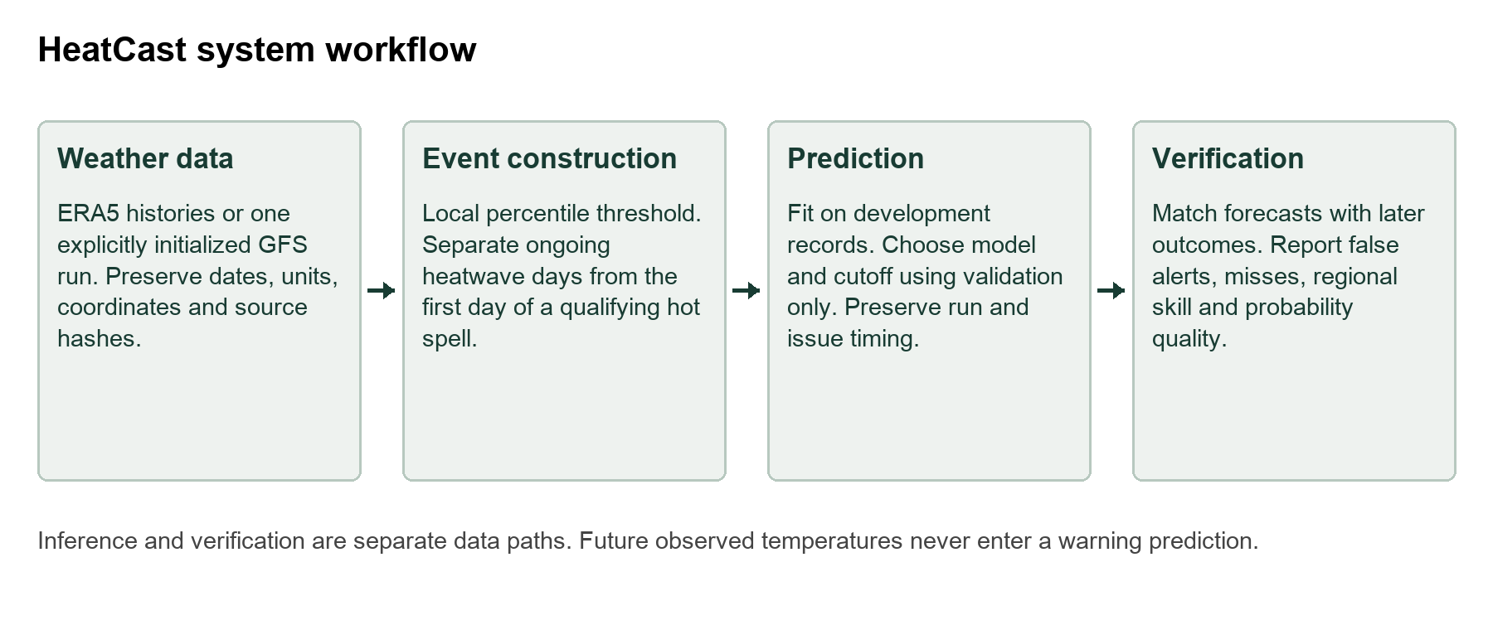
Figure 3.1 HeatCast data prediction and verification workflow
Source: Project system design.
The separation is especially important for onset. Its label requires two subsequent hot days for confirmation, but those observed days must never be used as predictor inputs. The numerical-forecast branch may predict all of those days from an earlier initialized run. A verification array is not supplied to its inference function. The research tests check these boundaries explicitly.
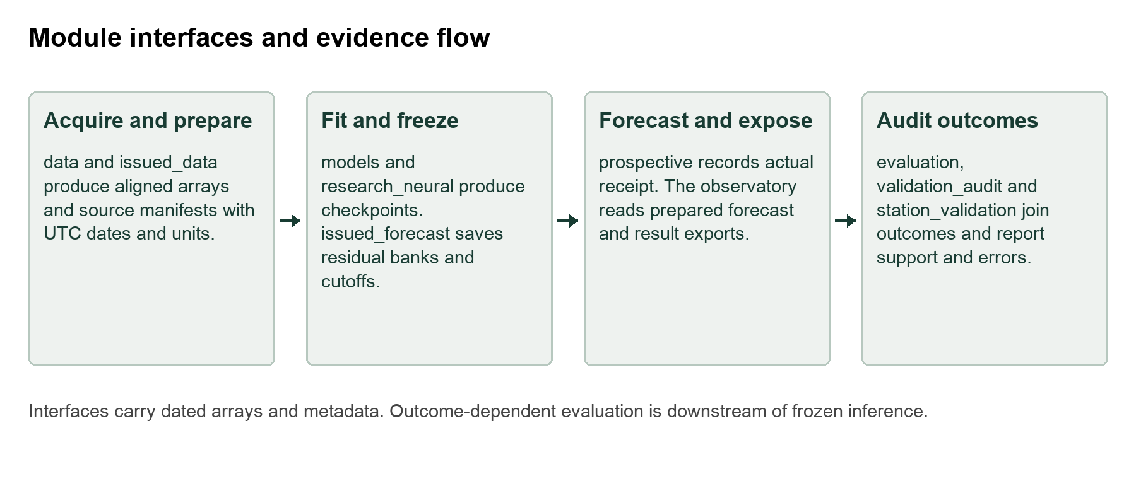
Figure 3.2 Module level architecture and data interfaces
Source: Project implementation modules and saved artifact contracts.
Table 3.1 Research system requirements
Requirement | Acceptance evidence
Traceable data | Source identity, units, UTC dates, coordinates and hashes saved with prepared arrays
No future outcome inputs | Forecast-only inference unchanged when verification arrays are removed or corrupted
Reproducible decisions | Frozen model, threshold and cutoff reconstruct saved probabilities and labels
Fair verification | Identical target records within comparisons; chronological development and test
Inspectable output | Location, target, issue, lead, probability, outcome and export accessible
External evidence path | Separate actual-receipt capture and provenance-backed station adapter

Table 3.2 Module input and output contracts
Module group | Input | Output
Data preparation | Source weather and metadata | Aligned arrays and immutable source manifest
Model development | Training and validation arrays | Estimator or checkpoint and selected cutoff
Forecast inference | Frozen bundle and dated forecast run | Target probabilities without observed outcomes
Evaluation | Saved predictions and later observations | Matched scores, support and uncertainty
Observatory | Prepared forecast and research exports | Interactive inspection and CSV download

Table 3.3 Evaluation settings and data conditions
Setting | Data and development | Test and purpose
Spatial grid | ERA5 hourly fields; 2020–2022 training and 2023–2024 validation | Available 2025–2026 days; next-day ongoing events over 1507 cells
Seven locations | ERA5 daily 1981–2025; training to 2016 and validation 2017–2020 | 2021–2025; ongoing and onset at 1 3 and 7 days
Issued forecasts | Explicit 2026 GFS runs; development targets 1 May–22 June | 8 July–30 September; actual warning leads 24 72 and 168 hours under replay policy
Forecast refinement | Same GFS development cases; five purged blocks | Same inspected 2026 test; exploratory comparison only

3.2 Event definition and local reference
Let Tmax(s,d) denote maximum temperature at location s on UTC day d, and q90(s,d) its local calendar-day 90th-percentile reference. The hot-day indicator is H(s,d) = 1 when Tmax(s,d) exceeds q90(s,d), and zero otherwise. The long-history and GFS experiments use the fixed 1981–2010 reference with a five-calendar-day window centred on the target calendar day. February 29 shares the February 28 threshold.
The ongoing label O(s,d) is one when H(s,d−2), H(s,d−1) and H(s,d) are all one. The onset label N(s,d) is one when day d−1 is non-hot and days d, d+1 and d+2 are hot. Thus an onset is dated at the first hot day, while an ongoing label starts on the third day. These are the project’s three-day definitions; they are not the six-day ETCCDI warm-spell duration index [16].
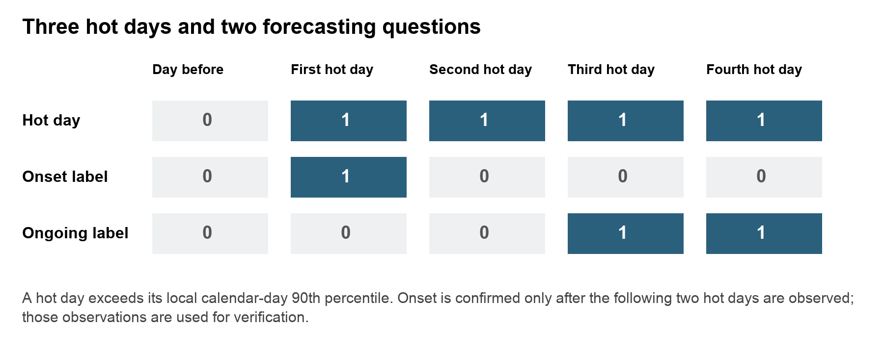
Figure 3.3 Hot day onset and ongoing event labels
Source: Project event definitions.
The 30-year reference predates validation and test records, keeping the event definition fixed across those periods [15]. It is intentionally not a study of adaptation to a moving contemporary normal. The spatial-grid experiment has a shorter training-only 2020–2022 reference and a wider calendar window. Its threshold is an experimental regional reference, so its scores are not directly comparable with the long-history experiment.

3.3 Spatial data preparation
The spatial dataset contains hourly ERA5 maximum-temperature inputs, mean sea-level pressure and surface soil moisture over 42 to 51 degrees north and 5 degrees west to 8 degrees east at 0.25-degree spacing. The resulting grid contains 37 by 53 cells. Complete UTC days are aggregated to maximum temperature in degrees Celsius and mean pressure and soil moisture. Partial days are excluded; the last complete available day is 10 August 2026.
The model uses seven consecutive daily inputs for a next-day ongoing target. Windows that cross missing days or seasonal gaps are excluded. The retained evaluation mask contains 1507 finite cells with training mean soil moisture above 0.001 cubic metres per cubic metre. This removes near-zero ocean encodings but is a documented proxy, not an official land-fraction mask. Scaling parameters use training records only.
Training uses 2020–2022, validation uses 2023–2024 and testing uses available 2025–2026 records. Local hot-day thresholds are estimated from training temperatures within a plus-or-minus 15-calendar-day window. The same dates, labels and retained cells are used for matched grid comparisons. A Paris point series forms its own comparison group.

3.4 Multi location weather histories
The seven-location dataset contains complete daily ERA5 records for Paris, London, Madrid, Rome, Athens, Berlin and Warsaw from 1 January 1981 to 31 December 2025. Open-Meteo requests explicitly select ERA5, UTC days and disabled elevation downscaling. The stored manifest records requested and returned coordinates, units, response hashes and prepared-data identity [13, 17, 21]. These are representative land grid cells associated with the named locations.
Six daily variables are maximum temperature, minimum temperature, mean sea-level pressure, top-layer soil moisture, mean relative humidity and precipitation. Quality checks require aligned dates, finite values, plausible physical ranges and minimum temperature no greater than maximum temperature. The experiment evaluates May–September targets while retaining the preceding observations and following verification days needed to construct valid sequences.
Training ends in 2016, validation spans 2017–2020 and the test spans 2021–2025. Target verification that could cross a chronological boundary is embargoed. Each test contains 765 target dates and 5355 location-days. The one-day test has 497 positive ongoing location-days and 155 exact onset events. Their different prevalence is retained in the interpretation of all metrics.

3.5 Predictor construction
Observation-history predictors end at target day minus lead. Tabular features include temperature anomalies and minimum temperature at lags 0, 1, 2, 3, 6 and 13 relative to that issue day. Full-feature variants also include pressure, soil moisture and humidity at those lags. Three-, seven- and fourteen-day anomaly means and precipitation sums describe recent persistence and moisture conditions. Anomaly change, the known target-day climate threshold, seasonal sine and cosine terms, latitude and longitude complete the feature set.
Temperature-only, no-soil and full-weather variants make input contribution testable. Known calendar thresholds and coordinates do not require future observed weather. The neural multi-location model receives fourteen daily steps with the six meteorological variables and a temperature anomaly, giving seven input features. Its standardization is fitted using training-era observations. Tests alter later records to verify that a target’s features remain unchanged.

3.6 Forecasting models and controls
The LSTM uses a single recurrent layer with 32 hidden units and a linear event-logit head. The point experiment has three channels and seven daily steps. The multi-location LSTM has seven features and fourteen daily steps. Although the recurrent class is shared, these configurations are different experiments and do not provide one common-data score.
The ConvLSTM retains the regional field in hidden and cell states. A three-by-three convolution maps the input and hidden channels into input, forget, output and candidate gates; the hidden width is 12. A one-by-one convolution produces cell logits. The no-soil ablation removes the soil channel while retaining the remaining spatial design. The experiment tests the predictive effect of that channel under a fixed training setup; Section 4.12 reports three-seed sensitivity.
Gradient boosting tests 7, 15 or 31 leaves and 180 iterations in the grid, using at most 250000 sampled training cell-days. Multi-location candidates test 7 or 15 leaves and 160 iterations across three feature sets. Both use learning rate 0.07 and L2 regularization 10. These are limited searches, not global optimization.
The multi-location logistic comparator standardizes tabular features and uses regularization C = 1. Neural training uses AdamW, weighted binary cross entropy, validation-loss checkpointing, gradient clipping and early stopping. Spatial neural runs allow at most 35 epochs with patience six; multi-location neural runs allow at most 20 epochs with patience four. Class weighting addresses imbalance in the loss, but does not guarantee calibrated output probabilities.
Persistence and climatology provide meaningful controls. In the spatial study, the categorical persistence control carries the preceding ongoing-event label forward. In the multi-location study, temperature persistence holds the latest observed daily maximum constant for unobserved future days and applies the event rule. Historical climatology estimates training-only seasonal event frequency. These are explicitly different persistence constructions, so baseline interpretation remains tied to each setting.
The 32-unit LSTM and 12-channel ConvLSTM are compact engineering baselines intended to limit fitting cost on the available summer histories. These widths were fixed in the implemented setup, not selected by an architecture-width search. Their adequacy is tested through held-out controls and seed sensitivity; no claim of an optimal width is made. The original LSTM formulation [39] and convolutional recurrence [14] motivate the following computations.
$$i_{t} = σ(W_{i}x_{t} + U_{i}h_{t-1} + b_{i}); f_{t} = σ(W_{f}x_{t} + U_{f}h_{t-1} + b_{f})$$
$$o_{t} = σ(W_{o}x_{t} + U_{o}h_{t-1} + b_{o}); g_{t} = tanh(W_{g}x_{t} + U_{g}h_{t-1} + b_{g})$$
$$c_{t} = f_{t} ⊙ c_{t-1} + i_{t} ⊙ g_{t}; h_{t} = o_{t} ⊙ tanh(c_{t})$$
Here x is an input, h the hidden state, c the cell state, σ the sigmoid and ⊙ elementwise multiplication. In ConvLSTM, dense input and hidden products are replaced by spatial convolutions over the concatenated input and hidden maps. The implementation uses three-by-three gate kernels and no peephole connections. A final linear or one-by-one convolutional head maps the final hidden state to an event logit.
$$L = -\frac{1}{N}\sum_{j = 1}^{N}{[w y_{j} log(p_{j}) + (1 - y_{j}) log(1 - p_{j})]}$$
$$w = √((1 - r)/max(r, ε)); p = σ(z)$$
The neural loss is weighted binary cross entropy, where r is training event prevalence and ε prevents division by zero. Class weighting changes the fitted objective, so probability reliability must be checked separately. Logistic regression uses p = σ(β₀ + βᵀx) with L2 regularisation controlled by inverse strength C. Boosting adds shallow-tree contributions to the logit function [40].
$$F_{m}(x) = F_{m-1}(x) + η h_{m}(x); p(x) = σ(F_{m}(x))$$
For binary log loss, the negative functional gradient has the form y − p; the fitted tree and regularisation determine the actual update. The empirical correction instead forms probabilities by counting which residual-adjusted forecast trajectories satisfy the full event rule.
$$p(event) = \frac{1}{K}\sum_{k = 1}^{K}{1\{event rule(T + αe_{k}, q) = 1\}}$$
Here T is the forecast temperature vector, e is a complete historical error vector, q is the threshold trajectory and α is the tested error scale. Keeping the vector intact retains its within-event dependence. It does not create independent physical ensemble members.
Table 3.4 Neural model dimensions and trainable parameters
Model | Input channels | Hidden width | Parameters
Paris point LSTM | 3 | 32 | 4769
Multi location LSTM | 7 | 32 | 5281
Grid ConvLSTM | 3 | 12 | 6541
Grid ConvLSTM without soil | 2 | 12 | 6109

3.7 Model selection and fair comparisons
Spatial checkpoints and cutoffs use validation data, with the final grid method chosen by validation F1. Multi-location feature and leaf settings are chosen by validation macro-site F1, giving each location equal weight. Candidate classification cutoffs maximize pooled validation F1. Matched one-day logistic and LSTM comparisons use the same sites, targets and chronological periods; their reported champion is selected using validation performance.
A separate local-cutoff policy requires at least 20 positive validation cases at a location; otherwise the pooled cutoff applies. Both policies remain visible because local tuning can overfit sparse support or transfer poorly. Test outcomes do not determine the policy choice.
Model rankings are meaningful only within common conditions. The grid ConvLSTM and point LSTM have different spatial inputs. The reanalysis-history model and GFS replay have different availability assumptions and test years. A fair architecture-only experiment would give both neural methods the same variables, dates, spatial information, label, lead, preprocessing and training budget.

3.8 Archived numerical forecast timing
The issued-forecast study requests explicit GFS Global runs rather than a stitched latest-weather series [18, 44]. Warning decisions occur at 00 UTC on issue day I. The selected run is initialized at 00 UTC on I−1 day, with an assumed publication allowance of twelve hours and a further twelve-hour buffer before the decision. Individual historical receipt timestamps are unavailable, so this is a documented replay assumption.
Targets occur at I+1, I+3 or I+7 days, corresponding to warning leads of 24, 72 and 168 hours. Because the run is already 24 hours old at issuance, initialization-to-target horizons are 48, 96 and 192 hours. Every required event day comes from that same run, including preceding days required by the event rule. No later run or retrospective ERA5 value fills a predictor.
Table 3.5 Timing for a target starting on 1 August 2026
Lead | Warning issue UTC | GFS initialization UTC | Initialization horizon
1 day | 31 July 00 | 30 July 00 | 48 hours
3 days | 29 July 00 | 28 July 00 | 96 hours
7 days | 25 July 00 | 24 July 00 | 192 hours

Development targets are 1 May–22 June 2026. Onset verification extends through 24 June. Under the conservative assumption that a complete ERA5 day becomes usable at D+6 00 UTC, the correction and cutoffs are frozen at 30 June. Common test targets are 8 July–30 September, ensuring that even seven-day warnings occur after that boundary. Of 53 nominal development dates, 50 remain after a missing archived run excludes three matched targets; all 85 test dates are retained.

3.9 Joint error adjustment and forecast refinement
Raw GFS applies the event rule directly to its deterministic temperature trajectory. The joint-error adjustment uses development vectors of ERA5-minus-GFS temperature errors over all event days. Adding a complete vector to the forecast preserves dependence across those days. The probability is the fraction of adjusted trajectories satisfying the event rule. These empirical scenarios are not independent physical weather-model ensemble members.
For development cutoff selection, the error bank excludes dates within seven calendar days of each held-out target. Test predictions use the full frozen development bank only. A pooled cutoff is selected from development outcomes. This design avoids using a test error vector to correct its own forecast, but assumes that early-summer errors remain useful later in the season.
The refinement experiment compares nine fixed alternatives: raw GFS; empirical error vectors scaled by 0.25, 0.5, 0.75 or 1; and pooled logistic margin models with C values 0.1 or 1, with and without balanced class weights. Margin inputs are forecast temperature minus the known local threshold over event days, together with their minimum, maximum, mean, standard deviation and consecutive changes.
Five contiguous development blocks supply held-out predictions. Each training set excludes every date within seven calendar days of the validation block, and whole location fields stay together. Scaling, residual banks and logistic fitting use only the remaining development records. Candidate and cutoff selection maximize macro-site F1 on combined out-of-fold development predictions; ties use development Brier and declared candidate order. Selection metadata is saved before test verification is accessed.
The refinement family was designed after the benchmark test outcomes had been inspected. Development-only fitting prevents direct label leakage, but cannot make that reused test untouched. Its results are therefore exploratory and require confirmation in another season. Every candidate remains reported, and a method is not promoted merely because it has a favourable test point estimate.

3.10 Metrics and uncertainty
Table 3.6 Measures used to evaluate forecasts
Measure | Interpretation | Main caution
Precision | Fraction of positive warnings that verify | Low precision means many false alerts
Recall | Fraction of true events detected | High recall can require many warnings
F1 | Harmonic balance of precision and recall | Depends on target prevalence and cutoff
Macro site F1 | Mean of location-specific F1 | Retain sparse and zero-event support
Average precision | Precision recall ranking summary | Use the event prevalence as context
ROC AUC | Ranking discrimination | Can remain high with poor alert precision
Brier score | Mean of probability minus outcome squared | Rare-event scores need a baseline
Brier skill | One minus model Brier over baseline Brier | Baseline must be stated and matched
Temperature MAE RMSE | Magnitude of forecast temperature error | Does not determine multi-day event accuracy
Episode detection | Whether any labelled ongoing day is detected | Does not establish advance onset warning

$$Precision = \frac{TP}{TP + FP}; Recall = \frac{TP}{TP + FN}$$
$$F_{1} = \frac{2TP}{2TP + FP + FN}$$
$$BS = \frac{1}{N}\sum_{j = 1}^{N}{(p_{j} - y_{j})²}; BSS = 1 - \frac{BS}{{BS}_{ref}}$$
TP, FP and FN denote hits, false alerts and misses. The Brier score evaluates squared probability error [43]; Brier skill is positive only when the score improves on the named reference for the same cases. F1 is cutoff-dependent and does not measure probability calibration.
Paired temporal resampling retains whole spatial or location fields, preserving dependence among locations on a day. The additional audit uses full-length moving blocks of 3, 7 and 14 days within each contiguous season, keeping each season’s sample size and never crossing winter gaps. The same resampled records are used for a candidate and its baseline. Intervals condition on the fitted models and observed years; they do not capture all uncertainty from retraining or an unseen climate regime.
Reliability uses ten supported probability bins, retaining empty bins. Brier skill references historical climatology in the main audit and frozen development frequencies in refinement. These descriptive diagnostics do not establish calibration.

3.11 Sample support and inferential precision
Table 3.7 Training validation and test support
Setting | Train | Validation | Test
Grid target dates | 348 | 232 | 211
Grid cell days at 1507 cells | 524436 | 349624 | 317977
Seven location target dates | 5508 | 612 | 765
Seven location days | 38556 | 4284 | 5355
GFS target dates | 50 development | Purged within development | 85
GFS location days | 350 development | Same blocked pool | 595

Grid training comprises 348 eligible seven-day windows, rather than hundreds of independent years. The 524436 cell-days share dates and spatial structure. Likewise, the multi-location rows share regional weather. The tree grid search samples at most 250000 training cell-days; the neural model retains full spatial fields. Parameter counts are therefore descriptive complexity measures, not a ratio proving sufficient independent training data.
The GFS test contains 23 exact onsets. Detecting 15 gives recall 0.652, with an independent-event Wilson interval of approximately 0.449–0.812. Regional clustering makes that illustration optimistic. A binomial planning approximation at recall 0.65 needs about 88 independent positive events for a 95 percent half-width near 0.10. This is not a power calculation for paired F1; dependence, site heterogeneity and model selection require further evidence. Additional event-bearing seasons matter more than correlated daily rows.

Chapter 4 Implementation Results and Discussion

4.1 Implementation and reproducibility
The implementation is organized as a Python package with separate modules for data preparation, model fitting, inference and evaluation. Saved arrays preserve the exact target-site records used in comparisons. Model bundles contain the fitted estimator or empirical residual bank, historical reference and cutoff. Forecast exports record issue time, target, lead, task, location, probability, decision and verification status.
Table 4.1 Main implementation components
Component | Implemented role
Data preparation | GRIB aggregation and daily-site acquisition; source hashes and units
Model development | LSTM ConvLSTM logistic and boosting training with chronological selection
Issued forecasts | Exact-run trajectory construction, correction and warning-time audit
Refinement study | Purged development folds, nine candidates and saved inference bundles
Validation audit | Reliability bins, Brier skill, episode detection and block sensitivity
Prospective capture | Actual receipt timestamps and separate delayed verification
Station validation | Quality checks, station-local reference and matched external diagnostics
Observatory | Location/date/lead/task inspection, temperature context and CSV exports

The recorded core model environment uses Python 3.13 with NumPy 2.5.2, pandas 2.3.3, scikit-learn 1.9.0 [41], PyTorch 2.11.0 [42], joblib 1.5.3 and requests 2.32.5. Version records support reconstruction, while source and data hashes identify the actual input artifacts. Neural results use the stated seed and checkpoint policy; repeating a deterministic tree seed alone would not measure sensitivity to the training sample.
The completed checks include 47 protocol and implementation tests. Artifact checks verify the saved research and issued-forecast models, labels, cutoffs and timing. All 3570 development-selected refinement probabilities reproduce from forecast-only arrays. Tests also remove or corrupt verification arrays and confirm that inference is unchanged. These checks establish implementation consistency, not forecasting accuracy on unobserved future data.

4.2 Spatial grid and point model results
Table 4.2 Spatial and Paris evaluation results
Model and scope | Val F1 | Test F1 | AP | Brier
Persistence grid | 0.5838 | 0.7822 | 0.6438 | 0.0633
Climatology grid | 0.0359 | 0.2541 | 0.1432 | 0.1385
ConvLSTM grid | 0.3643 | 0.5671 | 0.6045 | 0.0858
ConvLSTM no soil | 0.3687 | 0.5705 | 0.6438 | 0.0798
Gradient boosting grid | 0.7389 | 0.8505 | 0.8812 | 0.0390
Persistence Paris | 0.0000 | 0.8485 | 0.7436 | 0.0474
LSTM Paris | 0.5000 | 0.5505 | 0.5564 | 0.0994

Gradient boosting is the validation-selected grid method and reaches test F1 0.8505, compared with grid persistence 0.7822. Its conditional F1 interval is approximately 0.7733–0.9022, and the paired difference from persistence is 0.0152–0.1514 under the recorded seven-day block analysis. This supports an advantage for this fitted model and test interval within the spatial setting.
ConvLSTM reaches F1 0.5671, and the no-soil variant reaches 0.5705. Both remain below the matched grid persistence control. The small no-soil difference of about 0.0034 does not establish that soil moisture lacks physical relevance. These reference scores use seed 42 and a limited neural search. Section 4.12 reports sensitivity across three seeds; the result remains a predictive ablation under a short historical reference.
The Paris LSTM reaches F1 0.5505 while Paris persistence reaches 0.8485. Its point inputs and target series differ from the regional field supplied to ConvLSTM. Comparing 0.5505 with 0.5671 would therefore confound architecture with data support. The evidence supports separate within-scope comparisons, rather than a neural architecture ranking.
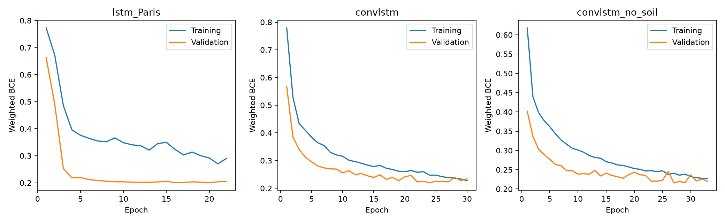
Figure 4.1 Training and validation histories for the recurrent grid and point models
Source: Saved spatial training histories.
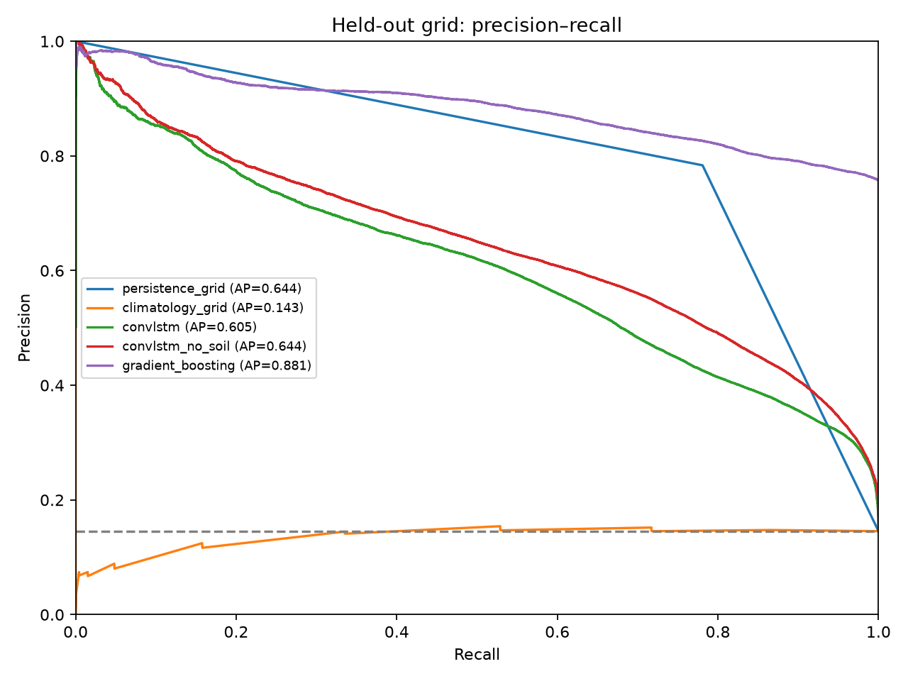
Figure 4.2 Precision recall performance in the spatial evaluation
Source: Saved spatial test predictions. Paris and grid curves retain separate scopes.

4.3 Spatial failures and case study
The regional audit retains event support and local performance instead of treating every cell as equally well evidenced. Four fixed geographic quadrants summarize spatial variation; these are descriptive bins rather than official climate regions. The south-west has F1 0.8050 and recall 0.9082, while the south-east has F1 0.8711 and recall 0.9325. Strong aggregate performance therefore coexists with weaker cells and different event frequencies.
Table 4.3 Spatial quadrant performance
Quadrant | Cells | F1 | Recall | Persistence F1
South west | 298 | .8050 | .9082 | .7166
South east | 381 | .8711 | .9325 | .7987
North west | 315 | .8386 | .9107 | .7783
North east | 513 | .8603 | .9541 | .8007

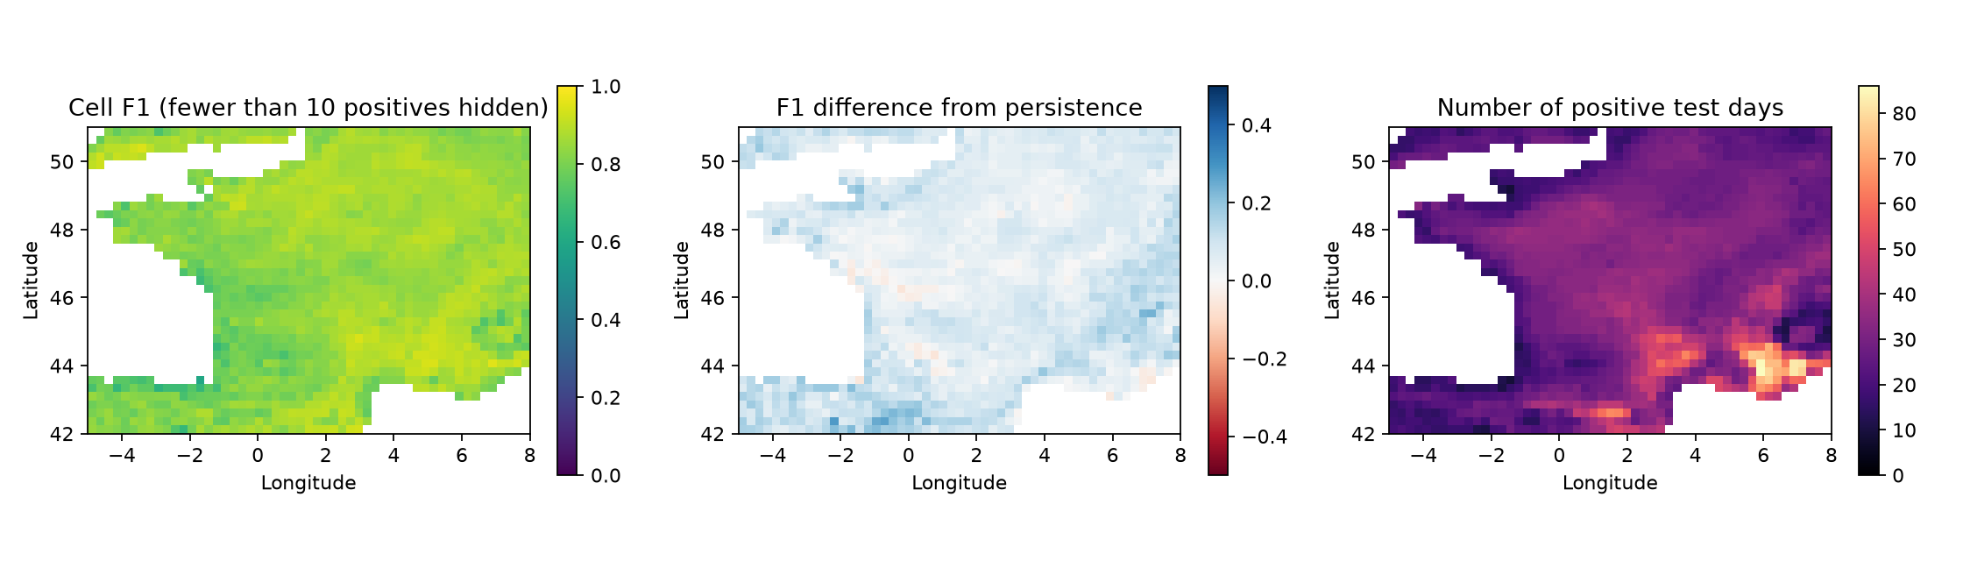
Figure 4.3 Spatial F1 difference from persistence and event support
Source: Cell-level regional audit. Cells with fewer than ten positives are hidden only in the F1 display.
Of 1507 evaluated cells, 1505 have at least ten positive test days. Among supported cells, the lowest reported F1 is 0.6000 at 43.5 degrees north and 1.75 degrees west, with twelve positive days. The map identifies where more representative local validation is needed; it does not justify tuning a replacement model on those same test errors.
The August case study selects the available day with greatest observed labelled extent, 10 August 2026. There are 163 observed event cells and 307 predicted cells, with intersection 157. These imply 150 false-positive cells, six missed cells and IoU 157 divided by 313, approximately 0.502. The model detects much of the observed footprint but overestimates its extent. The event was selected descriptively, so the case does not establish an unprecedented heatwave or a causal climate explanation.
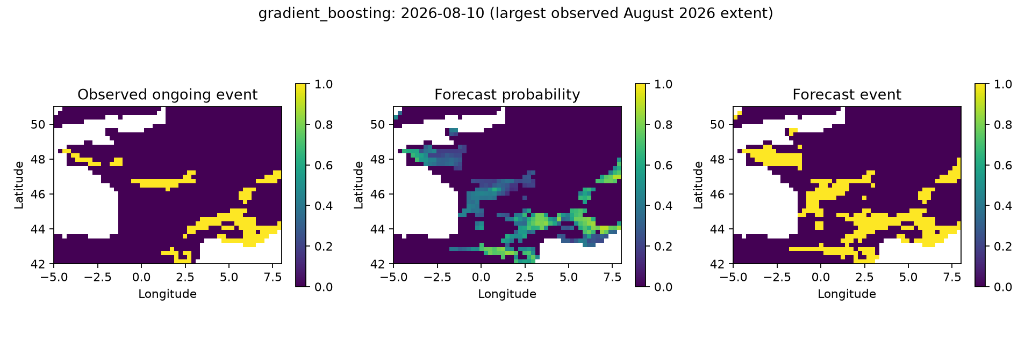
Figure 4.4 Observed and predicted event extent on 10 August 2026
Source: Saved descriptive August case study; date selected by observed event extent.

4.4 Matched multi location one day comparisons
Table 4.4 Matched one day methods at seven locations
Task and method | Val macro F1 | Test F1 | Macro F1 | AP | Brier
Ongoing boosting | .7992 | .8199 | .7988 | .8754 | .0248
Ongoing LSTM | .7344 | .7701 | .7431 | .7876 | .0375
Ongoing logistic | .6919 | .7250 | .6877 | .7275 | .0398
Onset boosting | .2926 | .2961 | .2921 | .2123 | .0256
Onset LSTM | .2243 | .2181 | .1955 | .1385 | .0375
Onset logistic | .1233 | .1137 | .1144 | .0560 | .0283

Gradient boosting leads the matched one-day methods by validation selection and reaches ongoing-event F1 0.8199. It detects 444 of 497 positive location-days, with 142 false alerts and 53 misses. Its precision is 0.7577 and recall 0.8934. The LSTM has higher recall 0.9235 but lower precision 0.6604, producing F1 0.7701. The comparison illustrates a practical alert tradeoff rather than neural superiority.
Onset is harder. Boosting detects 61 of 155 exact starts, with 196 false alerts and 94 misses. F1 is 0.2961 and precision is 0.2374. LSTM onset F1 is 0.2181, while logistic F1 is 0.1137. A high ROC AUC of 0.9123 for the boosting onset model does not remove the low alert precision at the selected cutoff.
Temperature persistence achieves ongoing F1 approximately 0.8043. The boosting advantage is only about 0.0157, and its paired block interval includes zero. We therefore cannot conclude that the apparent advantage is dependable across this sampled period. For one-day onset, boosting does exceed the much weaker persistence control under the recorded paired interval, but its absolute event performance remains limited.

4.5 Lead time and probability quality
Table 4.5 Gradient boosting performance across leads
Task and lead | F1 | Macro F1 | AP | ROC AUC | Brier
Ongoing 1 day | .8199 | .7988 | .8754 | .9895 | .0248
Ongoing 3 days | .4623 | .4168 | .4236 | .8888 | .0684
Ongoing 7 days | .2196 | .1678 | .1768 | .6489 | .0846
Onset 1 day | .2961 | .2921 | .2123 | .9123 | .0256
Onset 3 days | .0597 | .0546 | .0421 | .6083 | .0282
Onset 7 days | .0658 | .0613 | .0362 | .5692 | .0283

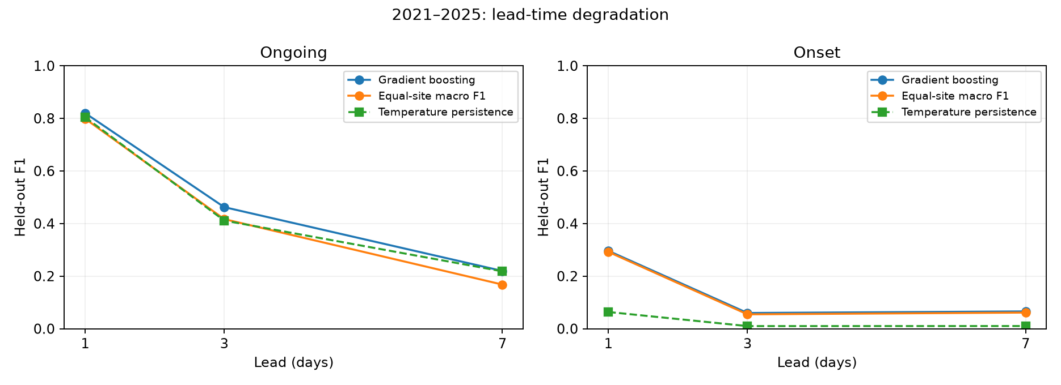
Figure 4.5 Event performance at one three and seven day leads
Source: Saved 2021–2025 multi-location test predictions and matched baselines.
Ongoing F1 falls from 0.8199 at one day to 0.4623 at three days and 0.2196 at seven days. At seven days, persistence and climatology are close to the boosting result. The observation-history model has limited information about future circulation changes, so a short-lead success cannot be presented as reliable week-ahead forecasting.
Onset F1 is low at both longer leads. Seven-day onset detects 48 events but produces 1256 false alerts, compared with 61 hits and 196 false alerts at one day. The larger hit count relative to three-day onset does not mean that seven-day warnings are better: the chosen cutoff changes the warning volume, and precision is only about 0.0368.
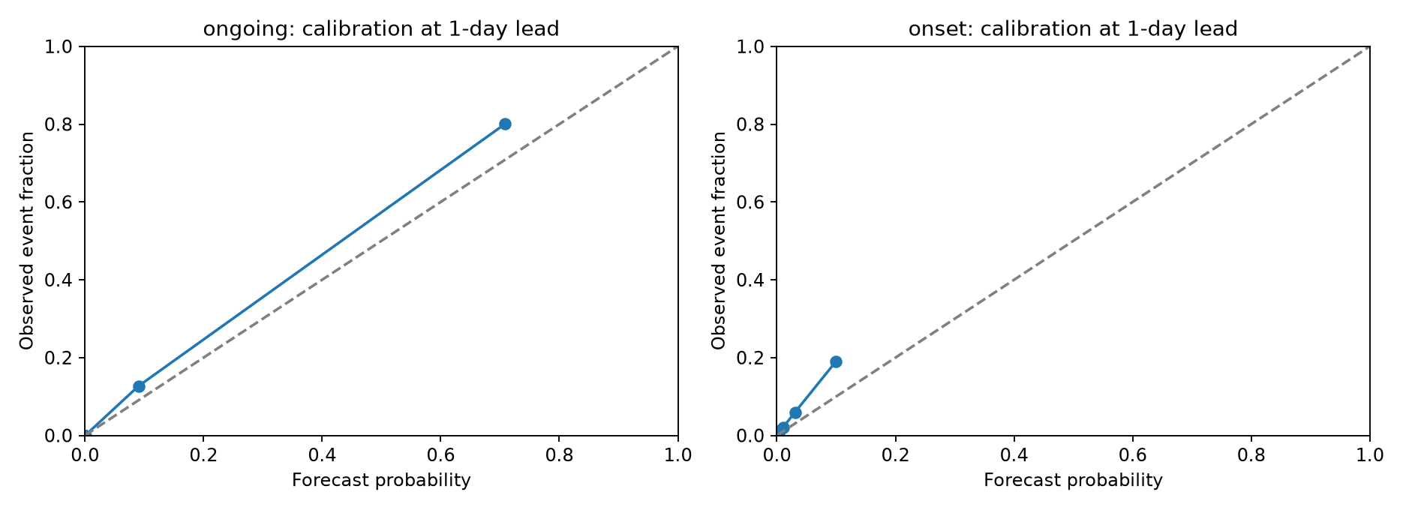
Figure 4.6 Probability reliability in the one day location models
Source: Saved probability calibration diagnostics; event rarity and bin support affect interpretation.
The audit compares Brier scores with the saved historical-climatology probabilities. Brier skill is about 0.718 for one-day ongoing boosting, 0.219 at three days and 0.035 at seven days. Onset Brier skill is about 0.097, 0.005 and 0.002, respectively. Long-lead onset probabilities therefore add little squared-error skill over that probability reference, even where ranking metrics appear above chance.

4.6 Regional annual and transfer results
Table 4.6 One day ongoing performance by location
Location | Positive days | F1 | Recall | Persistence F1
Paris | 55 | .8065 | .9091 | .7692
London | 64 | .7591 | .8125 | .7799
Madrid | 68 | .8054 | .8824 | .8095
Rome | 173 | .8852 | .9364 | .8819
Athens | 34 | .8421 | .9412 | .8000
Berlin | 36 | .6905 | .8056 | .6538
Warsaw | 67 | .8027 | .8806 | .7719

Rome has 173 positive ongoing days, compared with 34 in Athens and 36 in Berlin. A pooled score can therefore be influenced strongly by a high-support location. Berlin has the lowest one-day ongoing F1 at 0.6905. London’s boosting score is below its local persistence F1. Macro-site evaluation exposes these differences by assigning each location equal weight.
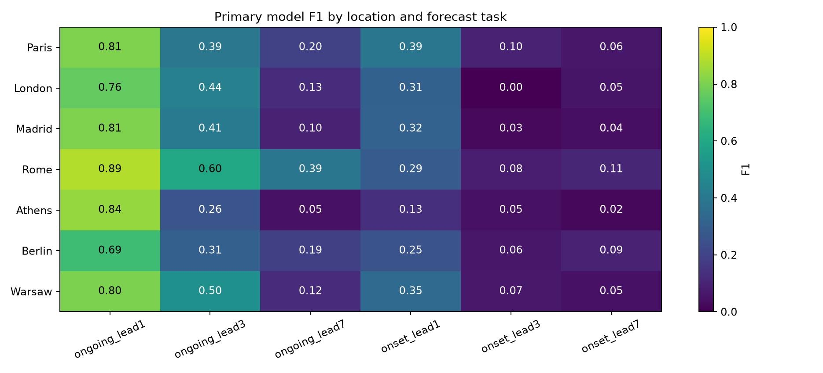
Figure 4.7 Regional skill across event types and forecast leads
Source: Saved multi-location regional metrics; each cell describes a representative location.
Local cutoffs do not consistently improve transfer. One-day ongoing macro F1 is 0.7988 with the pooled cutoff and 0.7903 with local cutoffs. One-day onset falls from 0.2921 to 0.2876. Small improvements at some longer leads do not justify selecting a policy with test scores. Sparse validation events and seasonal differences remain plausible sources of instability.
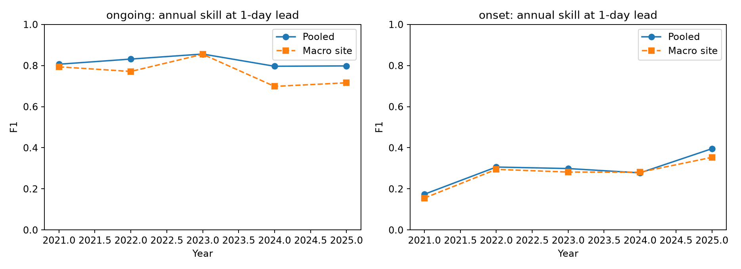
Figure 4.8 Annual pooled and equal site performance
Source: Saved annual metrics from 2021–2025.
An earlier temporal backtest uses training through 2012, validation 2013–2016 and testing 2017–2020. One-day ongoing F1 is 0.7735 and onset F1 is 0.2619. These results support reporting multiple periods, while their overlapping development histories mean that they are not independent replications. Training-sample sensitivity uses whole-day resamples with seeds 7, 21 and 42, preserving locations together.
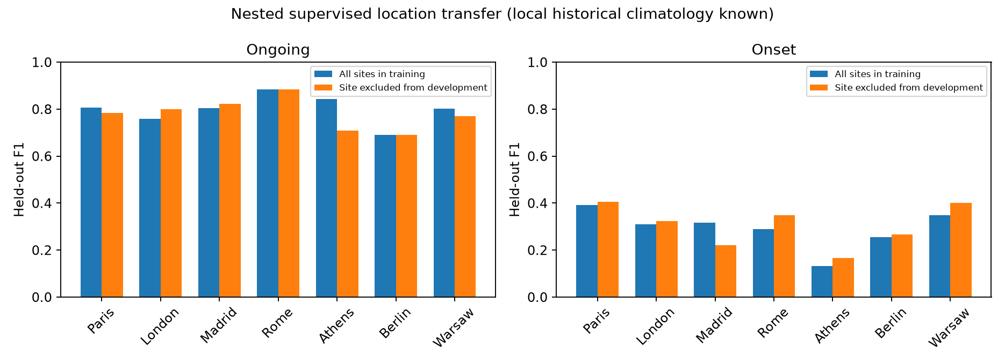
Figure 4.9 Supervised location holdout under known local climatology
Source: Saved nested location-holdout results; the omitted location retains its historical climate reference.
Each location-holdout run excludes that site from supervised training, feature and complexity selection, and cutoff tuning. Local 1981–2010 climatology is still available. Athens ongoing F1 changes from 0.8421 with all-site development to 0.7097 when omitted; Paris changes from 0.8065 to 0.7833. Other sites show smaller changes or occasional gains. This measures transfer to an omitted supervised location with known climate history, not transfer to a region without historical data.

4.7 Issued forecast replay results
Table 4.7 GFS replay event results
Task and lead | Raw F1 | Adjusted F1 | Adj precision | Adj recall | False alerts
Ongoing 1 day | 0.7715 | 0.7744 | 0.6398 | 0.9810 | 58
Ongoing 3 day | 0.7068 | 0.7132 | 0.5808 | 0.9238 | 70
Ongoing 7 day | 0.6259 | 0.5581 | 0.4017 | 0.9143 | 143
Onset 1 day | 0.3774 | 0.3896 | 0.2778 | 0.6522 | 39
Onset 3 day | 0.3077 | 0.3409 | 0.2308 | 0.6522 | 50
Onset 7 day | 0.1154 | 0.0833 | 0.0548 | 0.1739 | 69

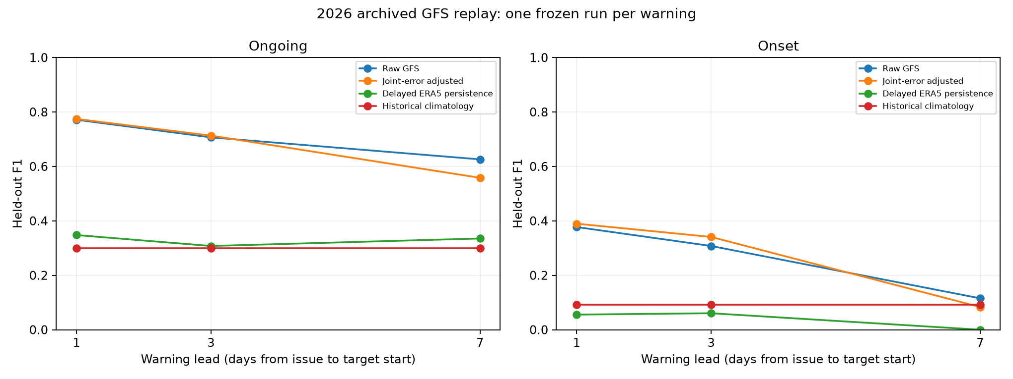
Figure 4.10 GFS warning skill at matched target dates and locations
Source: Saved issued-forecast comparisons for 85 target dates and seven locations.
The replay has 595 test location-days per task and lead, with 105 positive ongoing days and 23 onset events. Raw one-day GFS ongoing F1 is 0.7715; adjustment produces 0.7744. At three days the values are 0.7068 and 0.7132. These are small point gains, and their paired intervals include zero. They do not establish a dependable improvement.
At seven days, adjustment reduces ongoing F1 from 0.6259 to 0.5581. It raises hits from 87 to 96 but increases false alerts from 86 to 143. The recorded paired F1-difference interval, approximately −0.1131 to −0.0297, lies below zero. In this experiment the correction harms categorical performance despite improving some probability and detection measures.
For one-day onset, adjustment increases hits from 10 to 15 of 23 events, but false alerts rise from 20 to 39. F1 rises from 0.3774 to 0.3896, while precision falls. At three days onset F1 rises from 0.3077 to 0.3409 with an even larger warning volume. Seven-day onset remains poor and worsens after adjustment. These results show why correction cannot be judged by recall alone.
Raw target-day temperature MAE rises from about 1.59 degrees Celsius at one-day warning lead to 1.96 at three days and 3.01 at seven days. An event depends on the complete trajectory near a local threshold, so these temperature errors and multi-day dependence jointly influence warning outcomes. ERA5 remains a grid-based verification reference, not a station measurement.

4.8 Development selected forecast refinement
Table 4.8 Development selected refinement test results
Task lead days | Selected method | Selected F1 | Joint error F1 | Raw F1
Ongoing 1 | Error scale 0.25 | 0.7564 | 0.7744 | 0.7715
Onset 1 | Error scale 0.75 | 0.4478 | 0.3896 | 0.3774
Ongoing 3 | Logistic C 0.1 balanced | 0.6978 | 0.7132 | 0.7068
Onset 3 | Error scale 1 | 0.2143 | 0.3409 | 0.3077
Ongoing 7 | Logistic C 1 balanced | 0.5706 | 0.5581 | 0.6259
Onset 7 | Error scale 0.25 | 0.0488 | 0.0833 | 0.1154

The development-selected one-day onset method uses error scale 0.75 and reaches F1 0.4478. It retains 15 hits and eight misses while reducing false alerts from 39 to 29 relative to the benchmark adjustment. Precision increases from 0.2778 to 0.3409 at the same recall 0.6522. This is a favourable point result for alert efficiency on the reused test season.
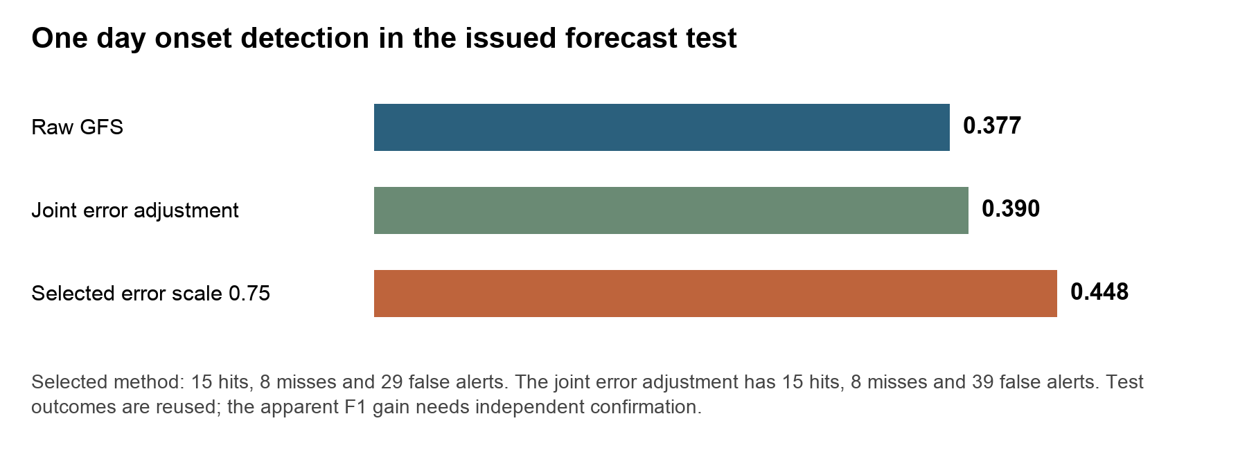
Figure 4.11 One day onset refinement and its false alert tradeoff
Source: Computed from saved GFS benchmark and refinement metrics on identical cases.
The gain has limits. Brier score increases from 0.03254 for the benchmark adjustment to 0.03433 for the selected refinement, so probability error worsens. The paired seven-day-block interval for F1 difference from raw GFS is approximately −0.0313 to 0.1963. Three- and fourteen-day block analyses also include zero. The result therefore motivates prospective testing rather than a claim of established improvement.
Most other selected candidates fail to outperform raw GFS. Seven-day ongoing F1 is 0.5706, above the benchmark adjustment’s 0.5581 but below raw GFS 0.6259. Three-day onset falls to 0.2143, and seven-day onset to 0.0488. The development period contains only 50 dates and differs seasonally from the test period. More complicated fitting and a changed selection policy do not remove that transfer problem.
All 54 candidate-task-lead evaluations remain available, including deterioration. The scale-one refinement is not numerically the same as the benchmark adjustment because its blocked development predictions and macro-site cutoff selection differ. Benchmark bundles remain available, and no universal replacement is justified by these outcomes.

4.9 Event level detection and reliability audit
Table 4.9 Event support detection and probability skill
Setting task lead days | Event support | Detected | Brier skill
ERA5 history ongoing 1 | 159 | 149 | 0.7176
ERA5 history ongoing 3 | 159 | 114 | 0.2192
ERA5 history ongoing 7 | 159 | 68 | 0.0352
ERA5 history onset 1 | 155 | 61 | 0.0974
ERA5 history onset 3 | 155 | 19 | 0.0054
ERA5 history onset 7 | 155 | 48 | 0.0022
GFS adjustment ongoing 1 | 25 | 23 | 0.7119
GFS adjustment ongoing 3 | 25 | 23 | 0.5861
GFS adjustment ongoing 7 | 25 | 23 | 0.4049
GFS adjustment onset 1 | 23 | 15 | 0.1409
GFS adjustment onset 3 | 23 | 15 | 0.1599
GFS adjustment onset 7 | 23 | 4 | -0.0800

An ongoing episode groups consecutive positive ongoing days at one location, without crossing gaps between seasons. A single long event therefore contributes one episode rather than many apparent independent successes. The one-day observation-history model detects at least one ongoing day in 149 of 159 labelled episodes. Exact onset detection remains 61 of 155 events. Episode detection is not an advance warning measure because the episode starts only on the third hot day, and season-boundary episodes may be truncated.
For the adjusted GFS replay, one-day ongoing detection covers 23 of 25 labelled episodes, while exact onset detection is 15 of 23. At seven days, the adjustment still detects 23 ongoing episodes but produces many false alerts. A favourable episode-detection fraction alone therefore cannot establish a useful warning policy.
Seven-day issued-onset Brier skill against saved historical climatology is approximately −0.080. That probability forecast is worse than its stated reference on squared probability error. The audit preserves site-level reliability bins so that low support and overconfident warnings can be examined. It also shows that the one-day ongoing boosting difference from persistence continues to include zero with 3-, 7- and 14-day block lengths.

4.10 Prospective capture and independent verification
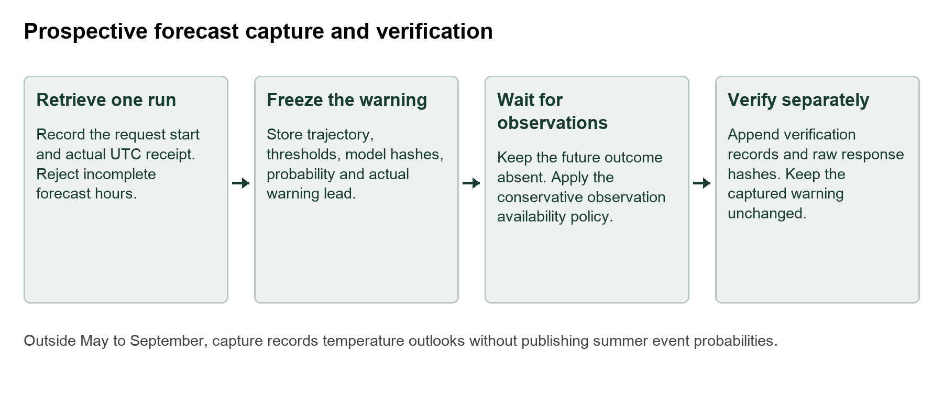
Figure 4.12 Actual receipt capture and later verification
Source: Implemented prospective capture and verification design.
The prospective module requests a single explicitly initialized GFS run and records the actual UTC request and receipt times. It preserves the raw response and hash, daily temperature trajectory, forecast targets and actual warning lead. Summer records also preserve the threshold trajectory, model-file hashes, probability and decision cutoff. The command does not accept a historical receipt timestamp, and repeated capture creates a separate record rather than overwriting an existing warning.
Targets start at least 24, 72 or 168 hours after actual receipt. Because receipt can occur during a UTC day, this differs from the replay’s assumed 00 UTC decision. The real horizon is recorded explicitly. Verification waits until the last required observation day plus six days, then writes a separate ERA5 response and result. It uses the threshold saved with the forecast, so a later model or reference change cannot silently alter the event definition.
A successful live capture saved 42 task-lead-location records. The receipt timestamp was 2 November 2026 at 18:35:42 UTC, equivalent to 3 November at approximately 00:05 IST. Because targets lie outside the evaluated May–September period, these records contain temperature outlooks without heatwave probabilities. This validates the capture pathway, not prospective summer warning skill. No automatic recurring capture schedule is installed, and local timestamps are not independent timestamp certification.
The independent-station adapter accepts provenance-backed daily observations with site, station identity, UTC date, maximum temperature and a quality flag. It requires a stable station identity and rejects duplicate dates, invalid values and incompatible daily definitions. A station-local 1981–2010 reference requires at least 90 percent quality-accepted daily coverage in every reference year and at least 100 samples per five-calendar-day percentile window. Missing or rejected event days are excluded with reasons.
Station outputs include matched cases, exclusion counts, temperature MAE, RMSE and bias, raw GFS event performance using station-local thresholds, and an explicitly labelled comparison of the grid-model probability against station events. That last comparison is an external target-transfer diagnostic, since the probability was developed for an ERA5 grid event. No independent station result is claimed: the adapter has been tested, but real compatible station data are still needed.

4.11 Error diagnosis and traced forecast cases
The error audit reconstructs saved predictions without refitting or changing cutoffs. For each fixed diagnostic category it selects the earliest matching target, then the stored site order. Categories cover a one-day onset miss and false alert, a seven-day ongoing false alert and rescued hit, and seven-day onset miss and false alert. This deterministic post hoc selection makes the examples reproducible, but it is not a frequency estimate or independent hypothesis test. Six complete trajectories are exported; Figure 4.13 shows three contrasting failures.
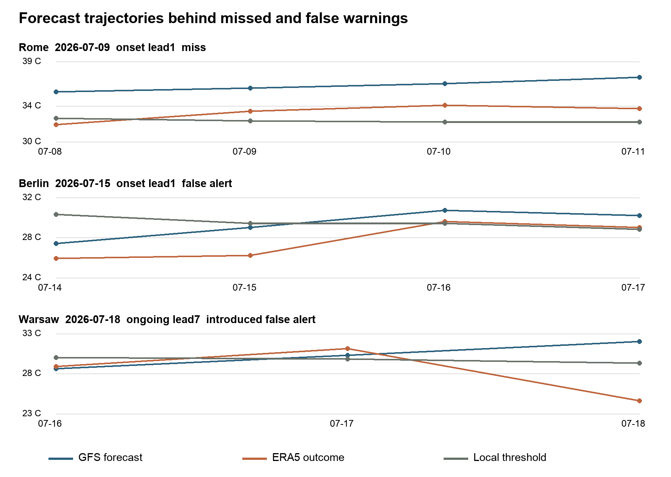
Figure 4.13 Temperature trajectories for traced warning failures
Source: Saved GFS trajectories, ERA5 verification and fixed local thresholds in results/error_analysis/case_trajectories.csv.
At Rome on 9 July, one-day onset is missed even though the forecast is too warm. On 8 July GFS predicts 35.6 degrees Celsius against a 32.61 threshold, whereas ERA5 is 31.9. The observed next three days are all hot. By predicting that heat has already begun, GFS breaks the required non-hot preceding day; the empirical onset probability is zero. This is a timing error that ordinary warm-bias correction summaries can hide.
At Berlin on 15 July, the adjusted onset probability is 0.28 against cutoff 0.1714. The target-day forecast is only 0.41 degrees below its threshold, allowing residual scenarios to cross it, while the ERA5 outcome is 3.21 degrees below. At Warsaw on 18 July, seven-day GFS predicts 32.0 degrees against ERA5 24.6 and threshold 29.32. The preceding two observed days are not enough: the final-day cooling breaks the ongoing event. Adjustment gives probability 0.24 and a false alert. These cases show errors in event timing and persistence, rather than only errors in mean temperature.
The complementary seven-day Madrid case on 9 July is a genuine rescued ongoing hit: forecast temperatures are 38.5, 36.1 and 38.9 degrees on 7–9 July, against thresholds 36.21, 36.70 and 36.71. ERA5 is above all three thresholds. Residual scenarios bridge the middle-day forecast deficit and produce probability 0.34. Complete onset examples also include a Rome miss at seven days and a Paris false onset where observed heat was already present on the preceding day.
Table 4.10 Changes caused by joint error adjustment
Task and lead | Added false alerts | Removed false alerts | Rescued positives | New misses
Ongoing 1 day | 12 | 13 | 1 | 1
Ongoing 3 days | 17 | 14 | 3 | 0
Ongoing 7 days | 60 | 3 | 9 | 0
Onset 1 day | 25 | 6 | 5 | 0
Onset 3 days | 31 | 2 | 7 | 0
Onset 7 days | 45 | 2 | 2 | 1

At seven days the ongoing adjustment expands warnings from 173 to 239. It adds 60 false alerts and removes three, while rescuing nine positive days and creating no new misses. Thus the F1 deterioration is directly attributable to the warning expansion in the confusion counts. The low cutoff of 0.1714 permits warnings when only a minority of residual scenarios satisfy the event. Mean ERA5-minus-GFS error also shifts from −0.568 degrees in development to −0.932 in testing, consistent with a warmer forecast bias in the later period. These aggregates support concern about residual transfer; they do not isolate a causal mechanism or prove that a single global bias adjustment would fix it.
In the observation-history onset model, seven-day boosting detects 48 events versus 19 at three days, yet issues 1304 warnings versus 481. Its validation-selected cutoff is 0.01892 rather than 0.03355. As a diagnostic only, applying the three-day cutoff to seven-day scores gives 328 warnings and 16 hits. The seven-day ROC AUC is also lower, 0.5692 versus 0.6083. The extra hits therefore reflect a much larger warning budget, not evidence of better seven-day discrimination. Scores at different leads need not share calibration, so the common-cutoff calculation is explanatory rather than a deployable policy comparison.
The spatial ConvLSTM has precision 0.6005 and recall 0.5372, with 16541 false alerts and 21417 misses. Its best checkpoint is epoch 24 of 30 recorded epochs, so the result is not an untrained early stop. Training event prevalence is 0.0285 versus 0.1455 in testing, a substantial shift relative to the short reference. Limited independent training dates, a fixed local recurrent design and this prevalence change are plausible contributors. The grid boosting result shows that the supplied data still contain useful predictive information. A learning-curve study, capacity search and controlled spatial-input comparison would be needed to distinguish those explanations.

4.12 Neural training variability
A retrospective sensitivity protocol fixes seeds 7, 21 and 42 while retaining the original inputs, splits, widths, optimiser, stopping policy and validation-only cutoffs. Seed 42 is the saved reference fit; seeds 7 and 21 are new independent initialisations. Fifteen model–seed records cover five experiments. No best seed is selected or promoted. The mean and sample standard deviation below describe F1 variation over three fits, not a confidence interval for future summers.
Table 4.11 Three seed neural F1 sensitivity
Experiment | Mean F1 | Sample SD | Minimum | Maximum
Grid ConvLSTM | 0.5612 | 0.0120 | 0.5474 | 0.5692
Grid without soil | 0.5854 | 0.0374 | 0.5578 | 0.6279
Paris point LSTM | 0.5389 | 0.0423 | 0.4921 | 0.5743
Seven site ongoing LSTM | 0.7747 | 0.0068 | 0.7701 | 0.7825
Seven site onset LSTM | 0.2225 | 0.0038 | 0.2181 | 0.2251

All three full-grid ConvLSTM fits remain below grid persistence F1 0.7822; the no-soil runs also remain below it. The no-soil range is much wider than the original single-seed difference of about 0.0034 from the full model. Its mean is higher, but three paired fits do not establish a reliable soil-feature effect. The Paris LSTM remains below its point persistence control. Both seven-site LSTM tasks remain below the corresponding boosting scores, although ongoing fits are relatively stable. Seed variability therefore does not reverse the reported model ranking within these comparisons.
This experiment measures initialisation and training-order sensitivity under fixed settings. It does not replace a common-input architecture experiment, broader tuning or additional seasons. Exact predictions, checkpoints, seed labels and recomputed scores are retained under results/neural_sensitivity, with protocol NEURAL_SENSITIVITY_PROTOCOL.md.

4.13 Observatory implementation evidence
The published HeatCast observatory provides a forecast explorer, location and date filters, task and lead selection, temperature context, an atlas and research-result access. Figure 4.14 is an actual publication screenshot rather than a conceptual mock-up. Its source and mode controls help users distinguish observation-history evidence from numerical-forecast outlooks. Saved CSV exports support case inspection outside the interface. The visual display is an implementation deliverable; the statistical claims continue to rely on the archived forecast records.

Figure 4.14 Published HeatCast observatory interface
Source: Published project interface snapshot retrieved on 3 November 2026. Displayed values are interface content and are not a new validation sample.

4.14 Summary of measured outcomes
Table 4.12 Results and interpretation at a glance
Endpoint | Measured result | Interpretation
Spatial ongoing | Boosting F1 0.8505; persistence 0.7822 | Best matched grid method; short experimental reference
Neural stability | ConvLSTM mean F1 0.5612 across three seeds | Underperformance persists; architecture confounding remains
Seven site ongoing 1 day | Boosting F1 0.8199; persistence 0.8043 | Paired difference interval includes zero
Seven site onset 1 day | Boosting F1 0.2961; LSTM mean 0.2225 | Exact first-day prediction remains difficult
GFS onset 1 day | Raw 0.3774; adjustment 0.3896; refinement 0.4478 | Refinement retains 15 hits and cuts false alerts to 29; reused test
GFS ongoing 7 days | Raw 0.6259; adjustment 0.5581 | Correction adds 57 net false alerts; paired F1 difference negative
Probability quality | Refinement onset Brier worsens; 7 day onset skill about −0.080 | Higher thresholded F1 does not ensure better probabilities
External confirmation | 42 off-season capture records; station adapter tested | Summer prospective and independent station skill unmeasured

The report examines many tasks, leads, models, feature sets and regional comparisons. Its reported 95 percent intervals are marginal, not adjusted to control family-wise error across all comparisons. A favourable isolated interval is therefore exploratory. The next confirmation should freeze the one-day onset endpoint and comparison policy before a new season, as specified in Section 1.3.

4.15 Findings and practical interpretation
The central finding is that event continuation, event onset and probability quality answer different questions. Boosting performs well for one-day ongoing heat in the multi-location benchmark, but detecting a first-day event remains difficult. Numerical forecasts supply future temperature trajectories, yet empirical correction can increase false alerts and fail across seasons or leads. The refinement experiment improves one onset point score without improving all probability metrics or all leads.
The system helps by making these differences inspectable. A researcher can reconstruct the exact run, observe when the warning would have been issued, compare the trajectory with local thresholds and count the missed and false warnings. Regional and episode audits help direct data collection. The observatory supports explanation and CSV access, while the research evidence comes from saved predictions and verification rather than interface appearance.

Chapter 5 Conclusions and Scope for Further Work

5.1 Conclusions against the research questions
RQ1 concerned ongoing heat prediction. Gradient boosting leads the matched spatial evaluation and reaches F1 0.8505, above grid persistence 0.7822. In the seven-location benchmark it reaches 0.8199, while the LSTM reaches 0.7701. The latter setting’s apparent boosting advantage over temperature persistence is not established by its paired uncertainty analysis. Strong performance therefore remains conditional on the target, period and baseline.
RQ2 concerned onset. One-day multi-location onset F1 is 0.2961, much lower than ongoing F1 0.8199. The issued-forecast adjustment detects 15 of 23 onset events at one-day lead but produces 39 false alerts. A selected empirical refinement reduces those false alerts to 29 while retaining the hits; its F1 of 0.4478 is promising, but reused-test status, worse Brier score and intervals crossing zero prevent a stronger generalization claim.
RQ3 concerned lead and geography. One-day performance does not transfer to a week ahead, and pooled metrics conceal regional differences. Berlin has weaker one-day ongoing F1 than Rome; London remains below its own persistence control. Local cutoffs and supervised location holdout have mixed outcomes. These findings justify reporting site support, annual variation and uncertainty alongside a headline score.
RQ4 concerned advance warnings from dated numerical forecasts. The GFS replay demonstrates a reproducible warning experiment using one initialized run and an explicit availability policy. It does not establish historical delivery uptime. Actual-receipt capture provides a path to prospective evidence, but the recorded off-season capture is not a verified summer warning result.
RQ5 concerned refinement. A fixed candidate family and purged development selection do not guarantee better test performance. Most selected alternatives remain below raw GFS. The negative outcomes are useful evidence about limited development support and seasonal transfer, and they discourage replacing a baseline on the basis of a favourable isolated result.
RQ6 concerned practical use. HeatCast supplies the software needed to capture forecasts before outcomes and to evaluate compatible independent stations. Operational usefulness still requires a prospective season, stable receipt and missing-run policies, station evidence and a clearly defined decision cost. No health or public-safety outcome was measured in this project.

5.2 Contributions of the completed project
The project brings local event construction, observation-history learning, numerical-forecast replay and verification into one auditable workflow. It includes separate onset and ongoing targets; chronological selection; matched neural, linear, tree and meteorological comparisons; a soil-moisture ablation; spatial and temporal diagnostics; probability references; episode counts; and reproducible inference bundles.
The contribution is also empirical. The results show when a simple baseline remains strong, where a recurrent model underperforms, and how a correction can improve recall while harming alert precision. The work documents these failures with the same detail as favourable scores. This provides a defensible basis for subsequent experiments rather than an unsupported claim of a universally best model.

5.3 Limitations
The spatial experiment uses a short training-derived threshold reference, a soil-moisture proxy mask and incomplete annual coverage in its final available summer. The multi-location experiment covers seven representative cells rather than the continent. Northern Europe is not adequately validated, and the project does not establish station accuracy, transfer to another continent or prediction of human heat exposure.
Neural experiments use a limited model search. Three recorded training seeds now quantify variability under fixed settings; they do not cover architecture choice or tuning uncertainty. Conditional block intervals account for dependence in the available test records but do not include all model-training, observation or between-year uncertainty. Overlapping development histories also limit the independence of temporal checks. A common-input comparison of LSTM and ConvLSTM remains necessary to isolate architecture.
The GFS replay contains one season with early-summer development and later-summer testing. Historical receipt times are assumed, forecasts are deliberately 24 hours old at issue, and verification uses ERA5 rather than independent observations. Forecast grids may differ from verification grids. Empirical residual scenarios assume transferable errors and are not a physical ensemble or calibration guarantee.
The forecast-refinement test was already inspected when the candidate family was designed. Development-only selection does not remove that retrospective design dependence. Prospective logging has been exercised outside summer, but a complete prospective season has not been collected. The station-verification adapter requires independent observations before its output can become new evidence.

5.4 Further experiments and completion criteria
Table 5.1 Further work and evidence required for completion
Priority | Experiment or task | Completion evidence
High | Collect a prospective summer | Actual receipt logs, frozen warnings, separate outcomes and missing-run coverage
High | Verify independent stations | Compatible UTC daily observations, station history, local reference and support counts
High | Strengthen onset prediction | Frozen candidate protocol and confirmation on another untouched season
High | Compare neural architectures fairly | Same inputs targets spatial support budgets and at least five recorded seeds
Medium | Broaden geography | Complete northern and climate-zone data with held-out-region evaluation
Medium | Assess forecast ensembles | Archived member trajectories and calibrated event probability verification
Medium | Test reference sensitivity | Predeclared percentile duration and climate-reference alternatives

A controlled neural comparison should supply LSTM and ConvLSTM with the same seven-day regional information and target records. A flattened field gives LSTM the same information set, while ConvLSTM retains the grid structure. Identical local patches with centre-cell outputs are another defensible design if compute is constrained. Parameter counts, tuning trials, training time, seeds and paired outputs must be reported. A point-only LSTM against a spatial ConvLSTM answers a different, information-plus-architecture question.
The onset work should focus on forecast-based predictors that describe the approach and persistence of heat, together with more representative development seasons. Any calibration or alert-cost policy should be fitted on development data and confirmed independently. A reduction in false alerts must be evaluated alongside misses and lead, rather than assuming that a higher F1 defines the best public-warning decision.
Independent stations require careful temporal alignment, quality control and station history. Elevation, urban exposure, relocations and changing instruments can affect comparisons. The supplied adapter deliberately enforces one stated UTC daily definition and stable identities. Additional designs for local-day or morning-to-morning maxima must be documented separately, rather than silently mixing them into the current event reference.
Broader geographic coverage and additional years would test whether the observed results depend on the selected locations and season. Ensemble forecasts could support physical uncertainty estimates if member identity and initialization are preserved. Neither adding locations nor adding model complexity should bypass matched-case verification, support counts or an untouched confirmation set.

5.5 Overall conclusion
We built HeatCast to answer whether sustained heat can be predicted with traceable inputs, useful warning leads and transparent errors. The implemented system demonstrates strong short-lead ongoing-event performance in some settings, weaker exact-onset detection, marked lead-time degradation and mixed effects from forecast correction. It also provides the tools needed to investigate those outcomes and collect stronger evidence. The project’s value is a reproducible and inspectable account of what was predicted, when it could have been known, what actually occurred and what remains to be tested.

References
References 1 to 12 provide IEEE journal background. Heat-specific studies, warning guidance, post-processing, model foundations and official software documentation complete the review. Reported HeatCast scores are supported by the project records listed in Appendix A.
[1] M. Yu, F. Xu, W. Hu et al., Using Long Short-Term Memory (LSTM) and Internet of Things (IoT) for Localized Surface Temperature Forecasting in an Urban Environment, IEEE Access, vol. 9, pp. 137406–137418, 2021. https://doi.org/10.1109/ACCESS.2021.3116809
[2] M. A. R. Suleman, S. Shridevi, Short-Term Weather Forecasting Using Spatial Feature Attention Based LSTM Model, IEEE Access, vol. 10, pp. 82456–82468, 2022. https://doi.org/10.1109/ACCESS.2022.3196381
[3] S. Furkan Tekin, A. Fazla, S. Serdar Kozat, Numerical Weather Forecasting Using Convolutional-LSTM With Attention and Context Matcher Mechanisms, IEEE Transactions on Geoscience and Remote Sensing, vol. 62, pp. 1–13, 2024. https://doi.org/10.1109/TGRS.2024.3409084
[4] N. Harilal, M. Singh, U. Bhatia, Augmented Convolutional LSTMs for Generation of High-Resolution Climate Change Projections, IEEE Access, vol. 9, pp. 25208–25218, 2021. https://doi.org/10.1109/ACCESS.2021.3057500
[5] D. S. Rodrigues, A. N. Caseri, S. Pesco, A Hybrid Spatiotemporal Approach for Severe Rainfall Nowcasting Using Kriging and Recurrent Neural Networks, IEEE Geoscience and Remote Sensing Letters, vol. 23, article 7507205, 2026. https://doi.org/10.1109/LGRS.2026.3727525
[6] C. Luo, X. Li, Y. Ye, PFST-LSTM: A SpatioTemporal LSTM Model With Pseudoflow Prediction for Precipitation Nowcasting, IEEE Journal of Selected Topics in Applied Earth Observations and Remote Sensing, vol. 14, pp. 843–857, 2021. https://doi.org/10.1109/JSTARS.2020.3040648
[7] T. Xiong, J. He, H. Wang et al., Contextual Sa-Attention Convolutional LSTM for Precipitation Nowcasting: A Spatiotemporal Sequence Forecasting View, IEEE Journal of Selected Topics in Applied Earth Observations and Remote Sensing, vol. 14, pp. 12479–12491, 2021. https://doi.org/10.1109/JSTARS.2021.3128522
[8] Z. Ma, H. Zhang, J. Liu, PrecipLSTM: A Meteorological Spatiotemporal LSTM for Precipitation Nowcasting, IEEE Transactions on Geoscience and Remote Sensing, vol. 60, pp. 1–8, 2022. https://doi.org/10.1109/TGRS.2022.3198222
[9] M. R. Ehsani, A. Zarei, H. V. Gupta et al., NowCasting-Nets: Representation Learning to Mitigate Latency Gap of Satellite Precipitation Products Using Convolutional and Recurrent Neural Networks, IEEE Transactions on Geoscience and Remote Sensing, vol. 60, pp. 1–21, 2022. https://doi.org/10.1109/TGRS.2022.3158888
[10] D. Niu, Y. Li, H. Wang et al., FsrGAN: A Satellite and Radar-Based Fusion Prediction Network for Precipitation Nowcasting, IEEE Journal of Selected Topics in Applied Earth Observations and Remote Sensing, vol. 17, pp. 7002–7013, 2024. https://doi.org/10.1109/JSTARS.2024.3376987
[11] L. Fan, C. Zhou, F. Neri, MT-GAN: A Multitask GAN for Severe Convective Weather Nowcasting, IEEE Geoscience and Remote Sensing Letters, vol. 22, pp. 1–5, 2025. https://doi.org/10.1109/LGRS.2024.3522463
[12] M. S. Pavithran, B. Sreeram, A. V. Pillai et al., Multi-Scale Weather Forecasting Using Deep Learning Architectures With Chennai Climate Data, IEEE Access, vol. 13, pp. 207303–207319, 2025. https://doi.org/10.1109/ACCESS.2025.3640667
[13] H. Hersbach, B. Bell, P. Berrisford et al., The ERA5 global reanalysis, Quarterly Journal of the Royal Meteorological Society, vol. 146, pp. 1999–2049, 2020. https://doi.org/10.1002/qj.3803
[14] X. Shi et al., Convolutional LSTM Network A Machine Learning Approach for Precipitation Nowcasting, Advances in Neural Information Processing Systems, vol. 28, pp. 802–810, 2015. https://papers.nips.cc/paper/5955-convolutional-lstm-network-a-machine-learning-approach-for-precipitation-nowcasting. Accessed 3 November 2026.
[15] World Meteorological Organization, WMO guidelines on the calculation of climate normals, WMO No. 1203, 2017. https://library.wmo.int/idurl/4/55797. Accessed 3 November 2026.
[16] L. V. Alexander, X. Zhang, T. C. Peterson et al., Global observed changes in daily climate extremes of temperature and precipitation, Journal of Geophysical Research: Atmospheres, vol. 111, article D05109, 2006. https://doi.org/10.1029/2005JD006290
[17] Open-Meteo, Historical Weather API documentation. https://open-meteo.com/en/docs/historical-weather-api. Accessed 3 November 2026.
[18] Open-Meteo, Single Runs API documentation. https://open-meteo.com/en/docs/single-runs-api. Accessed 3 November 2026.
[19] D. R. Roberts, V. Bahn, S. Ciuti et al., Cross‐validation strategies for data with temporal, spatial, hierarchical, or phylogenetic structure, Ecography, vol. 40, pp. 913–929, 2017. https://doi.org/10.1111/ecog.02881
[20] T. Dimitriadis, T. Gneiting, A. I. Jordan et al., Evaluating probabilistic classifiers: The triptych, International Journal of Forecasting, vol. 40, pp. 1101–1122, 2024. https://doi.org/10.1016/j.ijforecast.2023.09.007
[21] Copernicus Climate Change Service, ERA5 hourly data on single levels from 1940 to present. https://cds.climate.copernicus.eu/datasets/reanalysis-era5-single-levels. Accessed 3 November 2026.
[22] ECMWF, Climate reanalysis information. https://www.ecmwf.int/en/research/climate-reanalysis. Accessed 3 November 2026.
[23] S. E. Perkins, L. V. Alexander, On the Measurement of Heat Waves, Journal of Climate, vol. 26, pp. 4500–4517, 2013. https://doi.org/10.1175/JCLI-D-12-00383.1
[24] D. I. V. Domeisen, E. A. B. Eltahir, E. M. Fischer et al., Prediction and projection of heatwaves, Nature Reviews Earth & Environment, vol. 4, pp. 36–50, 2023. https://doi.org/10.1038/s43017-022-00371-z
[25] World Health Organization and World Meteorological Organization, Heatwaves and health guidance on warning-system development, 2015. https://www.who.int/publications/m/item/heatwaves-and-health--guidance-on-warning-system-development. Accessed 3 November 2026.
[26] Met Office, What is a heatwave. https://weather.metoffice.gov.uk/learn-about/weather/types-of-weather/temperature/heatwave. Accessed 3 November 2026.
[27] Australian Bureau of Meteorology, What is a heatwave. https://www.bom.gov.au/resources/learn-and-explore/heatwave-knowledge-centre/what-is-a-heatwave. Accessed 3 November 2026.
[28] E. Weirich-Benet, M. Pyrina, B. Jiménez-Esteve et al., Subseasonal Prediction of Central European Summer Heatwaves with Linear and Random Forest Machine Learning Models, Artificial Intelligence for the Earth Systems, vol. 2, 2023. https://doi.org/10.1175/AIES-D-22-0038.1
[29] E. Rouges, L. Ferranti, H. Kantz et al., Pattern-based forecasting enhances the prediction skill of European heatwaves into the sub-seasonal range, Climate Dynamics, vol. 62, pp. 9269–9285, 2024. https://doi.org/10.1007/s00382-024-07390-0
[30] V. Jacques-Dumas, F. Ragone, P. Borgnat et al., Deep Learning-Based Extreme Heatwave Forecast, Frontiers in Climate, vol. 4, article 789641, 2022. https://doi.org/10.3389/fclim.2022.789641
[31] C. van Straaten, K. Whan, D. Coumou et al., Using Explainable Machine Learning Forecasts to Discover Subseasonal Drivers of High Summer Temperatures in Western and Central Europe, Monthly Weather Review, vol. 150, pp. 1115–1134, 2022. https://doi.org/10.1175/MWR-D-21-0201.1
[32] D. Barriopedro, R. García‐Herrera, C. Ordóñez et al., Heat Waves: Physical Understanding and Scientific Challenges, Reviews of Geophysics, vol. 61, article e2022RG000780, 2023. https://doi.org/10.1029/2022RG000780
[33] J. Nairn, R. Fawcett, The Excess Heat Factor: A Metric for Heatwave Intensity and Its Use in Classifying Heatwave Severity, International Journal of Environmental Research and Public Health, vol. 12, pp. 227–253, 2015. https://doi.org/10.3390/ijerph120100227
[34] T. Gneiting, A. E. Raftery, A. H. Westveld et al., Calibrated Probabilistic Forecasting Using Ensemble Model Output Statistics and Minimum CRPS Estimation, Monthly Weather Review, vol. 133, pp. 1098–1118, 2005. https://doi.org/10.1175/MWR2904.1
[35] M. Clark, S. Gangopadhyay, L. Hay et al., The Schaake Shuffle: A Method for Reconstructing Space–Time Variability in Forecasted Precipitation and Temperature Fields, Journal of Hydrometeorology, vol. 5, pp. 243–262, 2004. https://doi.org/10.1175/1525-7541(2004)005<0243:TSSAMF>2.0.CO;2
[36] J. W. Messner, G. J. Mayr, A. Zeileis, Nonhomogeneous Boosting for Predictor Selection in Ensemble Postprocessing, Monthly Weather Review, vol. 145, pp. 137–147, 2017. https://doi.org/10.1175/MWR-D-16-0088.1
[37] I. Price, A. Sanchez-Gonzalez, F. Alet et al., Probabilistic weather forecasting with machine learning, Nature, vol. 637, pp. 84–90, 2025. https://doi.org/10.1038/s41586-024-08252-9
[38] R. Lam, A. Sanchez-Gonzalez, M. Willson et al., Learning skillful medium-range global weather forecasting, Science, vol. 382, pp. 1416–1421, 2023. https://doi.org/10.1126/science.adi2336
[39] S. Hochreiter, J. Schmidhuber, Long Short-Term Memory, Neural Computation, vol. 9, pp. 1735–1780, 1997. https://doi.org/10.1162/neco.1997.9.8.1735
[40] J. H. Friedman, Greedy function approximation: A gradient boosting machine., The Annals of Statistics, vol. 29, pp. 1189–1232, 2001. https://doi.org/10.1214/aos/1013203451
[41] F. Pedregosa et al., Scikit-learn Machine Learning in Python, Journal of Machine Learning Research, vol. 12, pp. 2825–2830, 2011. https://jmlr.org/papers/v12/pedregosa11a.html. Accessed 3 November 2026.
[42] A. Paszke et al., PyTorch An Imperative Style High Performance Deep Learning Library, Advances in Neural Information Processing Systems, vol. 32, 2019. https://proceedings.neurips.cc/paper/2019/hash/bdbca288fee7f92f2bfa9f7012727740-Abstract.html. Accessed 3 November 2026.
[43] G. W. Brier, Verification of forecasts expressed in terms of probability, Monthly Weather Review, vol. 78, pp. 1–3, 1950. https://doi.org/10.1175/1520-0493(1950)078<0001:VOFEIT>2.0.CO;2
[44] NOAA Environmental Modeling Center, Global Forecast System. https://www.emc.ncep.noaa.gov/emc/pages/numerical_forecast_systems/gfs.php. Accessed 3 November 2026.
Bibliographic audit: all 32 DOI-bearing entries returned matching title metadata from Crossref on 3 November 2026 IST. Journal issue years are used where online-first and volume years differ. This check validates bibliographic identity, not the correctness of each study or direct comparability of its findings. Primary documentation and publication pages support the remaining entries.

Appendix A Project Source Register and Reproduction
The following project records identify the measured results and implemented procedures. Each evaluation retains its own data definition and comparison conditions. Source hashes and protocol snapshots accompany the saved artifacts.
Table A.1 Project records supporting the report
Record | Evidence supplied
results/metrics.json and REPORT.md | Spatial and Paris model scores, split support and recorded uncertainty
results/research/metrics.json | Multi-location selection, baselines, matched comparisons and robustness
results/research regional and annual CSV files | Location support, annual variation, feature policies and supervised holdout
results/issued_forecasts/metrics.json | GFS timing, event counts, temperature error and paired uncertainty
results/improvement_study/metrics.json | All candidates, development choice, reliability and exploratory inference
results/validation_audit/metrics.json | Episode support, reliability and multiple block-length diagnostics
results/neural_sensitivity/metrics.json | Fifteen seed-labelled model records, checkpoints and prediction arrays
results/error_analysis/metrics.json | Deterministically selected trajectories and warning-transition counts
Data manifests and protocol snapshots | Requested and returned coordinates, units, hashes and evaluation rules
heatcast/prospective.py | Actual-receipt capture and separate verification
heatcast/station_validation.py | Independent-station data contract and matched verification checks
tests and artifact checks | Leakage, timing, label, model reproduction and input isolation checks

A.1 Reproduction commands
python3 -m unittest discover -s tests -v
python3 tests/check_research_artifacts.py
python3 tests/check_issued_artifacts.py
python3 -m heatcast.improvement_study --check
python3 -m heatcast.validation_audit
python3 -m heatcast.neural_sensitivity
python3 -m heatcast.error_analysis
python3 -m heatcast.prospective capture
python3 -m heatcast.prospective verify data/prospective/CAPTURE_ID
python3 -m heatcast.station_validation --observations station_daily.csv --provenance station_provenance.json

Appendix B Evidence and Implementation Status
Table B.1 Completed work and remaining scientific evidence
Area | Completed | Remaining
Historical modelling | Fitted spatial and multi-location models; three seeds across five neural experiments | Common-input architecture comparison and broader settings
Issued forecast study | One-season replay using initialized runs and explicit timing | Historical receipt certification and further seasons
Refinement | Nine candidates per task and lead with purged development selection | Untouched confirmation of any favourable result
Probability audit | Brier references and supported reliability bins | Independent calibration confirmation
Event audit | Ongoing episodes and exact onset counts | More seasons and boundary-complete episodes
Prospective workflow | Actual-receipt software and one successful off-season capture | A complete summer with verification
Independent stations | Quality-controlled CSV adapter and reference checks | Compatible independent observations
Geographic coverage | Seven representative European locations and grid diagnostics | Northern and wider regional validation

The status separates software capability from scientific evidence. A passing test shows that a procedure behaves as specified on its test cases; it does not create observations or prove forecast usefulness. The report therefore retains negative results, sparse support and incomplete evidence as part of the findings.

