**GHARVADA**

Anish Wagle

LC00017001332

TEXAS COLLEGE OF MANAGEMENT & IT



DEPARTMENT OF INFORMATION TECHNOLOGY

LINCOLN UNIVERSITY COLLEGE

September 27th, 2023

# **ACKNOWLEDGEMENT**

I would like to express my deepest appreciation to all those who provided me with the opportunity to complete this report. A special thank you goes to my project supervisor, Mr. **Suman Thapaliya**, whose stimulating suggestions and encouragement helped me coordinate this project, particularly in writing this report. Furthermore, I would also like to acknowledge, with much appreciation, the crucial role of the staff of Texas College, who granted permission to use all the required equipment and materials necessary to complete the task. I am thankful and fortunate enough to receive constant support from my seniors and every teaching staff member of the BIT department, which greatly contributed to the successful completion of my project. My regards also extend to all the non-teaching staff of the BIT department for their timely support. I must appreciate the guidance given by my other supervisor as well as the panel members, especially during our project presentation, which significantly improved my presentation skills thanks to their comments and advice. My appreciations also go to each and every one of my colleagues for their encouragement and support in developing the project. However, it would not have been possible without the kind support and help of many individuals, and I would like to extend my sincere appreciation to all of them.

With respect,

Anish wagle

# **Abstract**

Science and Technology has changed this world into a small, secure and easy to manage every activities of the individual and organization. Everything is more secure, easy to use and easily accessible in this modern world. Thus, the use of house rental system is needed to manage, search and book the housing system easily. In order to give easy access to find the houses as per the users need, the web application has been developed in this documentation. And it includes all the detail information about the project respectively.

**Table of Contents**

**ACKNOWLEDGEMENT** 2

**Abstract** 3

**CHAPTER ONE** 7

**INTRODUCTION** 7

**1.1 Introduction** 7

**1.2 Problem Statement** 7

**1.3 Objectives** 7

**1.4 Scope and limitation** 7

**CHAPTER TWO** 9

**BACKGROUND STUDY AND LITERATURE REVIEW** 9

**2.1 Background Study** 9

**2.2 How House Rental Services Work** 9

**2.2 Benefits of online House Rental Services** 10

**2.3 LITERATURE REVIEW** 11

**2.3.1 THE ROLE OF OBJECT ORIENTED PROGRAMMING (OOP)** 11

**2.3.2 THE ROLE OF RELATIONAL DATABASE MANAGEMENT SYSTEM (RDBMS)** 11

**CHAPTER THREE** 12

**REQUIREMENT AND ANALYSIS** 12

**3.1 HARDWARE & SOFTWARE REQUIREMENT** 12

**3.1.1 HARDWARE:** 12

**3.1.2 SOFTWARE:** 12

**3.2 Functional Requirements** 12

**3.3 Non-Functional Requirements** 13

**3.4 Feasibility analysis** 14

**3.4.1 Technical Feasibility** 14

**3.4.2 Operational feasibility** 14

**3.4.3 Economic feasibility** 14

**3.5 Gantt chart** 15

**CHAPTER FOUR** 16

**IMPLEMENTATION AND TESTING** 16

**4.1 Implementation** 16

**4.2 Tools Used** 17

**4.2.1 Case Tools** 17

**Entity Relation Diagram or ERD** 17

**Data Flow Diagram** 17

**Use Case Diagram** 19

**Class Diagram** 20

**4.3 SURVEY OF TECHNOLOGIES** 20

**4.3.1 About PHP** 20

**4.3.2 Introduction to MySQL** 23

**4.3.3 Introduction to APACHE SERVER** 24

**4.4 Testing** 26

**CHAPTER FIVE** 29

**CONCLUSION AND FUTURE RECOMMENDATION** 29

**5.1 Conclusion** 29

**5.2 Recommendation** 29

**REFERENCES** 30

**BIBLIOGRAPHY** 31

**List of figure**

Figure 1: Gantt chart 15

Figure 2: ER Diagram 17

Figure 3: Level 0 DFD Diagram 18

Figure 4: Level 1 DFD Diagram 18

Figure 5: Use Case Diagram 19

Figure 6: Class Diagram 20

**CHAPTER ONE**

# **INTRODUCTION**

## **1.1 Introduction**

The online House Rental System project in PHP is a simple web application developed in PHP MySQL database. The main purposes of the system is to manage the payment of the tenant and monitor the house rental. The system contain of admin and staff, the admin can manage all information of the tenant like edit, update, delete and check payment and accept.

**1.2 Problem Statement**

House Rental is a house/Apartment/home that can be used temporarily for a fee during a specified period. In today's fast-paced urban lifestyle, finding suitable rental housing has become a significant challenge for individuals and families. The process of locating, evaluating, and securing a rental property often involves numerous complexities, leading to stress, wasted time, and potentially unsatisfactory living conditions.

**1.3 Objectives**

* To produce a web-based system that allow customer to register and reserve houses online and for the company to effectively manage their House rental business.
* To transform the manual process of renting a house to an online and computerized system

**1.4 Scope and limitation**

This project traverses a lot of areas ranging from business concept to computing field, and required to perform several researches to be able to achieve the project objectives. The area covers include:

* Real Estate Company: This includes study on how the Real Estate business is being done, process involved and opportunity that exist for improvement.
* PHP Technology used for the development of the application.
* General customers as well as the company’s staff will be able to use the system effectively.
* Web-platform means that the system will be available for access 24/7 except when there is a temporary server issue which is expected to be minimal.

The system at present does not take care of the money payment methods, as the consolidated constructs need SSL standards and are critically to be initiated in the first face, the application of the credit card transactions is applied as a developmental phase in the coming days. The system needs more elaborative technicality for its inception and evolution.

# **CHAPTER TWO**

# **BACKGROUND STUDY AND LITERATURE REVIEW**

## **2.1 Background Study**

A background study for an online house rental project involves conducting thorough research and analysis to understand the context, market dynamics, user needs, and technical requirements for launching and operating the platform. Here's an overview of the key elements to include in my background study:

1. Market Analysis:

* Research current trends in the real estate and rental market.
* Identify demand, supply, and competition in your target area.
* Determine potential user segments (tenants, landlords).

1. User Needs:

* Understand tenant and landlord pain points in the rental process.
* Define key features that will enhance user experience.

## **2.2 How House Rental Services Work**

A House rental is a house that can be used temporarily for a period of time with a fee. Renting a house assists people to live in a comfortable house when they do not have access to build their own persona homes/houses or. The individual who want to rent a house/room/apartment/home must first contact the House rental company for the desire House/Home/apartment. This can be done online. At this point, this person has to supply some information such as; dates of rental, and type of house. After these details are worked out, the individual renting the house must present a valid Identification Card.

Most companies throughout the industry make a profit based of the type of house that are rented. The rental houses are categorized into modern Homes, Colonial, apartment, Rentals etc. And customers are free to choose any house of their choice based on their purse and availability of such houses at the time of booking.

## **2.2 Benefits of online House Rental Services**

**For Tenants:**

* More property choices.
* Convenient search and filters.
* Time and cost savings.
* Transparent property information.
* Direct communication with landlords.
* Reviews and ratings for decision-making.
* Easy online booking and payment.
* Simple digital contract signing.
* Instant alerts for updates.

**For Landlords:**

* Expanded tenant reach.
* Effective property marketing.
* Reduced vacancy periods.
* Centralized listing and reservation management.
* Direct communication with potential tenants.
* Tenant screening for better choices.
* Automated rent collection.
* Digital documentation and record-keeping.
* Improved reputation through reviews.
* Insights into market trends.

## **2.3 LITERATURE REVIEW**

“Literature review is a text written by someone to consider the critical points of current knowledge including substantive findings as well as theoretical and methodological contributions to a particular topic. Main goals are to situate the current study within the body of literature and to provide context for the particular reader” (Cooper, 1998).

### **2.3.1 THE ROLE OF OBJECT ORIENTED PROGRAMMING (OOP)**

(Levin, 1999) Database Management System (DBMS) has replaced the file system data management by having a pool of data that can be shared by multiple application programs and users concurrently. DBMS also provide logical and physical data independence, so that changing of data structure or application program will not affect one another.

### **2.3.2 THE ROLE OF RELATIONAL DATABASE MANAGEMENT SYSTEM (RDBMS)**

(Levin, 1999) “Database Management System (DBMS) has supplanted the record framework information administration by having a pool of information that can be shared by different application projects and clients simultaneously. DBMS additionally give sensible and physical information autonomy, so that changing of information structure or application program won't influence each other”.

**CHAPTER THREE**

# **REQUIREMENT AND ANALYSIS**

## **3.1 HARDWARE & SOFTWARE REQUIREMENT**

### **3.1.1 HARDWARE:**

Processor Pentium-II or higher

Processor speed 533 MHZ

Hard Disk Space 20 GB (min)

Ram Memory 2 GB (4 GB recommended)

### **3.1.2 SOFTWARE:**

Operating system Windows 10/8/7

Database Server MySql/XAAMP

Languages PHP

Text Editor Notepad++

## **3.2 Functional Requirements**

Requirement analysis is a software engineering technique that is composed of the various tasks that determine the needs or conditions that are to be met for a new or altered product, taking into consideration the possible conflicting requirements of the various users. Functional requirements are those requirements that are used to illustrate the internal working nature of the system, the description of the system, and explanation of each subsystem. It consists of what task the system should perform, the processes involved, which data should the system holds and the interfaces with the user. The functional requirements identified are:

* User Accounts: Registration, login, and secure authentication.
* Property Listings: Landlords create listings with details and photos.
* Search and Filters: Users can search and filter properties by location and features.
* Booking and Payment: Users can book properties, pay securely online.
* Messaging: Tenants and landlords can communicate.
* Reviews and Rating: Users leave property and landlord reviews.
* Landlord Dashboard: Landlords manage listings and reservations.
* Admin Dashboard: Admins manage users, properties, and content.

## **3.3 Non-Functional Requirements**

It describes aspects of the system that are concerned with how the system provides the functional requirements. They are:

1. Performance:

* Fast response times for user actions.
* Quick loading of property listings.

1. Security:

* Secure user data storage.
* Strong authentication measures.

1. User-Friendly:

* Intuitive interface for easy use.
* Accessibility for all users.

1. Reliability:

* High system uptime.
* Reliable data backups.

1. Support:

* Timely user support and issue resolution.
* Regular maintenance and updates.

## **3.4 Feasibility analysis**

### **3.4.1 Technical Feasibility**

Creating a house rental management system using PHP, XAMPP, and SQL is entirely feasible. PHP handles user interactions, XAMPP provides a development environment (consider a dedicated server for production), SQL manages data, and a framework like Laravel can simplify development. Security, scalability, user interface design, testing, documentation, and backups are vital considerations for success.

### **3.4.2 Operational feasibility**

This system can effectively operate within the existing environment and meet the needs of its users. Key considerations include user acceptance, integration with current processes, data migration, training, support capabilities, compliance with legal requirements, scalability, performance, security, and cost-effectiveness. The system aligns with these factors for its successful deployment and ongoing efficiency.

### **3.4.3 Economic feasibility**

I primarily used a personal computer, personal mobile device, and a personal internet subscription for the majority of the project. This makes the system highly economically feasible, as it doesn't necessitate a substantial budget to create the entire system. Since it doesn't involve a large database, and the data doesn't need to be stored permanently, maintenance is relatively straightforward, and the associated costs are not excessive.Once the system is prepared and users receive instructions on how to use it, implementation is quite simple and cost-effective.

## **3.5 Gantt chart**

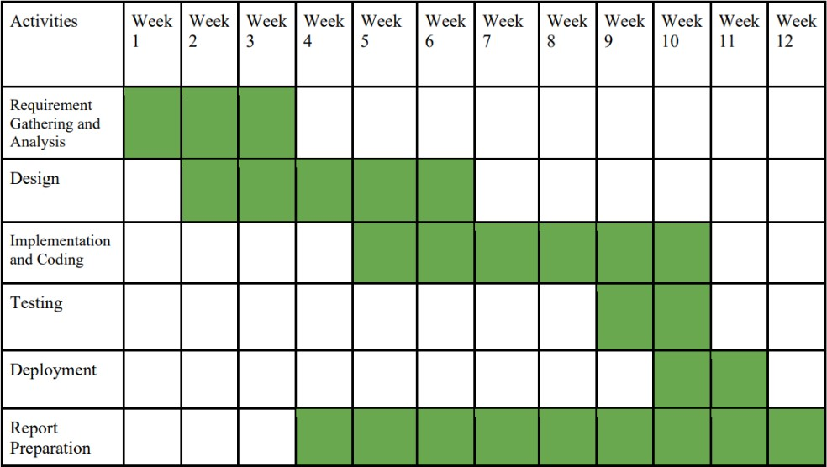

# Figure 1: Gantt chart

# **CHAPTER FOUR**

# **IMPLEMENTATION AND TESTING**

## **4.1 Implementation**

The online House Rental management system in used in the following modules that can be implemented. Modules Details: The Implemented modules in given below

1. Registration/Login module
2. Booking Module
3. House Posting Module
4. Feedback and contact module

**Login modules**: Login modules is implemented in the online House Rental Management to only allow a register person. We have to use this module in security purpose related on the detail. Registration modules: The online House Rental management system in Registration modules is used to collect the user personal information. It has to collect the address, name, phone number also. The registration module details are stored in the database.

**Booking Modules**: Online House Rental Management System has an implementation of House Booking where only registered members are allowed to view and book house/office/land/home for rental or lease Post

**House Module**: House Rental Management System has been implemented with House posting module where the seller/landlord or system administrator can upload house/property details for sale or rent.

## **4.2 Tools Used**

### **4.2.1 Case Tools**

### **Entity Relation Diagram or ERD**

E-R model or entity relation model is a high-level conceptual data model. This model and its variants are mainly used for the conceptual design of database applications and tool design. The E-R diagram helps create the database for any project, and it is represented in the form of tables. An ER diagram is only used for sound systems.



# Figure 2: ER Diagram

### **Data Flow Diagram**

A DFD is a graphical representation of data flow through a system. It can also be used to visualize the data processing. The data flow diagram is the first step in the design phase, and it functionally decomposes the requirements specification. In the DFD, some bubbles are connected by lines. Each bubble represents data transformation, and each line represents data flow. A DFD shows what data flow rather than how data flows.

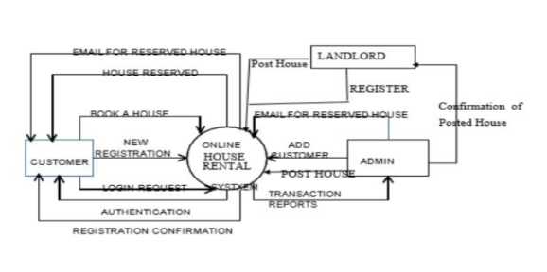

# Figure 3: Level 0 DFD Diagram

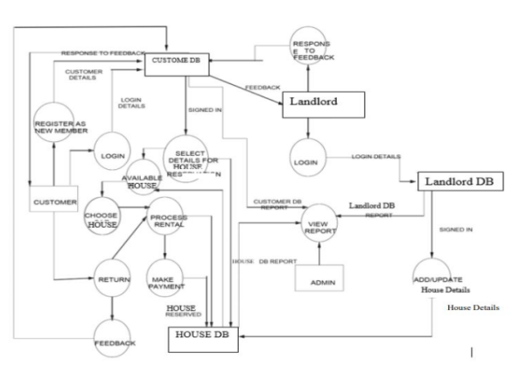

# Figure 4: Level 1 DFD Diagram

### **Use Case Diagram**

The Use case module of any system represents different ways the user can use the System. One of the ways to find all the use cases is to ask a simple question, “What can a user do with the system?” The use case module uses a partition, which changes the behavior of the system into transactions so that each of the transactions performs some specific and practical action. All these are accomplished from the user’s view.

The purpose of the use case is to define a coherent behavior without revealing the System’s internal structure. It typically represents a sequence of interactions between the user and the design. A simple line drawing can define these use cases. In the use case diagram, each use case is represented by an ellipse with the name written inside the ellipse. All the eclipses are enclosed inside a rectangle called a boundary

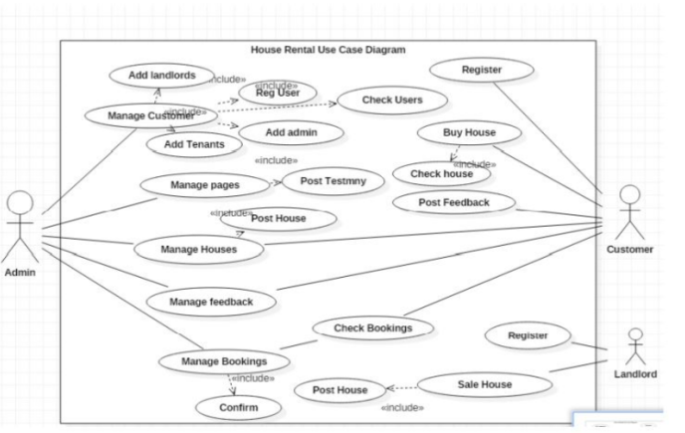

# Figure 5: Use Case Diagram

### **Class Diagram**

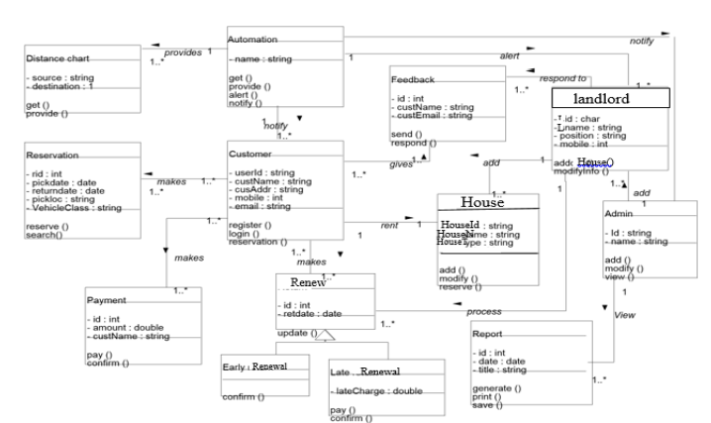

# Figure 6: Class Diagram

## **4.3 SURVEY OF TECHNOLOGIES**

### **4.3.1 About PHP**

**PHP**: Hypertext Pre-processor is a widely used, general-purpose scripting language that was originally designed for web development to produce dynamic web pages. For this purpose, PHP code is embedded into the HTML source document and interpreted by a web server with a PHP processor module, which generates the web page document.

As a general-purpose programming language, PHP code is processed by an interpreter application in command-line mode performing desired operating system operations and producing program output on its standard output channel. It may also function as a graphical application. PHP is available as a processor for most modern web servers and as standalone interpreter on most operating systems and computing platforms.

PHP was originally created by Rasmus Lerdorf in 1995 and has been in continuous development ever since. The main implementation of PHP is now produced by the PHP Group and serves as the de facto standard for PHP as there is no formal specification. PHP is free software released under the PHP License.

PHP is a general-purpose scripting language that is especially suited to server-side web development where PHP generally runs on a web server. Any PHP code in a requested file is executed by the PHP runtime, usually to create dynamic web page content. It can also be used for command-line scripting and client-side GUI applications. PHP can be deployed on most web servers, many operating systems and platforms, and can be used with many relational database management systems. It is available free of charge, and the PHP Group provides the complete source code for users to build, customize and extend for their own use.

Originally designed to create dynamic web pages, PHP now focuses mainly on server side scripting, and it is similar to other server-side scripting languages that provide dynamic content from a web server to a client, such as Microsoft's Active Server Pages, Sun Microsystems’ Java Server Pages, and mod_perl. PHP has also attracted the development of many frameworks that provide building blocks and a design structure to promote rapid application development (RAD). Some of these include CakePHP, Symfony, Code Igniter and Zend Framework, offering features similar to other web application frameworks.

**PHP Syntax**: HTML and PHP code is written on the same page, and to distinguish PHP code from HTML, the PHP code is enclosed within Tags. For example:

<html>

<head><title>php basics</title><head>

<body>

<h1>HELLO</h1><?php

Echo “hello”;

?>

</body>

</html>

In the above example PHP code is embedded within HTML. In this way PHP and HTML coding is combined on the same page.

Since PHP is a server side scripting language, the PHP coding cannot be seen by the end user through view source option, due to this feature PHP is very secure.

PHP is a parsed language; therefore PHP environment is necessary at the server for running PHP scripts.

**Working of PHP**: When a client requests web page containing PHP code from the server, then the requested PHP pages are parsed under PHP environment and interaction with database is made if required. After server side processing, the resulting HTML pages are passed to client and displayed on the browser. In this way the working of php is complete.

**Connecting PHP Application to MySQL Database**

Make a connection variable to the database:

$con= mysql_connect ("localhost","servername","password");

Here $con is a connection variable to database.

Select database over that connection variable

$db=mysql_select_db("databasename",$con);

Prepare a sql query to execute:

$qry= Select * from abc;

Run the sql query:

$result=mysql_query($qry);

Iterate over the result:

while($row = mysql_fetch_array($result))

{

//some logic

}

### **4.3.2 Introduction to MySQL**

MySQL is a relational database management system (RDBMS) that runs as a server providing multi-user access to a number of databases. MySQL is officially pronounced ("My S-Q-L"), but is often pronounced ("My Sequel"). It is named for original developer Michael Widenius's daughter My.

The MySQL development project has made its source code available under the terms of the GNU General Public License, as well as under a variety of proprietary agreements. MySQL is owned and sponsored by a single for-profit firm, the Swedish company MySQL AB, now owned by Sun Microsystems, a subsidiary of Oracle Corporation.

MySQL code uses C and C++. The SQL parser uses yacc and a home-brewed lexer, sql_lex.cc. MySQL works on many different system platforms, including AIX, BSDi, FreeBSD, HPUX, i5/OS, Linux, Mac OS X, NetBSD, Novell NetWare, OpenBSD, OpenSolaris, eComStation, OS/2 Warp, QNX, IRIX, Solaris, Symbian, SunOS, SCO OpenServer, SCO UnixWare, Sanos, Tru64 and Microsoft Windows. A port of MySQL to OpenVMS also exists.

All major programming languages with language-specific APIs include Libraries for accessing MySQL database. In addition, an ODBC interface called MyODBC allows additional programming languages that support the ODBC interface to communicate with a MySQL database, such as ASP or ColdFusion. The HTSQL - URL based query method also ships with MySQL adapter allowing direct interaction with MySQL database from any web client via structured URLs. The MySQL server and official libraries are mostly implemented in ANSI C/ANSI C++.

### **4.3.3 Introduction to APACHE SERVER**

In this project apache server is used to parse and execute PHP pages, before deploying websites on the server, the website should be tested at the developer side to get a feel of how the website will work on actual server.

Therefore apache server is like a local server on the developer side, apache server should be informed about the environment on which it should work.

In our project apache server is configured to work with PHP, in this way all the PHP pages are parsed and executed by the server.

When apache is installed on the system, then its services is controlled by apache service monitor. The following are the database entities used in this system;

**Houses**: House information, Rental or sale/Buy agreement administration, credit control, cash flow control, compatibility with accounting principles and practices and existing systems, accurate bookkeeping, owner reporting and identifying of key performance indicators.

**Tenant**: general tenant information (name and contact details), finding space for a tenant, accurate rent billing and collection, handling of payments, accounting and general ledger (GL) functions.

**Landlord, Client or Body Corporate**: general details (name and contact details), shareholding if applicable.

**Basic administration (supervisory level)**

Repair and maintenance schedules are required by the House manager, as well as a diary to “flag” important dates for tenant’s works, rent review and lease renewal dates. A good software program should also provide for a forward planning facility.

**General management (functional level)**

Aptly summarises the requirements at this level as follows:

“In terms of accounting procedures, the main property management related tasks will comprise • Rent invoicing and income connection

• Recovery of expenditure

• Disbursements/outgoings

• Service charge costing and apportionment

• Client and tenant accounts

• Report production.

Any rent invoicing system should record amounts owing from tenants quickly and accurately and bill them accordingly. Receipts will need to be processed quickly and credit control systems maintained. Rent demands and accounts should be easily accessible as should rent apportioned over periods not concurrent with a normal rent review period. Interest on unpaid rent should be calculable and a stop on rent collection made if necessary. Full analysis of rents, classified by tenant, property or client should also be possible. Service charge accounting is often provided as a separate module. This will need to cater for multi tenanted buildings where perhaps some tenants do not contribute to some services. Separate schedules may well need to be set up in such cases. In addition, a full analysis of property expenditure, service suppliers, tenant expenditure, service charges, wages and salaries, and VAT on expenditure should be possible”. Strategic management

Lastly, a software programme should provide the information necessary to make strategic decisions. Such decisions include the performance and valuation of individual properties and property portfolios, as well as development appraisals. Features that are required comprise, among other things, tenancy and tenure details, the calculation of yields and profitability, discounted cash flows, cost, financing, tax implications and the valuation of both freeholds and leaseholds. All these should be supported by good menu-driven features and help facilities

**4.4 Testing**

At this stage, I will guarantee both individual and coordinated entire are systematically confirmed to guarantee they are without mistake and fulfill client prerequisite. I will include both unit testing of individual code module, framework testing of the coordinated item and acknowledgment testing directed by or in the interest of client. I will guarantee bugs found are redressed before moving to the following stage. I will likewise get ready, survey and distribute item documentation at this stage.

**Test Plan**

|  |  |  |
| --- | --- | --- |
| What was tested | Expected Output | Remarks |
| Login Button was clicked after entering username and password | Should login and show dashboard. | Passed [Dashboard was shown as expected] |
| View All Button Users Tab Was clicked | Should go to users manager page and show all the users list | Passed [All users were listed as expected] |
| View All Button Houses Tab Was clicked | Should go to Houses manager page and show all the users list | Passed [All Houses were listed as expected] |
| View All Button Booking Tab Was clicked | Should go to Bookings manager page and show all the users list | Passed [All Bookings were listed as expected] |
| All the details were inserted and add button was clicked on add house page | Should add house and display the message | Passed [House was added and the message was successfully displayed] |
| All the details were inserted and add button was clicked on add user page | Should add user and display the message | Passed [User was added and the message was successfully displayed] |

**Software Testing**

Is it possible to invoke each menu function using logical assumptions that if all parts of the system are correct, the goal will be successfully achieved? In adequate testing or non-testing will leads to errors that may appear few months later. That’s why it is very important to always test the new software. This make two issues the motivation behind the framework testing is to consider all the feasible varieties to which it will be recommended and push the frameworks to limits. The testing procedure concentrates on the intelligent interims of the product guaranteeing that the sum total of what proclamations have been tried and on utilitarian interim is directing tests to reveal blunders and guarantee that characterized info will create real outcomes that concur with the required outcomes. Program level testing, modules level testing incorporated and did. There are two noteworthy sort of testing they are

**1. White Box Testing. :**

White box now and again called "Glass box testing" is an experiment plan that uses the control structure of the procedural outline to drive experiment. Utilizing white box testing strategies, the accompanying tests were made on the framework

a) All autonomous ways inside a module have been practiced once. In our framework, guaranteeing that case was chosen and executed checked all case structures. The bugs that were winning in some piece of the code where settled

b) All legitimate choices were checked for reality and misrepresentation of the qualities.

**2. Black Box Testing:**

Black Box Testing centers on the utilitarian prerequisites of the product. This is discovery trying empowers the product designing to determine an arrangement of info conditions that will completely practice every useful necessity for a program. Discovery testing is not another option to white box testing rather it is reciprocal approach that is probably going to reveal an alternate class of mistakes that white box techniques like..

a) Interface errors

b) Performance in data structure

c) Performance errors

d) Initializing and termination error

# **CHAPTER FIVE**

# **CONCLUSION AND FUTURE RECOMMENDATION**

## **5.1 Conclusion**

House Rental business has emerged with a new goodies compared to the past experience where every activity concerning House rental business is limited to a physical location only. Even though the physical location has not been totally eradicated; the nature of functions and how these functions are achieved has been reshaped by the power of internet. Nowadays, customers can reserve book/buy/sale House online, rent House online, and have the house contracted successfully without any sweat once the customer is a registered member of the House Rental Management System. The web based House rental system has offered an advantage to both Tenants as well as Landlords to efficiently and effectively manage the business and satisfies customers’ need at the click of a button.

## **5.2 Recommendation**

Our project is intended to fulfill the requirements of rental house proprietors. A few easy to understand interfaces have likewise been received. This bundle should end up being an effective in fulfilling every one of the prerequisites of the clients It is with most extreme confidence that I exhibit this product to you trusting that it will tackle your issues and urge you to keep acknowledging innovation since it is intended to change and facilitate all our work that is by all accounts exceptionally troublesome. I don't imply that my venture is the best or that I have utilized the best innovation accessible it only a straightforward and an unassuming endeavor that is straightforward. Be that as it may, I would support any individual who can propel it utilizing propelled innovations to expand its abilities.

# 

# **REFERENCES**

• http://www.resgroup.net/

• <http://www.a1realestate.solutions>

• Wikipedia.org

• www.w3schools.com

• [www.webcampzg.org](http://www.webcampzg.org)

# 

# **BIBLIOGRAPHY**

* Software Engineering - R.S. Pressman
* PHP for Dummies
* PHP Beginners Guide by McGraw-Hill Publication
* JavaScript by McGraw-Hill Publication