
LA GRANDEE INTERNATIONAL COLLEGE
Simalchaur, Pokhara Nepal
A Project Proposal
On
“PebbleX”

Submitted to:
Bachelor of Computer Application (BCA) Program
In partial fulfilment of the requirements for the degree of BCA under Pokhara University
Submitted by:
Name: | Course | Semester | P.U. Registration Number
Anish Baniya | BCA | 8th | 2021-1-53-0347
Gaurav Babu Ghimire | BCA | 8th | 2021-1-53-0351
Prajal Gurung | BCA | 8th | 2021-1-53-0359
Date:9/26/2025

Table of Contents
1. Introduction 1
2. Background Study 2
3. Problem Statement 3
4. Objectives 4
5. Methodology 5
6. Project Gantt chart 6
7. Deliverables 7
8. References 8

List of Figures
5.1: RAD Methodology 5
6.1: Project Gantt Chart 6

Introduction
A PebbleX is Hardware Supply Management System that is a dynamic web and mobile-based platform designed to streamline transactions between hardware supplier and their vendors. The system empowers supplier through a comprehensive web panel to efficiently manage product listings, inventories, vendor relationships and order processing. Meanwhile, vendors benefit from a user-friendly mobile app that offers easy access to browse product catalogs, place orders.
The system is being developed with the aim to connect a supplier with diverse range of vendors for the hardware products such as tools, electrical as well as plumbing supplies, construction materials, and industrial equipment. It creates an integrated B2B environment where supplier can control product management, manage bulk orders, pricing, stock updates and order fulfillment, while vendors can quickly fulfill procurement needs with transparency and operational ease. This dual-interface approach ensures smooth communication, streamlined supply chain operations, and transparency between suppliers and vendors.
By digitizing the supplier-vendor relationship, the PebbleX foster a digital ecosystem that enhances supply chain collaboration and increases business productivity while also reduces manual procurement process, improves efficiency in distribution. It creates a modern, scalable, and reliable solution tailored to Nepal’s growing hardware and construction sector.

Background Study
The hardware supply industry in Nepal has seen gradual growth, driven by increasing construction activities and urban development. However, challenges such as fragmented system, manual processes, and lack of supplier-vendor integration, which causes delays and inventory management issues.
- HamroNirman
HamroNirman is the first and one of the largest e-commerce platforms in the construction sector of Nepal. It offers both Business to Business (B2B) as well as Business to Consumer (B2C) marketplace, covering a wide range of construction-related products under one roof such as hardware, electrical, sanitary, plumbing, machinery, and building materials. (HamroNirman, 2025)
- GharBanau
GharBanau, on the other hand, operates as an online marketplace focused on enabling buyers and sellers of construction materials to directly connect and transact. It functions primarily as a bridge in the supply chain, allowing sellers to post product details and buyers to search and order materials conveniently via web and mobile apps. GharBanau offers additional services like professional product photography to make listed products more appealing. (GharBanau, 2025)
Our System builds upon the capabilities of existing platforms by integrating a dedicated web portal for supplier and a mobile app for vendors, emphasizing real time inventory tracking, advanced filtering, and automated order processing with better UI. This system aims to provide a seamless supplier-vendor ecosystem tailored Nepal’s market complexities, facilitating streamline operations, and enhancing supply chain transparency.

Problem Statement
Based on discussions with the supplier, several challenges within the hardware supply industry were identified. The supplier expressed difficulties in efficiently handling vendor orders efficiently, maintain accurate inventory levels. The absence of a fully integrated digital system has resulted in frequent order delays, stock mismatches, and operational bottlenecks. These challenges highlight the need for a dedicated hardware supply management system that can streamline supplier-vendor interactions and automate vital supply chain workflows, improving accuracy and responsiveness.
- Limited adoption of real-time inventory tracking and automated ordering
- Lack of centralized inventory management for supplier

Objectives
A PebbleX aims to optimize procurement, inventory, and distribution processes within the hardware supply chain, particularly suited to the challenging market conditions of Nepal. By integrating a web platform for suppliers and a mobile app for vendors, the system enhances communication, real-time tracking, and coordination, addressing existing logistical and operational inefficiencies.
- To improve supply chain efficiency by automating workflows
- To develop a centralized web platform for suppliers to manage inventory, pricing, and vendor orders
- To provide a vendor with a mobile application for bulk ordering

Methodology
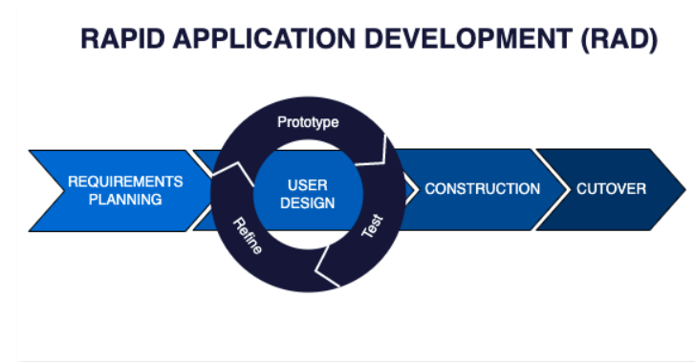
In Context of our project, we have chosen the Rapid Application Development (RAD) Methodology. Because due to time constraints or changing requirements. In a RAD approach, a small, cross-functional team of developers works closely with users to rapidly prototype and develop working software, using iterative and incremental development techniques. (LoneStar, 2024)
5.1: RAD Methodology

Project Gantt chart
A Gantt chart is a popular project management tool used to visualize the schedule of a project. It displays tasks or activities against time, allowing project managers to track progress, manage dependencies, and allocate resources efficiently.
6.1: Project Gantt Chart

Deliverables
- Supplier Web Panel
- A centralized platform for supplier to manage inventory, pricing, and vendor orders.
- Features include product management, order tracking, and invoice generation.
- Vendor Mobile Application
- A mobile app enabling vendors to place bulk orders, track invoices, and communicate with the supplier.
- Includes features like real-time stock availability and automated notifications.
- Documentation and User Manual
- Project documentation covering system design, architecture, and workflows.
- User guide for suppliers and vendors to operate the system effectively.

References
GharBanau. (2025). About us. Retrieved from gharbanau.com: https://www.gharbanau.com/page/about
HamroNirman. (2025). About us. Retrieved from hamronirman.com: https://www.hamronirman.com/aboutus
LoneStar. (2024). Rapid Application Development. Retrieved from https://www.agilelonestar.com/: https://www.agilelonestar.com/knowledge-base/rapid-application-development

