Steel Design
Assignment 2 yr 20

Due Date 22 May

Q 1
A simply supported beam of 9m length carries a design point load of 20 kN at the midpoint acting at the major principle plane and a design axial force of 200kN (a beam- column). The beam- column is 250 UB37.3 OF GRADE 300. Beam is continuously braced. Check the adequacy of the beam- column. What will be the situation if it is not braced against out of plane buckling?

Q2
Shown below is a sub frame of a frame work. Dead and Live load for the beams BE and BD shown. All ends are fixed. You can assume the joint B also behaves as fixed. Column AB transfers an ultimate axial load of 300kN to column BC. Design the column BC. BD and BE are perpendicular to each other. The whole frame is fully braced. Make necessary assumptions as necessary.
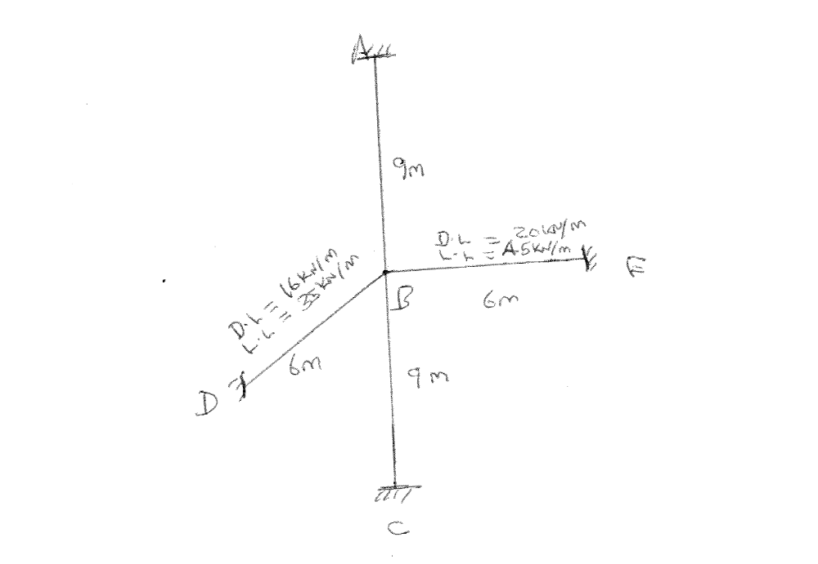
Q3
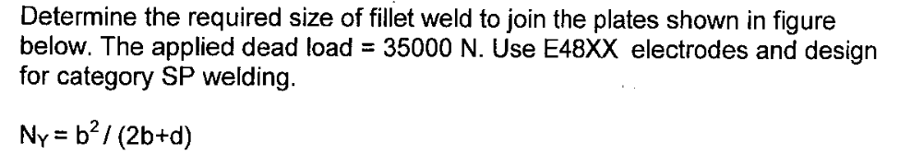
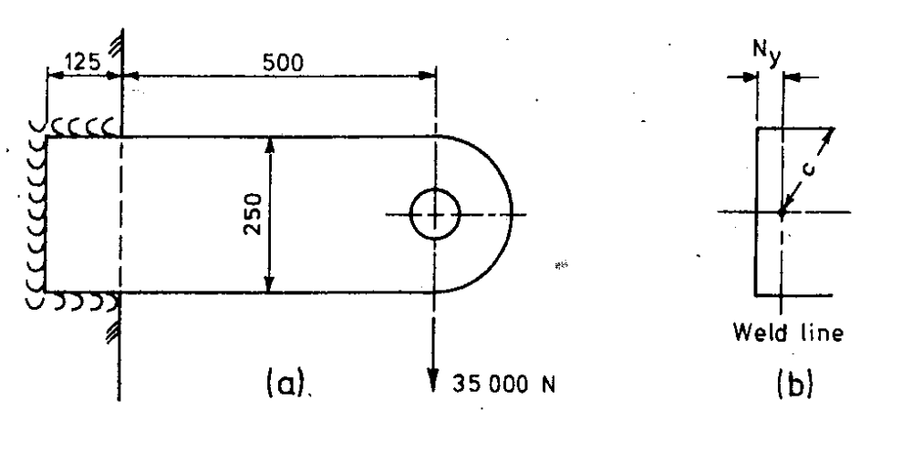

Q4
