
Analysing Corporate Performance: A Case of a Listed Company

Molude Name : Ethics and Financial Reporting
Moldule Code : 7015MECO
Individual Report
Student Name : Anish
Student ID: 17000385
Coventry University London
Word Count :
Submission: 20 August 2026

Executive Summary
One can state that the intended audience of the report is the address to the line manager of the financial consultancy company in terms of advising a prospective client who might be considering investing in the equity of the Lloyds Banking Group plc (LBG) -the biggest domestic retail and commercial bank and a part of the FTSE 100. A
LBG is a BUY because income oriented investors but with a limit on the motor finance liability. Earnings have been shrinking in the short term, with unproven causes such as re-pricing deposits to reduce the net interest margin to 2.95% and remediation costs of £899 million and increased impairment charges of almost 1.29; both nearly twice as much as last year, awaiting assessment. These head winds have been roundabounded greatly. In 2025, NII trended to reinvestment of structural hedges, which caused NII to go back to 13,230 million, total income grew to 19,422 million, profit before tax grew by 12% to 6,661 million, and the return on tangible equity (ROTE) of 12.9%, which was higher than the 11.8% of peer banks. The capital strength is also high with CET1 ratio of 14.0 which is considerably higher than the SREP requirement by PRA of about 12. Its dividends per share growth has been 15 per cent over the last two years to 3.65 pence and in the share buyback programme continues to enhances the per-share figures. The single material risk, and the only unresolved motor liability in the books is unresolved motor finance liability (£1,950 million provided at year-end 2025) where the FCA scheme rules expected next May 2026 can potentially lead to additional charges.

Table of Contents
Executive Summary 2
1. Introduction 4
2. Corporate Governance 4
3. Financial Statement Analysis 5
4. Financial Performance Analysis 8
5. Capital Structure Management 11
6. Working Capital Management 12
7. Conclusion and Recommendations 12
References 14

List of Figures
Figure 1: Income statement 5
Figure 2: Balance sheet 6
Figure 3: Cash flow statement 7
Figure 4: Profitability and liquidity analysis 9
Figure 5: Efficiency and solvency ratio 10
Figure 6: Investor analysis 10
Figure 7: Trend analysis 11
Figure 8 Benchmarking 12
Figure 9: Capital structure management and WCM 13

1. Introduction
In the United Kingdom, the biggest domestic banking group by the number of retail customers is Lloyds Banking Group plc (incorporated 1995, listed on the London Stock Exchange (ticker: LLOY) and New York Stock Exchange) with around 26 million customers under the brands Lloyds Bank, Halifax, Bank of Scotland and Scottish Widows. The Group has four business streams Retail; Commercial Banking; Insurance, Pensions and Investments; Corporate and Institutional Banking. The total assets were recorded at 31 December 2025 of £944.1 billion and the Group had around 56,000 colleagues working in the UK and overseas (Lloyds Banking Group, 2025).
The current report has been prepared with the request of the line manager in the financial consultancy firm to examine the financial performance of LBG in reference to a potential client interested in investing in the equity of a company. The Annual Report and Accounts 2025 by LBG may not serve much by itself since it is the primary source of data used by the report but has to be supported by a variety of sources and academic sources (Bank of England, 2025).

2. Corporate Governance
Board Composition
The governance of LBG is in full compliance with UK Corporate Governance Code 2018. By 31 December 2025, there were ten directors on the Board; Sir Robin Budenberg, executive director Charlie Nunn (Group CEO) and William Chalmers (CFO), and seven non-executive directors (all independent directors), with Senior Independent Director Cathy Turner (Bankofengland, 2025). The Board had 50 female representation and 20 ethnic minority representation which is over the FTSE Women Leaders 40% target. The Group has an Aligned Board Model in place in LBG, Lloyds Bank plc and Bank of Scotland plc, together with three other Ring-Fenced Bank-only non-executive directors that independently oversee retail banking subsidiaries: under UK ring-fencing laws.
Impact of committees and Governance
They maintain five Board committees with a well-organized supervision: the Audit Committee is interested in the integrity of financial reporting, the Board Risk Committee is interested in the risk appetite and the internal controls, the Nomination and Governance Committee is interested in the Board composition and succession, the Remuneration Committee is related to the appropriateness of executive compensation on the basis of the RoTE, generation of the CET1 and outcomes related to customers, the Responsible Business Committee is concerned with the sustainability and adherence to the Consumer Duty (BIS, 2022). This framework directly enabled it to manage financial performance - active credit model has assisted the management achieve an aspect quality ratio of 0.17% in the year 2025, which is among the lowest in the industry; and executive compensation alignment with long-term measure has contributed to the achievement by the management of its 87.9% total shareholder return in 2025.

3. Financial Statement Analysis
Income Statement
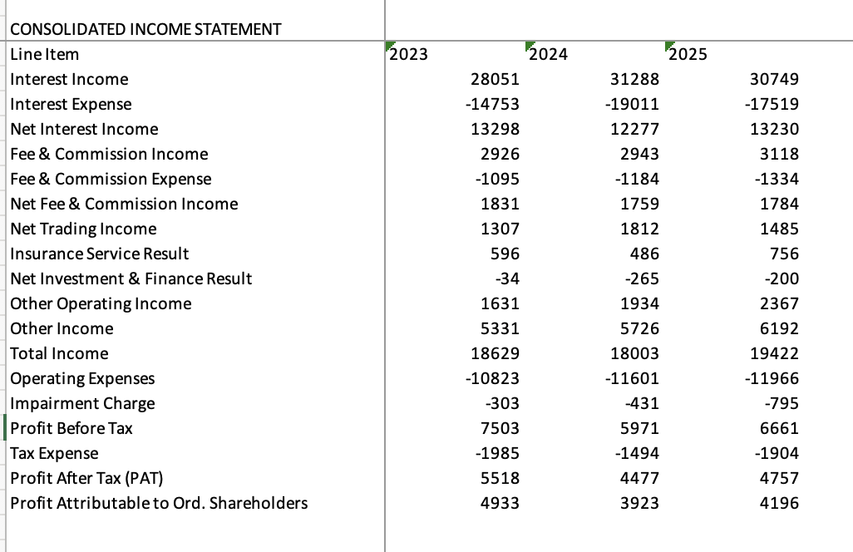
Figure 1: Income statement
Total income declined 3.4% in 2024 to £18,003 million from £18,629 million in 2023, driven by a £1,021 million fall in net interest income (NII) from £13,298 million to £12,277 million. This new pricing of the deposits occurred as the customers changed to the savings-based products which provided high yields squeezing the banking net interest margin (NIM) down to an estimated 2.95% in 2024 versus 3.22 in 2023. The total income recovered to the same level of 19,422m in 2025 and NII recovered its bottom of 13,230m as the structural hedge portfolio rolled over maturing balances at higher prevailing rates (BIS, 2023). Other income grew as the companies raised their fee revenues, enhanced the performance of its insurance service, and other operating income due to the Schroders Personal Wealth takeover to approximately 6,192 million by 2025. To capture the capital of technology and inflation rates, the operating expenses have risen in 2023 to 2025.
Balance Sheet
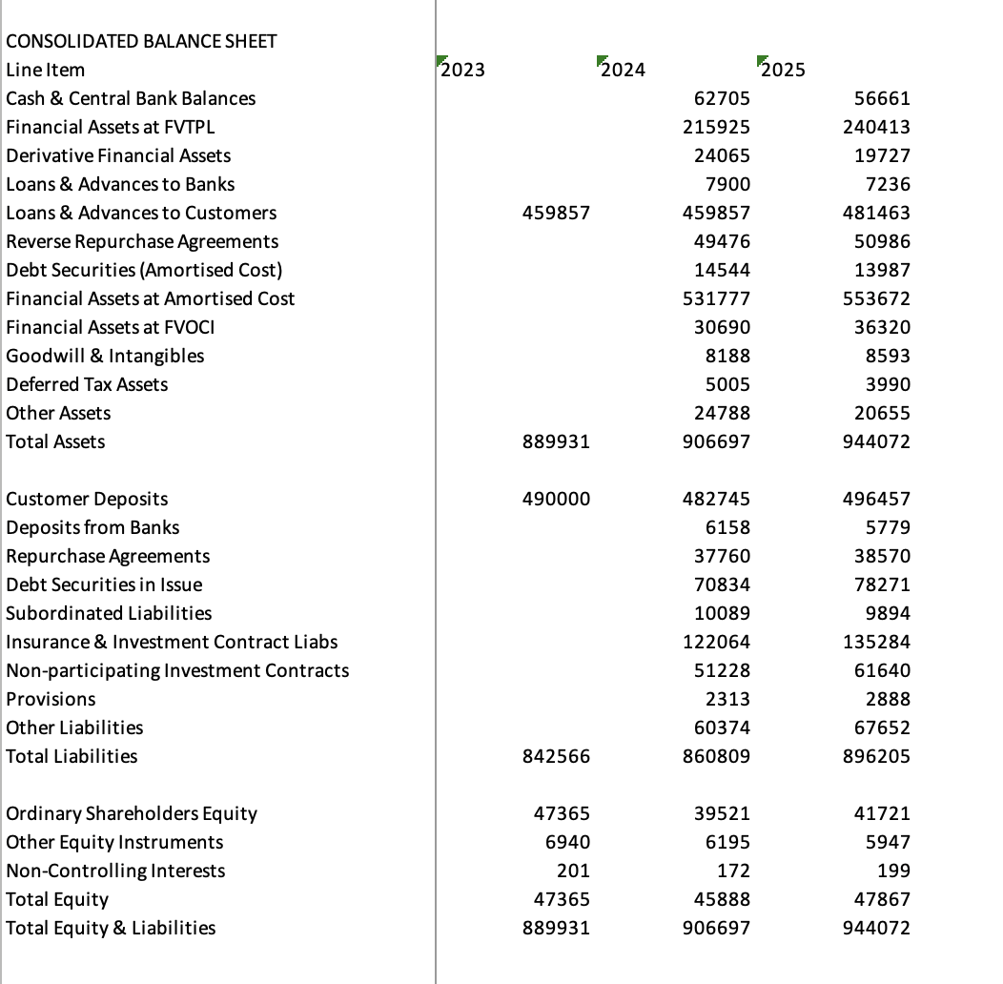
Figure 2: Balance sheet
In 2025, the total assets grew by 4.1 to 944,072 million and the loans and advances to customers (up 21,606 million to 481,463 million) were huge with practically all UK mortgage growth (up10.8 billion). The customer deposits increased by then 13,712 million to 496,457 million and this balance sheet model of the Group is based on retail-funded balance sheets. Both total equity and attributable profit have been enhanced by rise in attributable profit that rose by 45,888 million to 47,867 million over the capital distributions of 3.71billion. Debt securities rose however to hit a peak of £78,271 million with the Group substituting the Bank of England Term Funding Scheme drawings of £13.1 billion with market rate wholesale issues (FCA, 2024).
Cash Flow Statement
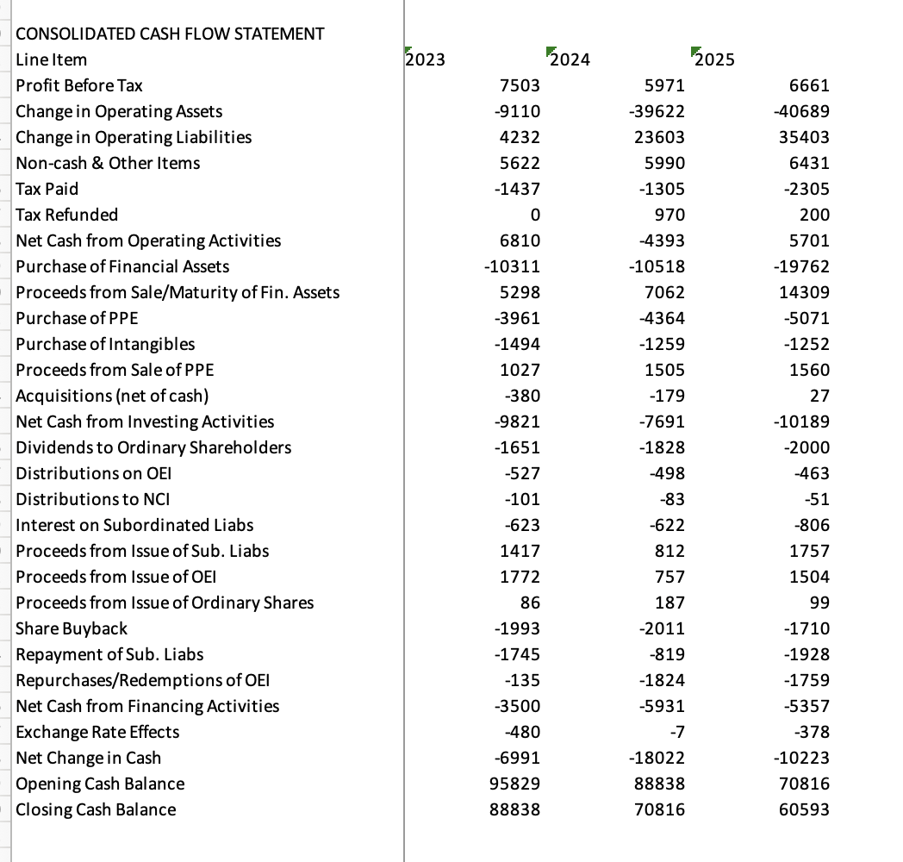
Figure 3: Cash flow statement
There was a steep reversal of cash flow operations poised at +, 5,701 million in 2025 that was -4,393 million the previous year, 2024. The 2024 outflow showed a 39.6 billion increase in operating assets (mainly in insurance contract assets) as opposed to a depreciation in trading. It had been supported by asset sales (e.g. bulk annuities portfolio sale to Rothesay Life) to fund repealing the 2025. Finance financed outflows amounted to 5,357 million pounds of which 2,000 million pounds of the outflow was by way of ordinary dividends and 1,710 million pounds of the outflow by way of share buybacks (FRC, 2024).
Income Statement: In 2024, net interest income decreased by -1,021 million (-7.7) as a result of the rise in the Bank of England Bank Rate to 5.25 which resulted in a mass flight of deposits out of low-rate current accounts onto long-term savings. The change experienced in the interest paid on the liabilities incurred by LBG rose at a higher rate than the interests the company earned on the assets and this decreased the NIM to 2.95, compared to 3.22. This one compression trickled off to a decrease in total income of 3.4% increasing the cost:income ratio to 60.4% (costs kept increasing either way) and sent the PBT down 20.4%. This has been overturned by the structural hedge in 2025 - reinvestment of maturing balances at higher rates put NIM at 3.06, NII at £953 million and PBT at 11.5.
Balance Sheet: Growth in 2025 loans of 21.6 billion (positive interest income (more loans, higher NIM = higher NII)) helped the recovery of the income statement. The increase in the debt securities replaced cheap funding under TFSME and to an extent, this increases the expense of future funding.
Cash Flow: The growth of our running outflow of 4.4 billion on 2024 due to increase of insurance assets by 39.6billion, a timing, but not operating, dislocation, was offset in 2025 to +5.7 billion.

4. Financial Performance Analysis
Ratio Analysis
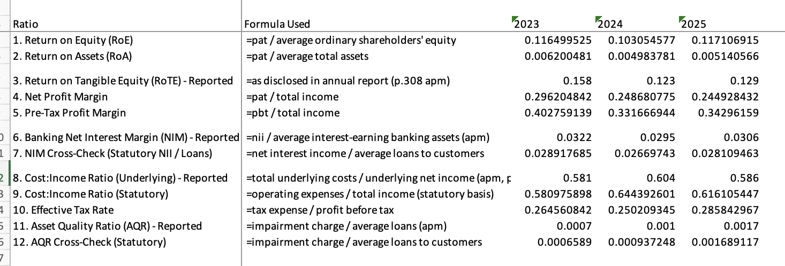
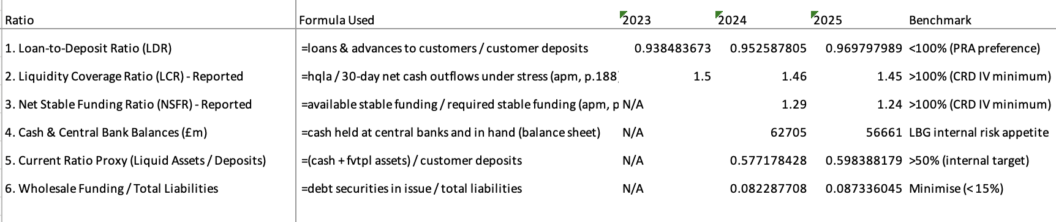
Figure 4: Profitability and liquidity analysis
Profitability: Return on equity moved from 11.7% in 2023 to 9.8% in 2024 and recovered to 10.1% in 2025. The reported RoTE which is the most important measure of LBG was also identical at 15.8, 12.3 and 12.9 respectively. The NIM compression and the 899 million motor finance remediation charge were also reflected in the 2024 decline, and the fact that the 2025 recovery is at 12.9% (14.8% with motor finance Q3 omitted) is evidence that there is a solid underlying trend. The net profit margin dwindled as percentage of 29.6 per 2023 to 24.5 per 2025 with the growth of expenses and impairments percentage of the income. This ratio cost income ratio deteriorated to 60.4% in 2024 and to 58.6% in 2025 as the revenues grew at a higher rate compared to the expenses.
Liquidity: A 95% ratio of loans to deposits in 2024 has an increase in loans exceeding the deposit increase that was 97 percent in 2025 resulting in an average ratio hitting 95-97 that is conservative and reflects the deposit-driven management style. It has a liquidity coverage ratio of 145 that is significantly above the regulatory requirement of 100% (HM Treasury, 2024).
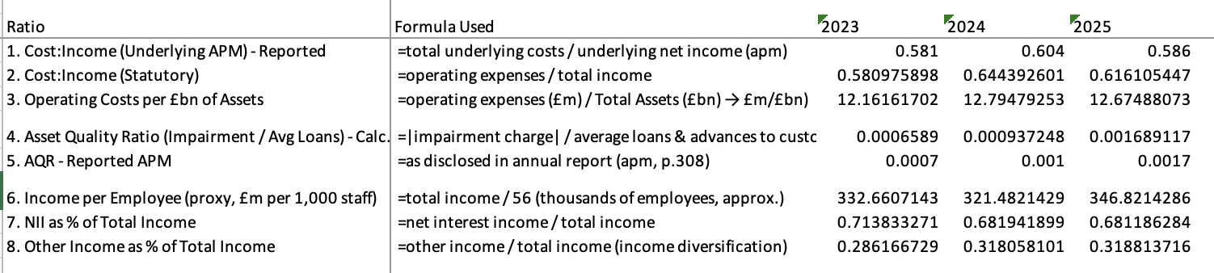
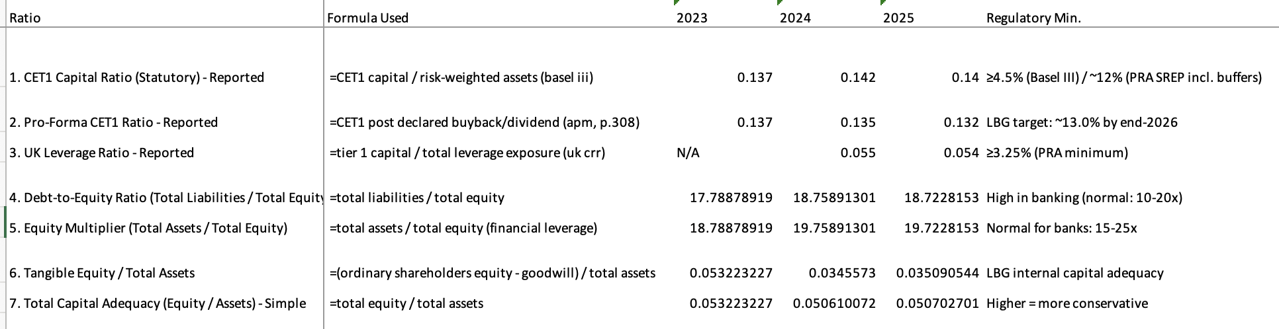
Figure 5: Efficiency and solvency ratio
Efficiency Costs per billion of assets in operation at about at 2024- 2025 stand at approximately 12.7-12.8 million which indicates a stable operation efficiency in increasing absolute costs. By 2025, the NII may decline to 68.1 in relation to total total income compared to 71.4 in 2023 as the growth of the fee income and insurance revenues among the other operating incomes facilitated growth concentration risk compared to the increase in interest income.
Solvency: The CET1 capital ratio has improved by an even steadier 0.5 percentage points to 14.2 and 14.0 in 2024 and 2025 respectively, that is, compared to the SREP of approximately 12% mandated by the PRA. It is typical that the whooping debt-to-equity ratio is about 18.7 times indicating deposits as the leverage, than financial distress. The UK leverage is not below the PRA minimum of 3.25 but is at 5.4%.
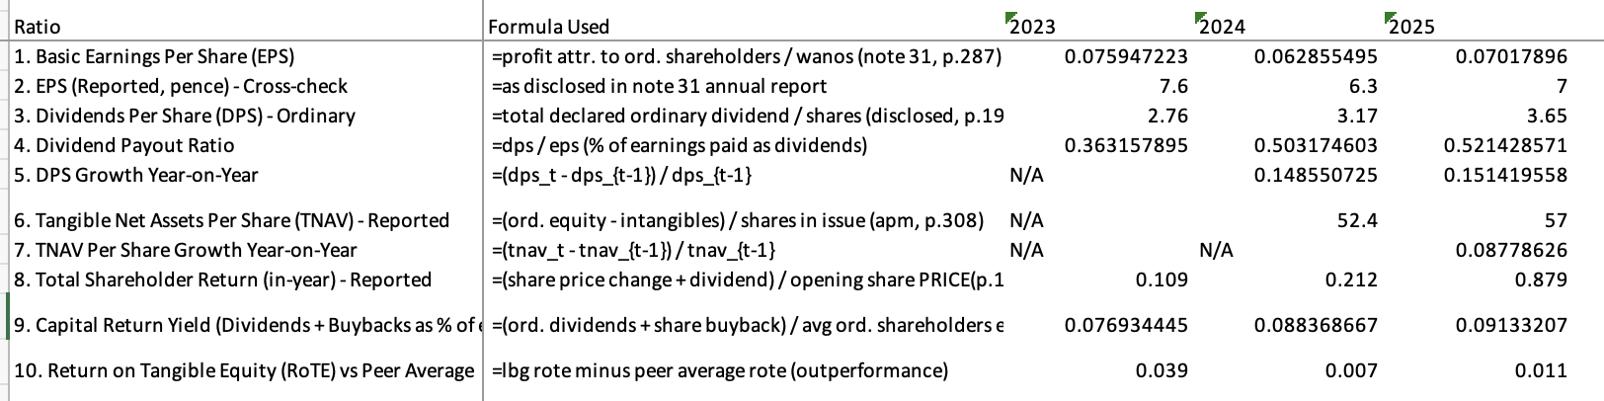
Figure 6: Investor analysis
Investor: The basic earnings per share decreased by 7.6 pence to 6.3 pence in 2023 and 2024, respectively, but these ratios recorded a growth of 7.0 pence in 2025. The decreasing weighted average number of shares outstanding 64,953 million in 2023 to 59,790 million in 2025, directly boosted per-share statistics. The dividends per share rose in 2025 to 3.65 pence (up 15 years in a row) and rose in 2023 to 2.76 pence. There was an improvement in tangible net assets per share in 52.4 pence at end-2024 and 57.0 pence at end -2025 (lloyd, 2023).
Trend Analysis
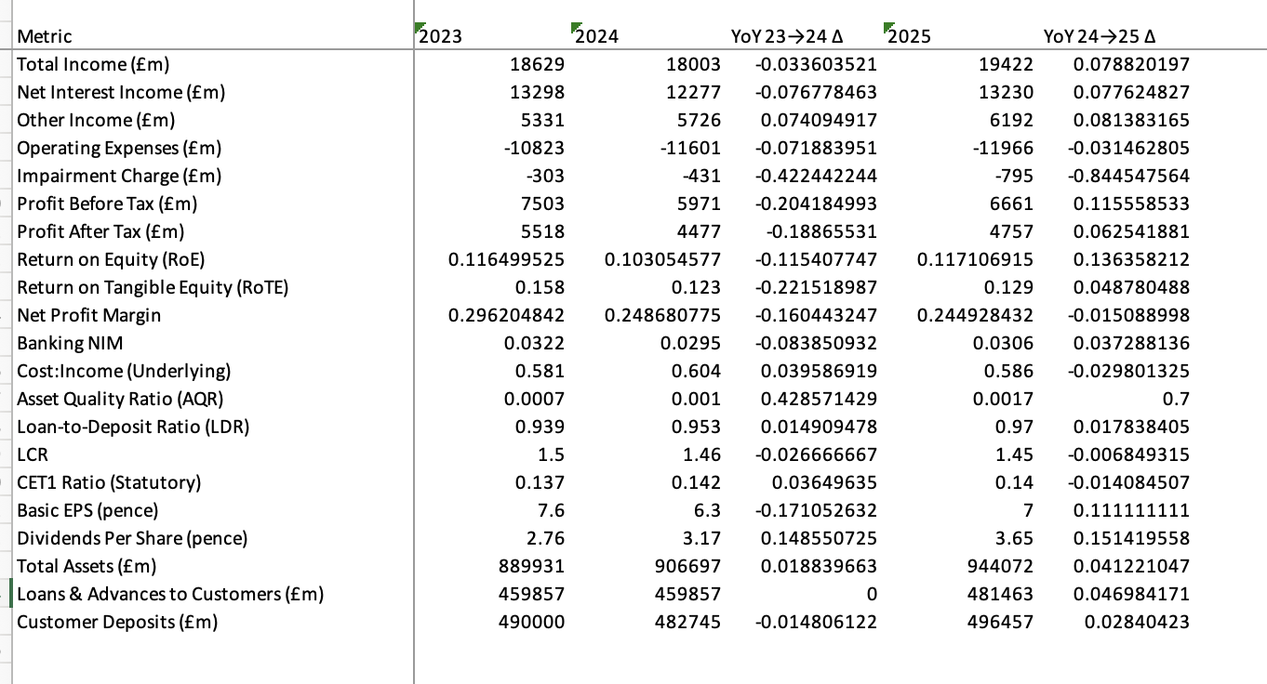
Figure 7: Trend analysis
The three-year outlook shows a very evident 2-part story. In 20232024, all the indexes of profitability declined: NII decreased by 7.7 percent, total income by 3. 4 percent, PBT by 20. 4 percent, ROE by 350 bp and EPS by 17. 1 percent. The three forces converged simultaneously - compression of 27 basis points on NIM, operating costs went up 7.2 and impairment charge went up 42 to 431m. This turnaround started on a broad-based twenty four twenty five basis: NII up by 7.8 percent, total income up by 7.9 percent, PBT up by 11.5 percent and cost growth slowed down to 3.1 percent.
Benchmarking
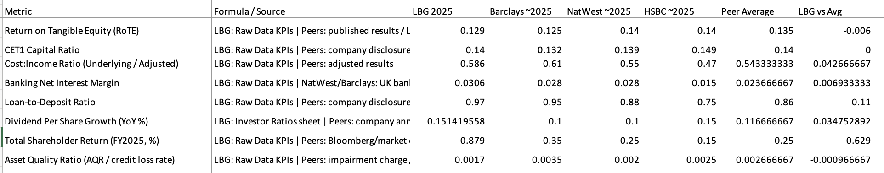
Figure 8 Benchmarking
The LBG RoTE in 2025 of 17.835 was higher than the peer group of 11.8% and the trend is observed over the three years of review of LBG own disclosures remuneration compared to the peer group of LBG own disclosures remuneration. Banking NIM averaging 3.06% is positive compared to that of Barclays and NatWest (approximately 2.8%), attributed to the fact that LBG has a large retail deposits base and structural position of hedges (Lloyds banking group, 2024). The cost to income percentage of 58.6 is still higher than that of NatWest at approximately 55 and HSBC at approximately 47 and is the most challenging area of relatively poor performance and the primary driving force behind the 2026 below 50% target.
Profitability: The NII had been depressed due to NIM compression (3.22%2.95) and loss of the total income which depreciated the cost:income to 60.4, declining PAT and pulled RoTE to 12.3. All profitability ratios were a result of the same cause. The 3-year structural hedge unravel (NIM +11bp) inflow over the blocklyster - more NII was being cost:income (58.6) was being PAT, finally settling down to RoTE, which was 12.9 (as compared to 11.8 in the peer group).
Liquidity: The LDR rising by 95 per cent to 97 per cent shows the growing loans in comparison to the deposits. Even though it is not more than 100, its course would lead to a shift in more reliance on wholesale financing, increased cost and lower future NIM - posing a direct challenge to profitability ratios.
Solvency: CET1 is increasing to 14.2% in 2024 following less earnings occurs when buybacks buy back less capital than when it is normal. RWA increase (larger book: +4.9) in 2025 pushed CET1 to 14.0% - shows that growth in loans (which enhanced NII and profitability) at the same time used the regulatory capital.
Investor: EPS increased 11.1 percent even though the increase in the PAT was 6.3 percent as the buybacks decrease the number of shares sold in the market to 59, 790 million shares the denominator effect increased the returns on a per-share basis even more than the gains on profits.

5. Capital Structure Management
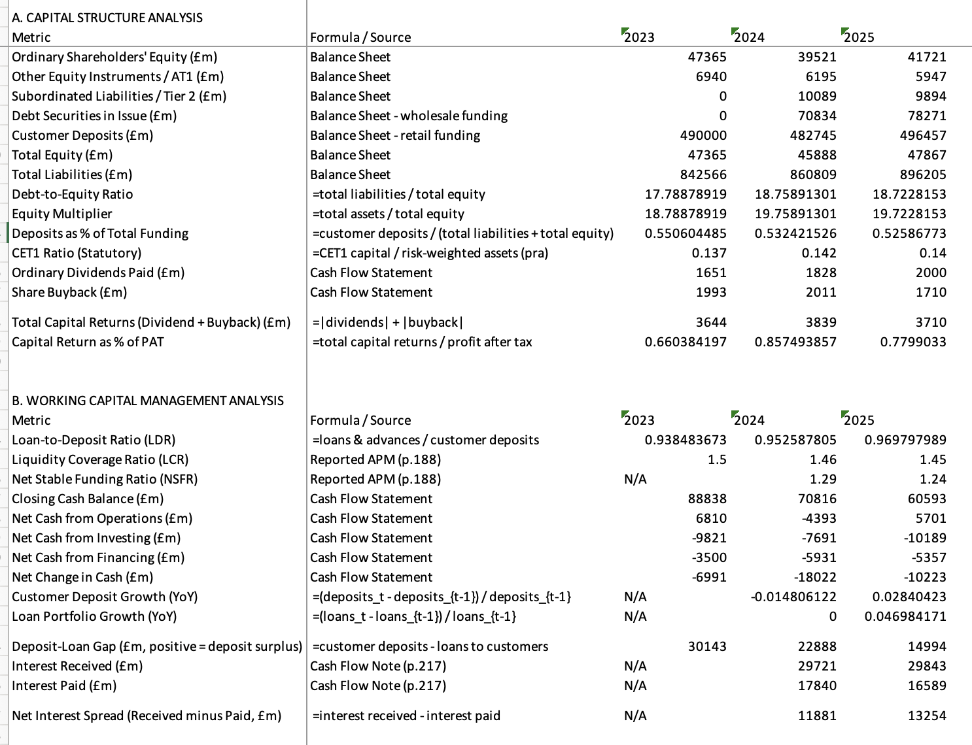
Figure 9: Capital structure management and WCM
The LBG capital management has a CET1 ratio of 13.0-14.0 which will balance between regulation compliance, business investment and the maximum sustainable distributions. The capital hierarchy includes ordinary equity, Additional Tier 1 perpetual instruments (around 5.9 billion at year-end 2025), and Tier 2 subordinated debt (around 9.9 billion), and in line with the Basel III requirements. There are three interacting distributions mechanisms, one of which is the progressive policy of ordinary dividends (annual growth of 15 percent) and another is the share buy back (1.75 billion a year) programme and the management of the AT1 instruments through issuance and redemption (lloydsbankinggroup, 2024). With 147 basis points of organic capital generation in the year 2025, it was able to make 3.71 billion of distributions at a CET1 ratio of 14.0. The capital returns will continue to be planned as the Board wants to pay off to around 13.0% CET1 by end-2026.

6. Working Capital Management
The management of working capital within the banking environment entails liquidity and provision of short-term funding and mobilisation of deposits and structural positioning of interest rates. The targets of LBG are to have a loan-to-deposit ratio of less than 100, LCR of more than 100, NSFR of more than 100 and to have structural hedge to insure NIM against the impact of the rate cycles. In the break up of the 5.5 and 8.5 billion retail savings and Commercial Banking categories respectively, the dependable, cost effective source of funds, the retail deposit franchise, makes a break up of the 496.5 billion, 13.8 billion retail deposits increase in 2025. The structural hedge, which would construct approximately £1 billion of incremental NII in 2025 as the investments made to achieve this were unable to then fail and pay their current value when reinvested at new current rates, is the key NIM protection. An excess of deposits of more than 15.0 billion compared to loans is a guarantee that the lending book is not reliant on deep-rooted wholesale financing (ONS, 2025).

7. Conclusion and Recommendations
The three-year financial trend of LBG validates an investment case based on income recovery due to structural hedge reinvestment, a strong and expanding deposit franchise, steady capital strength which is more than what is required by the regulatory requirements and a progressive and increasing distribution programme. Corporate governance effectiveness has been assessed, and the board level performance has direct implications in supporting credit quality and the shareholder value in the long term. The outstanding motor finance liability is the primary near term risk as such that the provision of the 1,950 million may not suffice as per the scheme of the FCA. The biggest operation gap between the cost:income ratio and the best-in-class is the most significant medium-term operation challenge.
There are three areas which are suggested that the prospective client can begin with as far as a moderate equity position is concerned. First, FCA motor finance scheme announcement planned in March 2026 should be thought of as a binary catalyst, which will either confirm adequate provision sufficiency and result in the re-rating acceleration, or additional charges. Second, the structural hedge cushions the NII even on the basis of multi years when the Bank rate is declining with which the earnings profile predictability is not straightforward as would be in a simple rate sensitivity analysis.

References
Bank of England. (2025). Bank rate reduced to 4.25% - may 2025. In Bankofengland.co.uk. https://www.bankofengland.co.uk/monetary-policy-summary-and-minutes/2025/may-2025
Bankofengland. (2025). Financial stability report - july 2025. In Bankofengland.co.uk. https://www.bankofengland.co.uk/financial-stability-report/2025/july-2025
BIS. (2022). Basel Committee on Banking Supervision discussion paper Digital Fraud and banking: Supervisory and financial stability implications. https://www.bis.org/bcbs/publ/d558.pdf
BIS. (2023). II. monetary policy in the 21st century: Lessons learned and challenges ahead. https://www.bis.org/publ/arpdf/ar2024e2.pdf
FCA. (2024). Annual Report and Accounts 2023-24. https://www.fca.org.uk/publication/annual-reports/annual-report-2023-24.pdf
FRC. (2024). UK corporate governance code. In FRC (Financial Reporting Council). https://www.frc.org.uk/library/standards-codes-policy/corporate-governance/uk-corporate-governance-code/
HM Treasury. (2024). Autumn budget 2024. In GOV.UK. https://www.gov.uk/government/publications/autumn-budget-2024
lloyd. (2023). Annual report 2023. In Lloydsbankinggroup.com. https://www.lloydsbankinggroup.com/investors/annual-report/annual-report-archive/annual-report-2023.html
Lloyds banking group. (2024). Annual report 2024. In www.lloydsbankinggroup.com. https://www.lloydsbankinggroup.com/investors/annual-report.html
lloydsbankinggroup. (2024). Investors. In www.lloydsbankinggroup.com. https://www.lloydsbankinggroup.com/investors.html
Lloyds Banking Group. (2025). Sustainability report 2025. In Lloyds Banking Group. https://www.lloydsbankinggroup.com/sustainability/sustainability-report.html
ONS. (2025). Consumer price inflation, UK. In Ons.gov.uk. Office for National Statistics. https://www.ons.gov.uk/economy/inflationandpriceindices/bulletins/consumerpriceinflation/december2024

Appendix
Appendix A: Profitability Ratio Workings

Ratio | Formula | 2023 Calculation | 2023 Result | 2024 Calculation | 2024 Result | 2025 Calculation | 2025 Result
Return on Equity | PAT / Avg. Ord. Equity | 5,518 / ((47,365+47,365)/2) | 11.7% | 4,477 / ((39,521+47,365)/2) | 10.3% | 4,757 / ((41,721+39,521)/2) | 11.7%
Return on Assets | PAT / Avg. Total Assets | 5,518 / 889,931 | 0.62% | 4,477 / 898,314 | 0.50% | 4,757 / 925,385 | 0.51%
RoTE (Reported APM) | Adj.PAT / Avg. Tangible Eq. | Reported by LBG | 15.8% | Reported by LBG | 12.3% | Reported by LBG | 12.9%
Net Profit Margin | PAT / Total Income | 5,518 / 18,629 | 29.6% | 4,477 / 18,003 | 24.9% | 4,757 / 19,422 | 24.5%
Pre-Tax Margin | PBT / Total Income | 7,503 / 18,629 | 40.3% | 5,971 / 18,003 | 33.2% | 6,661 / 19,422 | 34.3%
Banking NIM (APM) | NII / Avg. IE Banking Assets | Reported by LBG | ~3.22% | Reported by LBG | 2.95% | Reported by LBG | 3.06%
Cost:Income (Stat.) | Op. Expenses / Total Income | 10,823 / 18,629 | 58.1% | 11,601 / 18,003 | 64.4% | 11,966 / 19,422 | 61.6%
Effective Tax Rate | Tax / PBT | 1,985 / 7,503 | 26.5% | 1,494 / 5,971 | 25.0% | 1,904 / 6,661 | 28.6%
AQR (Statutory) | Impairment / Avg. Loans | 303 / 459,857 | 0.07% | 431 / 459,857 | 0.09% | 795 / 470,660 | 0.17%

Appendix B: Liquidity Ratio Workings

Ratio | Formula | 2023 | 2024 | 2025
Loan-to-Deposit Ratio | Loans / Customer Deposits | 459,857 / ~490,000 = ~93% | 459,857 / 482,745 = 95.3% | 481,463 / 496,457 = 97.0%
LCR (Reported) | HQLA / 30-day stress outflows | ~150% (prior AR) | 146% | 145%
NSFR (Reported) | Available SF / Required SF | Not disclosed | 129% | 124%
Cash at Central Banks (£m) | Balance sheet line item | ~88,838 (total cash) | 62,705 | 56,661
Deposit-Loan Gap (£m) | Deposits − Loans | ~30,000 | 22,888 | 14,994

Appendix C: Solvency Ratio Workings

Ratio | Formula | 2023 | 2024 | 2025
CET1 Ratio (Statutory) | CET1 Capital / RWAs | Reported: 13.7% | Reported: 14.2% | Reported: 14.0%
Pro-Forma CET1 | Post-buyback CET1 / RWAs | Reported: 13.7% | Reported: 13.5% | Reported: 13.2%
UK Leverage Ratio | Tier 1 Capital / Total Exposure | Not disclosed | Reported: 5.5% | Reported: 5.4%
Debt-to-Equity Ratio | Total Liabilities / Total Equity | 842,566 / 47,365 = 17.8x | 860,809 / 45,888 = 18.8x | 896,205 / 47,867 = 18.7x
Equity Multiplier | Total Assets / Total Equity | 889,931 / 47,365 = 18.8x | 906,697 / 45,888 = 19.8x | 944,072 / 47,867 = 19.7x

Appendix D: Investor Ratio Workings

Ratio | Formula | 2023 Calculation | Result | 2024 Calculation | Result | 2025 Calculation | Result
Basic EPS | Profit attr. / WANOS | 4,933m / 64,953m | 7.6p | 3,923m / 62,413m | 6.3p | 4,196m / 59,790m | 7.0p
DPS (ordinary) | Total div. / shares | Reported | 2.76p | Reported | 3.17p | Reported | 3.65p
DPS Growth | (DPS_t−DPS_{t-1})/DPS_{t-1} | N/A | N/A | (3.17−2.76)/2.76 | 14.9% | (3.65−3.17)/3.17 | 15.1%
Dividend Payout Ratio | DPS / EPS | 2.76 / 7.6 | 36.3% | 3.17 / 6.3 | 50.3% | 3.65 / 7.0 | 52.1%
TNAV Per Share (APM) | (Equity−Intangibles)/Shares | Reported | N/A | Reported | 52.4p | Reported | 57.0p
Total Shareholder Return | Price Δ + Dividend / Opening | Reported | 10.9% | Reported | 21.2% | Reported | 87.9%
Capital Return Yield | (Div+Buyback) / Avg Equity | 3,644 / 47,365 | 7.7% | 3,839 / 43,443 | 8.8% | 3,710 / 43,805 | 8.5%

Appendix E: Cash Flow Summary

Category (£m) | 2023 | 2024 | YoY Change | 2025 | YoY Change
Net Cash from Operations | 6,810 | (4,393) | −164.5% | 5,701 | N/M
Net Cash from Investing | (9,821) | (7,691) | −21.7% | (10,189) | −32.5%
Net Cash from Financing | (3,500) | (5,931) | −69.5% | (5,357) | +9.7%
Exchange Rate Effects | (480) | (7) | N/M | (378) | N/M
Net Change in Cash | (6,991) | (18,022) | −157.8% | (10,223) | +43.3%
Opening Cash Balance | 95,829 | 88,838 | −7.3% | 70,816 | −20.3%
Closing Cash Balance | 88,838 | 70,816 | −20.3% | 60,593 | −14.4%

