PREDICTING HEART DISEASES USING MACHINE LEARNING AND DIFFERENT DATA CLASSIFICATION TECHNIQUES
CardioSense: a web application comparing ANOVA, Chi-square and Mutual Information feature selection
A project report submitted in partial fulfilment of the requirements for the degree of
[Bachelor of Technology] in [Computer Science and Engineering]
by
[Student name 1] ([Register number])
[Student name 2] ([Register number])
[Student name 3] ([Register number])
Under the guidance of
[Guide name], [Designation]
[Department], [College / University name]
[Month Year]

Abstract
Heart disease is the leading cause of death worldwide, and many of the warning signs are already present in routine clinical measurements. This project builds and evaluates a system, CardioSense, that predicts the presence of heart disease from 13 standard attributes of the UCI Cleveland heart disease dataset (303 patients), and compares three filter-based feature-selection techniques: the ANOVA F-test, the Chi-square test and Mutual Information.
A data audit found that the widely redistributed copy of the dataset had every class label reversed; all 303 rows were matched against the original UCI file and the labels were corrected. A reproducible pipeline then holds out 61 patients for testing before any learning step, balances the training set with a tuned SMOTEENN (SMOTENC oversampling followed by Edited Nearest Neighbours cleaning), selects 8, 11 and 10 features with the three methods, trains eleven classifiers (including voting and stacking ensembles), and keeps the best per method by 5-fold cross-validation.
The best models reach a cross-validated accuracy of 85.5% (ANOVA with KNN), 84.6% (Chi-square with Naive Bayes) and 83.8% (Mutual Information with Naive Bayes), with test-set ROC AUC between 0.84 and 0.87. The three methods are within normal fold-to-fold variation of each other, and three additional stacking ensembles did not improve on them. The project also shows that a 100% accuracy reported by earlier notebooks came from resampling before the train/test split (data leakage).
The models are deployed in a Flask web application with secure sign-up (hashed passwords, email OTP, sessions), single-patient prediction with an explanation of each value, side-by-side comparison of the three methods on the same patient, dataset analytics, live model-evaluation charts and per-user history. An automated test suite and a 45-case responsive layout test pass in full.
Keywords: heart disease prediction, feature selection, ANOVA, Chi-square, mutual information, SMOTEENN, stacking, cross-validation, data leakage, Flask.

TABLE OF CONTENTS
Abstract i
1. INTRODUCTION 1
1.1 Background 1
1.2 Motivations 1
1.3 Scope of the Project 2
2. PROJECT DESCRIPTION AND GOALS 3
2.1 Literature Review 3
2.2 Research Gap 4
2.3 Objectives 5
2.4 Problem Statement 5
2.5 Project Plan 5
3. TECHNICAL SPECIFICATION 6
3.1 Requirements 6
3.1.1 Functional 6
3.1.2 Non-Functional 6
3.2 Feasibility Study 7
3.2.1 Technical Feasibility 7
3.2.2 Economic Feasibility 7
3.2.3 Social Feasibility 7
3.3 System Specification 8
3.3.1 Hardware Specification 8
3.3.2 Software Specification 8
4. DESIGN APPROACH AND DETAILS 9
4.1 System Architecture 9
4.2 Design 9
4.2.1 Data Flow Diagram 9
4.2.2 Use Case Diagram 10
4.2.3 Class Diagram 11
4.2.4 Sequence Diagram 12
5. METHODOLOGY AND TESTING 13
5.1 Module Description 13
5.1.1 Data Preparation and Label Verification 13
5.1.2 Train/Test Split 13
5.1.3 Resampling with SMOTEENN 13
5.1.4 Feature Selection 13
5.1.5 Model Training and Selection 14
5.1.6 Web Application Modules 14
5.2 Testing 15
6. PROJECT DEMONSTRATION 17
7. RESULT AND DISCUSSION 23
7.1 Classifier Results per Method 23
7.2 Comparison of the Three Methods 24
7.3 Effect of SMOTEENN 25
7.4 Stacking Experiment 25
7.5 Comparison with the Original Notebooks 25
7.6 Cost Analysis 26
8. CONCLUSION 27
9. REFERENCES 28
APPENDIX A – SAMPLE CODE 30
A.1 Tuned SMOTEENN (train.py) 30
A.2 Cross-validated training and model choice (train.py) 30
A.3 Input validation (app.py) 30
A.4 Prediction route (app.py) 31

1. INTRODUCTION

1.1 Background
Cardiovascular diseases (CVDs) are the leading cause of death globally; the World Health Organization estimates that about 17.9 million people die from CVDs each year [1]. Coronary artery disease, the most common form, develops over years and is often detected late. Diagnosis normally relies on a combination of symptoms, risk factors and tests such as the electrocardiogram (ECG), exercise stress testing, thallium scanning and coronary angiography.
Many of the measurements collected during this work-up are numeric or categorical values recorded in patient files: age, resting blood pressure, serum cholesterol, maximum heart rate during exercise, ST-segment depression, and so on. Machine learning (ML) can learn the relationship between these values and a confirmed diagnosis, and so act as a low-cost first screen that flags patients who need further investigation.
The best-known public benchmark for this task is the Cleveland heart disease database collected by Detrano et al. [2] and distributed by the UCI Machine Learning Repository [3]. It contains 303 patients described by 13 clinical attributes and a diagnosis of angiographic heart disease. Its small size and mix of numeric and categorical attributes make it a good test bed for comparing preprocessing and classification techniques.

1.2 Motivations
- Fewer, better measurements. If a small subset of the 13 attributes predicts as well as all of them, screening becomes cheaper and simpler. Feature selection identifies that subset, and different selection techniques can disagree; comparing them is the core question of this project.
- Trustworthy numbers. Many published and student works on this dataset report accuracies above 95%, sometimes 100%. Such figures often come from evaluation mistakes, especially resampling or selecting features before splitting off the test set (data leakage) [4]. We wanted results that hold up when the experiment is re-run.
- Understandable results. A bare "positive/negative" output is hard to trust. A tool that shows the risk, compares methods on the same patient, and explains which values point toward disease is more useful for learning and discussion.
- Secure, usable software. The original codebase stored passwords as plain text and embedded an email password in the source. A health-related application should handle personal data responsibly.

1.3 Scope of the Project
In scope:
- Binary prediction (heart disease present or absent) from the 13 UCI Cleveland attributes.
- Three filter feature-selection methods (ANOVA F-test, Chi-square, Mutual Information) and eleven classifiers per method.
- Class balancing with SMOTEENN applied to training data only; evaluation by a held-out test set and 5-fold cross-validation.
- A web application for registration, prediction, comparison, dataset analytics, model insights and history, usable on desktop and mobile.
Out of scope: clinical deployment or diagnosis, other datasets or hospitals, imaging or ECG signal analysis, and real-time monitoring. The system is a study and screening aid, not a medical device.

2. PROJECT DESCRIPTION AND GOALS

2.1 Literature Review
Dataset and clinical background. Detrano et al. [2] collected the Cleveland, Hungarian, Swiss and Long Beach VA databases and evaluated a probability algorithm for diagnosing coronary artery disease across the four sites, establishing the attribute set used by almost all later work. Only the Cleveland subset is commonly used for ML because the other sites have many missing values in key attributes such as the number of major vessels (ca) and the thallium scan result (thal) [3].
Feature selection. Guyon and Elisseeff [5] describe the three families of feature selection: filter methods that score each feature independently of the classifier, wrapper methods that search subsets using a model, and embedded methods that select during training. Filter methods are fast and classifier-independent, which suits a comparison study. The ANOVA F-test compares feature means across classes; the Chi-square test measures dependence between a non-negative feature and the class; Mutual Information, estimated with nearest-neighbour methods [6], captures non-linear dependence. Noroozi et al. [7] compared filter, wrapper and embedded selection on heart disease data and found that the benefit of feature selection depends strongly on the classifier, which motivates testing several classifiers per method.
Class imbalance and resampling. Chawla et al. [8] introduced SMOTE, which creates synthetic minority-class samples by interpolating between neighbours. Wilson [9] proposed Edited Nearest Neighbours (ENN), which removes samples whose neighbours mostly belong to another class. Batista et al. [10] showed that combining them (SMOTE+ENN) can improve results by both balancing and cleaning the data. The imbalanced-learn library [11] implements these methods in a pipeline that can be cross-validated correctly.
Classifiers and ensembles. Random forests [12], AdaBoost [13], gradient boosting implementations XGBoost [14] and LightGBM [15], and stacked generalisation [16], which trains a meta-model on the predictions of several base models, are standard choices for tabular medical data. Simpler models such as Naive Bayes, logistic regression and k-nearest neighbours often perform competitively on small datasets. All are available in scikit-learn [17].
Evaluation pitfalls. Kaufman et al. [4] define leakage as information from outside the training data entering model building, and show that it produces optimistic results that do not hold in practice. Oversampling or selecting features before the train/test split is a common form of leakage in imbalanced-data studies.
Table 2.1: Summary of the literature reviewed
Ref. | Work | Key idea | Use in this project
[2] | Detrano et al., 1989 | Multi-centre heart disease data and diagnostic algorithm | Source of the dataset and attributes
[5] | Guyon & Elisseeff, 2003 | Filter, wrapper and embedded feature selection | Choice of filter methods for a fair comparison
[6] | Kraskov et al., 2004 | Nearest-neighbour estimate of mutual information | Basis of the MI scores
[7] | Noroozi et al., 2023 | Feature selection effects vary by classifier | Eleven classifiers per method
[8]–[10] | Chawla 2002; Wilson 1972; Batista 2004 | SMOTE, ENN, and their combination | Tuned SMOTEENN on training data
[12]–[16] | Breiman; Freund & Schapire; Chen; Ke; Wolpert | Tree ensembles, boosting, stacking | Classifier and ensemble choices
[4] | Kaufman et al., 2012 | Leakage gives optimistic results | Split first; resample inside CV folds

2.2 Research Gap
- Leaky evaluation. Many works on this dataset oversample the whole dataset before splitting, so synthetic copies of test patients appear in training and accuracy is inflated. The original notebooks of this project reported 100% for the stacking model for this reason.
- Unverified data. Redistributed copies of the dataset are used without checking them against the original source. We found that one popular copy has every label reversed, which does not change accuracy but inverts every prediction.
- Point estimates without uncertainty. Results are usually a single test-split accuracy. On about 60 test patients, one patient moves accuracy by 1.6 points, so differences between methods are often within noise.
- No side-by-side view. Tools rarely let a user see how different feature-selection methods treat the same patient, or how a prediction compares with the real diagnosis.

2.3 Objectives
- Audit the dataset against its original source and correct any errors.
- Build a reproducible training pipeline that keeps the test set completely separate from every learning step.
- Compare ANOVA, Chi-square and Mutual Information feature selection using eleven classifiers each, and report cross-validated accuracy with its spread.
- Measure whether SMOTEENN resampling and stronger stacking ensembles improve the results.
- Deploy the best model per method in a secure, responsive web application with prediction, comparison, explanation and analytics.
- Verify the system with automated and responsive-layout tests.

2.4 Problem Statement
Given 13 routine clinical measurements of a patient, predict whether the patient has heart disease, and determine which of three feature-selection methods (ANOVA, Chi-square, Mutual Information) yields the most accurate classifier, using an evaluation that is free of data leakage, and make the result usable through a secure web application.

2.5 Project Plan
The work was organised in the phases below. [Adjust the weeks to your actual schedule.]
Table 2.2: Project plan
Phase | Weeks | Activities | Deliverable
1. Study | 1–2 | Literature review, dataset study, problem definition | Synopsis
2. Audit | 3 | Security review of the code base; dataset check against UCI | Security report; corrected dataset
3. Pipeline | 4–6 | Split, SMOTEENN, feature selection, 11 classifiers, cross-validation | train.py, saved models, metrics.json
4. Application | 7–9 | Flask app: authentication, prediction, comparison, analytics, history; UI design | Working web application
5. Testing | 10 | Automated suite, responsive layout tests, manual tests | Test report
6. Documentation | 11–12 | Report, presentation, demonstration | Final report and slides

3. TECHNICAL SPECIFICATION

3.1 Requirements

3.1.1 Functional
Table 3.1: Functional requirements
ID | Requirement
FR1 | A visitor can register with username, name, email, phone and password, confirmed by a 6-digit code sent by email.
FR2 | A registered user can log in and out; all prediction and analysis pages require login.
FR3 | The user can choose a feature-selection method (ANOVA, Chi-square, MI) and enter the patient values that method uses.
FR4 | The system validates every value (range for numbers, allowed codes for categories) and rejects invalid input with a message.
FR5 | The system returns a prediction (positive/negative) with an estimated risk percentage.
FR6 | The user can fill the form with a random real patient from the dataset; the result then shows the real diagnosis and whether the model was correct.
FR7 | The user can run the same patient through all three methods and compare the results side by side.
FR8 | For each result, the system explains which values point toward or away from heart disease, based on the dataset.
FR9 | The system shows dataset analytics: class balance, averages by diagnosis, disease share per group, SMOTEENN stages and a feature glossary.
FR10 | The system shows model insights: feature-selection scores, an 11-classifier leaderboard, ROC curve, confusion matrix and resampling comparison.
FR11 | Each prediction is saved to the user’s history; the user can view and clear it.
FR12 | Results can be printed or saved as PDF; the interface offers light and dark themes.

3.1.2 Non-Functional
Table 3.2: Non-functional requirements
Quality | Requirement
Security | Passwords hashed (scrypt via Werkzeug); secrets only in environment variables; signed session cookies; OTP expires in 5 minutes and allows 5 attempts; credentials sent by POST only.
Performance | A prediction returns in well under a second; models are loaded once at start-up; retraining takes about 3 minutes on a laptop.
Usability | Responsive layout from 375 px phones to desktops; keyboard-operable dropdowns; info notes on every input; light and dark themes.
Reliability | Server-side validation of every input; invalid or tampered requests are rejected without errors.
Maintainability | One source of truth (metrics.json) drives forms and charts; automated test suite; plain HTML/CSS/JS front end.
Reproducibility | Fixed random seed (42); pinned package versions in requirements files; training and experiments are scripts.
Portability | Python 3.10 or newer on Windows, macOS or Linux; any modern browser.

3.2 Feasibility Study

3.2.1 Technical Feasibility
All components are mature, open-source and run on an ordinary laptop: Python, scikit-learn, imbalanced-learn, LightGBM and XGBoost for modelling, Flask for the web server and SQLite for storage. The dataset is small (302 unique patients), so training all 11 classifiers for 3 methods with cross-validation completes in about three minutes on the development machine, and a prediction takes milliseconds. No GPU or cloud service is required.

3.2.2 Economic Feasibility
The project has no licensing cost: every library is free, the dataset is public, and the application runs on an existing computer. The only external service, Gmail SMTP for OTP emails, is free within normal sending limits. A public deployment would add only a small hosting cost (see the cost analysis in Chapter 7).

3.2.3 Social Feasibility
A screening aid that uses routine measurements can raise awareness of heart-disease risk factors and support teaching. The application states clearly on every result that it is not a diagnosis. Personal data is limited to account details, stored locally with hashed passwords, and each user sees only their own history.

3.3 System Specification

3.3.1 Hardware Specification
Table 3.3: Hardware specification
Component | Minimum | Development machine (tested)
Processor | Any 64-bit dual-core CPU | 12th Gen Intel Core i5-1240P (12 cores)
Memory | 4 GB RAM | 16 GB RAM
Storage | 2 GB free (Python environment and project) | SSD
Display | 375 px wide (phone) or larger | Laptop display
Network | Internet for installing packages and sending OTP emails | Wi-Fi

3.3.2 Software Specification
Table 3.4: Software specification
Software | Version | Purpose
Operating system | Windows 11 (also macOS / Linux) | Development and running
Python | 3.13 (3.10 or newer) | Programming language
Anaconda / conda | Any recent version | Environment management (optional)
Flask / Werkzeug | 3.1.3 / 3.1.9 | Web framework, password hashing
scikit-learn | 1.9.1 | Feature selection, classifiers, metrics
imbalanced-learn | 0.14.2 | SMOTENC, ENN, resampling pipelines
LightGBM / XGBoost | 4.7.0 / 3.4.1 | Gradient boosting (stacking meta-model; XGBoost classifier)
NumPy / SciPy / joblib | 2.5.4 / 1.18.1 / 1.6.0 | Numerics and model files
SQLite | Built into Python | Users and prediction history
Browser | Chrome, Edge, Firefox or Safari | User interface

4. DESIGN APPROACH AND DETAILS

4.1 System Architecture
CardioSense follows a three-layer architecture with a separate offline training stage (Figure 4.1). The presentation layer consists of Jinja2 templates rendered in the browser, one stylesheet (light and dark themes) and one small JavaScript file. The application layer is a Flask application that handles authentication, input validation, prediction, comparison, analytics and history. The data and model layer holds the SQLite database, the saved models and the metrics file.
Training is offline: train.py reads the dataset, runs the full pipeline and writes the three model files plus metrics.json. The web application reads its feature lists, leaderboards and charts from that file, so retraining updates the whole interface without code changes.
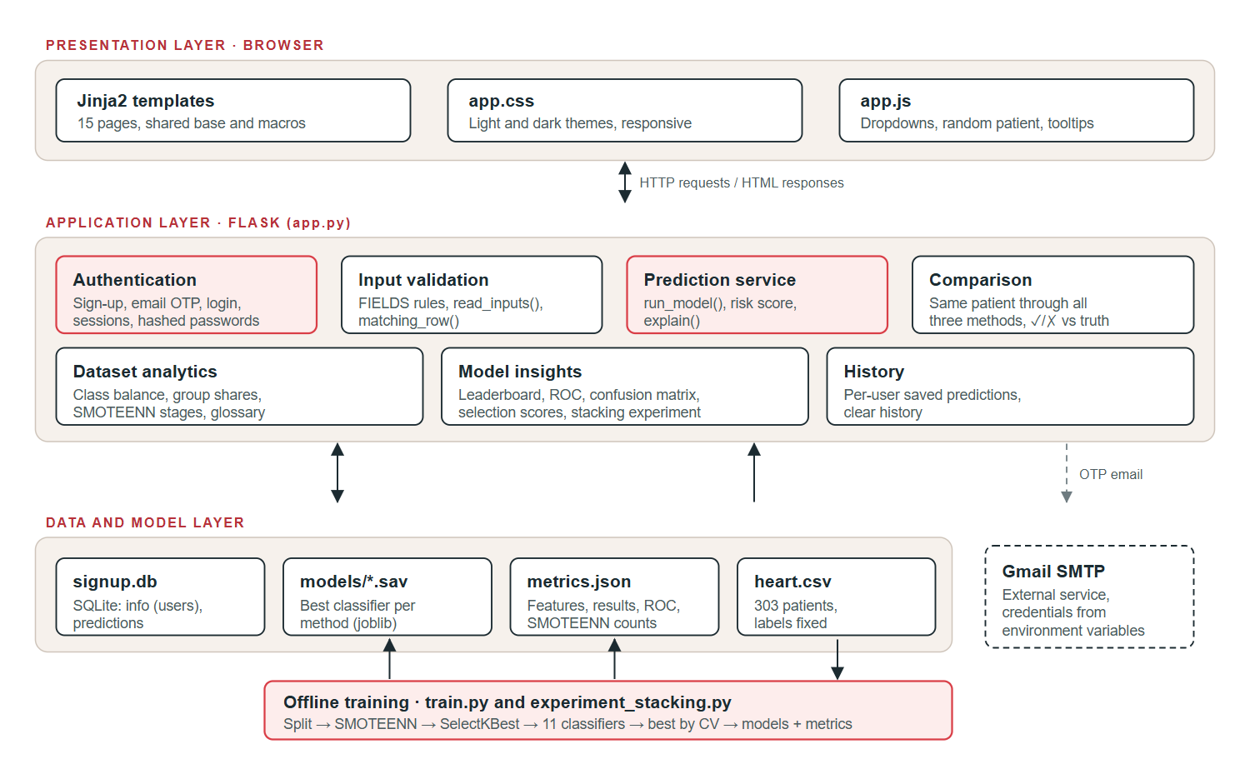
Figure 4.1: System architecture of CardioSense

4.2 Design

4.2.1 Data Flow Diagram
Figure 4.2 shows the context (level 0) diagram: the user exchanges registration details, credentials and patient values with the system, and the system asks the email service to deliver the one-time password. Figure 4.3 decomposes the system into six processes and four data stores.
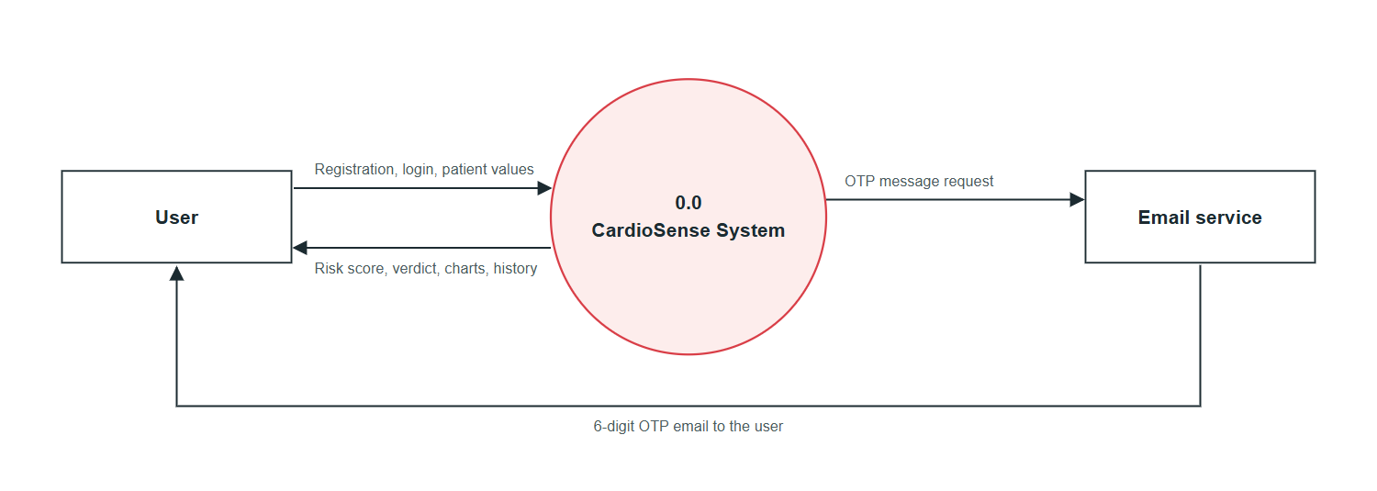
Figure 4.2: Data flow diagram, level 0 (context diagram)
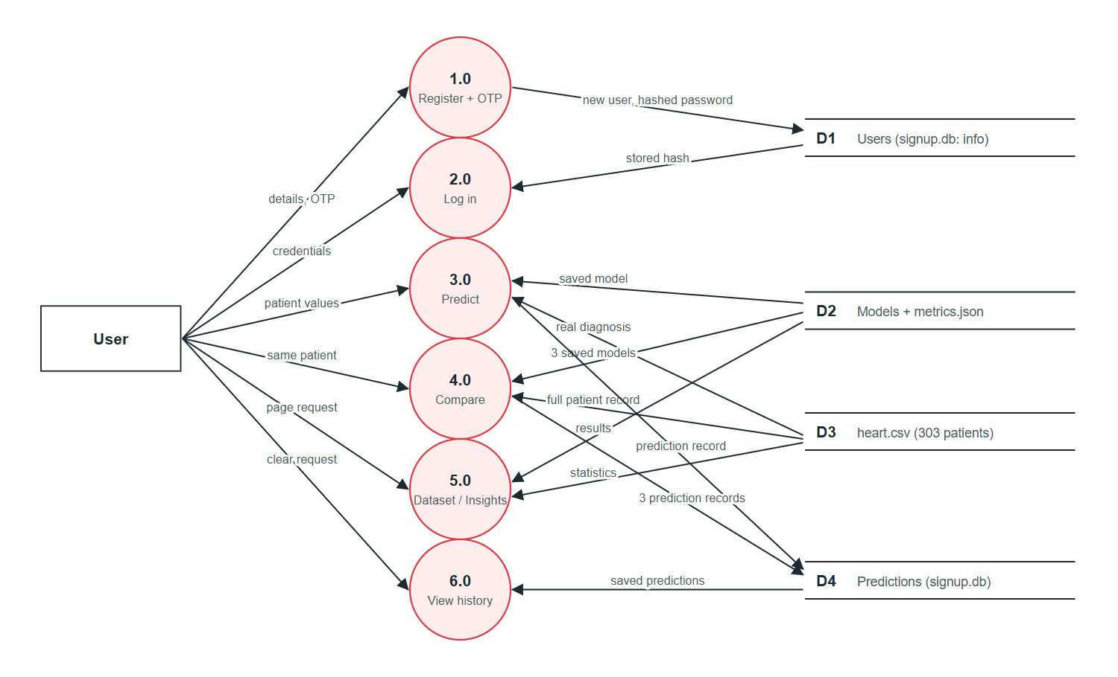
Figure 4.3: Data flow diagram, level 1

4.2.2 Use Case Diagram
The main actor is the user, who registers, logs in, predicts, compares, explores analytics and manages history. The email service is a secondary actor in registration. The developer retrains the models, runs the stacking experiment and runs the tests (Figure 4.4).
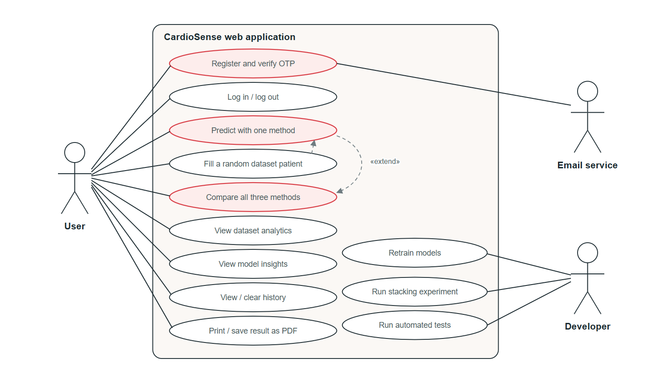
Figure 4.4: Use case diagram

4.2.3 Class Diagram
The application is written in a functional style in Python, so Figure 4.5 shows its modules and data structures as classes: the Flask application, the per-method model registry (MODELS), the input rules (FIELDS), the database tables for users and predictions, the dataset statistics and the training module.
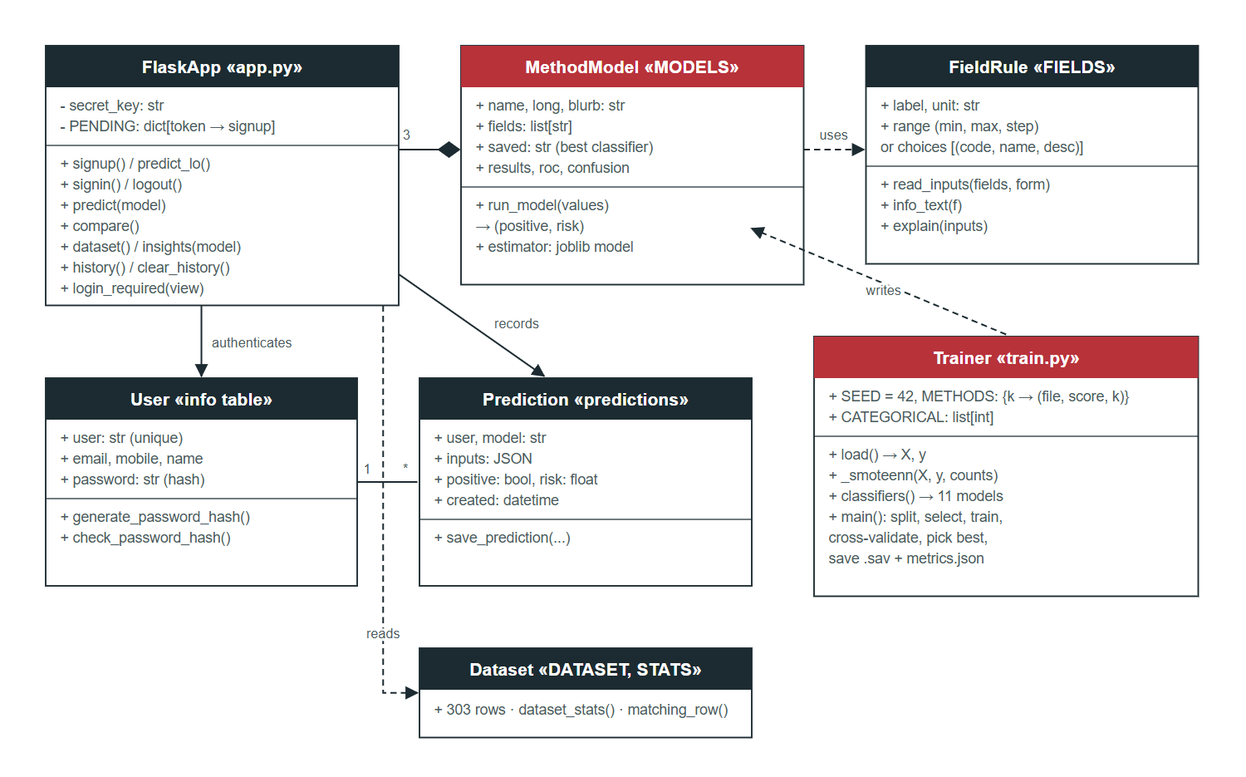
Figure 4.5: Class diagram (modules and data structures)

4.2.4 Sequence Diagram
Figure 4.6 shows the main interaction: a user fills a random dataset patient, predicts with one method, then compares the same patient across all three methods.
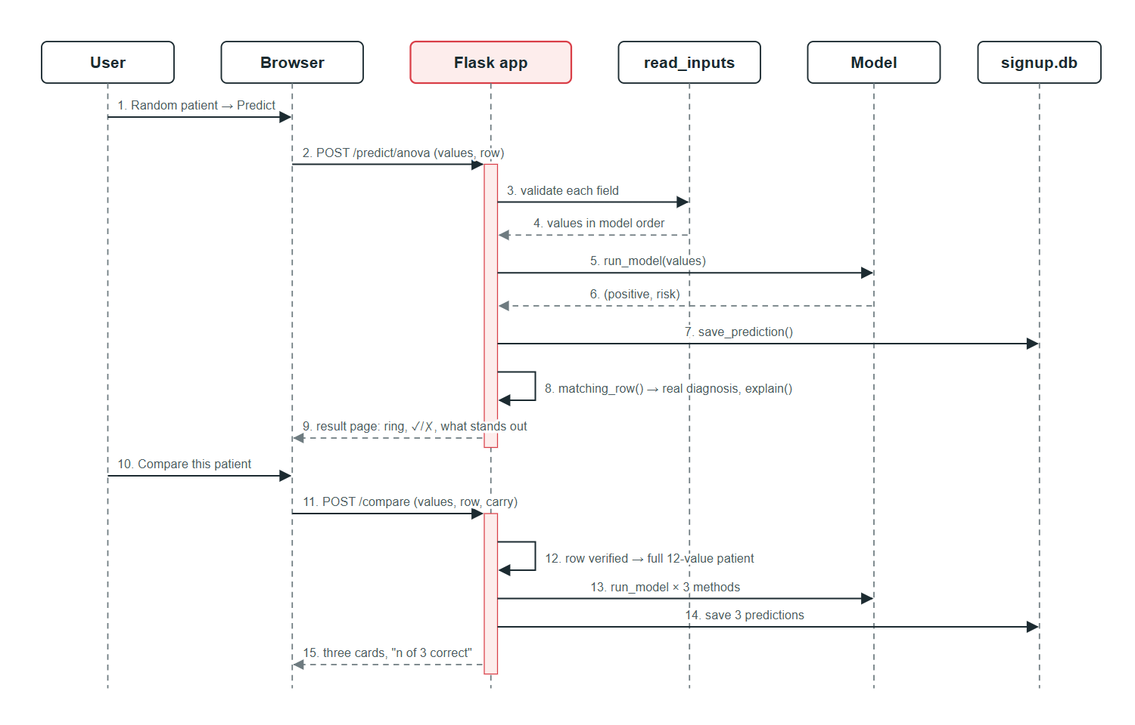
Figure 4.6: Sequence diagram for prediction and comparison

5. METHODOLOGY AND TESTING

5.1 Module Description

5.1.1 Data Preparation and Label Verification
The dataset (archive/heart.csv) has 303 rows and 14 columns. One exact duplicate is dropped, leaving 302 patients. Every row was matched against the original UCI file processed.cleveland.data on eight attributes stored identically in both (age, sex, blood pressure, cholesterol, fasting sugar, maximum heart rate, angina, ST depression). All 303 rows matched and all 303 labels were reversed: the "disease" group had a higher maximum heart rate (158.5 vs 139.1 bpm) and far less exercise angina (14% vs 55%), the opposite of clinical expectation. The labels were flipped so that 1 means disease; the original file is kept. The same matching decoded the categorical codes into their clinical meanings (e.g. chest pain type 0 = asymptomatic).

5.1.2 Train/Test Split
The data is split once, stratified by class, into 241 training and 61 test patients (80/20, seed 42). The test patients are never used for resampling, feature selection or model choice.

5.1.3 Resampling with SMOTEENN
The default SMOTEENN removed about three quarters of the training set because unscaled cholesterol dominated its distance calculations. The tuned version scales features first, uses SMOTENC so categorical attributes keep valid codes, and uses ENN with kind_sel="mode". On the training set, SMOTE adds 21 synthetic patients with disease (110 → 131) and ENN removes 21 (20 real, 1 synthetic), leaving 131 healthy and 110 diseased patients, 20 of them synthetic.

5.1.4 Feature Selection
SelectKBest is fitted on the resampled training data with three scoring functions: f_classif (ANOVA, k = 8), chi2 (k = 11) and mutual_info_classif (k = 10, fixed random state). Table 5.1 lists the features each method keeps. All three agree on eight core signs; none selects fasting blood sugar.
Table 5.1: Features selected by each method
Feature | ANOVA | Chi-square | MI
Age | – | Yes | –
Sex | Yes | Yes | Yes
Chest pain type | Yes | Yes | Yes
Resting blood pressure | – | Yes | Yes
Serum cholesterol | – | Yes | Yes
Fasting blood sugar | – | – | –
Resting ECG | – | – | –
Max heart rate | Yes | Yes | Yes
Exercise angina | Yes | Yes | Yes
ST depression | Yes | Yes | Yes
ST slope | Yes | Yes | Yes
Major vessels | Yes | Yes | Yes
Thallium scan | Yes | Yes | Yes

5.1.5 Model Training and Selection
Eleven classifiers are trained per method: Naive Bayes, SVM, XGBoost, AdaBoost, Bagging, Decision Tree, KNN (k = 3), Random Forest, Logistic Regression, soft Voting of the first nine, and Stacking (boosted decision stumps and extra trees combined by LightGBM). SVM, KNN and logistic regression are preceded by a standard scaler. Each classifier is cross-validated with 5 stratified folds, with resampling and feature selection repeated inside every fold through an imbalanced-learn pipeline. The classifier with the best cross-validated accuracy is saved for the method.

5.1.6 Web Application Modules
Table 5.2: Application modules
Module | Responsibility | Main functions / pages
Authentication | Sign-up with email OTP, login, logout, session protection | signup, predict_lo, signin, login_required
Input validation | Range and code checks for all 12 inputs | FIELDS, read_inputs, matching_row
Prediction | Risk and verdict from the saved model; dataset explanation | run_model, explain, /predict/<method>
Comparison | Same patient through all three methods, correct/wrong vs truth | /compare
Analytics | Dataset statistics and live model-evaluation charts | /dataset, /insights/<method>
History | Per-user saved predictions, clear history | save_prediction, /history
Interface | Custom dropdowns, toggles, info notes, themes, print | templates, app.css, app.js

5.2 Testing
Testing combined an automated suite (test_app.py, run with the Flask test client against a temporary database), a responsive layout test that loads every page at three screen widths, and manual tests in the browser.
Table 5.3: Test cases
ID | Test case | Expected result | Result
T1 | Start-up with plain-text passwords in the database | Passwords are hashed; old users can still log in | Pass
T2 | Open a protected page without logging in | Redirect to login | Pass
T3 | Send credentials in the URL (GET /signin) | Rejected (HTTP 405) | Pass
T4 | Register; check the emailed code | 6-digit numeric OTP | Pass
T5 | Enter a wrong OTP five times | Sign-up cancelled | Pass
T6 | Second visitor signs up while first is verifying | First visitor’s account is created correctly | Pass
T7 | Register an existing username | Rejected with a message | Pass
T8 | Validate all 303 dataset rows for each method | Every row accepted | Pass
T9 | Text in a number field; value out of range | Rejected with a message, no crash | Pass
T10 | Predict with each method | Page shows POSITIVE or NEGATIVE with risk | Pass
T11 | Unknown method in the URL | HTTP 404 | Pass
T12 | Saved models vs metrics.json | Feature counts match; saved model is the best by CV | Pass
T13 | Dataset patient → result → compare | Real diagnosis shown; all 3 models see the full record | Pass
T14 | Edit a value after picking a random patient | No longer linked to the dataset row | Pass
T15 | Typed patient → compare | Compare form opens pre-filled | Pass
T16 | Explanation for a sick patient | Age, angina, vessels, heart rate flagged as risk | Pass
T17 | Clear history | Only the user’s own entries are removed | Pass
T18 | Insights page | ROC, SMOTEENN and stacking sections render | Pass
Responsive layout test. Fifteen pages, including a submitted result and a comparison, were loaded at 1280 px, 820 px and 375 px. For each, the test checked that the page does not scroll sideways, no element overflows its card, every dropdown is built and no image is broken: 45 of 45 passed, with no browser console errors. Dark mode, keyboard operation of the dropdowns and the info notes were checked manually.

6. PROJECT DEMONSTRATION
This chapter walks through the application as a user sees it. The screenshots were taken from the running system at desktop size.
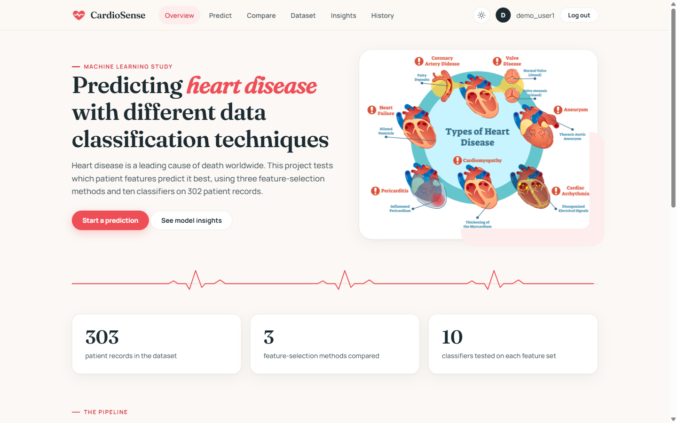
Figure 6.1: Overview page with the training pipeline
After logging in, the user opens Predict, chooses a method and enters the patient’s values. Yes/no inputs are toggles, coded inputs are dropdowns with clinical names, and numbers show their unit and the range found in the dataset. Every input has an (i) note.
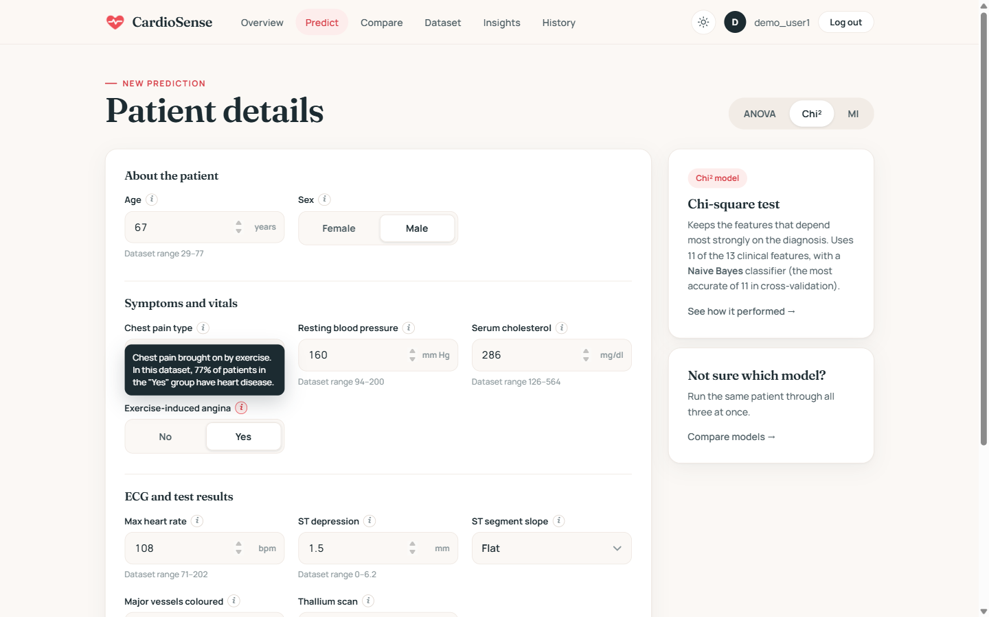
Figure 6.2: Prediction form with an info note open
The result shows the estimated risk, the verdict and, for a dataset patient, the real diagnosis and whether the model was right. Below it, each value is marked as pointing toward or away from heart disease.
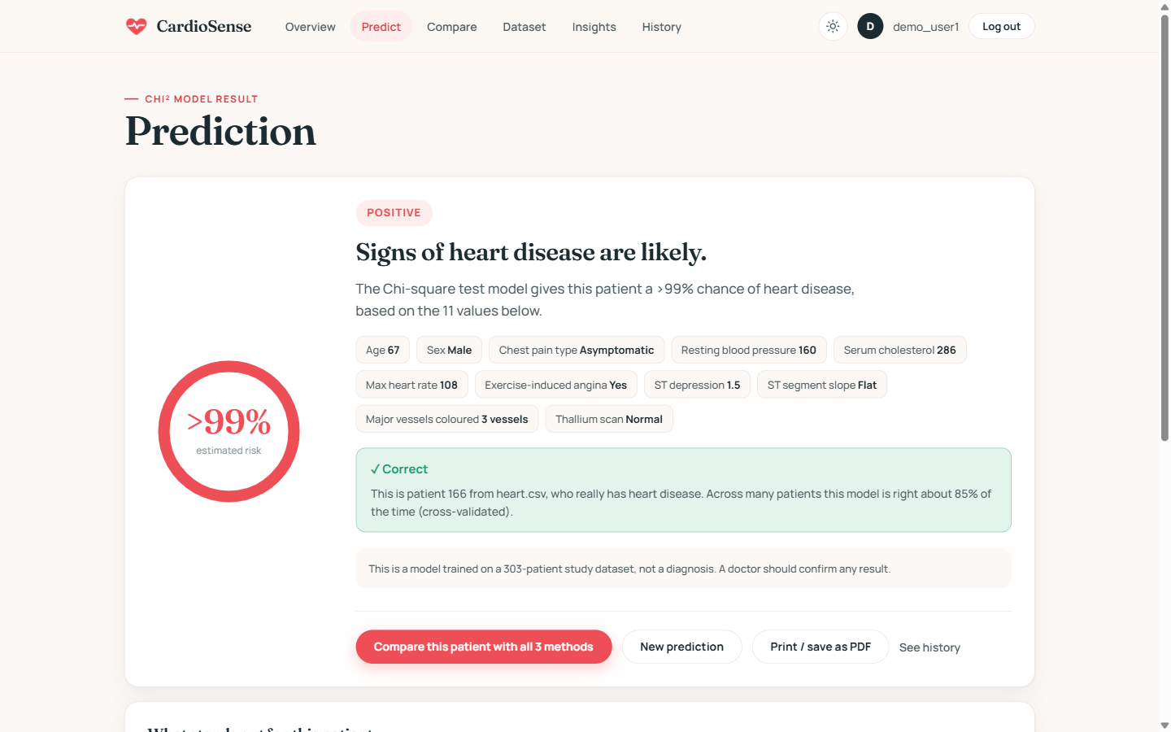
Figure 6.3: Prediction result for dataset patient 166
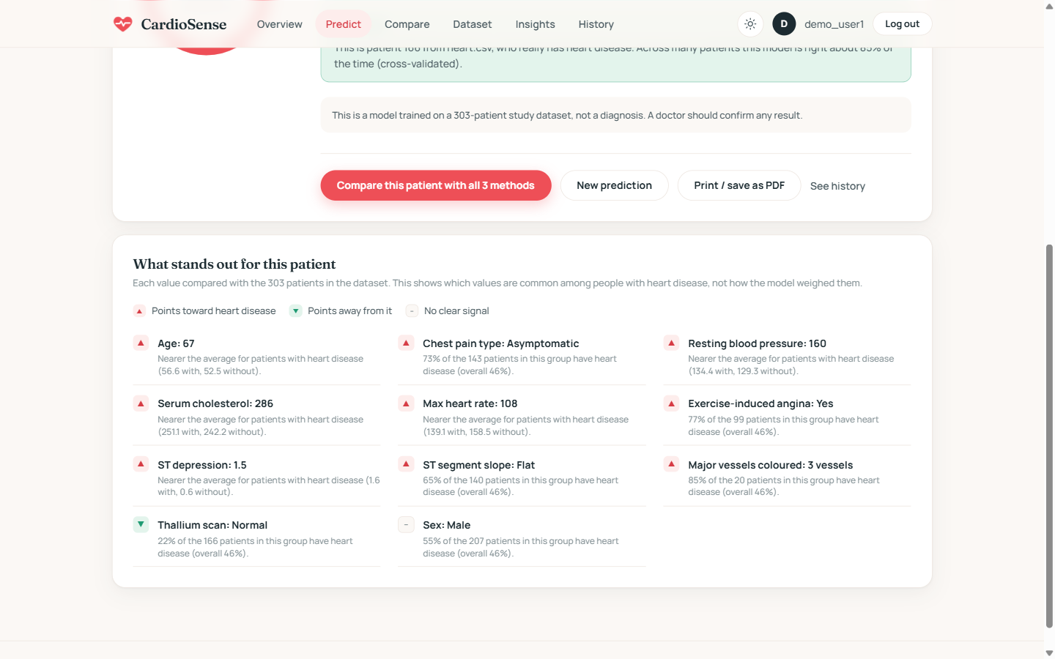
Figure 6.4: “What stands out for this patient”
Compare this patient with all 3 methods runs the same patient through every method and shows each one’s verdict, correctness, accuracy and ignored features.
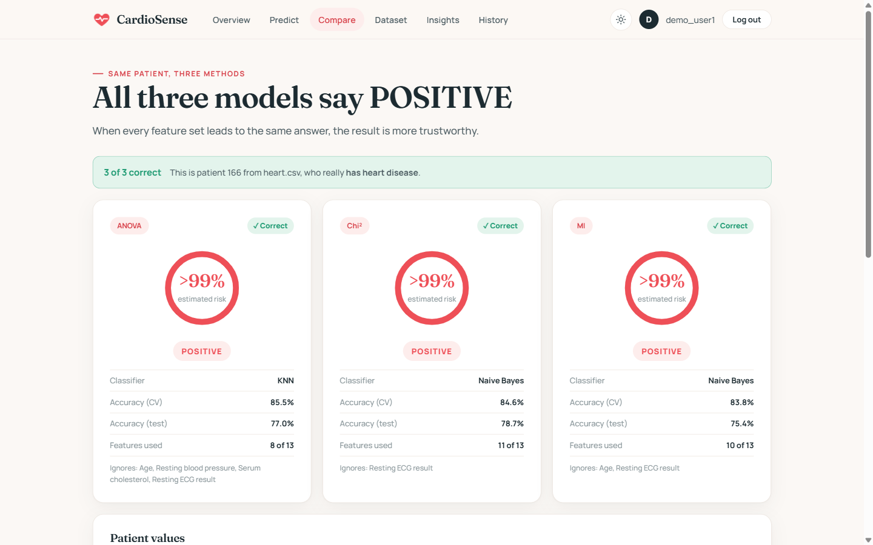
Figure 6.5: Comparison of the three methods on the same patient
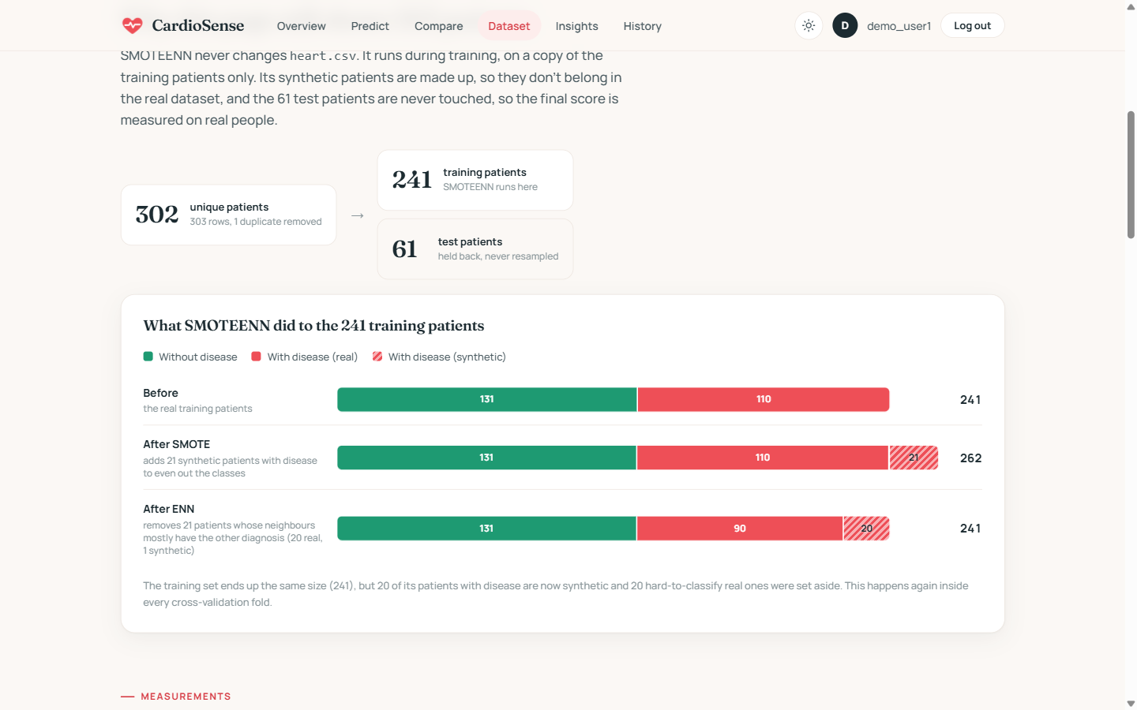
Figure 6.6: Dataset page: train/test split and SMOTEENN stages
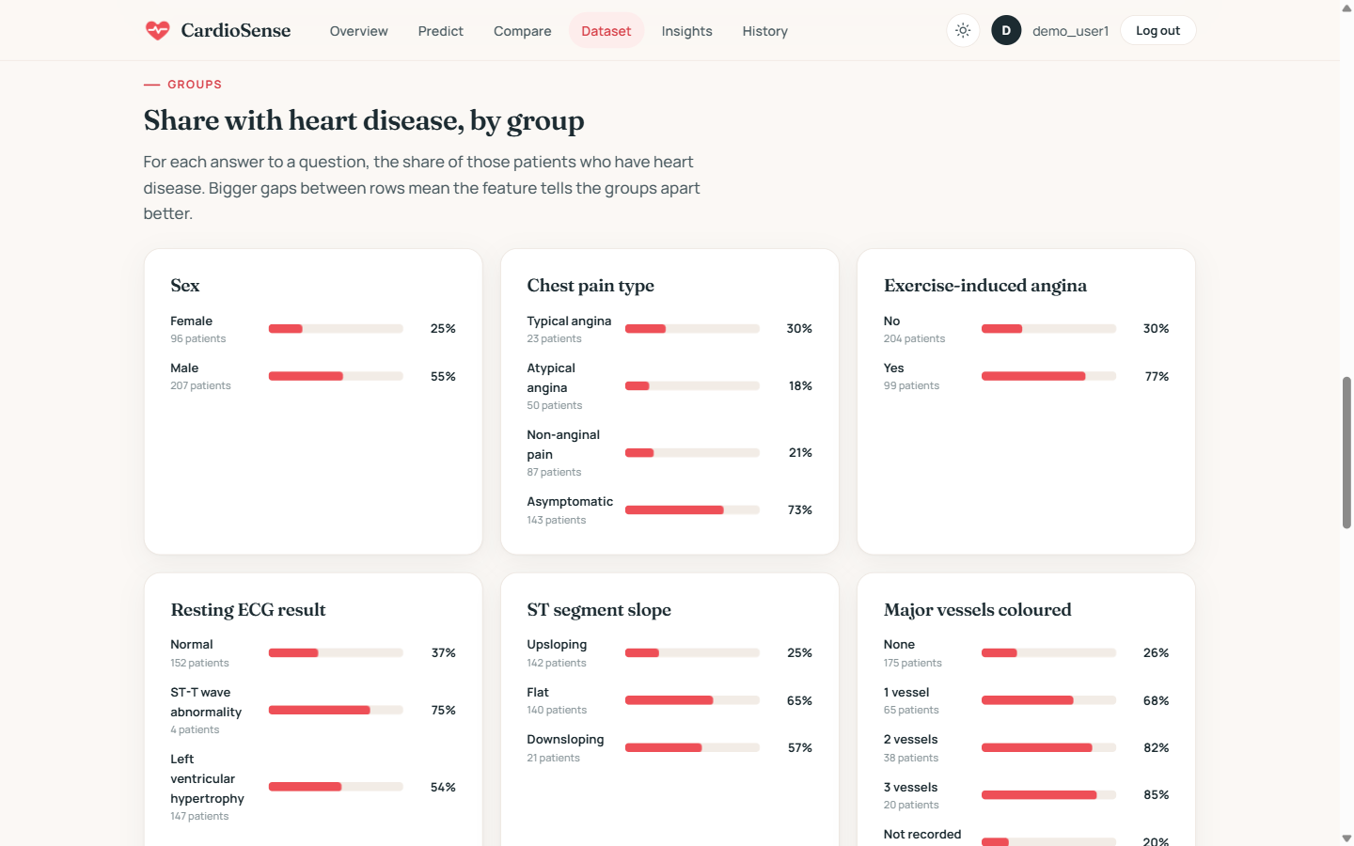
Figure 6.7: Dataset page: share of patients with heart disease by group
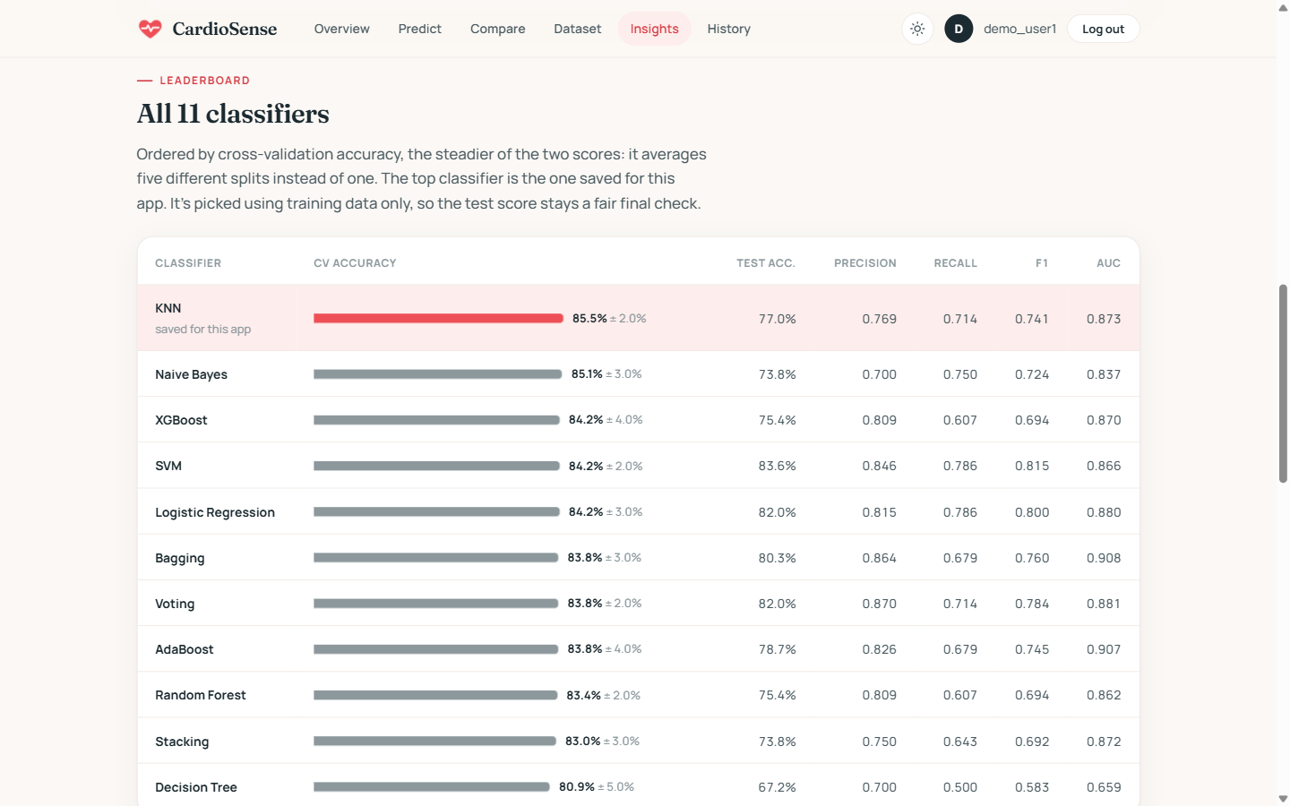
Figure 6.8: Insights: leaderboard of the eleven classifiers
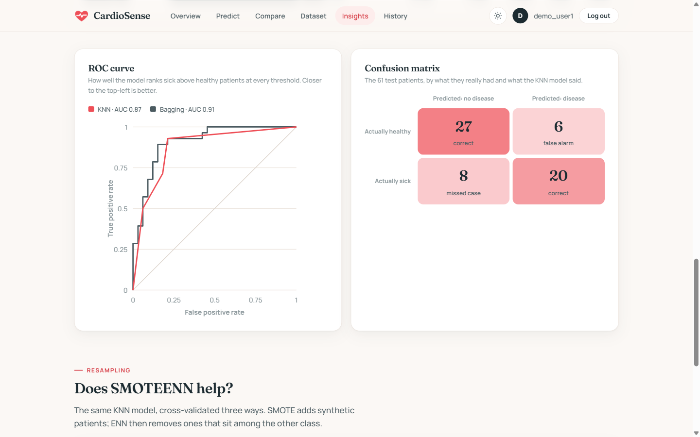
Figure 6.9: Insights: ROC curve and confusion matrix
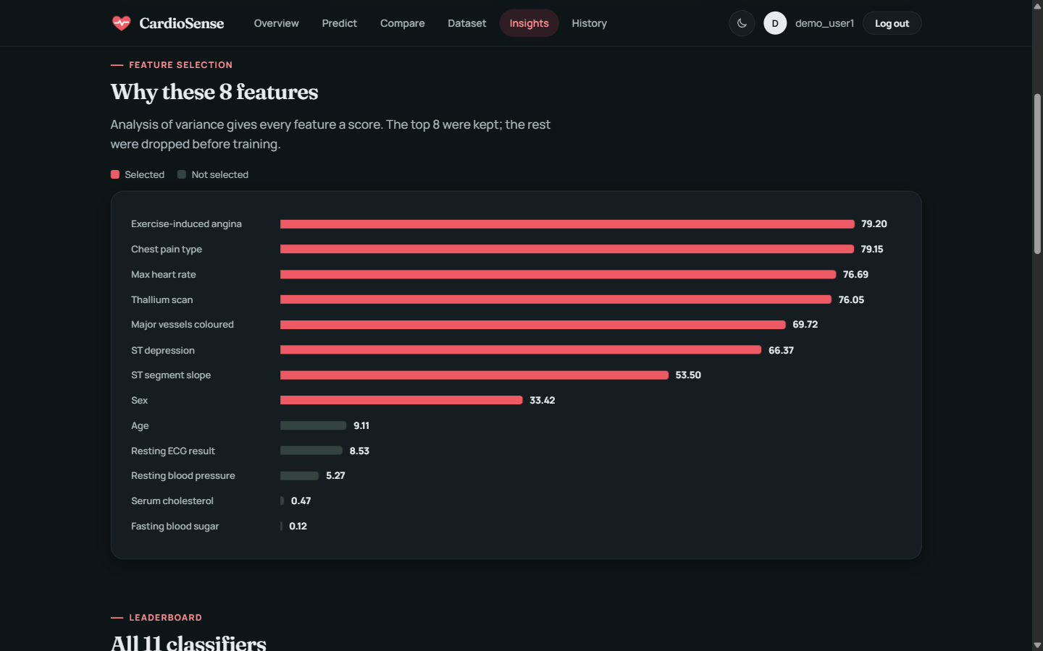
Figure 6.10: Insights in dark mode: feature-selection scores

7. RESULT AND DISCUSSION

7.1 Classifier Results per Method
Tables 7.1 to 7.3 list all eleven classifiers for each method, ordered by cross-validated accuracy. Test-set figures are on the 61 held-out patients.
Table 7.1: ANOVA (8 features)
Classifier | CV acc. (± sd) | Test acc. | Precision | Recall | F1 | AUC
KNN (saved) | 85.5% ± 2.3 | 77.0% | 0.769 | 0.714 | 0.741 | 0.873
Naive Bayes | 85.1% ± 2.8 | 73.8% | 0.700 | 0.750 | 0.724 | 0.837
XGBoost | 84.3% ± 3.8 | 75.4% | 0.809 | 0.607 | 0.694 | 0.870
SVM | 84.2% ± 2.1 | 83.6% | 0.846 | 0.786 | 0.815 | 0.866
Logistic Regression | 84.2% ± 3.1 | 82.0% | 0.815 | 0.786 | 0.800 | 0.880
Bagging | 83.8% ± 3.0 | 80.3% | 0.864 | 0.679 | 0.760 | 0.908
Voting | 83.8% ± 2.4 | 82.0% | 0.870 | 0.714 | 0.784 | 0.881
AdaBoost | 83.8% ± 3.6 | 78.7% | 0.826 | 0.679 | 0.745 | 0.907
Random Forest | 83.4% ± 1.8 | 75.4% | 0.809 | 0.607 | 0.694 | 0.862
Stacking | 83.0% ± 3.1 | 73.8% | 0.750 | 0.643 | 0.692 | 0.872
Decision Tree | 80.9% ± 4.7 | 67.2% | 0.700 | 0.500 | 0.583 | 0.659
Table 7.2: Chi-square (11 features)
Classifier | CV acc. (± sd) | Test acc. | Precision | Recall | F1 | AUC
Naive Bayes (saved) | 84.6% ± 2.1 | 78.7% | 0.759 | 0.786 | 0.772 | 0.850
Logistic Regression | 83.8% ± 3.1 | 83.6% | 0.821 | 0.821 | 0.821 | 0.882
Voting | 82.2% ± 4.1 | 82.0% | 0.870 | 0.714 | 0.784 | 0.890
Bagging | 82.1% ± 3.2 | 82.0% | 0.870 | 0.714 | 0.784 | 0.897
KNN | 81.7% ± 4.9 | 82.0% | 0.815 | 0.786 | 0.800 | 0.853
SVM | 81.3% ± 4.1 | 83.6% | 0.846 | 0.786 | 0.815 | 0.870
AdaBoost | 81.3% ± 3.0 | 78.7% | 0.857 | 0.643 | 0.735 | 0.908
XGBoost | 80.5% ± 3.9 | 78.7% | 0.826 | 0.679 | 0.745 | 0.890
Random Forest | 80.1% ± 3.3 | 80.3% | 0.864 | 0.679 | 0.760 | 0.879
Stacking | 79.7% ± 3.1 | 73.8% | 0.833 | 0.536 | 0.652 | 0.889
Decision Tree | 75.5% ± 3.1 | 70.5% | 0.727 | 0.571 | 0.640 | 0.695
Table 7.3: Mutual Information (10 features)
Classifier | CV acc. (± sd) | Test acc. | Precision | Recall | F1 | AUC
Naive Bayes (saved) | 83.8% ± 2.4 | 75.4% | 0.724 | 0.750 | 0.737 | 0.843
Bagging | 83.0% ± 4.1 | 82.0% | 0.870 | 0.714 | 0.784 | 0.905
AdaBoost | 82.2% ± 3.1 | 77.0% | 0.850 | 0.607 | 0.708 | 0.912
Logistic Regression | 82.2% ± 3.9 | 83.6% | 0.821 | 0.821 | 0.821 | 0.887
Stacking | 81.8% ± 3.5 | 78.7% | 0.857 | 0.643 | 0.735 | 0.884
XGBoost | 81.7% ± 3.3 | 78.7% | 0.826 | 0.679 | 0.745 | 0.897
SVM | 81.3% ± 3.6 | 83.6% | 0.846 | 0.786 | 0.815 | 0.875
Voting | 80.9% ± 3.2 | 83.6% | 0.875 | 0.750 | 0.808 | 0.882
Random Forest | 80.5% ± 2.7 | 78.7% | 0.826 | 0.679 | 0.745 | 0.869
Decision Tree | 80.1% ± 6.5 | 68.8% | 0.714 | 0.536 | 0.612 | 0.677
KNN | 79.3% ± 5.2 | 82.0% | 0.815 | 0.786 | 0.800 | 0.839

7.2 Comparison of the Three Methods
Table 7.4: Saved model per method
Method | Classifier | CV accuracy | Test acc. | Recall | AUC | Confusion (TN FP / FN TP)
ANOVA | KNN | 85.5% ± 2.3 | 77.0% | 71.4% | 0.87 | 27 6 / 8 20
Chi-square | Naive Bayes | 84.6% ± 2.1 | 78.7% | 78.6% | 0.85 | 26 7 / 6 22
Mutual Information | Naive Bayes | 83.8% ± 2.4 | 75.4% | 75.0% | 0.84 | 25 8 / 7 21
ANOVA with KNN has the highest cross-validated accuracy, but the three saved models are only 1.6 percentage points apart, while one model’s score moves by about ±2.3 points between folds. The difference is therefore within normal variation: no method is clearly better. Chi-square catches the most patients with disease on the test set (recall 78.6%), which matters most for screening, while ANOVA reaches the same accuracy with only 8 of the 13 measurements.
Some classifiers score higher than the saved model on the single test split; for example, SVM and logistic regression reach 83.6% test accuracy with ANOVA features against 77.0% for KNN. The saved model is deliberately chosen by cross-validation, not by test score: with only 61 test patients, one patient changes accuracy by 1.6 points, and choosing the model that happens to do best on the test set would turn the test set into part of training and make its score optimistic. Cross-validation over five splits is the steadier guide, and the test set remains an untouched final check.

7.3 Effect of SMOTEENN
Table 7.5: Cross-validated accuracy of the saved model with different resampling
Resampling | ANOVA | Chi-square | Mutual Information
No resampling | 84.6% | 83.0% | 82.2%
SMOTEENN (default) — 65 rows left | 72.6% | 73.0% | 76.3%
SMOTEENN (tuned, used) | 85.5% | 84.6% | 83.8%
The tuned SMOTEENN gives a small, consistent gain over no resampling for all three methods. The default SMOTEENN is clearly harmful here because it discards most of the training data. Since the dataset is already fairly balanced (164 healthy vs 138 with disease), large gains were not expected.

7.4 Stacking Experiment
Table 7.6: Additional stacking ensembles (cross-validated accuracy)
Stacking ensemble (meta-model: logistic regression) | ANOVA | Chi-square | MI
Saved models (best of 11) | 85.5% | 84.6% | 83.8%
Naive Bayes + KNN + Logistic Regression | 83.8% | 82.6% | 83.0%
Naive Bayes + KNN + LR + SVM + Random Forest | 83.4% | 81.3% | 82.6%
Naive Bayes + LR + Random Forest + Extra Trees | 83.4% | 83.0% | 83.4%
To test whether a stronger ensemble could lift any method, three further stacking ensembles were cross-validated in the same way on all three methods (experiment_stacking.py). None beat the saved models. On a dataset of this size, simple well-chosen models are as good as complex ensembles.

7.5 Comparison with the Original Notebooks
The original notebooks reported 100% accuracy for the stacking model. That figure came from applying SMOTE to the whole dataset before splitting, so near-copies of test patients were in the training data, and AUC was computed on training data. With the test set separated first, the same stacking model scores 73.8–78.7% on the test set; picking the best classifier by cross-validation instead raises recall from 54–64% to 71–79%. Honest figures of about 84–86% are lower but reproducible.

7.6 Cost Analysis
Table 7.7: Cost analysis
Item | Cost
Software (Python, Flask, scikit-learn, imbalanced-learn, LightGBM, XGBoost, SQLite) | ₹0 (open source)
Dataset (UCI Cleveland heart disease) | ₹0 (public, CC BY 4.0)
Development hardware | ₹0 (existing laptop)
Email OTP (Gmail SMTP) | ₹0 within normal sending limits
Optional public deployment (small cloud server and domain) | [About ₹500–1,000 per month; check current provider prices]
Total for development and demonstration | ₹0

8. CONCLUSION
This project built CardioSense, a heart-disease prediction system that compares ANOVA, Chi-square and Mutual Information feature selection across eleven classifiers. Its main results are: a data audit that found and corrected reversed labels in a widely used copy of the dataset; a leakage-free pipeline in which the test set is separated before any learning step; and a fair comparison showing cross-validated accuracies of 85.5%, 84.6% and 83.8%, within normal variation of each other. A small set of eight routine measurements selected by ANOVA performs as well as larger sets.
The web application turns these models into an understandable tool: it shows risk, compares methods on the same patient, checks predictions against the real diagnosis for dataset patients, and explains each value against the dataset, while handling accounts securely.
Future work. (1) Calibrate the predicted probabilities so that risk percentages are reliable (e.g. with CalibratedClassifierCV). (2) Validate the models on data from other hospitals, handling missing values. (3) Deploy behind HTTPS with rate limiting of OTP emails and CSRF protection. (4) Explore model-specific explanations such as SHAP values.

9. REFERENCES
[1] World Health Organization, “Cardiovascular diseases (CVDs) — Fact sheet,” 2021. [Online]. Available: https://www.who.int/news-room/fact-sheets/detail/cardiovascular-diseases-(cvds)
[2] R. Detrano et al., “International application of a new probability algorithm for the diagnosis of coronary artery disease,” American Journal of Cardiology, vol. 64, no. 5, pp. 304–310, 1989.
[3] A. Janosi, W. Steinbrunn, M. Pfisterer and R. Detrano, “Heart Disease,” UCI Machine Learning Repository, 1988. doi: 10.24432/C52P4X.
[4] S. Kaufman, S. Rosset, C. Perlich and O. Stitelman, “Leakage in data mining: Formulation, detection, and avoidance,” ACM Transactions on Knowledge Discovery from Data, vol. 6, no. 4, 2012.
[5] I. Guyon and A. Elisseeff, “An introduction to variable and feature selection,” Journal of Machine Learning Research, vol. 3, pp. 1157–1182, 2003.
[6] A. Kraskov, H. Stögbauer and P. Grassberger, “Estimating mutual information,” Physical Review E, vol. 69, 066138, 2004.
[7] Z. Noroozi, A. Orooji and L. Erfannia, “Analyzing the impact of feature selection methods on machine learning algorithms for heart disease prediction,” Scientific Reports, vol. 13, 22588, 2023.
[8] N. V. Chawla, K. W. Bowyer, L. O. Hall and W. P. Kegelmeyer, “SMOTE: Synthetic minority over-sampling technique,” Journal of Artificial Intelligence Research, vol. 16, pp. 321–357, 2002.
[9] D. L. Wilson, “Asymptotic properties of nearest neighbor rules using edited data,” IEEE Transactions on Systems, Man, and Cybernetics, vol. 2, no. 3, pp. 408–421, 1972.
[10] G. E. Batista, R. C. Prati and M. C. Monard, “A study of the behavior of several methods for balancing machine learning training data,” ACM SIGKDD Explorations, vol. 6, no. 1, pp. 20–29, 2004.
[11] G. Lemaître, F. Nogueira and C. K. Aridas, “Imbalanced-learn: A Python toolbox to tackle the curse of imbalanced datasets in machine learning,” Journal of Machine Learning Research, vol. 18, no. 17, pp. 1–5, 2017.
[12] L. Breiman, “Random forests,” Machine Learning, vol. 45, pp. 5–32, 2001.
[13] Y. Freund and R. E. Schapire, “A decision-theoretic generalization of on-line learning and an application to boosting,” Journal of Computer and System Sciences, vol. 55, no. 1, pp. 119–139, 1997.
[14] T. Chen and C. Guestrin, “XGBoost: A scalable tree boosting system,” in Proc. 22nd ACM SIGKDD Int. Conf. Knowledge Discovery and Data Mining, pp. 785–794, 2016.
[15] G. Ke et al., “LightGBM: A highly efficient gradient boosting decision tree,” in Advances in Neural Information Processing Systems 30, 2017.
[16] D. H. Wolpert, “Stacked generalization,” Neural Networks, vol. 5, no. 2, pp. 241–259, 1992.
[17] F. Pedregosa et al., “Scikit-learn: Machine learning in Python,” Journal of Machine Learning Research, vol. 12, pp. 2825–2830, 2011.

APPENDIX A – SAMPLE CODE
Selected excerpts from the project source. The full code is in the project folder.

A.1 Tuned SMOTEENN (train.py)
def _smoteenn(X, y, counts=None):
"""SMOTEENN tuned for this data, done as its two steps so we can report what each one
did.
Features are scaled first so cholesterol (hundreds) doesn't drown out yes/no features in
the
distance checks; SMOTENC keeps categories as real codes instead of inventing values
like
cp = 1.37; ENN 'mode' only removes a patient when most of its neighbours disagree.
The default SMOTEENN threw away most of the training set.
Pass a dict as `counts` to get the class sizes before, after SMOTE and after ENN."""
scaler = StandardScaler().fit(X)
X_s, y_s = SMOTENC(categorical_features=CATEGORICAL,
random_state=SEED).fit_resample(scaler.transform(X), y)
enn = EditedNearestNeighbours(kind_sel='mode')
X_e, y_e = enn.fit_resample(X_s, y_s)
if counts is not None:
counts.update({stage: np.bincount(labels, minlength=2).tolist()
for stage, labels in (('before', y), ('after_smote', y_s),
('after_enn', y_e))})
kept = set(enn.sample_indices_.tolist()) # SMOTENC appends synthetic rows after the
len(y) real ones
counts.update(synthetic_added=len(y_s) - len(y),
synthetic_kept=sum(i >= len(y) for i in kept),
real_removed=sum(i not in kept for i in range(len(y))))
X_res = scaler.inverse_transform(X_e)
X_res[:, CATEGORICAL] = np.round(X_res[:, CATEGORICAL])
return np.clip(X_res, 0, None), y_e # clip guards chi2, which needs non-negative inputs

A.2 Cross-validated training and model choice (train.py)
# 3. train and score all eleven classifiers
results, roc, fitted = [], {}, {}
for name, clf in classifiers().items():
clf.fit(Xs_res, y_res)
fitted[name] = clf
pred, prob = clf.predict(Xs_te), clf.predict_proba(Xs_te)[:, 1]
# cross-validation repeats resampling + selection inside every fold, so no fold
sees its own test rows
cv_pipe = Pipeline([('resample', resampler()), ('select', SelectKBest(score_fn,
k=k)),
('model', classifiers()[name])])
cv_acc = cross_val_score(cv_pipe, X_tr, y_tr, cv=cv, scoring='accuracy')
results.append(dict(name=name, accuracy=accuracy_score(y_te, pred),
precision=precision_score(y_te, pred),
recall=recall_score(y_te, pred), f1=f1_score(y_te, pred),
auc=roc_auc_score(y_te, prob),
cv_mean=cv_acc.mean(), cv_std=cv_acc.std()))
fpr, tpr, _ = roc_curve(y_te, prob)
roc[name] = [[round(a, 4), round(b, 4)] for a, b in zip(fpr, tpr)]

# 4. keep the best by cross-validated accuracy (ties: steadier, i.e. smaller spread
across folds)
best = max(results, key=lambda r: (round(r['cv_mean'], 3), -r['cv_std']))
joblib.dump(fitted[best['name']], path)
matrix = confusion_matrix(y_te, fitted[best['name']].predict(Xs_te)).tolist()

A.3 Input validation (app.py)
def read_inputs(fields, form):
"""Return the form values as floats in model order, or raise ValueError with a readable
message."""
values = []
for f in fields:
label, _, rule = FIELDS[f]
try:
v = float(form[f])
except (KeyError, ValueError):
raise ValueError(f'{label} needs a number.')
ok = (rule[0] <= v <= rule[1]) if isinstance(rule, tuple) else v in CHOICE_NAMES[f]
if not ok:
raise ValueError(f'{label} is out of range.')
values.append(v)
return values

A.4 Prediction route (app.py)
@app.route('/predict/<model>', methods=['GET', 'POST'])
@login_required
def predict(model):
m = get_model(model)
if request.method == 'GET':
return render_template('predict.html', key=model, m=m,
rows=dataset_rows(m['fields']))
try:
values = read_inputs(m['fields'], request.form)
except ValueError as e:
flash(str(e))
return redirect(url_for('predict', model=model))
positive, risk = run_model(model, values)
save_prediction(model, m['fields'], values, positive, risk)
row = matching_row(request.form, dict(zip(m['fields'], values)))
return render_template('result.html', key=model, m=m, positive=positive, risk=risk,
inputs=list(zip(m['fields'], values)), row=row,
actual=None if row is None else DATASET[row]['target'] == 1)

