Worksheet 5

Student Name: Rhydham Sharma UID: 25MCI10043
Branch: MCA (AI & ML) Section/Group: 25MAM-4 (B)
Semester: 2nd Date of Performance: 02-04-2026 Subject Name: Advanced Internet Programming Subject Code: 25CAP-656
- Aim/Overview of the practical:
Implement CRUD (Create, Read, Update, Delete) operations in NodeJS using MongoDB and MySQL.

Apparatus:
Supported Operating Systems: Windows 11 64-bit Pro Programming Language: HTML and NodeJS Development Environment: VS Code

Coding: -

register.html
<!DOCTYPE html>
<html>
<head>
<title>Register</title>
<style> body{
font-family:Arial; background:#f2f2f2;
}
.container{ width:400px; margin:auto; margin-top:40px; background:white; padding:20px; border-radius:10px;
box-shadow:0px 0px 10px gray;
}
input{ width:95%; padding:8px; margin:8px 0;
}
button{ padding:8px 15px;

background:#2575fc; color:white; border:none;
}
table{
margin-top:30px; width:80%; margin-left:auto; margin-right:auto;
border-collapse:collapse;
}
th,td{
border:1px solid gray; padding:10px;
text-align:center;
}
</style>
</head>
<body>
<div class="container">
<h2>Register</h2>
<form id="registerForm" action="/register" method="POST">
<input type="text" name="name" placeholder="Name" required>
<input type="email" name="email" placeholder="Email" required>
<input type="password" name="password" placeholder="Password" required>
<button type="submit">Register</button>
</form>
</div>
<h2 style="text-align:center">Registered Users</h2>
<table id="userTable">
<tr>
<th>Name</th>
<th>Email</th>
<th>Action</th>
</tr>
</table>
<script>
async function loadUsers() {
const response = await fetch("/users"); const users = await response.json();
const table = document.getElementById("userTable"); table.innerHTML = `
<tr>
<th>Name</th>
<th>Email</th>
<th>Action</th>
</tr>
`;
users.forEach(user => {
const row = document.createElement("tr");

row.innerHTML = `
<td>${user.name}</td>
<td>${user.email}</td>
<td>
<button onclick="editUser('${user._id}','${user.name}','${user.email}')" style="background:green;color:white;">Edit</button>
<a href="/delete/${user._id}">
<button style="background:red;color:white;">Delete</button>
</td>
`;
table.appendChild(row);
});
}
document.getElementById("registerForm").addEventListener("submit", async function(e){ e.preventDefault();
const name = document.querySelector('input[name="name"]').value; const email = document.querySelector('input[name="email"]').value;
const password = document.querySelector('input[name="password"]').value; await fetch("/register", {
method:"POST", headers:{
"Content-Type":"application/x-www-form-urlencoded"
},
body:`name=${name}&email=${email}&password=${password}`
});
document.getElementById("registerForm").reset(); loadUsers();
});
loadUsers();
</script>
<script>
function editUser(id,name,email){ document.querySelector('input[name="name"]').value = name; document.querySelector('input[name="email"]').value = email; document.getElementById("registerForm").action = "/update/" + id;
}
</script>
</body>
</html>
User.js
const mongoose = require("mongoose");
const UserSchema = new mongoose.Schema({ name:String,
email:String, password:String
});
module.exports = mongoose.model("User",UserSchema);
userRoutes.js
const express = require("express");

const router = express.Router();
const User = require("../models/User");
// CREATE
router.post("/register", async (req, res) => { const user = new User({
name: req.body.name, email: req.body.email,
password: req.body.password
});
await user.save(); res.redirect("/register.html");
});
// READ
router.get("/users", async (req, res) => { const users = await User.find(); res.json(users);
});
// DELETE
router.get("/delete/:id", async (req, res) => { await User.findByIdAndDelete(req.params.id); res.redirect("/register.html");
});
module.exports = router;
server.js
const express = require("express"); const mongoose = require("mongoose");
const bodyParser = require("body-parser"); const app = express();
app.use(bodyParser.urlencoded({ extended: true })); app.use(express.static("views")); mongoose.connect("mongodb://localhost:27017/userDB")
.then(()=>console.log("MongoDB Connected"))
.catch(err=>console.log(err));
const userRoutes = require("./routes/userRoutes"); app.use("/", userRoutes);
app.listen(3000,()=>{
console.log("Server running on port 3000");
});

Output:
MongoDB Page
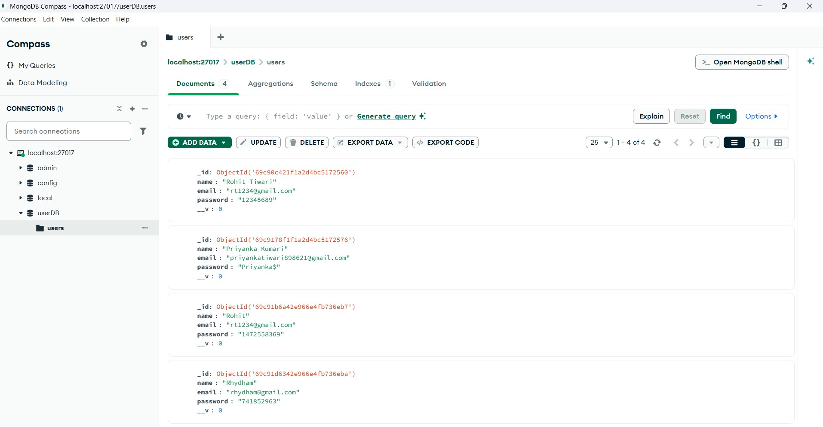
VS code Page
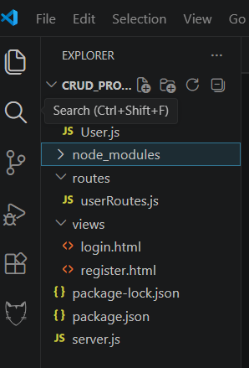

Register Page
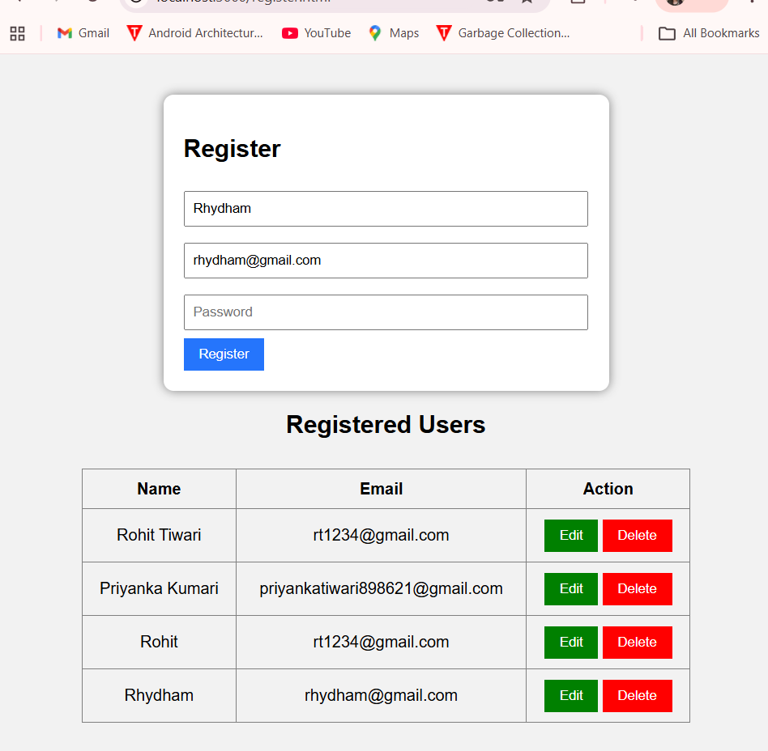

Learning outcomes (What I have learnt):
  - Understand how to build a web application using NodeJS and Express framework.
  - Learn how to connect a MongoDB database with a NodeJS application using Mongoose.
  - Implement CRUD operations (Create, Read, Update, Delete) to manage user data.
  - Develop a simple user interface using HTML and CSS to interact with the backend.

Gain practical experience in handling server-side programming and database management.

