Worksheet 3.2

Student Name: Vansh Kumar Agarwal UID:25MCI10107
Branch: MCA(AI/ML) Section/Group: MAM-4B
Semester: 2 SEM Date of Performance: Subject Name: Front End Technologies Subject Code:25CAH-655

- Aim/Overview of the practical:

To design and implement Change Password and Forgot Password forms using React.js by utilizing different form controls, managing state, handling events, and performing basic validation.
- Objective:
Create change password, and forget password forms using different React controls..
- Coding:
import React, { useState } from "react"; function App() {
const [mode, setMode] = useState("forgot");

const [data, setData] = useState({ email: "",
oldPassword: "", newPassword: "", confirmPassword: ""
});

const handleChange = (e) =>
setData({ ...data, [e.target.name]: e.target.value });

const handleSubmit = (e) => { e.preventDefault();

if (mode === "forgot") {

if (!data.email.includes("@")) { alert("Enter valid email"); return;
}
alert("Reset link sent");
}
if (mode === "change") { if (!data.oldPassword) {
alert("Old password required"); return;
}

if (data.newPassword !== data.confirmPassword) { alert("Passwords do not match");
return;
}
alert("Password changed");
}
};
return (
<div>
<h2>{mode === "forgot" ? "Forgot Password" : "Change Password"}</h2>

<form onSubmit={handleSubmit}>
<input type="email" name="email"
placeholder="Email" onChange={handleChange}
/>
<br /><br />
{mode === "change" && (
<>
<input type="password" name="oldPassword"
placeholder="Old Password" onChange={handleChange}
/>
<br /><br />

<input type="password" name="newPassword"
placeholder="New Password" onChange={handleChange}
/>
<br /><br />

<input type="password"
name="confirmPassword" placeholder="Confirm Password" onChange={handleChange}
/>
<br /><br />
</>
)}
<button type="submit">
{mode === "forgot" ? "Send Link" : "Change Password"}
</button>
</form>
<br />

<button onClick={() => setMode("forgot")}>Forgot</button>
<button onClick={() => setMode("change")}>Change</button>
</div>
);
}
export default App;

- OUTPUT:
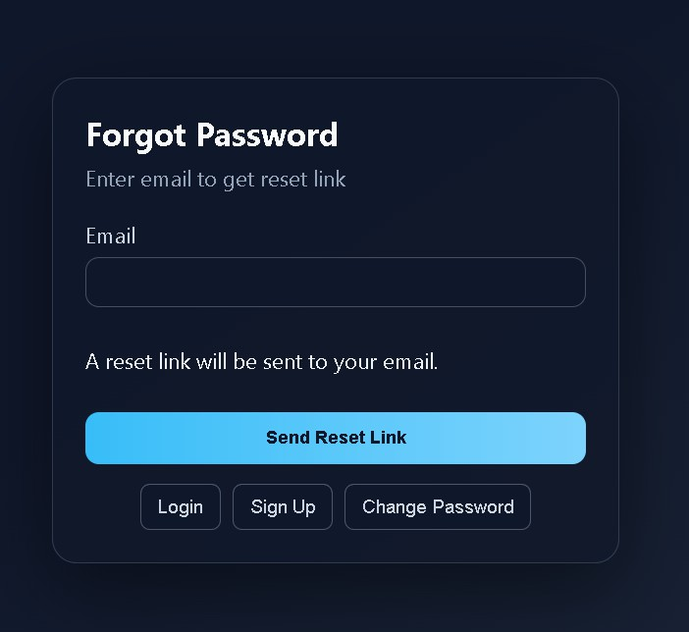
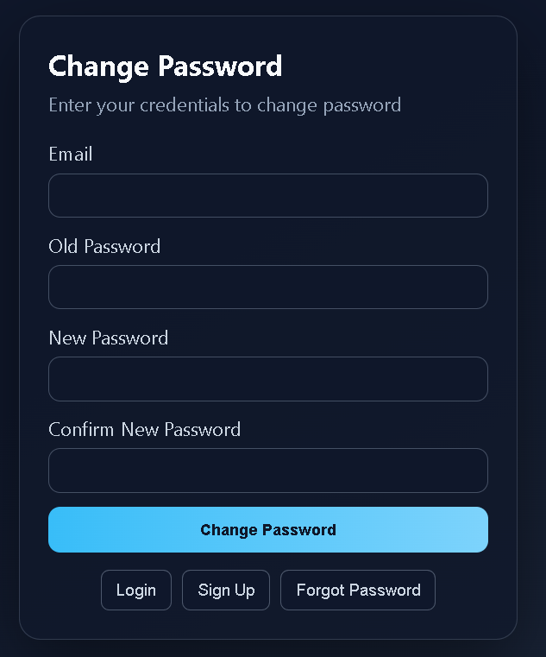
- Learning outcomes (What I have learnt):
  - Learned how to create and manage forms in React using different input controls like text fields, password fields, and buttons.
  - Gained knowledge of managing form data dynamically using React state (useState hook).
  - Learned how to handle user actions such as input changes and form submission using event handlers like onChange and onSubmit.
  - Implemented basic validation such as checking empty fields, password matching, and input correctness.
- Evaluation Grid (To be created as per the SOP and Assessment guidelines by the faculty):

Sr. No. | Parameters | Marks Obtained | Maximum Marks
1. | Worksheet Completion |  | 08 marks
2. | Conduct |  | 12 marks
3. | Viva Voice |  | 10 marks
 | Total |  | 30 marks

