Assignment 6: Pipelining (Theory Assignment 3)

Anish Deshpande
180100013

Consider the execution of the following sequence of three instructions on the 5-stage MIPS pipeline.

1)add 8 9 10
2)lw 10 400(8)
3)sub 9 10 8

a) Dependences:
- (Write After Read):
  - Anti-dependence of instruction 2 and 1. (Register 10 might be written to in 2 before it is read from in 1).
  - Anti-dependence of instruction 3 and 1. (Register 9 might be written to in 3 before it is read from in 1).
- (Read After Write):
  - True-dependence of instruction 2 and 1. (Register 8 might be read from in 2 before it is written to in 1).
  - True-dependence of instruction 3 and 2. (Register 10 may be read from in 3 before it is written to in 2)
  - True-dependence of instruction 3 and 1. (Register 8 might be read from in 3 before it is written to in 1).
- no WAW dependence and RAR dependence is not a thing.
b) Forwarding Links:
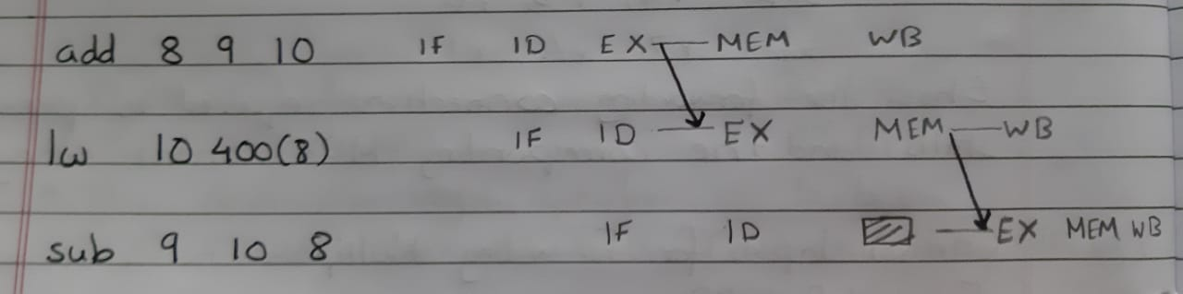
Links denoted by the black arrows. The shaded box is a stall, as the sub instruction must wait for the value of register 10 to be supplied before execution.

i) NO Forwarding

c)
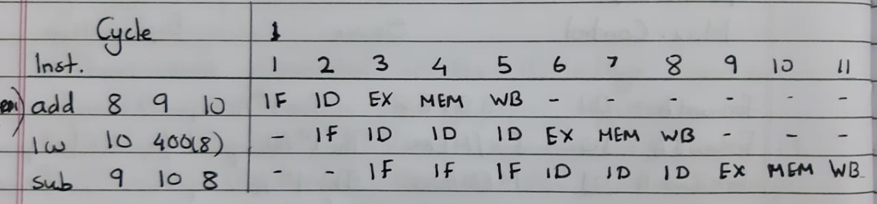
d) Pipeline clock cycle time = 250 ps
Total no. Of cycles = 11
Total execution time = clock cycle time * no. of cycles
= 250 * 11 ps
= 2750 picoseconds

e) Average Pipeline Utilisation:

APU= (number of instructions * number of unique stages/instruction)
--------------------------------------------------------------------------------------------------
(number of cycles * num of possible stages that can be executed/cycle)

(Equivalent to filled boxes/total boxes in the cycles vs. Stage table)

APU = 3*5/(11*5) = 3/11

f) No, the instructions cannot be re-ordered to reduce the execution time.
The load word instruction requires the value in register 8 as an operand.
However, register 8 is being written to in the AND instruction. Hence instruction 2 cannot be placed before instruction 1.
Instruction 3 cannot be placed before instruction 2 either. That’s because instruction 3 requires register 10. But register 10 is being updated in the load word instruction.

ii) ALU-ALU Forwarding

c)
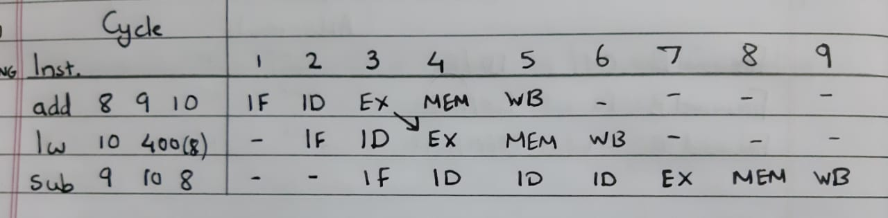
d) Pipeline clock cycle time = 270 ps
Total no. Of cycles = 9
Total execution time = clock cycle time * no. of cycles
= 270 * 9 ps
= 2430 picoseconds

e) Average Pipeline Utilisation:

APU= (number of instructions * number of unique stages/instruction)
--------------------------------------------------------------------------------------------------
(number of cycles * num of possible stages that can be executed/cycle)

(Equivalent to filled boxes/total boxes in the cycles vs. Stage table)

APU = 3*5/(9*5) = 3/9 = 1/3

f)No, the instructions cannot be re-ordered to reduce the execution time.
The load word instruction requires the value in register 8 as an operand.
However, register 8 is being written to in the AND instruction. Hence instruction 2 cannot be placed before instruction 1.
Instruction 3 cannot be placed before instruction 2 either. That’s because instruction 3 requires register 10. But register 10 is being updated in the load word instruction.

iii) FULL Forwarding

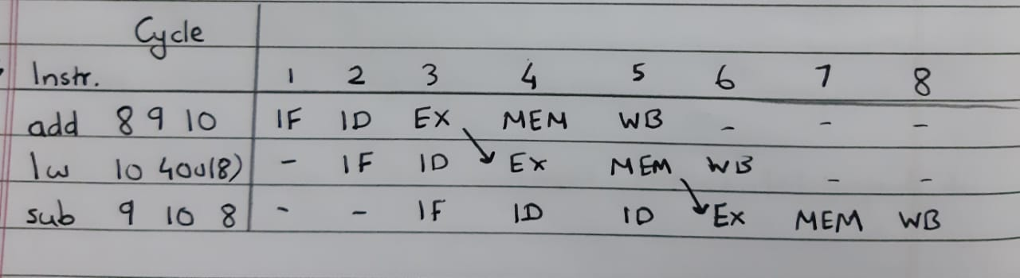
c)
d) Pipeline clock cycle time = 280 ps
Total no. Of cycles = 8
Total execution time = clock cycle time * no. of cycles
= 280 * 8 ps
= 2240 picoseconds

e) Average Pipeline Utilisation:

APU= (number of instructions * number of unique stages/instruction)
--------------------------------------------------------------------------------------------------
(number of cycles * num of possible stages that can be executed/cycle)

(Equivalent to filled boxes/total boxes in the cycles vs. Stage table)

APU = 3*5/(8*5) = 3/8

f)No, the instructions cannot be re-ordered to reduce the execution time.
The load word instruction requires the value in register 8 as an operand.
However, register 8 is being written to in the AND instruction. Hence instruction 2 cannot be placed before instruction 1.
Instruction 3 cannot be placed before instruction 2 either. That’s because instruction 3 requires register 10. But register 10 is being updated in the load word instruction.

Question 2)

(a) The number of mispredictions with a (0,2) branch predictor is 51 out of 100 and is asymptotically 4/8 (50%= 50 out of every 100, 4 out of every 8) .

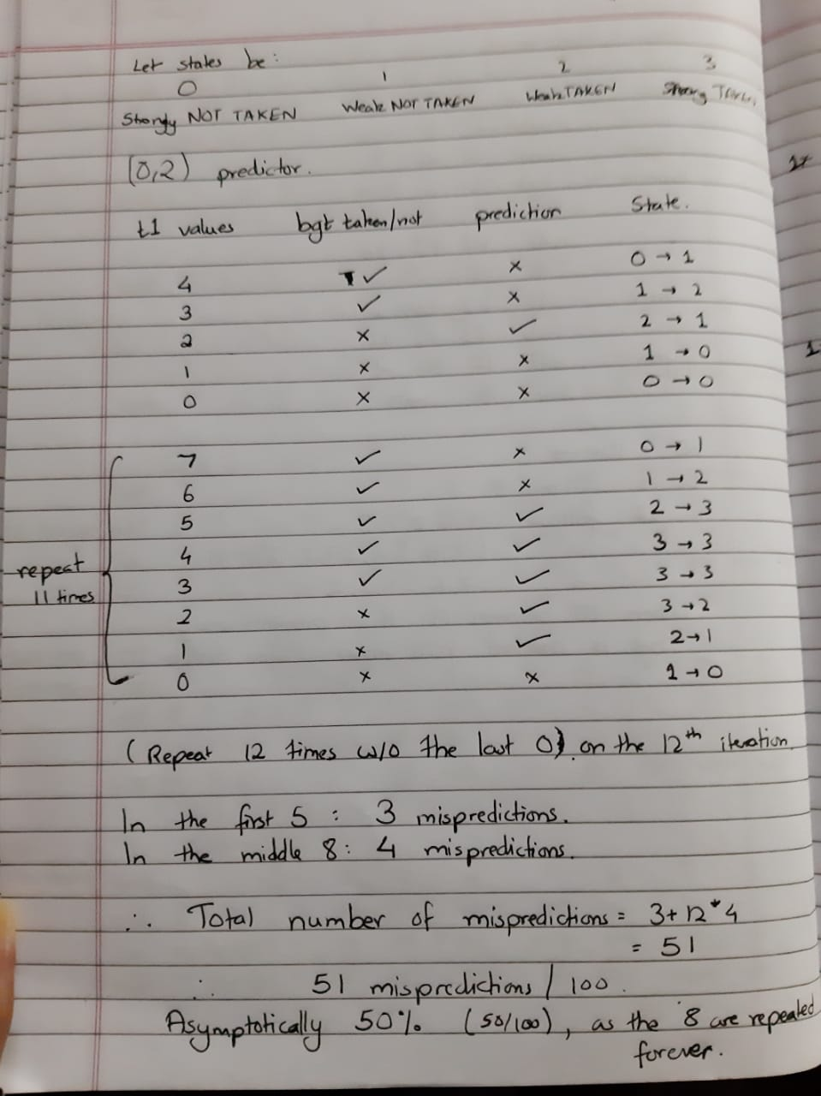

(b) The number of mispredictions with a (0,3) branch predictor is 42 out of 100 and is asymptotically 3/8.
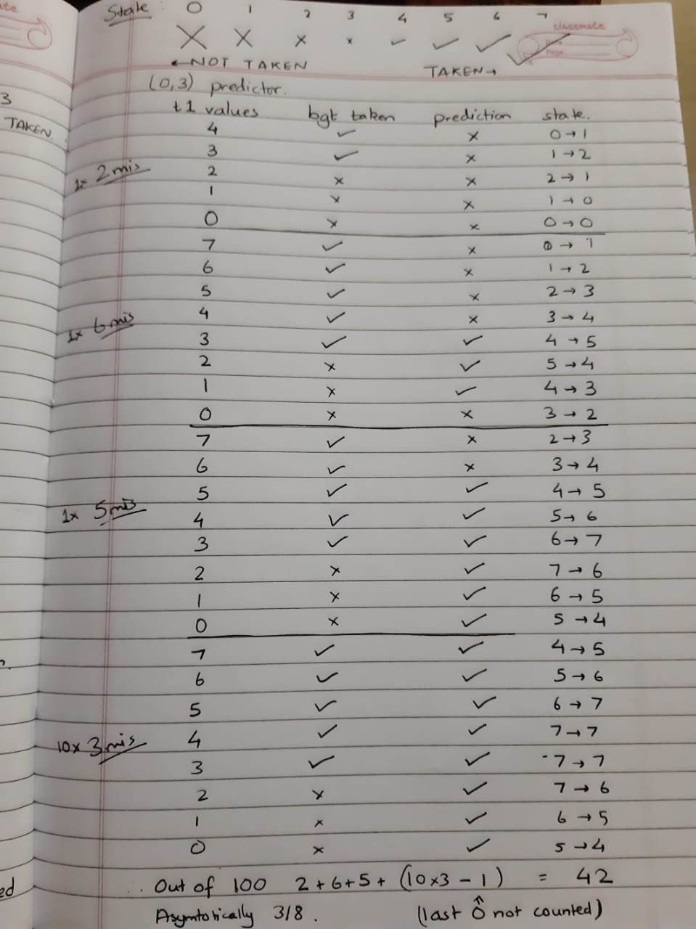

(c) The minimum number of mispredictions with a (0,k) branch predictor is 26 out of 100, is asymptotically 1/4 and occurs for k = 1 (as higher k dimishes performance, asymtotically 3/8 for k>=3)

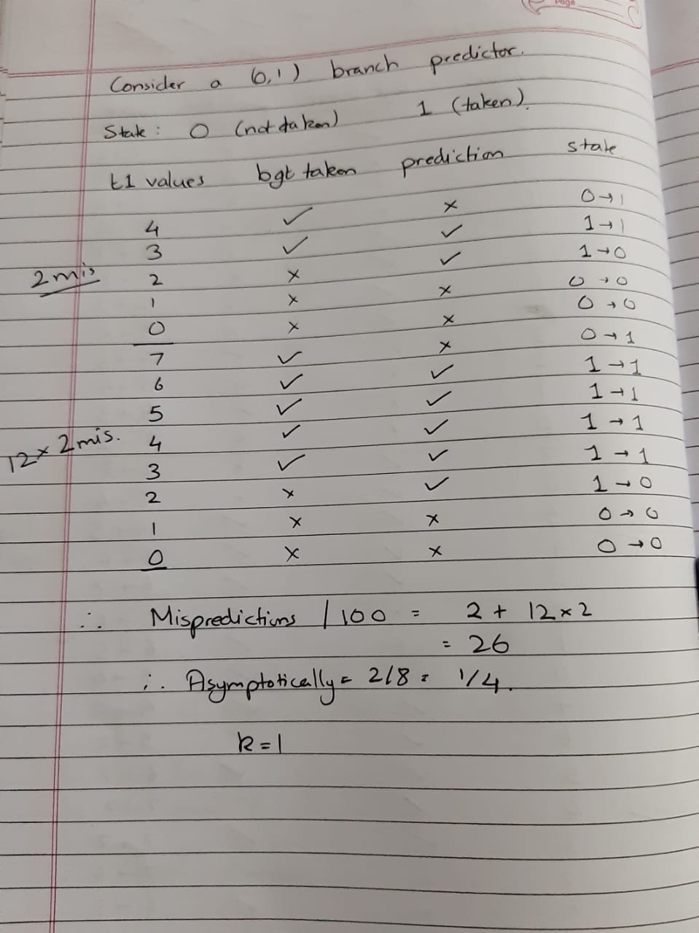
2 + 4 + 2*11 = 28/100 mispredictions , asymptotically 2/8 = 1/4.
(d) The number of mispredictions with a (2,2) correlating branch predictor is 28 out of 100 and is asymptotically 1/4 (25%).

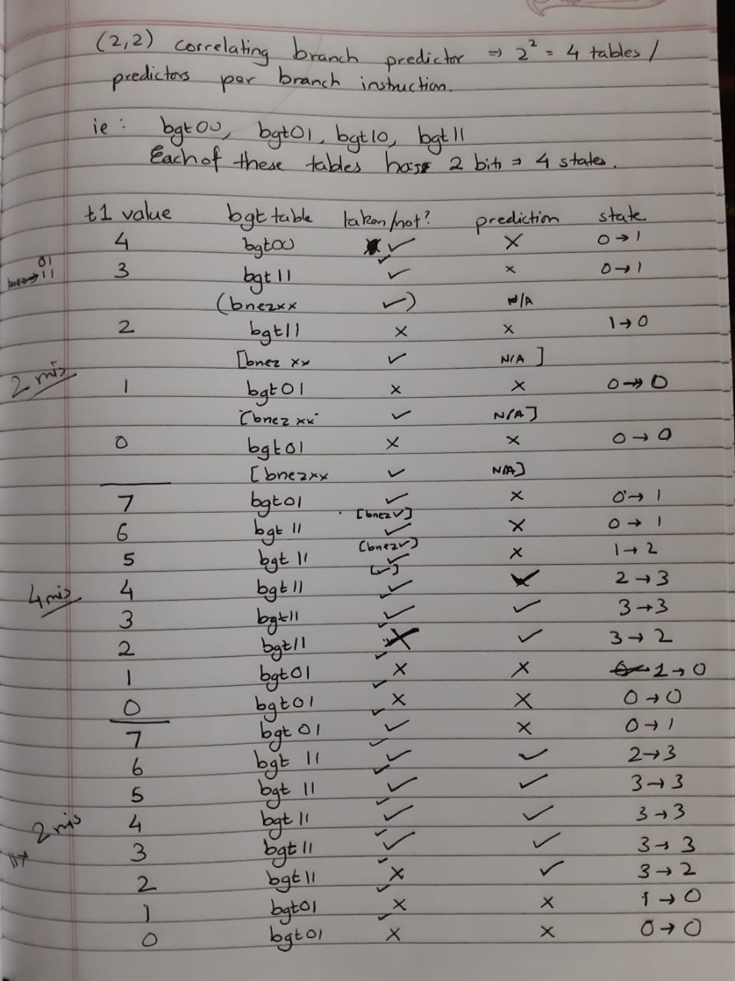
After a while, I am representing any bnez branch predictor as just a small tick mark (the bnez is always taken) Each of the 4 branch predictors per branch instruction has 4 states: 0,1,2,3 (Strongly not taken to strongly taken) The table shows which branch predictor for bgt is used as t1 changes, what actually happens at bgt (taken/not taken), what each predictor predicts, and the state changes for each predictor (based on its last prediction).

(e) As the number of iterations, n, tends to infinity, the minimum number of mispredictions with an (m,k) correlating branch predictor is achieved for m=10 and k= 1. For this predictor, the number of mispredictions is 7 out of 100 and is asymptotically 0 .

By trial and error, it does not work for m = 8 or m = 6. As there are 5 takens and 3 not takens, it seems that 5 bits for the bgt alone is the minimum required to have a sufficient number of branch predictors, whose states are set appropriately, to predict correctly each time.

2 + 5 + 0*11 = 7 mispredictions out of 100.
0 mispredictions thereafter.
