IT LAB 1

**Question 1**

<html>

<head>

<title>

Question 1

</title>

<style>

img {

display: block;

margin-left: auto;

margin-right: auto;

}

div.center {

margin-left: auto;

margin-right: auto;

}

</style>

<script src="http://ajax.googleapis.com/ajax/libs/jquery/3.5.1/jquery.min.js"></script>

<script type="text/javascript">

$(document).ready(function() {

$("tr:even").css("background-color","#ADD8E6");

$("tr:odd").css("background-color","#FFCCCB");

$("#btn").click(function(){

$("div").animate({right:"200px"})

})

});

</script>

</head>

<body>

<div style="position: relative;">

<table border>

<caption>MY DETAILS</caption>

<tr>

<th>Cars</th>

<th>Price</th>

<th>Top Speed</th>

</tr>

<tr>

<td>Buggati Chiron</td>

<td>$3.3M</td>

<td>261 MPH</td>>

</tr>

<tr>

<td>Lamborghini Huracan</td>

<td>$1.07M</td>

<td>199 MPH</td>>

</tr>

<tr>

<td>Lykan Hypersport</td>

<td>$4.1M</td>

<td>245 MPH</td>>

</tr>

</table>

<br><br>

<img src="C:\Users\OSLAB\Desktop\Atish IT\Lykan_HyperSport.jpg" alt="Super Car" width="500px" height="500px">

</div>

<br><br>

<button type="button" id="btn" style="position: absolute;">Button</button>

</body>

</html>

**Output**

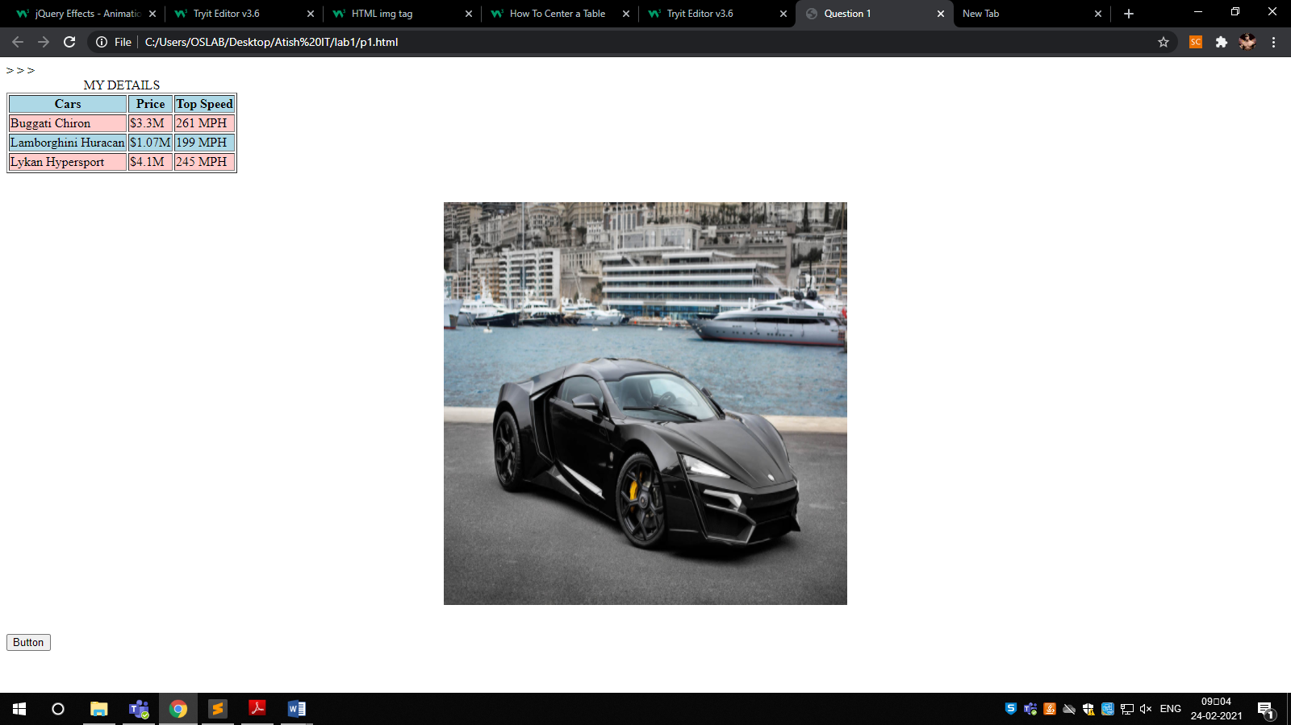

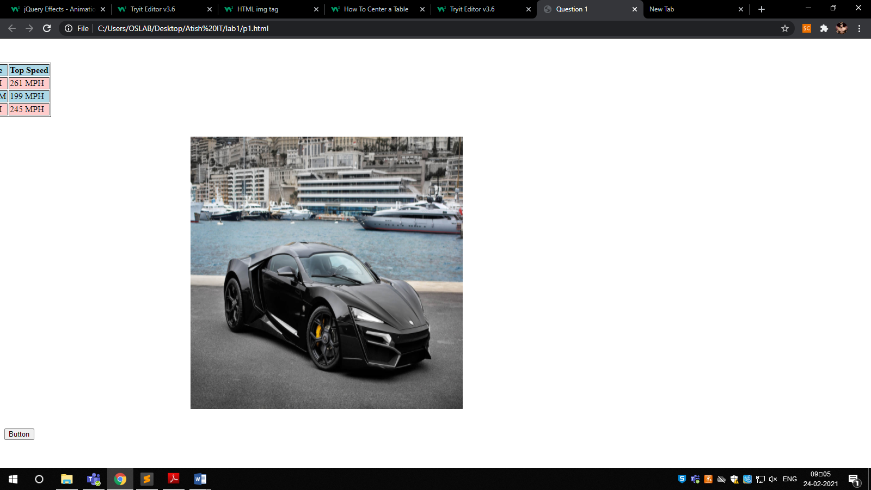

**Question 2**

<html>

<head>

<title>

Question 2

</title>

<script src="http://ajax.googleapis.com/ajax/libs/jquery/3.5.1/jquery.min.js"></script>

<script type="text/javascript">

$(document).ready(function() {

//sum

$("#add").click(function(){

var x1=parseInt($("#n1").val());

var x2=parseInt($("#n2").val());

var result1 =x1+x2;

$("#result").val(result1);

})

//substraction

$("#sub").click(function(){

var x1=parseInt($("#n1").val());

var x2=parseInt($("#n2").val());

var result1 =x1-x2;

$("#result").val(result1);

})

//multiply

$("#mul").click(function(){

var x1=parseInt($("#n1").val());

var x2=parseInt($("#n2").val());

var result1 =x1*x2;

$("#result").val(result1);

})

//division

$("#div").click(function(){

var x1=parseInt($("#n1").val());

var x2=parseInt($("#n2").val());

var result1 =x1/x2;

$("#result").val(result1);

})

})

</script>

</head>

<body>

<input type="text" id="n1"><br><br>

<input type="text" id="n2"><br><br>

<button type="button" id="add">+</button>

<button type="button" id="sub">-</button>

<button type="button" id="mul">*</button>

<button type="button" id="div">/</button>

<br><br>

<input type="text" id="result"><br><br>

</body>

</html>

**Output**

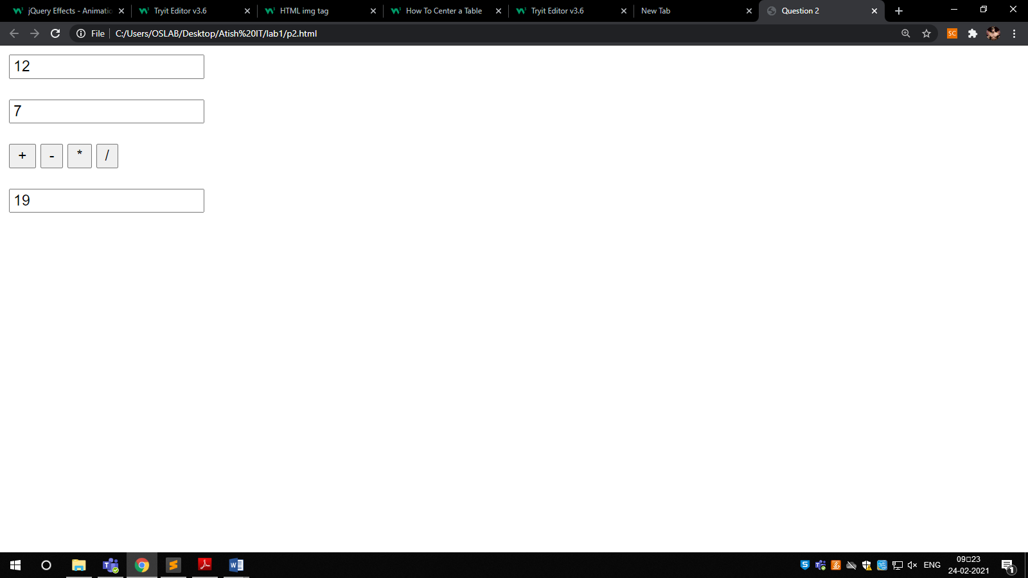

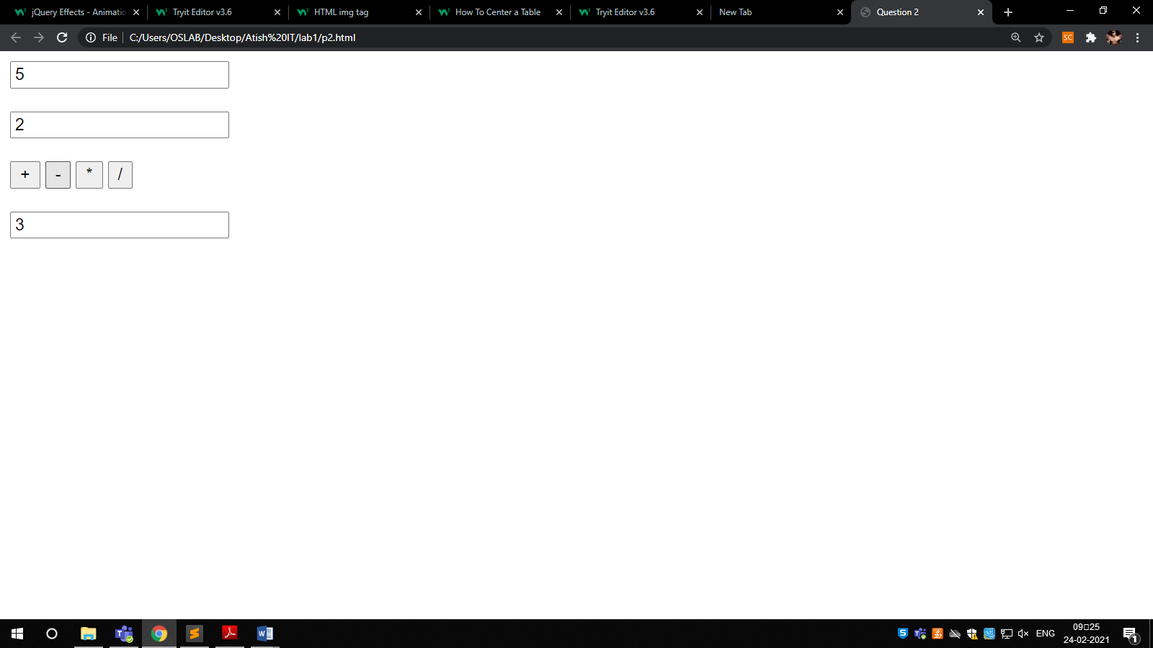



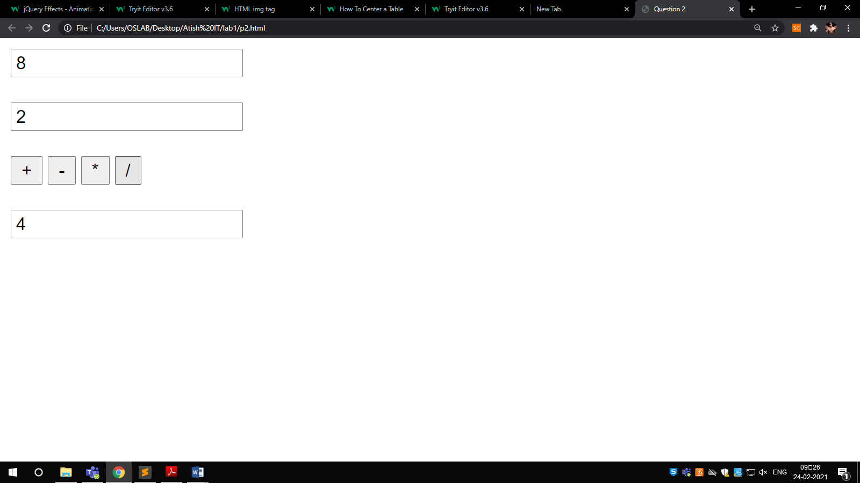

**Question 3**

<html>

<head>

<title>

Question 3

</title>

<script src="http://ajax.googleapis.com/ajax/libs/jquery/3.5.1/jquery.min.js"></script>

<script type="text/javascript">

$(document).ready(function() {

$("#update").click(function(){

var style = $('input[type="radio"]:checked').val();

var color = $('#color').val();

var font = $('#font').val();

var fontsize = parseInt($("#size").val());

var checkbox = $('input[type="checkbox"]:checked').val();

var text = $("#textbox").val();

$("#card").css("background-color",color);

$("#card").css("border-style",style);

$("#card").css("font-size",fontsize);

$("#card").css("font",font);

$("#card").html(text);

if(checkbox){

var imageUrl = "birthday.jfif";

$("#card").css("background-image", "url(" +imageUrl+")");

$("#card").css("background-size","75% 50%" );

$("#card").css("background-repeat","no-repeat" );

$("#card").css("background-position","center" );

}

else{

$("#card").css("background-image", "none");

}

});

});

</script>

</head>

<body>

<table style="width:100%">

<td>

Choose a background color:<br>

<select name="color" id="color">

<option value="red">Red</option>

<option value="yellow">Yellow</option>

<option value="orange">Orange</option>

</select><br><br>

Choose a font:<br>

<select name="font" id="font">

<option value="verdana">Verdana</option>

<option value="Courier New">Courier New</option>

</select><br><br>

Specify a numeric font size:<br>

<input type="size" id="size"><br>

Choose a border style:<br>

<input type="radio" id= "None" name="border-style" value="None">

<label for="None">None</label><br>

<input type="radio" id= "Double" name="border-style" value="Double">

<label for="Double">Double</label><br>

<input type="radio" id= "Solid" name="border-style" value="Solid">

<label for="Solid">Solid</label><br><br>

<input type="checkbox" id="picture" name="picture" value="pic">

<label for="picture"> Add a default picture</label><br><br>

Enter greeting text below: <br>

<input type="text" id="textbox"></input><br>

<button id="update">Update</button><br><br>

</td>

<td>

<div id ="card" style="height: 400px;width: 300px;background:yellow" >></div>

</td>

</table>

</body>

</html>

**Output**

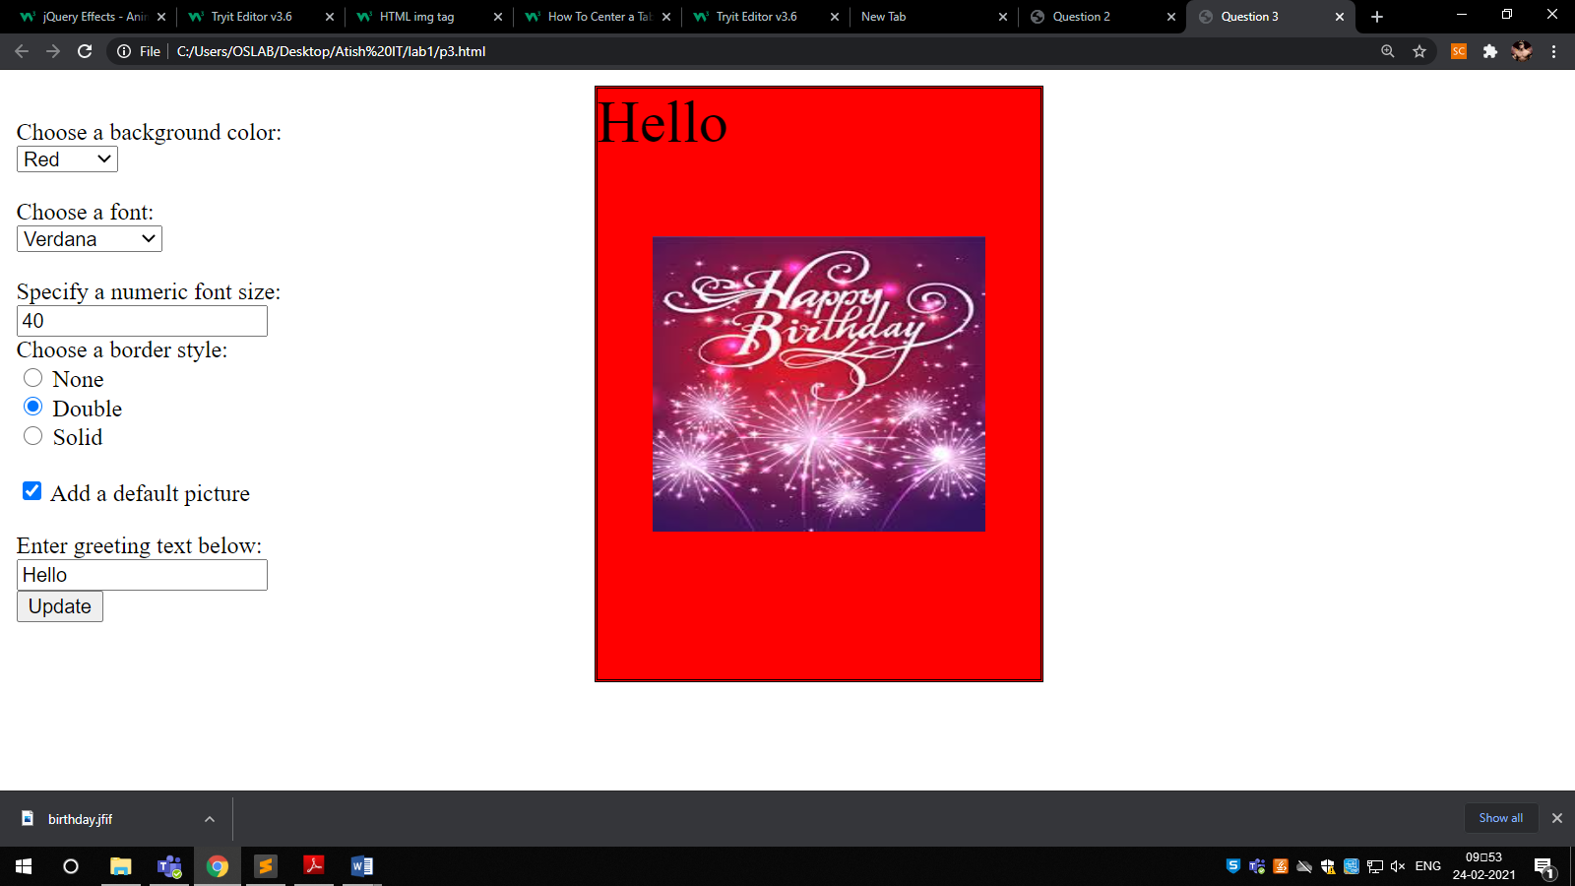

**Question 4**

<!DOCTYPE html>

<html lang="en">

<head>

<meta charset="UTF-8">

<meta http-equiv="X-UA-Compatible" content="IE=edge">

<meta name="viewport" content="width=device-width, initial-scale=1.0">

<title>WEEK 1 Q4</title>

<script src="https://ajax.googleapis.com/ajax/libs/jquery/3.5.1/jquery.min.js"></script>

<script type = "text/javascript" language = "javascript">

$(document).ready(function(){

$('#bill').click(function(){

let brand_name = $('#brand-choice').val();

let quan = $('#quantity').val();

console.log({quan});

let amt = 0;

let price = 0;

if(brand_name == 'HP'){

if($('#laptop').prop("checked") == true){

price = 20000;

}

else{

price = 6000;

}

}

else if(brand_name == 'Nokia'){

if($('#laptop').prop("checked") == true){

price = 11000;

}

else{

price = 6000;

}

}

else if(brand_name == 'Samsung'){

if($('#laptop').prop("checked") == true){

price = 12000;

}

else{

price = 7000;

}

}

else if(brand_name == 'Motorola'){

if($('#laptop').prop("checked") == true){

price = 13000;

}

else{

price = 8000;

}

}

else{

if($('#laptop').prop("checked") == true){

price = 14000;

}

else{

price = 9000;

}

}

let n = parseInt(quan);

amt = n*price;

alert(amt);

});

});

</script>

</head>

<body>

<p>

<table>

<tr>

<td>Brand</td>

<td>Laptop</td>

<td>Mobile</td>

</tr>

<tr>

<td>HP</td>

<td>20000</td>

<td>6000</td>

</tr>

<tr>

<td>Nokia</td>

<td>11000</td>

<td>6000</td>

</tr>

<tr>

<td>Samsung</td>

<td>12000</td>

<td>7000</td>

</tr>

<tr>

<td>Motorola</td>

<td>13000</td>

<td>8000</td>

</tr>

<tr>

<td>Apple</td>

<td>14000</td>

<td>9000</td>

</tr>

</table>

</p>

<label for="brand-choice">Choose a Brand:</label>

<input list="brands" id="brand-choice" name="brand-choice" />

<datalist id="brands">

<option value="HP"></option>

<option value="Nokia"></option>

<option value="Samsung"></option>

<option value="Motorola"></option>

<option value="Apple"></option>

</datalist>

<p>Choose:</p>

<div>

<input type="checkbox" id="laptop" name="laptop" checked>

<label for="laptop">Laptop</label>

</div>

<div>

<input type="checkbox" id="mobile" name="mobile">

<label for="mobile">Mobile</label>

</div>

<div>

<label for="quantity">Quantity</label>

<input type="text" id="quantity" name="quantity" required>

</div>

<button id="bill">Bill Amount</button>

<p id="write-bill"></p>

</body>

</html>

**Output**

