Software Requirements Specification (SRS) Document
VTS Android Application | Requirements Document
SSAD Team 5 | Ravsimar Singh Sodhi  Anish Gulati  Daksh Lalwani  Srikeshav Kothapalli

Brief problem statement
The fundamental purpose of the application is to track vehicles in real-time, and to present it with such an interface, such that it takes minimum effort on part of the user to view his/her tracked vehicles, all at the same time. The application can be used for safety and security purposes in case one of vehicles goes rogue.

System requirements
- System must be capable of running on android devices with API level 21 (Android Lollipop) and higher.
- System requires web services (already provided by the client).

Users profile
- Vehicle fleet owners
  - Basic mobile operations
  - Able to use and interact with Google Maps or similar map applications.

Feature requirements (described using use cases)

No. | User Case Name | Description | Release
1. | App Initialization | At the start of the application:  - Login is displayed | R1
2. | Get devices List | For each user, display the list of registered devices for that user. | R1
3. | Get real-time device location | All devices are rendered on a map, which updates as per data obtained from web services. | R1
4. | Display Device Information | On selecting a particular device, more information is obtained namely:  - Vehicle Details  - Driver Details  - Vehicle status | R1
5. | Display current location | Current location of mobile is displayed along with the registered devices on the map. | R1
6. | Get route distance | Get the distance between a device and the current user’s location. | R2

Use case diagram
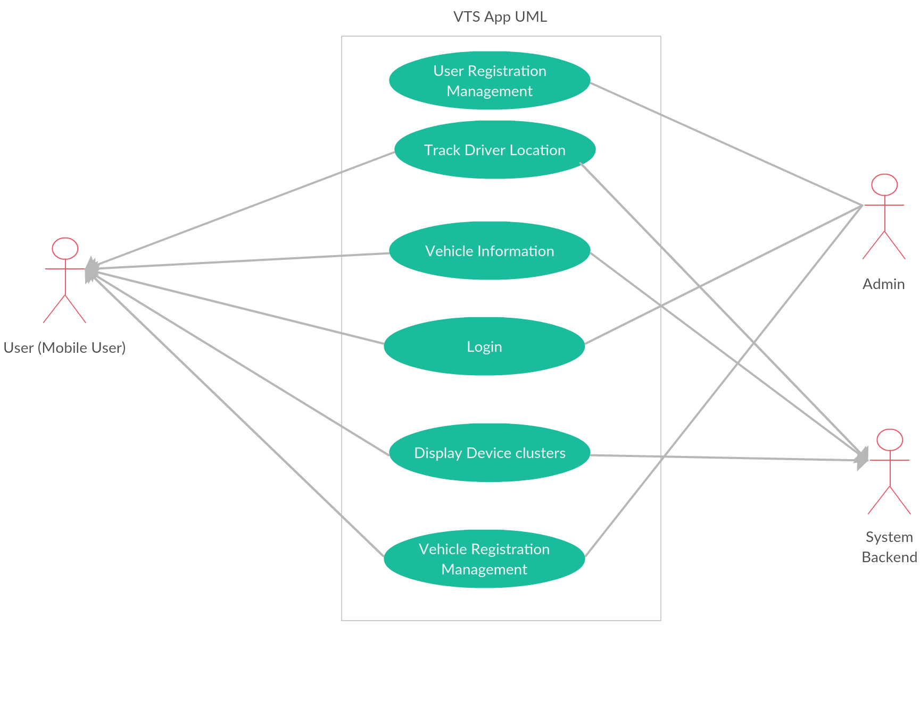

Use case description

Use Case Number: | UC-01
Use Case Name: | App Initialization
Overview: | Login page will be displayed demanding user-id, tenant-id and password of a specific user.
Actors: | The user demanding access, The backend user granting access.
Pre condition: | The system user must have a user-id, tenant-id and password provided by the company.
Flow: | Main (success) Flow:  1. Verified user-id, tenant-id and password then login successful.  2. Redirection to the dashboard.
Alternate Flows:
1. Error message shown, unsuccessful login.
Post Condition: | 1. Dashboard is displayed.

Use Case Number: | UC-02
Use Case Name: | Get devices List
Overview: | List of all the devices of the user will be displayed.
Actors: | The user interacting to system backend.
Pre condition: | Login must be successful, user profile page must show device’s list.
Flow: | Main (success) Flow:  1. All devices of the particular user shown.  2. Device details are provided eg.: device model.
Alternate Flows:
1. Device list fails to load.
Post Condition: | The devices’ current locations are loaded on the map.

Use Case Number: | UC-03
Use Case Name: | Get real-time device location
Overview: | Each device related to the user would be shown at its current locaton.
Actors: | The user interacting to system backend.
Pre condition: | The device information must be available from the backend.
Flow: | Main (success) Flow:  1. Each device’s real-time information is loaded, shown upon selecting the  particular device.
Alternate Flows:
1. The device information fails to load.
Post Condition: | Each device’s real-time information will be loaded on press.

Use Case Number: | UC-04
Use Case Name: | Display Device Information
Overview: | Displays the real-time vehicle status (eq.: vehicle location, vehicle speed), driver’s information and vehicle-owner information.
Actors: | Vehicle owner, interacts with the backend.
Pre condition: | The vehicle information must be loaded from the backend.
Flow: | Main (success) Flow:  1. Onclicking a particular vehicle:  - The vehicle-status should be displayed:  - current location of the vehicle.  - real time speed of vehicle.  - The vehicle model information.  - The vehicle owner information.
Alternate Flows:
1. The device information fails to load.
Post Condition: | The device status keeps updating in real-time.

Use Case Number: | UC-05
Use Case Name: | Display current location
Overview: | Displays the current location of the user logged-in.
Actors: | The user interating with the backend.
Pre condition: | User should be successfully logged in, profile page should be loaded.
Flow: | Main (success) Flow:  1. The logged-in user’s real time location gets updated.
Alternate Flows:
1. Login-in fail error generated by the backend.
Post Condition: | Pointer depicting the user’s current location loads on the map.

