**PROJECT SYNOPSIS**

**Title:** Online Car And Bike Rental System

**Motivation:**

The Motivation to design this web application was that it was difficult to find Cars and bikes on rent as per your choice and it was very hectic to compare the prices of different Vendors by physically going to each vendor to get the best. One might be new to place so he/she might not know from where to get a car or a bike on rent. And it was very difficult for small vendors to run their renting business due to lack of advertisement or platform.

**Introduction:**

In this web application we provide Vendors/Partners to register their vehicles on our website for rental. The Car Rental System is being developed for customers so that they can book their vehicles from any part of the world. This application takes information from the customers through filling their details. A customer being registered in the website has the facility to book a vehicle which he requires.

The proposed system is completely integrated online systems. It automates manual procedure in an effective and efficient way. This automated system facilitates customer and provides to fill up the details according to their requirements. It includes type of vehicle they are trying to hire and location. The purpose of this system is to develop a web site for the people who can book their vehicles along with requirements from any part of the world. Our Website also provide a platform for the vendors to advertise their cars and bikes for rental and get the payments on weekly bases.

**Features:**

* Easy Register and login
* Advanced Search Filters to ease the Booking Process
* Online payment
* Basic Inventory Management for Vendor

**Technology:**

* HTML
* CSS
* JAVASCRIPT
* Php
* MySQL

**Team Members:**

* Anish Naik : 201105007
* Ashwin Bokade : 201105011

**Project Schema**

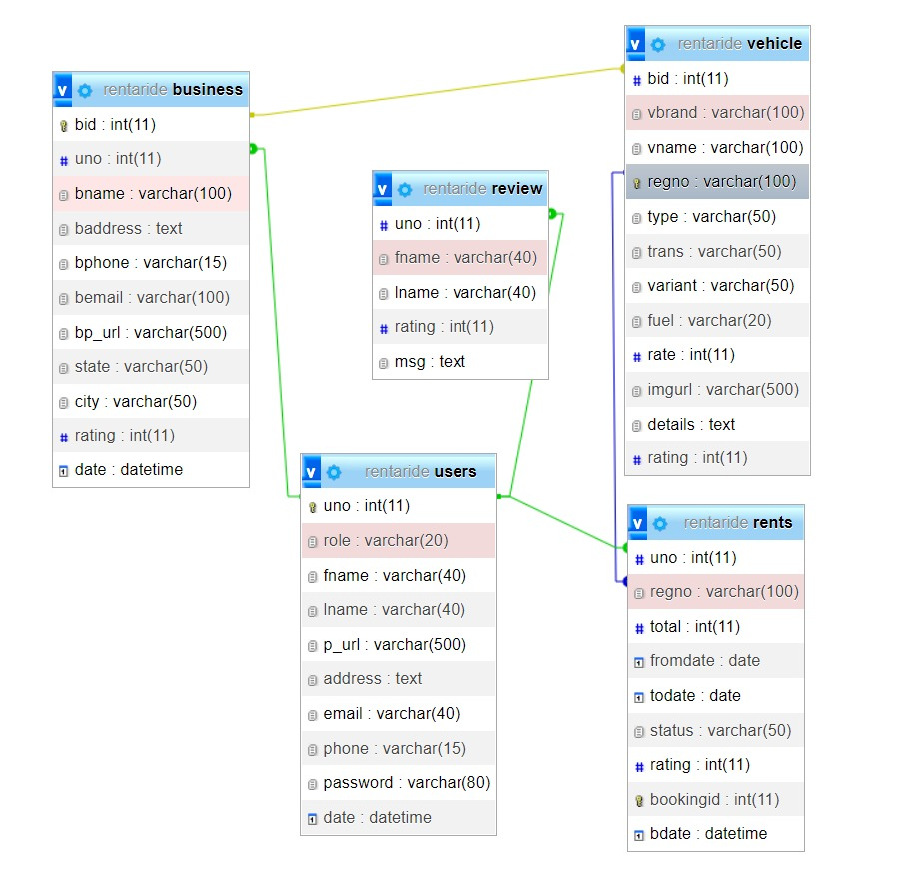

**Project Screenshots**

**Landing Page**

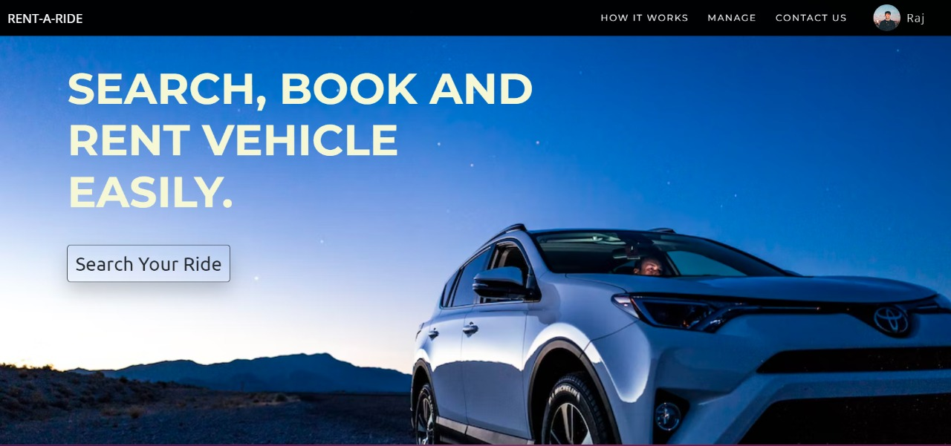

**Bookings page**

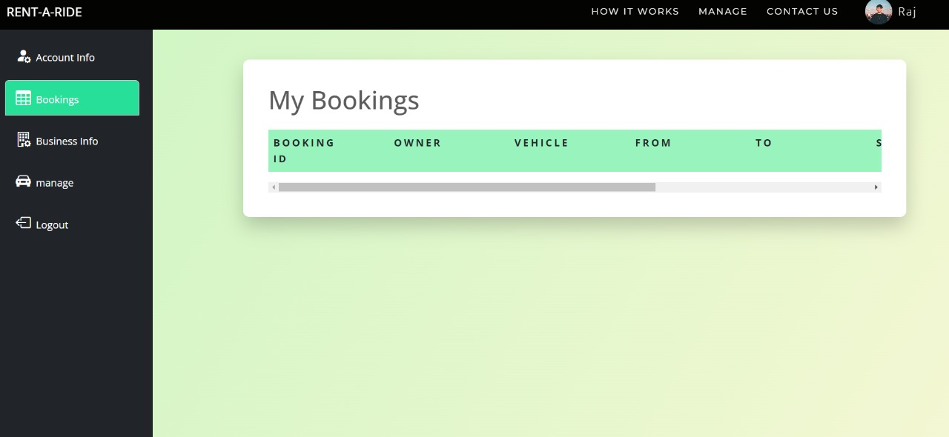

**Manage**

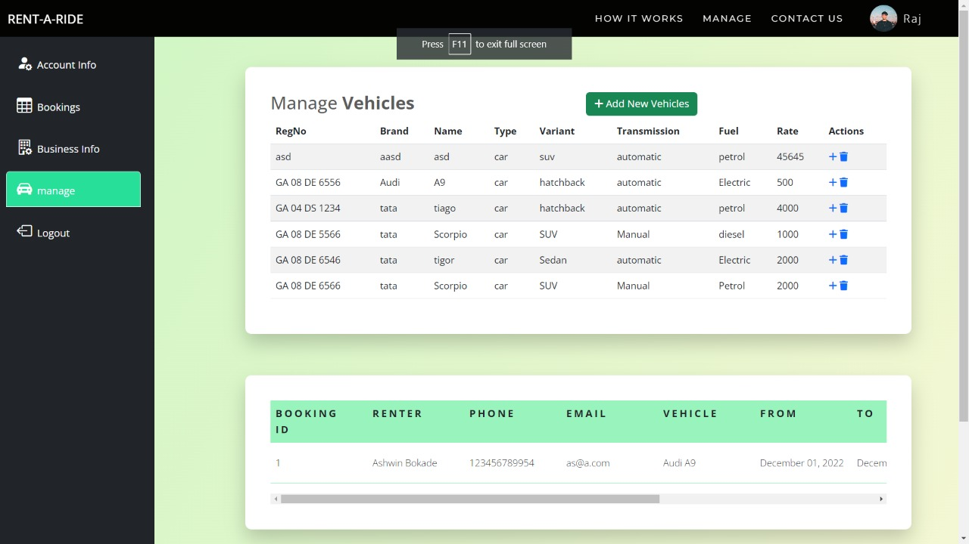

**User profile**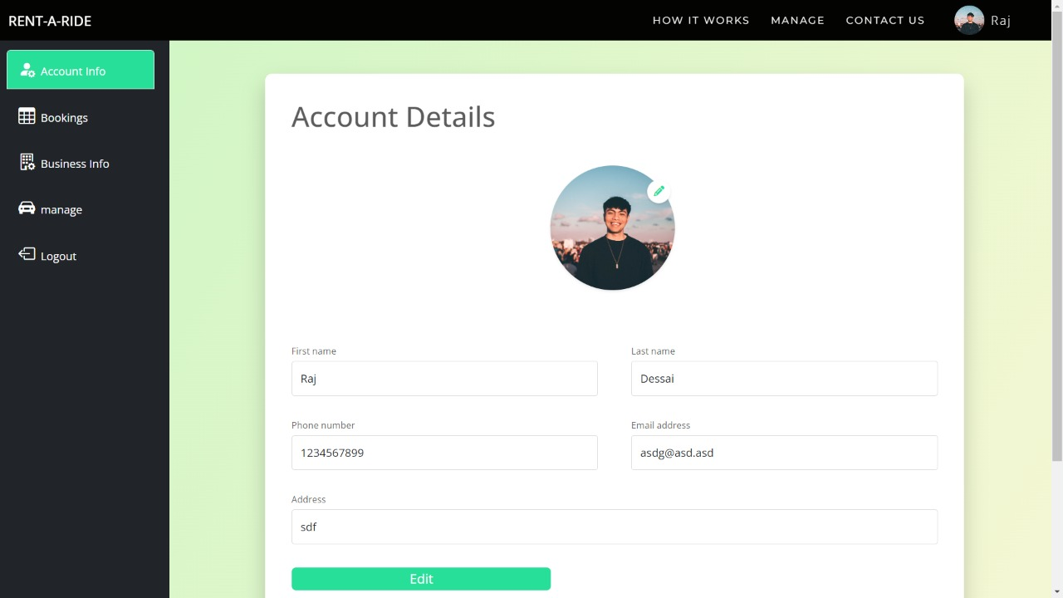

**Search Page**

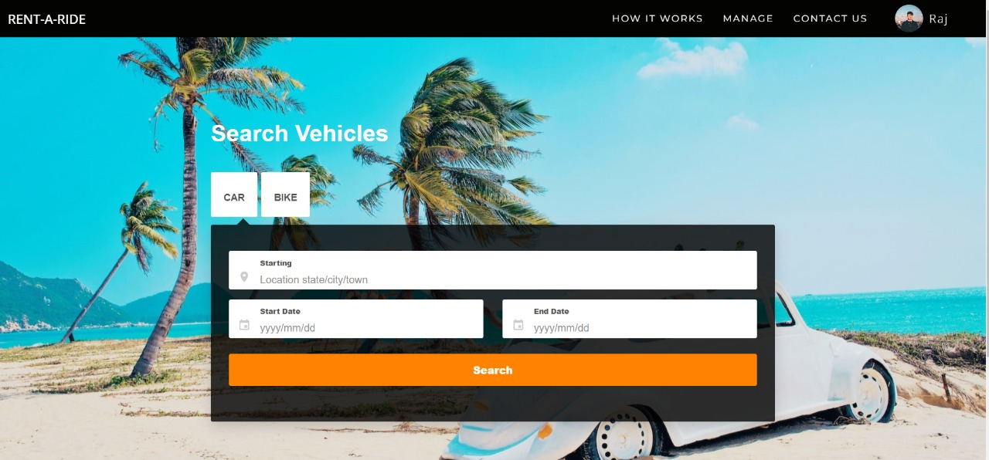

**Contact Us page**

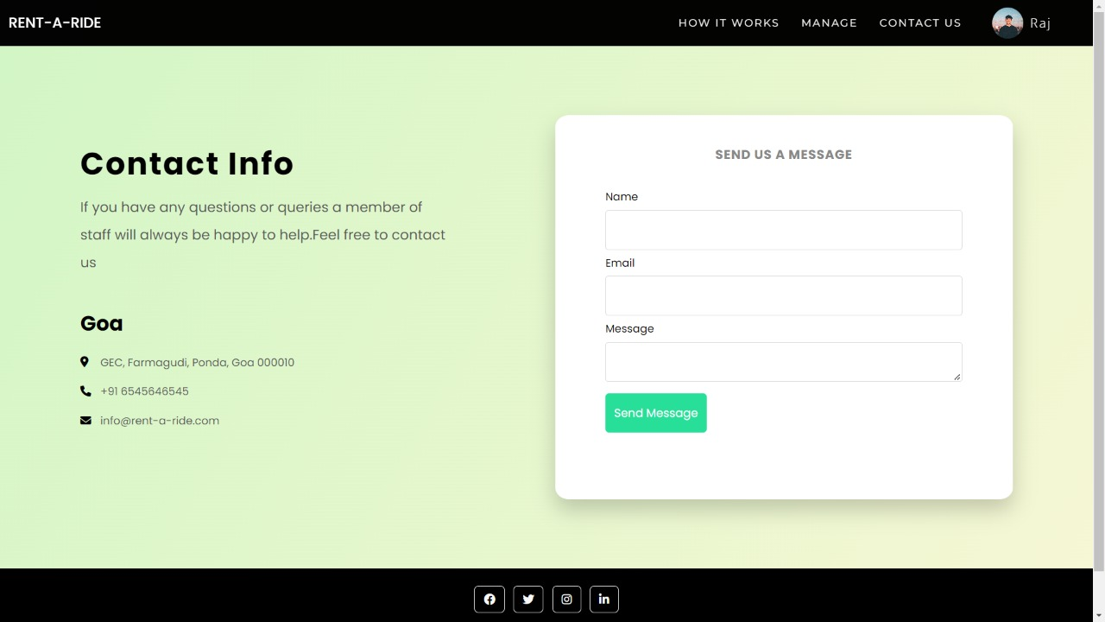

**Car Listing Page**

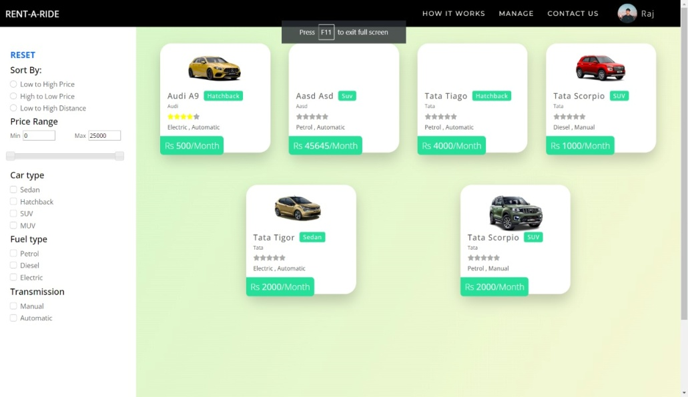

**Login page**

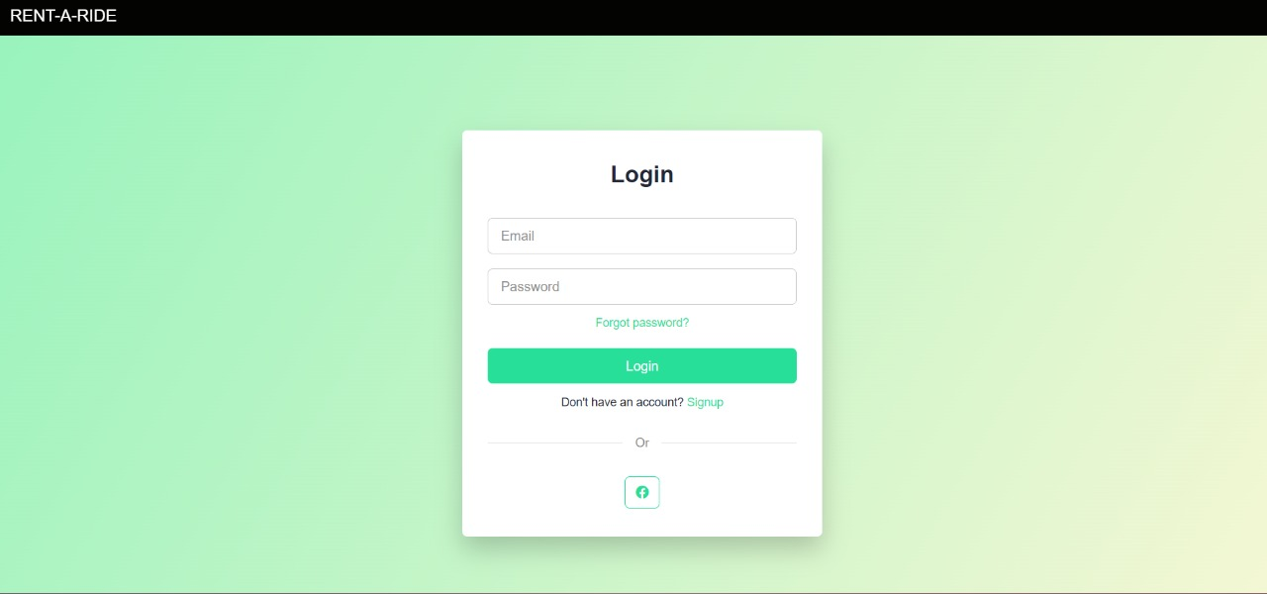

**Signup page**

