Implemented workflow

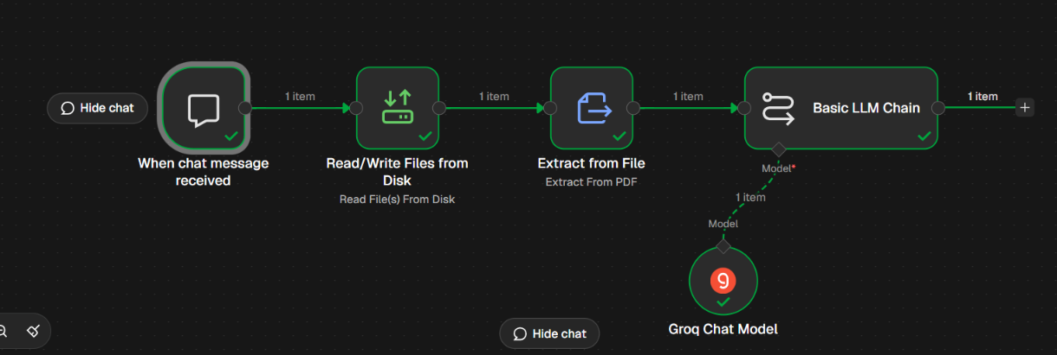

E2E Workflow

Trigger Node

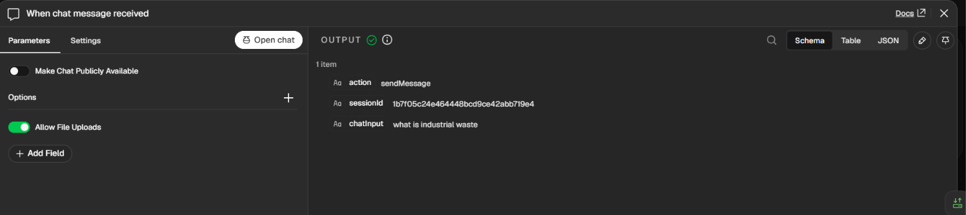

Read/Write file from disk Node

Chat message received in this node

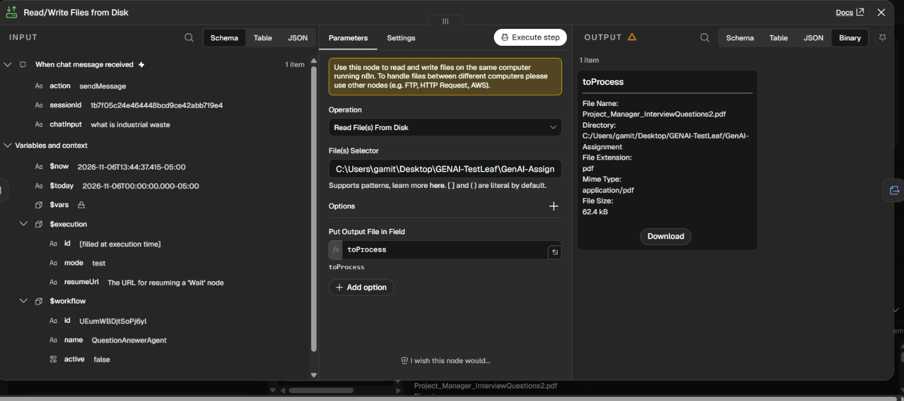

Extract from file Node

Extract from file is received, can be seen in the output below

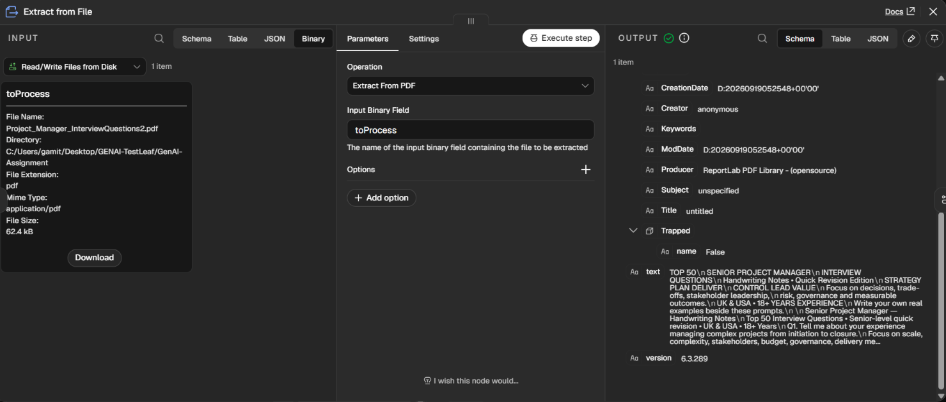

Basic LLM - Output shows its able to answer correctly

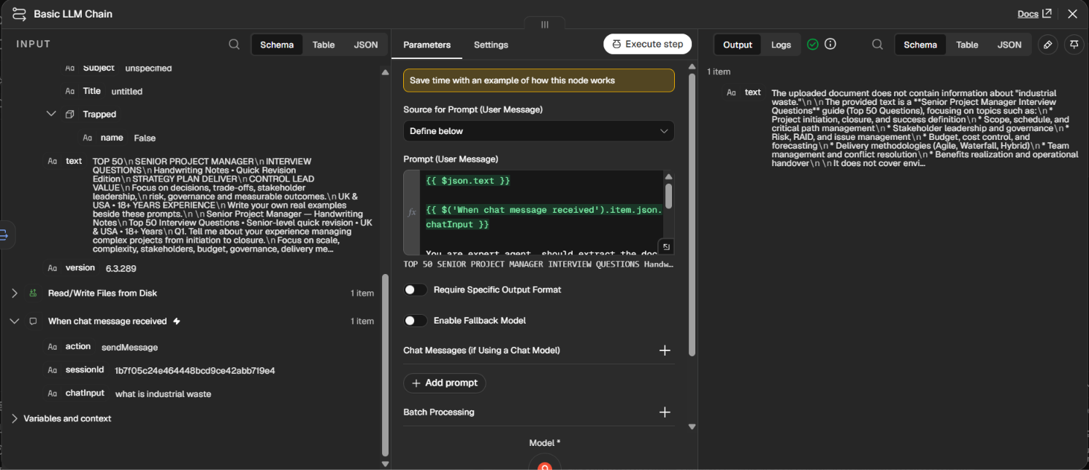

When question was out of context

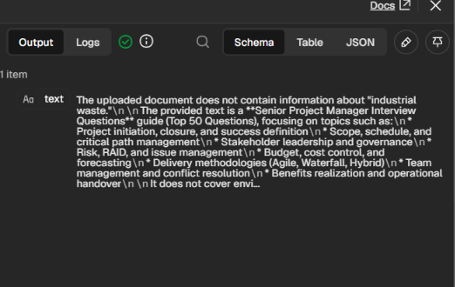

When question was within the ambit of the document


