Playwright code generated

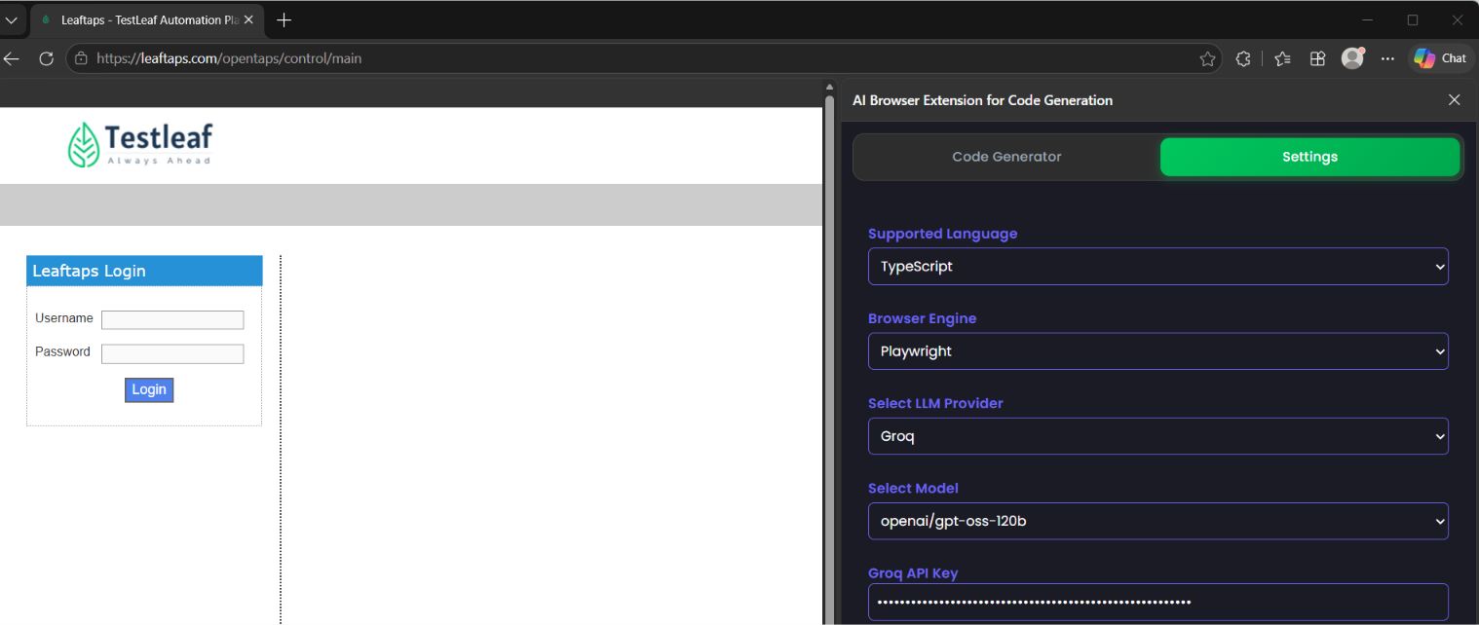

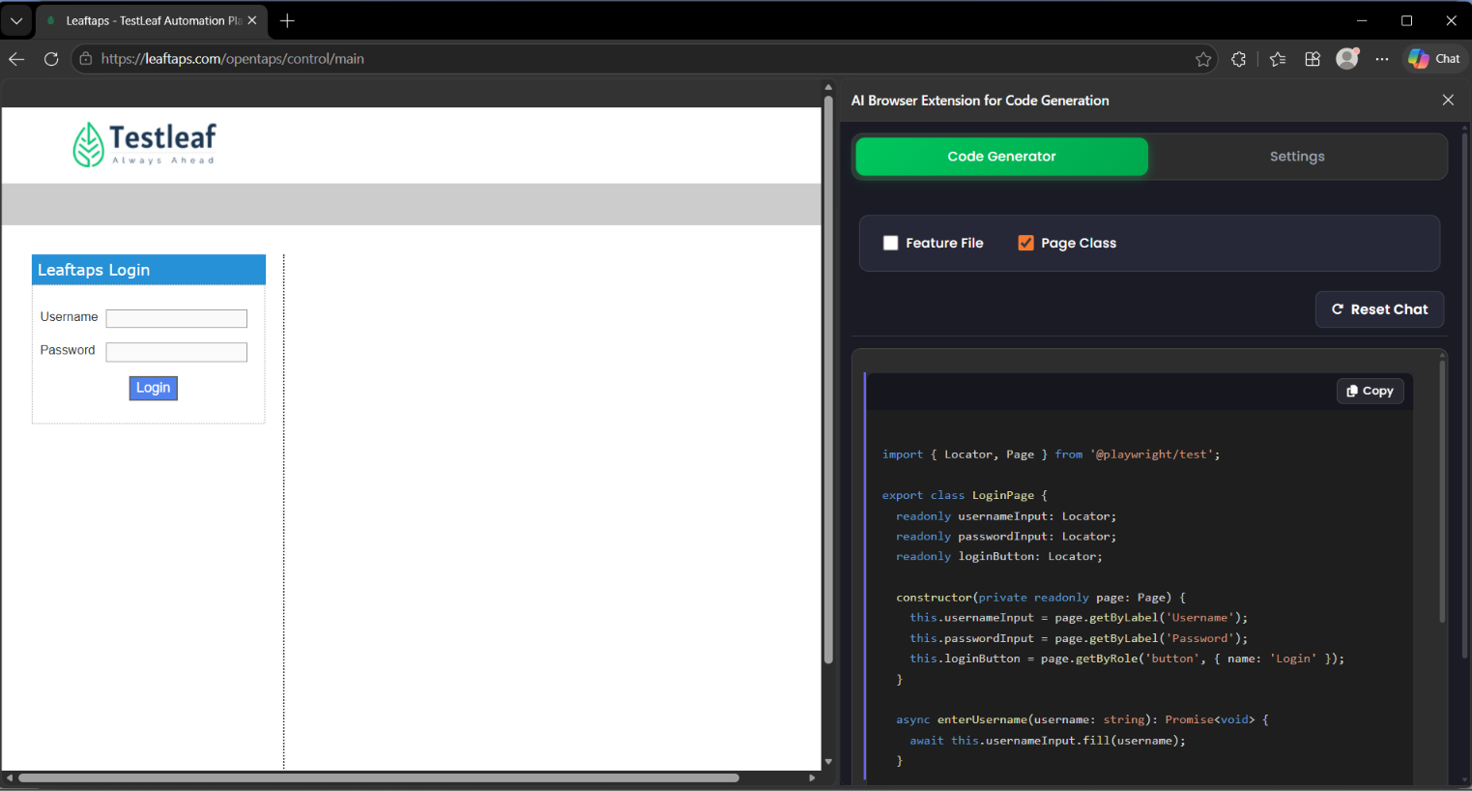
import { Locator, Page } from '@playwright/test';

export class LoginPage {
readonly usernameInput: Locator;
readonly passwordInput: Locator;
readonly loginButton: Locator;

constructor(private readonly page: Page) {
this.usernameInput = page.getByLabel('Username');
this.passwordInput = page.getByLabel('Password');
this.loginButton = page.getByRole('button', { name: 'Login' });
}

async enterUsername(username: string): Promise<void> {
await this.usernameInput.fill(username);
}

async enterPassword(password: string): Promise<void> {
await this.passwordInput.fill(password);
}

async clickLogin(): Promise<void> {
await this.loginButton.click();
}

async login(username: string, password: string): Promise<void> {
await this.enterUsername(username);
await this.enterPassword(password);
await this.clickLogin();
}
}

