**Practical File**

Computer Graphics

**Submitted to – Mrs** Simmi Sahni

Submitted By:

**Anish Kashyap**

Roll No - 2016

**BCA 6th semester**

**Govt. College Solan**

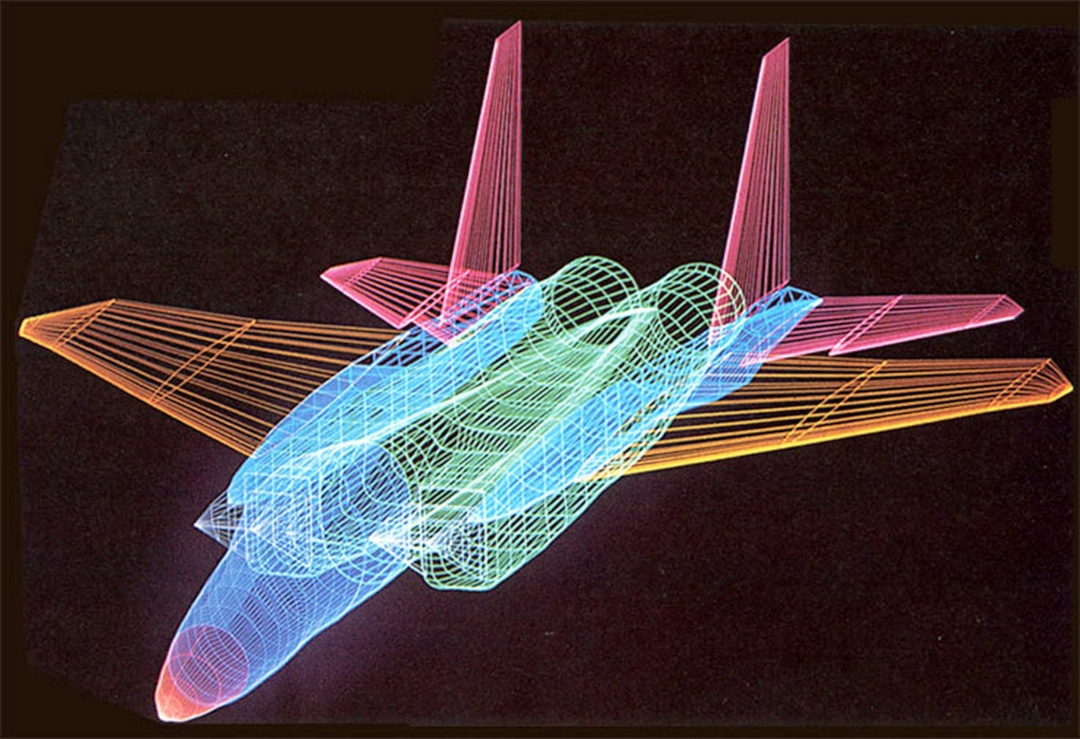

Practical 1:

Draw a circle filled with yellow colour

Code:

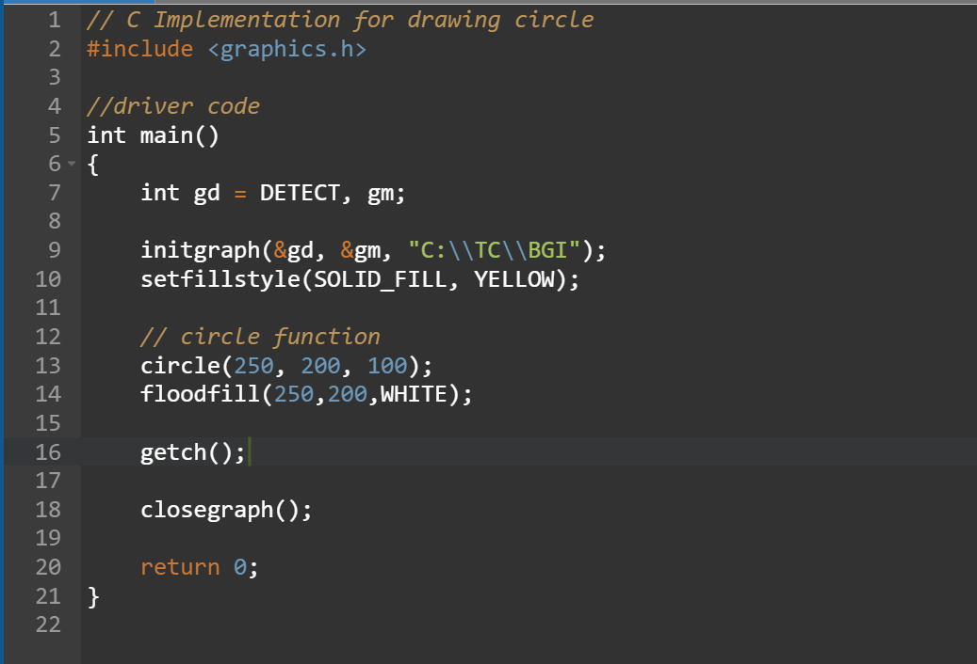

Output:

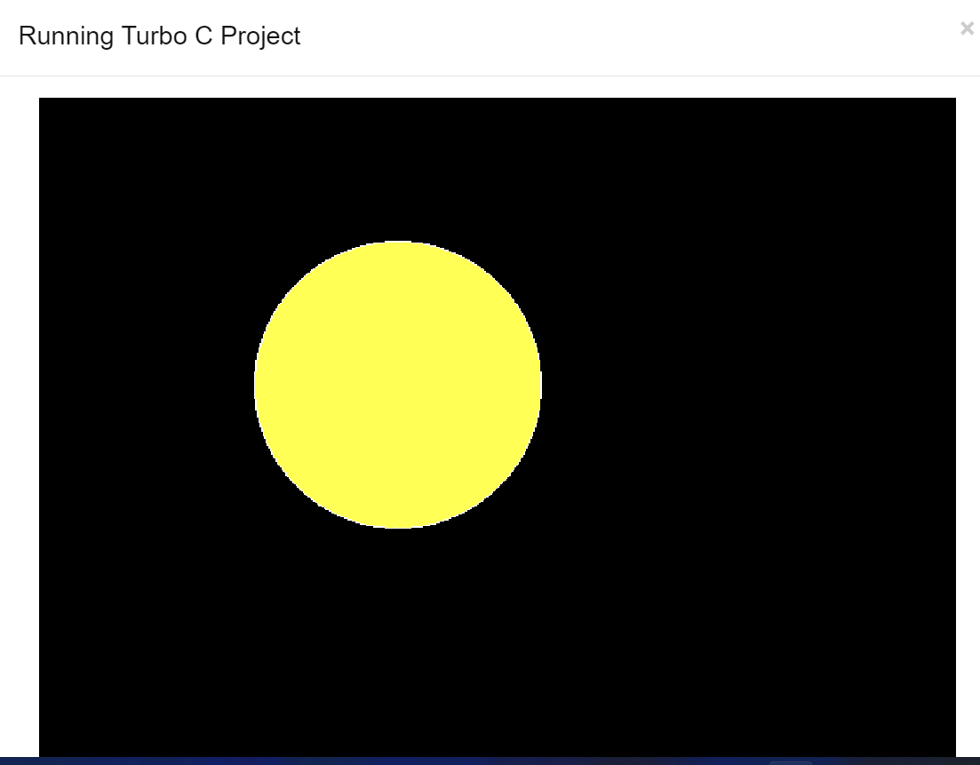

Practical 2

Draw Hexagon

**CODE :**

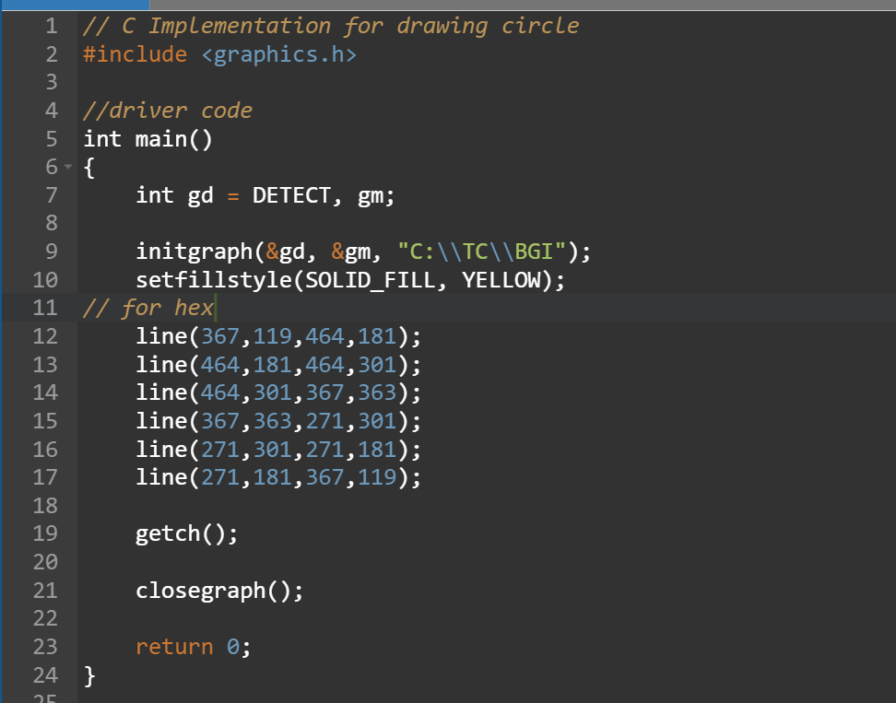

OUTPUT:

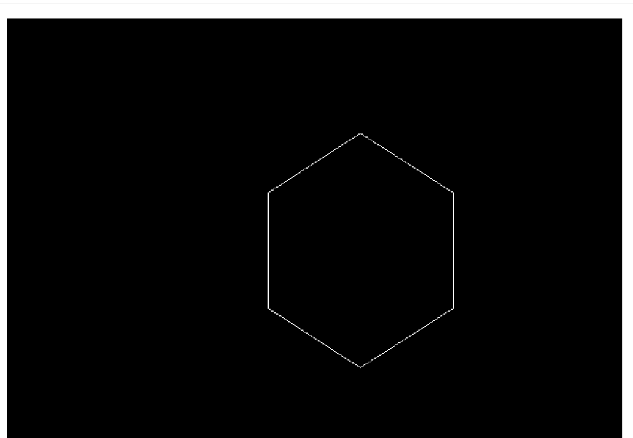

Practical 3

Draw a complete elipse with red colour

CODE: 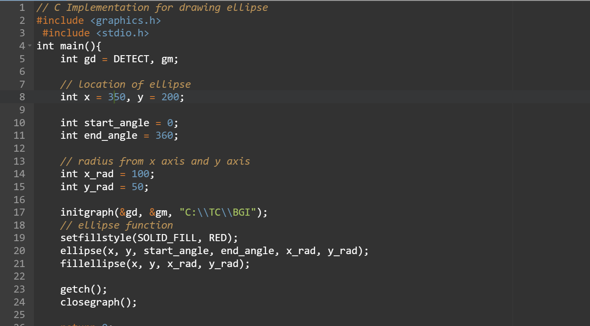

**OUTPUT :**



Practical 4

Draw cocentric circles with different colors

**CODE :** 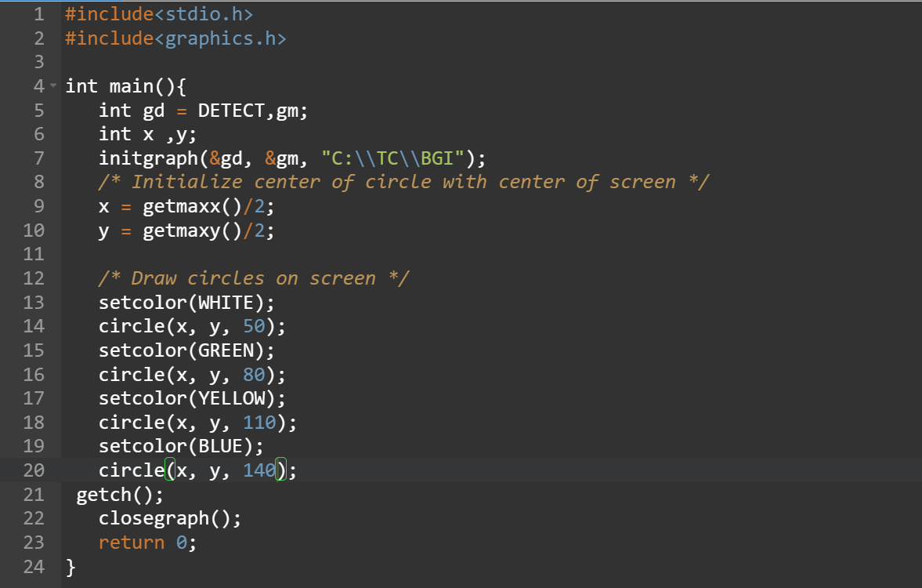

OUTPUT :

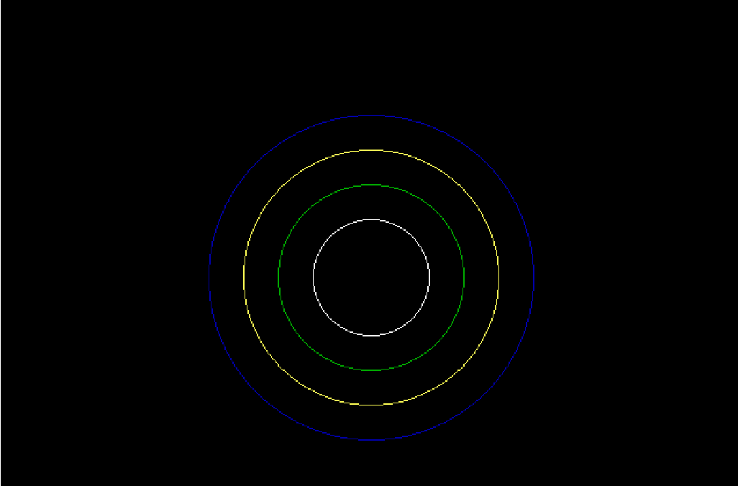

Practical 5

Draw a line with (150, 150) and (300, 300)

CODE :



OUTPUT :



Practical 6

Draw a rectangle with (150, 150) and (200,200)

CODE:

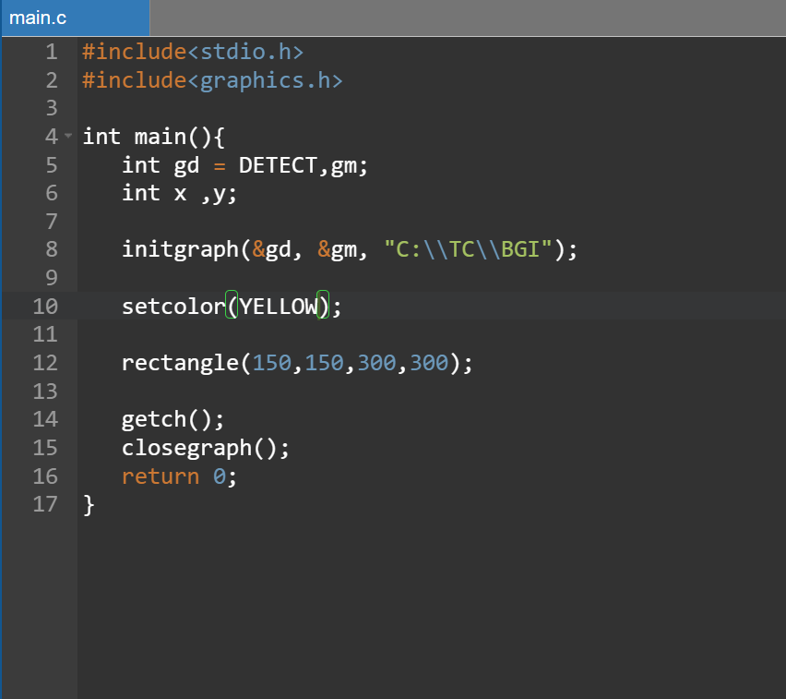

**OUTPUT:**



**Practical 7**

**Draw a hut**

**CODE :**

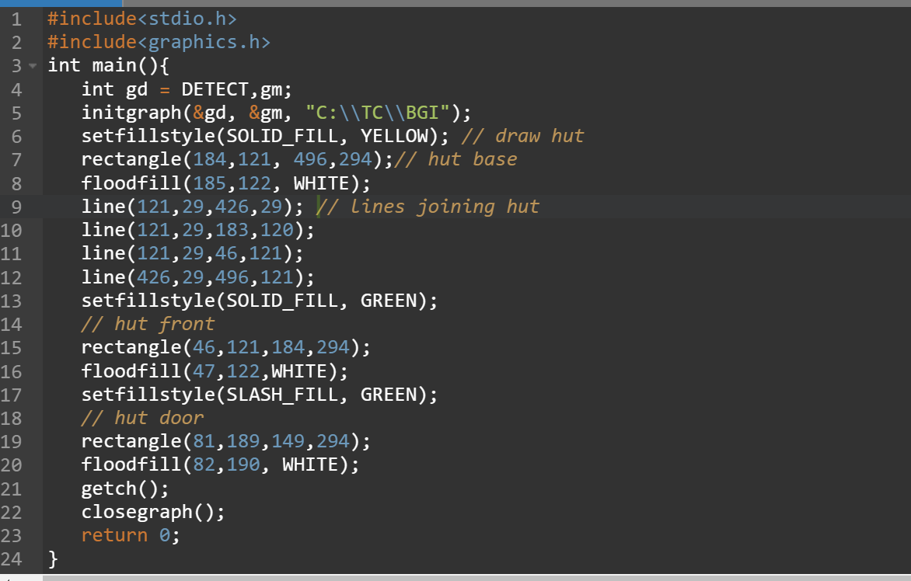

**OUTPUT :**

