Frontend End-Term Examination

By: Anish Kumar Garg

R.No: 2110990192

Group: 5

Branch: CSE

Year: 2021

Semester: 5th

Submitted to: Mr. Lavish Arora

Challenges and obstacles

During this project I worked heavily on the core concepts of the implementation of JavaScript, CSS and HTML.

I used subsets of the above said technologies like HTML Forms, HTML5, CSS Selectors, CSS Inheritance, DOM Manipulation, Event handling, localStorage, querySelectors, etc.

Throughout the project I overcame many challenges that were faced by me, like implementing carousels, accordions and a globally controlled theme that retains even after page refresh.

I overcame these obstacles by looking up the documentation for the specific functions that I should use to achieve the desired functionality.

In the concepts of CSS, I faced the challenge of rendering the date input selector in dark mode. Through searching on the internet I found out it could be resolved using the ‘color-scheme’ property of css elements.

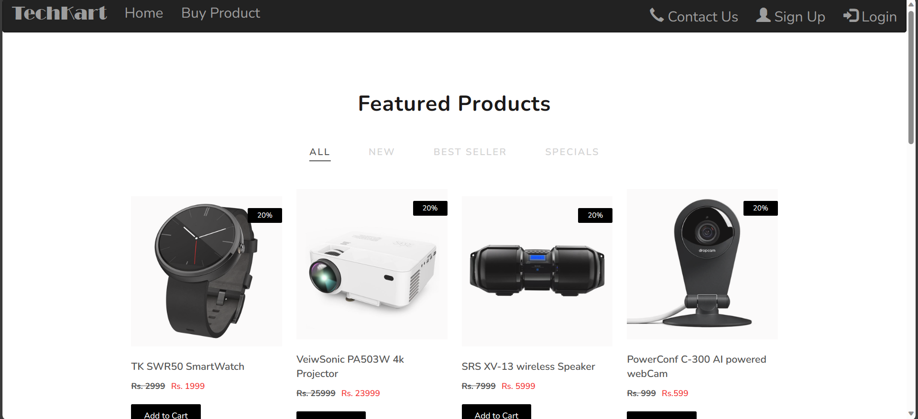Screenshots

* Landing Page
* Includes global control for theme and user state management
* Includes carousels
* Includes dynamic mapping of products and categories.
* Implementation of accordions

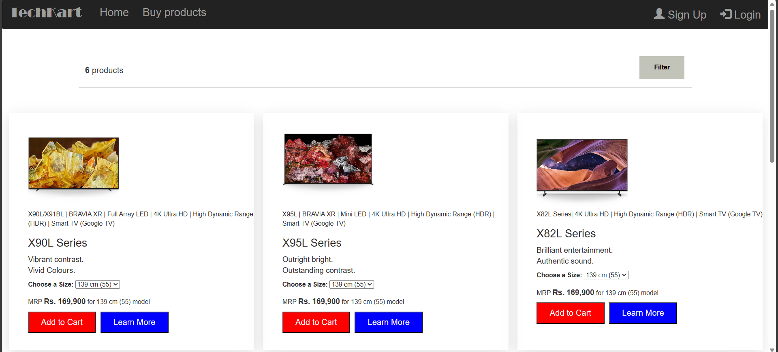

* All products page
* Products dynamically rendered using Array functions like filter(), map()
* Each Product card is dynamically linked to its own dynamically rendered product page
* Each category heading is linked to a category page where the products only present in that category are shown.

* Individual product page
* Contains Detailed Overview, Technical information and costumer reviews of each product.

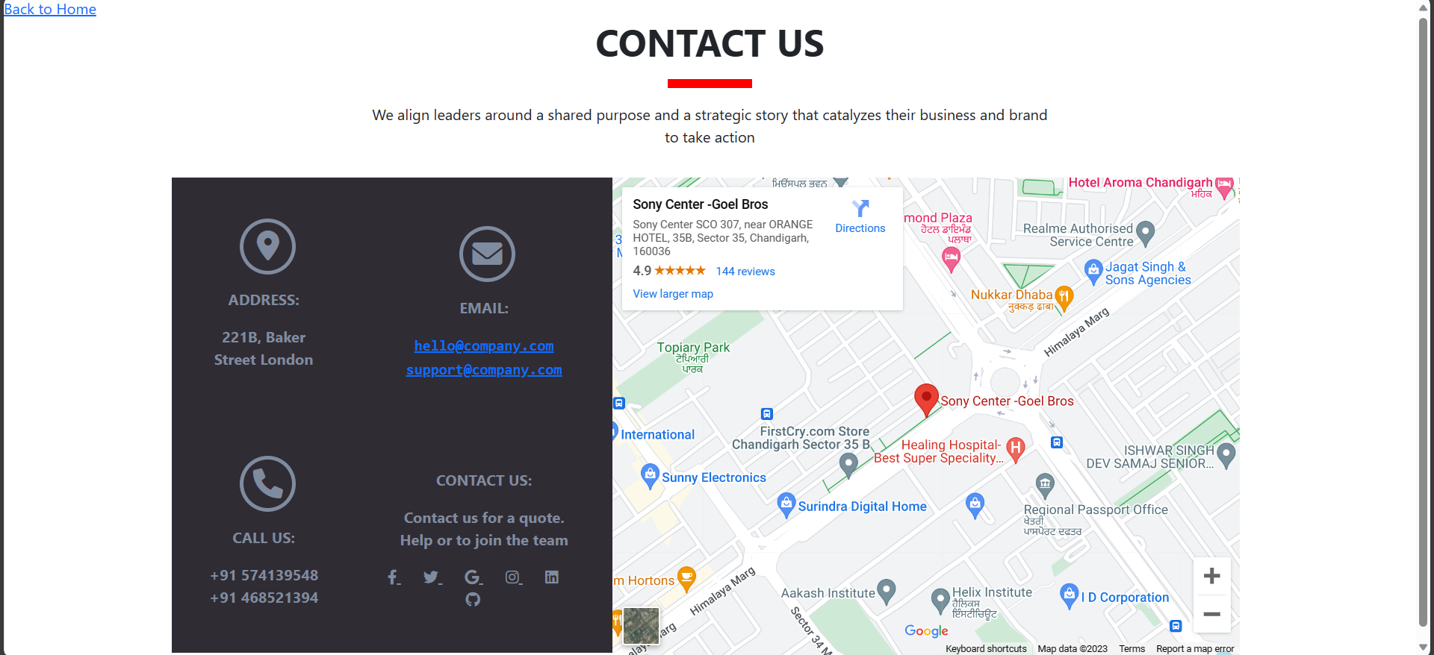

* Contact us page
* Google Maps implementation

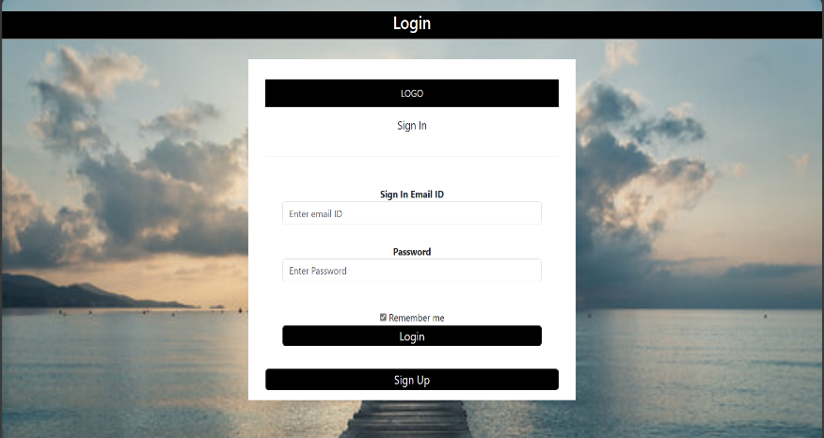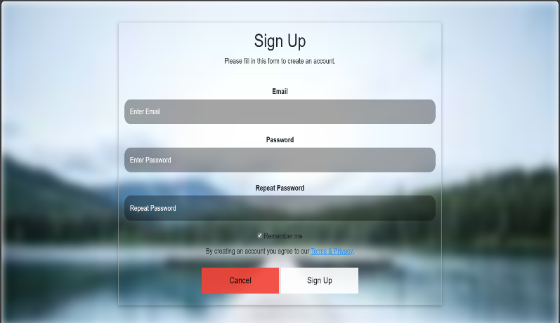

* Sign Up and Login Pages
* JavaScript Form Validation

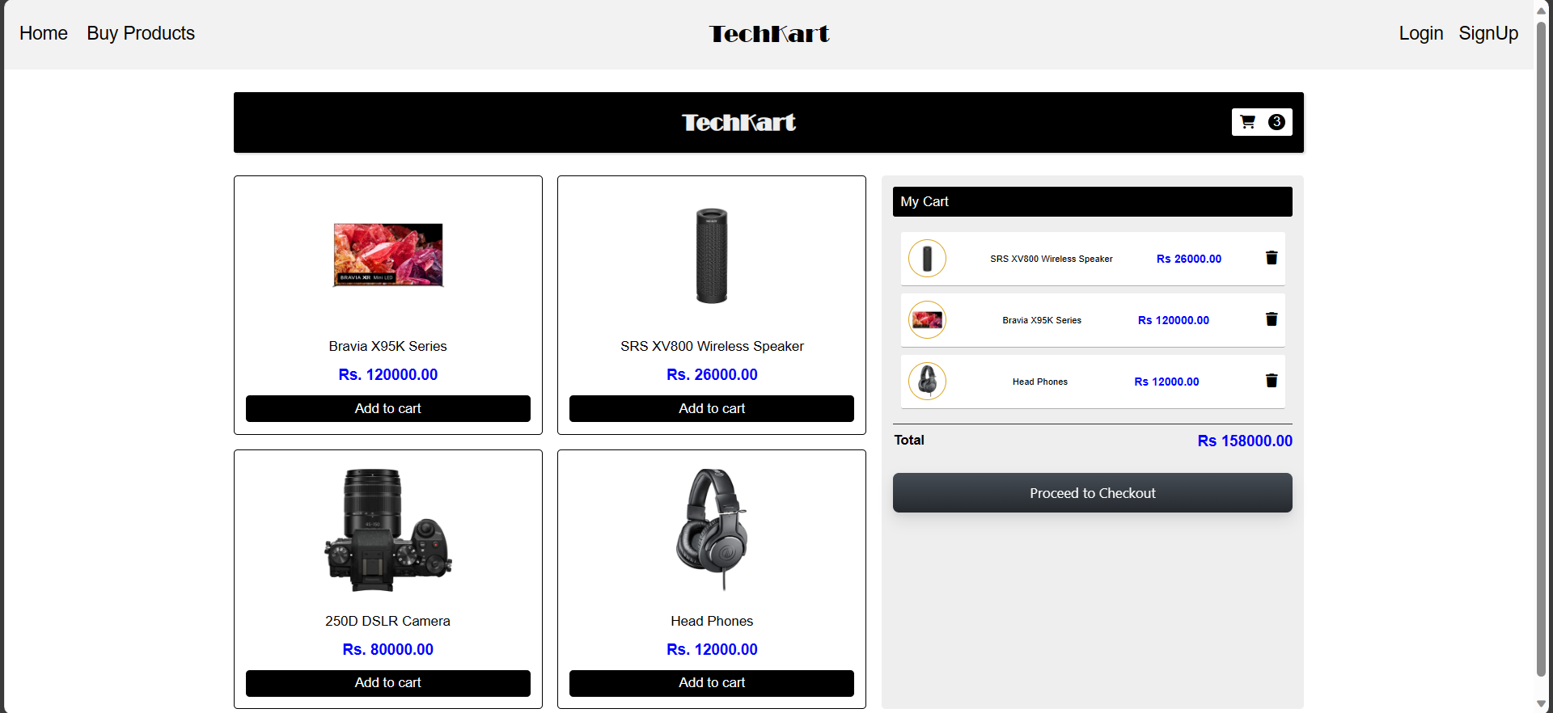

* Cart page
* Loads products into the page using arrays in JS.
* Calculates total on the fly

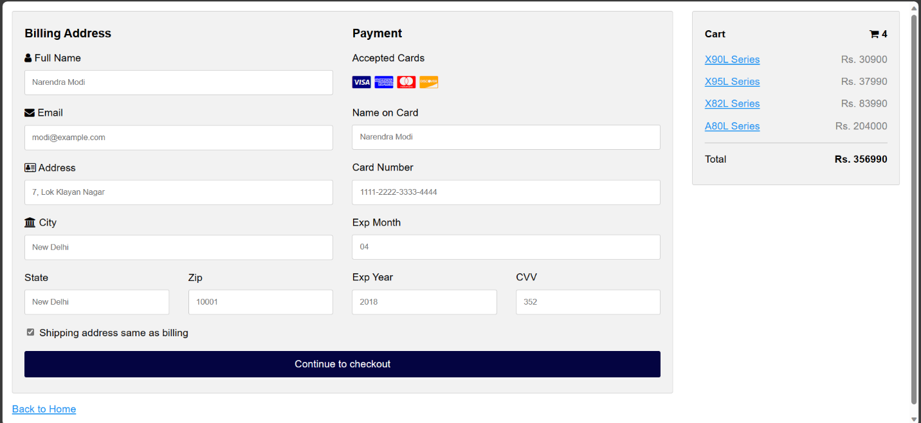

* Payment Gateway
* JavaScript Form Validation

—THANK YOU—