Anish Laddha

Chapter 7, Page 340

R7.1, 2, 4, 7, 8, 15, 16, 19, 21 to 27

Chapter 7 HW

1.

1. p = addr of a, a = 1000, b= 1000
2. *p = 3000
3. p = &b; *p = b = 2000
4. a = *p * 2 = 2000*2=4000

2.

|  |  |  |  |  |
| --- | --- | --- | --- | --- |
| After line | a | b | p | q |
| 1 | 1000 |  |  |  |
| 2 | 1000 | 2000 |  |  |
| 3 | 1000 | 2000 | 20300 |  |
| 4 | 1000 | 2000 | 20300 | 20308 |
| 5 | 2000 | 2000 | 20300 | 20308 |
| 6 | 2000 | 2000 | 20308 | 20308 |
| 7 | 2000 | 3000 | 20308 | 20308 |

4.

Line 3: p is a pointer to an int, while a is a double. This will throw an error as an int pointer cant point to double

Line 5: pointer points to address in memory, 2000 in heap not in memory

Line 7: see line 5

7.

1. 20300
2. 2
3. 20332
4. 11
5. 11
6. 20332

8.

1. 41
2. 17
3. 36
4. 0
5. compiler error

15.

1. p is defined as a pointer to a character, and is pointing to NULL.
2. q is defined as a pointer to a character, and is pointing to an empty string, which contains a single character: string terminator
3. r is a character array of length one, with the only element in it being the string terminator.

16.

5

19.

The memory is inaccessible and causes a memory leak until the function is done running and the heap is cleared.

You get a runtime error.

21.

2 - p can only be set to an address not a value

3 - p is not properly initialized, therefore cannot be used

5- s is not a pointer, so *s makes no sense

9 - array size is ten so it stops after the 9th index. A[10] does not exist

12 - q is not initialized, and isn't pointing anywhere

13 - q is not pointing to dynamically allocated memory

22.

We can create a vector of other vectors, and those vectors could be scaled dynamically to any size we want.

23.

struct Employee{

string name;

StreetAddress *office;

};

struct StreetAddress *accounting = new StreetAddress;

accounting->house_number = "1729";

accounting->street_name = "Park Avenue";

struct Employee *harry = new Employee;

harry->name = "Smith, Harry";

harry->office = &accounting;

struct Employee *sally = new Sally;

sally->name = "Lee, Sally";

sally->office = &accounting;

24.

struct person

{

string name;

person* father;

person* mother;

};

struct person *me = new struct person;

struct person *mom = new struct person;

struct person *dad = new struct person;

me->father = dad;

me->mother = mom;

me->name = “Anish”;

mom->father = NULL;

mom->mother = NULL;

mom->name = “Archana”;

dad->father = NULL;

dad->mother = NULL;

dad->name = “Piyush”;

25.

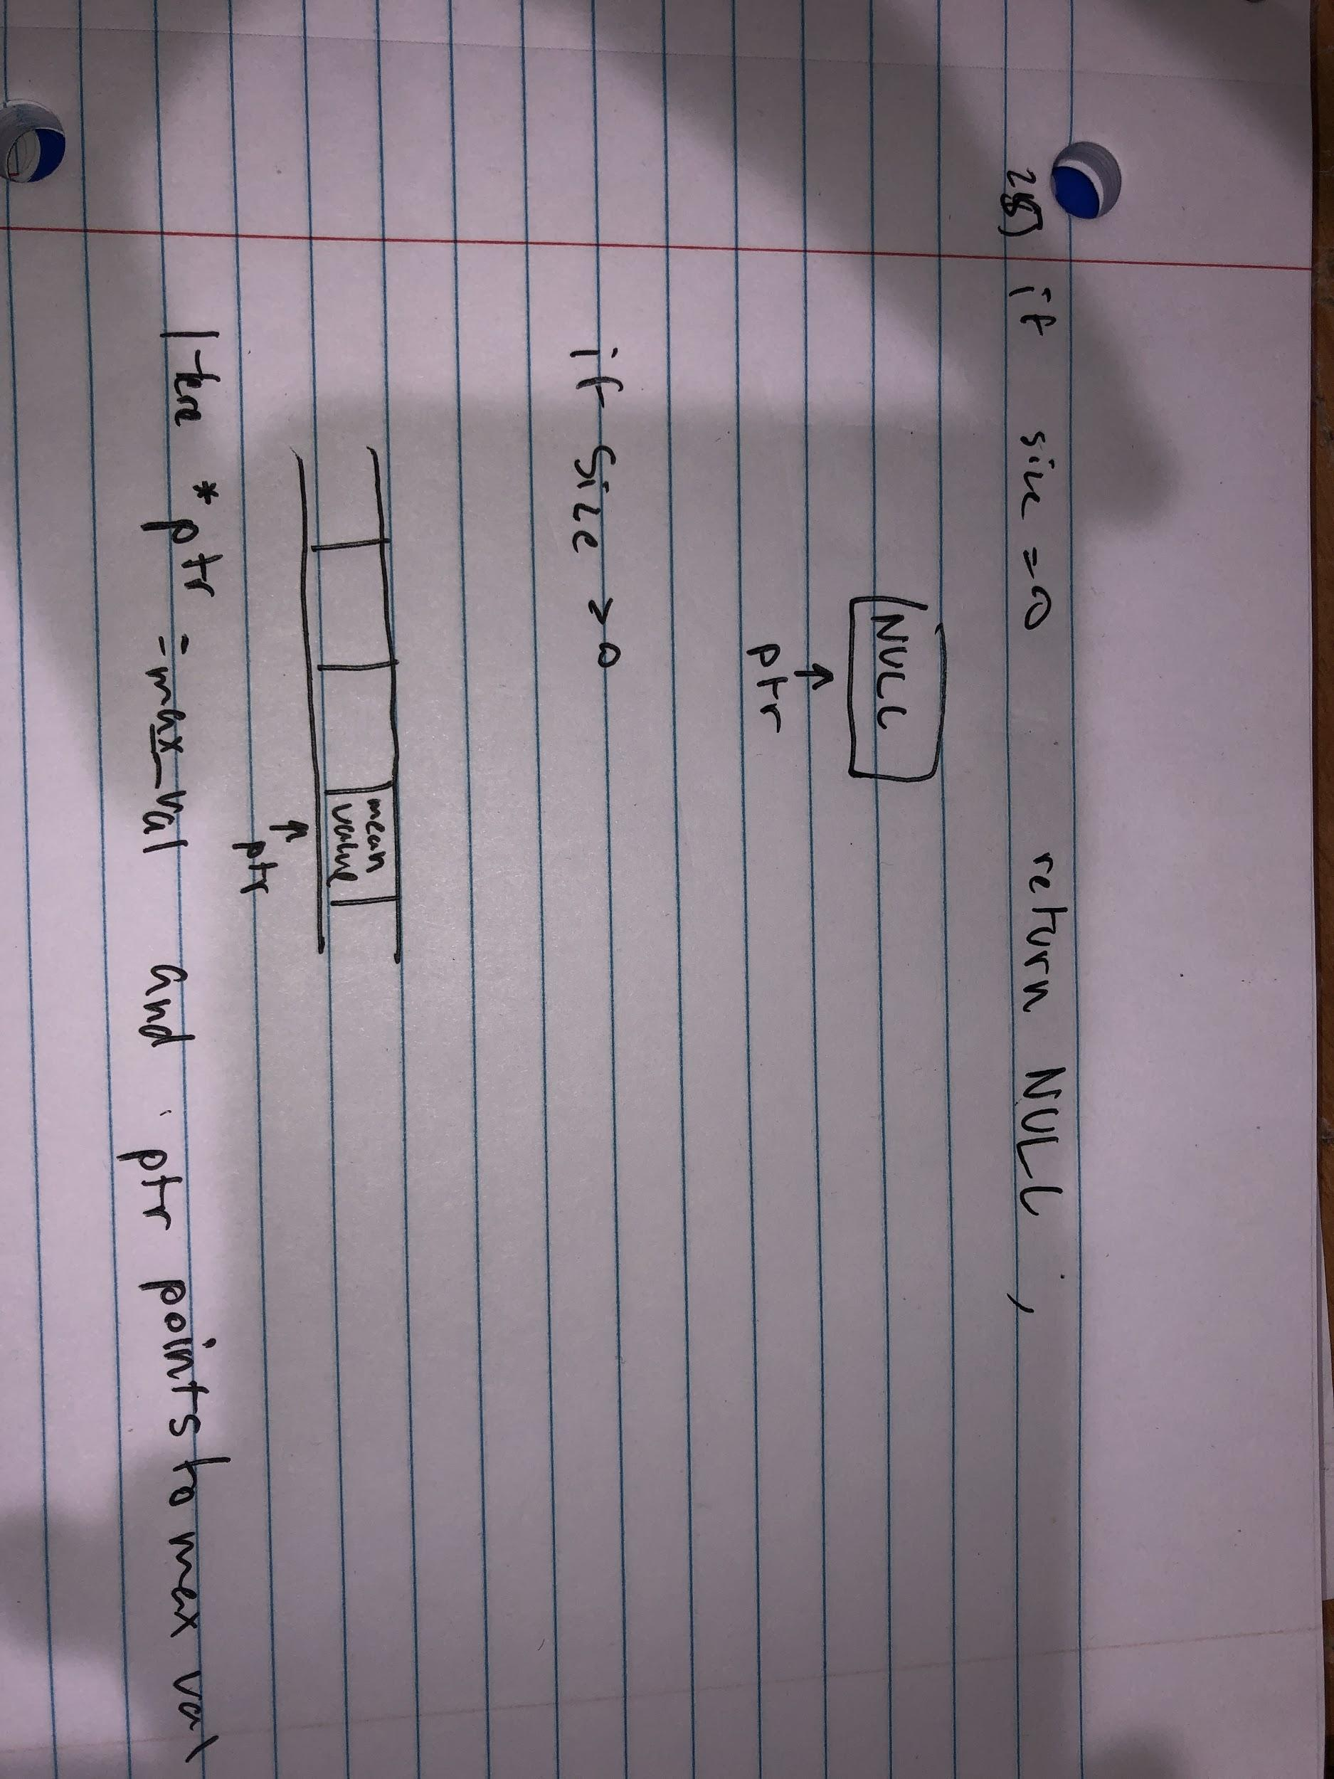

26.

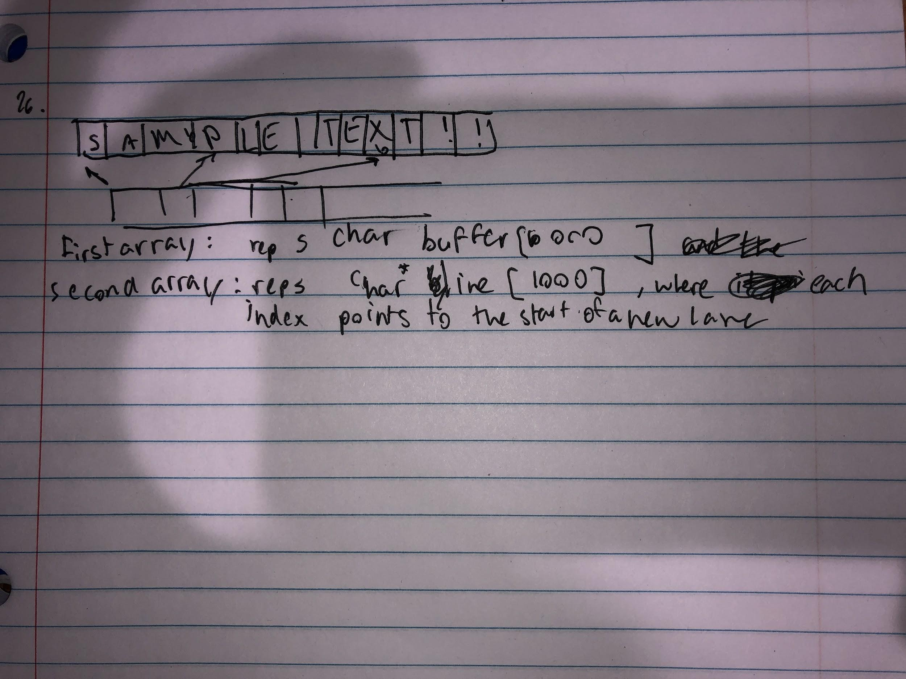

27.