**User Guide**

**Installation/Running The Program:**

* Download the zip folder which contains the application files
* Unzip/import the folder as project into a java IDE such as NetBeans or Eclipse
* Run the Main.java file
* Exit out of the window when you are done with the application
* Note: You must have Java 8.x installed on your machine
* Note: The program may be slow for 3-5 seconds upon start up, as it is reading through an English dictionary and setting up the core algorithms

**Purpose**:

The purpose of my application, Boggle!, is to allow users to play Boggle on an electronic board against a timer. However in addition to simply playing Boggle, my program also serves the purpose of providing a computer analysis of any given Boggle board - this is to help the user verify answers, learn new words, and determine how well they did against an algorithm!

**Special/Key Features:**

* The ability to play different Boggle timer modes; user has the option to play 30 seconds, 1 minute, 1.5 minutes, (…) , up to 3 minutes
* Randomly generated Boggle boards; no two games will ever be the same!
* Boggle solver - after completing a game, the user can request a computer analysis to find all the words they missed
* The game is based on a version of the English dictionary with 200,000+ words!

**Instructions/Screen Captures/Reference Guide:**

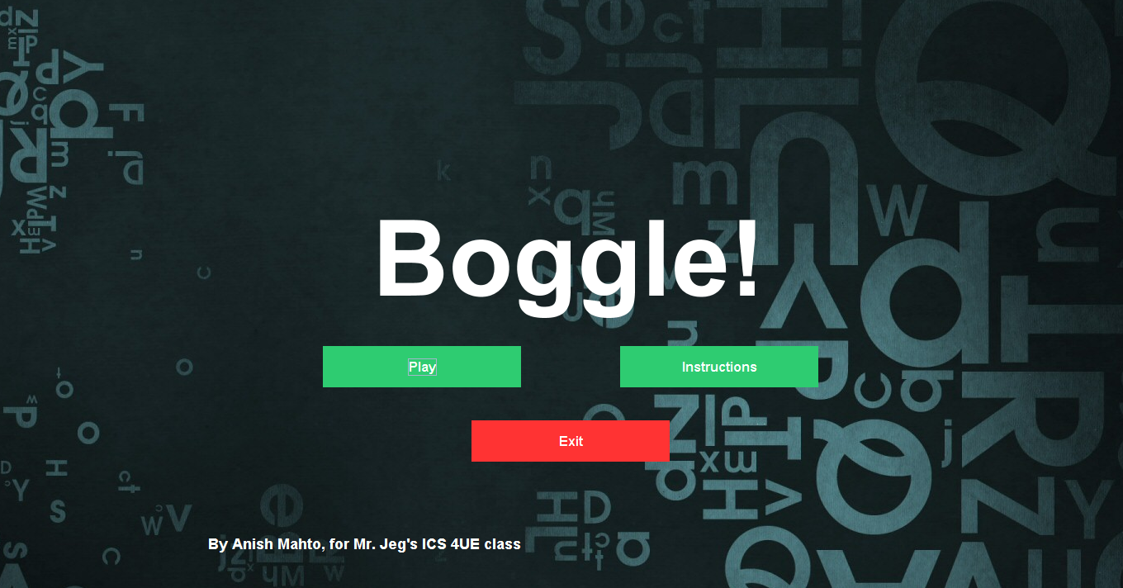

*Home Page*

Usage Instructions/Reference (Alpha Order):

* **Exit:** To end the program execution, click the “Exit” button
* **Instructions:** To move to the instructions page, click the “Instructions” button
* **Play:** To move on to the main game page, click the “Play” button

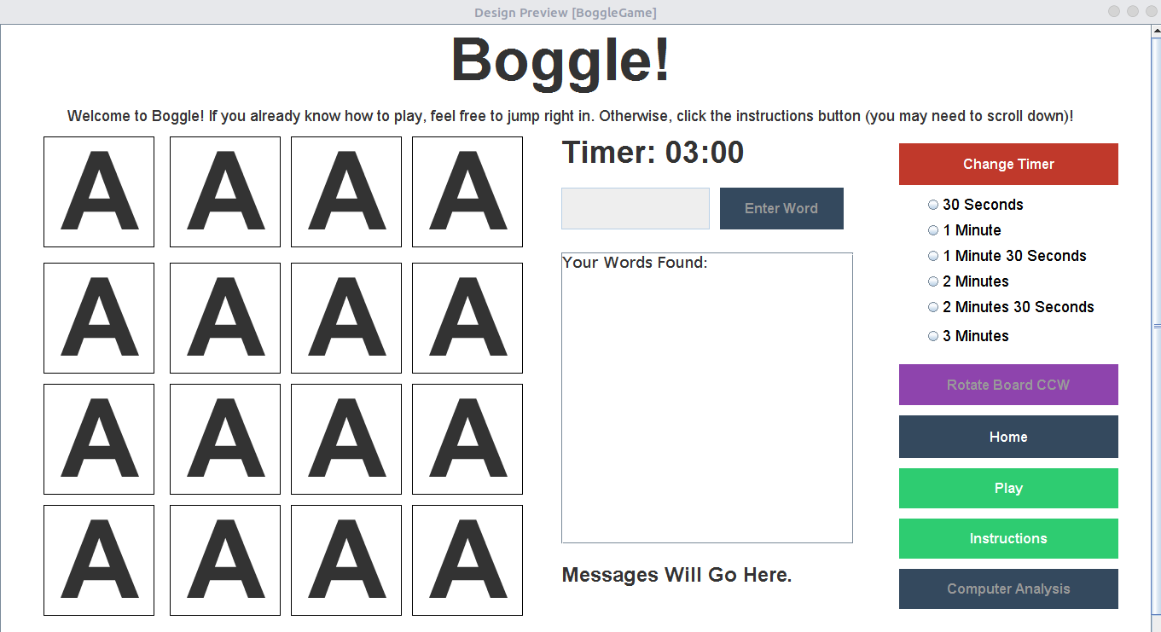

*Main Game Page*

Usage Instructions/Reference (Alpha Order):

* **Change Timer:** To change the timer limit, select the desired timer limit from one of the radio buttons, and click the “Change Timer” button
  + This can only be done if a game is not currently being played, otherwise the option is disabled
* **Computer Analysis:** To request a compute analysis, click the “Computer Analysis” button
  + This can only be done if a game is not currently being played, otherwise the option is disabled
  + The computer analysis will be appended to the textarea
* **Guessing Word:** To guess a word on the current Boggle board, type your word in the
* text input box and then hit enter or click the “Enter Word” button
  + The option to input a word will only be enabled if a game is currently being played
  + Valid guesses made will be outputted in the textarea
* **Home:** To return to the home page, click the “Home” button
* **Instructions:** To read instructions on how to play Boggle, click the “Instructions” button
* **Play:** Boggle board is initially set to ‘A’ by default. To actually play, user must click the “Play” button
  + This will set off the timer, generate a board, and allow the user to make guesses
* **Rotate CCW:** To rotate the Boggle board 90 degrees counterclockwise to change board perspective, click the “Rotate Board CCW” button
  + This can only be done if a game is currently being played, otherwise the option is disabled

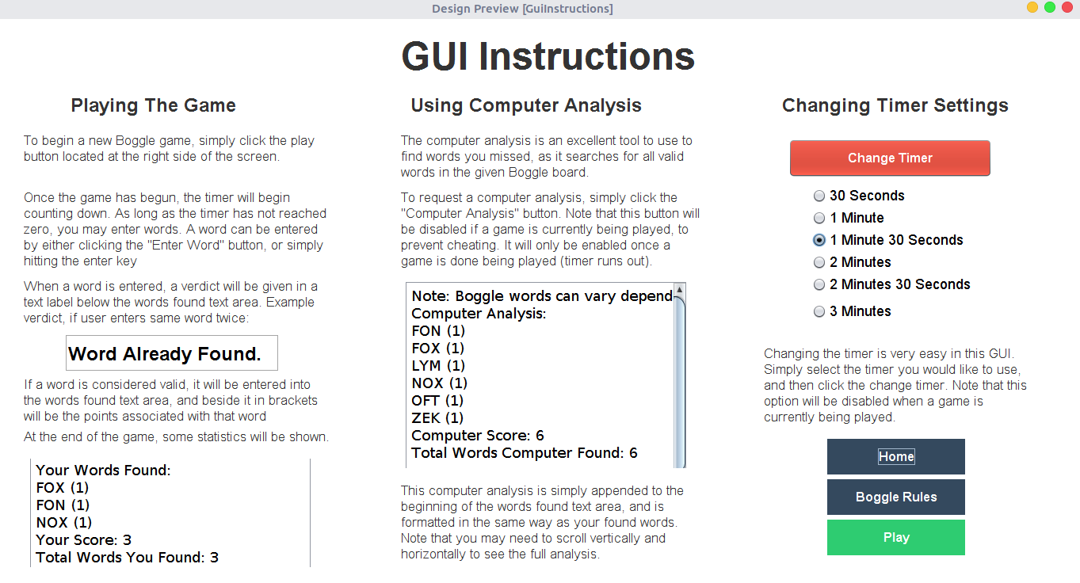

*GUI Instructions Page*

Usage Instructions/Reference (Alpha Order):

* **Boggle Rules:** To go to the Boggle rules page, click the “Boggle Rules” button
* **Home:** To go to the home page, click the “Home” button
* **Play:** To go to the main game page, click the “Play” button

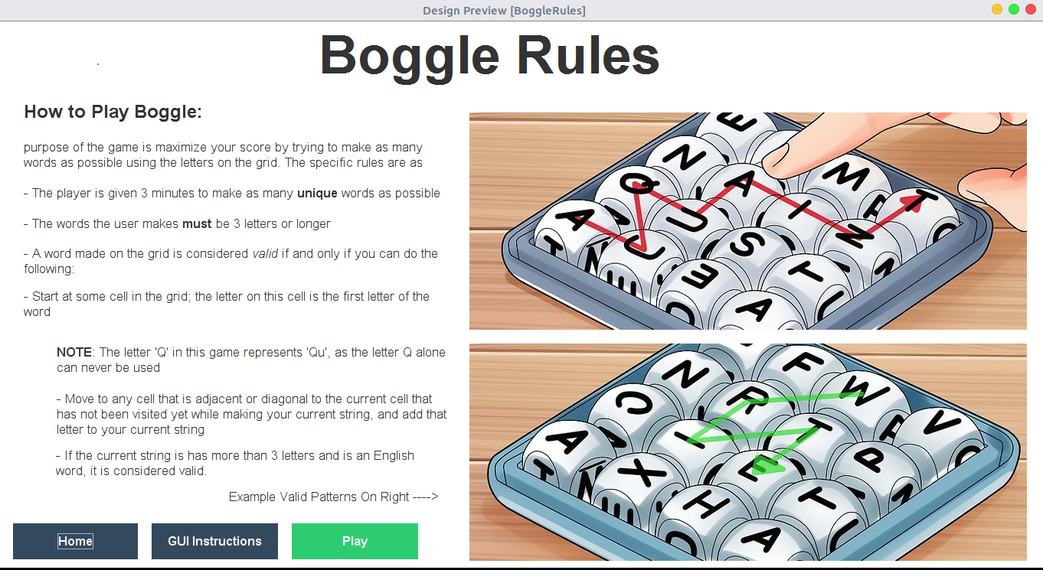

*Boggle Rules Page*

Usage Instructions/Reference (Alpha Order):

* **GUI Instructions:** To go to the GUI instructions rules page, click the “GUI Instructions” button
* **Home:** To go to the home page, click the “Home” button
* **Play:** To go to the main game page, click the “Play” button