Anish Malladi

Kevin Yao

Ph360 Final Project Proposal

Prof. Anita Raja

***The IPO Blockchain***

Initial Public Offerings (IPOs) have been used for centuries to finance a firm using public equity. The firm sells equity for liquid cash to the public, and this is commonly termed as “going public”. A public firm has a stock that is traded on the stock market and has shareholders that are from the public. However, the prevalence of IPOs has declined over the years, as seen below:

[insert graph]

This phenomenon is attributed to various factors: that the process is extremely expensive, not very transparent, and is riddled with middlemen that contribute to high costs. Further, after the financial crisis of 2008, the financial market is not It is hypothesised that this is hence a good case for a blockchain application.

The IPO process can be summarised as below:

After-market Stabilization

Valuation in public domain [1]

Pricing

Roadshow!

Due Diligence

Selecting Underwriters

Listing happens here!

Pre-IPO

IPO Process

Post-IPO

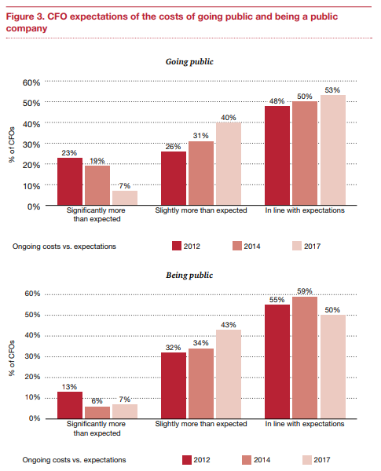 At every stage of the process, the firm encounters substantial costs. PricewaterhouseCoopers conducted a study analysing the costs of an IPO. They show that close to 50% of CFOs incurred more than expected costs while going public and over 50% incurred higher than expected costs while being public.

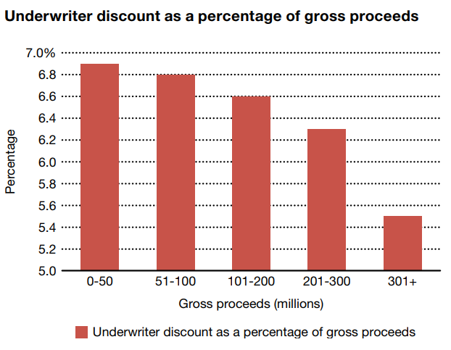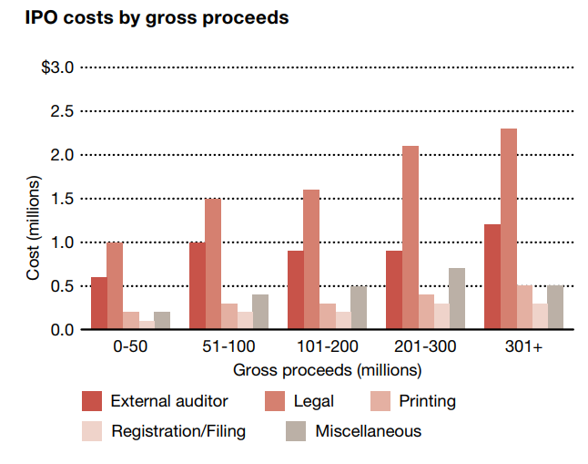The study goes on to break down costs based on the specific process of the IPO. The relevant statistics are shown below:

The costs of going public are significant, and they scale with size. However, the burden of these costs is felt more by companies at the lower end of the offering spectrum. Underwriter costs are a larger percentage of a smaller offering, leaving less resources for the companies to utilise. Over 60% of the costs of going public are shared by underwriter fees and legal fees.

Underwriters are paid for three functions that they perform:

1. Assuming Risk
2. Pricing the shares
3. Actual buying and selling of company stock.

The involvement of the underwriters is clearly seen below:

Clearly, if it is possible to reduce or eliminate the fees associated with an IPO, companies will be able to more easily access the public markets and more people can take active roles in investment and the growth of both SMEs and larger corporations.

It is thus hypothesised that by introducing a blockchain, it is possible to eliminate the fees that are paid to underwriters, as well as the legal and printing fees incurred by the company. By automating the share pricing and the initial offering to the public via blockchain, the necessity to involve an underwriter is eliminated – thus saving the company significant amounts in fees.

The platform we intend to use is Hyperledger Fabric. It has a built-in consensus algorithm which substitutes the necessity of mining. We intend to use two separate systems and link them – firstly using a multi-agent system in order to verify the legal filings and such of the IPO. The multiple agents here are the various entities involved – the CFO, the banks, the investors, the government and so on – who each have their own role to play in the process. The system will link them all together to streamline the process.

Hyperledger uses Assets and Participants to understand how the multiagent system functions. In our case, a non-exhaustive list of assets would include:

1. Firm Commitment
2. Engagement Letter
3. Underwriting Agreement
4. Red Herring Document (DRHP)
5. Shares (Potentially tokenised)

A non-exhaustive list of participants would include:

1. Company X
2. Underwriter U
3. Government G
4. Lawyer L
5. Accountant A
6. Institutional Investor II “n”
7. Public Investor P “n”

Our project’s main deliverable is a proof of concept of a network which performs the required tasks. The network should handle the multiagent lifecycle of the IPO as well as the auction and sales framework for the initial sale of shares. Further, we intend to have usage documentation for future development. We intend to record all our information using Github Pages as a VCS platform.

Our expected challenges revolve primarily around working with the Hyperledger Fabric as a development platform. Further, the biggest hurdle during the initial offering and subsequent sale of shares is the share price revision over time during trading. This will be limited by the transaction speed of the chain – which will be slower than transactions on the stock market. Given time, we hope to implement some level of flexibility in the initial sale method – which will likely be auction based.

*References*

1. https://corporatefinanceinstitute.com/resources/knowledge/finance/ipo-process/
2. https://www.pwc.com/us/en/services/deals/library/cost-of-an-ipo.html
3. https://www.theipojournal.com/2016/03/2016-ipo-study-ipo-fees-and-expenses/
4. https://www.pwc.com/us/en/deals/publications/assets/cost-of-an-ipo.pdf
5. https://chainium.io/uploads/files/Chainium-Business-Whitepaper-v3.pdf
6. http://www.the-blockchain.com/2016/03/17/overstock-com-announces-historic-blockchain-public-offering/
7. Consensys, “Designing a good Blockchain Use Case”. Moodle, Accessed 09.04.18
8. http://composer-playground.mybluemix.net
9. Demos, Telis. (21 June 2012) [What Is a Dutch Auction? – Deal Journal – WSJ](https://blogs.wsj.com/deals/2012/06/21/exactly-what-is-a-dutch-auction/). Blogs.wsj.com. Retrieved on 2012-10-16.