# Bansilal Ramnath Agarwal Charitable Trust’s

Vishwakarma Institute of Technology, Pune-37

*(An autonomous Institute of Savitribai Phule Pune University)*



**Department of Artificial intelligence and Data Science**

|  |  |
| --- | --- |
| **Division** | A |
| **Batch** | 1 |
| **Roll no** | 07 |
| **PRN no** | 12211542 |
| **Name** | Anish Naphade |
| **Subject** | Computer Network |

**Assignment-1 (CN)**

**NAME- ANISH AJAY NAPHADE**

**PRN-12211542**

**ROLL NO-7**

**DIV- AI-A**

**Q. Study and implement various networking commands on terminal.**

1. **PING**: The Ping command is one of the most widely used commands in the prompt tool, as it allows the user to check the connectivity of our system to another host.

This command sends four experimental packets to the destination host to check whether it receives them successfully, if so, then, we can communicate with the destination host. But in case the packets have not been received, that means, no communication can be established with the destination host.

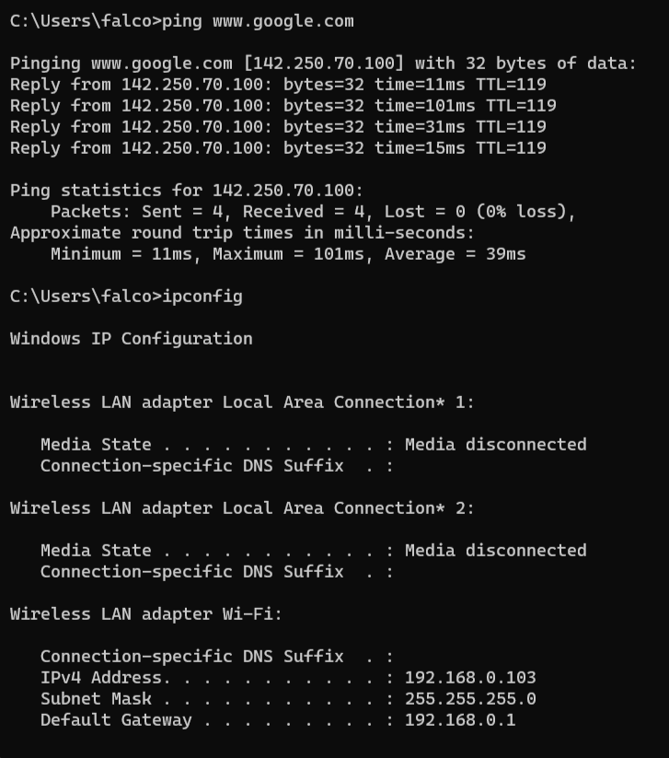

1. **IP CONFIG:** The IPCONFIG network command provides a comprehensive view of information regarding the IP ADRESS configuration of the device we are currently working on.

The IPConfig command also provides us with some variation in the primary command that targets specific system settings or data, which are:

* IPConfig/all - Provides primary output with additional information about network adapters.
* IPConfig/renew - Used to renew the system’s IP address.
* IPConfig/release - Removes the system’s current IP address.

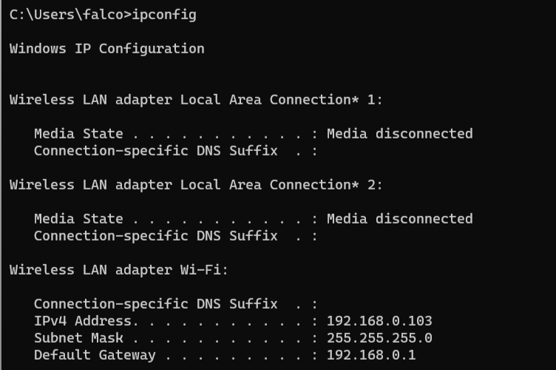

1. ARP: The ARP(Address Resolution Protocol) command is used to access the mapping structure of IP addresses to the MAC address. This provides us with a better understanding of the transmission of packets in the network channel.

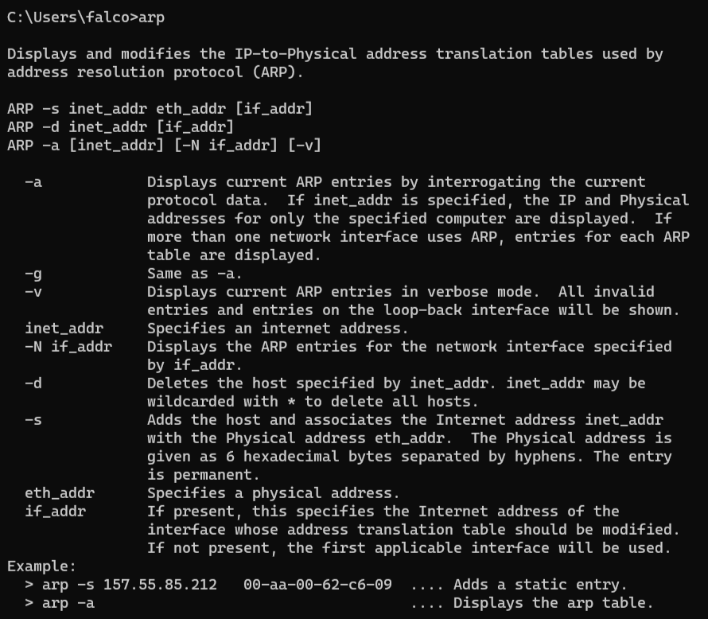

1. Netstat: The Netstat command as the name suggests displays an overview of all the network connections in the device. The table shows detail about the connection protocol, address, and the current state of the network.

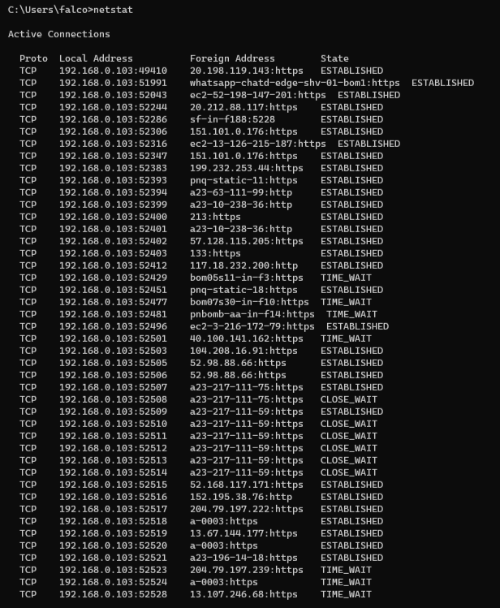

1. Tracert: The TRACERT command is used to trace the route during the transmission of the data packet over to the destination host and also provides us with the “hop” count during transmission.

Using the number of hops and the hop IP address, we can troubleshoot network issues and identify the point of the problem during the transmission of the data packet.

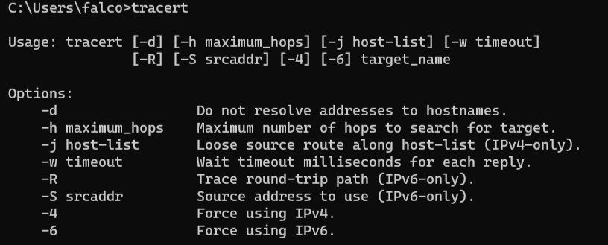

1. Ns lookup: The NSLOOKUP command is used to troubleshoot network connectivity issues in the system. Using the nslookup command, we can access the information related to our system’s DNS server, i.e., domain name and IP address.

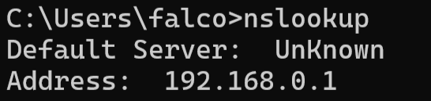

1. Hostname : The HOSTNAME command displays the hostname of the system. The hostname command is much easier to use than going into the system settings to search for it.

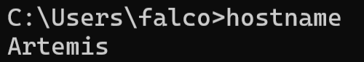

1. Systeminfo : Using the SYSTEMINFO command, we can access the system’s hardware and software details, such as processor data, booting data, Windows version, etc.

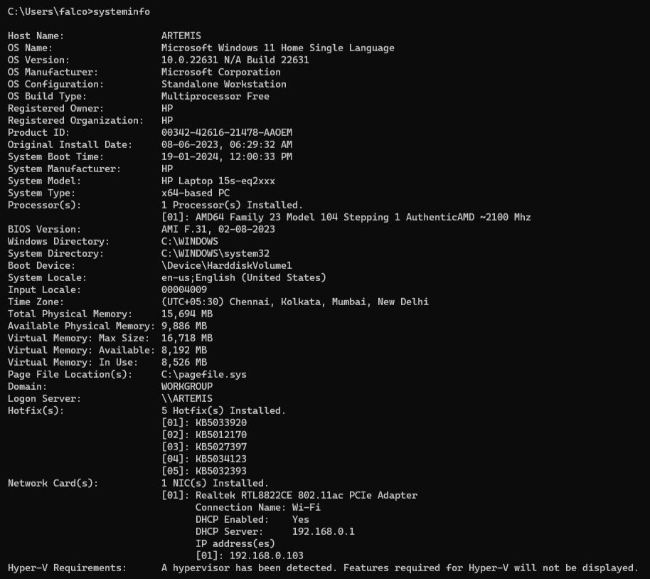

**CONCLUSION-**

In this Assignment-1 on ‘Networking Commands’, we understood the need of using network commands and the way to implement them in the Windows command prompt. We also learned about the different network commands to troubleshoot and configure the system's network settings.