# Bansilal Ramnath Agarwal Charitable Trust’s

Vishwakarma Institute of Technology, Pune-37

*(An Autonomous Institute of Savitribai Phule Pune University)*



**Department of Artificial Intelligence and Data Science**

|  |  |
| --- | --- |
| **Division** | A |
| **Batch** | 1 |
| **GR-no** | 12211542 |
| **Roll No.** | 07 |
| **Name** | Anish Naphade |
| **Subject** | Digital Electronics and Microprocessor |

**Title: Logic Gates**

**Theory:**

**WHAT ARE LOGIC GATES?**

A logic gate is a device that acts as a building block for digital circuits. They perform basic logical functions that are fundamental to digital circuits.

1. **AND Gate:** The AND gate is named so because, if 0 is false and 1 is true, the gate acts in the same way as the logical "and" operator. The following illustration and table show the circuit symbol and logic combinations for an AND gate.

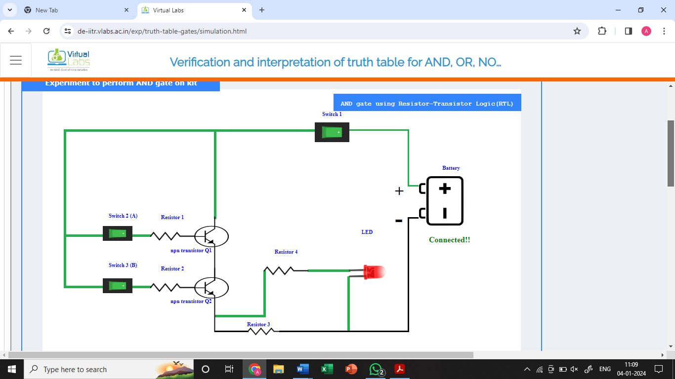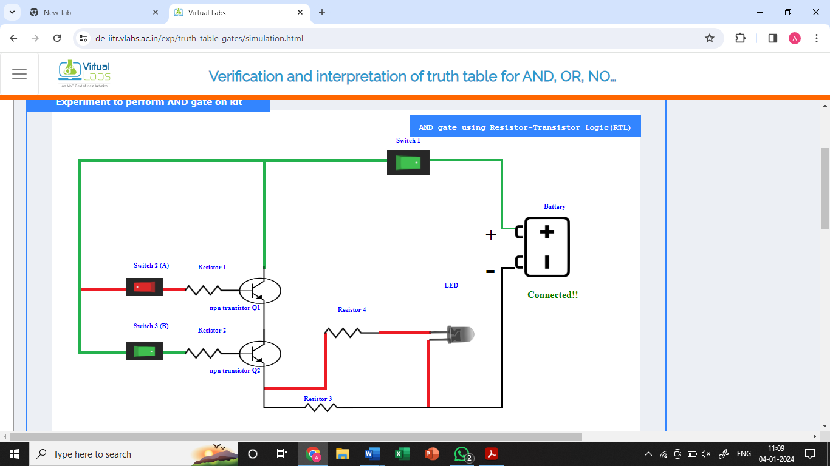**Circuit Diagram**

**Symbol**

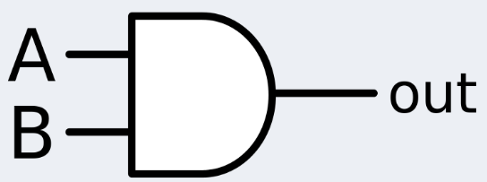

**Truth Table:**

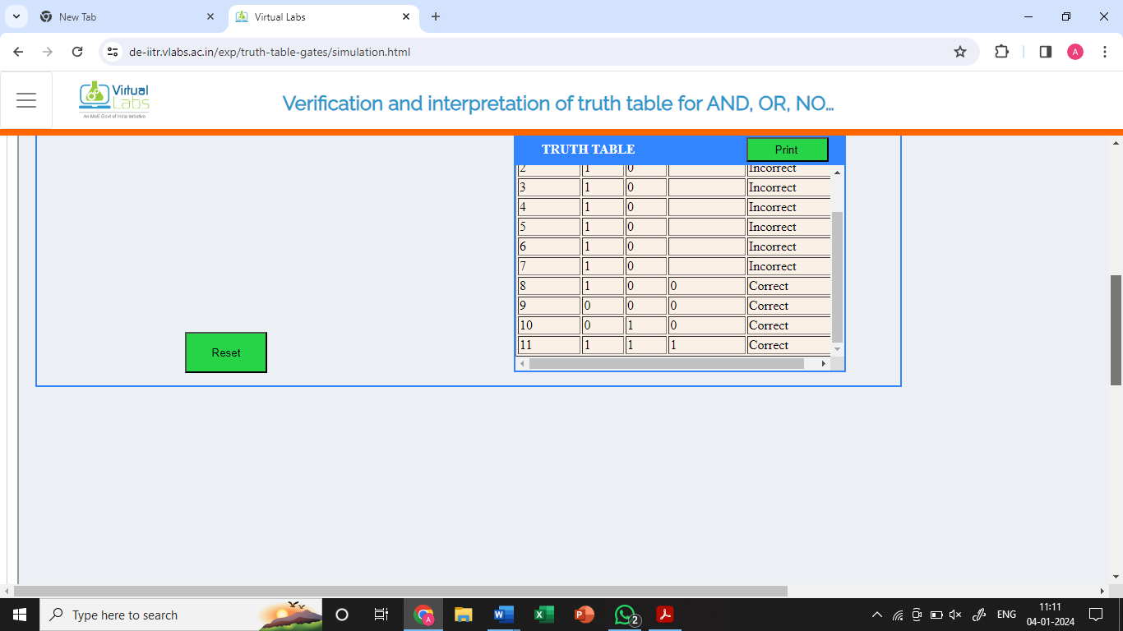

1. **OR Gate:** The OR gate gets its name from behaving like the logical inclusive "or." The output is true if one or both of the inputs are true. If both inputs are false, then the output is false. In other words, for the output to be 1, at least one input must be

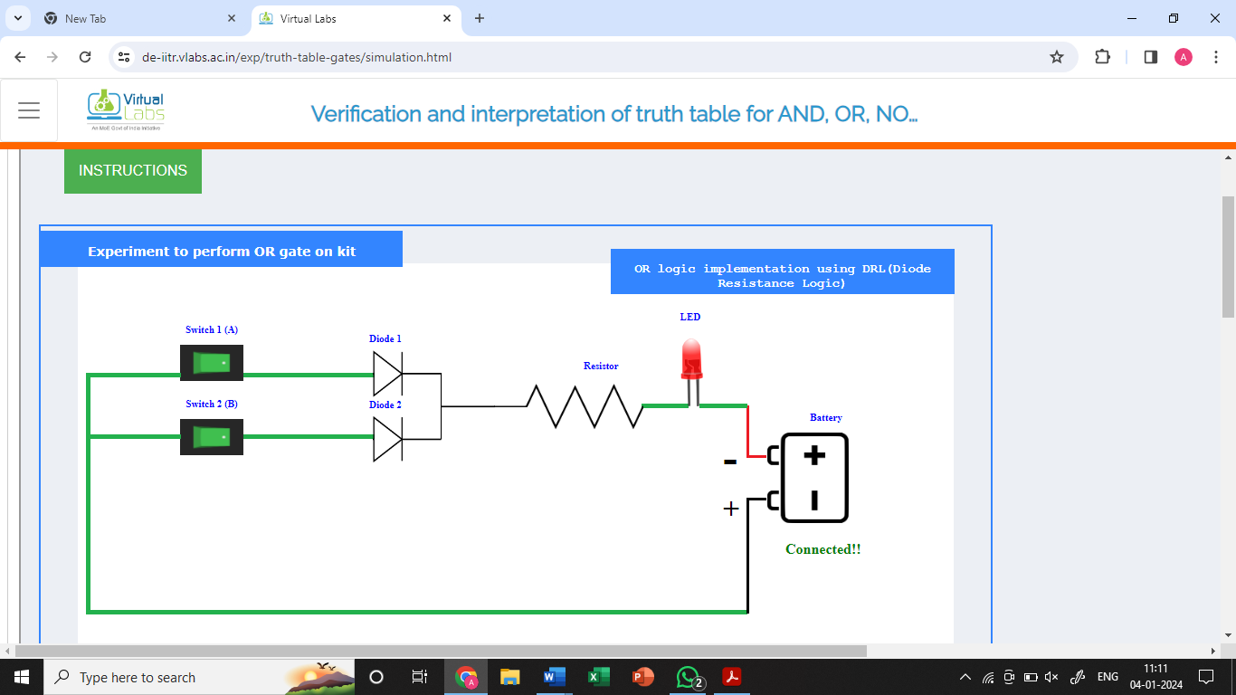**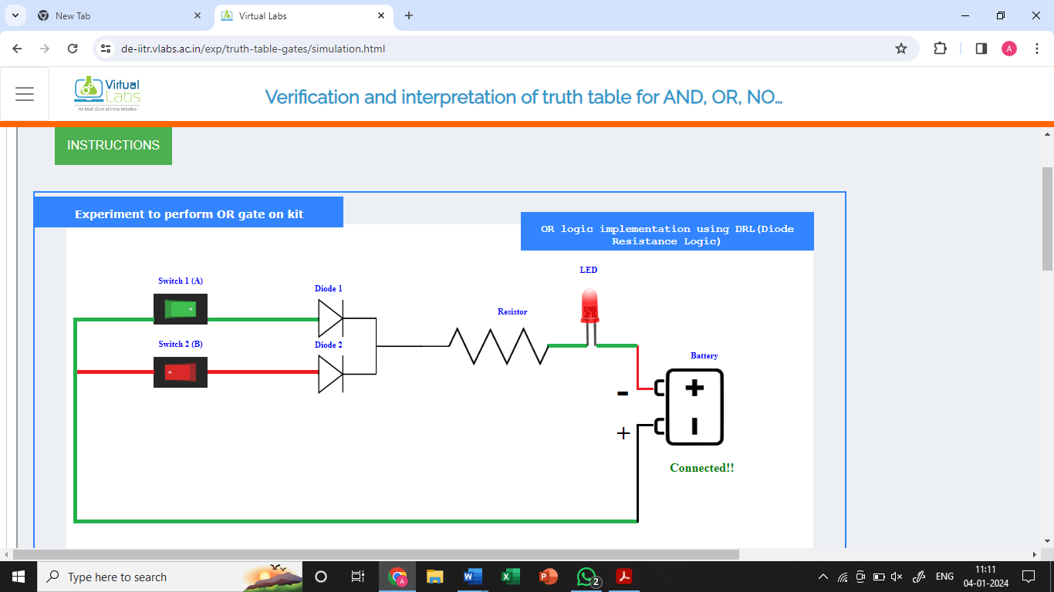Circuit Diagram**

**Symbol**

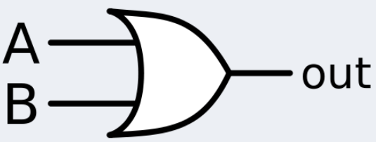

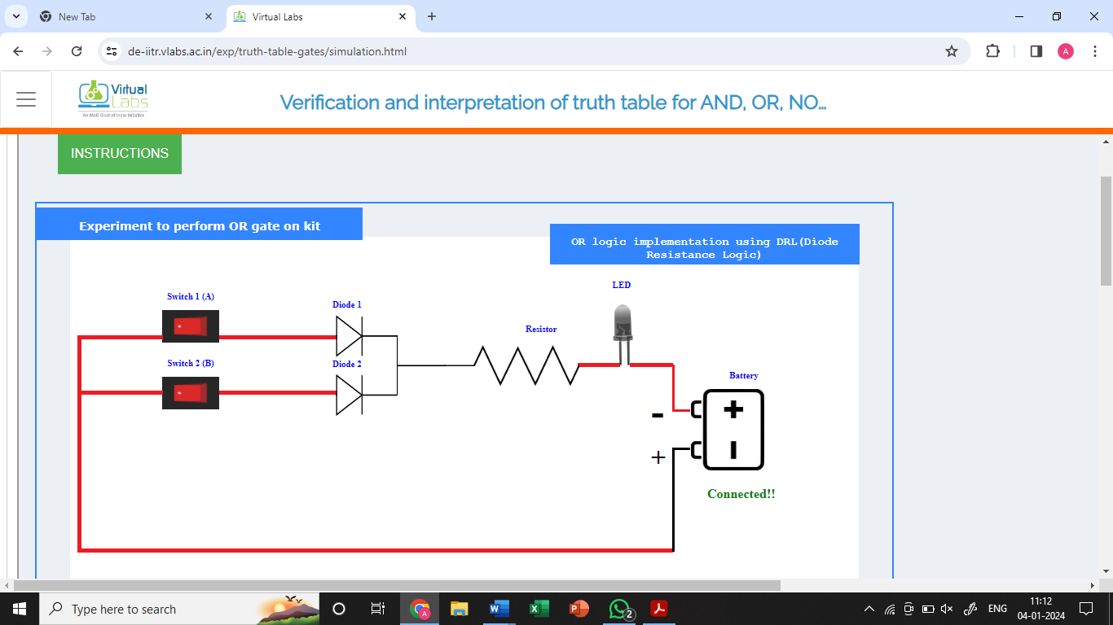

**Truth Table**

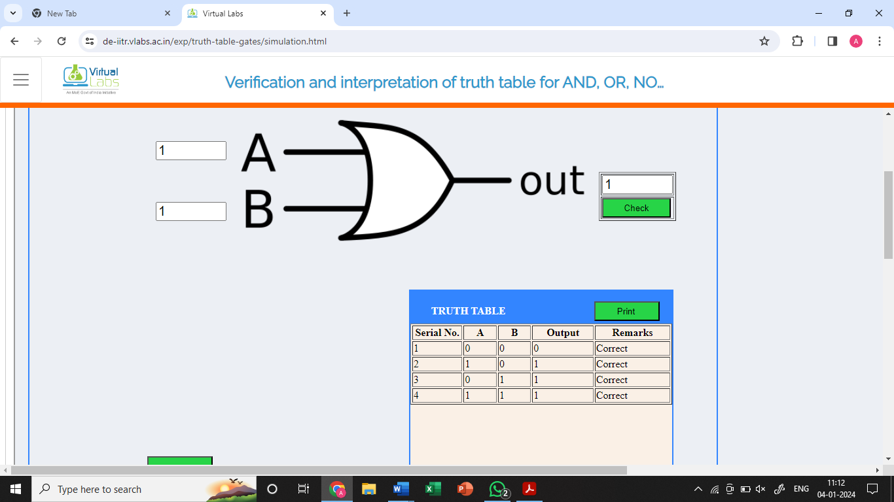

1. **NOT Gate:** A logical inverter, sometimes called a NOT gate to differentiate it from other types of electronic inverter devices, has only one input. A NOT gate reverses the logic state. If the input is 1, then the output is 0. If the input is 0, then the output is 1.

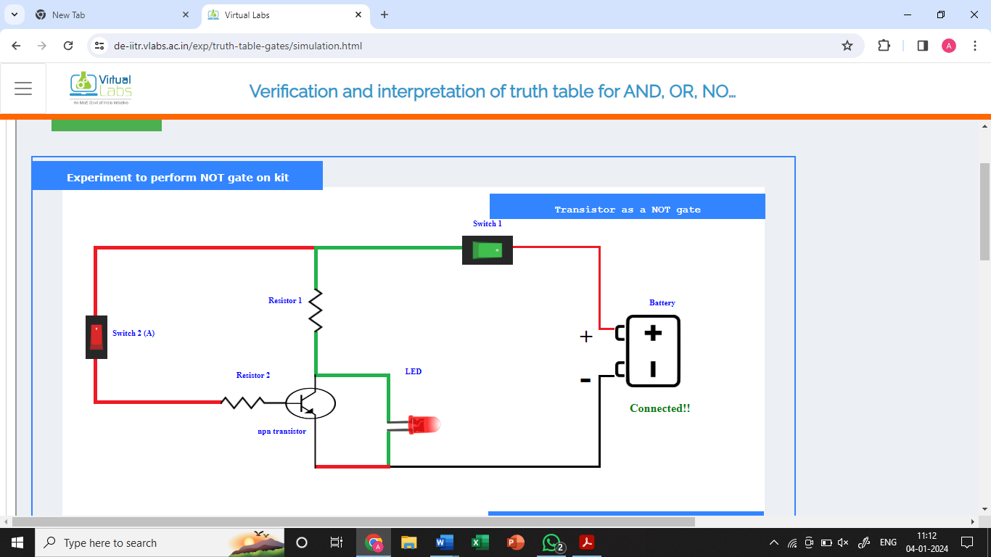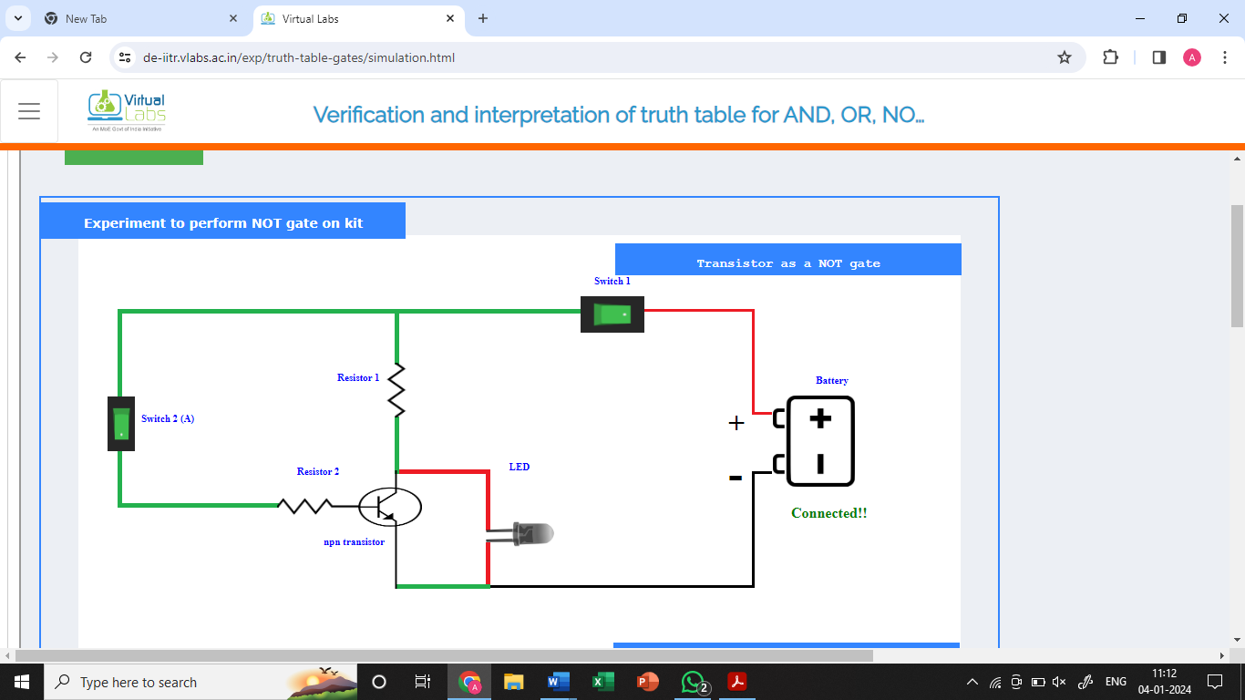**Circuit Diagram**

**Symbol**

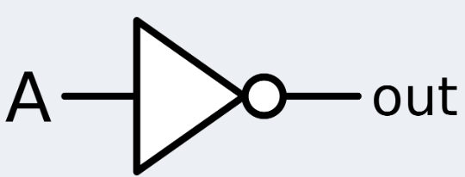

**Truth Table**

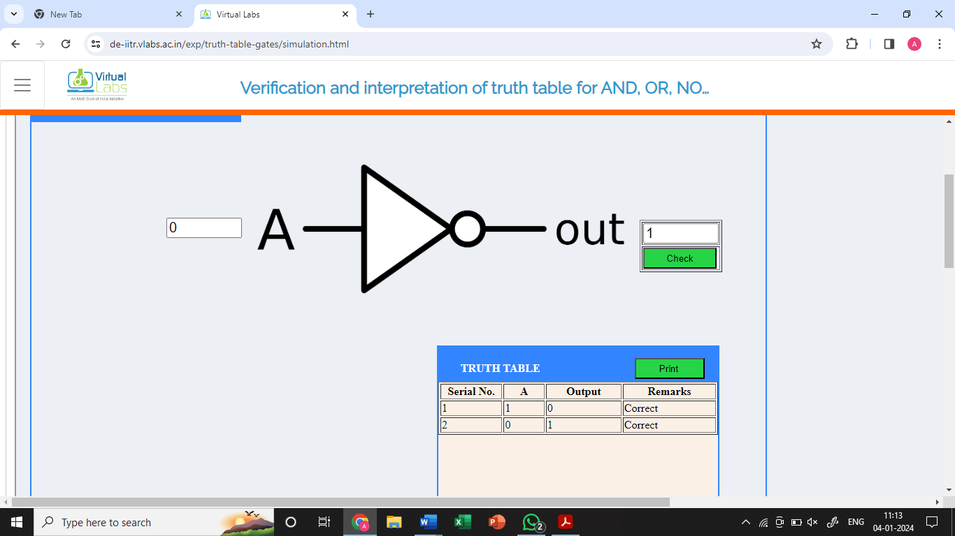

1. **NAND Gate:** The NAND (Negated AND) gate operates as an AND gate followed by a NOT gate. It acts in the manner of the logical operation "and" followed by negation. The output is false if both inputs are true. Otherwise, the output is true. Another way to visualize it is that a NAND gate inverts the output of an AND gate. The NAND gate symbol is an AND gate with the circle of a NOT gate at the output

**Symbol**

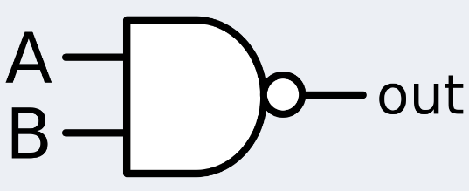

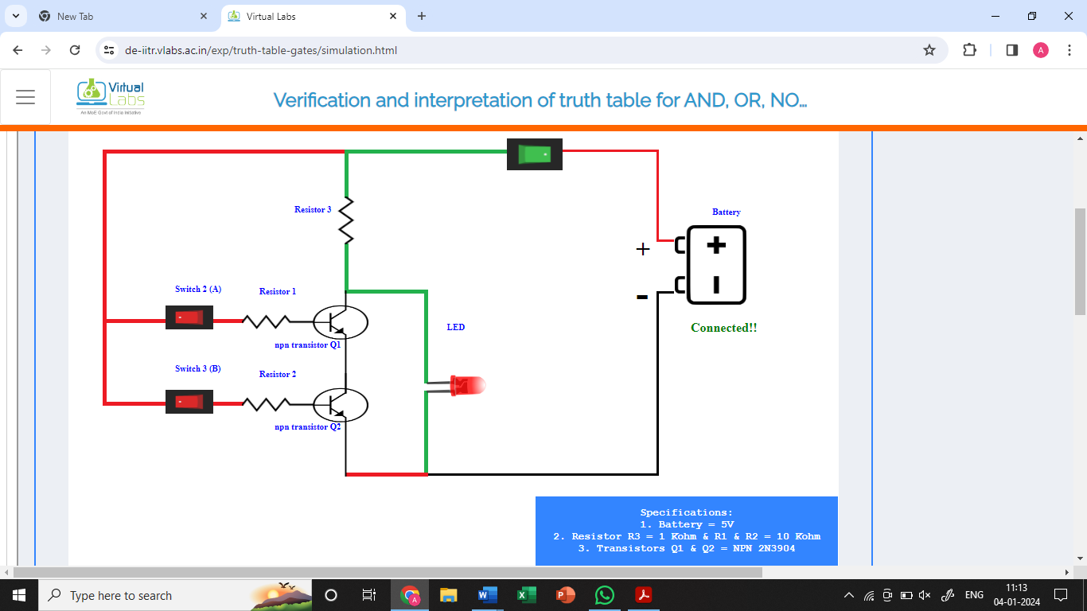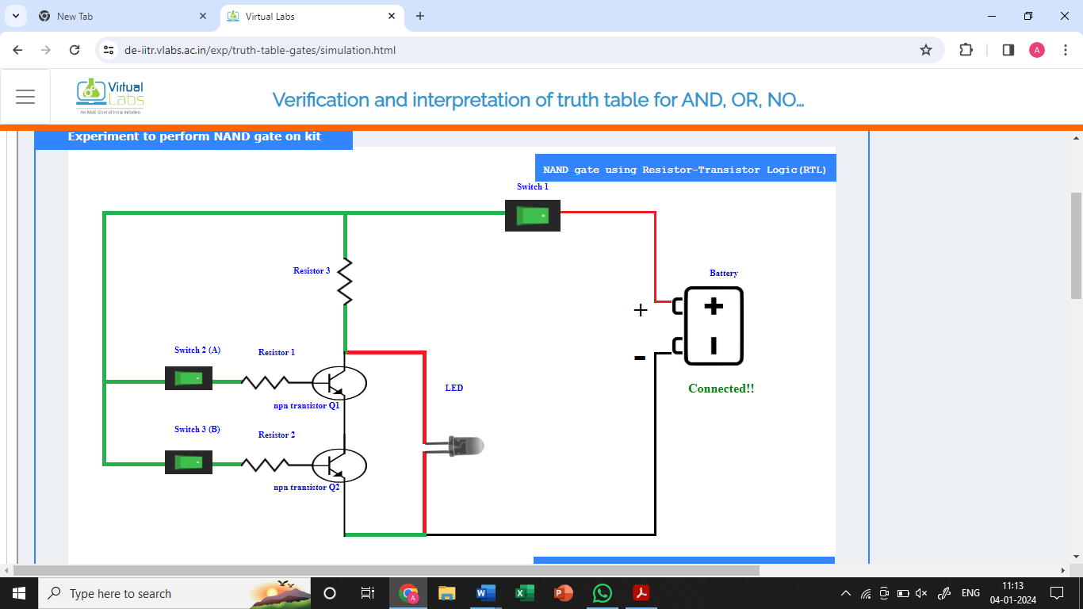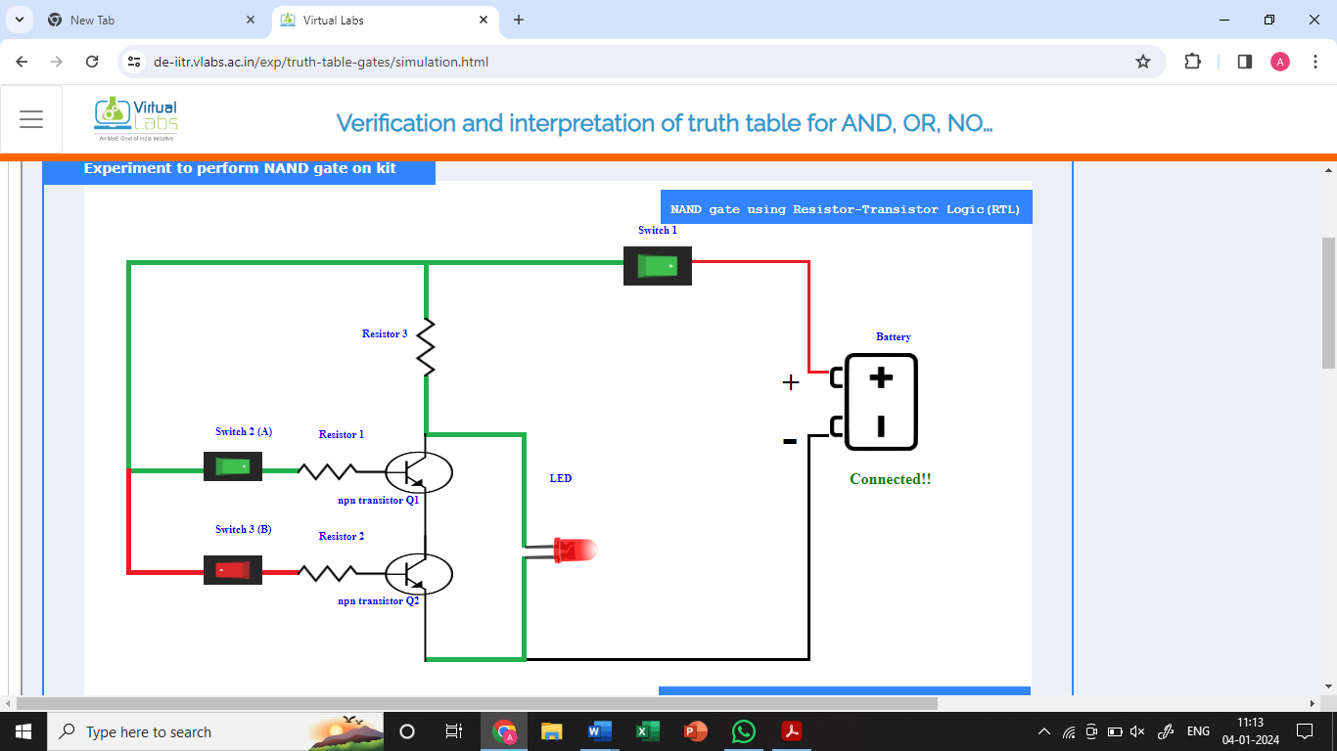**Truth Table**

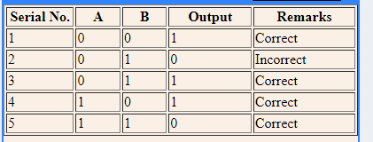

1. **NOR gate:** The NOR (NOT OR) gate is a combination OR gate followed by an inverter. Its output is true if both inputs are false. Otherwise, the output is false.

**Symbol**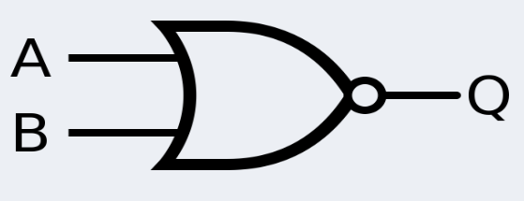

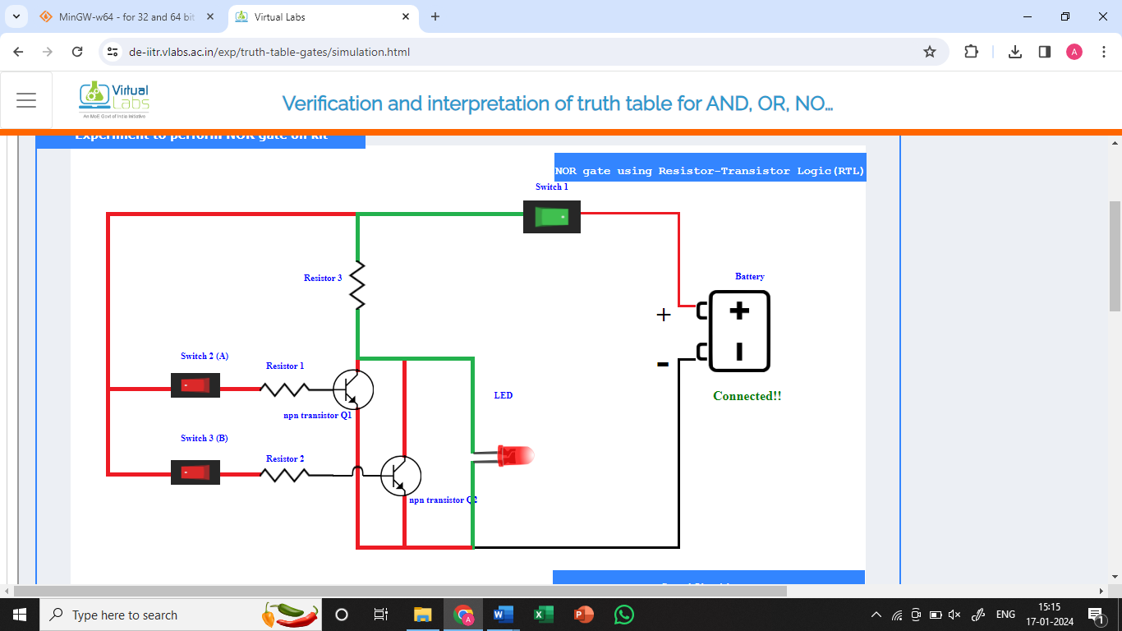

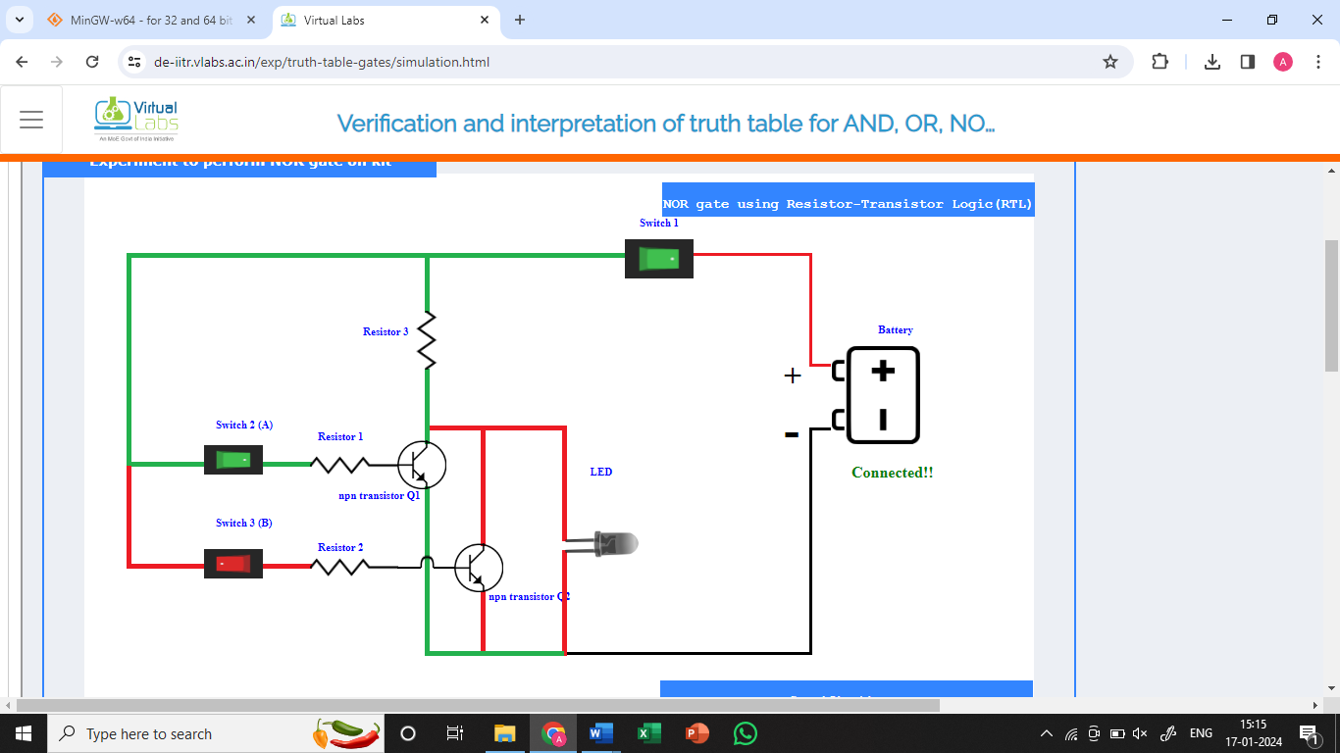

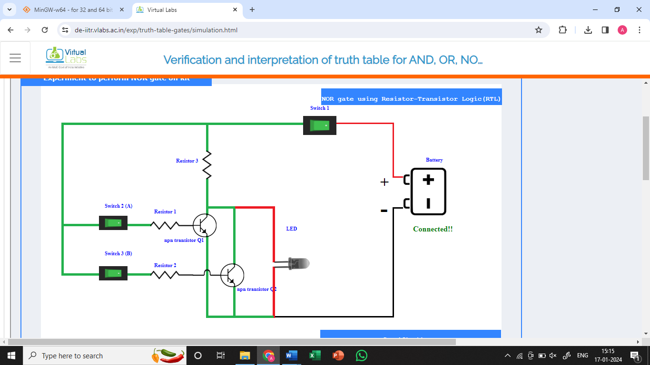

**Truth Table**

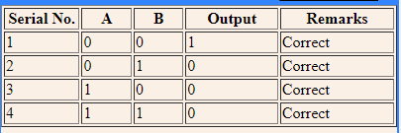

1. **XOR:** The XOR (exclusive-OR) gate acts in the same way as the logical "either/or." The output is true if either, but not both, of the inputs are true. The output is false if both inputs are "false" or if both inputs are true. Similarly, the output is 1 if the inputs are different but 0 if the inputs are the same.

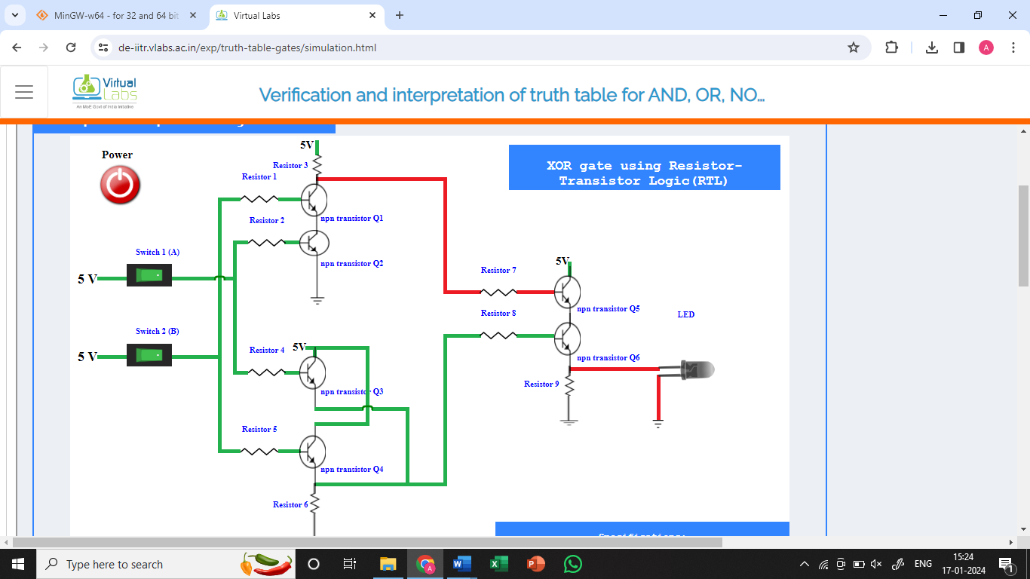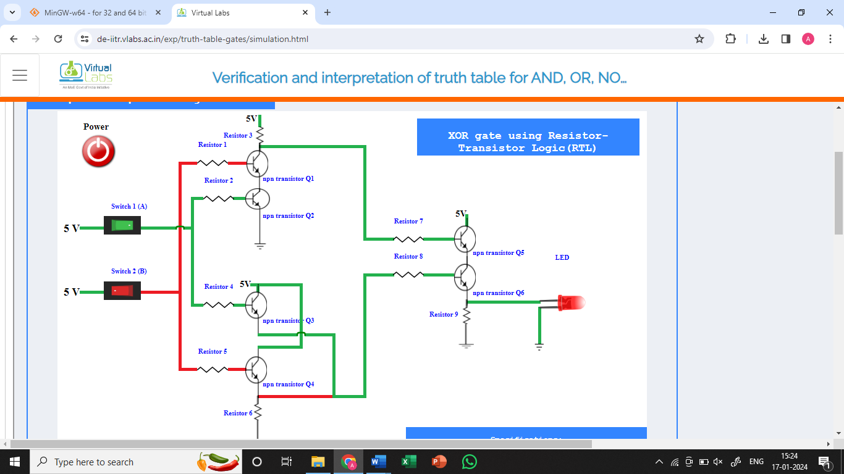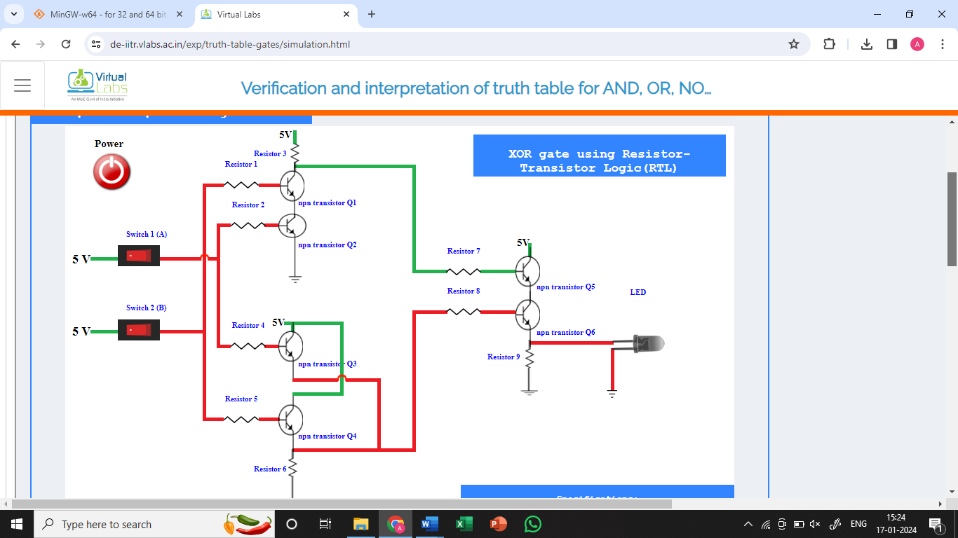

**Symbol**

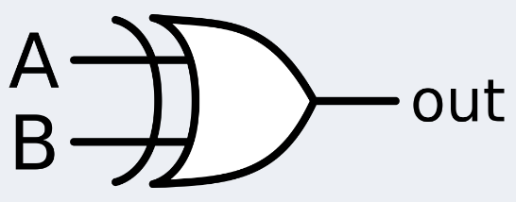

**Truth table**

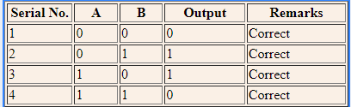

1. 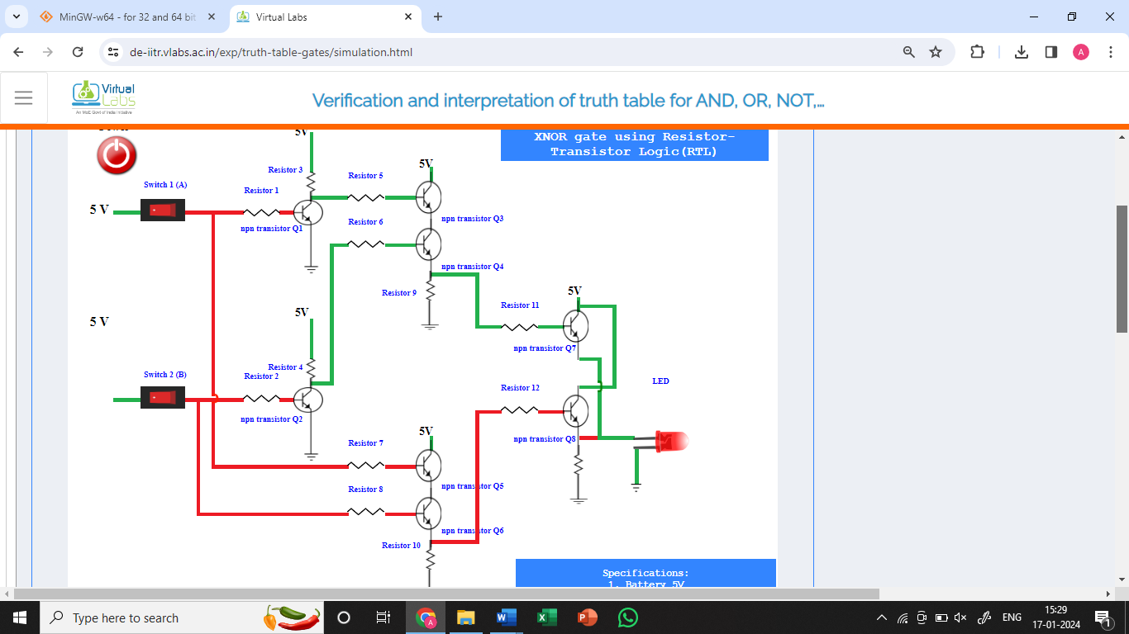**X-NOR gate:** The XNOR (exclusive-NOR) gate is a combination of an XOR gate followed by an inverter. Its output is true if the inputs are the same and false if the inputs are different.

**Symbol**

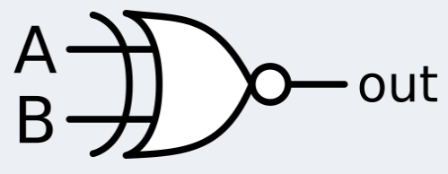

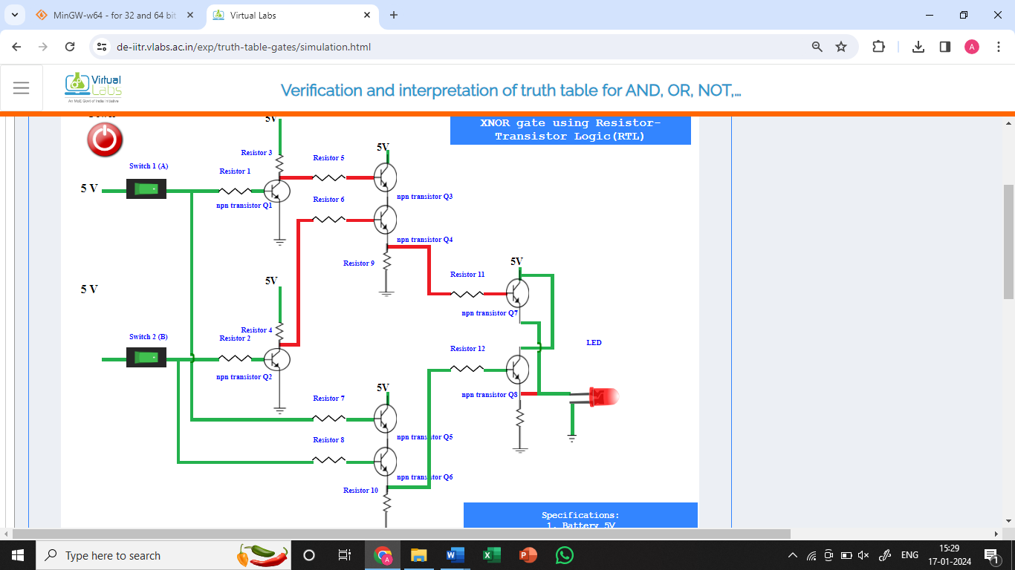

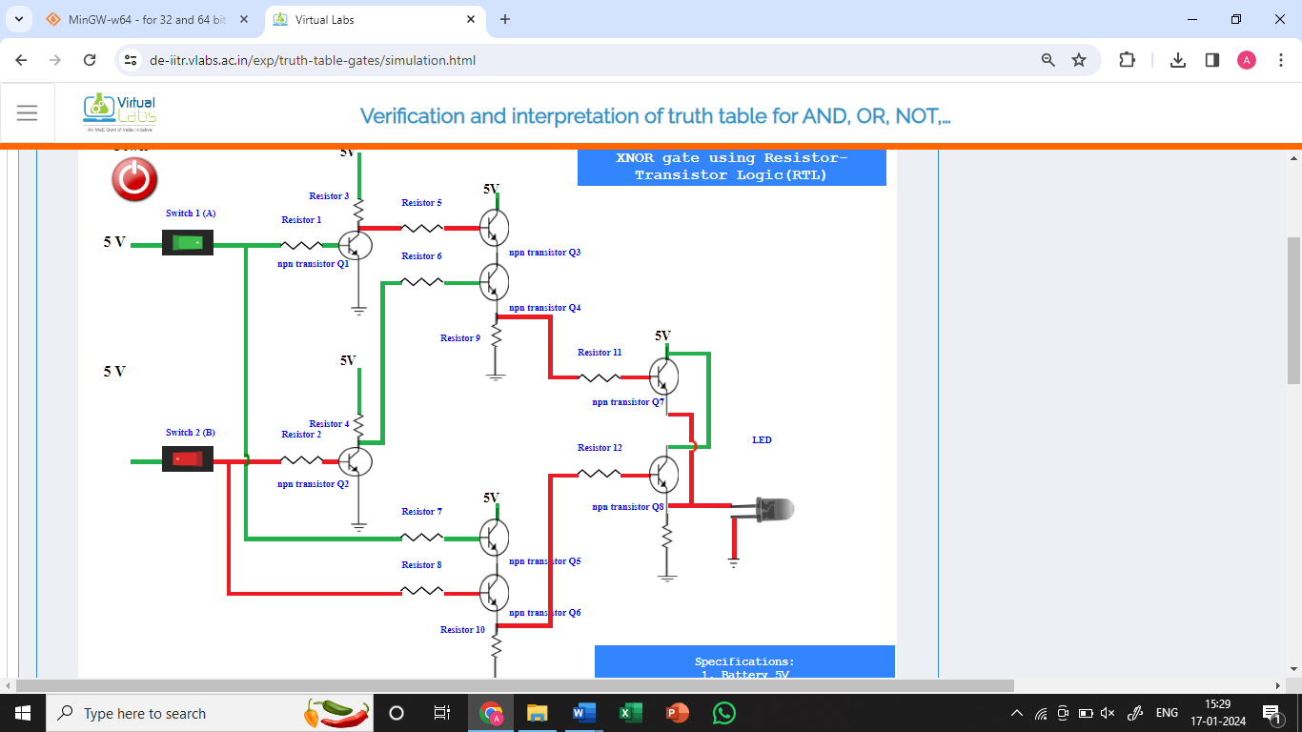

**Truth table**

