# **Bansilal Ramnath Agarwal Charitable Trust’s**

**Vishwakarma Institute of Technology, Pune-37**

*(An Autonomous Institute of Savitribai Phule Pune University)*

|  |  |
| --- | --- |
|  |  |
|  |  |

**Department of Artificial Intelligence and Data Science**

|  |  |
| --- | --- |
| **Division** | AI-A |
| **Batch** | 1 |
| **GR-no** | 12211542 |
| **Roll No.** | 07 |
| **Name** | Anish Naphade |
| **Subject** | Digital Electronics and Microprocessor |

**TITLE**: **Code converters BCD to Excess-3 using logical gates and vice-versa.**

What is BCD?

In binary-coded decimal, each digit in a decimal base 10 number is represented as a group of four binary digits, or bits. Any base 10 number or digit can be represented in binary notation using binary-coded decimal.

What is Excess-3?

The excess-3 code (or XS3) is a non-weighted code used to express code used to express decimal numbers. It is a self-complementary binary coded decimal (**BCD**) code and numerical system which has biased representation. It is particularly significant for arithmetic operations as it overcomes shortcoming encountered while using 8421 (**BCD code to add 2 decimal digits**) whose sum exceeds 9. Excess-3 arithmetic uses different algorithm than normal non-biased BCD or binary **Positional Number System**.

**BCD to Excess 3:**

Truth table for conversion is given. X is don’t care condition.

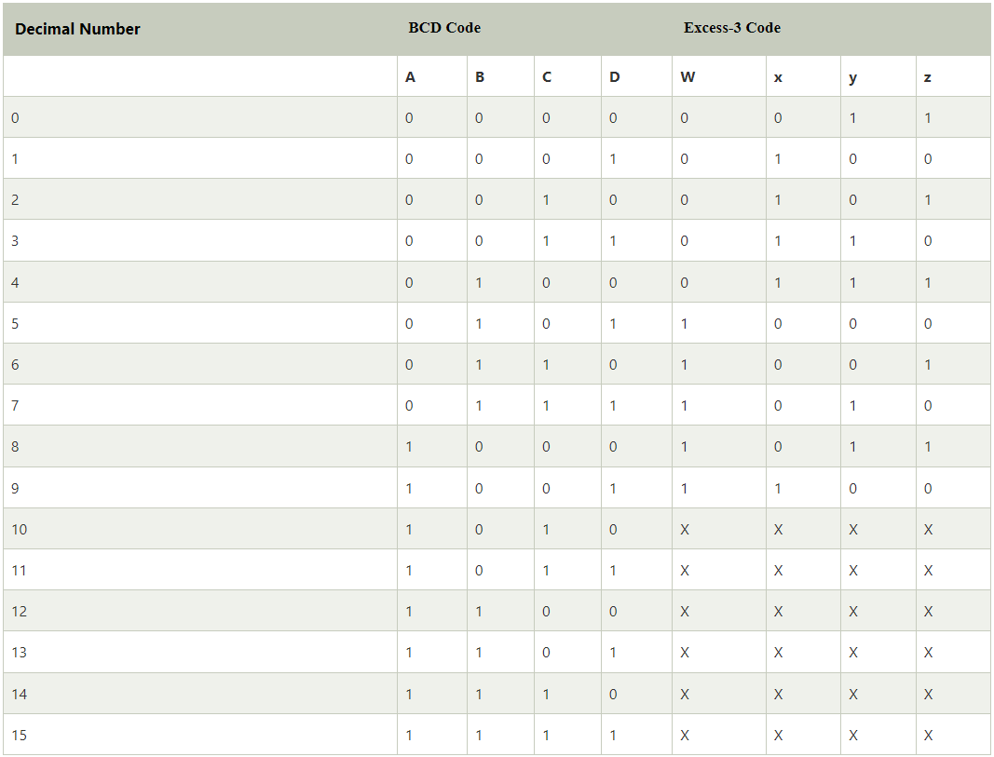

K-map :

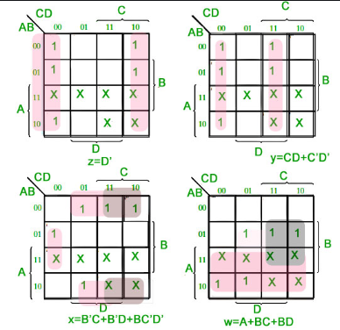

w=A+BC+BD

x=B’C’+B’C’+BC’D’

y=CD+C’D’

z=D’

These are the output expressions of BCD to Excess 3 we got from K-map .

Circuit diagram of BCD to excess 3: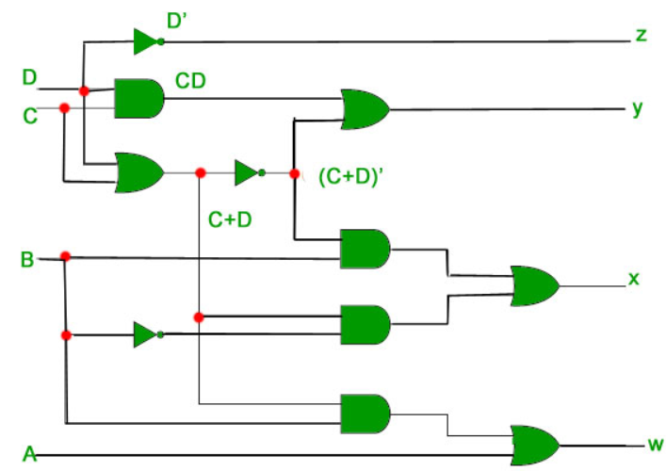

**Conclusion:** In this conversion we are just adding 3 to existing BCD.

For example, the excess-3 code for 3(0011) is 0110, and to find the excess-3 code of the complement of 3, we just need to find the 1’s complement of 0110 -> 1001, which is also the excess-3 code for the 9’s complement of 3 -> (9-3) = 6.

**Excess 3 to BCD:**

Truth table for conversion:

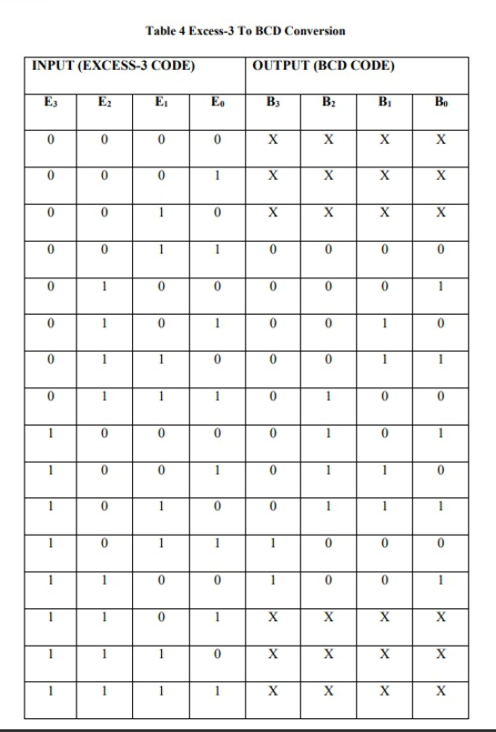

**K-map for D:**

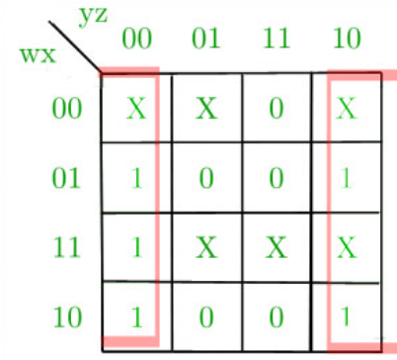

**K-map for C:**

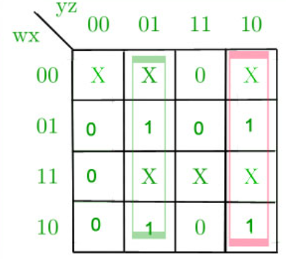

**K-map for B:**

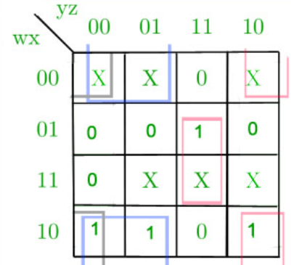

**K-map for A:**

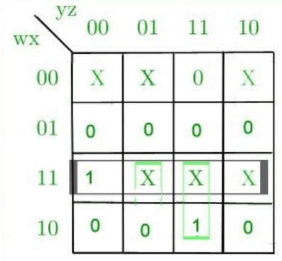

**Corresponding minimized expression for Excess-3 code bits:**

A= wx + wyz

B=x’y’ + x’z’ + xyz

C=y’z + yz’

D=z’

**Corresponding digital circuit:**

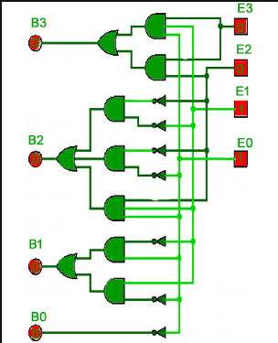

**Conclusion:**

Excess – 3 Code To BCD Conversion:

The 4 bit Excess-3 coded digit can be converted into BCD code by subtracting decimal value 3 i.e. 0011 from 4 bit Excess-3 digit.

e.g. Convert 4-bit Excess-3 value 0101 to equivalent BCD code.

0101-0011= 0010- BCD for 2