# **Bansilal Ramnath Agarwal Charitable Trust’s**

**Vishwakarma Institute of Technology, Pune-37**

*(An Autonomous Institute of Savitribai Phule Pune University)*

|  |  |
| --- | --- |
|  |  |
|  |  |

**Department of Artificial Intelligence and Data Science**

|  |  |
| --- | --- |
| **Division** | AI-A |
| **Batch** | 1 |
| **GR-no** | 12211542 |
| **Roll No.** | 07 |
| **Name** | Anish Naphade |
| **Subject** | Digital Electronics and Microprocessor |

**TITLE**: Code converters BCD to Excess-3 using logical gates and vice-versa.

Binary-Coded Decimal (BCD):

- BCD is a binary representation of decimal digits.

- Each decimal digit is represented by its 4-bit binary equivalent.

- The BCD representation of decimal numbers 0 to 9 is straightforward:

0: 0000

1: 0001

...

9: 1001

Excess-3 (XS-3) Code:

- Excess-3 is derived from BCD by adding 3 to each 4-bit BCD representation.

- It is used to simplify arithmetic operations in digital systems.

Conversion Steps:

1. Take each BCD digit.

2. Add 3 to the 4-bit binary representation of the BCD digit.

Advantages of Excess-3:

- Easier arithmetic operations in digital circuits.

- Simplifies addition and subtraction operations.

- Provides a certain level of error detection and correction.

Representation:

- BCD: 0 to 9 is represented as 0000 to 1001.

- Excess-3: Derived from BCD by adding 3 to each 4-bit BCD representation.

Usage:

- Commonly used in digital systems, especially for arithmetic operations involving decimal numbers.

Example (for illustration):

- BCD representation of 0101 (decimal 5) is 0101.

- Excess-3 representation is obtained by adding 3 to each bit: 1010.

Repeat the conversion steps for each BCD digit in a multi-digit number.

**BCD to Excess 3:**

Truth table for conversion is given. X is don’t care condition.

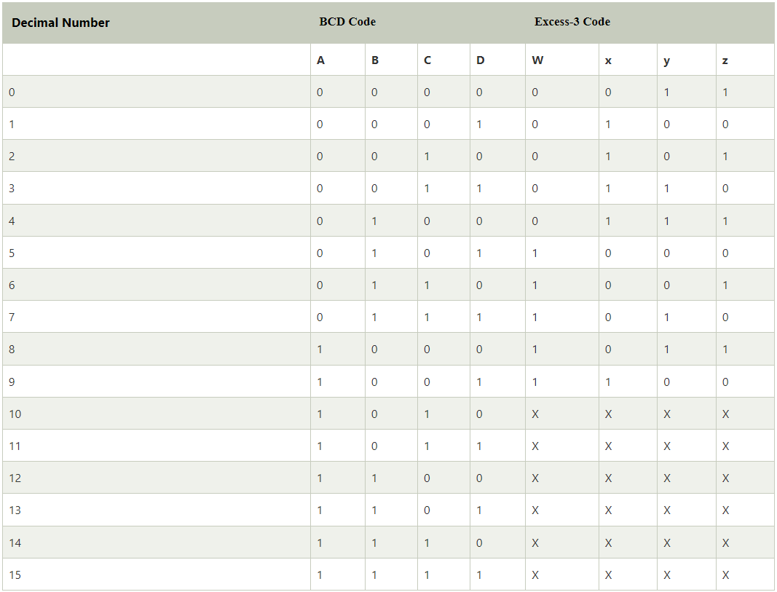

K-map :

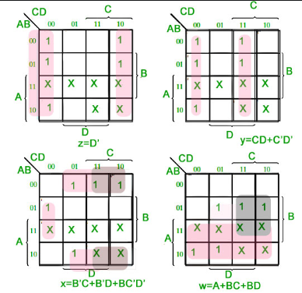

w=A+BC+BD

x=B’C’+B’C’+BC’D’

y=CD+C’D’

z=D’

These are the output expressions of BCD to Excess 3 we got from K-map .

Circuit diagram of BCD to excess 3: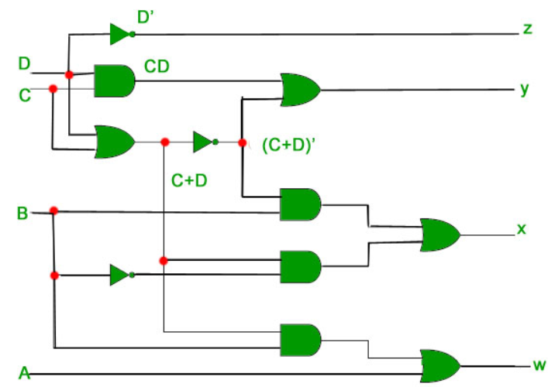

**Excess 3 to BCD:**

Excess-3 (XS-3) to Binary-Coded Decimal (BCD) conversion involves subtracting 3 from each 4-bit XS-3 representation to obtain the corresponding BCD representation. Here's the theory:

**Excess-3 (XS-3) Code:**

- XS-3 is derived from BCD by adding 3 to each 4-bit BCD representation.

- Each decimal digit is represented by its 4-bit binary equivalent plus 3.

**Binary-Coded Decimal (BCD):**

- BCD is a binary representation of decimal digits.

- Each decimal digit is represented by its 4-bit binary equivalent.

**Conversion Steps:**

1. Take each XS-3 digit.

2. Subtract 3 from the 4-bit binary representation of the XS-3 digit.

**Example (for illustration):**

Let's convert the XS-3 number 1010 to BCD.

1. XS-3 representation: 1010

2. Subtract 3 from each bit: 1001 (1010 - 0011 = 1001)

So, the BCD representation of the XS-3 number 1010 is 1001.

Repeat these steps for each XS-3 digit in a multi-digit number.

**Advantages of XS-3 to BCD Conversion:**

- Easier conversion back to BCD.

- Simplifies arithmetic operations in digital systems that use BCD.

Keep in mind that XS-3 to BCD conversion is often performed in digital systems, especially when dealing with arithmetic operations involving decimal numbers.

Truth table for conversion:

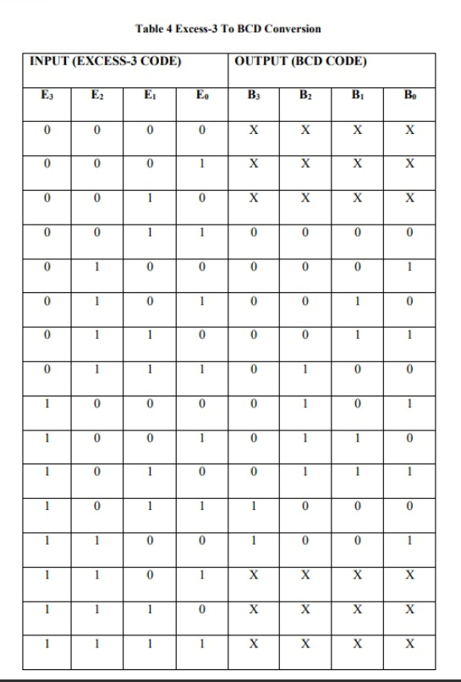

**K-map for D:**

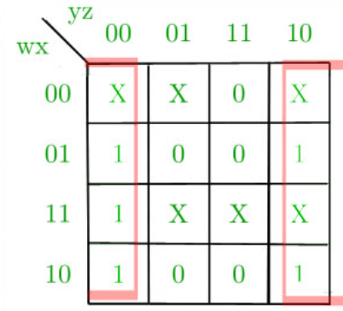

**K-map for C:**

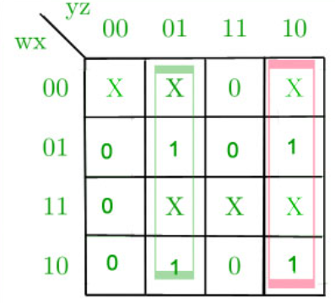

**K-map for B:**

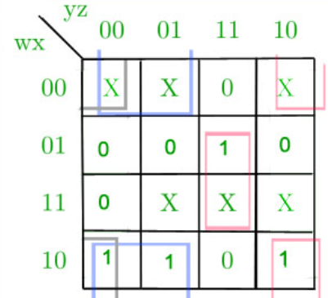

**K-map for A:**

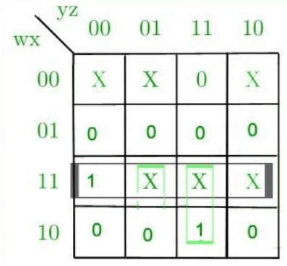

**Corresponding minimized expression for Excess-3 code bits:**

A= wx + wyz

B=x’y’ + x’z’ + xyz

C=y’z + yz’

D=z’

**Corresponding digital circuit:**

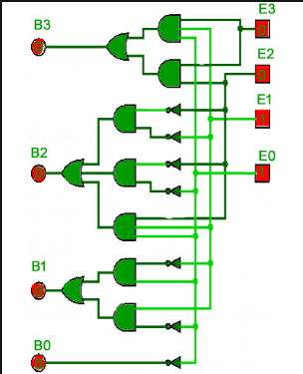

**Conclusion:**

The conversion between Excess-3 (XS-3) and Binary-Coded Decimal (BCD) serves a fundamental role in digital systems, particularly in the context of decimal arithmetic. Here's a concise summary without bullet points:

**BCD to Excess-3 Conversion:**

The conversion from BCD to XS-3 is achieved by adding 3 to each 4-bit BCD representation. This transformation facilitates easier arithmetic operations in digital circuits, simplifies addition and subtraction processes, and provides a certain level of error detection and correction. This conversion is widely used in digital systems, particularly in scenarios requiring efficient manipulation of decimal numbers.

**Excess-3 to BCD Conversion:**

Converting XS-3 to BCD involves subtracting 3 from each 4-bit XS-3 representation. This process is advantageous as it simplifies the conversion back to BCD and aids in arithmetic operations in digital systems dealing with decimal numbers. Commonly employed in various digital applications where decimal arithmetic is essential.