ASSIGENMENT-3

# **Bansilal Ramnath Agarwal Charitable Trust’s**

**Vishwakarma Institute of Technology, Pune-37**

*(An Autonomous Institute of Savitribai Phule Pune University)*

|  |  |
| --- | --- |
|  |  |
|  |  |

**Department of Artificial Intelligence and Data Science**

|  |  |
| --- | --- |
| **Division** | AI-A |
| **Batch** | 1 |
| **GR-no** | 12211542 |
| **Roll No.** | 07 |
| **Name** | Anish Naphade |
| **Subject** | Digital Electronics and Microprocessor |

Objective: To learn different techniques of designing multiplexer.

Problem statement: Design and realization of Boolean expressions for suitable combination logic using MUX 74151, IC 7404, UC7432, patch cords , +5V power supply.

Multiplexer:

1. What is multiplexer?

->A multiplexer is a combinational circuit that has 2n input lines and a single output line. Simply , the multiplexer is a multi-input and single-output combinational circuit. The binary information is received from the input lines and directed to the output line. On the basis of the values of the selection lines, one of these data inputs will be connected to the output.

Multiplexers that are built from transistors and relays are termed as analog multiplexers which are used in analog applications and multiplexers that are built from logic gate termed as digital multiplexers which are used in digital applications. The inverse of a multiplexer is known as a demultiplexer.

1. Necessity of multiplexer?

* In most of the electronics systems, digital data is available on more than one lines. It is necessary to route this data over a single line.
* It selects one of the many I/P at a time.
* MUX improves the reliability of digital system because it reduces the number of external wire connection.

1. Enlist significance and advantages of multiplexer.

* It does not need k-map and logic simplification.
* It IC package count is minimized.
* It simplifies the logic design.
* It reduces the complexity and cost.

1. Application of MUX

* Data selector to select one out of many data I/P.
* In data acquisition system.
* In the D/A converter.

1. Multiplexer tree

* It is nothing but construction of more number of lines using less number of lines.
* It is possible to expand the range of inputs for MUX’s beyond the available range in the integrated circuits. This can be accomplished b interconnecting several MUX’s.

8:1 MUX:

The block diagram of 8:1 and bits as shown. It has eight data I/P and one enable input, three select lines and one O/P.

**|8:1 MULTIPLEXER:**

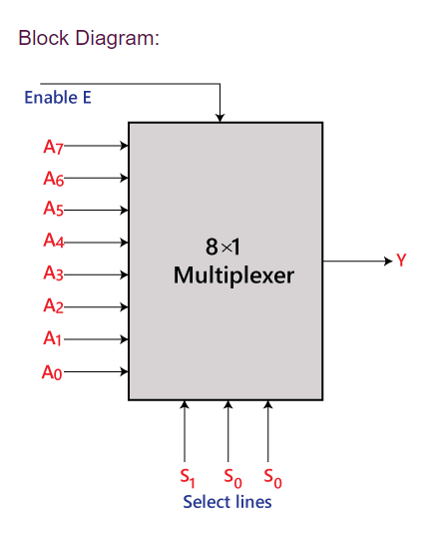

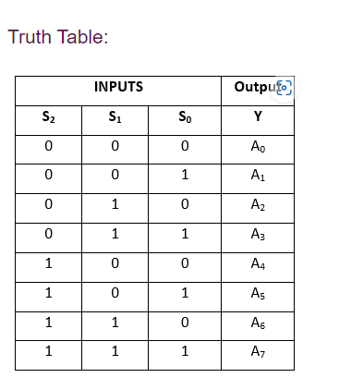

Logical circuit of the above expression is given

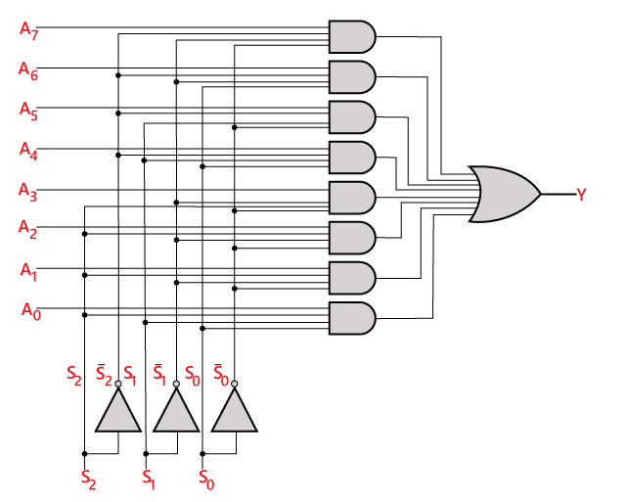

**16:1 MULTIPLEXER**

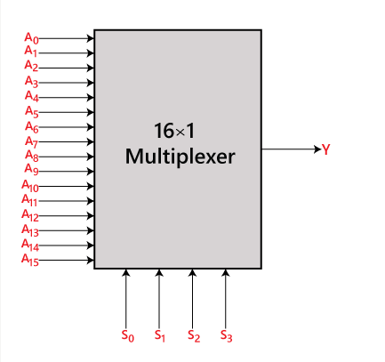

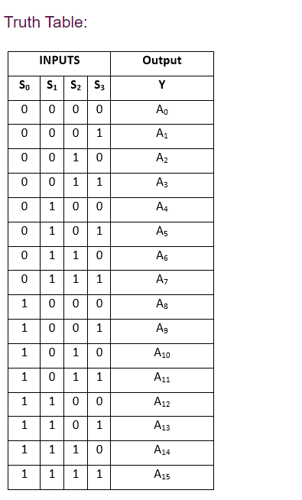

Logical circuit of the above expression is givern below

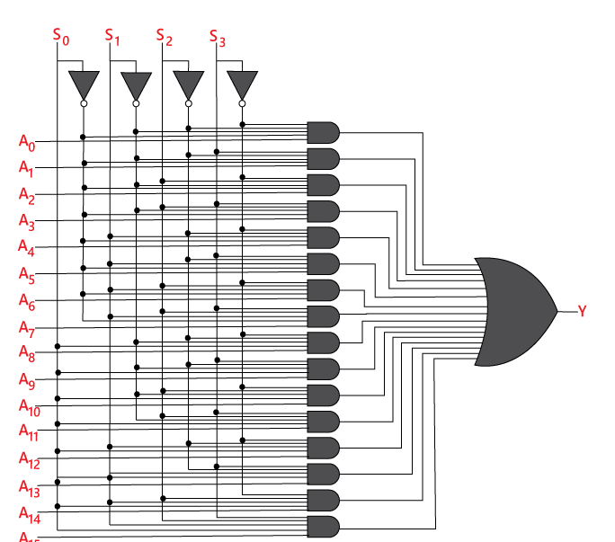

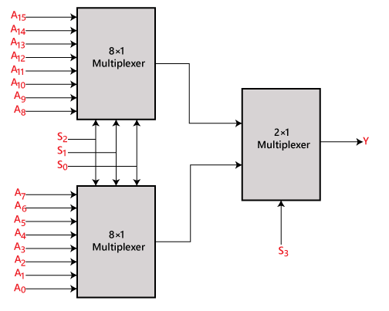

**De-Multiplexer:**

A De-multiplexer is a combinational circuit that has only 1 input line and 2N output lines. Simply, the multiplexer is a single-input and multi-output combinational circuit. The information is received from the single input lines and directed to the output line. On the basis of the values of the selection lines, the input will be connected to one of these outputs. De-multiplexer is opposite to the multiplexer

1 x 8 demultiplexer:

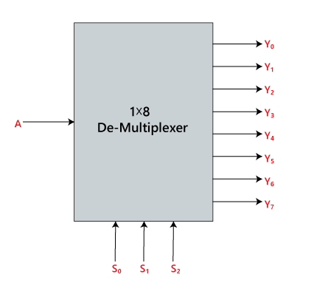

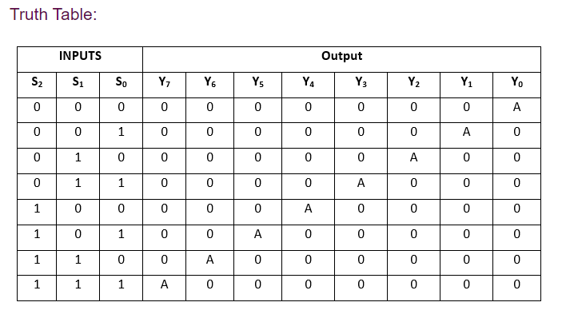

Logical circuit of the above expression is given below.

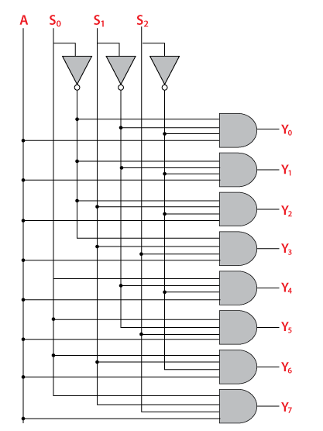

**1 x 16 De-Multiplexer:**

n 1×16 de-multiplexer, there are total of 16 outputs, i.e., Y0, Y1, …, Y16, 4 selection lines, i.e., S0, S1, S2, and S3 and single input, i.e., A. On the basis of the combination of inputs which are present at the selection lines S0, S1, and S2, the input will be connected to one of these outputs. The block diagram and the truth table of the 1**×**16 de-multiplexer are given below.

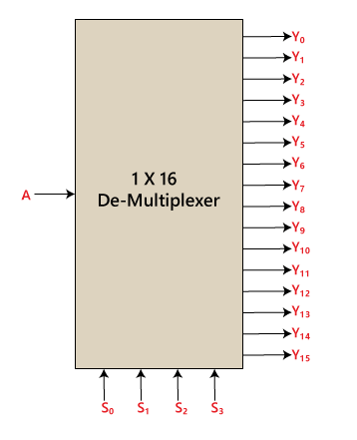

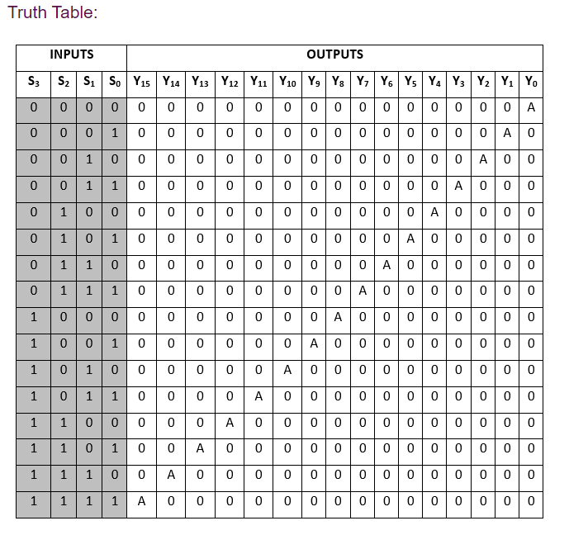

Logical circuit of the above expression is given below:

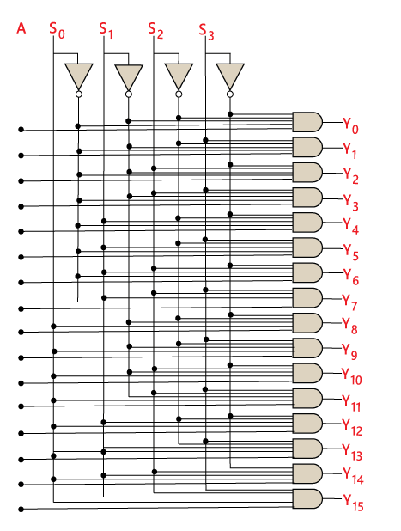

**1 x 16 De-Multiplexer using 1 x 8 and 1 x2 De-Multiplexer:**

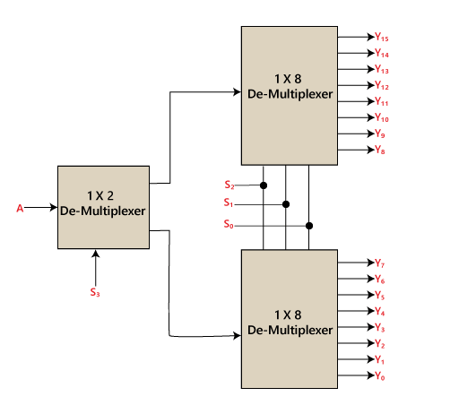

**Conclusion:**

**1) Understanding of how multiplexers and demultiplexers function**

**and how they can be used to manipulate data or signals in digital**

**circuits.**

**2) Learnt about how multiplexers can route data from multiple**

**sources to a single destination**

**3) And how demultiplexers can distribute data from one source to**

**multiple destinations.**

**4) Gained Knowledge about managing complexity in digital circuit**

**design.**