Artificial Intelligence Based Interpretation of Radiographic Film

# Input Data

The Dataset consisted of 11 high resolution DCM format images.

# Pre-processing

# Due to scarcity of data, the input images were augmented 5 times to get a total of 55 images. The augmentations include rotation, flip, histogram equalisation, shift and zoom.

The data was then manually labelled using ‘LabelImg’ software to detect one class, i.e. cracks in the images.

# Object Detection

YOLOv5 is a cutting-edge object detection algorithm that combines speed and accuracy for real-time object detection tasks. With its streamlined architecture and advanced techniques, YOLOv5 delivers impressive performance across a wide range of applications. It offers various model sizes to balance speed and precision, making it adaptable to different hardware and requirements. The ability to customize and fine-tune models on specific datasets further enhances its versatility. YOLOv5 has gained significant popularity in the computer vision community, thanks to its open-source nature and the continuous improvements contributed by its active community. Whether it's detecting objects in images or videos, YOLOv5 provides a powerful and efficient solution for object detection tasks.

# Results

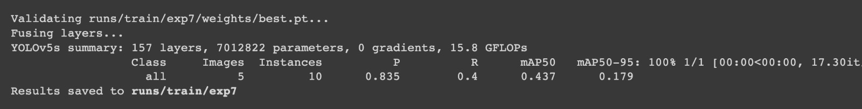The results show a decent mAP score for the threshold of 0.5 i.e. 50% confidence. But show poorer results for thresholds set between 50-90% confidence. To make the inference, threshold was set to 0.3 i.e. 30% confidence to get optimal results on the given dataset. Due to this some of the images show multiple bounding boxes of different confidence levels. This could be eradicated using non maximum suppression.

