Objective

The main objective of this simulation was to find the best possible path for the Try Robot

To catch the rugby ball passed by the Passing Robot and to place the ball in a particular Try Spot so that it requires lesser time to traverse.

Simulation solution

The path planning was simulated using Simscape and Simulink from MATLAB.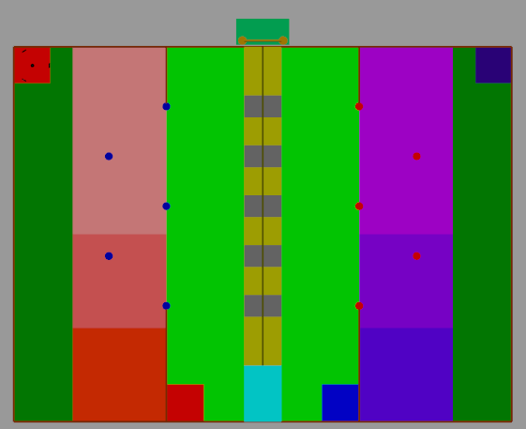

The model of the Arena and the Try robot were completely developed using Simulink in MATLAB using a number of Brick Solid and Rigid Transform blocks.

The mass of the chassis was taken as 2.6 kg and the coefficient of friction between the

ground and the wheels is 0.4.

Rectangular joint was used to provide motion to the try robot by using the actuatures of the rectangular joints 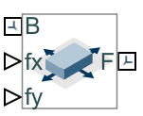

(All the forces and the equations that have been mentioned below are wrt the center of the Bot and not the wheels)

IMPLEMENTATION

For the simulation first the bot was provided with a force only along the negative y direction so that it moves downwards and reaches at the desired position for receiving the rugby ball from the Pass Robot.

TRY SPOT 2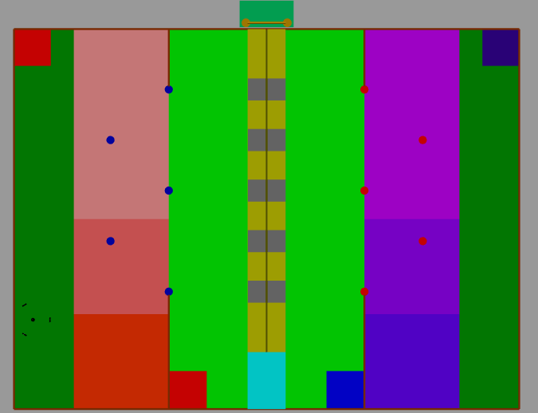

Once the ball is successfully received the bot then moves to Try Spot 2,along a straight line path.

This was done by providing a certain amount of force along the x and y directions in such a way that the resultant of the two forces obtained lies along the required straight line path so that the Try Robot reaches the Try Spot 2 diagonally and then it places the rugby ball in to the spot. Then for the Try Robot to return to its initial catching position same amount of forces were given but in opposite direction.

TRY SPOT 3

Once the try robot returns to its original position and receives the ball for the second time,similar kind of approach as used for Try Spot 2 was used to move the Try robot to Try Spot 3 diagonally and then bring it back again to the original position.

TRY SPOT 4

Once the try robot reaches to its original position and then after receiving the try ball try robot then moves to try spot 4 by following a parabolic path the equation used for the robot to move along the parabolic path is

*y = 2.5 + (3.854(x-0.575))½*

This equation was provided in the f(y) of the rectangular joint and a small force along the x direction was given in the f(x) of the rectangular joint to make sure that the try robot moves properly along the parabolic arc

TRY SPOT 5

Once the try robot reaches to its original position and then after receiving the try ball try robot then moves to try spot 5 by following a parabolic path the equation used for the robot to move along the parabolic path is

*y = 2.5 + (5.2(x-0.575))½*

This equation was provided in the f(y) of the rectangular joint and a small force along the x direction was given in the f(x) of the rectangular joint to make sure that the try robot moves properly along the parabolic arc

STOPPING THE TRY ROBOT AT TRY SPOT POSITIONS 4 & 5

For stopping the ball near the try spots 4 and 5 a brick solid was added close to the positions of the try spot 4 &5 and a new coefficient of friction between the wheels and the brick solid was introduced which was given very high value so that the bot stops at any condition near the try spot 4 & 5 which is the required position.for moving the bot to position 5 the path for try spot 4 was commented and vice versa

CONCLUSION

The best path is when the try robot acquires a diagonal path for try spot 2 &3 and a curved path for try spot 4 & 5