Simulation of the kicking mechanism

Table of Contents

Objectives 1

Rotating Arm Kicking Mechanism 1

Working 2

Simulation parameters 2

Simulation Input 2

Contact Modelling 2

1. Contact model of rugby-plane (ground) contact force: 2

2. Contact model of rugby-tee contact force: 3

3. Contact model of rugby-kicking surface contact force: 3

Determination of contact properties 4

Simulation inputs: 4

Results 5

Conclusions 6

# Objectives

The objectives of this simulation are:

1. Obtain a proof of concept for the proposed rotating-arm kicking mechanism. The mechanism should be able to kick the rugby ball so as to travel 10m horizontally and pass the goal post with a height of 1.5 m or above with minimum off-centering (<= +/- 0.25m)
2. Determine the optimum torque for the above stated projectile motion.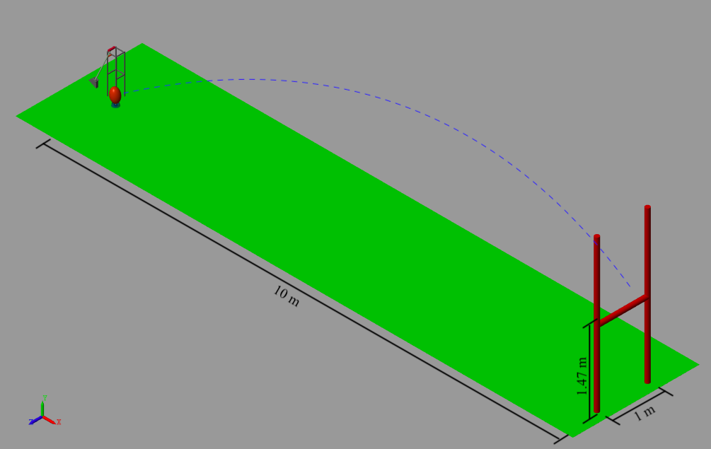

Figure 1:Simulation objective

# Rotating Arm Kicking Mechanism

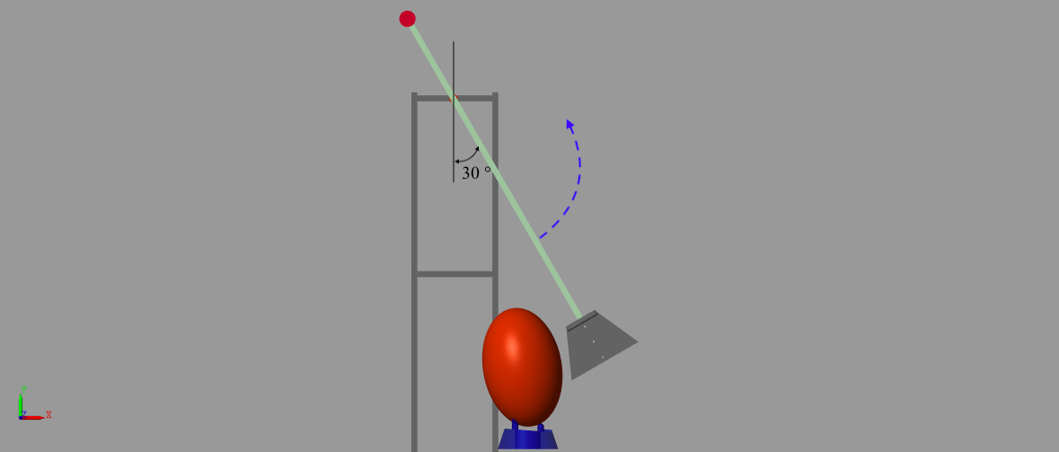 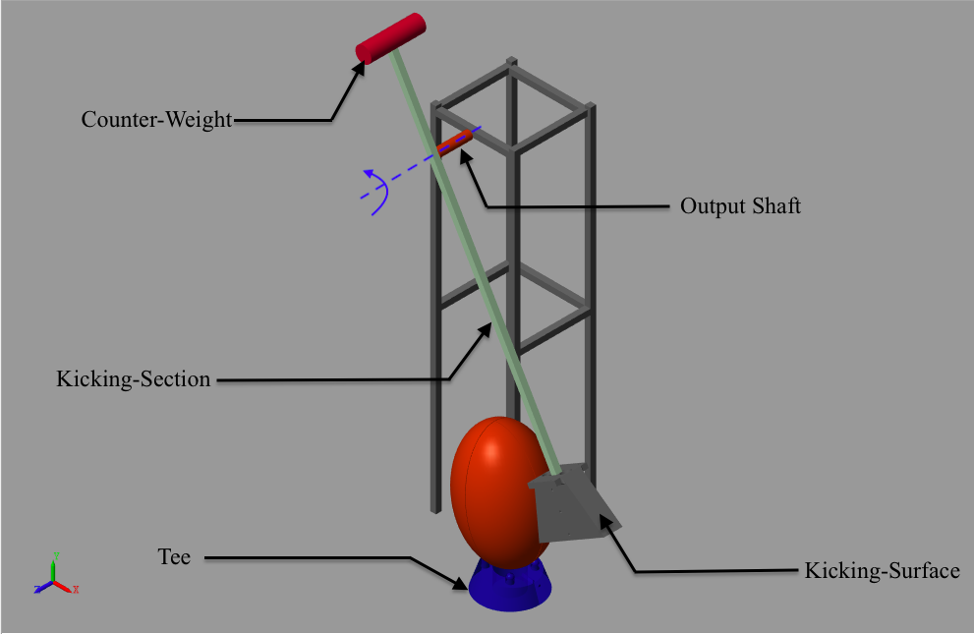

Figure 2: Rotating Arm Kicking Mechanism at rest. The Kicking section is at 30 degree with respect to the vertical axis. Motor rotates the kicking section through 330 degrees anti-clockwise to hit the rugby

The Rotating Arm kicking mechanism shown in Figure 2 above was simulated using **Simscape in MATLAB R2019b**. The main components of the mechanism are Output shaft, kicking section, Kicking surface and the Counter-weight.

# Working

The rugby was placed on the tee making an angle of 10 degree with the vertical to account for any minor tilt that might occur while placing the ball. A motor rotates the output shaft through 330 degrees in the anti-clockwise direction, which in turn rotates the kicking section and kicking surface. The kicking surface hits the rugby ball, giving it the required momentum for the desired projectile motion.

# Simulation parameters

## Simulation Input

The PWM given to the motor was converted into torque using Ampflow software.

The converted torque provides the kicking shaft the required momentum.

## Contact Modelling

In our simulation, the contact was to be modelled on a rugby ball (near ellipsoid), which is not a standard shape provided by **MATLAB** **R2019b** contact modules. To overcome this limitation, we devised a new method to generate custom contact surfaces using standard contact surfaces (sphere).

### Contact model of rugby-plane (ground) contact force:

The contact forces between the rugby and the plane (ground) were given using **multiple sphere-to-plane contact force module** as shown in Figure 3 below:

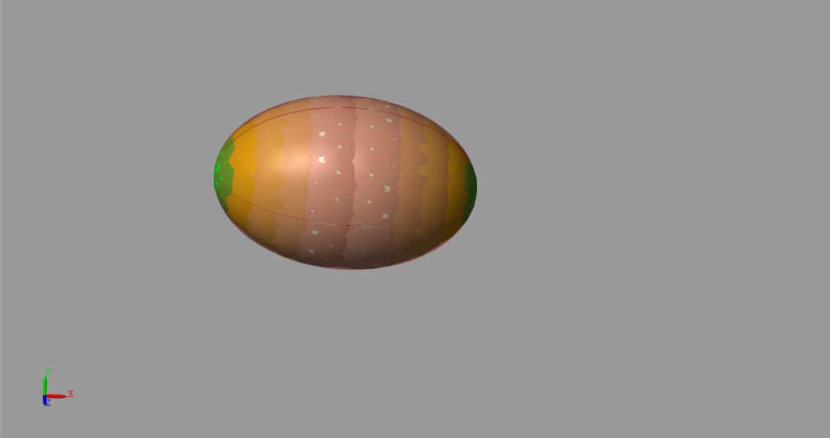

Figure 3: Multiple contact spheres covering the entire rugby surface, accurately emulating the contact between rugby and ground

Each contact sphere has a fixed displacement from the center of the rugby ball and approximated radius that is determined w.r.t the radius of curvature of rugby ball. Thus, **we need very few contacts as compared to creating thousands of small point sized spheres contact force, making it computationally lighter and hence faster.**

This contact force model gives very accurate results as the contact spheres cover the entire surface area of the rugby ball, accurately simulating the collision between ball and ground.

### Contact model of rugby-tee contact force:

The contact modelling between the rugby and the tee is similar to the contact modelling between rugby and ground, the only difference being the number of contact spheres.

Due to the placement of the rugby, only the bottom half of it will remain in contact with the tee. Hence the removal of the top half of the multiple contact sphere model would not affect it’s functioning. This will **save computing time without loss of accuracy**. Hence, only the bottom half of the rugby that is in contact with the tee was covered with multiple sphere contacts as shown in Figure 4 below.

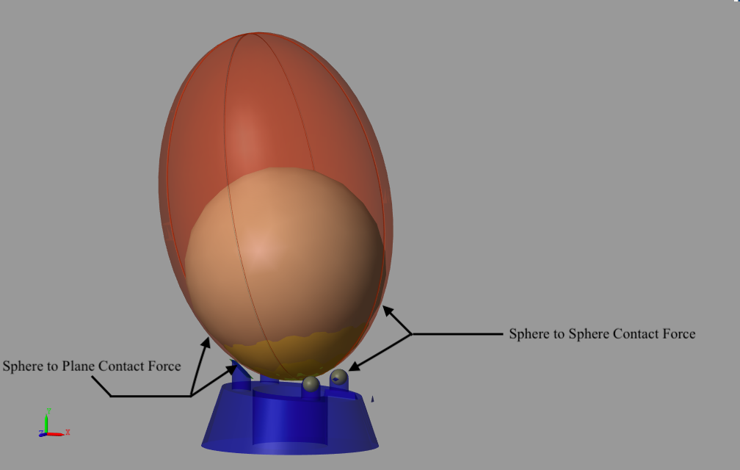

Figure 4:Contact force spheres depicting contact between rugby and tee

### Contact model of rugby-kicking surface contact force:

The contact forces between the rugby and the kicking surface were given using sphere to plane contact force modules as shown below:

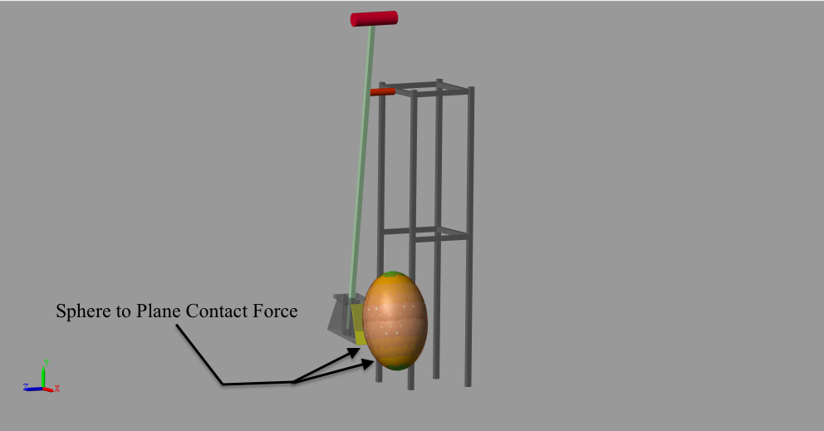

Figure 5:Contact force spheres depicting contact between rugby and kicking surface

The contact model of rugby-kicking surface contact force is similar to rugby-plane (ground) contact model.

## Determination of contact properties

Since this model is simulating a mechanical impulse (between kicking surface and the rugby), the determination of contact stiffness was necessary. However, the standard contact stiffness values of a rugby ball were not readily available. Hence, we decided to experimentally determine it.

(The pressure of the rugby was 9.5 psi, during the conduction of this experiment)

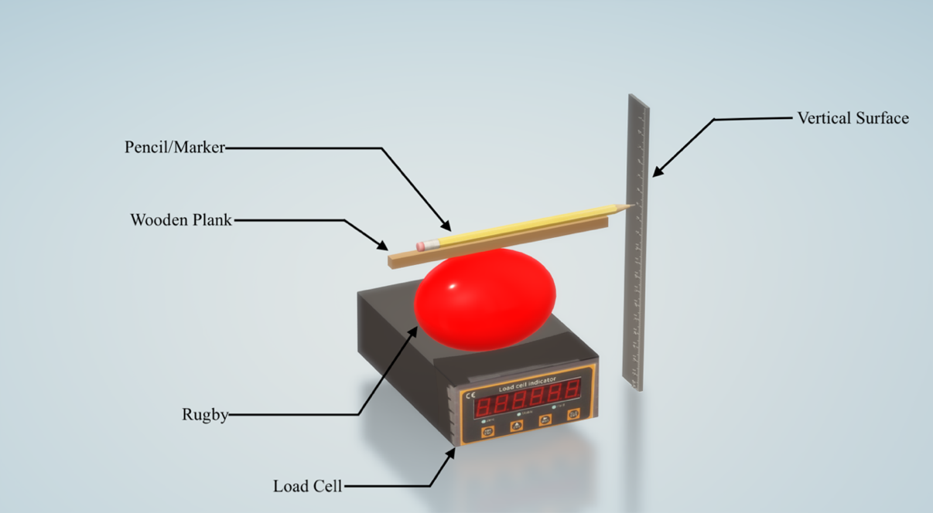

Figure 6: Experimental setup for determining contact stiffness

A light wooden piece was placed on the rugby with a pencil on top of it with the help of a Duct tape. This system was placed on a loadcell near a vertical surface. Force was applied on this system in the vertically downward direction to compress the ball. As the ball was compressed, the pencil was displaced vertically, marking a line on the vertical surface. The length of this line was measured and the applied force was measured using the loadcell, this gave us the stiffness of the ball in Newton per meter

The calculated **avg. stiffness** (calculated over 5 readings) was **73497.3 N/m**.

# Simulation inputs:

* The Converted torque is provided to a revolute joint, which lies in the same frame as the output shaft, providing it with a circular motion.
* The starting inclination of the kicking section was 60 degrees from the horizontal position.

# Results

The results were obtained by connecting a transform sensor between the COM of the ball and COM of tee, giving us the relation between x, y and z-displacements of the ball.

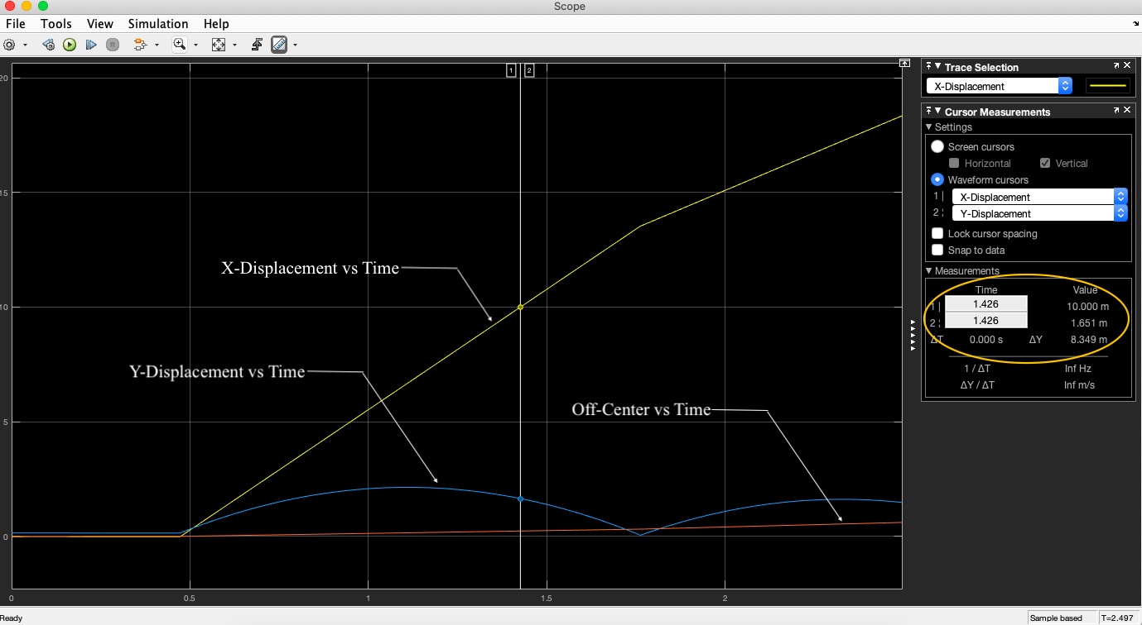

Figure 7: Motion Curves of Rugby Projectile

**Distance vs Torque observation table:**

|  |  |  |  |
| --- | --- | --- | --- |
| **Torque**  **(Nm)** | **Horizontal**  **Distance (m)** | **Height when crossing 10m** | **Comments** |
| 2 | 3.346 | -- | Rugby does not cross 10 m |
| 2.4 | 4.196 | -- | Rugby does not cross 10 m |
| 2.8 | 5.501 | -- | Rugby does not cross 10 m |
| 3.2 | 7.078 | -- | Rugby does not cross 10 m |
| 3.6 | 7.700 | -- | Rugby does not cross 10 m |
| 4 | 9.204 | -- | Rugby does not cross 10 m |
| 4.4 | 11.061 | 0.72 | Rugby crosses 10 m but height is not sufficient |
| 4.8 | 11.806 | 0.99 | Rugby crosses 10 m but height is not sufficient |
| 5.2 | 12.925 | 1.48 | Rugby crosses 10 m but height is not sufficient |
| **5.4** | **13.552** | **1.65** | **Rugby crosses 10 m with sufficient height** |
| 5.6 | 14.223 | 1.887 | Rugby crosses 10 m with more than sufficient height |



Distance (m)

Applied Torque (Nm)



Height(m)

Torque (Nm)

# Conclusions

1. The proposed mechanism was able to kick the rugby ball and give it suitable mechanical impulse to attain the desired projectile trajectory.
2. Simulations were performed for torque range between 2 - 5.6 Nm.
3. The desired projectile trajectory was obtained at 5.4 Nm torque.
4. The optimum torque range is 5.4 to 5.6 Nm

The simulation results are coherent with the physical experiment. The actual experimental model gave optimum results for applied torque range of 5.0 - 5.6 Nm.

---------------------------------------------------------------------------------------------------------------------------