**Objective**

The objective of this simulation was to determine the optimum pressure range for a projectile range of 5-6 m of the rugby ball, using our proposed throwing mechanism.

**Simulation Solution**

The kicking mechanism was simulated using simscape, in MATLAB.

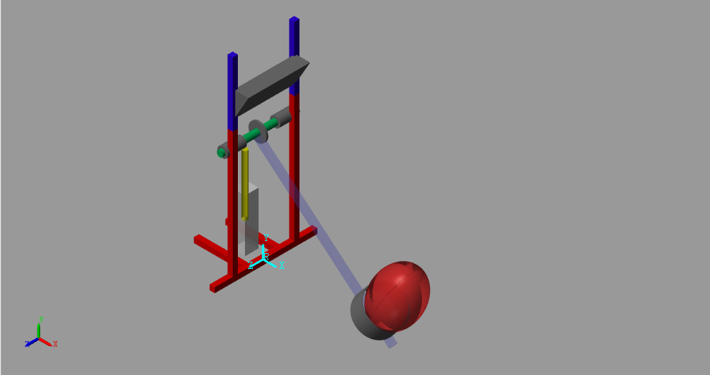

Fig 1.1: Proposed Kicking Mechanism

The above Mechanism consists of:

1. Piston (highlighted in yellow)
2. Gear sprocket
3. Arm
4. Cylindrical Ball Holder
5. Motion limiter

**Working of mechanism**

The translational motion of the piston is provided to the rotational arm with the help of a gear sprocket, which rotates the arm, giving the rugby ball a projectile motion.

**Implementation**

1. The pressure from the piston was converted into torque provided to the sprocket using the relations given below:

Pressure(P) provided by the piston =Force/Area of the piston

Hence, Force = (P x Area of piston)-frictional force of the piston

*The frictional force of the piston was calculated experimentally ≅21N

Torque applied to the sprocket = radius of the sprocket x force applied on sprocket

Therefore,

Torque applied to sprocket = [(P x Area of piston)- 21] x radius of sprocket

Pressure to torque conversion table:

|  |  |
| --- | --- |
| Pressure(bar) | Torque(Nm) |
| 6.0 | 25.65 |
| 5.8 | 24.77 |
| 5.6 | 23.89 |
| 5.4 | 23.00 |
| 5.2 | 22.13 |
| 5.0 | 21.25 |
| 4.8 | 20.37 |
| 4.6 | 19.49 |
| 4.4 | 18.61 |
| 4.2 | 17.73 |
| 4.0 | 16.85 |

1. The contact forces between the ball and the plane were given using sphere to plane contact force module as shown below

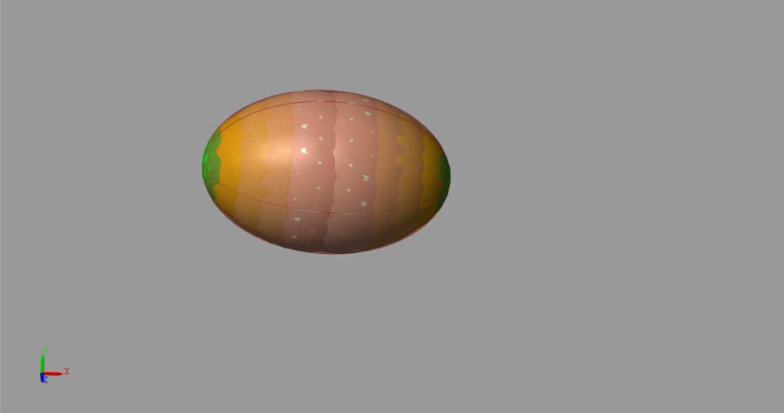

Fig 1.2: Contact force spheres of the rugby ball

Each contact sphere has a fixed displacement from the center of the rugby ball and a approximated radius (determined w.r.t the radius of curvature of rugby ball).

This contact force model gives very accurate results as the contact spheres cover the entire surface area of the rugby ball, accurately simulating the collision between ball and ground.

1. The holder and the ball are provided contact forces as shown below

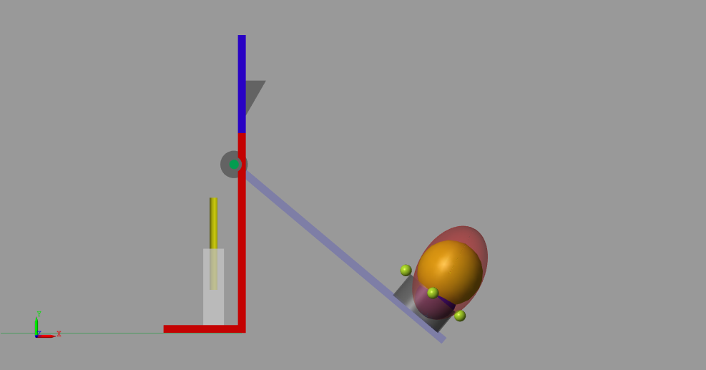

Fig 1.3: Contact forces between rugby and holder

The central sphere, which is coaxial with the ball’s axis, is given a contact force with four imaginary spheres on the periphery of the hollow cylindrical holder, and the smallest contact sphere at the end of the ball is given a contact force with the arm, hence simulating the action of the holder.

1. **Simulation inputs:**

* The Converted torque is provided to a revolute joint, which lies in the same frame as the sprocket, providing it with a circular motion.
* The starting inclination of the arm was 40 degrees below the horizontal and the final position of the arm was 60 degrees above the horizontal.
* The revolute joint is given an actuation limit of 100 degrees from its original position, replicating the physical mechanism.

**Results**

The results were obtained by connecting a transform sensor between the COM of the ball and world frame, giving us the relation between x and y displacements of the ball.

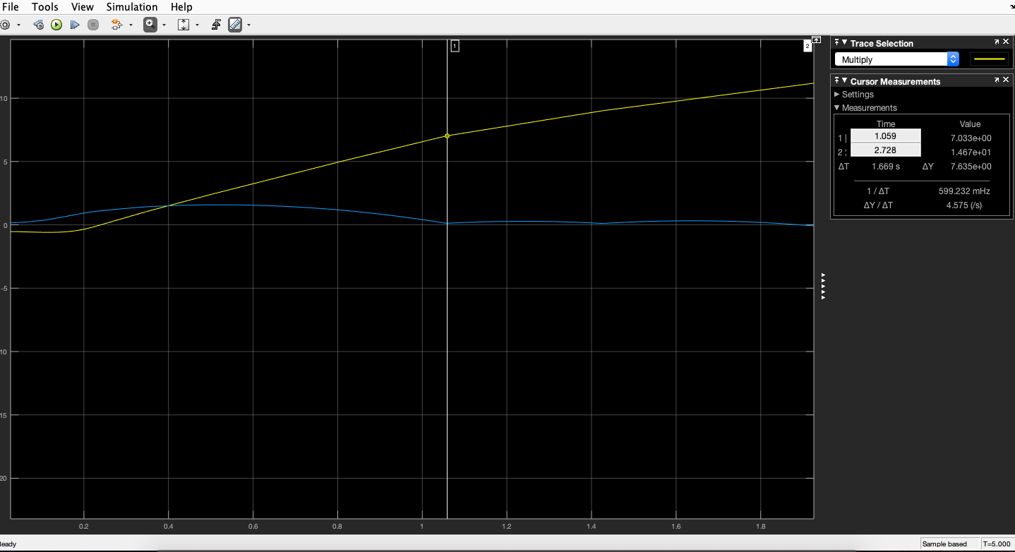

Graph 1.1: x distance (yellow graph) and y distance (blue graph) of COM of the ball

From the above graph, we can calculate the distance of the ball from the starting position, just after the first bounce.

Whenever the value of blue graph (y distance of the COM) becomes, the ball has collided with the ground, hence we can find out the corresponding point on the yellow line (x distance of COM), giving us the required distance.

Pressure vs Range table:

|  |  |
| --- | --- |
| Pressure(bar) | Range(m) |
| 6.0 | 9.5 |
| 5.8 | 9.227 |
| 5.6 | 8.54 |
| 5.4 | 7 |
| 5.2 | 6.746 |
| 5.0 | 6.6 |
| 4.8 | 6.39 |
| 4.6 | 6.237 |
| 4.4 | 6.493 |
| 4.2 | 5.97 |
| 4.0 | 5.1 |

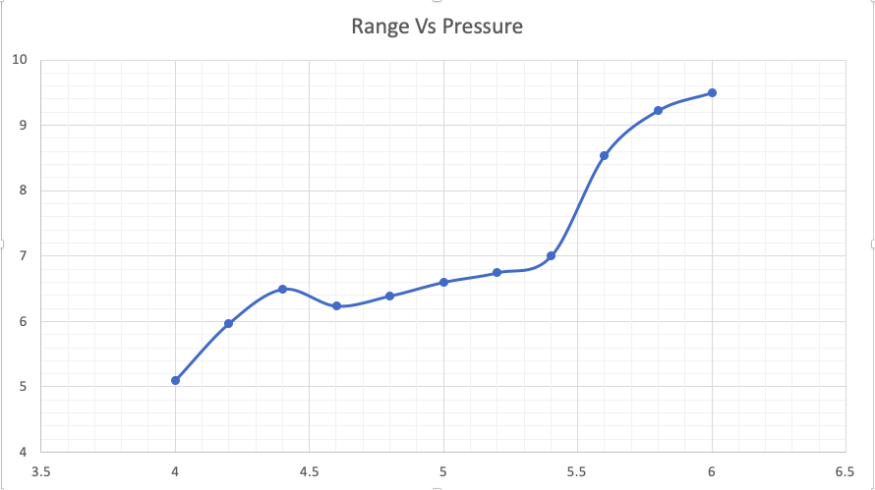

Range (m)

Pressure (bar)

Graph 1.2:Range vs Pressure

**Conclusion**

Simulations were performed for pressure range between 4-6 bar in steps of 0.2 bar for ball orientation of 11.25 degrees with the vertical. The desired projectile range of 5-6m was obtained for a pressure range of 4-4.4 bar.