 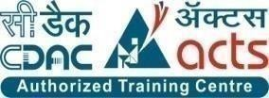

**INSTITUTE FOR ADVANCED COMPUTING ANDSOFTWARE DEVELOPMENT (IACSD), AKURDI, PUNE**

Documentation On

Job Portal

PG-DAC March 2023

# Submitted By:

**Group No: 09**

**Roll No. Name:**

**233012 Anish Rachcha**

**233046 Komal Rochlani**

# Mrs. Sonali Mogal Mr. Rohit Puranik

**Project Guide Centre Coordinator**

# ABSTRACT

The "Job Portal" project presents a dynamic web-based platform that connects Job Providers, Job Seekers, and Administrators in a seamless ecosystem. This system offers a suite of features including Create, Read, Update, and Delete (CRUD) operations for job listings, bolstering efficient management. Job Seekers benefit from advanced search functionalities, refining job searches by criteria like location and job type.

Security is a paramount concern, hence the integration of Spring Security with JWT token-based authentication. User data, including passwords, is fortified through encryption, elevating data protection. For password retrieval, the system employs an email-based OTP mechanism, enhancing account security.

To streamline communication, the project integrates JavaMailSender, enabling effective correspondence between users and the platform. This aids in sending vital notifications, including OTPs and account verifications.

The "Job Portal" not only simplifies job hunting and posting but also underscores contemporary security and communication paradigms. With a user-friendly interface and meticulous security measures, it promises a reliable and up-to-date solution for job-related interactions, ensuring an enriched experience for Job Seekers and Job Providers alike.

# ACKNOWLEDGEMENT

I take this occasion to thank God, almighty for blessing us with his grace and taking our endeavor to a successful culmination. I extend my sincere and heartfelt thanks to our esteemed guide, **Mrs.Sonali Mogal** for providing me with the right guidance and advice at the crucial juncture sand for showing me the right way. I extend my sincere thanks to our respected **Centre Co-Ordinator Mr. Rohit Puranik**, for allowing us to use the facilities available. I would like to thank the other faculty members also, at this occasion. Last but not the least, I would like to thank my friends and family for the support and encouragement they have given me during the course of our work.

**Komal Rochlani (233046)**

**Anish Rachcha (233012)**

**Table of Contents**

Chapter 1 : Introduction .................................................................................................................. 5

1.1 Brief Overview of Work ........................................................................................................…5

1.2 Objective ....................................................................................................................................5

1.3 Scope ......................................................................................................................................... 5

1.4 Project Modules ........................................................................................................................ 5

1.4.1 Registration ............................................................................................................................ 5

1.4.2 Search ..................................................................................................................................... 5

1.4.3 Job Post .................................................................................................................................. 6

1.4.4 Manage Account ............................................................................................................ ……6

1.5 Project Requirements ................................................................................................................ 6

1.5.1 Hardware ................................................................................................................................ 6

1.5.2 Software ................................................................................................................................. 6

1.6 Company Profile ....................................................................................................................... 7

Chapter 2 : System Analysis ........................................................................................................... 7

2.1 Literature Review....................................................................................................................... 8

2.2 Project Feasibility Study ........................................................................................................... 8

2.2.1 Technical Feasibility .............................................................................................................. 8

2.2.2 Economical Feasibility............................................................................................................ 8

2.2.3 Operational Feasibility ........................................................................................................... 8

2.5 Detailed Module Description with all Functionalities .............................................................. 8

2.5.1 Registration ............................................................................................................................ 8

2.5.2 Job Post .................................................................................................................................. 8

2.5.3 Search ..................................................................................................................................... 9

2.5.4 Manage Account .................................................................................................................... 9

Chapter 3 : System Design .............................................................................................................. 10

3.1 Use Case Diagrams ................................................................................................................…10

3.2 Data Flow Diagrams ................................................................................................................ 11

3.3 Class Diagram ..........................................................................................................................12

3.4 Entity Relationship Diagram................................................................................................... 13

3.5 Activity Diagram .................................................................................................................... 14

3.6 Deployment Diagram…………………………………………………………………………16

3.7 Data Dictionary ....................................................................................................................... 17

Chapter 4 : Implementation .......................................................................................................... 23

4.1 User Interface and snapshots .................................................................................................. 23

Conclusion & Future work............................................................................................................ 30

**Chapter 1 : Introduction**

* 1. **Brief Overview of Work**

Now a day, we know that searching of jobs is so difficult in proficient areas the portal developed for the providing the simple and good job searching. With the help of this portal easily the job seeker can submit their resume and get the lot of opportunity of the job related to their profile. And by this website the companies or employer can also find the good and well profiled resume.

* 1. **Objective**

The job Portal System that is to be developed provides the members with jobs information, online applying for jobs and many other facilities. This system provides service to the job applicants to search for working opportunities.

Job Portal will allow job provider to establish one to one relationships with candidates. This Portal will primarily focus on the posting and management of job vacancies. This system is designed such that ultimately all vacancies will be posted online and would offer employers the facilities to post their vacancies online. It helps to review and manage the resulting applications efficiently through the web. Job Provider can also find the resume according to key skill in very less amount of time.

**1.3 Scope**

As of Indian market, there is ample opportunities for the job portal sites, as more and more number of educated and skilled young people are coming out each and every year. Also, as the growth rate of India is zooming to be at a healthy rate over 7%, so it is boom time for corporate also. So, more and more number of lucrative careers will be available for the job seekers. So, it is now the right period for the job portal sites to think out of the box, and to make most of the opportunities available.

* 1. **Project Modules**

**1.4.1 Registration**

Employee or Employer can register with valid details like contact details, experience details, profile details.

**1.4.2 Search**

Employee Can Search job according to their interest. And also apply for that job.

Employer search candidates for their requirements using keyword. Employer also can communicate with employee for their any other query or information via send message.

**1.4.3 Job Post**

Employer post job for their organization. And include job vacancy, salary details, working hours, designation details, experienced details.

**1.4.4 Manage Account**

Employee can also delete his/her account anytime.

Admin Can Manage Employee and Employer Details. Admin observed Users Action like job posting, candidate details false or not.

* 1. **Project Requirements**

**1.5.1 Hardware**

The system requires the following hardware:

* RAM: 1 GB (further increase that as per requirement.)
* Hard Disk: 80 GB (further increase that as per requirement.)
* Display: 1024 * 768, True Type Color-32 Bit
* Mouse: Any Normal Mouse.
* Keyboard: Any window Supported Keyboard.

**1.5.2 Software**

* Database Server : MySQL Server
* Web Server : Internet Information Server
* Technologies : React js, CSS, SPRING BOOT

**Chapter 2 : System Analysis**

**2.1 Literature Review**

Job Procurement: Old and New Ways Job seeking usually involves different ways to look for jobs such as through personal contacts, direct telephone calls to employers, job agency office, scanning online job listings, etc. Before the Internet, became widely uses as a method of seeking jobs, jobseekers spent a lots of time using various methods to look for job openings. Today, jobseekers use online methods which are very convenient and save a lot of time. The following methods to be the traditional (old) ways for recruitment:

1) Employment recruitment agencies

2) Job fairs

3) Advertising in the mass media such as newspapers

4) Management Consultants

5) Advertisement in television and radio

6) Existing employee contacts

7) Schools colleges or universities students services department

8) Workers or professional referrals

These old job seeking methods are too slow, stressful, challenging and also lack quality. In addition, the applicants have to consider the cost and the amount of time to get the information they need, and other preparations they have to make. Finding all available job vacancies is a main step at in the job-seeking process. The Internet is now a powerful tool that jobseekers can use. Today, there are many sites that advertise job positions to be filled by people with certain skills in various fields. The Internet plays an important role in the area of human resource planning and development. Most planning and development organizations are now using computer technology and the Internet for staff recruitment. It should be noted that although the Internet has facilitated the process of job-seeking, it has not replaced the traditional methods, completely.

**Importance of Job Portals**

In the age of technology, the Internet has become the main source of information for jobseekers. Large corporations, Institutions, and universities include information on career Prospects on their websites. According to a survey, 70% of the workforce uses websites or portals on the Internet to Search for jobs in France. These websites or portals provide search engine to access information on job opportunities.

**2.2 Project Feasibility Study**

**2.2.1 Technical Feasibility**

Technical feasibility study is concerned with specifying equipment and software that will successfully satisfy the user requirement; the technical needs of the system may vary considerably.

The facility to produce outputs in a given time. Our project is a web based application which is based on client-server based application. In this application every page as output is render from server to client so it is necessary that the page should be rendered in time. For this I have avoided more and more code in the page- load event.

**2.2.2 Economical Feasibility**

Economical feasibility is the measure to determine the cost and benefit of the proposed system. A project is economical feasible which is under the estimated cost for its development. These benefits and costs may be tangible or intangible. Job Portal is the cost-effective project in which there is less possibility of intangible cost so there is no difficulty to determine the cost of the project.

**2.2.3 Operational Feasibility**

Operation feasibility is used to check whether the project is operationally feasible or not. Our project is mainly different from the other system because of its web-support feature. So the measure for operational feasibility is something different from other system. Generally the operational feasibility is related to organization aspects.

The change determination is as such that early product were either a man or group of men or the jobs based manual but now a day with the advent of Internet technology.

**2.5 Detailed Module Description with all Functionalities**

**2.5.1 Registration**

In the registration module job seeker have to include all the details like personal details, contact details, education details like school , graduation, post-graduation, course certification details etc. Also job seeker has to add his experience details, job requirements and uploading resume and photo.

While job recruiter has to add his contact details and organization details for the registration and upload company logo and profile.

**2.5.2 Job Post**

Employer can post a job by providing all the job details like qualifications details, requirements for the job, designation details, job salary details and also provide type of jobs. They also can delete the jobs whenever they want. After successfully posted a job it will be available for all the job seekers who are searching for a job. And it will be available on home page as recently posted job.

**2.5.3 Search**

Employee Can Search job according to their interest. And also apply for that job or they can add into wishlist for future whenever they find for job for that company then they easily find out company from wishlist.

Employer search candidates for their requirements using keyword like technology. And also can communicate with employee for their any other query or information via send message .and also employer see the resume of applicants.

**2.5.4 Manage Account**

While employers can manage their job postings. And providing all the job details like qualifications details, requirements for the job, designation details, job salary details and also provide type of jobs. They also can delete the jobs whenever they want.

While employee can manage their wishlist, applied for job and also getting full details of employer. Employees can delete their account anytime. Also they can apply for the different jobs according to their interests.

**Chapter 3 : System Design**

**3.1 Use Case Diagrams**

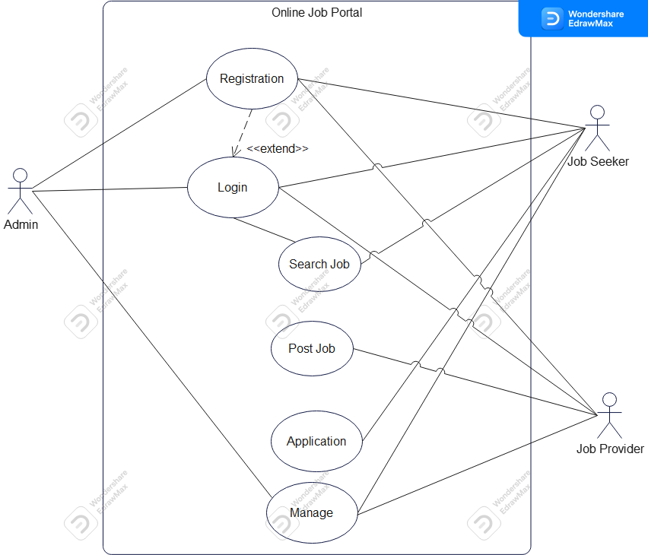

**3.2 Data Flow Diagrams**

**3.2.1 Context-Level (Level 0) DFD**

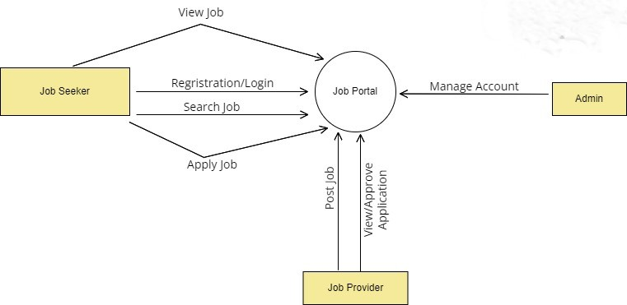

**3.3 Class Diagram**

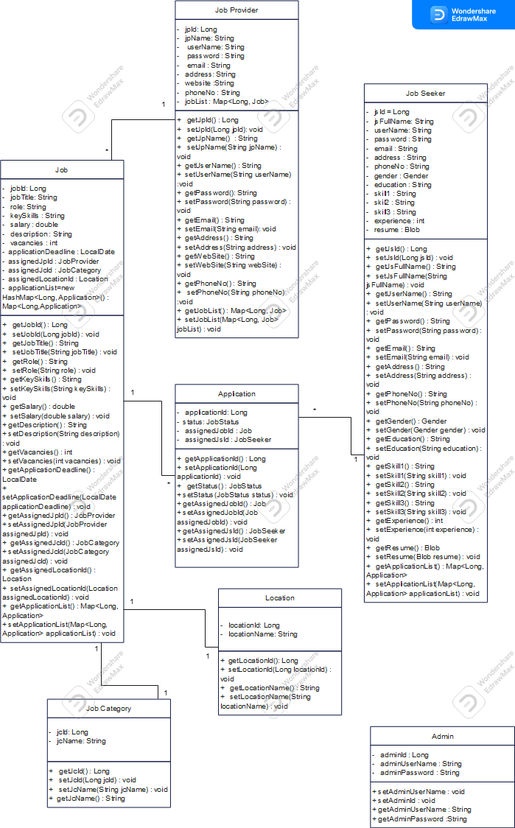

**3.4 Entity Relationship Diagram**

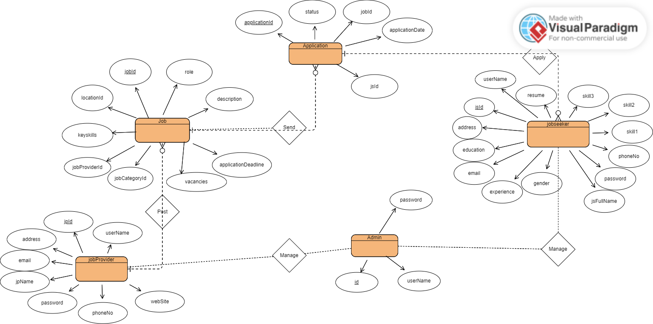

**3.5 Activity Diagram**

**3.5.1 Job Provider**

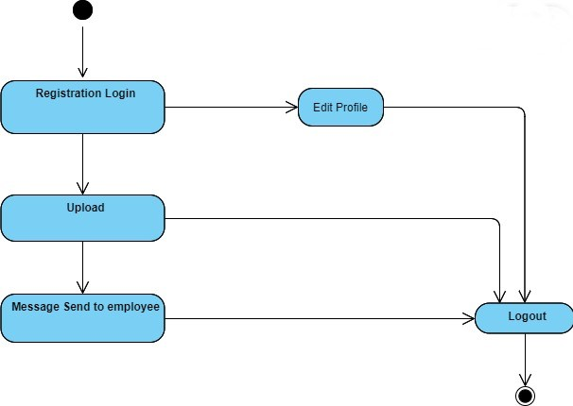

**3.5.2 Job Seeker**

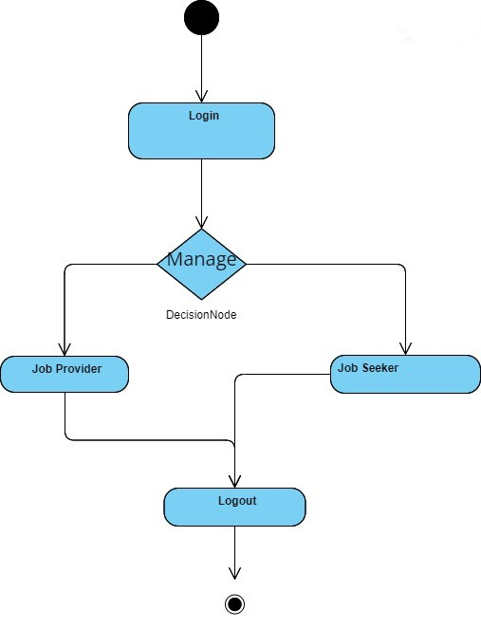

**3.5.3 Admin**



**3.6 Deployment Diagram**

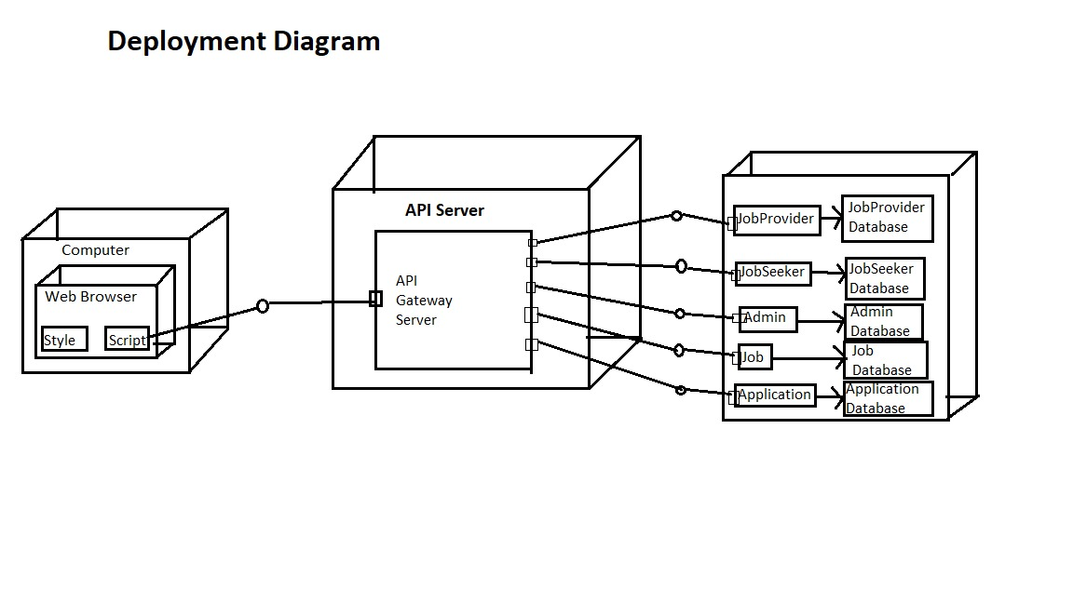

**3.6 Data Dictionary**

Table 1- Job Provider table

|  |  |  |  |  |  |
| --- | --- | --- | --- | --- | --- |
| **Table 1:** | | | | | |
| **Name:** | | | Job Provider | | |
| **Description:** | | | Records information regarding Job Pro. | | |
| **Fields** | | | | | |
| **Sr. No.** | **Field Name** | **Field Type** | | **Constraints** | **Description** |
| 1 | jpId | bigint | | primary key | Holds unique id of job provider. |
| 2 | jpName | varchar(40) | | Null | Holds full name of the job provider. |
| 3 | password | varchar(50) | | Null | Holds password of the job provider. |
| 4 | phoneNo | varchar(50) | | Null | Holds phone no of the job provider. |
| 5 | userName | varchar(50) | | Null | Holds user name of job provider. |
| 6 | webSite | varchar(50) | | Null | Holds website of job provider. |
| 7 | address | varchar(300) | | Null | Holds address of job provider. |
| 8 | email | varchar(40) | | Null | Holds email of job provider. |

Table 2 – jobseeker table

|  |  |  |  |  |  |
| --- | --- | --- | --- | --- | --- |
| **Table 2:** | | | | | |
| **Name:** | | | Job seeker | | |
| **Description:** | | | Records information regarding Job Seeker | | |
| **Fields** | | | | | |
| **Sr. No.** | **Field Name** | **Field Type** | | **Constraints** | **Description** |
| 1 | jsId | bigint | | primary key | Holds unique id of job seeker. |
| 2 | jsFullName | varchar(40) | | Null | Holds full name of the job seeker. |
| 3 | password | varchar(50) | | Null | Holds password of the job seeker. |
| 4 | phoneNo | varchar(50) | | Null | Holds phone no of the job seeker. |
| 5 | userName | varchar(50) | | Null | Holds user name of job seeker. |
| 6 | education | varchar(50) | | Null | Holds education of job seeker |
| 7 | address | varchar(300) | | Null | Holds address of job seeker. |
| 8 | email | varchar(40) | | Null | Holds email of job seeker. |
| 9 | experience | varchar(50) | | Null | Holds experience of job seeker. |
| 10 | gender | varchar(50) | | Null | Holds gender of job seeker |
| 11 | resume | varchar(50) | | Null | Holds resume of job seeker |
| 12 | skill1 | varchar(50) | | Null | Holds skill1 of job seeker |
| 13 | Skill2 | varchar(50) | | Null | Holds skill2 of job seeker |
| 14 | Skill3 | varchar(50) | | Null | Holds skill3 of job seeker |

Table 3- jobcategory table

|  |  |  |  |  |  |
| --- | --- | --- | --- | --- | --- |
| **Table 3:** | | | | | |
| **Name:** | | | jobcategory | | |
| **Description:** | | | Record information about categories of job. | | |
| **Fields** | | | | | |
| **Sr. No.** | **Field Name** | **Field Type** | | **Constraints** | **Description** |
| 1 | jcId | Int | | primary key | Holds id of job category. |
| 2 | jcName | varchar(50) | | not null | Holds job category name. |

Table 4- job table

|  |  |  |  |  |  |
| --- | --- | --- | --- | --- | --- |
| **Table 4:** | | | | | |
| **Name:** | | | Job | | |
| **Description:** | | | Records information about job posted by recruiter. | | |
| **Fields** | | | | | |
| **Sr. No.** | **Field Name** | **Field Type** | | **Constraints** | **Description** |
| 1 | jobId | int | | primary key | Holds id of job. |
| 2 | applicationDeadline | date | | Not Null | Holds deadline of job. |
| 3 | description | int | | foreign key | Holds description of job. |
| 4 | jobTitle | Int | | Foreign key | Holds jobTitle og job |
| 5 | keySkills | varchar(150) | | Null | Holds Keyskills required for the job. |
| 6 | role | varchar(50) | | Null | Holds role of the job. |
| 7 | salary | double | | Null | Holds salary for the job. |
| 8 | vacancies | int | | Null | Holds number of vacancies job. |
| 9 | jobCategoryId | bigint | | Null | Holds type of category of job. |
| 10 | jobProviderId | bigint | | Null | Holds job provider id. |
| 11 | locationId | bigint | | Null | Holds location id of job. |

Table 5- applications table

|  |  |  |  |  |  |
| --- | --- | --- | --- | --- | --- |
| **Table 5:** | | | | | |
| **Name:** | | | applications | | |
| **Description:** | | | Records information about job application | | |
| **Fields** | | | | | |
| **Sr. No.** | **Field Name** | **Field Type** | | **Constraints** | **Description** |
| 1 | applicationId | int | | primary key | Holds the id of job application. |
| 2 | status | int | | Varchar(20) | Holds the status of application of job. |
| 3 | jobId | int | | foreign key | Holds the information for which job applied. |
| 4 | jsId | varchar(50) | | foreign key | Holds the information for which job seeker applied. |

Table 6- location table

|  |  |  |  |  |  |
| --- | --- | --- | --- | --- | --- |
| **Table 6:** | | | | | |
| **Name:** | | | location | | |
| **Description:** | | | Record information about city. | | |
| **Fields** | | | | | |
| **Sr. No.** | **Field Name** | **Field Type** | | **Constraints** | **Description** |
| 1 | locationId | Int | | Primary Key | Holds unique id for city. |
| 2 | locationName | varchar(50) | | Null | Holds the name of city. |

**Chapter 4 : Implementation**

**4.1 User Interface and snapshots**

**Home Page**

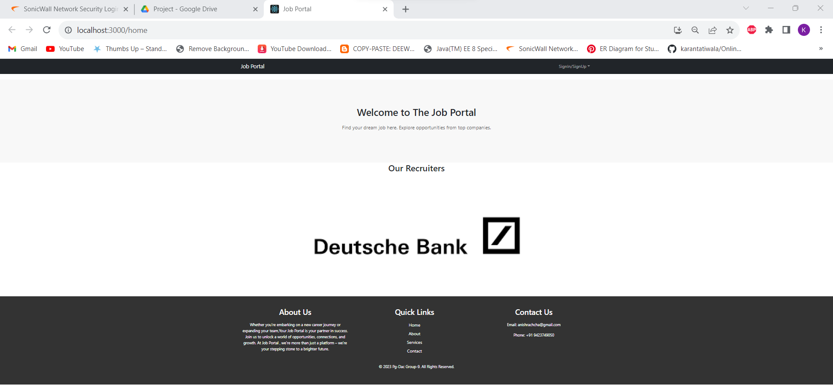

**Admin Login**

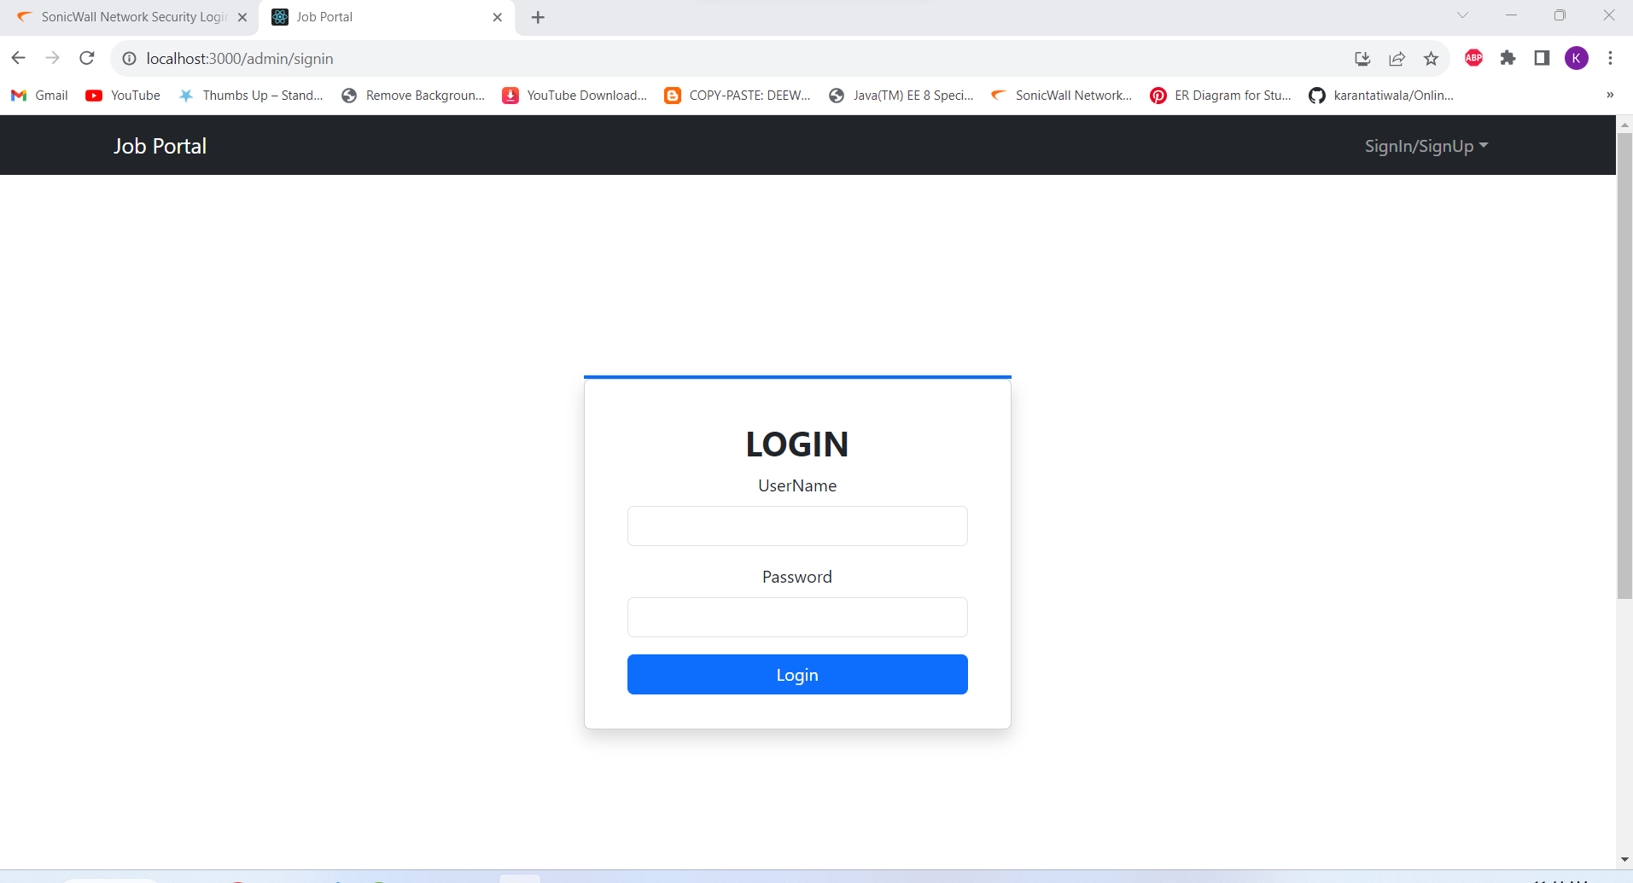

**Admin Home Page**

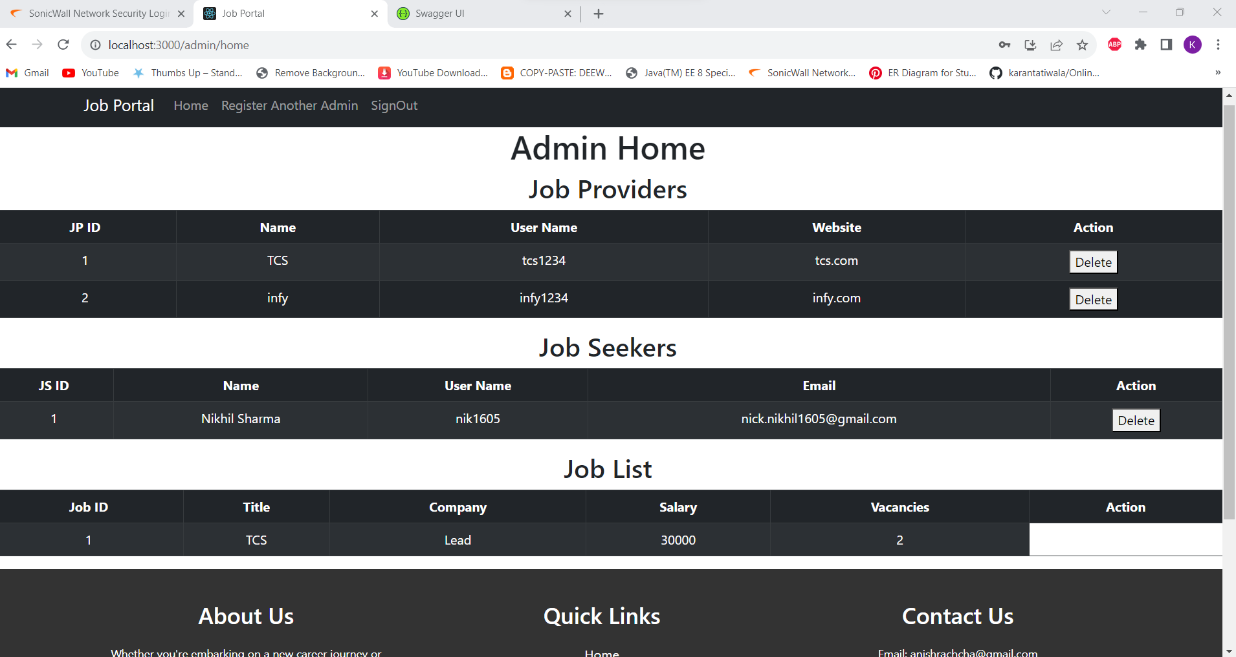

**Job Provider Login**

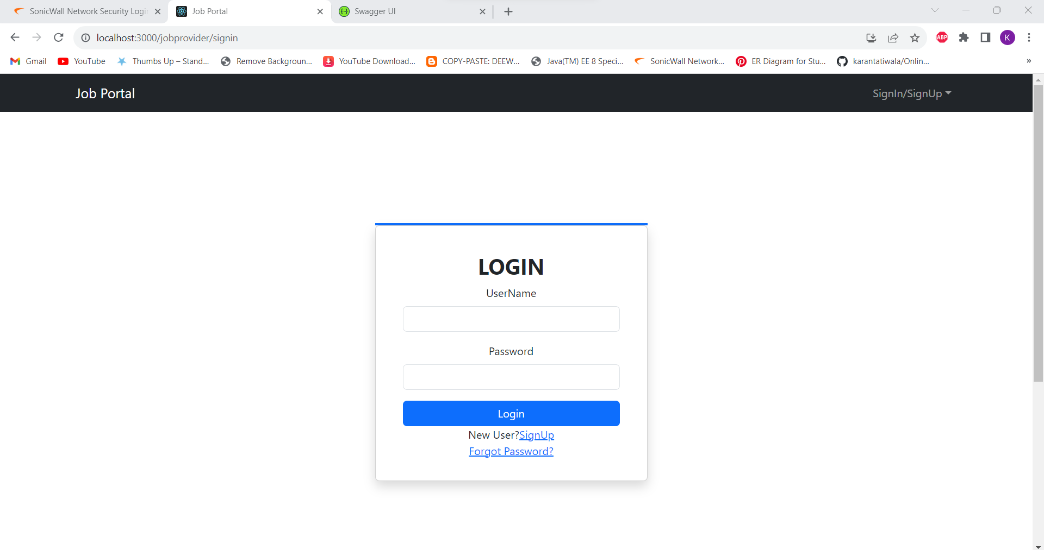

**Post Job**

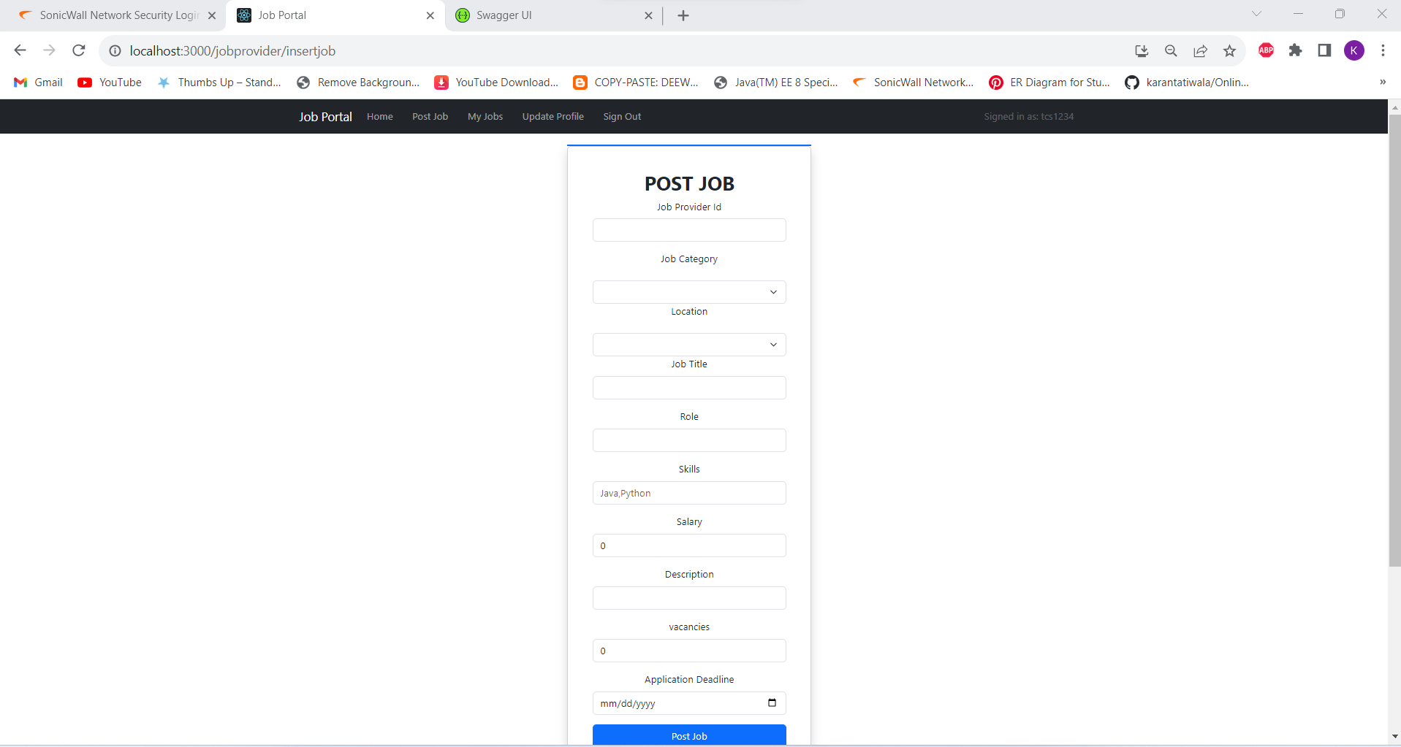

**Job Posted List**

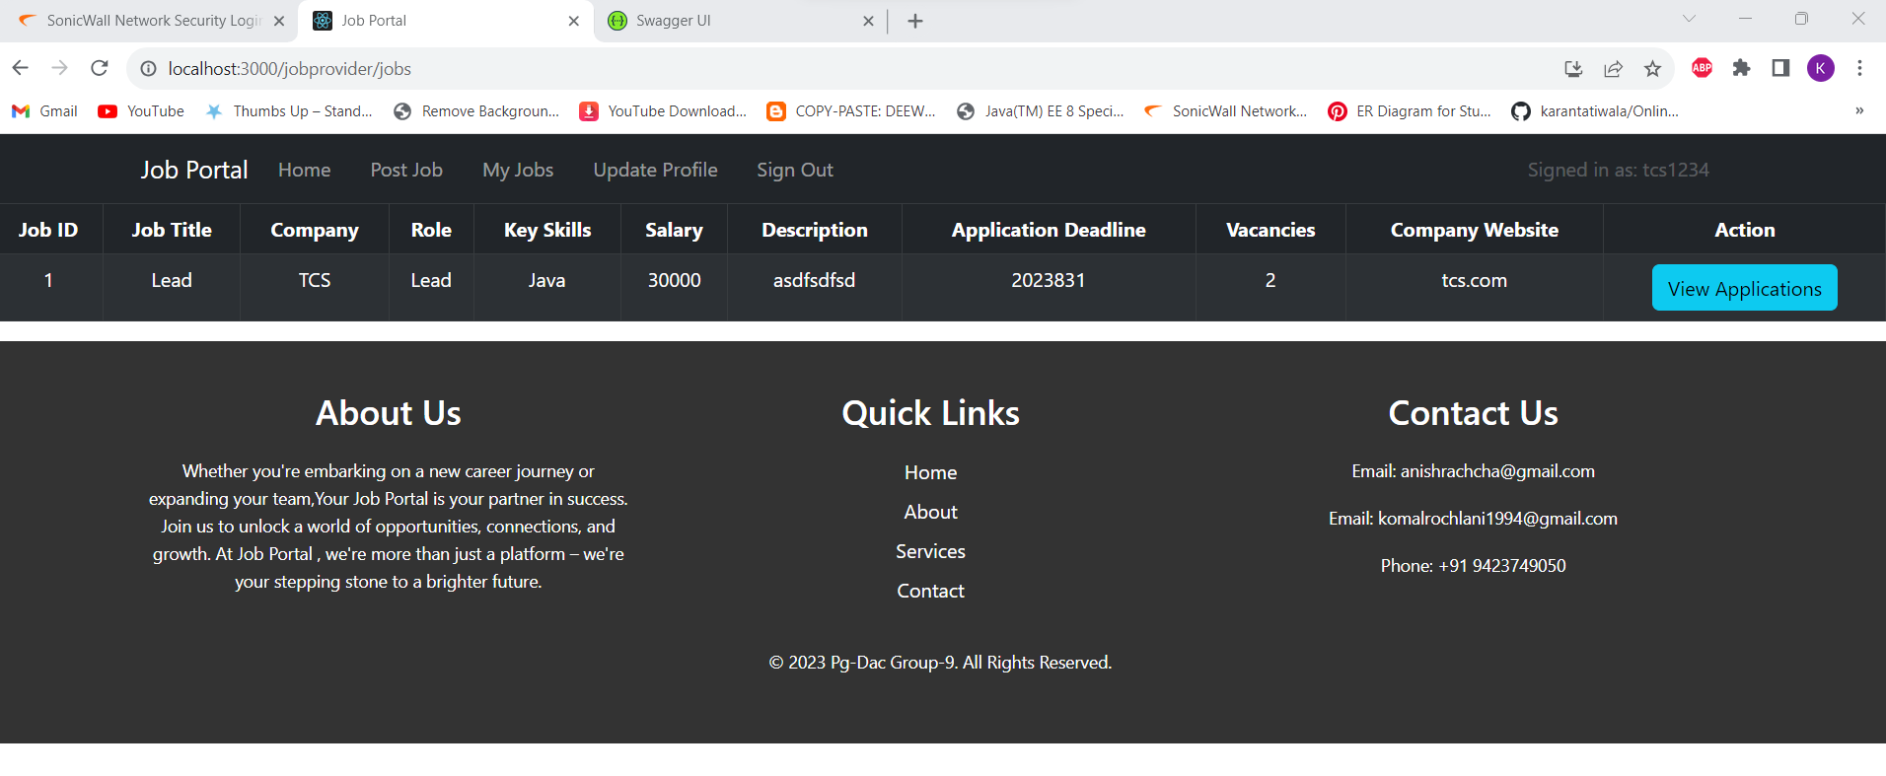

**Job Provider Registration**

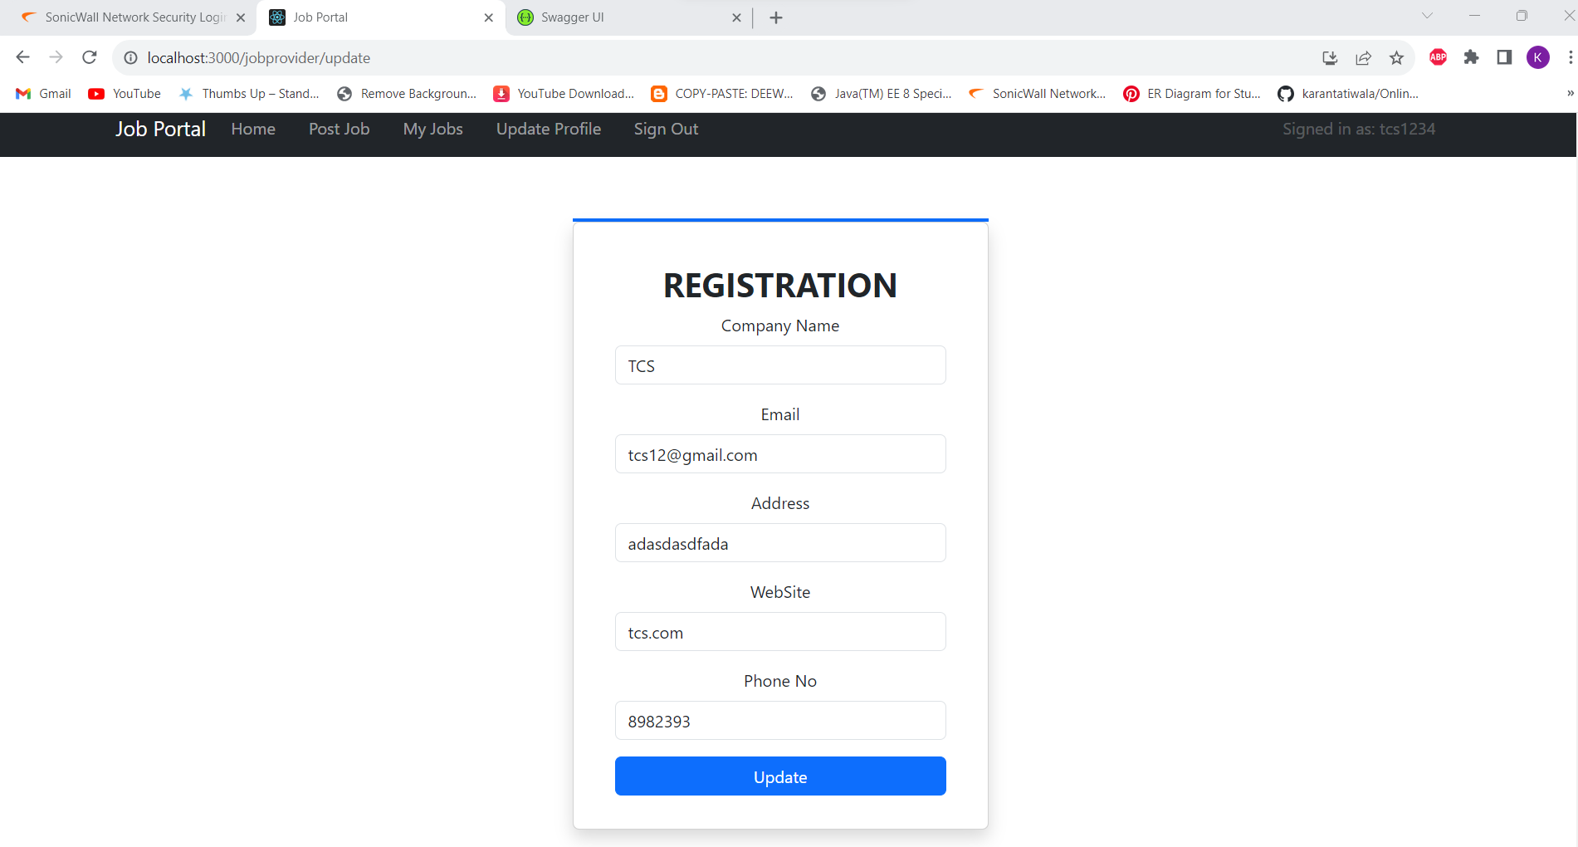

**Job Provider Update Page**

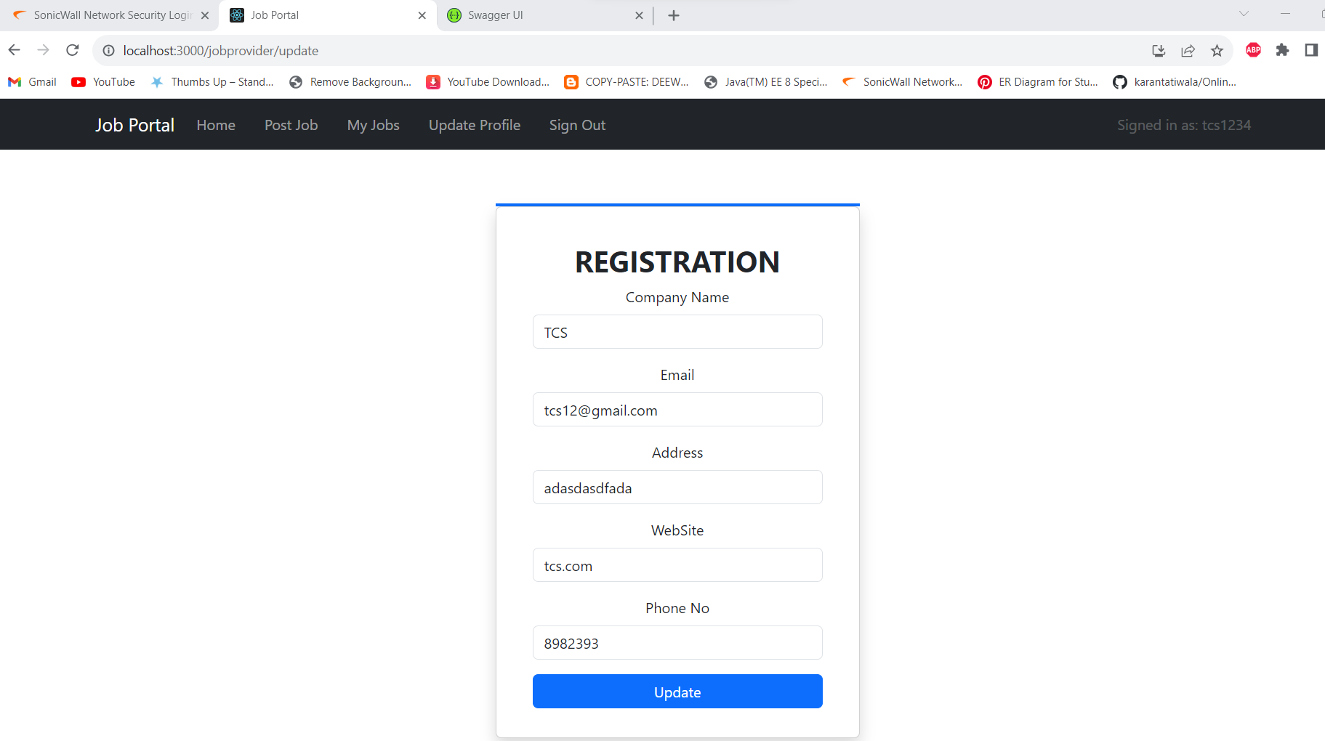

**Job Provider Forgot Password**

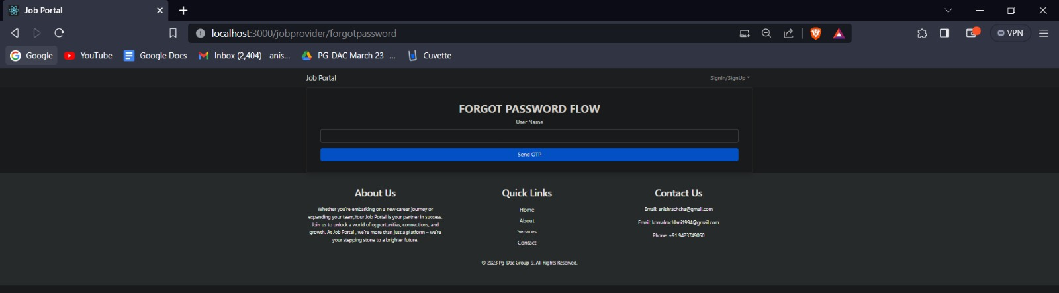

**Job Seeker Job List Page**

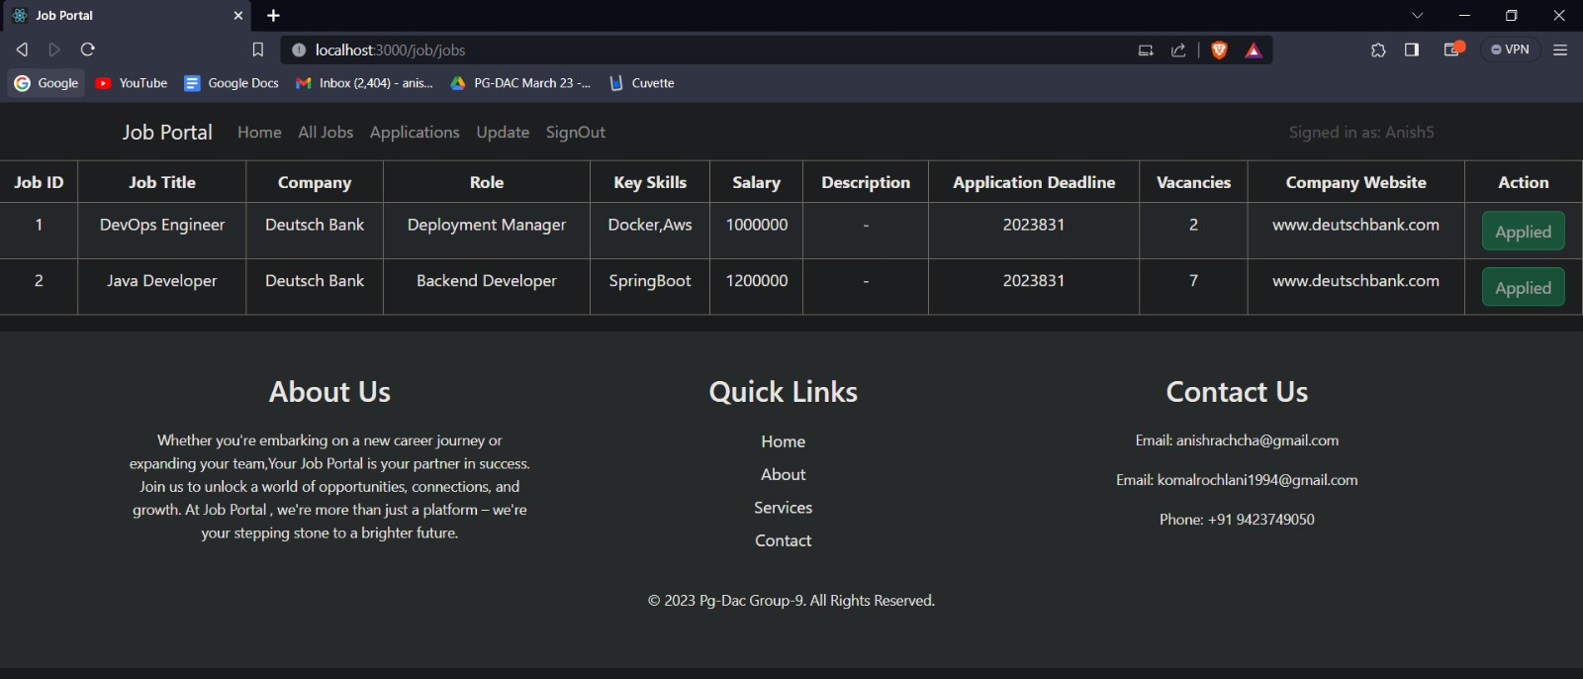

**Job Seeker Applied List Page**

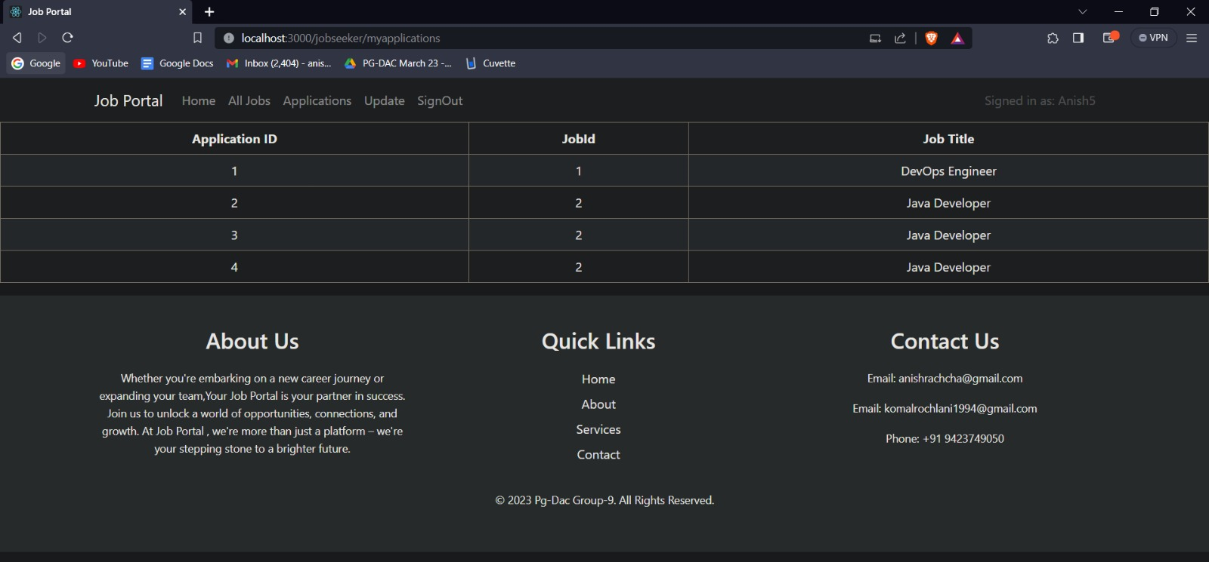

**Job Seeker Update Page**

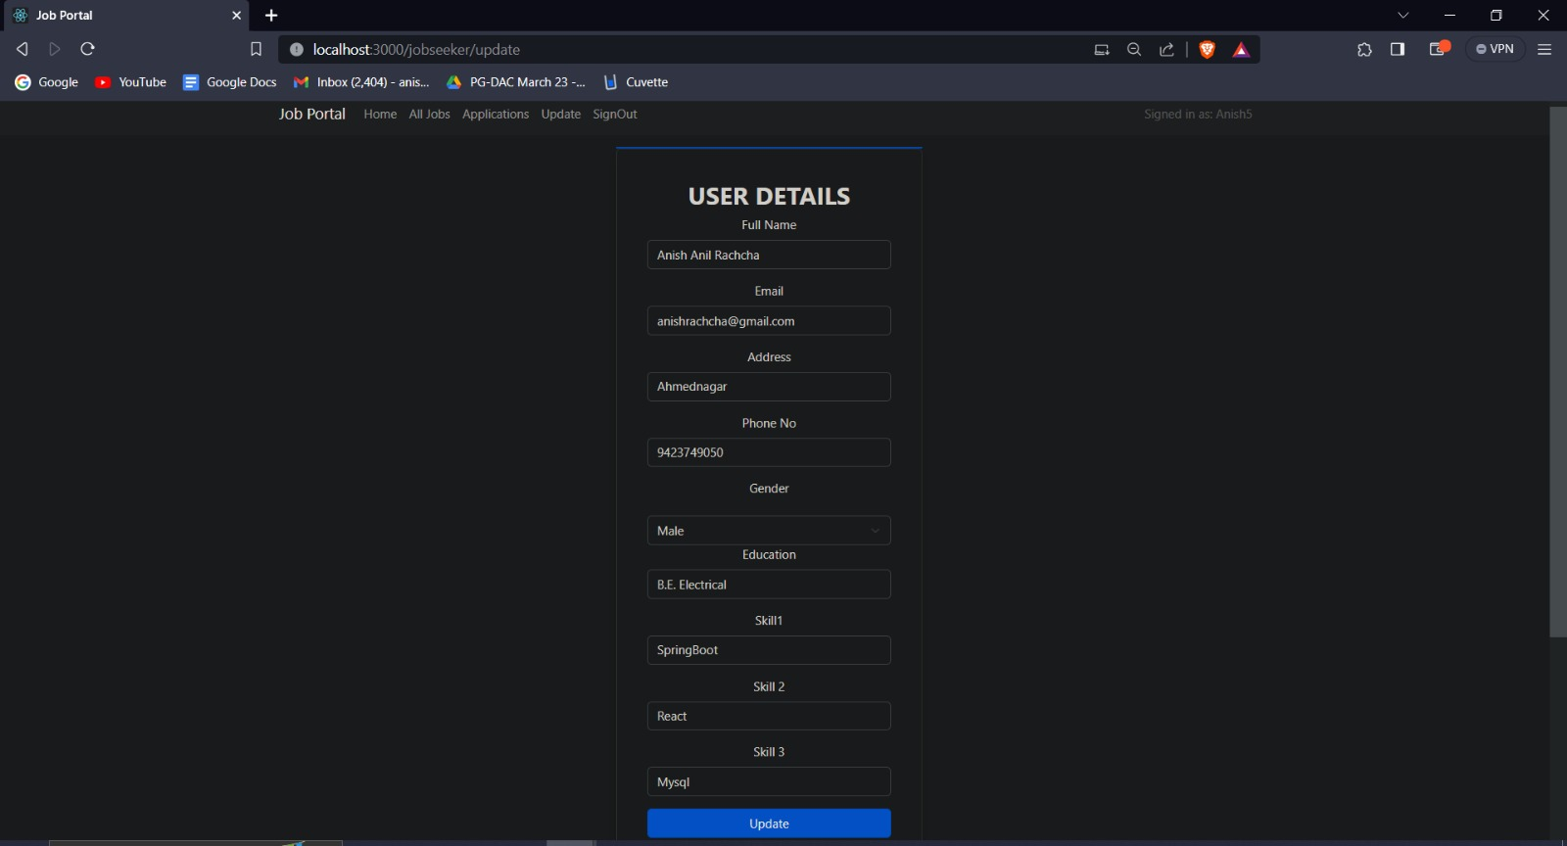

**Job Seeker Registration Page**

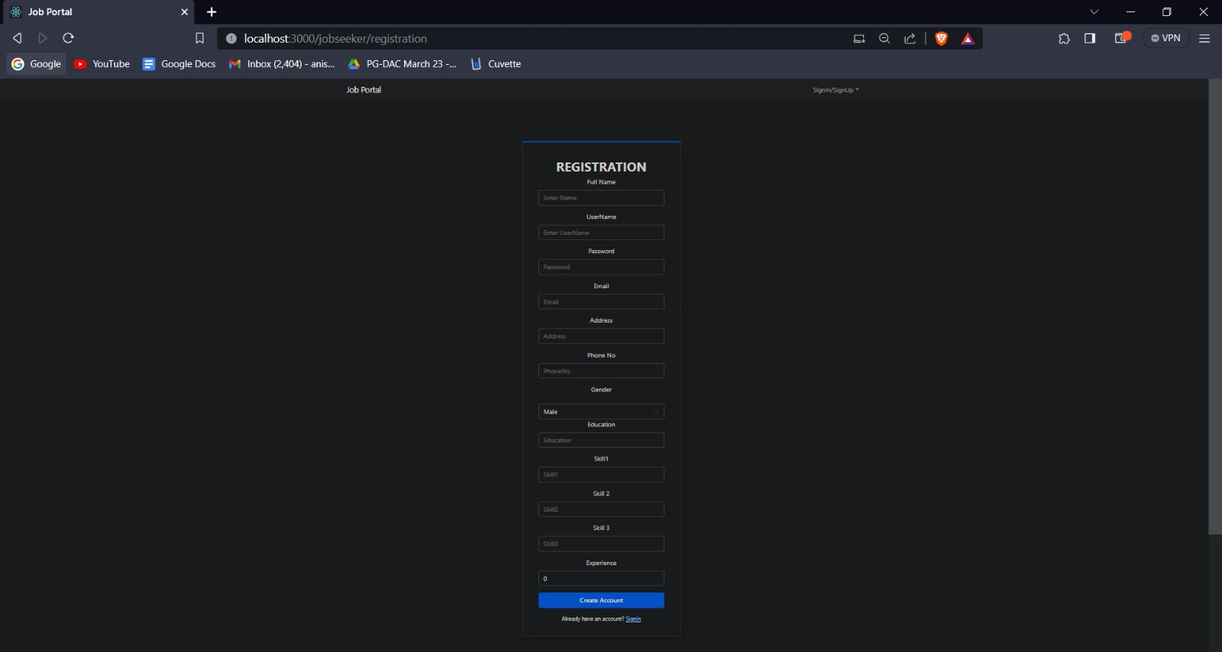

**Job Seeker Forget Password Page**

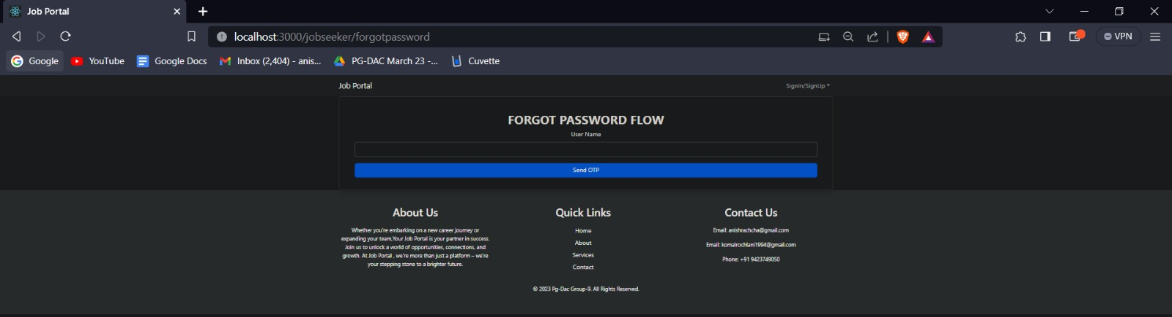

**Conclusion & Future work**

It has been a great pleasure for me to work on this exciting and challenging project. This project proved good for me as it provided practical knowledge of not only programming in Java web based application and no some extent Windows Application and SQL Server, but also about all handling procedure related with online job portal. It also provides knowledge about the latest technology used in developing web enabled application and client server technology that will be great demand in future. This will provide better opportunities and guidance in future in developing projects independently.

In culmination, the "Job Portal" project stands as a testament to the modernization of job recruitment and engagement. With its seamless interconnection of Job Providers, Job Seekers, and Administrators, the project has effectively reshaped the landscape of job listing, application, and oversight. The intrinsic features of the platform, spanning from the foundational CRUD operations to the advanced search capabilities, have been meticulously developed to cater to the multifaceted requirements of its diverse user base.

The adoption of Spring Security supplemented by JWT token-based authentication lays a formidable groundwork for safeguarding user data and ensuring controlled access to the various segments of the portal. This integrated security framework guarantees that user information remains protected and interactions within the platform remain confidential. The reinforcement of password encryption and the implementation of an email-based OTP verification mechanism for the "Forgot Password" feature further amplify the project's dedication to fortifying user accounts and maintaining a secure digital environment.